**PROBLEM 1:**

include \masm32\include\masm32rt.inc

.code

start:

call main

exit

main proc

LOCAL v1 :DWORD

LOCAL v2 :DWORD

LOCAL v3 :DWORD

mov v1, sval(input("Nhap A: "))

mov v2, sval(input("Nhap B: "))

mov v3, sval(input("Nhap C: "))

mov eax, v2

cmp v1, eax

jl less_1

print chr$("A is not less than B", 13, 10)

jmp stop

less_1:

cmp eax, v3

je assign_v1

mov v3, 0

print chr$("C = ")

print str$(v3)

jmp stop

assign_v1:

mov v1, 0

print chr$("A = ")

print str$(v1)

jmp stop

stop:

ret

main endp

end start

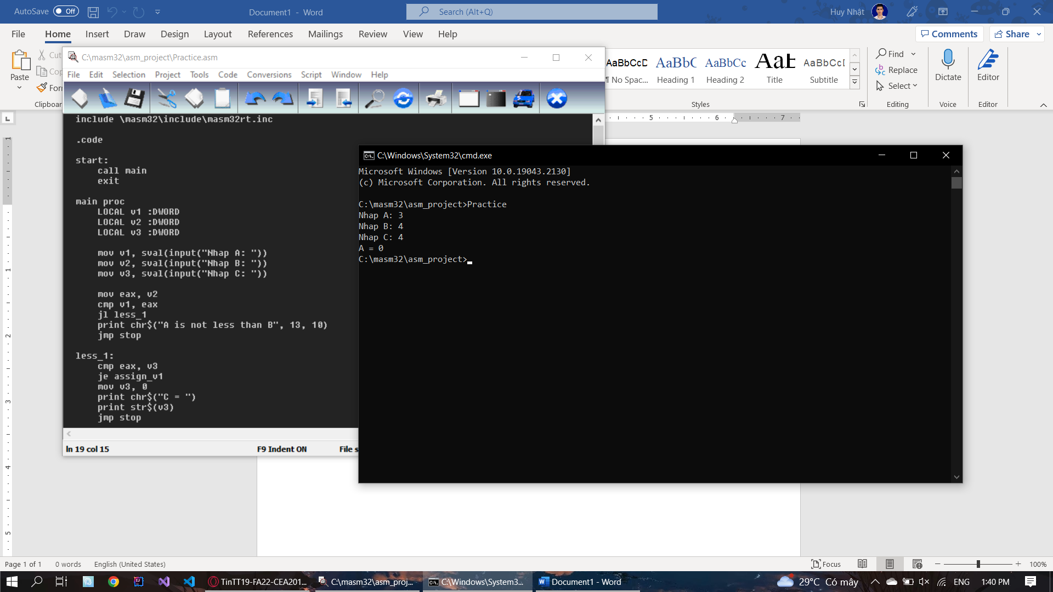

**PROBLEM 3:**

include \masm32\include\masm32rt.inc

.code

start:

call main

exit

main proc

LOCAL v1 :DWORD

LOCAL v2 :DWORD

LOCAL result :DWORD

mov v1, sval(input("Enter no.1: "))

mov v2, sval(input("Enter no.2: "))

mov eax, v1

cmp eax, v2

jg SWAP_NUMBER

AFTER_SWAP:

mov eax, v1

add eax, v2

cmp eax, v1

jge NEXT_STEP

dec eax

mov result, eax

print chr$("Sum: ")

print str$(result)

print chr$(".", 13, 10)

jmp STOP

NEXT_STEP:

cmp eax, v2

jle FINAL_STEP

dec eax

mov result, eax

print chr$("Sum: ")

print str$(result)

print chr$(".", 13, 10)

jmp STOP

FINAL_STEP:

inc eax

mov result, eax

print chr$("Sum: ")

print str$(result)

print chr$(".", 13, 10)

jmp STOP

SWAP_NUMBER:

mov ebx, v2

mov v2, eax

mov v1, ebx

jmp AFTER_SWAP

STOP:

ret

main endp

end start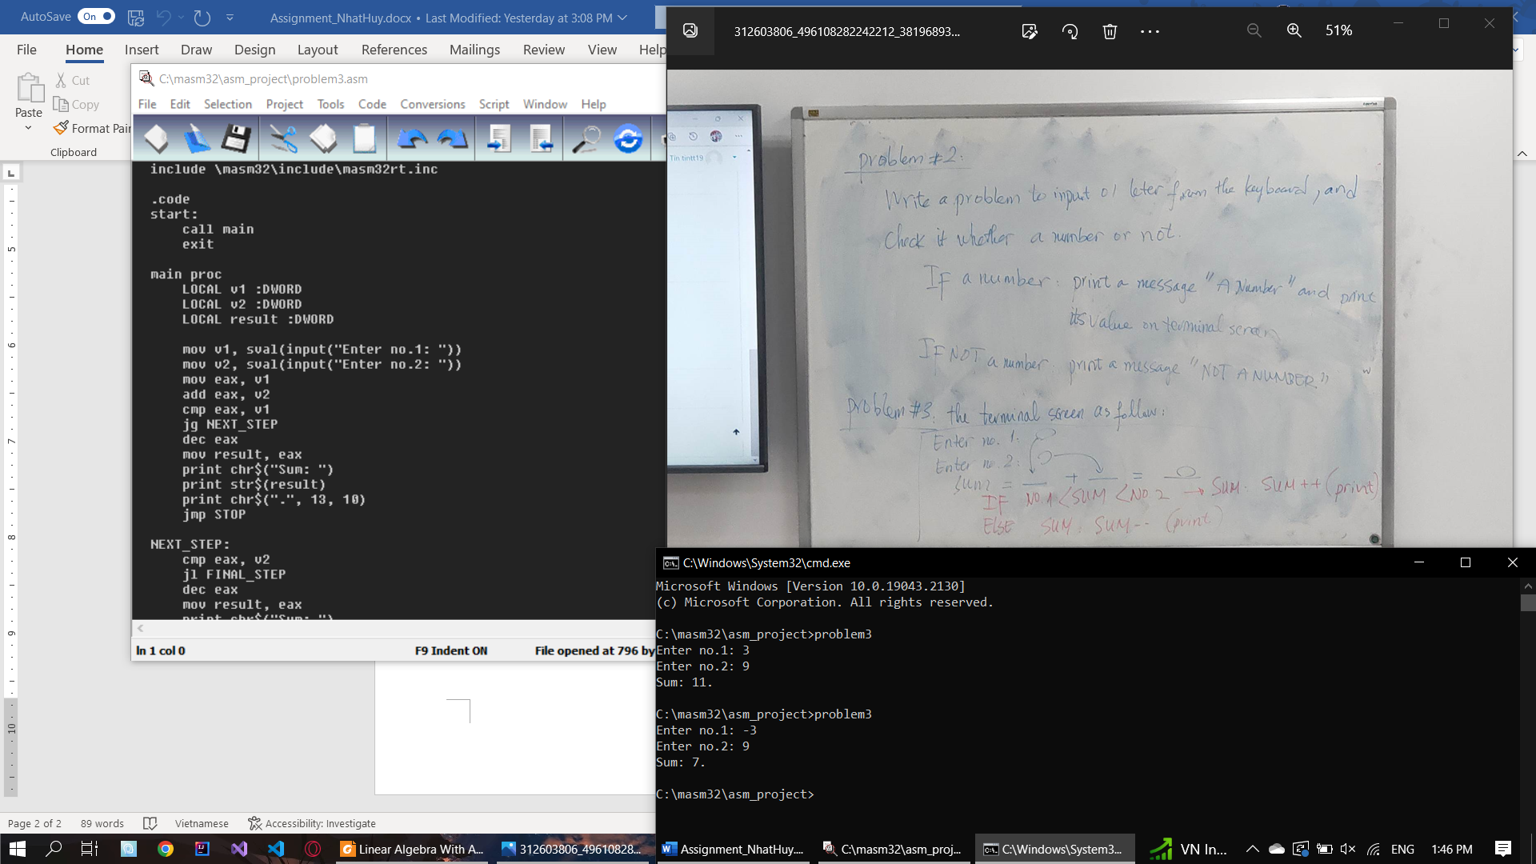

**PROBLEM 4: (FOR/WHILE loop)**

include \masm32\include\masm32rt.inc

sum PROTO :DWORD, :DWORD

.data

n dd 0

.code

start:

mov n, sval(input("Nhap so lan ban muon tinh: "))

print chr$("Chuong trinh se tinh tong cua 2 so nguyen ")

print str$(n)

print chr$(" lan.", 13, 10)

call main

print chr$(10, "Ket thuc chuong trinh!", 13, 10)

exit

main proc

LOCAL count :DWORD

LOCAL v1 :DWORD

LOCAL v2 :DWORD

LOCAL result :DWORD

mov count, 1

START_LOOP:

cmp n, 0

je STOP_LOOP

print chr$(10, "Lan tinh thu ")

print str$(count)

print chr$(": ", 13, 10)

mov v1, sval(input("Nhap so thu nhat: "))

mov v2, sval(input("Nhap so thu hai: "))

push eax

invoke sum, v1, v2

mov result, eax

pop eax

print chr$("Tong hai so la: ")

print str$(result)

print chr$(13, 10)

dec n

inc count

jmp START_LOOP

STOP_LOOP:

ret

main endp

sum proc v1 :DWORD, v2 :DWORD

mov eax, v1

add eax, v2

ret

sum endp

end start

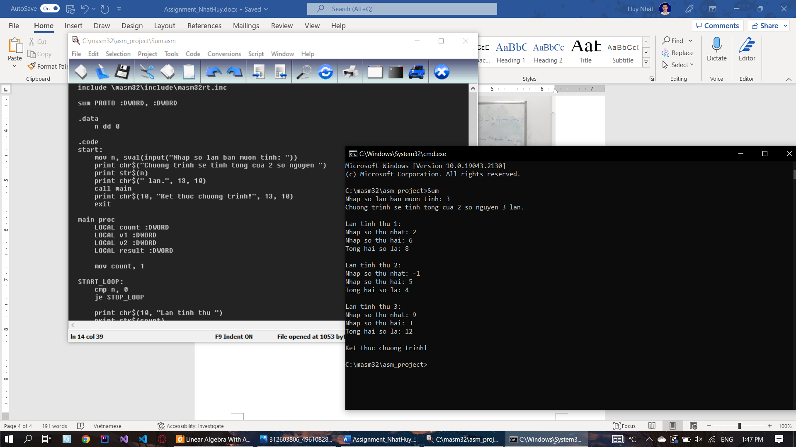

**PROBLEM 5: (DO-WHILE loop)**

include \masm32\include\masm32rt.inc

sum PROTO :DWORD, :DWORD

.data

n dd 0

.code

start:

mov n, sval(input("Nhap so lan ban muon tinh: "))

print chr$("Chuong trinh se tinh tong cua 2 so nguyen ")

print str$(n)

print chr$(" lan.", 13, 10)

call main

print chr$(10, "Ket thuc chuong trinh!", 13, 10)

exit

main proc

LOCAL count :DWORD

LOCAL v1 :DWORD

LOCAL v2 :DWORD

LOCAL result :DWORD

mov count, 1

START_LOOP:

print chr$(10, "Lan tinh thu ")

print str$(count)

print chr$(": ", 13, 10)

mov v1, sval(input("Nhap so thu nhat: "))

mov v2, sval(input("Nhap so thu hai: "))

push eax

invoke sum, v1, v2

mov result, eax

pop eax

print chr$("Tong hai so la: ")

print str$(result)

print chr$(13, 10)

dec n

inc count

cmp n, 0

je STOP_LOOP

jmp START_LOOP

STOP_LOOP:

ret

main endp

sum proc v1 :DWORD, v2 :DWORD

mov eax, v1

add eax, v2

ret

sum endp

end start

