**Homework**

**CEA201- Assembly**

1. **Assume that terminal screen**

**Enter number #1: 2**

**Enter number #2: 3**

**Sum = 2 + 3 = 5**

**If number #1 < = Sum < = number #2**

**Sum = Sum ++**

**Else**

**Sum = Sum—**

include \masm32\include\masm32rt.inc

.code

start:

call main

exit

main proc

LOCAL v1 :DWORD

LOCAL v2 :DWORD

LOCAL result :DWORD

mov v1, sval(input("Enter no.1: "))

mov v2, sval(input("Enter no.2: "))

mov eax, v1

cmp eax, v2

jg SWAP_NUMBER

AFTER_SWAP:

mov eax, v1

add eax, v2

cmp eax, v1

jge NEXT_STEP

dec eax

mov result, eax

print chr$("Sum: ")

print str$(result)

print chr$(".", 13, 10)

jmp STOP

NEXT_STEP:

cmp eax, v2

jle FINAL_STEP

dec eax

mov result, eax

print chr$("Sum: ")

print str$(result)

print chr$(".", 13, 10)

jmp STOP

FINAL_STEP:

inc eax

mov result, eax

print chr$("Sum: ")

print str$(result)

print chr$(".", 13, 10)

jmp STOP

SWAP_NUMBER:

mov ebx, v2

mov v2, eax

mov v1, ebx

jmp AFTER_SWAP

STOP:

ret

main endp

end start

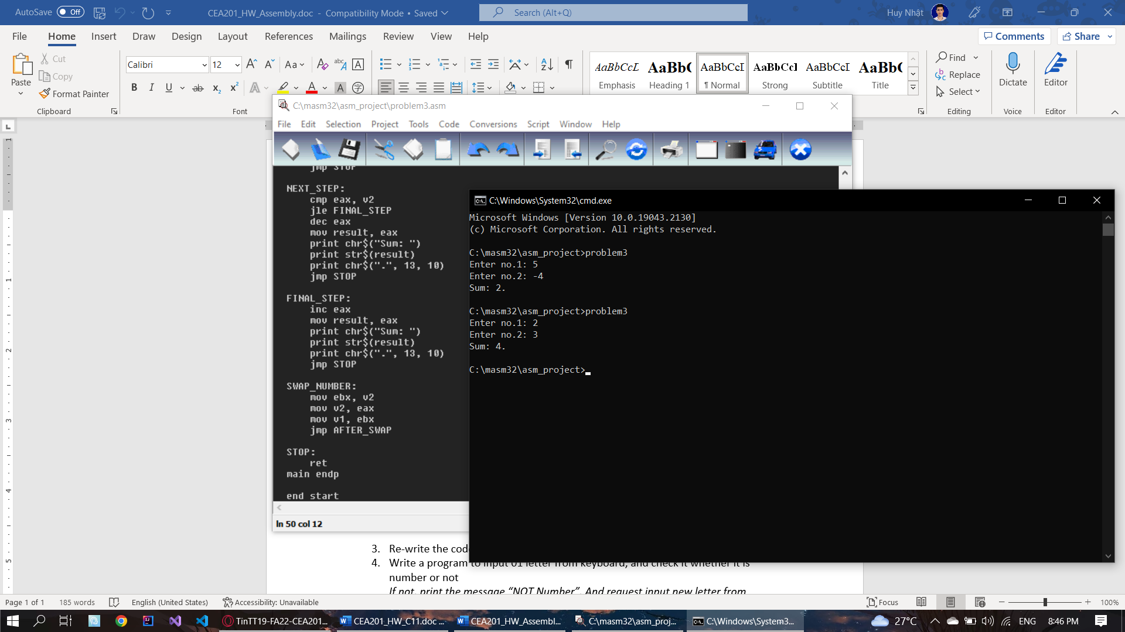

1. **Write a program to compare 03 numbers each other which inputed from keyboard, using the nested IF as following conditions:**

**If A < B**

**True: jump to label <Less_1>**

**False: print a message “A is not less than B” and quit a program**

**In label <Less_1>, compare B == C**

**True: assign A = 0 and print A with its assigned value on terminal screen**

**False: assign B = 0 and print A with its assigned value on terminal screen**

include \masm32\include\masm32rt.inc

.code

start:

call main

exit

main proc

LOCAL v1 :DWORD

LOCAL v2 :DWORD

LOCAL v3 :DWORD

mov v1, sval(input("A = "))

mov v2, sval(input("B = "))

mov v3, sval(input("C = "))

mov eax, v1

cmp eax, v2

jl Less_1

print chr$("A is not less than B.", 13, 10)

jmp STOP

Less_1:

mov eax, v2

cmp eax, v3

je Equal_1

mov v2, 0

print chr$("B = ")

print str$(v2)

print chr$(".", 13, 10)

jmp STOP

Equal_1:

mov v1, 0

print chr$("A = ")

print str$(v1)

print chr$(".", 13, 10)

jmp STOP

STOP:

ret

main endp

end start

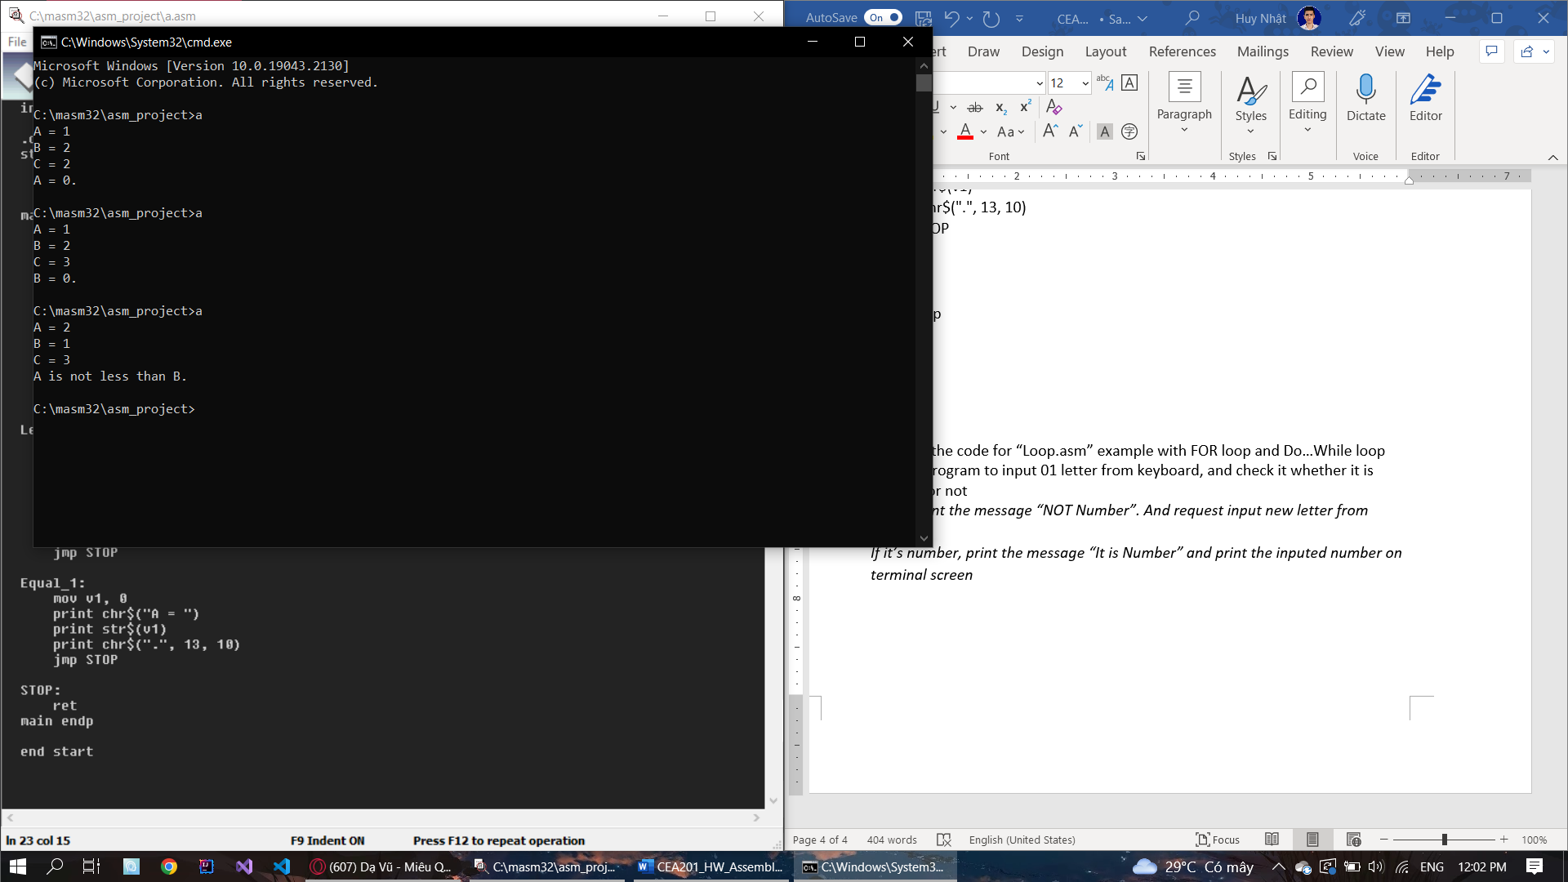

1. **Re-write the code for “Loop.asm” example with FOR loop and Do…While loop**

**FOR-LOOP:**

include \masm32\include\masm32rt.inc

sum PROTO :DWORD, :DWORD

.data

n dd 0

.code

start:

mov n, sval(input("Nhap so lan ban muon tinh: "))

print chr$("Chuong trinh se tinh tong cua 2 so nguyen ")

print str$(n)

print chr$(" lan.", 13, 10)

call main

print chr$(10, "Ket thuc chuong trinh!", 13, 10)

exit

main proc

LOCAL count :DWORD

LOCAL v1 :DWORD

LOCAL v2 :DWORD

LOCAL result :DWORD

mov count, 0

START_LOOP:

mov ebx, count

cmp ebx, n

je STOP_LOOP

print chr$(10, "Lan tinh thu ")

inc ebx

print str$(ebx)

print chr$(": ", 13, 10)

mov v1, sval(input("Nhap so thu nhat: "))

mov v2, sval(input("Nhap so thu hai: "))

push eax

invoke sum, v1, v2

mov result, eax

pop eax

print chr$("Tong hai so la: ")

print str$(result)

print chr$(13, 10)

inc count

jmp START_LOOP

STOP_LOOP:

ret

main endp

sum proc v1 :DWORD, v2 :DWORD

mov eax, v1

add eax, v2

ret

sum endp

end start

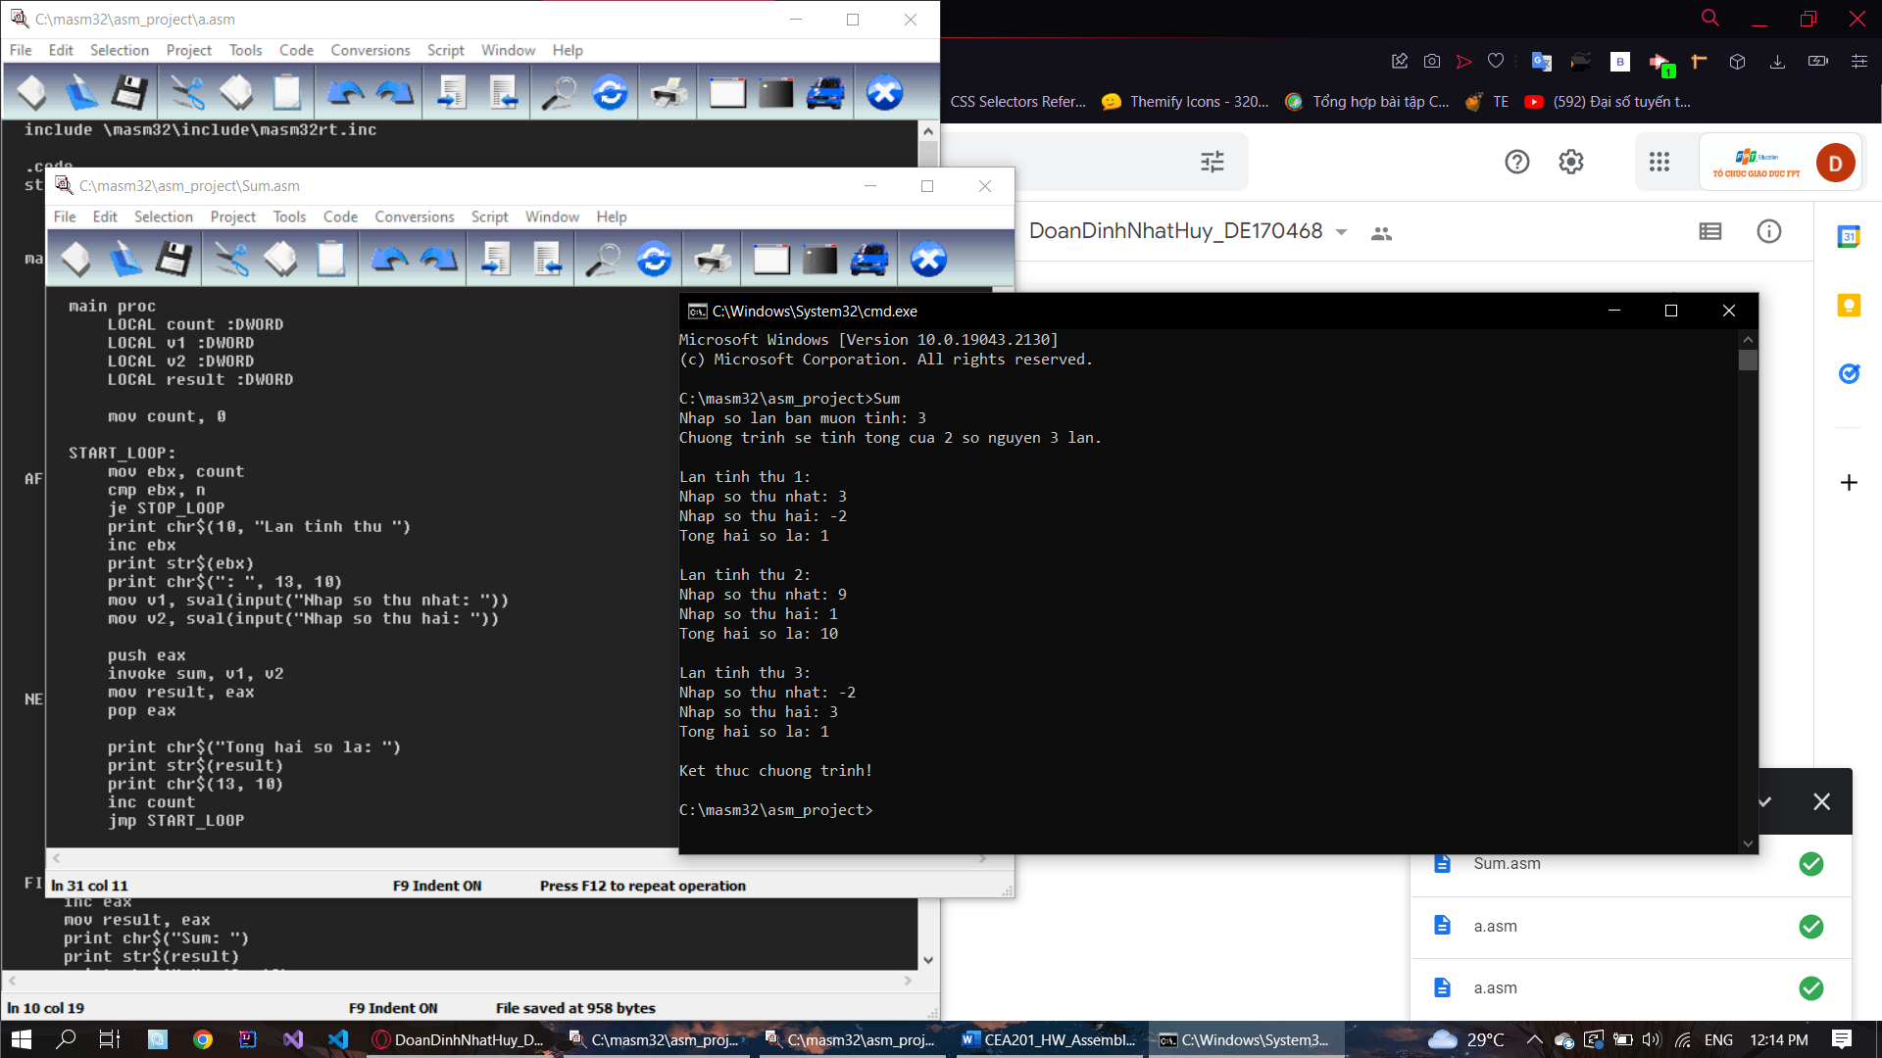

**DO-WHILE LOOP:**

include \masm32\include\masm32rt.inc

sum PROTO :DWORD, :DWORD

.data

n dd 0

.code

start:

mov n, sval(input("Nhap so lan ban muon tinh: "))

print chr$("Chuong trinh se tinh tong cua 2 so nguyen ")

print str$(n)

print chr$(" lan.", 13, 10)

call main

print chr$(10, "Ket thuc chuong trinh!", 13, 10)

exit

main proc

LOCAL count :DWORD

LOCAL v1 :DWORD

LOCAL v2 :DWORD

LOCAL result :DWORD

mov count, 1

START_LOOP:

print chr$(10, "Lan tinh thu ")

print str$(count)

print chr$(": ", 13, 10)

mov v1, sval(input("Nhap so thu nhat: "))

mov v2, sval(input("Nhap so thu hai: "))

push eax

invoke sum, v1, v2

mov result, eax

pop eax

print chr$("Tong hai so la: ")

print str$(result)

print chr$(13, 10)

dec n

inc count

cmp n, 0

je STOP_LOOP

jmp START_LOOP

STOP_LOOP:

ret

main endp

sum proc v1 :DWORD, v2 :DWORD

mov eax, v1

add eax, v2

ret

sum endp

end start

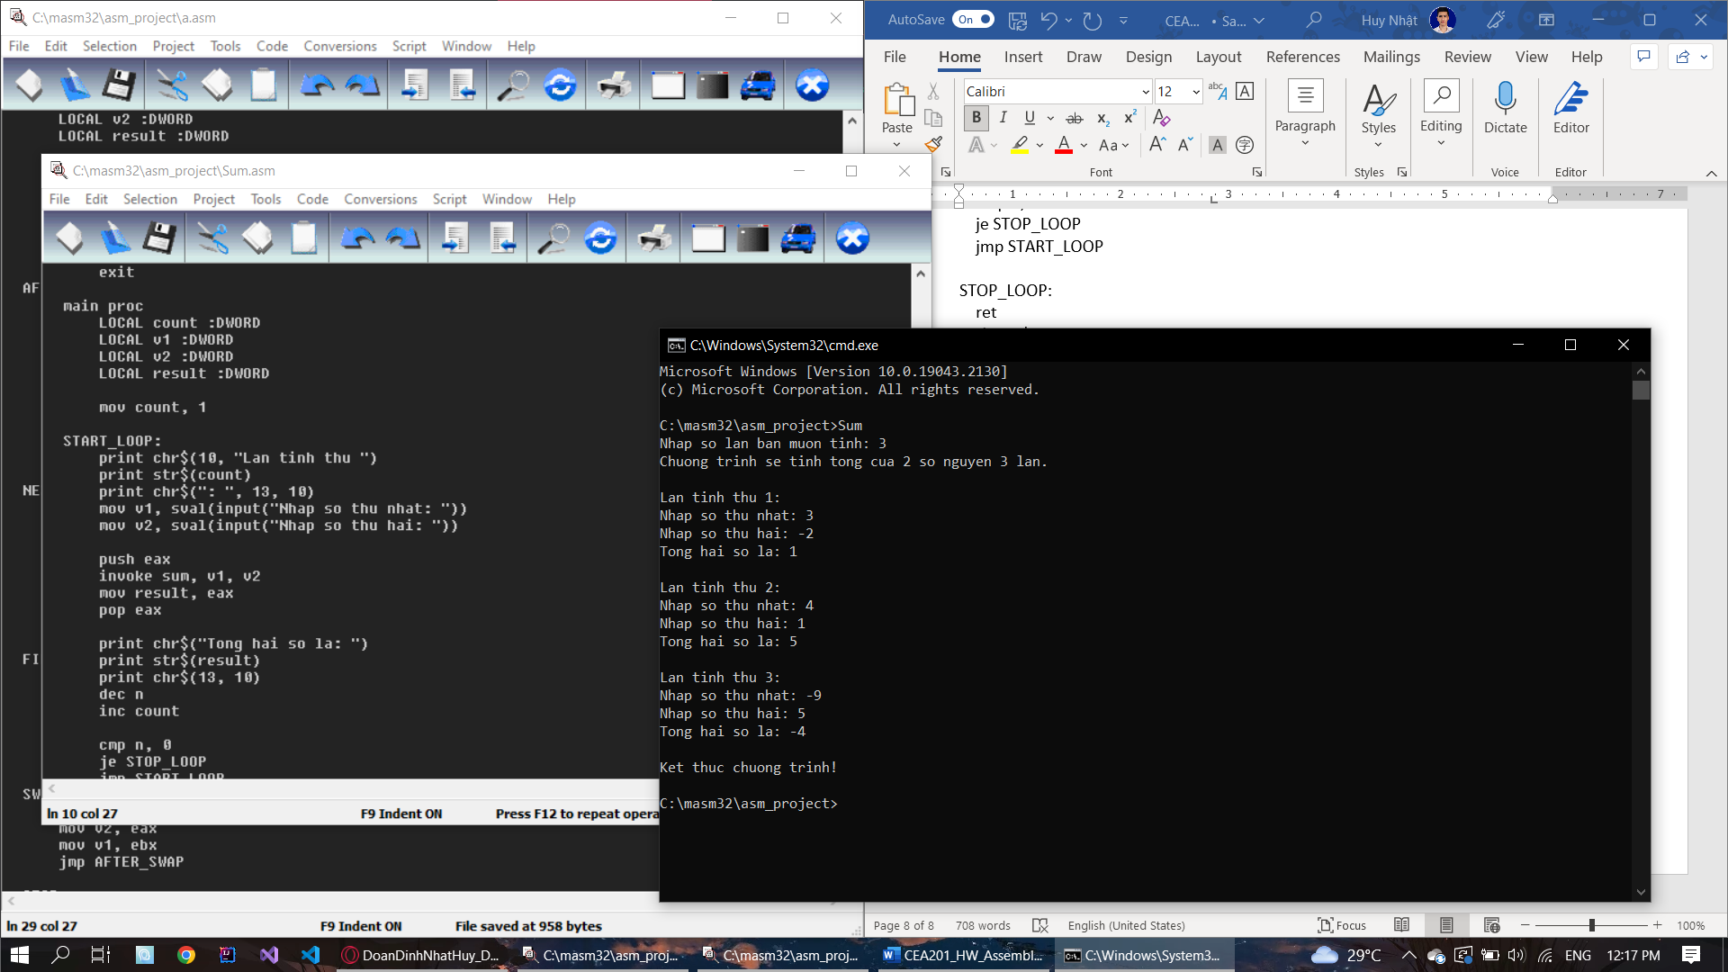

1. Write a program to input 01 letter from keyboard, and check it whether it is number or not

*If not, print the message “NOT Number”. And request input new letter from keyboard*

*If it’s number, print the message “It is Number” and print the inputed number on terminal screen*