**Homework**

**CEA201- Chapter 11**

1. Using some equalities, and basic indentities of Boolean Algebra with table below:

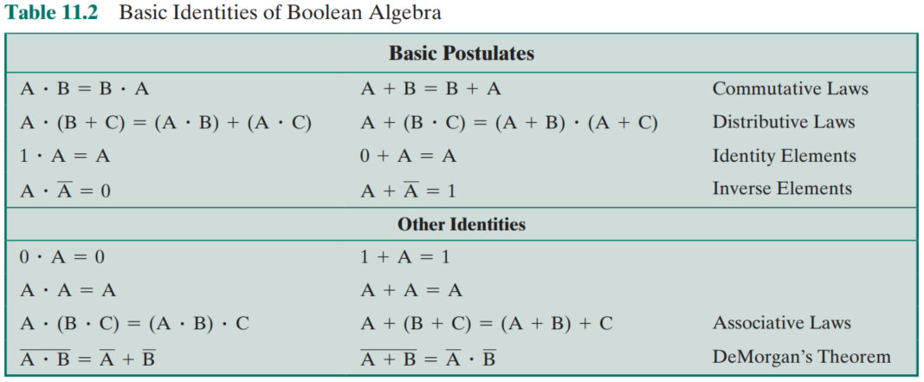

To simplify the Boolean functions: (Note: A = MSB and A’ = Not A)

1. F(A,B,C,D) = ABC + AB’C + ABC’D

= AC(B + B’) + ABC’D

= AC + ABC’D

= A(C + BC’D)

= A(C + BD)

1. F(A,B,C,D) = (A+BC) + A’(B’+C’)(AD+C)

= A + (B’ + C’)(AD + C) + BC

= A + (BC)’(AD + C) + BC

= A + AD + C + BC

= A + C

1. F(A,B,C,D) = Ʃ(0,3,4,7,8,9,14,15). In which, the number is the value of combination with Decimal expression

= B’C’D’ + AB’C’ + A’CD + ABC

1. F(A,B,C) = (A+C’)(B+C)(A+B)

= (A + C’)(B + C)

= AB + AC + BC’ + CC’

= AC + BC’

1. Using Karnaugh map to simplify the Boolean function (A = MSB)
2. F(A,B,C) = Ʃ(1,3,4) = A’BC’ + AB’C’ + A’B’C
3. F(A,B,C) = Ʃ(1,3,7) = A’BC’ + A’B’C + ABC
4. F(A,B,C) = Ʃ(0,3,4,6,7) = AB + C’
5. F(A,B,C,D) = Ʃ(2,2,5,6,9,11,13,14) = BC’D + AB’D + A’CD’ + BCD’
6. F(A,B,C,D) = Ʃ(0,5,9,10) with the other combinations (2,3,8,15) achived “d” (don’t care condition)