**Q1:**

**Explain the difference between connectionless unacknowledged service and connectionless acknowledged service. How do the protocols that provide these services differ?**

Solution:.

Connection Less:

-- > Connectionless service comes with a single free-standing data unit for all transmissions.

-- > In this, each unit contains all of the protocols that control information necessary for delivery perspective, but this also contains no provision for sequencing or flow control.

>> Acknowledged:

-- > This is achieved by the use of ACK and NAK control messages.

-- > These types of protocols are well suited for communication over the network, where high layers are very sensitive to loss and can have a significant probability of error in these underlying networks.

Example: HDLC, which offers for unnumbered acknowledgment service (setup and release).

>> Unacknowledge:

-- > This comes with a very simpler version and provides faster communication for networks, which are inherently reliable or provide service to a higher layer, that can tolerate loss in the information, or which has built-in error control/recovery feature.

* Connectionless: Connectionless service is provided with a single standalone data unit for all transmissions. Each unit has the necessary protocols for delivery but does not provide sequencing or flow control.
* Acknowledged: This service is achieved by using ACK and NAK control messages. These protocols are suitable for communication over a network where higher layers are sensitive to loss and have a significant probability of error in the underlying networks. HDLC offers unnumbered acknowledgment service for setup and release.
* Unacknowledged: This service is a simpler version and provides faster communication for inherently reliable networks or higher layers that can tolerate loss or have built-in error control/recovery features.

The protocols that provide these services differ in the way they handle the delivery of data units. For example, the High-level Data Link Control (HDLC) protocol offers an unnumbered acknowledgment service, which is an example of connectionless acknowledged service. On the other hand, the Point-to-Point Protocol (PPP) provides a connectionless unacknowledged service for faster communication over reliable networks or for use with higher layers that can tolerate data loss.

**Q2:**

**Explain the difference between connection-oriented acknowledged service and connectionless acknowledged service. How do the protocols that provide these services differ?**

Solution:

Less & Oriented:

>> Connection-oriented:

-- > In this type of service, a setup phase will be initialized between sender and receiver, to establish a context for transferring the information

-- > This connection is provided to the sender for all SDUs.

-- > This service requires a stateful protocol, which is used to keep track of sequence numbers, and timers.

>> ConnectionLess:

-- > Here, there will be no prior context provided for transferring the information between sender and receiver.

-- > The sender will pass its SDU to an underlying layer without any notice.

-- > And in this, the sender requires an acknowledgment of SDU delivery.

-- > The protocols are very different in these services

-- > this service also does not require transmitting protocols to track the acknowledgment of PDU.

-- > After receiving the PDU, the receiver needs to send acknowledgment, If not received in time, then it will return failure.

Connection-oriented acknowledged service and connectionless acknowledged service are two types of communication services provided by network protocols.

Connection-oriented acknowledged service involves establishing a dedicated connection between two network devices before data transmission. The connection is maintained throughout the communication session, and each data packet is acknowledged by the receiver, ensuring that data is reliably transmitted. Examples of protocols that provide connection-oriented acknowledged service are TCP (Transmission Control Protocol) and ATM (Asynchronous Transfer Mode).

On the other hand, connectionless acknowledged service does not require establishing a dedicated connection between devices. Each data packet is independently transmitted and acknowledged, allowing for faster transmission but with a lower level of reliability. Examples of protocols that provide connectionless acknowledged service are UDP (User Datagram Protocol) and ICMP (Internet Control Message Protocol).

The main difference between these two services is the establishment of a dedicated connection before data transmission. Connection-oriented acknowledged service provides a reliable and ordered data transmission, but with higher overhead due to the establishment and maintenance of the connection. Connectionless acknowledged service provides faster and more efficient transmission but with a lower level of reliability.

**Q3: Explain the differences between PPP and HDLC.**

Solution :

HDLC, which stands for High-level Data Link Control, performs the encapsulation of data. Point-to-Point Protocol (PPP), on the other hand, is a protocol that allows different devices to communicate without the need for any changes in the data format.

There are some notable differences between the two protocols. For instance, HDLC uses a bit-oriented protocol for both point-to-point and multipoint link channels, while PPP uses a byte-oriented protocol for point-to-point links. Another difference is that HDLC is only suitable for synchronous media encapsulation, whereas PPP can handle both synchronous and asynchronous media. Finally, HDLC is restricted to use with CISCO devices only, whereas PPP is more versatile and can be used with a wider range of devices.

PPP (Point-to-Point Protocol) and HDLC (High-level Data Link Control) are both protocols used for communication over serial links, but they have some differences:

1. Encapsulation: HDLC encapsulates data in frames, while PPP encapsulates data in packets.
2. Protocol support: HDLC supports only a limited set of protocols, while PPP supports multiple network layer protocols such as IP, IPX, and AppleTalk.
3. Authentication: PPP provides authentication options such as PAP (Password Authentication Protocol) and CHAP (Challenge Handshake Authentication Protocol), while HDLC does not provide any authentication mechanism.
4. Error detection and recovery: PPP has built-in error detection and recovery mechanisms, while HDLC relies on the underlying physical layer for error detection and recovery.
5. Compatibility: HDLC is a proprietary protocol used mainly by Cisco devices, while PPP is an open standard protocol that can be used by any device.

Overall, PPP is a more flexible and feature-rich protocol than HDLC, but HDLC is simpler and more efficient in certain situations.

**Q4:**

**A 1.5 Mbps communications link is to use HDLC to transmit information to the moon.  What is the smallest possible frame size that allows continuous transmission?  The distance between earth and the moon is approximately 375,000 km, and the speed of light is 3 x 108 meters/second.**

Solution :

|  |  |  |
| --- | --- | --- |
|  | Maximum Send Window Size in Default HDLC Frame | Maximum Send Window Size in Extended HDLC Frame |
| Go-Back-N | 7 | 127 |
| Selective Repeat | 4 | 64 |

D (Distance) = 375,000 km = 375 x 10^6   m

c (Speed of Light) = 3 x 10^8  m

R = 1,5 Mbps = 1,5 x 10^6 bps.

We have:

Maximum Send Window:

For Default HDLC Frame:

Go Back N : 7

Selective Repeat : 4

For Extended HDLC Frame:

Go Back N : 127

Selective Repeat : 64

Round Trip Propagation Delay: RTT

                       RTT = 2 x Propagation delay = 2 *D /c = 2 * 375*10^6/(3*10^8) = 2.5 s

Possible Frame Size (bits): Nf

                       N x Nf / R = RTT => Nf = 2.5 * 1.5 * 10 ^6 / N ( N is maximum send window size)

* Minimum frame size => Maximum send window size

For Go-Back-N:

With N = 7 : Nf = 535 715 bits

With N = 127: Nf = 29 528 bits

For Selective Repeat:

With N = 4: Nf = 973 500 bits

With N = 64: Nf =  58 594 bits

2/To determine the smallest possible frame size that allows continuous transmission over a 1.5 Mbps communications link between Earth and the Moon using HIDIC, we need to consider the round-trip time (RTT) for a signal to travel from Earth to the Moon and back.

The distance between Earth and the Moon is approximately 375,000 km, which means that the total distance that a signal has to travel is 750,000 km (since the signal has to travel both to and from the Moon). The speed of light is 3 x 10^8 meters/second, which is equivalent to 300,000 km/second.

Therefore, the time it takes for a signal to travel from Earth to the Moon and back is:

RTT = 2 * (distance / speed)

RTT = 2 * (750,000 / 300,000)

RTT = 5 seconds

This means that if we want continuous transmission over the 1.5 Mbps link, we need to ensure that the time it takes to transmit a frame plus the RTT is less than or equal to the time it takes to transmit the next frame.

Assuming a simple frame structure that consists of a header and data payload, with no padding or other overhead, the smallest possible frame size that allows continuous transmission can be calculated as follows:

frame size = (link speed * (time between frames)) - header size

time between frames = RTT + (frame size / link speed)

Substituting the given values into the equation, we get:

frame size = (1.5 Mbps * (5 seconds - (frame size / 1.5 Mbps))) - header size

Solving for frame size, we get:

frame size = (1.5 Mbps * 5 seconds) / (1 + (1.5 Mbps * header size / (1.5 Mbps * 5 seconds)))

frame size = 6 Mb / (1 + (0.1 * header size))

To achieve continuous transmission, the time between frames must be less than or equal to the time it takes to transmit a frame plus the RTT:

time between frames <= frame size / link speed + RTT

time between frames <= (frame size + header size) / 1.5 Mbps + 5 seconds

Substituting the given values into the equation, we get:

5 seconds + header size / 1.5 Mbps >= frame size / 1.5 Mbps

Simplifying and substituting the previous equation, we get:

5 seconds + header size / 1.5 Mbps >= 6 Mb / (1 + (0.1 * header size)) / 1.5 Mbps

Solving for header size, we get:

header size >= 0.056 Mb

Therefore, the smallest possible frame size that allows continuous transmission is:

frame size = 6 Mb / (1 + (0.1 * 0.056 Mb))

frame size = 534,883 bits

Note that this calculation assumes ideal conditions and does not take into account any potential errors or other sources of delay. In practice, the actual frame size required for continuous transmission may need to be larger to accommodate these factors.

**Q5:**

**Suppose HDLC is used over a 1.5 Mbps geostationary satellite link. Suppose that 250-byte frames are used in the data link control. What is the maximum rate at which information can be transmitted over the link?**

Solution :

R = 1.5 Mbps or R = 1,5 x 106 bps, and nf =250 bytes or 2000 bits (250 x 8).

The distance that the information must travel is the earth-to-satellite distance, or D ≈ 36,000 km = 3,6 x 107m .

The speed of light c is 3 x 108 . We can calculate the propagation delay and processing rate as follows:

$t_{prop}= \frac{D}{c}=\frac{3,6×{10}^{7}}{3×{10}^{8}}=0,12 s=120 ms$

$t_{f}=\frac{n_{f}}{R}=\frac{2000}{1,5×{10}^{6}} = 0,00133 s = 1,33 ms$

We can use either Go-Back-N or Selective Repeat ARQ. The default window size is N = 7 (with a 3- bit sequence number).



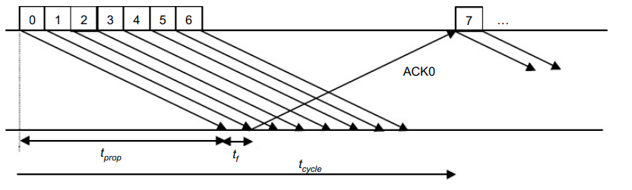

The maximum information rate is achieved with no error, and hence, no retransmission.

$t_{cycle}$ = minimum time to transmit a group of N packets

= $t_{f}$ + 2 $t_{prop}$ = 1.33 + 2 x 120 = 241.33 ms

In which, $t_{cycle}$ is the minimum time to transmit a group of N packets.

n = no. of bits transmitted in a cycle = N. $n_{f}$ = 7 x 2000 = 14000 bits

$R_{max}$ = no. of bits sent in a cycle / minimum cycle time = n / $t_{cycle}$ = 58 kbps

In which, $n$ is number of bits transmitted in a cycle, $R_{max}$ is number of bits sent in a cycle / minimum cycle time.

If the extended sequence numbering option (7-bit) is used, the maximum send window size would be N = 27– 1 = 127, and hence, the maximum information rate is:

$n=N×n_{f}=127×2000=254000 bits$

$$R_{max}=\frac{n}{t_{cycle}}=\frac{254000}{241,33}=1052,5 kbps=1,0525 Mbps$$

**Q6:**

**Suppose that a multiplexer receives constant-length packet from N = 60 data sources. Each data source has a probability p = 0.1 of having a packet in a given T-second period. Suppose that the multiplexer has one line in which it can transmit eight packets every T seconds. It also has a second line where it directs any packets that cannot be transmitted in the first line in a T-second period. Find the average number of packets that are transmitted on the first line and the average number of packets that are transmitted in the second line.**

Solution :

Firstly, we find out the probability of the k packets that have reached the T- second. It can be computed with the help of binomial distribution that has parameters as N=60 and shows the probability of p=0.1.

The average number for the arrivals of the packets can be given as Np=6. Now, calculate the average number of packets received through the first line as below:

X= $\sum_{k=0 }^{8}{}k . C_{k}^{60} . {(0,1)}^{k}. {(0,9)}^{60- k}=4.59$

Now, the average number of packets received is 4.59 that gets transmitted through the first line. The remaining will get transmitted by the second line. Now, the average number of packets transmitted through the second line per T second can be obtained as below:

Y= Np – X = 6 – 4,59 = 1,41

Therefore, it will transmit 1.41 packets on average per T second from the second line.

**Q7:**

**Consider the transfer of a single real-time telephone voice signal across a packet network. Suppose that each voice sample should not be delayed by more than 20 ms.**

1. **Discuss which of the following adaptation functions are relevant to meeting the requirements of this transfer: handling of arbitrary message size; reliability and sequencing; pacing and flow control; timing; addressing; and privacy, integrity and authentication.**
2. **Compare a hop-by-hop approach to an end-to-end approach to meeting the requirements of the voice signal.**

Solution

a.

For sending a single real-time telephone speech signal across a packet network with a maximum delay of 20 ms, there are four adaptation functions are necessary:

1. Reliability and sequencing: To prevent lossing or misordering. When the receiver end, packets must be sequenced and arranged as well as detected and corrected for errors.
2. Time: To keep the required time gaps between packets, the network must synchronize its clock with the sender and reciever.
3. Pacing and flow control: To prevent packet loss due to congestion, it control the rate at which packets are transmitted and received to meet the required the capacity of the network.
4. Addressing: To identify the source and destination of each voice sample, also enables routing of packets through the network.

b.

|  |  |
| --- | --- |
| The hop-by-hop strategy | In the end-to-end strategy |
| * Putting the necessary adaption functions at each intermediate packet network node. * Each node processes the ones it has received before sending the packets to the sub node. * May cause more delays and costs. If one node fails, the security may be affected. * Are better because of reducing overhead and delays | * Where the necessary adaption functions are implemented. * The packets are sent unchanged through the network, and the endpoints carry out any necessary processing. * Reduces delays and overhead, but it could not handle well in networks with high packet loss rates delays. * Are prefered when additional processing is required at intermediary nodes |

3/

a. For the transfer of a single real-time telephone voice signal across a packet network, the relevant adaptation functions to meet the requirement of not delaying each voice sample by more than 20 ms are:

Timing: ensuring that packets carrying voice samples are transmitted at regular intervals to prevent delay.

Pacing and flow control: regulating the rate of packet transmission to avoid congestion and ensure timely delivery.

Reliability and sequencing: ensuring that packets arrive in order and without error to maintain the quality of the voice signal.

The other adaptation functions - handling of arbitrary message size, addressing, and privacy, integrity, and authentication - may also be important for overall network functionality but are less directly related to meeting the real-time constraint of the voice transfer.

b. There are two main approaches to meeting the requirements of the voice signal: hop-by-hop and end-to-end.

A hop-by-hop approach involves implementing the relevant adaptation functions (timing, pacing and flow control, reliability and sequencing) at each node or hop along the path between the source and destination. In this approach, each node must perform the necessary processing to ensure that the real-time constraint is met. However, this approach can lead to increased delay and jitter due to the additional processing and coordination required at each hop.

An end-to-end approach involves implementing the relevant adaptation functions only at the endpoints of the communication path (i.e., the source and destination). In this approach, the network simply forwards the packets without any processing or modification. This reduces the delay and jitter introduced by intermediate nodes but requires that the endpoints have more intelligence and processing power to handle the adaptation functions.

Overall, an end-to-end approach may be more effective at meeting the requirements of the voice signal as it minimizes the delay and jitter introduced by intermediate nodes. However, it places more responsibility on the endpoints to ensure that the necessary adaptations are made, which can be challenging in complex networks with multiple nodes and routes. On the other hand, a hop-by-hop approach provides greater control over the performance of individual nodes but can lead to additional delay and jitter that may negatively impact the quality of the voice signal.

a. Message size is important because in real-time signals of voice it is necessary to transfer a fixed packet size of that holds no more than 20 ms of the speech signal. The handling of arbitrary message size is not as important as long as the desired packet size for voice can be handled.

Sequencing is essential because each packet needs to arrive in the same sequence that it was generated. Reliability is moderately important since voice transmission can tolerate a certain level of loss and error.

Pacing and flow control are not as important because the synchronous nature of the voice signal implies that the end systems will be matched in speed.

Timing, for real-time voice transfer, is important because this adaptation function helps to control the jitter in the delivered signal.

Addressing is only during the connection setup phase if we assume some form of virtual circuit packet switching method.

Privacy, integrity, and authentication have traditionally not been as important as the other issues discussed above.

b. Compare a hop-by-hop approach to an end-to-end approach to meeting the requirements of the voice signal.

Answer: -

If the underlying network is reliable then the end-to-end approach is better because the probability of error is very low so processing at the edge suffices to provide acceptable performance.

If the underlying network is unreliable then the hop-by-hop approach may be required. For example, if the probability of error is very high, as in a wireless channel, then error recovery at each hop may be necessary to make effective communication possible.

**Q8 :**

**Consider the Stop-and-Wait protocol as described. Suppose that the protocol is modified so that each time a frame is found in error at either the sender or receiver, the last transmitted frame is immediately resent.**

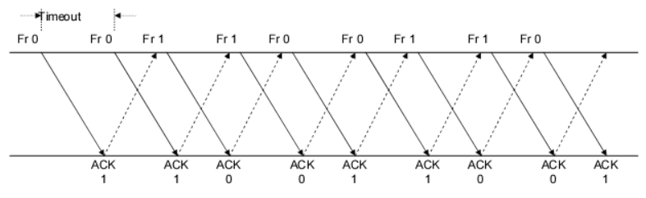

1. **Show that the protocol still operates correctly.**
2. **Does the state transition diagram need to be modified to describe the new operation?**
3. **What is the main effect of introducing the immediate-retransmission feature?**

Solution:

a/The sender in the stop-and-wait protocol described in the chapter retransmits a frame when an acknowledgment is not received in time. The modified protocol says that the frame is retransmitted every time the sender or receiver sees an error.

Therefore, the only difference is that frames are retransmitted sooner. So, the protocol will work correctly.

b/ No. The state transition diagram will stay the same.

c/ The error recovery process will be faster with this modified protocol.

**Q9**

**Suppose that two peer-to-peer processes provide a service that involves the transfer of discrete messages. Suppose that the peer processes are allowed to exchange PDUs that have a maximum size of M bytes including H bytes of header. Suppose that a PDU is not allowed to carry information from more than one message.**

Solution :

1. Develop an approach that allows the peer processes to exchange messages of arbitrary size .

To exchange messages of arbitrary size, large messages must be segmented into parts of M-H bytes

each in length to be transmitted in multiple PDUS. Small messages must be placed in a single PDU.

b. What essential control information needs to be exchanged between the peer processes?

The peer processes need to communicate information that allows for the reassembly of messages at

the receiver. For example, the first PDU may contain the message length. The last PDU may contain

and end-of-message marker. Sequence numbers may also be useful to detect loss in connection

oriented networks and to help in reconstruction of the messages in connectionless networks. Lastly,

since variable size PDUS are permitted, the size of the PDU must be transmitted in the PDU header.

c. Now suppose that the message transfer service provided by the peer processes is shared by several message source-destination pairs. Is additional control information required, and if so, where should it be placed?

In this case, in addition to all of the header information mentioned in b), each PDU must be labeled

with a stream ID, so that the receiver can treat each stream independently when reassembling

messages.

a)Large messages must be split into sections of M-H bytes each to be transmitted in several PDUs in order to exchange messages of any size. A single PDU must include all small messages.

b)Peer processes must exchange information that permits messages to be reassembled at the recipient. The message length, for example, could be included in the first PDU. A message end-of-message marker could be included in the last PDU. In connection-oriented networks, sequence numbers can be used to detect loss, while in connectionless networks, they can be used to aid in message reconstruction. Finally, because variable-size PDUs are allowed, the PDU size must be specified in the PDU header.

c)In this instance, each PDU must be identified with a stream ID in addition to all of the header information specified in (b), so that the receiver may treat each stream separately while reassembling messages.

**Q10 :**

**A 1 Mbyte file is to be transmitted over a 1 Mbps communication line that has a bit error rate of p = 10-6.**

1. **What is the probability that the entire file is transmitted without errorsWe conclude that it is extremely unlikely that the file will arrive error free.**
2. **The file is broken up into N equal-sized blocks that are transmitted separately. What is the probability that all the blocks arrive correctly without error? Does dividing the file into blocks help?**
3. **Suppose the propagation delay is negligible, explain how Stop-and-Wait ARQ can help deliver the file in error-free form. On the average how long does it take to deliver the file if the ARQ transmits the entire file each time?**

Solution :

1Mbyte = 106 byte = 8 x ${10}^{6}$ bits because1 byte = 8 bits

The file length n = 8 x 106 bits, the transmission rate R = 1 Mbps = 106 bps and p = 10-6

1. Note : For n lagrge and p very small , ${(1-p)}^{n}≈e^{-np}$

P[no error in the entire file] = ${(1-p)}^{n}≈e^{-np}$ for n >> 1 , p << 1

= $e^{-8}$ = 3.35 x ${10}^{-4}$

We conclude that it is extremely unlikely that the file will arrive error free

1. A subblock of length n/N is received without error with probability :

P[no error in subblock] = ${(1-p)}^{n/N}$

A block has no errors if all subblocks have no errors, so

P[no error in block]= ${P[no error in subblock]}^{N}$ = ${(1-p)}^{{(n/N)}^{N}}$ = ${(1-p )}^{n}$

So simply dividing the blocks does not help.

c.

Refer to the following figure for the discussion .

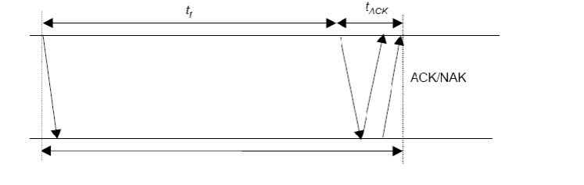

We assume the following:

* $t_{0 }$ = basic time to send a frame and receive the ACK/NAK $≈$ ttimeout
* $t_{total}$ = total transmission time until success
$n_{f}$ $=number of bits / frame$

* $n_{a}$ = number of bits per ACK
* $n_{t}$ = number of transmissions
* $P_{f}$ = probability of frame transmission error

$t_{0}$ = $t_{f}+ t_{ACK}$ = $\frac{n_{f}}{R}+\frac{n_{a}}{R}$ ($t_{prop ≈0 )}$

$P\left[n_{t}=i \right]=P[one success after i-1 failure]$ = (1 - $p_{f}){p_{f}}^{i-1}$

Given i transmissions : | = i $t_{0}$

*

E[$t_{total}$] = $\sum_{i=1}^{∞}{}it_{0}$ P[$n_{t}=i$] = $t_{0}(1-P_{f})\sum_{i=1}^{∞}{}i . P_{f}^{i-1}$ = $\frac{t_{0}\left(1-P_{f}\right)}{{(1-P_{f})}^{2}}$ = $\frac{t_{0}}{1- p_{f}}$

Here , $n_{f}$ = n >> $n_{a }$ thus $t_{0}$ $≈t_{f}$ = n/R ; and $P_{f} =1-P[no error]$ =

1 $-$ $e^{-np}$

E[total] = n/R(1 - $p_{f})=n/[{Re}^{-np}]$ = 8 / (3.35 x 10-4) = 23847 seconds = 6,62 hours

The file gets through, but only after many retransmissions.

Q11

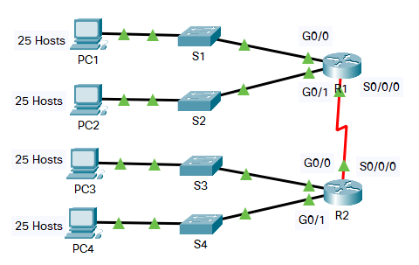

**In this activity, you are given the network address of 192.168.100.0/24 to subnet and provide the IP addressing for the Packet Tracer network. Each LAN in the network requires at least 25 addresses for end devices, the switch and the router. The connection between R1 to R2 will require an IP address for each end of the link.**

1. **Based on the topology, how many subnets are needed?**
2. **How many bits must be borrowed to support the number of subnets in the topology table?**
3. **How many subnets does this create?**
4. **How many usable hosts does this create per subnet?**

Solution:

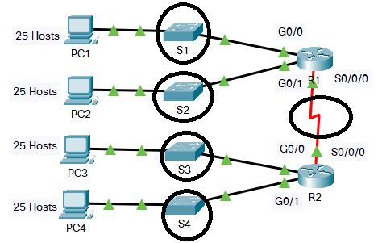

a.

Base on topology, there are 5 subnets which are S1,S2, S3, S4, S0/0/0

b.

Because we have 4 subnet S1, S2, S3, S4, doesn’t include S0/0/0/0

N is the number of bits

${4×2}^{N }-2≥25$

* N = 3.

c.

Because the number of bits N = 3, then the number of subnets does this create is $2^{3 }=8.$

d.

Usable hosts does this create per subnet:

28-n – 2 = 28-3 – 2 = 30

**Q12:**

**Five stations (S1-S5) are connected to an extended LAN through transparent bridges (B1-B2), as shown in the following figure. Initially, the forwarding tables are empty. Suppose the following stations transmit frames: S1 transmits to S5, S3 transmit to S2, S4 transmits to S3, S2 transmits to S1, and S5 transmits to S4. Fill in the forwarding tables with appropriate entries after the frames have been completely transmitte**d.

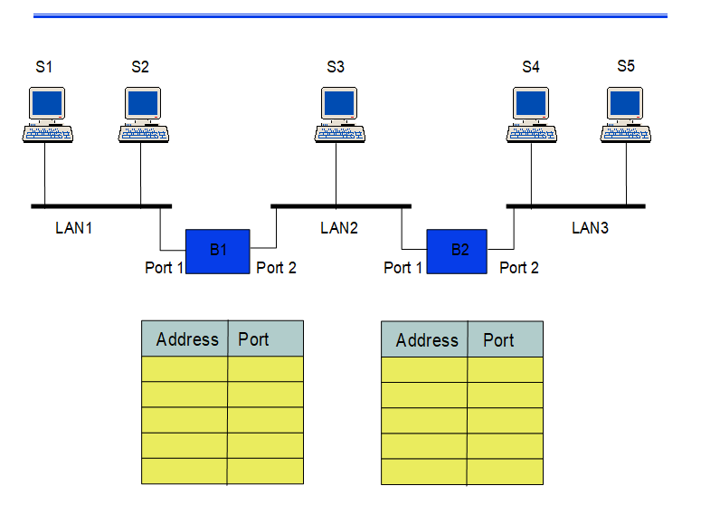

Solution :

Firstly, we know that we have 3 types of LAN, and each LAN is arranged follow BUS. Then, if a device sends data, it will send according to broardcast type (send to any device and internet port).

B1

|  |  |  |  |
| --- | --- | --- | --- |
|  |  | Address | Port |
| Step 1 | S1 => S5 | S1 | 1 |
| Step 2 | S3 => S2 | S3 | 2 |
| Step 3 | S4 => S3 | S4 | 2 |
| Step 4 | S2 => S1 | S2 | 1 |
| Step 5 | S5 => S4 |  |  |

B2

|  |  |  |  |
| --- | --- | --- | --- |
|  |  | Address | Port |
| Step 1 | S1 => S5 | S1 | 1 |
| Step 2 | S3 => S2 | S3 | 2 |
| Step 3 | S4 => S3 | S4 | 2 |
| Step 4 | S2 => S1 |  | 1 |
| Step 5 | S5 => S4 | S5 |  |

**Q13 :**

1. **Consider the network in Figure.**

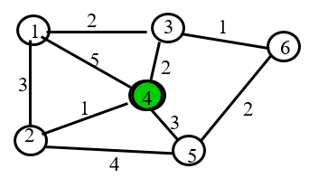

1. **Use the Dijkstra algorithm to find the set of shortest paths from node 4 to other nodes.**

**We call that node that have number N is V(N) (i.e the green one is V(4))**

**b, Find the set of associated routing table entries (Destination, Next Hop, Cost)**

|  |  |  |
| --- | --- | --- |
| **Destination** | **Cost** | **Next Hop** |

Solution:

a.

|  |  |  |  |  |  |  |
| --- | --- | --- | --- | --- | --- | --- |
| Iteration | N | D1 | D2 | D3 | D5 | D6 |
| Initial | {4} | $$(-1,∞)$$ | $$-1,∞)$$ | $$(-1,∞)$$ | $$(-1,∞)$$ | $$(-1,∞)$$ |
| 1 | {4,2} | (5,4) | (1, 4) | (2,4) | (3,4) | $$(-1,∞)$$ |
| 2 | {4,2,3} | (4,2) | ______ | (2,4) | (3,4) | $$(-1,∞)$$ |
| 3 | {4,2,3, 5} | (4,2) | ______ | ______ | (3,4) | (3,3) |
| 5 | {4,2,3,5,6} | (4,2) | ______ | ______ | ______ | (3,3) |
| 6 | {4,2,3,5,6,1} | (4,2) | ______ | ______ | ______ | ______ |

The shortest part from D4 to D1 is 4 and the path is D4 -> D2 -> D1

The shortest part from D4 to D2 is 1 and the path is D4 -> D2

The shortest part from D4 to D3 is 2 and the path is D4 -> D3

The shortest part from D4 to D5 is 3 and the path is D4 -> D5

The shortest part from D4 to D6 is 3 and the path is D4 -> D3 -> D6

b.

|  |  |  |
| --- | --- | --- |
| Destination | Cost | Next Hop |
| 1 (chính là D1) | 4 | 2 |
| 2 | 1 | 2 |
| 3 | 2 | 3 |
| 5 | 3 | 5 |
| 6 | 3 | 3 |

Q14 :

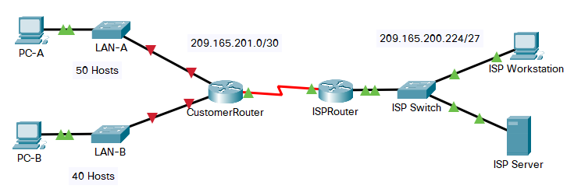

**You are a network technician assigned to install a new network for a customer. You must create multiple subnets out of the 192.168.12.0/24 network address space to meet the following requirements:**

* + **The first subnet is the LAN-A network. You need a minimum of 50 host IP addresses.**
  + **The second subnet is the LAN-B network. You need a minimum of 40 host IP addresses.**
  + **You also need at least two additional unused subnets for future network expansion.**

**Note: Variable length subnet masks will not be used. All of the device subnet masks should be the same length.**

**Answer the following questions to help create a subnetting scheme that meets the stated network requirements:**

1. **How many host addresses are needed in the largest required subnet?**
2. **What is the minimum number of subnets required?**
3. **The network that you are tasked to subnet is 192.168.12.0/24. What is the /24 subnet mask in binary?**
4. **The subnet mask is made up of two portions, the network portion, and the host portion. This is represented in the binary by the ones and the zeros in the subnet mask.**

**Questions:**

**In the network mask, what do the ones and zeros represent?**

1. **When you have determined which subnet mask meets all of the stated network requirements, derive each of the subnets. List the subnets from first to last in the table. Remember that the first subnet is 192.168.12.0 with the chosen subnet mask.**

|  |  |  |
| --- | --- | --- |
| **Subnet Address** | **Prefix** | **Subnet Mask** |

Solution :

a. How many host addresses are needed in the largest required subnet?

Soln: 50

b. What is the minimum number of subnets required?

Soln : According to the question , two subnet are required for LAN-A and LAN-B and two subnets are needed to be left for future use Therefor the total number of subnets are 4 .

c. The network that you are tasked to subnet is 192.168.12.0/24. What is the /24 subnet mask in binary?

Soln : /24 is prefix length.

1. In binary, it is 11111111.111111111.111111111.000000000

There are 24 bits 1. It means that the address left 24 first bits for network portion

d. The subnet mask is made up of two portions, the network portion, and the host portion. This is represented in the binary by the ones and the zeros in the subnet mask. In the network mask, what do the ones and zeros represent?

Soln : In the nerwork mask, the ones represent the network portion and the zeroes represent the host portion.

e. When you have determined which subnet mask meets all of the stated network requirements, derive each of the subnets. List the subnets from first to last in the table. Remember that the first subnet is 192.168.12.0 with the chosen subnet mask.

|  |  |  |
| --- | --- | --- |
| **Subnet Address** | **Prefix** | **Subnet Mask** |
| **192.168.12.0** | **/26** | **255.255.255.192** |
| **192.168.12.64** | **/26** | **255.255.255.192** |
| **192.168.12.128** | **/26** | **255.255.255.192** |
| **192.168.12.192** | **/26** | **255.255.255.192** |

**Câu 15:**

**Suppose that Selective Repeat ARQ is modified so that ACK messages contain a list of the next m frames that it expects to receive.**

**Solutions follow questions:**

**a. How does the protocol need to be modified to accommodate this change?**

**b. What is the effect of the change on protocol performance?**

Solution :

GIVENTHAT :

a) There are 2 things are needed to be modified: The frame header and transmitter operation.

•The frame header needs to be changed to recieve the list of frames, when the reciever show that which frames are needed to be sent.

•Transmitter operation. It can be used to skip retransmission of frames that have already been received, if the recieved list includes oldest frames that aren’t received.

b) There will be an signifiant increase of performance if the error rate or delay is high. A single frame can ask for the retransmission of several frames. The complexity of the protocol will improve to the unchanged Selective repeat ARQ

1/

a. To accommodate this change in Selective Repeat ARQ, the following modifications need to be made:

The sender needs to maintain a list of all sent frames and their sequence numbers.

The receiver needs to maintain a list of all received frames and their sequence numbers.

When the receiver receives a frame, it should add the frame to its received frame list and send an ACK message containing a list of the next m expected frames.

Upon receiving an ACK message, the sender should update its sent frame list and remove any frames that have been acknowledged. It should then resend any unacknowledged frames that fall within the range of the next m expected frames listed in the ACK message.

b. The effect of this change on protocol performance is that it can increase the throughput of the protocol by reducing the number of retransmissions and maximizing the use of available bandwidth. With the original Selective Repeat ARQ protocol, the sender would only receive acknowledgement for a single frame at a time before sending the next frame. With the modified protocol, the sender can send multiple frames before waiting for acknowledgement, which reduces the overall transmission time. Additionally, by including a list of the next m expected frames in each ACK message, the receiver can reduce the number of duplicate frames sent by the sender, further increasing throughput.

**Q.1. (2 marks)**

**Suppose the size of an uncompressed text file is 1 megabyte**

**Note: Explain your answer in details.**

**a. How long does it take to download the file over a 32 kilobit/second modem?**

**b. How long does it take to take to download the file over a 1 megabit/second**

**modem?**

**c. Suppose data compression is applied to the text file. How much do the transmission**

**times in parts (a) and (b) change?**

solu:

Câu a)

(Đổi hết sang đơn vị bit và bit / second)

Size text file = 1 x 1024 x 1024 x 8 (b

Speed = 32 x 1000 (bit / second)

=> T (32k) = (1 x 1024 x 1024 x 8) / (32 x 1000) = 262.144 (seconds)

Câu b)

(Đổi hết sang đơn vị bit và bit / second)

Size text file = 1 x 1024 x 1024 x 8 (bit)

Speed = 1 x 1000 x 1000 (bit / second)

=> T (1M) = (1 x 1024 x 1024 x 8) / (1 x 1000 x 1000) = 8.38 (seconds)

Câu c)

(Đề kêu 1:6 thì chỉ việc nhân thêm cho 6 ở chỗ tốc độ là xong, nếu trường ra đề 1:10 thì nhân 10)

=> T (32k) = (1 x 1024 x 1024 x 8) / (32 x 1000 x 6) = 43.69 (seconds)

=> T (1M) = (1 x 1024 x 1024 x 8) / (1 x 1000 x 1000 x 6) = 1.4 (seconds)

**Q2. (2 marks)**

**Let g(x)=x3+x+1. Consider the information sequence 1001. Find the codeword**

**corresponding to the preceding information sequence. Using polynomial arithmetic we obtain**

**Note: Explain your answer in details.**

Solu:

Step 1: Add 000 to data bits string. It will be 1001000

Step 2: Devide 1001000 to 1011 in modulo – 2 method.

g(x) = x3+x+1 -> 1011

Using polynomial arithmetic we obtain:

101

-----------------

1011 | 1001000

| 1011

---------------

001000

1011

---------------

00110

Codeword = 1 0 0 1 1 1 0

**Q.4. (2 marks)**

**A router has the following CIDR entries in its routing table:**

**Address/mask Next hop**

**135.46.56.0/22 Interface 0**

**135.46.60.0/22 Interface 1**

**192.53.40.0/23 Router 1**

**default Router 2**

**(a) What does the router do if a packet with an IP address 135.46.63.10 arrives?**

**(b) What does the router do if a packet with an IP address 135.46.57.14 arrives?**

solu:

a)

Taking the first 22 bits of the above IP address as network address, we have 135.46.60.0.

It matches the network address of 135.46.60.0/22. So, the router will forward the packet to Interface 1.

b)

Taking the first 22 bits of the above IP address as network address, we have 135.46.56.0.

It matches the network address of 135.46.56.0/22. The packet will be forwarded to Interface 0.

(ko chep vao) Cách nhận biết:

Xét 135.46.63.10 có 135.46 giống Interface 0 và 1.

135.46.63 lớn hơn Interface 1 thì chọn Interface 1, ngược nếu ví dụ như đề câu b chỉ có 57 (lớn hơn 56 nhưng nhỏ hơn 60) -> chọn Interface 0.

Nếu đề hỏi khác nữa như cho 10.10.10.10 không giống cái nào ở Interface 0, 1 hay Router 1 thì mặc định chọn Default -> Router 2.

**Câu 15:**

**A Large number of consecutive IP address are available starting at 198.16.0.0.**

**Suppose four organizations, A, B, C, D request 4000, 2000, 4000, and 8000**

**addresses, respectively. For each of these organizations, give:**

**1. the first IP address assigned**

**2. the last IP address assigned**

**3. the mask in the w.x.y.z/s notation**

solu:

IP addresses will be allocated in blocks of power of 2. So the four organizations will be allocated IPs as A-4096, B-2048, C-4096 and D-8192. Remaining unused IPs are wasted. IPs will be allocated to the organizations contiguously

A has 2^12 hosts. So lower order 12 bits will denote host ID and higher order 32-12=20 bits denotes network ID

A's first IP=198.16.0.0 (Host IP part contains all Os)

A's last IP=11000110.00010000.00001111.11111111 (Host ID part contains all 1s=198.16.15.255)

A's Mask=198.16.15.255

------------------------------------------------------------------------------------------------------------

B has 2^11 hosts. So lower order 11 bits will denote host ID and higher order 32-11=21 bits denotes network ID

B's first IP=198.16.16.0

B's last IP=11000110.00010000.00010111.11111111=198.16.23.255

B's Mask=198.16.16.0/21

------------------------------------------------------------------------------------------------------------

C has 2^12 hosts. So lower order 12 bits will denote host ID and higher order 32-12=20 bits denotes network ID

C's first IP=198.16.24.0

C's last IP=11000110.00010000.00011111.11111111=198.16.31.255

C's Mask=198.16.24.0/20

--------------------------------------------------------------------------------------------------------------

D has 2^13 hosts. So lower order 13 bits will denote host ID and higher order 32-13=19 bits denotes network ID

D's first IP=198.16.32.0

D's last IP=11000110.00010000.00111111.11111111=198.16.63.255

D's Mask=198.16.32.0/19