Câu 1: Explain the difference between connectionless unacknowledged service and connectionless acknowledged service. How do the protocols that provide these services differ?

Connectionless service: No connection path between the sender and the receiver

|  |  |
| --- | --- |
| Connectionless unacknowledge service: | Connectionless acknowledged service |
| * No confirmation that a message sent by the sender has been received by the receiver. * No confirmation that it will be sent back to the sender | * The sender waits for a confirmation or receipt from the receiver after sending the message * If the receiver receives the message, it sends an acknowledgement back to the sender. Also if the sender doesn’t get any confirmation, it can consider that the message was not received. |

Handling packet loss and overhead are the diference citeria between there service:

|  |  |
| --- | --- |
| Connectionless unacknowledge service | Connectionless acknowledged service protocols |
| * UDP ( User Datagram Protocol) * Lightweight and and few overhead. * No confirmation of successful delivery | * ICMP (Internet Control Message Protocol) and ARP (Address Resolution Protocol) * More overhead * Have the confirmation of successful delivery |

Câu 2. Explain the difference between connection-oriented acknowledged service and connectionless acknowledged service. How do the protocols that provide these services differ?

|  |  |
| --- | --- |
| Connection-oriented acknowledged service | Connectionless acknowledged service |
| * Create a specific connection between the sender and receiver before any transmission of data arrival. * The receiver sends an acknowledgement to the sender after receiving one-by-one packet of data. * Requires a stateful protocol, which is used to keep track of sequence numbers, and timers. | * Does not establish a dedicated connection before data transmission. * The sender simply sends packets to the receiver, and the receiver sends acknowledgements back to the sender for each received packet. * Does not require transmitting protocols to track the acknowledgment of PDU. |

Handling packet loss and overhead are the diference citeria between there service:

|  |  |
| --- | --- |
| Connection-oriented acknowledged service | Connectionless acknowledged service |
| - TCP (Transmission Control Protocol)  - Using a three-way handshake to form a reliable connection between the sender and receiver.  - Efficiency data transfer and minimize packet  - Close after the data transmission completed.  - Reliable, slower | * UDP (User Datagram Protocol) * Do not establish a dedicated connection with the receiver. * Simply send the packets to the receiver without any confirmation for their delivery or order. * Faster but less reliable |

Câu 3: Explain the differences between PPP and HDLC.

|  |  |  |
| --- | --- | --- |
|  | PPP (Point-to-Point Protocol) | HDLC (High-level Data Link Control) |
| 1.Flexibility | - More flexible.  - Multiple network layer protocols, including IP, IPX, and AppleTalk. | - Less flexible  - Mainly designed for 1 protocol. |
| 2. Error detection | - More better  - Cyclic redundancy check (CRC), more effective for data transsmion in detecting error | - Less than PPP  - Frame check sequence (FCS) |
| 3. Configuration | - Easy to config  - LCP(Link Control Protocol), which automates the configuration process. | - More difficult  - HDLC requires manual configuration of parameters, such as the address field and control field. |
| 4. Sliding Window Protocol | - Using a sliding window protocol for flow control  - Optimize the data transmission, ensuring that the receiver is not overwhelmed with too much data at once. | - Does not |

Câu 4:

A 1.5 Mbps communications link is to use HDLC to transmit information to the moon. What is the smallest possible frame size that allows continuous transmission? The distance between earth and the moon is approximately 375,000 km, and the speed of light is 3 x 108 meters/second.

D (Distance) = 375,000 km = 375 x 10^6   m

c (Speed of Light) = 3 x 108  m

R = 1,5 Mbps = 1,5 x 10^6 bps.

|  |  |  |
| --- | --- | --- |
|  | Maximum Send Window Size in Default HDLC Frame | Maximum Send Window Size in Extended HDLC Frame |
| Go-Back-N | 7 | 127 |
| Selective Repeat | 4 | 64 |

Round Trip Propagation Delay: RTT

                       RTT = 2 x Propagation delay = 2 *D /c = 2 * 375*10^6/(3*10^8) = 2.5 s

Possible Frame Size (bits): Nf

                       N x Nf / R = RTT => Nf = 2.5 * 1.5 * 10 ^6 / N ( N is maximum send window size)

* Minimum frame size => Maximum send window size

For Go-Back-N:

If N = 7 : Nf=535 715 bits

If N = 127: Nf=29 528 bits

For Selective Repeat:

If N = 4: Nf= 973 500 bits

If N = 64: Nf=  58 594 bits

**Câu 5**: Suppose HDLC is used over a 1.5 Mbps geostationary satellite link. Suppose that 250-byte frames are used in the data link control. What is the maximum rate at which information can be transmitted over the link?

R = 1.5 Mbps= 1,5 x 10^6 bps , and Nf =250 bytes = 2000 bits.

Distance D = 36,000 km = 3,6 x 10^7m .

Speed of light: c = 3 x 10^8 .

Propagation delay: Tprop= D/c=3,6×10^7/(3×10^8)=0,12 s=120 ms

Processing rate: Tf=Nf/R=2000/(1,5×10^6) = 0,00133 s = 1,33 ms

We can use Go-Back-N or Selective Repeat ARQ . The default window size is N = 7 (with a 3 bits sequence number).

With no error -> no retransmission -> the maximum information rate is achieved

Tcycle = minimum time to transmit a group of N packets

= Tf+ 2 x Tprop = 1.33 + 2 x 120 = 241.33 ms

Number of bits transmitted in 1 cycle : n = cycle = N x Nf= 7 x 2000 = 14000 bits

Rmax= n / Tcycle= 58 kbps

(Rmax is number of bits sent in a cycle / minimum cycle time)

If the extended sequence numbering option (7-bit) is used, the maximum send window size

would be N = 2^7– 1 = 127.

The maximum information rate is:

n=N×Nf=127×2000=254000 bits

Rmax=n/Tcycle=254000/241,33=1052,5 kbps=1,0525 Mbps

# Câu 6:

Suppose that a multiplexer receives constant-length packet from N = 60 data sources. Each data source has a probability p = 0.1 of having a packet in a given T-second period. Suppose that the multiplexer has one line in which it can transmit eight packets every T seconds. It also has a second line where it directs any packets that cannot be transmitted in the first line in a T-second period. Find the average number of packets that are transmitted on the first line and the average number of packets that are transmitted in the second line.

First, we determine the possibility that the k packets have arrived at the T-second. A binomial distribution with parameters of N=60 and a probability of p=0.1 can be used to calculate it.

Np=6 can be used to represent the average number of packet arrivals.

The average number of packets received through the first line:

X= $\sum_{k=0 }^{8}{}k . C_{k}^{60} . {(0,1)}^{k}. {(0,9)}^{60- k}=4.59$

The remaining will get transmitted by the second line:

Y= Np – X =  6 – 4,59 = 1,41

Therefore, it will transmit 1.41 packets on average per T second from the second line.

# Câu 7:

Consider the transfer of a single real-time telephone voice signal across a packet network. Suppose that each voice sample should not be delayed by more than 20 ms.

1. Discuss which of the following adaptation functions are relevant to meeting the requirements of this transfer: handling of arbitrary message size; reliability and sequencing; pacing and flow control; timing; addressing; and privacy, integrity and authentication.
2. Compare a hop-by-hop approach to an end-to-end approach to meeting the requirements of the voice signal.

a. There are four adaption functions that relevant to meet the requirement of transferring a single real-time telephone voice signal across a packet network with a maximum delay of 20 ms:

In order to send a single real-time telephone speech signal across a packet network with a maximum delay of 20 ms, the following four adaptation functions are necessary:

1. Time: The time adaption function is vitally important in making sure that each voice sample is supplied by the deadline. To keep the required time gaps between packets, the network must be able to synchronize its clock with the sender and recipient.
2. Reliability and sequencing: The reliability and sequencing adaptation function is required to make sure that there are no lossing or misordering. At the receiver end, packets must be sequenced and reordered as well as detected and corrected for errors.
3. Pacing and flow control: To prevent packet loss due to congestion, pacing and flow control mechanisms are necessary. These mechanisms regulate the rate at which packets are transmitted and received to match the capacity of the network.
4. Addressing: Addressing is necessary to identify the source and destination of each voice sample. It also enables routing of packets through the network.

b. The hop-by-hop approach and the end-to-end approach are the two methods for implementing a real-time telephone speech signal over a packet network.

The hop-by-hop strategy entails putting the necessary adaption functions in place at each intermediate packet network node. Before sending the packets to the subsequent node, each node processes the ones it has received. Due to processing at each node, this method may cause extra delays and costs. Additionally, if one node fails, the security of the entire transmission may be compromised.

In the end-to-end approach, the sender and receiver of the speech signal are the sole locations where the necessary adaption functions are implemented. The packets are sent unchanged via the network, and the endpoints carry out any necessary processing. Although this method reduces delays and overhead, it could not function well in networks with high packet loss rates or unpredictable delays.

In conclusion, for real-time voice communications over packet networks, the end-to-end method is generally favored since it reduces overhead and delays. However, in some circumstances, such as when the network has significant delay or loss rates or when additional processing is required at intermediary nodes, the hop-by-hop method may be required.

# Câu 8:

Consider the Stop-and-Wait protocol as described. Suppose that the protocol is modified so that each time a frame is found in error at either the sender or receiver, the last transmitted frame is immediately resent.

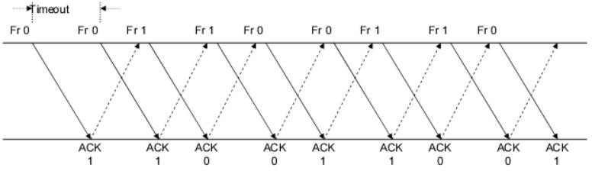

1. Show that the protocol still operates correctly.
2. Does the state transition diagram need to be modified to describe the new operation?
3. What is the main effect of introducing the immediate-retransmission feature?

a. The modified Stop-and-Wait protocol operates correctly because it ensures that every frame is received accuracy before the next one is forwarded. If a frame is found in error, the sender immediately resends the last transmitted frame, which ensures that the receiver will receive a correct copy of the frame.

b. No. The state transition diagram will stay the same.

1. This process will be faster. The main effect of introducing the immediate-retransmission feature is to improve the protocol's error recovery capabilities. With this feature, errors can be quickly corrected by resending the last transmitted frame.

Câu 9:

Suppose that two peer-to-peer processes provide a service that involves the transfer of discrete messages. Suppose that the peer processes are allowed to exchange PDUs that have a maximum size of M bytes including H bytes of header. Suppose that a PDU is not allowed to carry information from more than one message.

a.Develop an approach that allows the peer processes to exchange messages of arbitrary size:

* To exchange messages of arbitrary size, large messages must be segmented into parts of M-H bytes, each in length to be transmitted in multiple PDUS.
* Small messages must be placed in a single PDU.

b. What essential control information needs to be exchanged between the peer processes?

* The peer processes need to communicate information that allows for the reassembly of messages at the receiver. For example, the first PDU may contain the message length.
* The last PDU may contain end-of-message marker.
* Sequence numbers may also be useful to detect loss in connection oriented networks and to help in reconstruction of the messages in connectionless networks. Lastly,
* Since variable size PDUS are permitted, the size of the PDU must be transmitted in the PDU header.

c. Now suppose that the message transfer service provided by the peer processes is shared by several message source-destination pairs. Is additional control information required, and if so, where should it be placed?

In this case, in addition to all of the header information mentioned in b), each PDU must be labeled with a stream ID, so that the receiver can treat each stream independently when reassembling

messages.

Câu 10:

A 1 Mbyte file is to be transmitted over a 1 Mbps communication line that has a bit error rate of p = 10-6.

1. What is the probability that the entire file is transmitted without errors? Note for n large and p very small, (1 − p)n ≈ e-np.
2. The file is broken up into N equal-sized blocks that are transmitted separately. What is the probability that all the blocks arrive correctly without error? Does dividing the file into blocks help?
3. Suppose the propagation delay is negligible, explain how Stop-and-Wait ARQ can help deliver the file in error-free form. On the average how long does it take to deliver the file if the ARQ transmits the entire file each time?

Solution :

1Mbyte = 106 byte = 8 x bits

The file length n = 8 x 106 bits, the transmission rate R = 1 Mbps = 106 bps and p = 10-6

1. Note : For n lagrge and p very small , ${(1-p)}^{n}≈e^{-np}$

P[no error in the entire file] = ${(1-p)}^{n}≈e^{-np}$ for n >> 1 , p << 1

= $e^{-8}$ = 3.35 x ${10}^{-4}$

We conclude that it is extremely unlikely that the file will arrive error free

1. A subblock of length n/N is received without error with probability :

P[no error in subblock] = ${(1-p)}^{n/N}$

A block has no errors if all subblocks have no errors, so

P[no error in block] = ${P[no error in subblock]}^{N}$ = ${(1-p)}^{{(n/N)}^{N}}$ = ${(1-p )}^{n}$

So simply dividing the blocks does not help.

c.

Refer to the following figure for the discussion .

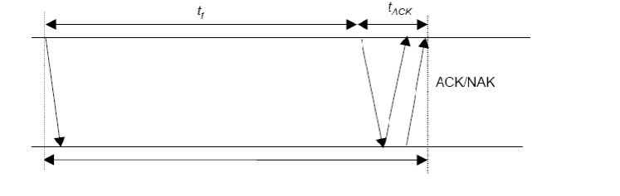

We assume the following:

* $t_{0 }$ = basic time to send a frame and receive the ACK/NAK $≈$ ttimeout
* $t_{total}$ = total transmission time until success
$n_{f}$ $=number of bits / frame$

* $n_{a}$ = number of bits per ACK
* $n_{t}$ = number of transmissions
* $P_{f}$ = probability of frame transmission error

$t_{0}$ = $t_{f}+ t_{ACK}$ = $\frac{n_{f}}{R}+\frac{n_{a}}{R}$ ($t_{prop ≈0 )}$

$P\left[n_{t}=i \right]=P[one success after i-1 failure]$ = (1 - $p_{f}){p_{f}}^{i-1}$

Given i transmissions : | = i $t_{0}$

*

E[$t_{total}$] = $\sum_{i=1}^{∞}{}it_{0}$ P[$n_{t}=i$] = $t_{0}(1-P_{f})\sum_{i=1}^{∞}{}i . P_{f}^{i-1}$ = $\frac{t_{0}\left(1-P_{f}\right)}{{(1-P_{f})}^{2}}$ = $\frac{t_{0}}{1- p_{f}}$

Here , $n_{f}$ = n >> $n_{a }$ thus $t_{0}$ $≈t_{f}$ = n/R ; and $P_{f} =1-P[no error]$ =

1 $-$ $e^{-np}$

E[total] = n/R(1 - $p_{f})=n/[{Re}^{-np}]$ = 8 / (3.35 x 10-4) = 23847 seconds = 6,62 hours

The file gets through, but only after many retransmissions.

Câu 11:

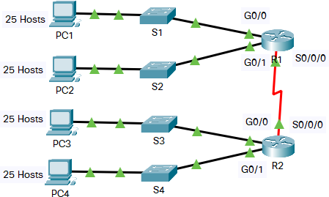

In this activity, you are given the network address of 192.168.1.0/24 to subnet and provide the IP addressing for the Packet Tracer network. Each LAN in the network requires at least 25 addresses for end devices, the switch and the router. The connection between R1 to R2 will require an IP address for each end of the link.

1. Based on the topology, how many subnets are needed?
2. How many bits must be borrowed to support the number of subnets in the topology table?
3. How many subnets does this create?
4. How many usable hosts does this create per subnet?

a. S1, S2, S3, S4, S0/0/0 are the subnets needed, so that there are 5 subnets are needed.

b.N is the number of bits

${4×2}^{N }-2≥25$

* N = 3.

(4 because 4 is subnet S1, S2, S3 , S4 not S0/0/0)

c. We saw that number of bits N = 3, then the number of subnets does this create is $2^{3 }=8.$

d.How many usable hosts does this create per subnet? 28-n – 2 = 28-3 – 2 = 30

Câu 12:

Five stations (S1-S5) are connected to an extended LAN through transparent bridges (B1- B2), as shown in the following figure. Initially, the forwarding tables are empty. Suppose the following stations transmit frames: S1 transmits to S5, S3 transmit to S2, S4 transmits to S3, S2 transmits to S1, and S5 transmits to S4. Fill in the forwarding tables with appropriate entries after the frames have been completely transmitted.

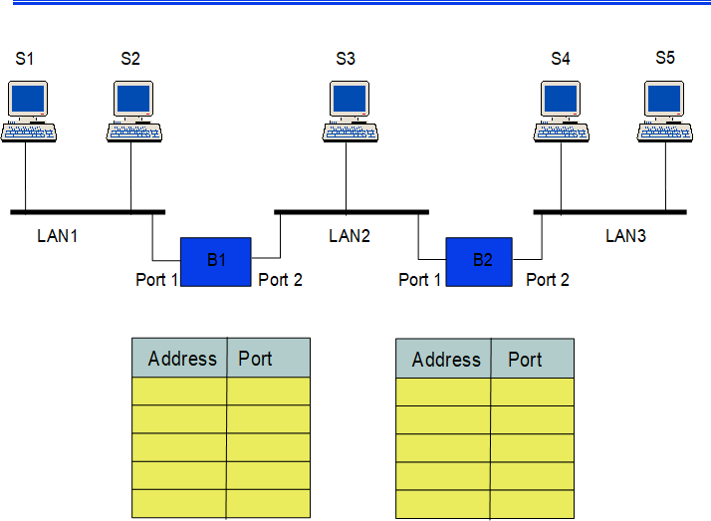

For B1

|  |  |  |  |
| --- | --- | --- | --- |
|  |  | Address | Port |
| Step 1 | S1 => S5 | S1 | 1 |
| Step 2 | S3 => S2 | S3 | 2 |
| Step 3 | S4 => S3 | S4 | 2 |
| Step 4 | S2 => S1 | S2 | 1 |
| Step 5 | S5 => S4 |  |  |

For B2

|  |  |  |  |
| --- | --- | --- | --- |
|  |  | Address | Port |
| Step 1 | S1 => S5 | S1 | 1 |
| Step 2 | S3 => S2 | S3 | 2 |
| Step 3 | S4 => S3 | S4 | 2 |
| Step 4 | S2 => S1 |  | 1 |
| Step 5 | S5 => S4 | S5 |  |

Câu 13:

* 1. Consider the network in Figure.

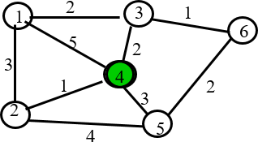

1. Use the Dijkstra algorithm to find the set of shortest paths from node 4 to other nodes.

|  |  |  |  |  |  |  |
| --- | --- | --- | --- | --- | --- | --- |
| Iteration | N | D1 | D2 | D3 | D5 | D6 |
| Initial | {} |  |  |  |  |  |
| 1 | {} |  |  |  |  |  |
| 2 | {} |  |  |  |  |  |
| 3 | {} |  |  |  |  |  |
| 4 | {} |  |  |  |  |  |

1. Find the set of associated routing table entries (Destination, Next Hop, Cost)

|  |  |  |
| --- | --- | --- |
| Destination | Cost | Next Hop |
|  |  |  |
|  |  |  |
|  |  |  |
|  |  |  |
|  |  |  |

a.

|  |  |  |  |  |  |  |
| --- | --- | --- | --- | --- | --- | --- |
| Iteration | N | D1 | D2 | D3 | D5 | D6 |
| Initial | {4} | $$(-1,∞)$$ | $$-1,∞)$$ | $$(-1,∞)$$ | $$(-1,∞)$$ | $$(-1,∞)$$ |
| 1 | {4,2} | (5,4) | (1, 4) | (2,4) | (3,4) | $$(-1,∞)$$ |
| 2 | {4,2,3} | (4,2) | ______ | (2,4) | (3,4) | $$(-1,∞)$$ |
| 3 | {4,2,3, 5} | (4,2) | ______ | ______ | (3,4) | (3,3) |
| 5 | {4,2,3,5,6} | (4,2) | ______ | ______ | ______ | (3,3) |
| 6 | {4,2,3,5,6,1} | (4,2) | ______ | ______ | ______ | ______ |

From D4 to D1 , the path is D4 -> D2 -> D1 : 4

From D4 to D2 , the path is D4 -> D2: 1

From D4 to D3, the path is D4 -> D3: 2

From D4 to D5, the path is D4 -> D5 : 3

From D4 to D6, the path is D4 -> D3 -> D6: 3

b.

|  |  |  |
| --- | --- | --- |
| Destination | Cost | Next Hop |
| D1 | 4 | 2 |
| D2 | 1 | 2 |
| D3 | 2 | 3 |
| D5 | 3 | 5 |
| D6 | 3 | 3 |

14)

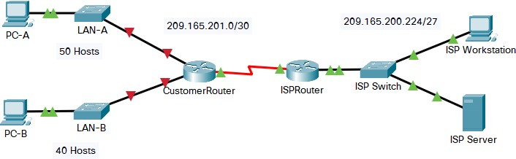

You are a network technician assigned to install a new network for a customer. You must create multiple subnets out of the 192.168.0.0/24 network address space to meet the following requirements:

* The first subnet is the LAN-A network. You need a minimum of 50 host IP addresses.
* The second subnet is the LAN-B network. You need a minimum of 40 host IP addresses.
* You also need at least two additional unused subnets for future network expansion.

**Note**: Variable length subnet masks will not be used. All of the device subnet masks should be the same length.

Answer the following questions to help create a subnetting scheme that meets the stated network requirements:

* 1. How many host addresses are needed in the largest required subnet?
  2. What is the minimum number of subnets required?
  3. The network that you are tasked to subnet is 192.168.0.0/24. What is the /24 subnet mask in binary?
  4. The subnet mask is made up of two portions, the network portion, and the host portion. This is represented in the binary by the ones and the zeros in the subnet mask.

In the network mask, what do the ones and zeros represent?

* 1. When you have determined which subnet mask meets all of the stated network requirements, derive each of the subnets. List the subnets from first to last in the table. Remember that the first subnet is 192.168.0.0 with the chosen subnet mask.

a. How many host addresses are needed in the largest required subnet?

50 port the largest subnet

b. What is the minimum number of subnets required?

Two subnet are required for LAN-A and LAN-B and two subnets are needed to be left for future use. So the total number of subnets are 4 .

c. The network that you are tasked to subnet is 192.168.12.0/24. What is the /24 subnet mask in binary?

/24 is prefix length.

In binary, it is 11111111.111111111.111111111.000000000

There are 24 bits 1. It means that the address left 24 first bits for network portion

d. The subnet mask is made up of two portions, the network portion, and the host portion. This is represented in the binary by the ones and the zeros in the subnet mask. In the network mask, what do the ones and zeros represent?

In the nerwork mask, the ones represent the network portion and the zeroes represent the host portion.

e. When you have determined which subnet mask meets all of the stated network requirements, derive each of the subnets. List the subnets from first to last in the table. Remember that the first subnet is 192.168.12.0 with the chosen subnet mask.

|  |  |  |
| --- | --- | --- |
| **Subnet Address** | **Prefix** | **Subnet Mask** |
| **192.168.12.0** | **/26** | **255.255.255.192** |
| **192.168.12.64** | **/26** | **255.255.255.192** |
| **192.168.12.128** | **/26** | **255.255.255.192** |
| **192.168.12.192** | **/26** | **255.255.255.192** |

Câu 15:

Suppose that Selective Repeat ARQ is modified so that ACK messages contain a list of the next m frames that it expects to receive.

1. How does the protocol need to be modified to accommodate this change?
2. What is the effect of the change on protocol performance?

a) There are 2 things are needed to be modified:

* The frame header needs to be changed to recieve the list of frames, when the reciever explicitly show that which frames are needed to be sent.
* Change in transmitter operation. If the recieved list contains m oldest frames that are yet to be recieved , then it can be used to skip retransmission of frames that have already been received.

b) What is the effect of change on protocol performance?

Performance will surely increase if the error rate is high or delay is high. A single frame can ask for the retransmission of several frames.

The complexity of the protocol will surely increase relative to the unchanged Selective repeat ARQ

# Q.16. (2 marks)

Suppose the size of an uncompressed text file is 1 megabyte

***Note: Explain your answer in details.***

1. How long does it take to download the file over a 32 kilobit/second modem?
2. How long does it take to take to download the file over a 1 megabit/second modem?
3. Suppose data compression is applied to the text file. How much do the transmission times in parts (a) and (b) change?

Câu a)

Size of file : 1 x 1024 x 1024 x 8 (bit)

Speed = 32 x 1000 (bit / second)

=> T (32k) = (1 x 1024 x 1024 x 8) / (32 x 1000) = 262.144 (seconds)

Câu b)

Size text file = 1 x 1024 x 1024 x 8 (bit)

Speed = 1 x 1000 x 1000 (bit / second)

=> T (1M) = (1 x 1024 x 1024 x 8) / (1 x 1000 x 1000) = 8.38 (seconds)

Câu c)

(Đề kêu 1:6 thì chỉ việc nhân thêm cho 6 ở chỗ tốc độ là xong, nếu trường ra đề 1:10 thì nhân 10)

=> T (32k) = (1 x 1024 x 1024 x 8) / (32 x 1000 x 6) = 43.69 (seconds)

=> T (1M) = (1 x 1024 x 1024 x 8) / (1 x 1000 x 1000 x 6) = 1.4 (seconds)

# Q17. (2 marks)

Let g(x)=x3+x+1. Consider the information sequence 1001. Find the codeword corresponding to the preceding information sequence. Using polynomial arithmetic we obtain

***Note: Explain your answer in details.***

Step 1: Convert g(x) to binary form:

g(x) = x3+x+1 -> 1011

Step 2: Add (n-1=3, n is number of bits of g(x)) 0 bits to data bits string. It will be 1001000

Devide 1001000 to 1011 in modulo – 2 method.

Step 3: Using polynomial arithmetic we obtain:

|  |  |
| --- | --- |
| 1001000 | 1011 |
| 1011  ------  001000  1011  ---------  00110 | 101 |

= > Codeword = 1 0 0 1 1 1 0

**Q.18. (2 marks)**

**A router has the following CIDR entries in its routing table:**

*Address/mask Next hop*

135.46.56.0/22 Interface 0

135.46.60.0/22 Interface 1

* + - 1. /23 Router 1

default Router 2

* + - * 1. What does the router do if a packet with an IP address 135.46.63.10 arrives?
        2. What does the router do if a packet with an IP address 135.46.57.14 arrives?

a)

Convert an IP address to binary form: 10000111.00101110.00111111.00001010

Taking the first 22 bits of the above IP address as network address => 135.46.60.0.

It matches the network address of 135.46.60.0/22. So, the router will forward the packet to Interface 1.

b)

Convert an IP address to binary form: 10000111.00101110.00111001.00001110

Taking the first 22 bits of the above IP address as network address, we have 135.46.56.0.

It matches the network address of 135.46.56.0/22. The packet will be forwarded to Interface 0.

Câu 19:

A Large number of consecutive IP address are available starting at 198.16.0.0. Suppose four organizations, A, B, C, D request 4000, 2000, 4000, and 8000 addresses, respectively. For each of these organizations, give:

1. the first IP address assigned
2. the last IP address assigned
3. the mask in the w.x.y.z/s notation

The start address, the ending address, and the mask are as follows:

IP addresses will be allocated in blocks of power of 2. So the four organizations will be allocated IPs as A-4096, B-2048, C-4096 and D-8192 (remaining unused IPs are wasted, IPs will be allocated to the organizations contiguously)

A has 2^12 hosts. So lower order 12 bits will denote host ID and higher order 32-12=20 bits denotes network ID

A's first IP=198.16.0.0 (Host IP part contains all Os)

A's last IP=11000110.00010000.00001111.11111111 (Host ID part contains all 1s=198.16.15.255)

A's Mask=198.16.15.255

------------------------------------------------------------------------------------------------------------

B has 2^11 hosts. So lower order 11 bits will denote host ID and higher order 32-11=21 bits denotes network ID

B's first IP=198.16.16.0

B's last IP=11000110.00010000.00010111.11111111=198.16.23.255

B's Mask=198.16.16.0/21

------------------------------------------------------------------------------------------------------------

C has 2^12 hosts. So lower order 12 bits will denote host ID and higher order 32-12=20 bits denotes network ID

C's first IP=198.16.24.0

C's last IP=11000110.00010000.00011111.11111111=198.16.31.255

C's Mask=198.16.24.0/20

--------------------------------------------------------------------------------------------------------------

D has 2^13 hosts. So lower order 13 bits will denote host ID and higher order 32-13=19 bits denotes network ID

D's first IP=198.16.32.0

D's last IP=11000110.00010000.00111111.11111111=198.16.63.255

D's Mask=198.16.32.0/19

Câu 20:

The ability to work with IPv4 subnets and determine network and host information based on a given IP address and subnet mask is critical to understanding how IPv4 networks operate. The first part is designed to reinforce how to compute network IP address information from a given IP address and subnet mask. When given an IP address and subnet mask, you will be able to determine other information about the subnet.

Fill out the tables below with appropriate answers given the IPv4 address, original subnet mask, and new subnet mask.

|  |  |  |  |
| --- | --- | --- | --- |
| **Given:** | | |  |
| **Host IP Address:** | 192.135.250.180 | |
| **Original Subnet Mask** | 255.255.255.0 | |
| **New Subnet Mask:** | 255.255.255.248 | |
| **Find:** | | | |
| **Number of Subnet Bits** | | 5 | |
| **Number of Subnets Created** | | 32 | |
| **Number of Host Bits per Subnet** | | 3 | |
| **Number of Hosts per Subnet** | | 6 | |
| **Network Address of this Subnet** | | |  | | --- | | 192.135.250.176 | |  | | |

|  |  |
| --- | --- |
| **IPv4 Address of First Host on this Subnet** | 192.135.250.177 |
| **IPv4 Address of Last Host on this Subnet** | 192.135.250.182 |
| **IPv4 Broadcast Address on this Subnet** | 192.135.250.183 |

Convert to binary form:

Original Subnet Mask: 11111111.11111111.11111111.00000000

New Subnet Mask: 11111111.11111111.11111111.11111000

The number of subnet bits = The number of additional bits in the new subnet mask compared to the original subnet mask.

=> Number of Subnet Bits: 5

The number of subnets created : 2 ^ subnet bit:

=>Number of Subnets Created: 2^5 = 32

The number of host bits per subnet = Number of bits in the IP address - the number of subnet bits:

=> Number of Host Bits per Subnet: 32 - 29 = 3

The number of hosts per subnet is equal to 2 ^ the number of host bits per subnet - 2

* Number of Hosts per Subnet: 2^3 - 2 = 6

The block size = 2 ^ the number of host bits in the new subnet mask:

=> Block Size: 2^3 = 8

Performing a bitwise AND operation between the host IP address and the new subnet mask:

11000000.10000111.11111010.10110100 (host IP address)

AND 11111111.11111111.11111111.11111000 (new subnet mask)

= 11000000.10000111.11111010.10110000 (network address) = 192.135.250.176

To find the IPv4 address of the first host, we add 1 to the network address:

IPv4 Address of First Host on this Subnet: 192.135.250.182

To find the IPv4 address of the last host, we subtract 2 from the total number of addresses in the subnet (536,870,910), since one address is reserved for the network address and one address is reserved for the broadcast address. We then add this result to the network address to get the IPv4 address of the last host:

Last Address = Network Address + Number of Hosts per Subnet

IPv4 Address of Last Host on this Subnet: 192.135.251.126

To find the IPv4 broadcast address, we set all the host bits in the subnet mask to 1's and perform a bitwise OR operation with the network address:

11000000.10000111.11111010.10110000 (network address)

OR 00000000.00000000.00000000.00000111 (host bits set to 1 in subnet mask)

11000000.10000111.11111010.10110111 (broadcast address)

IPv4 Broadcast Address on this Subnet: 192.135.250.183