Homework

CEA201- Assembly

- Assume that terminal screen
Enter number #1: 2
Enter number #2: 3
Sum = 2 + 3 = 5
If number #1 < = Sum < = number #2
Sum = Sum ++
Else
Sum = Sum—

include \masm32\include\masm32rt.inc

.code
start:
call main
exit

main proc
LOCAL v1 :DWORD
LOCAL v2 :DWORD
LOCAL result :DWORD

mov v1, sval(input("Enter no.1: "))
mov v2, sval(input("Enter no.2: "))

mov eax, v1
cmp eax, v2
jg SWAP_NUMBER

AFTER_SWAP:
mov eax, v1
add eax, v2
cmp eax, v1
jge NEXT_STEP
dec eax
mov result, eax
print chr$("Sum: ")
print str$(result)
print chr$(".", 13, 10)
jmp STOP

NEXT_STEP:
cmp eax, v2
jle FINAL_STEP
dec eax
mov result, eax
print chr$("Sum: ")
print str$(result)
print chr$(".", 13, 10)
jmp STOP

FINAL_STEP:
inc eax
mov result, eax
print chr$("Sum: ")
print str$(result)
print chr$(".", 13, 10)
jmp STOP

SWAP_NUMBER:
mov ebx, v2
mov v2, eax
mov v1, ebx
jmp AFTER_SWAP

STOP:
ret
main endp

end start
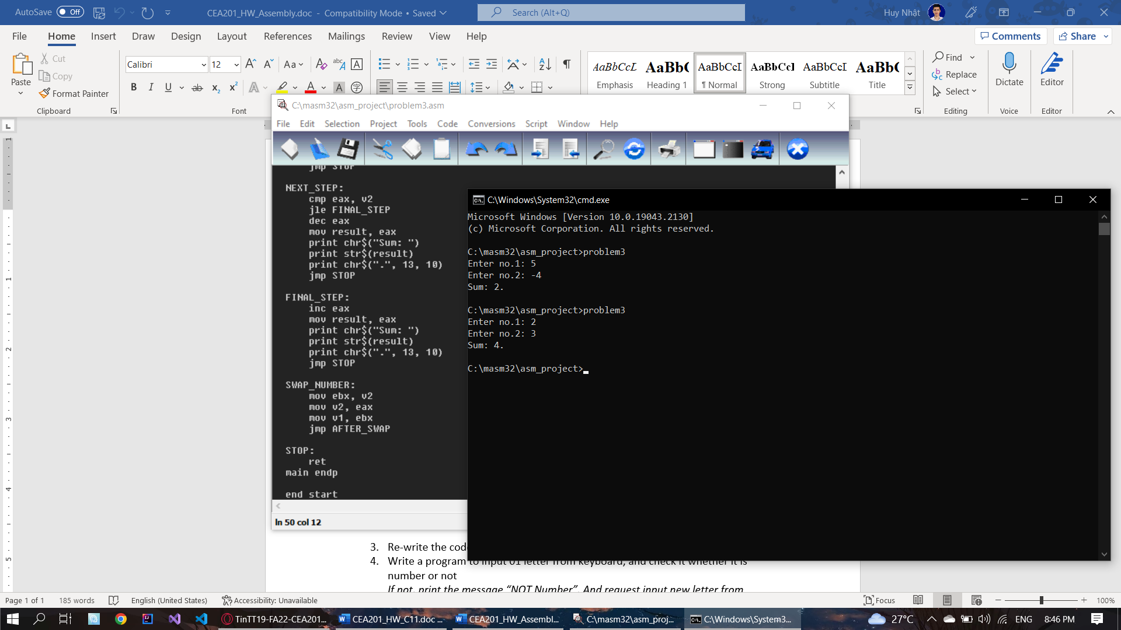

- Write a program to compare 03 numbers each other which inputed from keyboard, using the nested IF as following conditions:
If A < B
True: jump to label <Less_1>
False: print a message “A is not less than B” and quit a program
In label <Less_1>, compare B == C
True: assign A = 0 and print A with its assigned value on terminal screen
False: assign B = 0 and print A with its assigned value on terminal screen

- Re-write the code for “Loop.asm” example with FOR loop and Do…While loop
- Write a program to input 01 letter from keyboard, and check it whether it is number or not
If not, print the message “NOT Number”. And request input new letter from keyboard
If it’s number, print the message “It is Number” and print the inputed number on terminal screen

