Homework

CEA201- Chapter 11

- Using some equalities, and basic indentities of Boolean Algebra with table below:

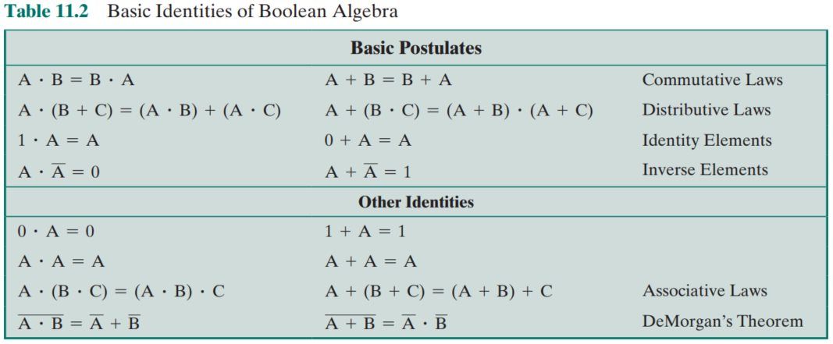

To simplify the Boolean functions: (Note: A = MSB and A’ = Not A)
- F(A,B,C,D) = ABC + AB’C + ABC’D
- F(A,B,C,D) = (A+BC) + A’(B’+C’)(AD+C)
- F(A,B,C,D) = Ʃ(0,3,4,7,8,9,14,15). In which, the number is the value of combination with Decimal expression
- F(A,B,C) = (A+C’)(B+C)(A+B)

- Using Karnaugh map to simplify the Boolean function (A = MSB)
- F(A,B,C) = Ʃ(1,3,4)
- F(A,B,C) = Ʃ(1,3,7)
- F(A,B,C) = Ʃ(0,3,4,6,7)
- F(A,B,C,D) = Ʃ(2,2,5,6,9,11,13,14)
- F(A,B,C,D) = Ʃ(0,5,9,10) with the other combinations (2,3,8,15) achived “d” (don’t care condition)

