**Fee Structure for the Academic Year 2017-2018**

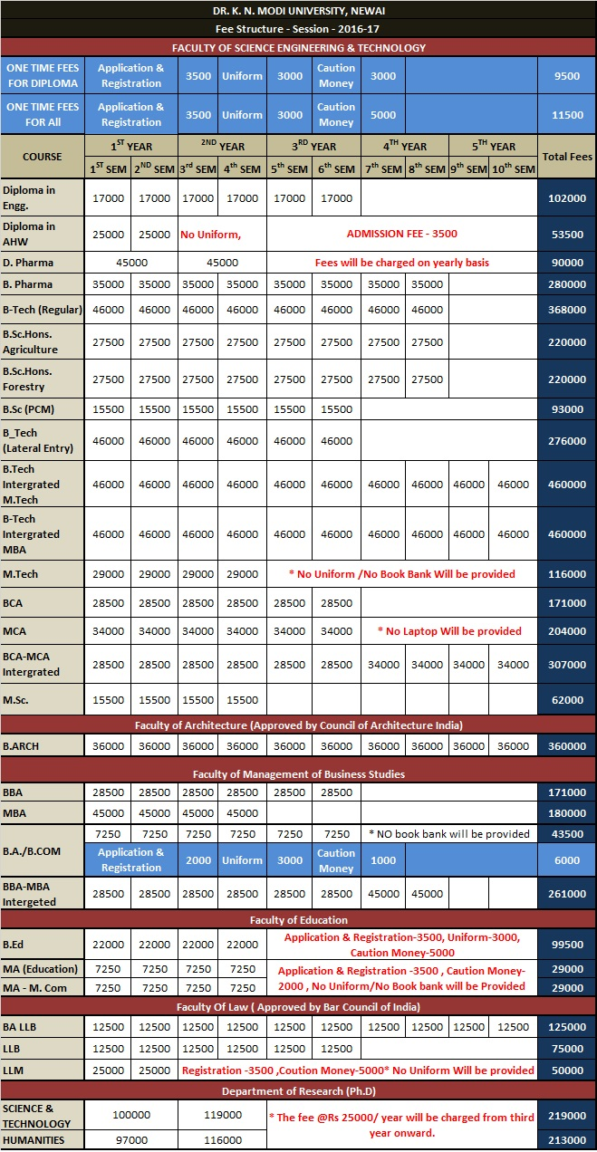

**Hostel Fee**

|  |  |  |  |
| --- | --- | --- | --- |
| **Hostel Fee** | | | |
| **Particular** | **Veg Mess Fee** | **Hostel Fee** | **Fees Per year** |
| Hostel Fee with Veg Food Three Seater  (Non AC Triple Sharing Room) | 29925 | 26000 | 55925 |
| Non AC Triple Sharing Room with Attached Toilet | 29925 | 30000 | 59925 |
| Hostel fee with veg food Two Seater  (Non AC Double Sharing with common  Toilet) | 29925 | 32000 | 61925 |
| Deluxe Non AC double sharing with attach Toilet | 29925 | 36000 | 65925 |
| Hostel fee with veg food Two Seater  (Non AC Double Sharing with Attached Toilet) | 29925 | 38000 | 67925 |
| AC hostel Fee With Veg Food Three Seater  (AC Triple Sharing with Attached Toilet) | 29925 | 43000 | 72925 |
| AC Hostel Fee With Veg Food Two Seater  (AC Double Sharing with Attached Toilet) | 29925 | 50000 | 79925 |
| Deluxe Triple Sharing AC Room | 29925 | 48000 | 77925 |
| **Non Veg Food (2BF + 3 Lunches or Dinner in a week )** | | | **40400** |
| Dormitory Hostel Charge with Veg Food Only for Students of Diploma in Engineering (Dormitory (Limited accommodation only for Students of  Diploma in Engineering)) | 29925 | 15000 | 44925 |
| Delux Dormitory  (Limited accommodation only for Students of  Diploma in Engineering)) | 29925 | 20000 | 49925 |
| Extra Charge for Air Cooled Room Per Student and Cooler to be arranged their own. | | | 6000 |