Yash Soni  
Big Data Programming  
Final Project Part 2: Instructions for AWS Website

Used:

NodeJS  
Cloudfront  
S3  
IAM Credentials

How:

1. Created a S3 Bucket
   1. Uploaded a index.html file to S3 Bucket that contains website code.
2. Using CloudFront to distribute it:
   1. Created a distribution
   2. Set Default Root Object as “index.html”
   3. This step created a domain name
   4. This domain name is the URL Location
3. Created IAM Credentials
   1. Created IAM Profile
   2. Created Lambda as a role using “AWSLambdaExecute”
   3. Used the following code for “trust relationships”
   4. 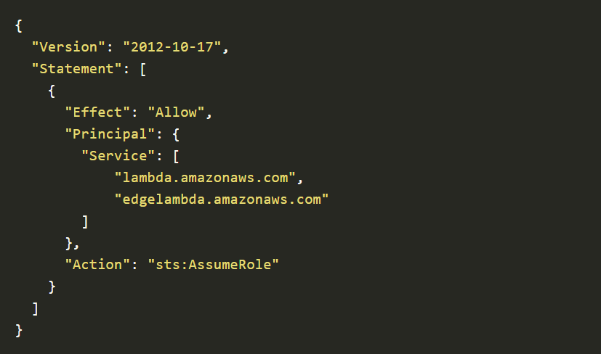
4. Created Authentication Layer using AWS Lambda
5. Used CloudFront to create Triggers