**INTRODUCTION**

In this report, we would explore the relationship between population growth and energy consumption from 1900 to 2014.

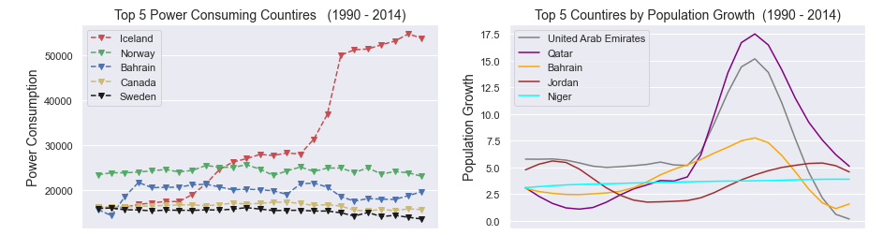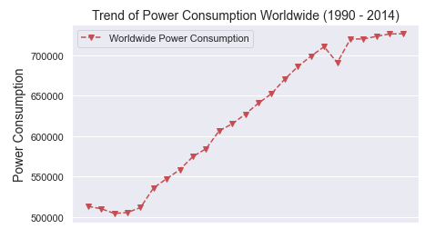We would start by exploring the trends worldwide, then on some selected countries.

Figure 1

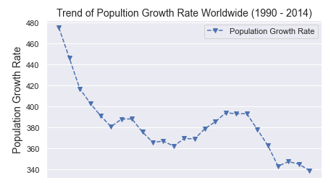

Figure 2

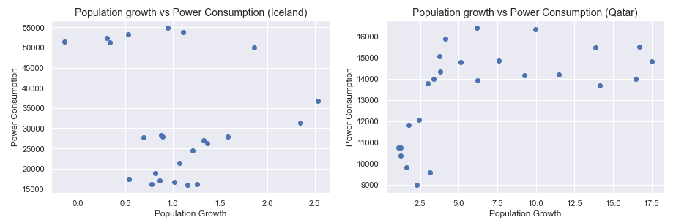Figure 1 shows that there is a rising trend in power consumption from 1990 to 2014, while figure 2 shows a decline in population growth within the same period. The trends could be due to several factors such as increase in technology and industrialization for power consumption and outburst of infectious diseases, famine war etc. on population growth.

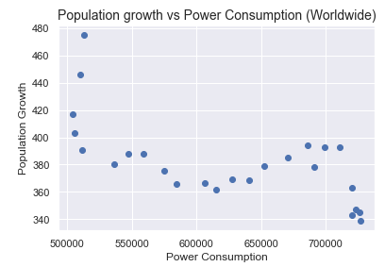

Figure 3

A Pearson correlation coefficient score of **-0.66** shows a negative correlation between power consumption and population growth as seen in figure 3. Since correlation dose not translate to causation, we can’t assume that decrease in population growth is because of the increase in power consummation.

Let us explore further by looking at the top power consuming countries as well as the countries with most growth rate.

Figure 4

In figure 4, Iceland, Norway, Bahrain, Canada, and Sweden were the top power consuming countries from 1990 to 2014, while UAE, Qatar, Bahrain, Jordan, and Niger were the countries with the high population growth in the same period.

Power consumption figures for Iceland has shown a rapid rise over time while Canada and Sweden maintained a steady power consumption rate overtime. UAE and Qatar had a shape rise followed by a sharp fall in the population growth rate within the period.

Figure 5

The Pearson correlation coefficients based on figure 5 has -**0.13** for Iceland and **0.57** for Qatar. While there is little or no correlation between Power consumption and population growth in Iceland, Qatar shows a somewhat positive correlation between power consumption and population growth.

In summary, while there may be a slight correlation between Population Growth and Power Consumption, we cannot attribute one to the other as so many other factors such as infectious diseases, war, industrialization etc. need to be considered.