Lab Tasks

- Find out the purpose of the following commands and execute them on your system with different parameters. [5 marks]
ls, cd, pwd, mkdir, rmdir, rm, cp, mv, touch

ls : List of files in directory
cd: Change directory
pwd: Print current folder path
mkdir: Create new directory
rmdir: Remove dirctory
mv: Move to new direectory
touch: create empty file
cp: Copy file

- In the table below you are given various network commands. Run the commands in the Linux terminal and interpret the results. You are also required to attach screenshots of the results obtained after you run the commands. [7 marks]

top
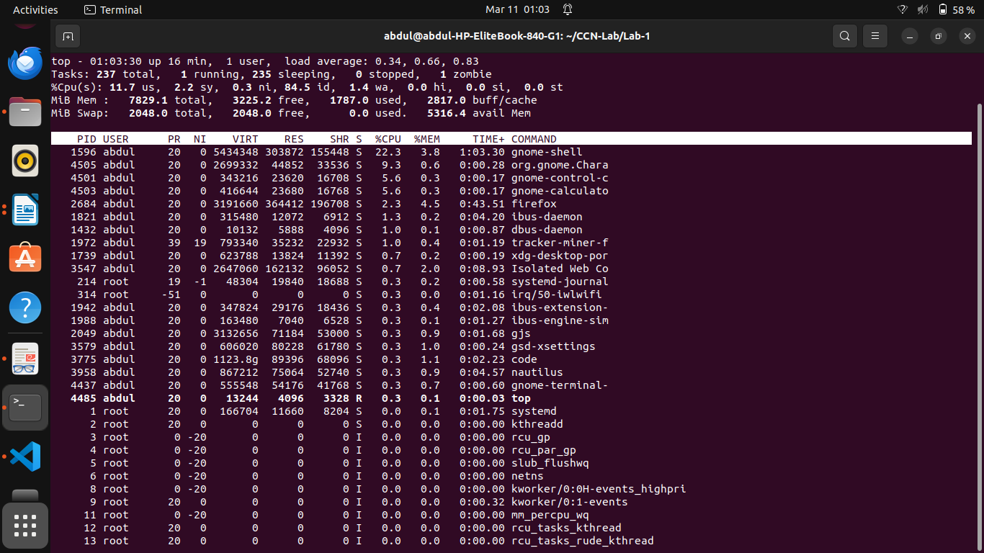

ps

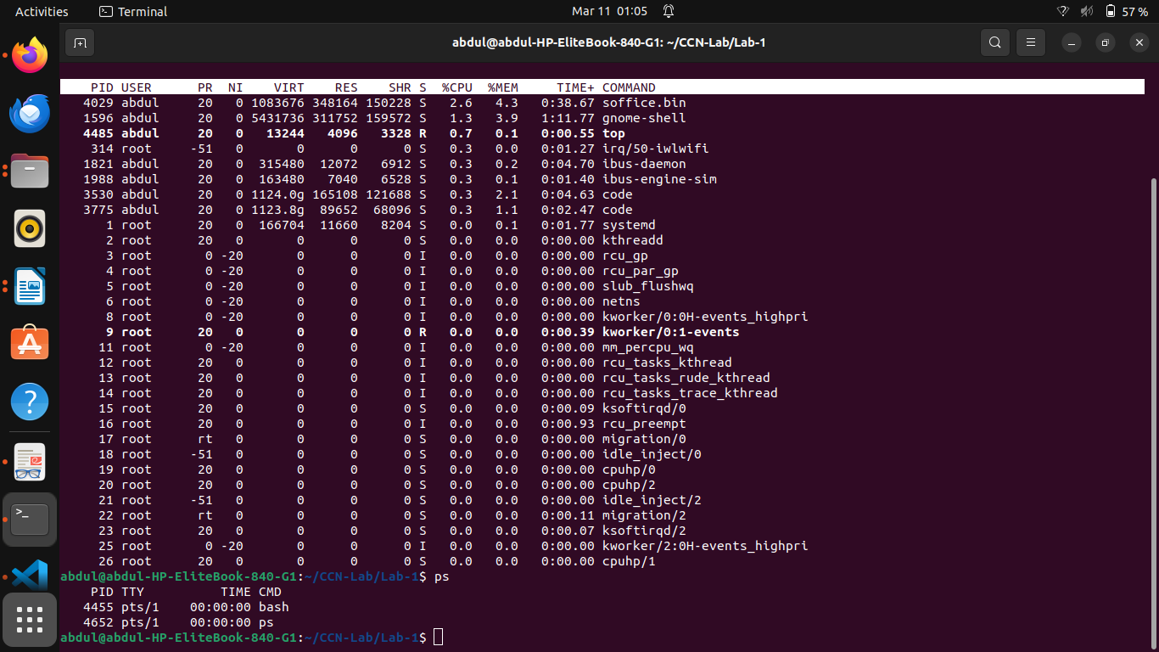
Kill -SIGKILL pid
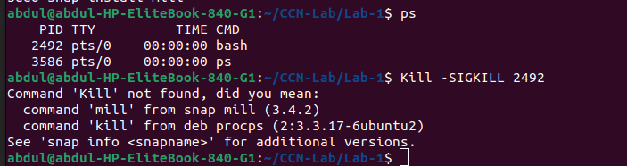
chomd
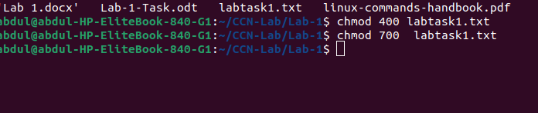

ifconfig
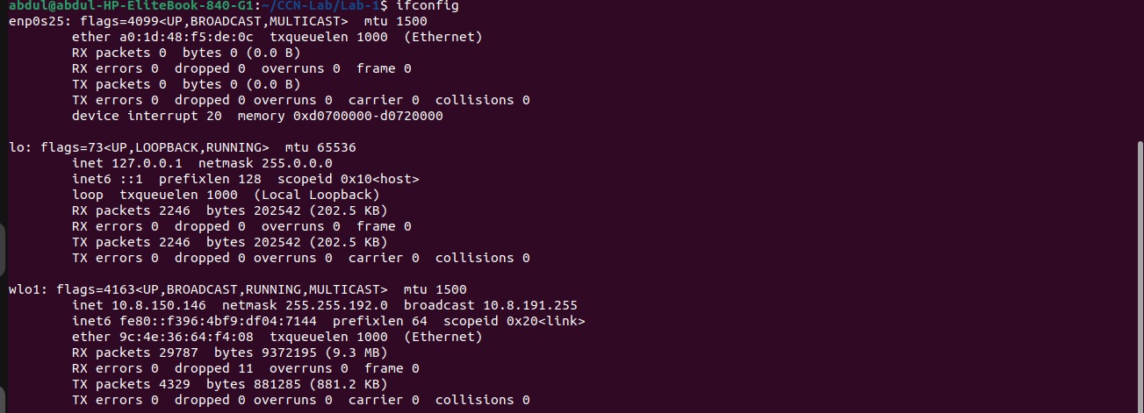

traceroute
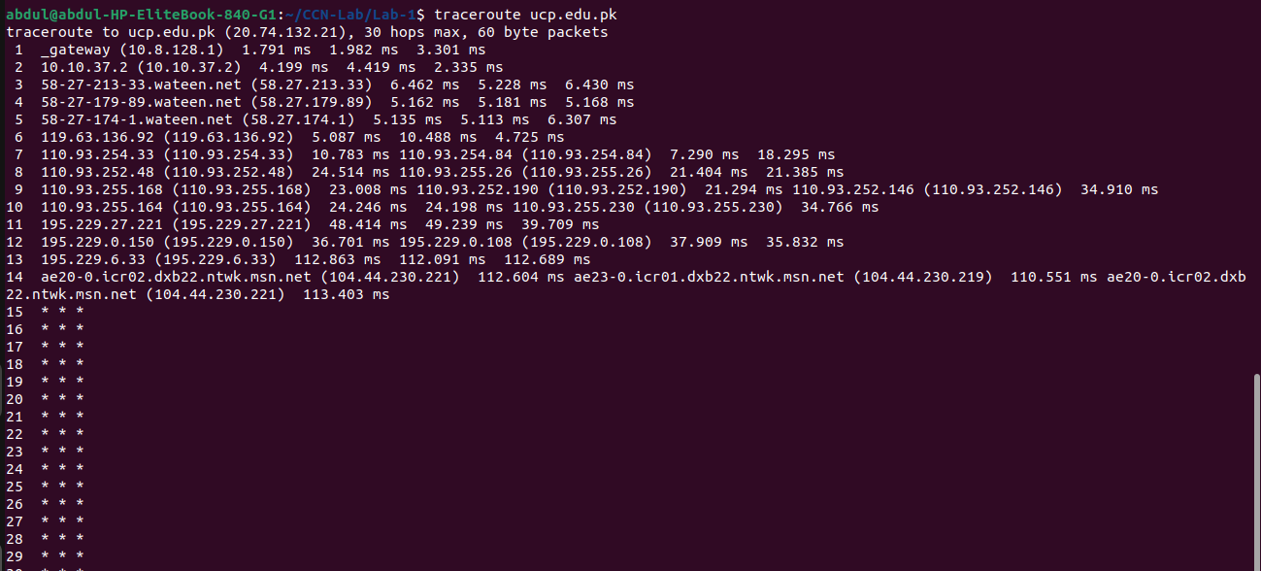

ping
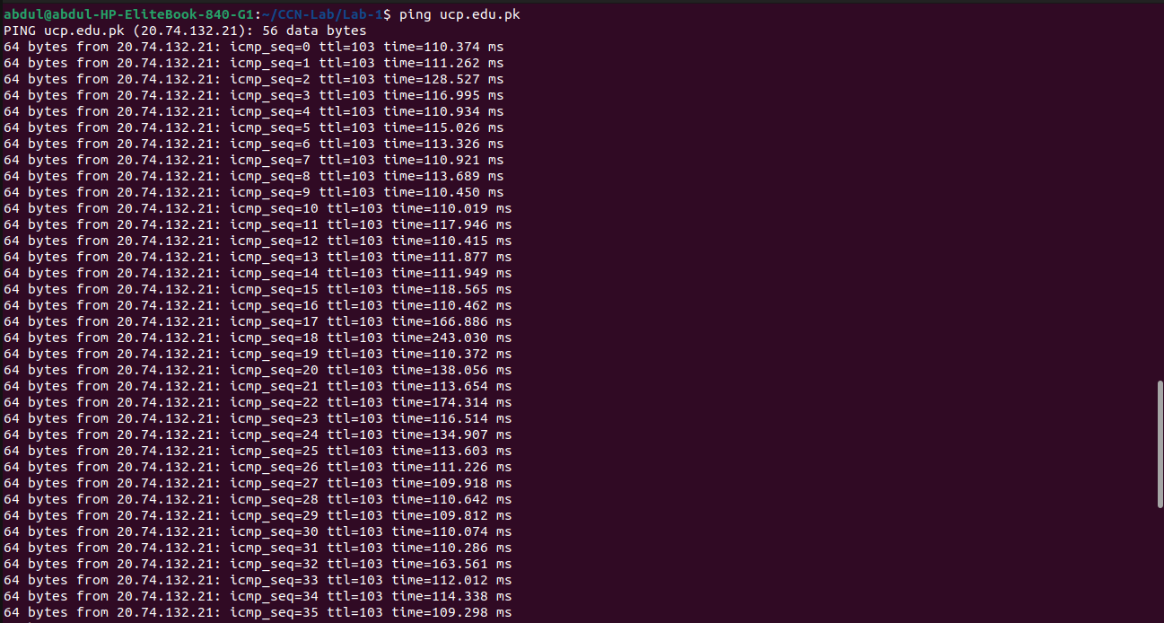

- Write a C program to find the host byte order (little endian or big endian) of your machine. Your program must output the byte order of your machine along with the data stored in the individual bytes; e.g, you can store a number in hex, as 0x3412, and visualize how data is stored in the memory (either in little or big endian format).

#include <stdio.h>
int main() {
unsigned int num = 0x12345678;
unsigned char *ptr = (unsigned char *)&num;
printf("Number 0x%08x is stored in memory as:\n", num);
if (*ptr == 0x78) {
printf("Little Endian\n");
} else if (*ptr == 0x12) {
printf("Big Endian\n");
} else {
printf("Unknown Endian\n");
}
printf("Byte order: ");
for (int i = 0; i < sizeof(num); i++) {
printf("%02x ", *(ptr + i));
}
printf("\n");
return 0;
}

