Script-Controlled ACL-Restrict Record Access Based on Field Value
Milestone-2: Tables Creation
Creation of Tables
- In the Application Navigator, search for System Definition → Tables.
- Click New and create a custom table with the following details
- Label: Institution Details
- Name: u_institution_details
- Extends for : false`
- Save or Submit the form
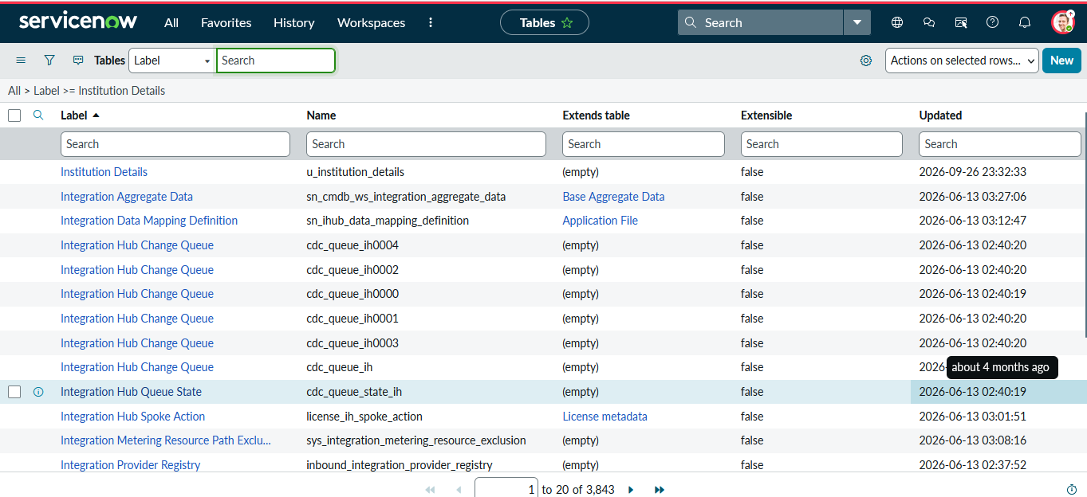

- In the columns tab, user Insert a New row method to create the mentioned fields as shown below picture
- The following fields to the u_institution_details table
- Student Roll Number– Auto Number
- Student Name – Reference- User
- Faculty Name – Reference- User
- Branch – Choice (ECE, EEE, CSE)
- Email– String
- Phone Number– String
- Description– Multi String
- Save the Table
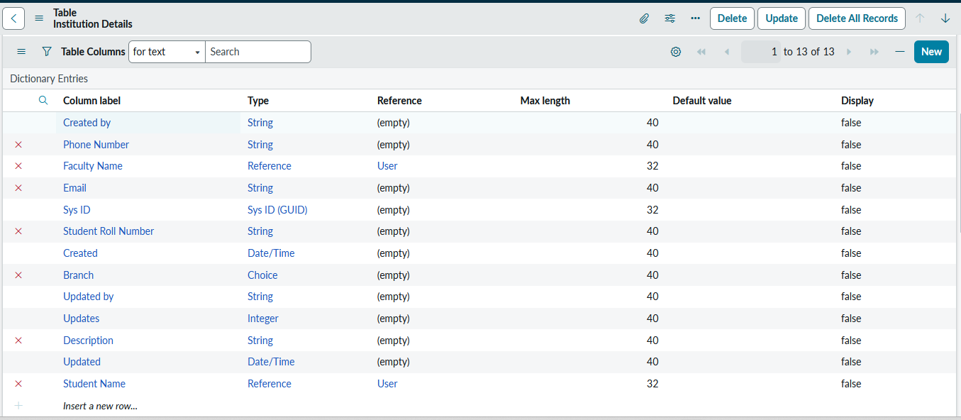
- Click on the Show List in the Related Links
- Create multiple records in the Student Records table with different branch values (ECE, EEE, CSE).

