**Project Name: Simplilearn Project phase2**

**Project Developer: Abraham Joseph Kannampuzha**

**Project detail:**

The project shows user two interfaces for login

1. User
2. Admin

The project handles the flight booking request and also shows the admin a complete Master list of all flight schedules.

**User Window:**

* User can input the detail in Flight_Booking.jsp

1. Source city
2. Destination City
3. Date of journey

* User submits the query and redirected to the Flight_details.jsp.
* There user can Book the flight through clicking on the “Book Now” button.
* User is prompted to the BookFlightAndPayment.jsp. Where the flight details are given by default which cannot be changed.
* User can enter the debit card details.
* The field cannot be left empty, which are validated with JavaScript?

The project contains DBConfig file for leveraging the switching of Database information.

All the files are shown in alphabetically ascending order.

**Github link**:<https://github.com/iamabj1996/airlineBookingPortal.git>

**Technology used:**

* Eclipse
* Java
* Java Server Pages
* JavaScript
* JavaEE Servlets
* MySQL
* Git Bash
* Git Hub

**Core Concepts used:**

* HttpSession
* Servlet
* Java Beans
* Exception Handling
* JDBC
* Javascript validation

**Sprint detail:**

**Sprint 1:**

1. Load index page with two tabs: index.jsp

Let user/admin login through it.

1. Show flight detail Master list to admin.
2. Show Flight_Booking.jsp page with booking window to User.
3. Validate the user input for each choice.

**Sprint 2:**

1. Fetch table from database with the flight details according to user details. Show Flight_Details.jsp
2. Show users Book Now button.
3. “Book Now” redirects the user to BookingPaymentAndDetails.jsp page.
4. The page must show the flight data and the section for user debit card details.
5. User payment details must be validated.
6. User card payment is accepted by dummy payment gateway and redirect to PaymentResult.jsp.
7. Show payment successful with the Debit cardnumber.

**Scrum Burndown chart:**

**Figure 1: Scrum Burn Down Chart**

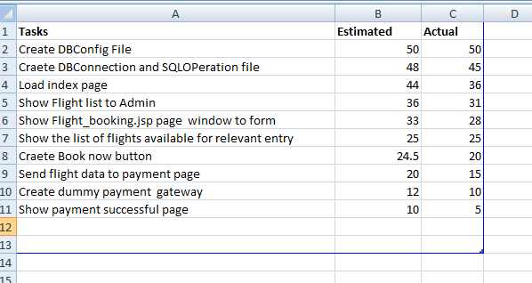

**Conclusion:**

The project can be made more interactive with some engaging design and features for searching the flights with any of the inputs by user on same page. Input text boxes can also be given auto complete feature.