

Department of Computer Science and Engineering
“Web Based Exam Control System”
Course Title: | Information System and Design Lab
Course Code: | CSE(438)
Section: | 182(EA)
Lab Report: | 04
Title of Lab Report: | System implementation for Web Based Exam Control System
Date of Submission:

Submitted by:
Submitted to:

System Implementation for “Web Based Exam Control System”
Systems implementation is the process of defining how the information system should be built (i.e. physical system design), ensuring that the information system is operational and used, ensuring that the information system meets quality standard (i.e. quality assurance). For Implementation of the project we worked for six major activities such as :

Coding and Planning:
In this part we divide whole development process into several parts.
- UI/UX Prototyping using Adobe xD
- UI Design (HTML5,CSS and JavaScript)
- UI Testing
- Database Design
- Backend Programming with PHP
- Integrating the Web App
- Testing
- Debugging
- Production Release
- Installing the web app in the live server.

UI/UX Prototyping using Adobe xD
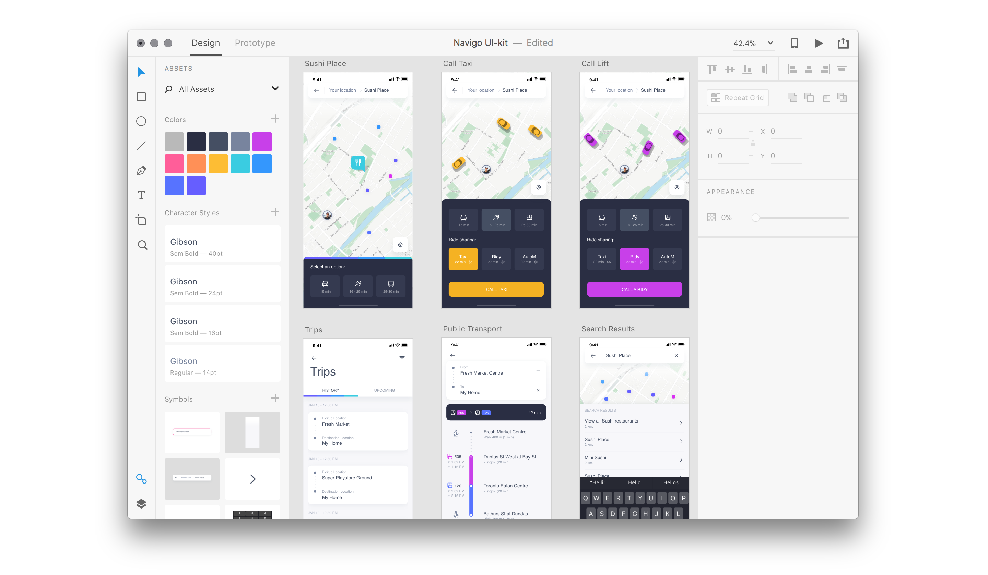This is the first step of our project. We will develop a prototype using most popular UI Prototyping tool “Adobe xD”

UI Design (HTML5,CSS and JavaScript)
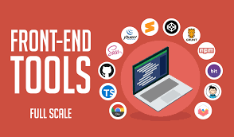

In this step we will write front end code for our UI. Adobe xD files can be converted into dynamic UI using HTML5, CSS and JavaScript.
We will design a user and admin login system. Generated seat plan or Exam quiz maker UI using front end technologies.
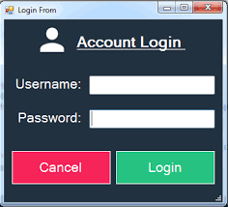

After designing database using Maria db we can connect database, UI and Backend together. PHP is the most popular programming language for backend programming. We will use secure login system for our apps. After completing development process We will use xDebug to check error in our PHP code. Final step is to upload our apps in live server.

Installation
The installation process for software depends on operating system and the programs are installing. The manual, or a README file, usually contains instructions on how to install a program.

Documentation
- System Documentation
To build a system documentation we used detailed information
about a system’s design specifications, its internal working
process, and its all functionality.
- User Documentation
For user documentation we wrote a user manual about this
application system such as how it works, and how to use it,
installation process, its security etc.

Support
Both online and offline we always will support operator team .

