**CC – 215 Database Systems**

***CS Fall 2020***

# LAB – 07

*Hope you are fine and feeling yourself comfortable and exciting to play with Structured Query Language (SQL) in this lab. You have been taught in the lecture about SQL and query writing. Why not to get all what you have learned with a hands-on experience? So, let’s Start!*

**The objective of this lab is to:**

1. DDL
2. DML
3. Views

**Course & Lab Instructor:** Sir Asif Sohail

|  |
| --- |
| Instructions: • Gossips are not allowed. So be gentle and do what you know. The lab is not to deduct your sessional marks but to prepare you to achieve good marks in quizzes, mids and finals and finally have good grades. So, try to perform all your tasks in time and at your own.   * Teacher assistants are for your help, so be nice with them. Respect them as they are teaching you. Raise your hands if you have some problem and need help from TA. * Avoid calling them by raising your voice and disturbing the environment of Lab. * You must revise the content of the past lectures before starting the lab, it will help you resolve most of your general queries and give you the confidence that you can do it. * Evaluation will be considered final and you cannot debate for the marks. So, focus on performing the tasks when the time is given to you. * TA may deduct your marks for any kind of ill-discipline or misconduct from your side. * Evaluation of tasks will be conducted in lab. * Anyone caught being indulged in the act of plagiarism would be awarded an “F” grade in lab. * Finally, pray before you start. And, Best of Luck! * **Max Time: 120 mins.**   • |

# Task 01: [DDL] [04 Marks]

1. Create the following tables for a Sales System. You must give meaningful names to all the constraints.

## *Table Vendor*

### Data Type

***Col Name***

*V_code*

CHAR (10)

*V_name*

VARCHAR2 (15)

*V_addr*

VARCHAR2 (20)

*Table*

***Shipment***

***Col Name***

**Data Type**

**Constraints**

*s_no*

NUMBER (5)

*s_date*

Date

Default sysdate

*p_no*

NUMBER (5)

*V_code*

CHAR (10)

*Qty_delivered*

NUMBER (4)

1. Add primary key constraint on *v_code* in vendor.

**Query: alter table vendor**

**add primary key(V_CODE)**

**output: table altered**

1. Add not null constraint on *v_name* in vendor.

**Query**: **alter table vendor**

**modify v_name varchar2(15) not null**

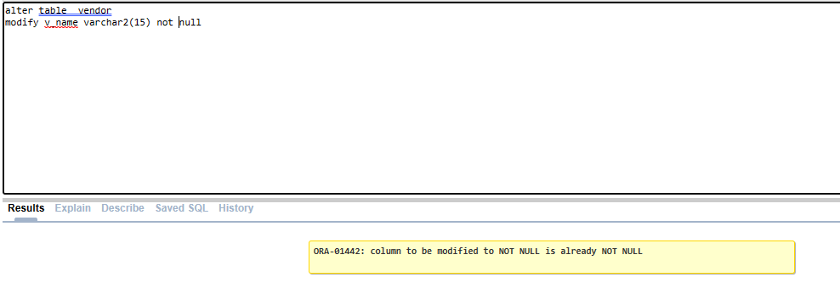

1. Add primary key constraint on *s_no* in shipment.

**Query** **:alter table shipment**

**add primary key(S_NO)**

**output: table altered**

1. Add *p_no* foreign key reference product on shipment.

**Query: alter table shipment**

**add foreign key(P_NO) references product(P_NO)**

**output: table altered**

1. Add *v_code* foreign key reference vendor on shipment.

**Query: alter table shipment**

**add foreign key(V_CODE) references vendor(V_CODE)**

**output: table altered**

1. Unmark your *auto-commit* option in oracle.

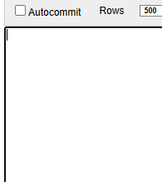

# Task 01: [DML] [16 Marks]

**1.** Insert following data in customer table.

## C_no C_name City Cnic Phone

|  |  |  |  |
| --- | --- | --- | --- |
| **1001** Syed | Karachi | 35202-1234567-8 | 0306-1234567 |
| **1002** Chatha | Hafizabad | 35203-1234567-8 | 0333-1234567 |
| **1003** Sultan | Lahore | 35204-1234567-8 | 0345-1234567 |

**1004** Mughal Lahore 35205-1234567-8 0321-1234567

**Query:**

**insert into customer**

**values(1001, 'Syed' ,'Karachi', '35202-1234567-8' ,'0306-1234567')**

**same for other rows just change values**

**output:**

**row inserted**

1. Validate all the integrity constraints of customer table by attempting to insert a row that violates the integrity constraint.

**Query: Insert into customer values(1001,null, null, '35202-**

**2567881221734',0301-4416475 )**

1. Insert your data in the customer table & View the contents of the customer table and **Commit.**

**Query:**

**My data:**

**Insert into customer values(1005,'Akmal', 'Lahore', '35222-1234567-8','0301-4416475' )**

**Viewing contents:**

**select * from customer**

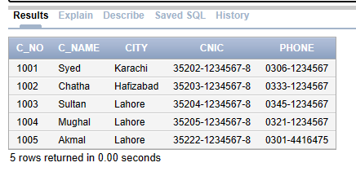

**Commit is also done**

1. Insert following data in tables. (Date format should be same as in table)

## Table Invoice

|  |  |  |  |
| --- | --- | --- | --- |
| **Inv_no** | **Inv_date** | **C_no** | **Payment** |
| **101** | Feb 10, 2003 | 1001 | Cash |
| **102** | Mar 23, 2003 | 1003 | Cash |
| **103** | Jun 12, 2003 | 1001 | Cheque |
| **104** | Sep 20, 2003 | 1004 | Credit Card |
| **Table** | Product |  |  |
| **p_no** | **P_name** | **Cost_price** | **Qty_in_hand** |
| **201** | USB | 600 | 25 |
| **202** | Type-C | 200 | 13 |

**203** Charger 550 18

|  |  |  |  |
| --- | --- | --- | --- |
| **Table** Invoice_details | | | |
| **Inv_no** | **P_no** | **Qty** | **Sale_price** |
| **101** | 201 | 2 | 800 |
| **103** | 203 | 3 | 750 |
| **104** | 202 | 2 | 400 |

## Table Vendor

|  |  |  |
| --- | --- | --- |
| **V_code** | **V_name** | **V_addr** |
| **V-100** | TCS | Lahore |
| **V-101** | Lipord | Karachi |

## Table Shipment

|  |  |  |  |  |
| --- | --- | --- | --- | --- |
| **S_no** | **S_date** | **P_no** | **V_code** | **Qty_delivered** |
| **77** | Feb 11, 2003 | 201 | V-100 | 1 |
| **78** | Mar 24, 2003 | 202 | V-100 | 1 |

**79** Jun 17, 2003 203 V-101 1

1. View content of all tables & COMMIT

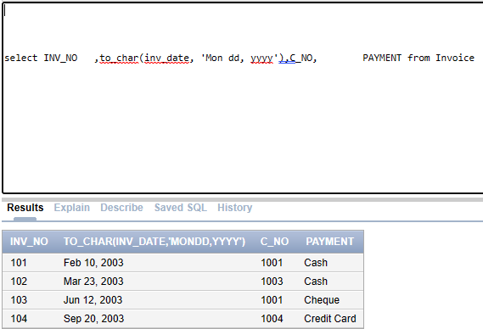

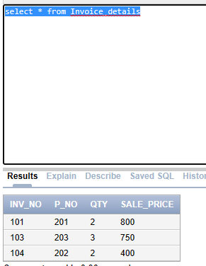

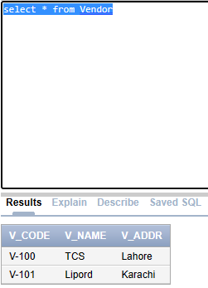

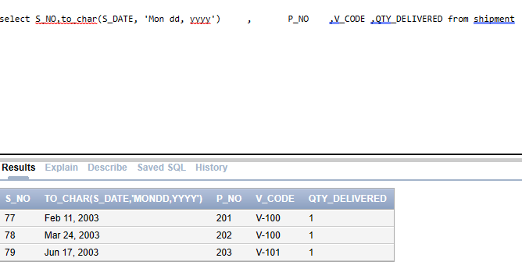

**Commit also done**

1. Delete a row from the shipment table where s_no = 79 & view the contents of the shipment table.

**Query:**

**delete from shipment**

**where s_no = 79**

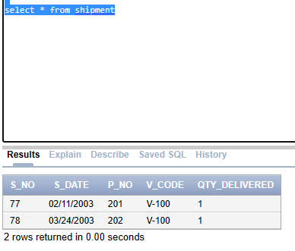

1. **ROLLBACK** & view the contents of the shipment table.

**After rollback:**

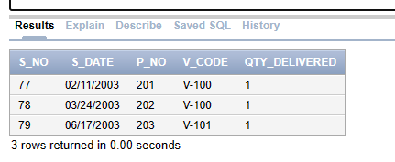

1. Increase the cost price by 25% of the current price and qty in hand by 25 of the current amounts of Type-c in the product table.
2. Set the sale price of Type-c by 25% increment of current price in invoice_details.
3. SAVEPOINT S1
4. Attempt to change phone numbers of customer belongs to Lahore by 0901-0676010
5. Delete a row from the invoice_details table using the primary key of the table & view the contents of the product, customer and invoice_details table.
6. ROLLBACK TO S1
7. Alter the foreign key constraint on prod# in the invoice_details table and set it to cascaded deletion.
8. Check the response when an attempt is made to delete a row from the product table that has matching rows in the invoice_details table.

# Task 01: [Views] [05 Marks]

1. Create a view sales_invoice consisting of c_no, c_name, inv_no, inv_date, p_no, p_name, cost_price, invoice_details.qty, and total. (total = cost_price* invoice_details.qty).
2. Write select all query using sales_invoice view.
3. Find the names of the most and the least sold products.
4. List all the shipments made by a certain vendor.
5. Create a view All_stock_view consisting of sum of all qty_in_hand as sum_qty_purchased, sum of invoice_details.qty as sum_qty_sold, and stock (=sum_qty_purchased - sum_qty_sold) Submission Link (MOR):<https://forms.gle/i7JdrxkGgzE97fSa6>Submission Link (AFT):<https://forms.gle/UzZVrJPauKyUBeQe7>*link will expire on 12:30pm.*