

Bachelor of Computer Applications (BCA) Programme

Project Report

BCA Sem V

AY 2018-19

*<Topic Title: iEdit(Image Editing Tool)>*

*by*

|  |  |
| --- | --- |
| Exam No. | Name of Student |
| *104* | Pandey Aadarsh H. |

|  |  |
| --- | --- |
| Project Guide by : | |
| Nidhi Desai |  |

*I N D E X*

|  |  |  |
| --- | --- | --- |
| **Sr. No** | **Description** | **Page No.** |
| 1 | Introduction |  |
|  | 1.1 Abstract |  |
|  | 1.2 Scope & Objective |  |
| 2 | Requirement Analysis |  |
|  | 2.1 Requirement Gathering |  |
|  | 2.2 Requirement Analysis |  |
|  | 2.3 Software Model |  |
|  | 2.4 Technology Details |  |
| 3 | Designing |  |
|  | 3.1 Data Flow Diagram |  |
|  | 3.2 Database Design |  |
|  | 3.3 User Interface |  |
| 4 | Coding |  |
| 5 | Testing |  |
|  | 5.1 Unit Testing |  |
|  | 5.2 Navigation Testing |  |
|  | 5.3 Functional Testing |  |
|  | 5.4 Environment Testing |  |
| 6 | Conclusion |  |
| 7 | Bibliography |  |

**1. Introduction**

iEdit is online image editing tool which help user to edit their images online without downloading and installing any application to their device.

**1.1 Abstract**

iEdit is online image editing tool which help user to edit their images online without downloading and installing any application to their device.

iEdit gives user freedom to save their images on server otherwise just "Edit and Download" images.

iEdit provide following features.

* **Crop/Resize:** Crop and resize your photos easily without any loading time.
* **Apply Effects on Image:**Glorify image by applying different effects on image like changing seturation, greyscale, blur etc...
* **Cliparts:**You can add interesting clipart from our clipart gallery where you can find lot of freely available clipart.
* **Adding Frames**
* **Adding Text**

**1.2 Scope & Objective**

**Scope:**

Scope of this project is for users who want to edit their photos quickly and easily without installing any kind of software to their device.

**Objective:**

1. Provide User Convinet and easy way to edit their photos.
2. Allow user to devorate their images with cool Cliparts and frames.
3. Allow user to add text to their photos.
4. Provide Web based solution for editing photos.
5. Store photos edited by user’s on server for further use.

**2.Requirement Analysis**

**2.1 Requirement Gathering.**

Following Requirements are gathered for Online image editing tool “iEdit”.

1. System should allow user to upload their photo and then edit them.
2. It Should support all popular image formats like jpg,png,bmp etc.
3. It should provide lightweight interface to user so it can save time of user.
4. Website should work with most of web browsers.
5. User should be allowed to do following tasks.
   1. Crop/Resize
   2. Apply Effects on Image
   3. Cliparts
   4. Adding Frames
   5. Adding Text
6. User should be able to save their photos on server for further use.
7. User should have security and privecy for their uploaded photos.

**2.2 Requirement Analysis.**

After Analyzing requirements gathered above We can satisfy all of above requirements.

.

**2.3 Software Model.**

As we have all requirements ready with us and there is no much risk in system so we will follow waterfall model for project development.

Waterfall model consists of 5/6 simple stages which are follow. where 2st stage is completed which is requirement analysis.

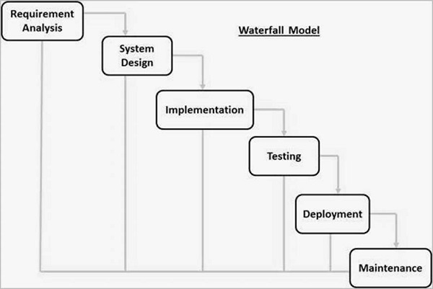

**2.4 Technology Details.**

|  |  |
| --- | --- |
| **Project Title** | iEdit(Online Image Editing Tool) |
| **Project Objective** | Allow user to edit their photos online on web based editor. |
| **Name Of College** | SDJ International College |
| **Front-End Tool** | ASP.NET |
| **Back-End Tool** | Ms Access Database along with ADO.NET |
| **Operating System** | Any Operating System with latest Browser Support.  eg. Chrome, Firefox |
| **Internal Guide** | Nidhi Desai |
| **Submitted By** | Pandey Aadarsh H. |

**3. Designing**

**3.1 Data Flow Diagram.**

**3.1.1 Context Level DFD**

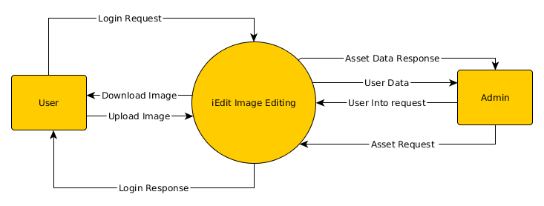

**Context Level Data Flow Diagram for iEdit**

**3.1.2 Level 1 DFD**

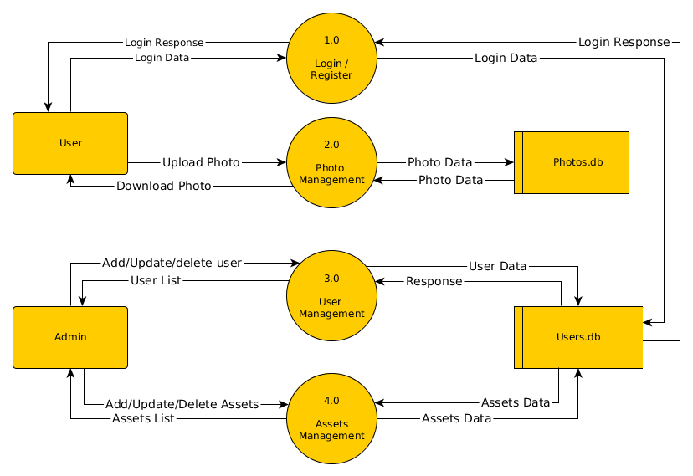

**Level 1 Data Flow Diagram for iEdit**

**3.1.3 Level 2 DFD**

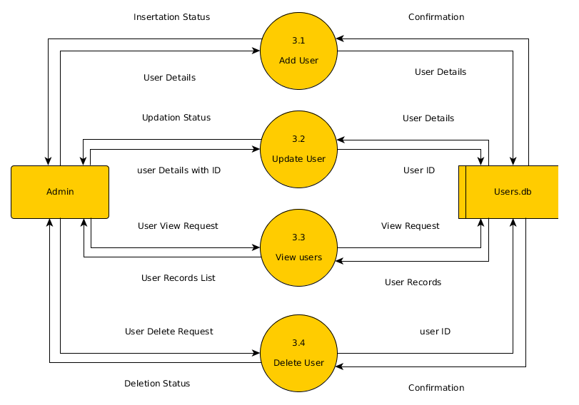

**Level 2 Data Flow Diagram for iEdit (Users)**

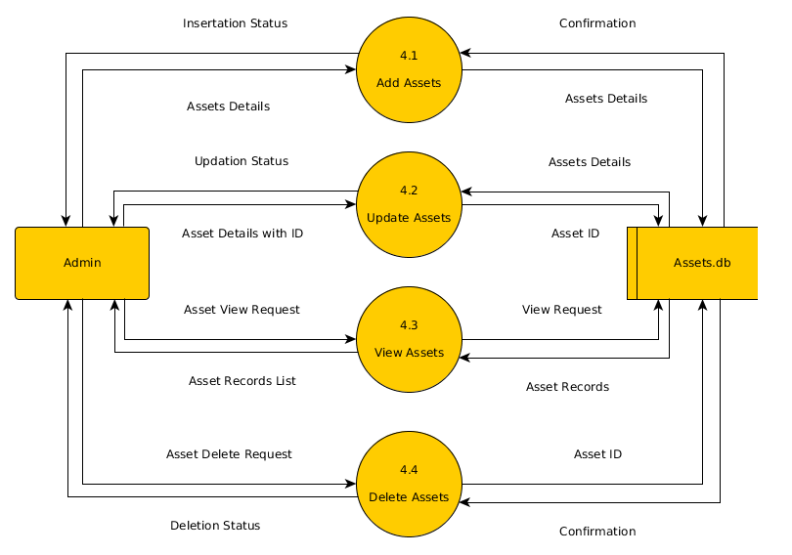

**Level 2 Data Flow Diagram for iEdit (Assets)**

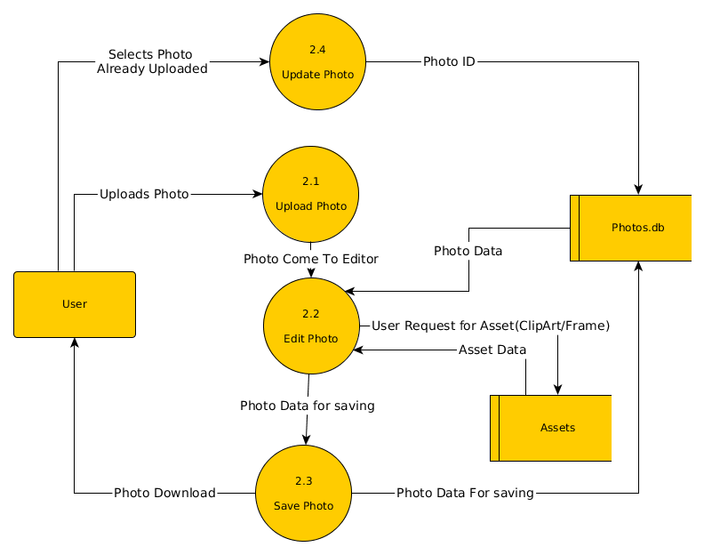

**Level 2 Data Flow Diagram for Accounts++ (Photos)**

**3.2 Database Design**

**Users**

|  |  |  |  |
| --- | --- | --- | --- |
| **Column Name** | **Data Type** | **Description** | **Constraints** |
| Id | Number | Unique ID of Users | Primary Key |
| Name | Text | Full Name of User | - |
| Username | Text | Unique Username for all users | - |
| Email | Text | Email of User | - |
| Password | Text | Password for user Login | - |

**User_Profile**

|  |  |  |  |
| --- | --- | --- | --- |
| **Column Name** | **Data Type** | **Description** | **Constraints** |
| User_id | Number | Reference to User’s Actual Id | Foreign key |
| Gender | Text | Gender of User(Male/Female) | - |
| Dob | Date | Date of Birth of user | - |
| Country | Text | Country of user | - |
| Sate | Text | State of User | - |
| City | Text | City of User | - |

**Assets**

|  |  |  |  |
| --- | --- | --- | --- |
| **Column Name** | **Data Type** | **Description** | **Constraints** |
| Id | Number | Unique ID of Asset | Primary Key |
| Name | Text | Name of Asset | - |
| Type | Text | Asset type (clipart/frame) | - |

**User_Photos**

|  |  |  |  |
| --- | --- | --- | --- |
| **Column Name** | **Data Type** | **Description** | **Constraints** |
| Id | Number | Unique ID of Photo | Primary Key |
| Name | Text | Name of Photos Provided by user | - |
| User_id | Number | Reference to User’s id who created photo | Foreign Key |
| Status | Text | Status of Photo. Active or not | - |
| Path | Text | Path where photo is saved | - |

**3.2 User Interface**

Note: Common CSS and Javascript files are included on later pages.

Library used Bootstrap for styling

Notie Plugin used for notification

**Client Side Interfaces**

Home Page

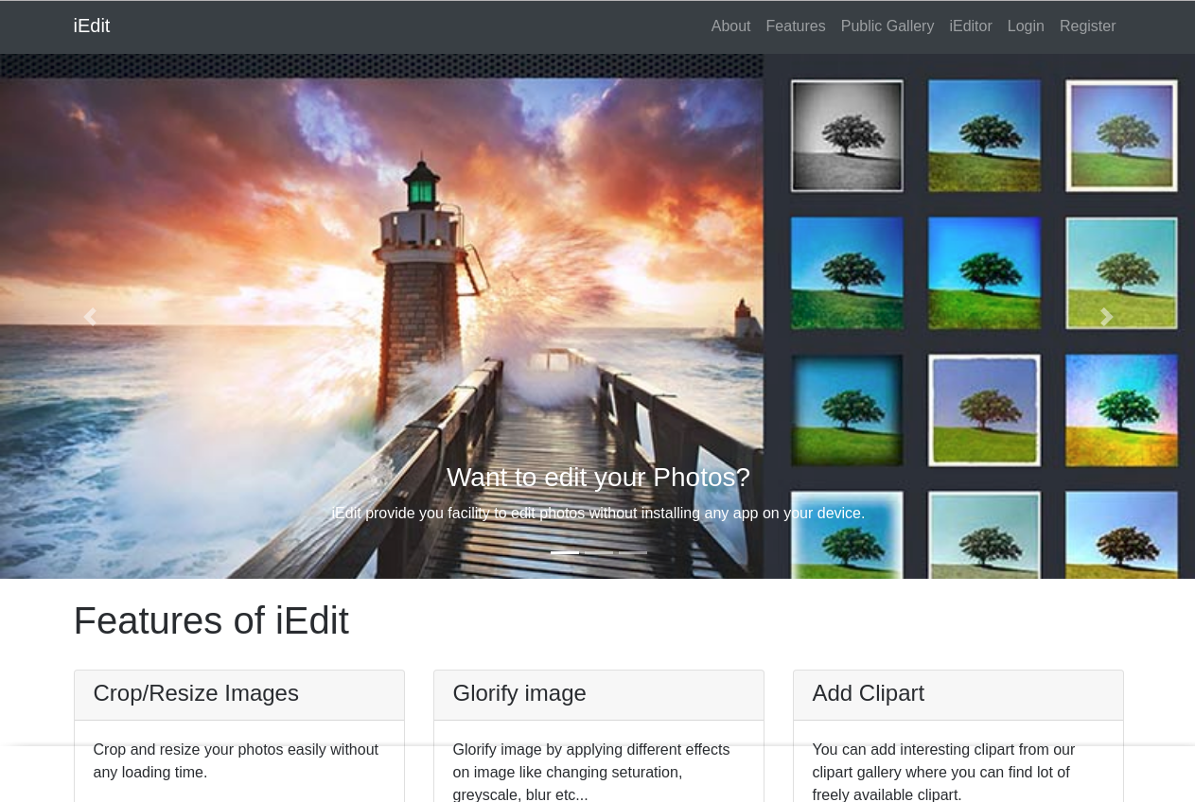

Features Page

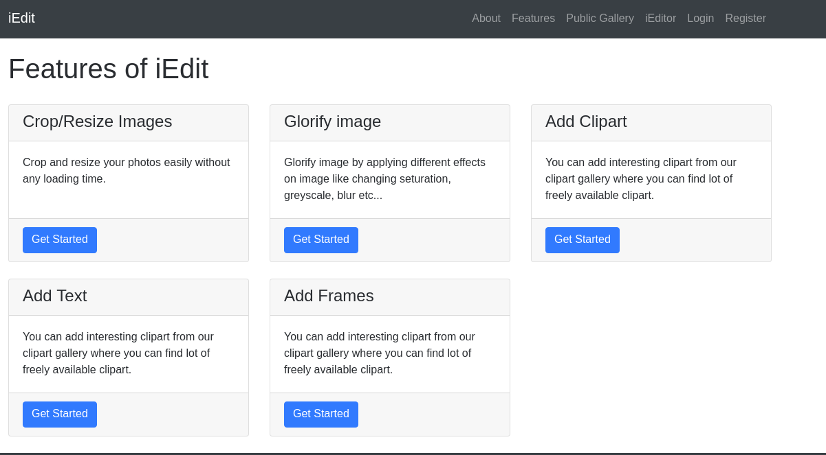

About Page

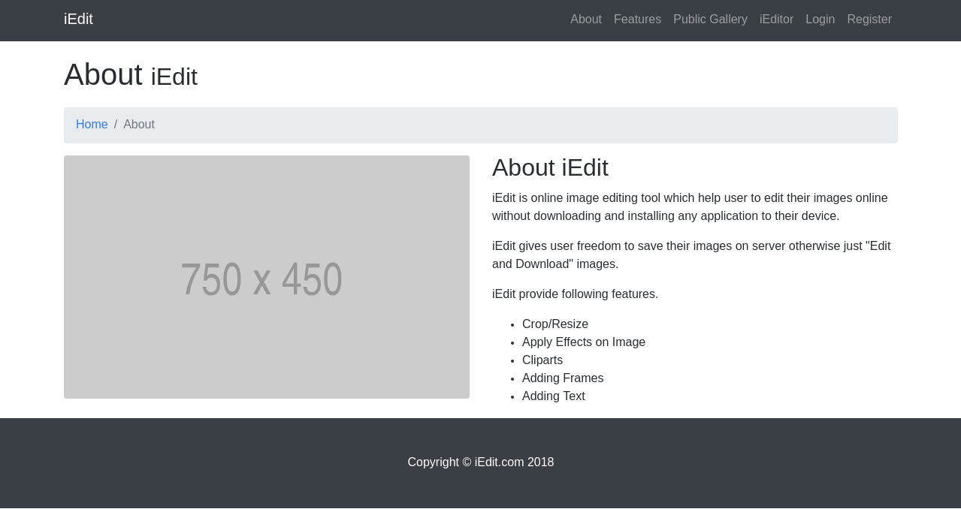

Public Gallery Page

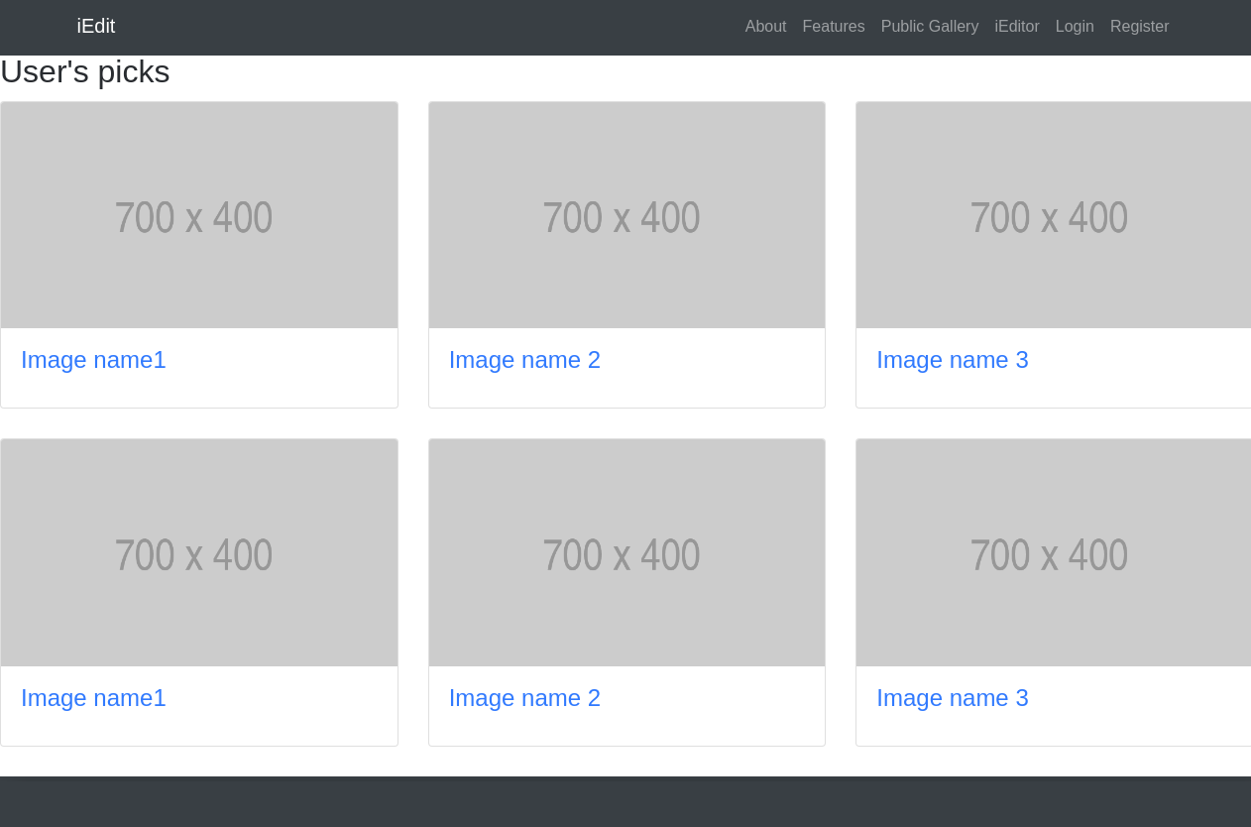

Login Page

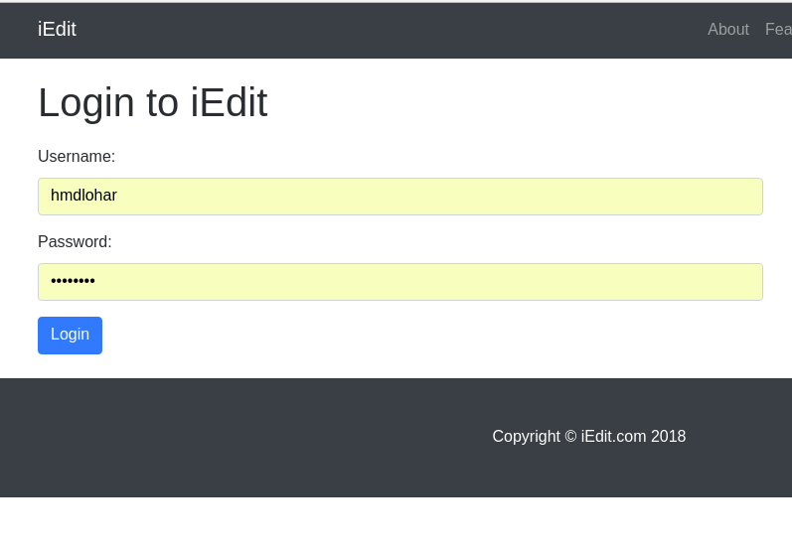

Register Page

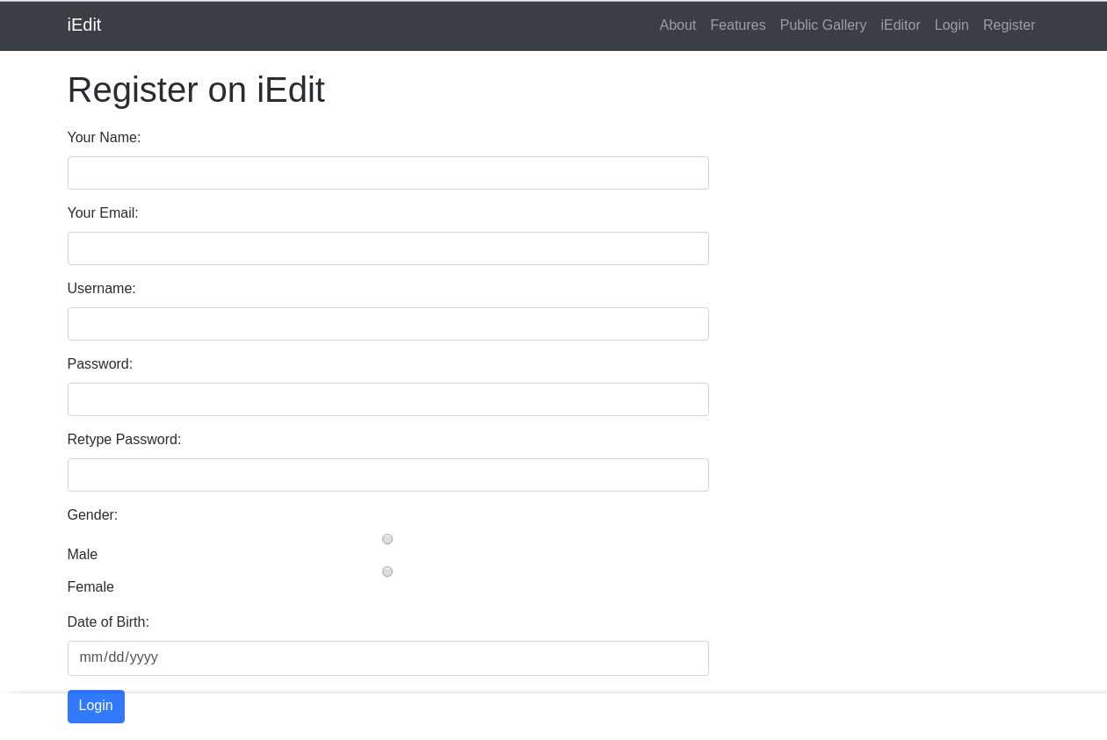

Main Editor

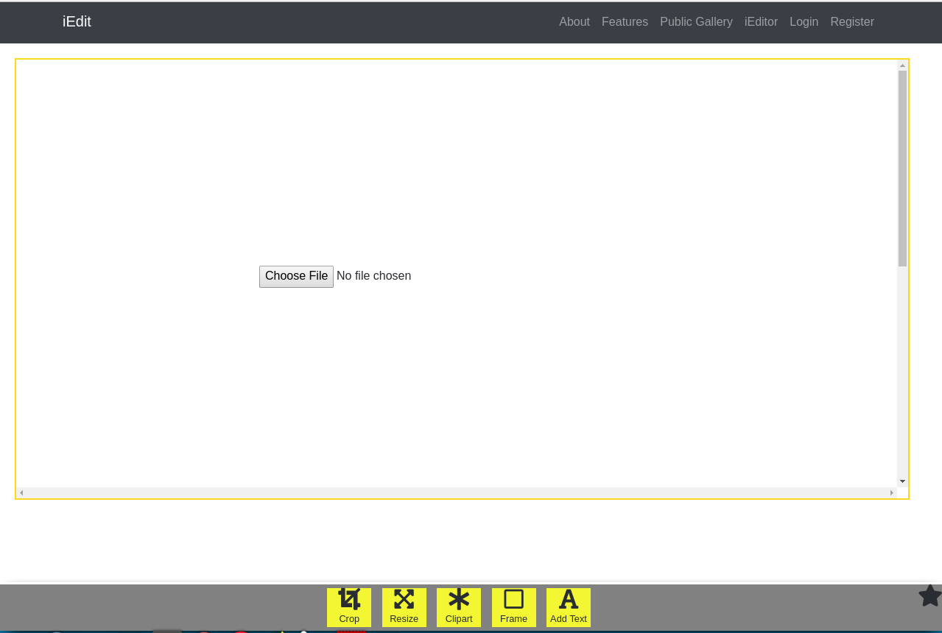

**AdminSide Interfaces**

Users List

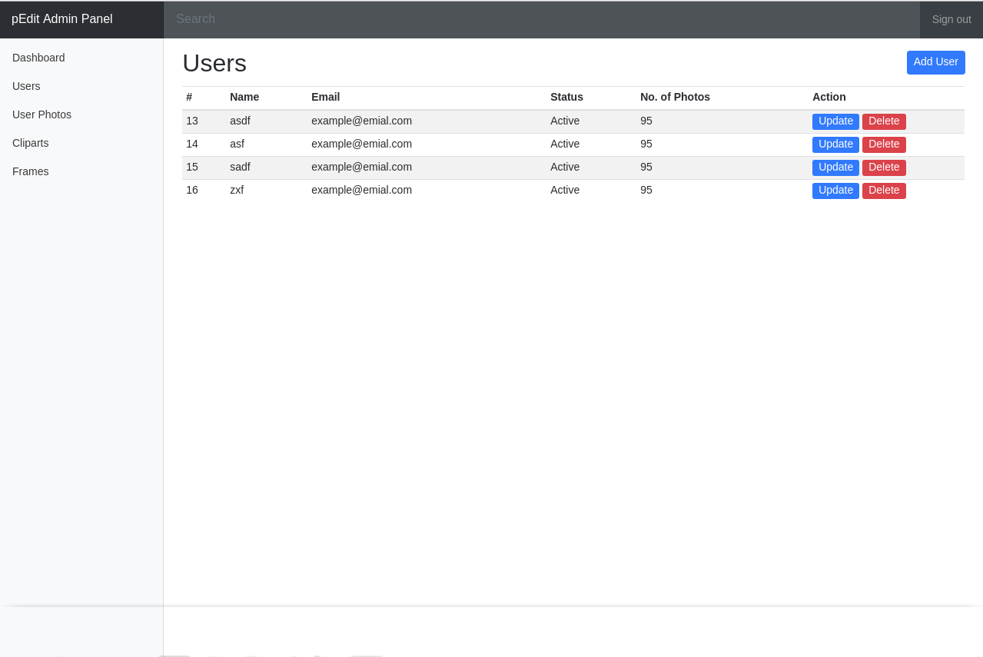

Clipart/Frame List

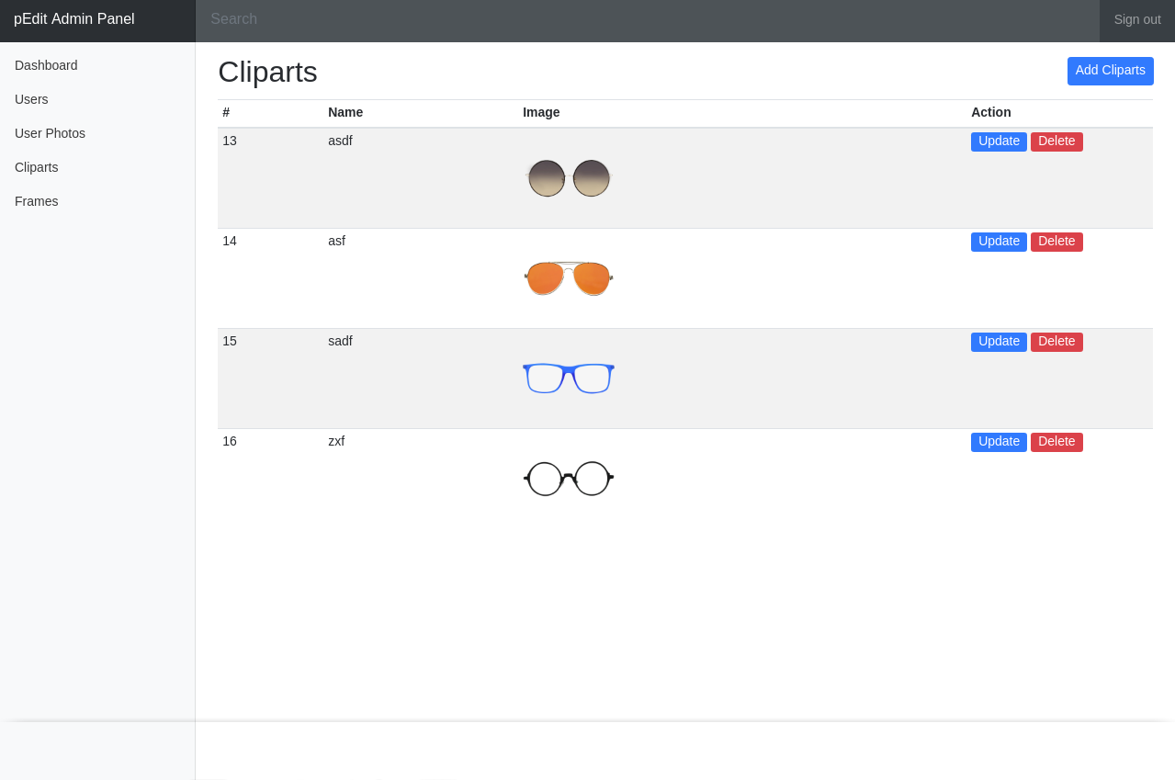

Clipart/Frame Add/Update Page

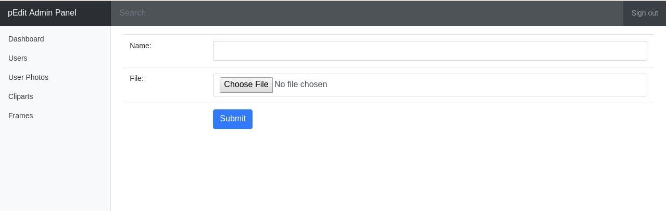

User Photos List Page

