

Bachelor of Computer Applications (BCA) Programme

Project Report

BCA Sem V

AY 2018-19

*Topic Title: iEdit(Image Editing Tool)*

*by*

|  |  |
| --- | --- |
| Exam No. | Name of Student |
| *104* | Pandey Aadarsh H. |

|  |  |
| --- | --- |
| Project Guide by : | |
| Nehal Patel |  |

*I N D E X*

|  |  |  |
| --- | --- | --- |
| **Sr. No** | **Description** | **Page No.** |
| 1 | Introduction |  |
|  | 1.1 Abstract | 3 |
|  | 1.2 Scope & Objective | 3 |
| 2 | Requirement Analysis |  |
|  | 2.1 Requirement Gathering | 4 |
|  | 2.2 Requirement Analysis | 4 |
|  | 2.3 Software Model | 5 |
|  | 2.4 Technology Details | 6 |
| 3 | Designing |  |
|  | 3.1 Database Design | 7 |
|  | 3.2 User Interface & Coding | 9 |

**1. Introduction**

iEdit is online image editing tool which help user to edit their images online without downloading and installing any application to their device.

**1.1 Abstract**

iEdit is online image editing tool which help user to edit their images online without downloading and installing any application to their device.

iEdit gives user freedom to save their images on server otherwise just "Edit and Download" images.

iEdit provide following features.

* **Crop/Resize:** Crop and resize your photos easily without any loading time.
* **Apply Effects on Image:** Glorify image by applying different effects on image like changing seturation, greyscale, blur etc...
* **Cliparts:** You can add interesting clipart from our clipart gallery where you can find lot of freely available clipart.
* **Adding Frames**
* **Adding Text**

**1.2 Scope & Objective**

**Scope:**

Scope of this project is for users who want to edit their photos quickly and easily without installing any kind of software to their device.

**Objective:**

1. Provide User Convinet and easy way to edit their photos.
2. Allow user to devorate their images with cool Cliparts and frames.
3. Allow user to add text to their photos.
4. Provide Web based solution for editing photos.
5. Store photos edited by user’s on server for further use.

**2.Requirement Analysis**

**2.1 Requirement Gathering.**

Following Requirements are gathered for Online image editing tool “iEdit”.

1. System should allow user to upload their photo and then edit them.
2. It Should support all popular image formats like jpg,png,bmp etc.
3. It should provide lightweight interface to user so it can save time of user.
4. Website should work with most of web browsers.
5. User should be allowed to do following tasks.
   1. Crop/Resize
   2. Apply Effects on Image
   3. Cliparts
   4. Adding Frames
   5. Adding Text
6. User should be able to save their photos on server for further use.
7. User should have security and privecy for their uploaded photos.

**2.2 Requirement Analysis.**

After Analyzing requirements gathered above We can satisfy all of above requirements.

.

**2.3 Software Model.**

As we have all requirements ready with us and there is no much risk in system so we will follow waterfall model for project development.

Waterfall model consists of 5/6 simple stages which are follow. where 2st stage is completed which is requirement analysis.

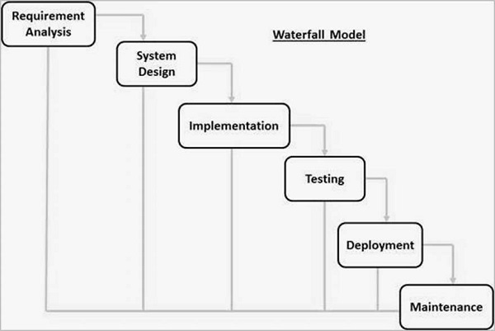

|  |  |
| --- | --- |
| **Project Title** | iEdit(Online Image Editing Tool) |
| **Project Objective** | Allow user to edit their photos online on web based editor. |
| **Name Of College** | SDJ International College |
| **Front-End Tool** | JavaScript,SVG,HTML |
| **Back-End Tool** | PHP with MySql Database |
| **Operating System** | Any Operating System with latest Browser Support.  eg. Chrome, Firefox |
| **Internal Guide** | Nehal Patel |
| **Submitted By** | Pandey Aadarsh H. |

**2.4 Technology Details.**

**3. Designing**

**3.1 Database Design**

**Users**

|  |  |  |  |
| --- | --- | --- | --- |
| **Column Name** | **Data Type** | **Description** | **Constraints** |
| Id | Number | Unique ID of Users | Primary Key |
| Name | Text | Full Name of User | - |
| Username | Text | Unique Username for all users | - |
| Email | Text | Email of User | - |
| Password | Text | Password for user Login | - |

**Assets**

|  |  |  |  |
| --- | --- | --- | --- |
| **Column Name** | **Data Type** | **Description** | **Constraints** |
| Id | Number | Unique ID of Asset | Primary Key |
| Name | Text | Name of Asset | - |
| Type | Text | Asset type (clipart/frame) | - |

**User_Photos**

|  |  |  |  |
| --- | --- | --- | --- |
| **Column Name** | **Data Type** | **Description** | **Constraints** |
| Id | Number | Unique ID of Photo | Primary Key |
| Name | Text | Name of Photos Provided by user | - |
| User_id | Number | Reference to User’s id who created photo | Foreign Key |
| Status | Text | Status of Photo. Active or not | - |
| Path | Text | Path where photo is saved | - |

**3.2 User Interface**

**Client Side Interfaces**

Home Page

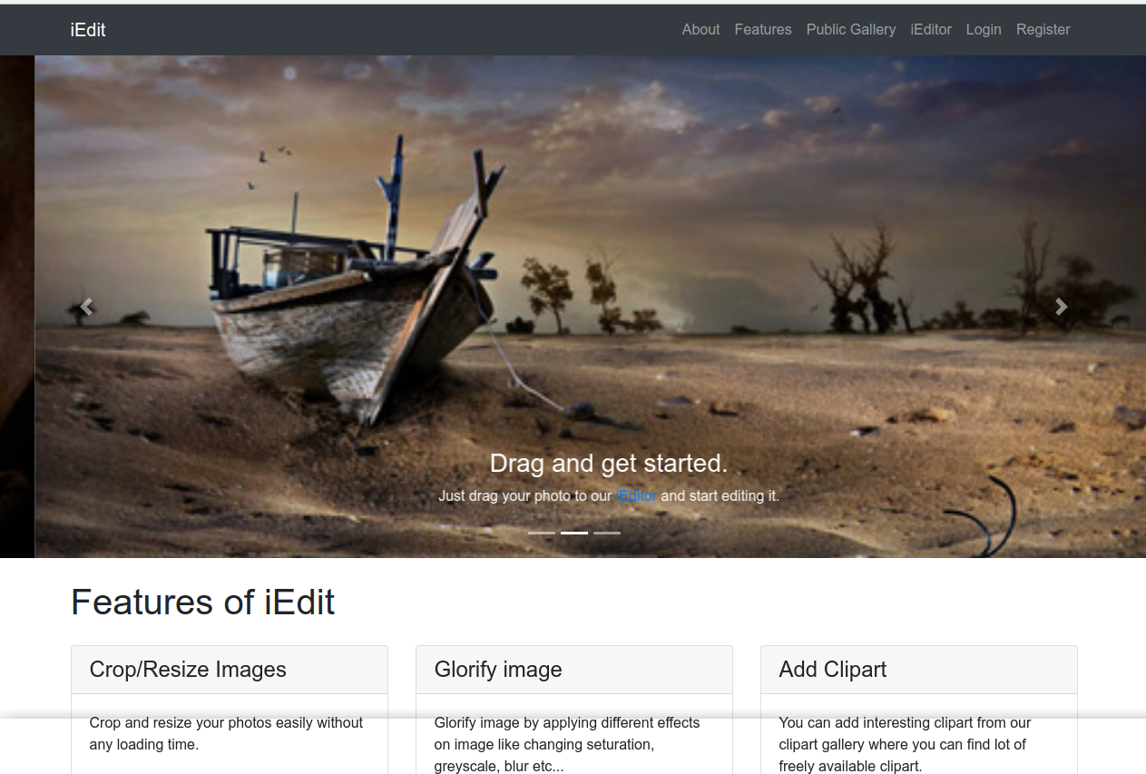

**Description:**

Home page of website shown when user first time visit Website. It contains Menus to navigate through whole website.

Features Page

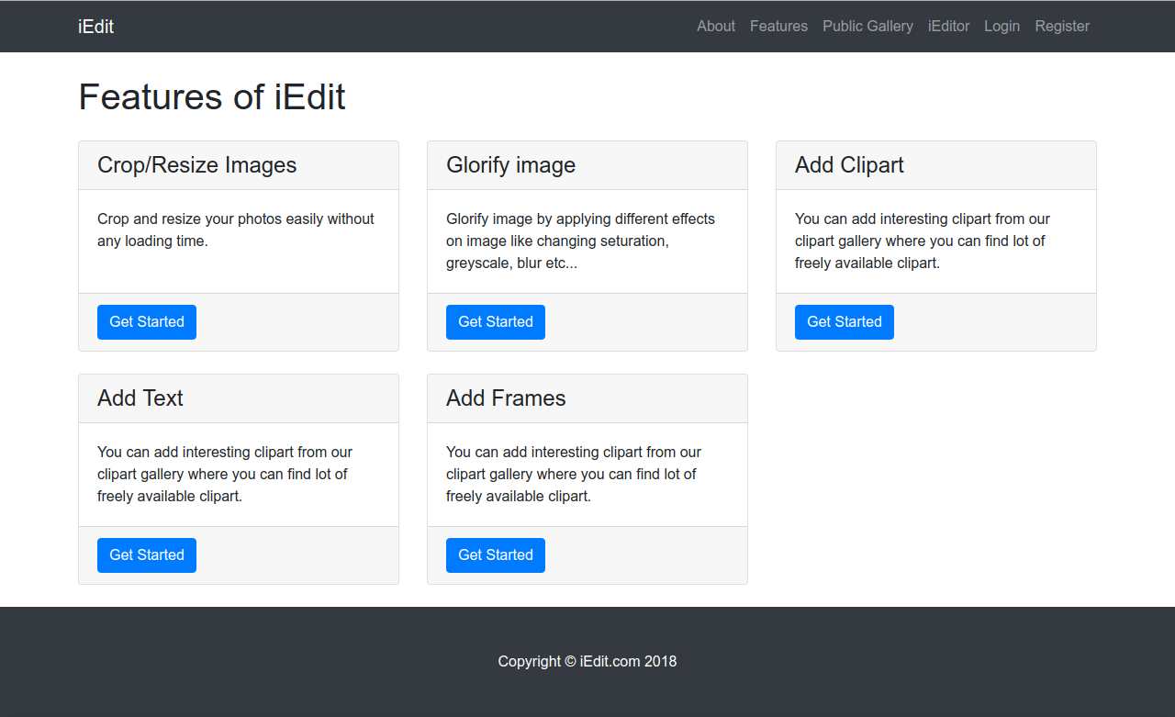

**Description:**

Features page describe all features of website. What kind of function website provides are written in this page.

About Page

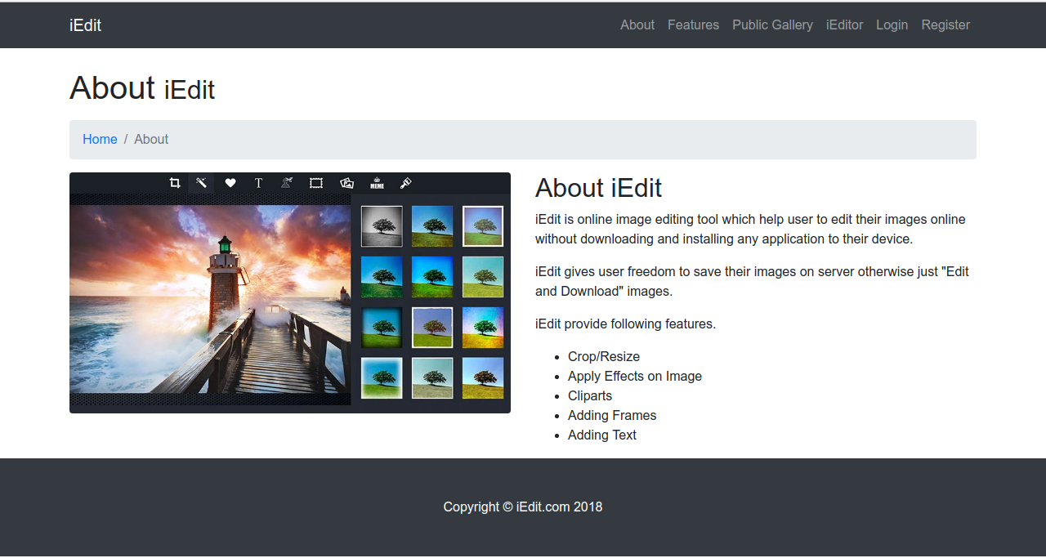

**Description:**

About page gives information about website. It describe motive of having iEdit.

Public Gallery Page

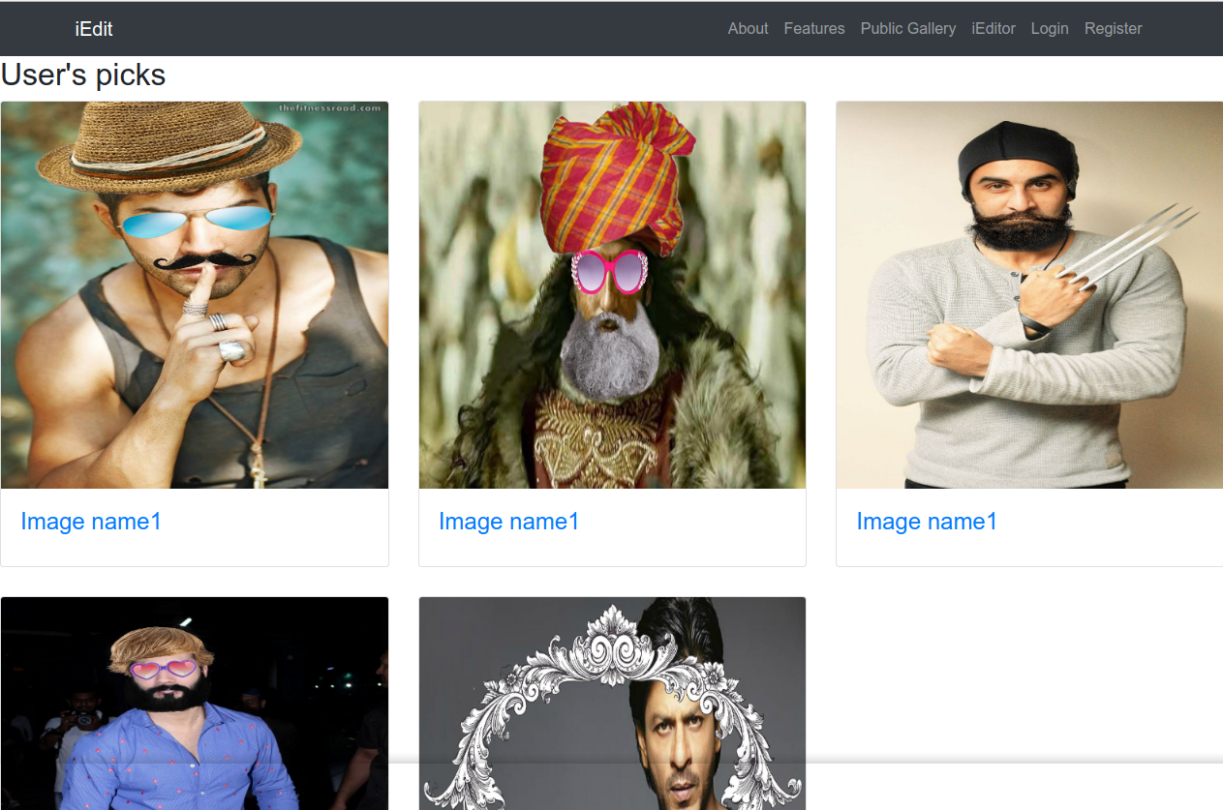

**Description:**

Public gallery shows list of photos edited and then saved by users. It shows list al all photos.

Login Page

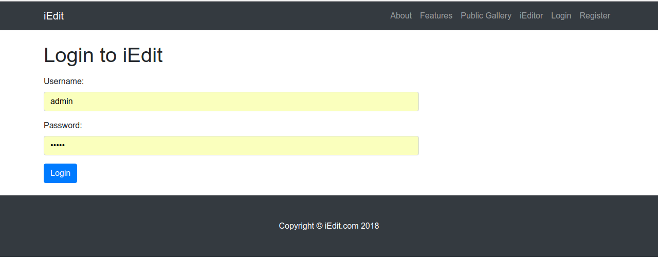

**Description:**

Login form using which user can login to their account.

Register Page

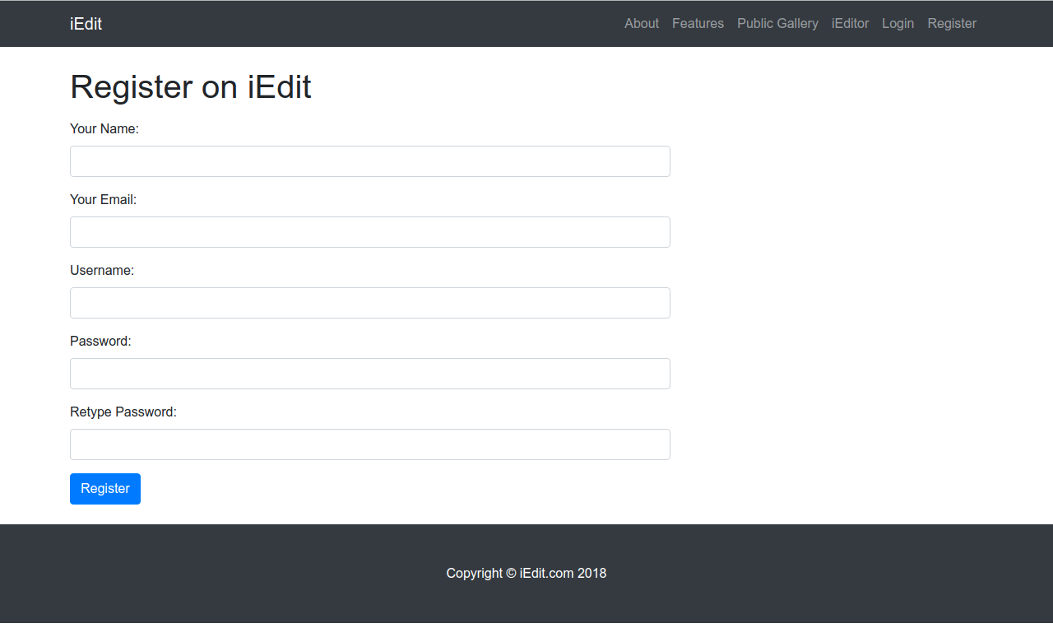

Description : This page is used to Register the Details of the Client who is new to the WebSite.

Main Editor

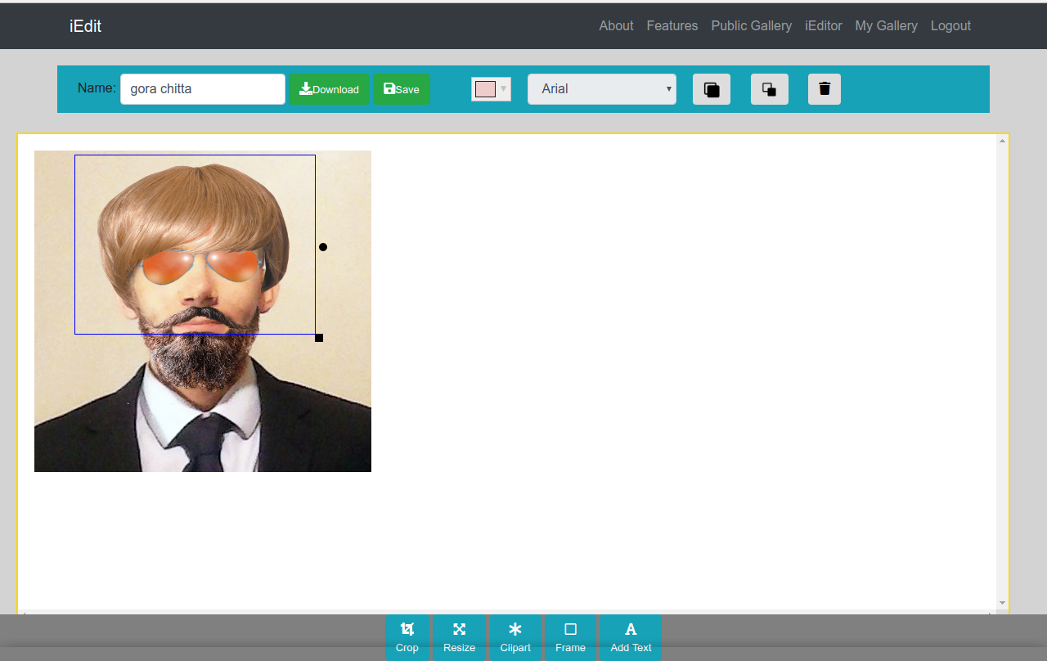

**Description:**

This is Main Editor which is called iEditor. It is core of iEdit website. It provides various function to users. Like user can upload their photo here and then he/she can add text,clipart,frame of resize and crop their photos. After doing this all things user can download their photo from here also.

My Gallery:

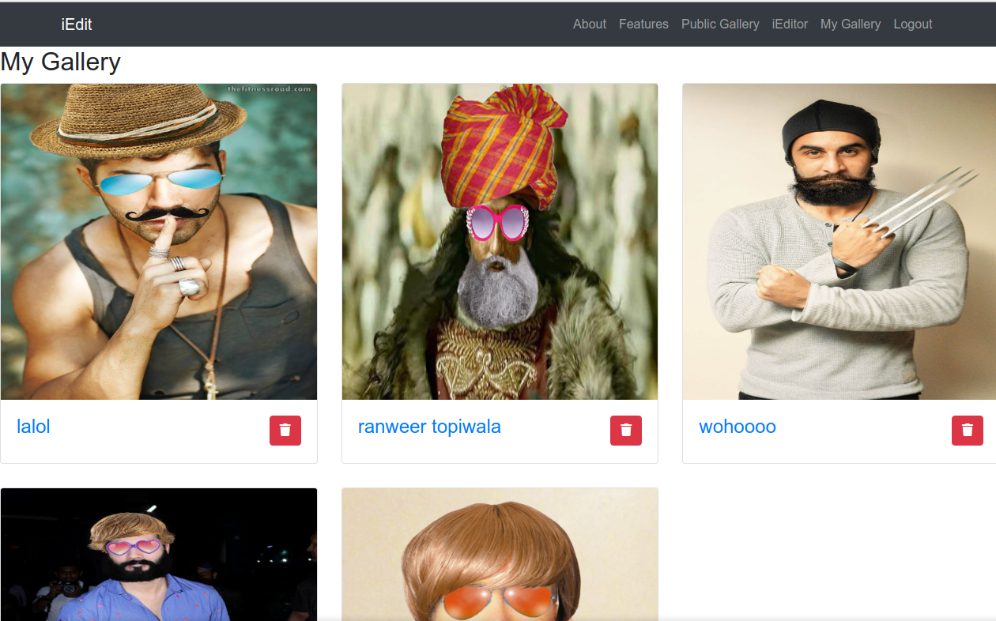

**Description:**

My gallery shows photos edited by user who is loged in. It is user’s gallery.

**AdminSide Interfaces**

Users List

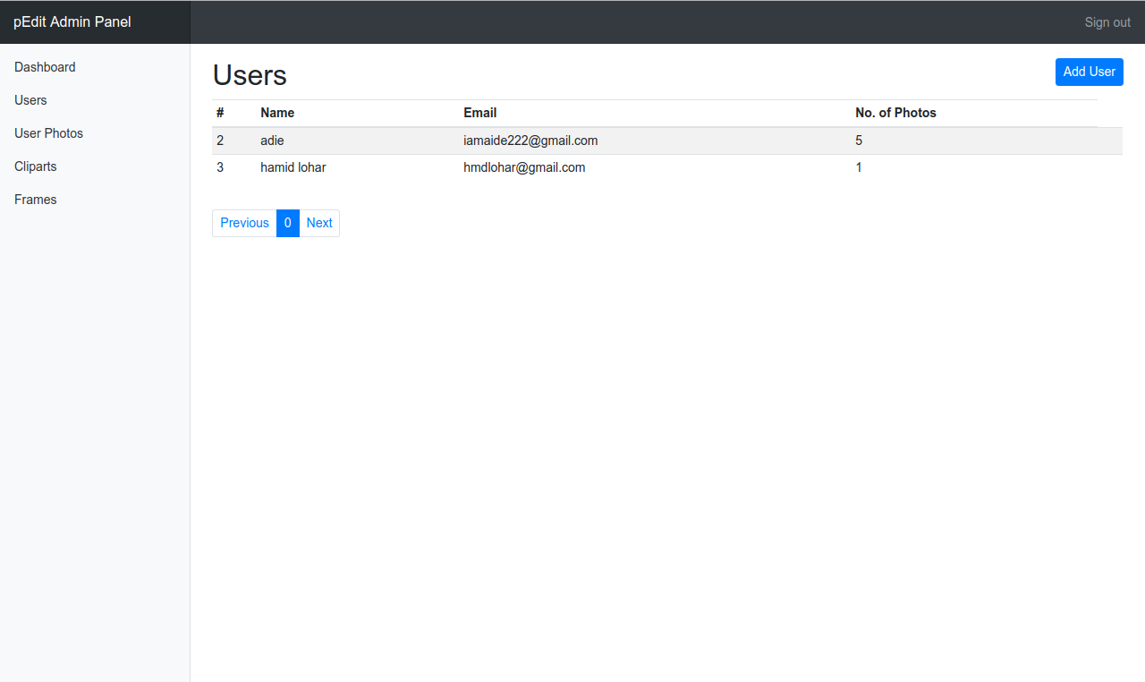

**Description:**

Here admin can see user’s list and can change status of users.

Clipart List

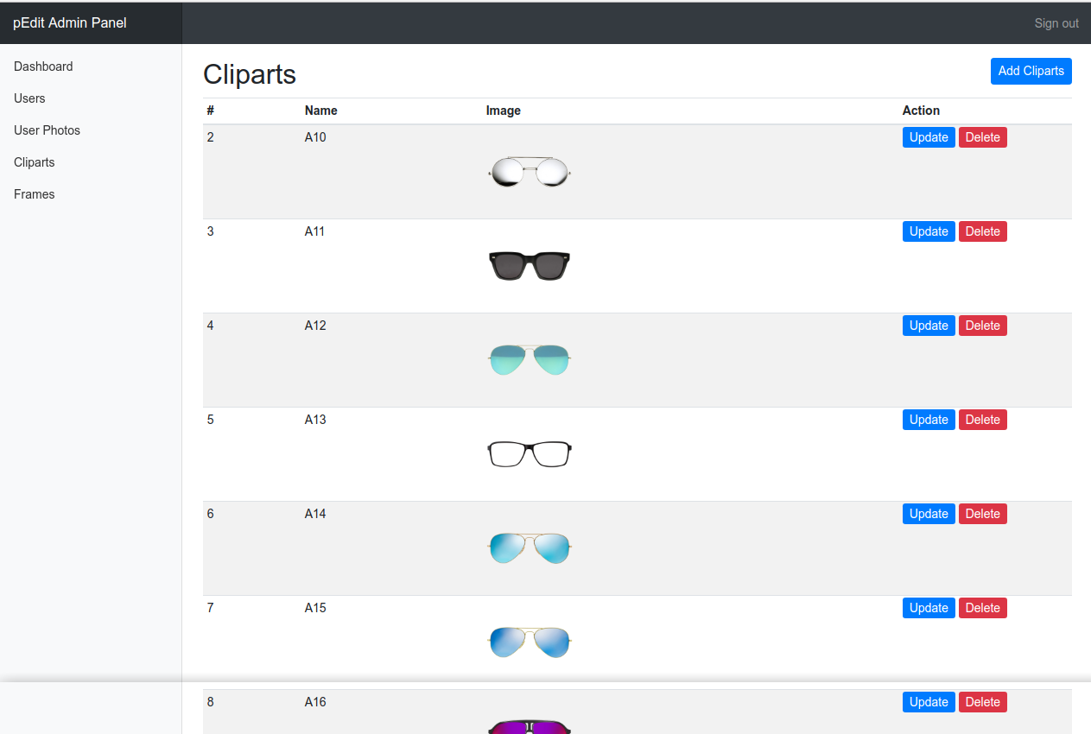

**Description:**

This is clipart management page. Here admin can add, update or delete cliparts easily using advance Ajax interface which provide better experience.

Frames list:

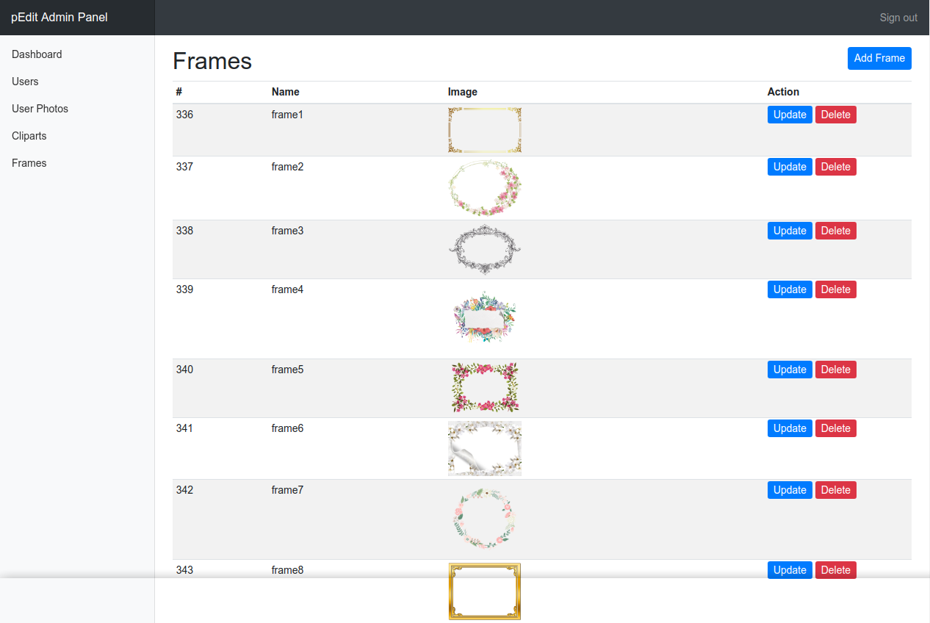

**Description:**

This is Frame management page. Here admin can add, update or delete Frame easily using advance Ajax interface which provide better experience.

User Photos List Page

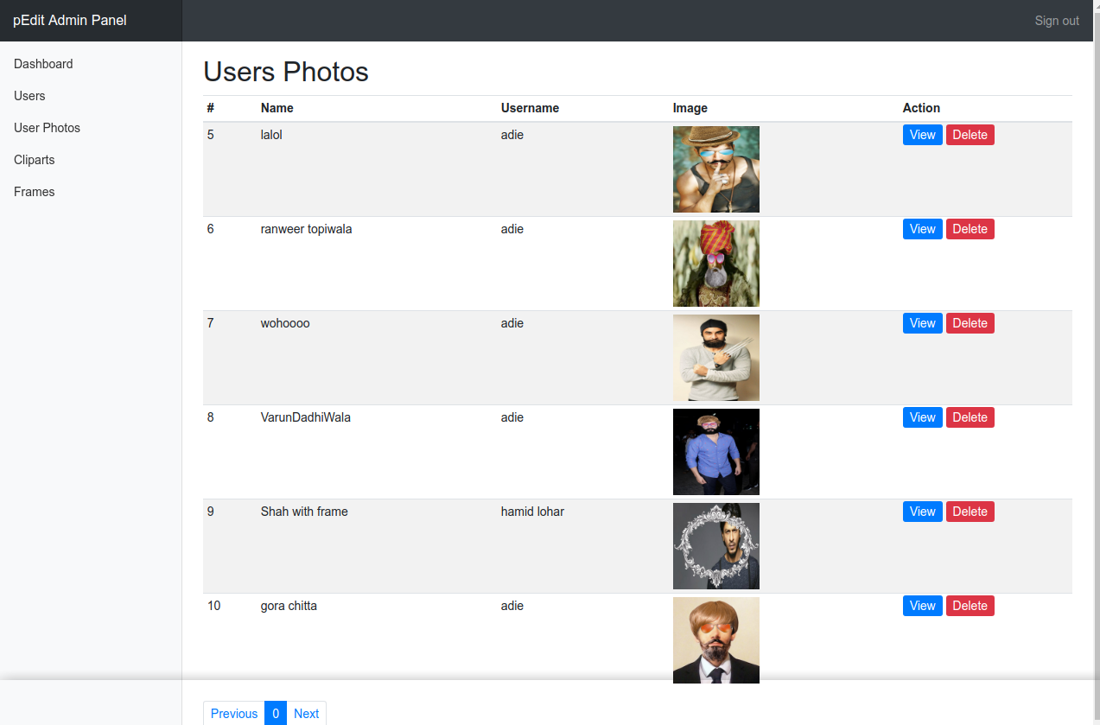

**Description:**

Here admin can view photos edited by user. Admin can also delete their photos from here.