LABOR CONNECT

YUVRAJ SINGH  
CHANDIGARH UNIVERSITY

GHARUAN MOHALI  
20bcs3527@cuchd.in

ADITYA SHARMA  
CHANDIGARH UNIVERSITY  
GHARUAN MOHALI

20bcs3512@cuchd.in

# Introduction

The Work Associate Undertaking is a demonstration of the force of innovation in tending to true difficulties. With the multiplication of cell phones and web network, our venture use the omnipresence of cell phones to give workers a helpful and successful instrument to interface with open positions. At the same time, it enables bosses with an incorporated web administrator page, offering a consistent method for finding and deal with the labor force they need.This venture isn't simply one more application; it's a groundbreaking power in the work market. The Work Interface application and web administrator page work with a dynamic, ongoing work trade, giving exceptional simple entry to occupations for workers and admittance to ability for bosses. Whether you're a talented dealer searching for your next gig or an organization looking for qualified work, Work Interface offers a client driven, instinctive arrangement that streamlines and speeds up the recruiting and work tracking down process organizational editing before formatting. Please note sections A-D below for more information on proofreading, spelling and grammar.

Keep your text and graphic files separate until after the text has been formatted and styled. Do not use hard tabs, and limit use of hard returns to only one return at the end of a paragraph. Do not add any kind of pagination anywhere in the paper. Do not number text heads-the template will do that for you.

2.METHODOLOGY

The research employed a mixed-methods approach, incorporating both quantitative and qualitative techniques to achieve a comprehensive understanding of the research questions. This approach allowed for a triangulation of data, enhancing the robustness and depth of the findings.

Quantitative data was collected through surveys, designed to gather structured information from a large sample of participants. A random sampling method was used to select participants from the target population. The survey included closed-ended questions, which were administered through an online survey platform. Data from the surveys were analyzed using statistical software (e.g., SPSS) to draw quantitative insights.

Qualitative data was collected through semi-structured interviews. Purposive sampling was employed to select key informants with expertise in the subject matter. The interviews were conducted face-to-face and lasted approximately 45 minutes each. Audio recordings and field notes were taken during the interviews. Thematic analysis was used to extract key themes and insights from the qualitative data.

The participants in this study included [specify the characteristics of your study participants, such as demographics, professions, or other relevant attributes]. A total of [number of participants] were involved in the research.

Quantitative data were analyzed using [mention the statistical analysis methods or software used, e.g., descriptive statistics, regression analysis]. The findings were presented through charts, tables, and statistical measures to provide a clear understanding of the quantitative aspects of the research.

Thematic analysis was employed for qualitative data analysis. The recorded interviews were transcribed, and themes and patterns emerged through an iterative process of coding and categorization. These themes were interpreted in the context of the research objectives to derive meaningful insights.

Quantitative and qualitative data were integrated during the interpretation phase to provide a holistic view of the research findings. This integration was conducted by comparing and contrasting the quantitative and qualitative results to gain a deeper understanding of the research questions.

This research adhered to ethical guidelines and obtained informed consent from all participants. Anonymity and confidentiality of participant information were maintained, and ethical review and approval were sought from the [mention the relevant institutional review board or ethical committee].

It is important to acknowledge the limitations of this research. Limitations may include [mention the potential limitations, such as sample size, data collection constraints, or other factors].

3.TECHNOLOGY USED

**The template is designed for, but not limited to, six authors.** A minimum of one author is required for all conference articles. Author names should be listed starting from left to right and then moving down to the next line. This is the author sequence that will be used in future citations and by indexing services. Names should not be listed in columns nor group by affiliation. Please keep your affiliations as succinct as possible (for example, do not differentiate among departments of the same organization).



**HTML** (Hypertext Markup Language): HTML is the standard markup language used to create the structure and content of web pages. It consists of elements and tags that define the layout, headings, paragraphs, links, and multimedia content on a web page. HTML provides the foundation for web content.

**CSS** (Cascading Style Sheets): CSS is a stylesheet language used to control the visual presentation and layout of HTML elements. It allows designers and developers to define styles like fonts, colors, spacing, and positioning to create visually appealing and responsive web designs.

**JavaScript** (JS): JavaScript is a versatile, high-level programming language primarily used for enhancing the interactivity and functionality of web pages. It can manipulate HTML and CSS, create dynamic content, handle user interactions, and connect with web servers to build interactive web applications. JavaScript is essential for creating modern, client-side web experiences.



**Firebase** is a comprehensive mobile and web application development platform provided by Google. It offers various services, including real-time database, authentication, cloud storage, and hosting. Firebase simplifies app development by providing tools for back-end functions, user authentication, and real-time data synchronization, enabling efficient and scalable development and deployment. Positioning Figures and Tables: Place figures and tables at the top and bottom of columns. Avoid placing them in the middle of columns. Large figures and tables may span across both columns. Figure captions should be below the figures; table heads should appear above the tables. Insert figures and tables after they are cited in the text. Use the abbreviation “Fig. 1”, even at the beginning of a sentence.

**The Firebase Realtime Database** is a cloud-hosted NoSQL database that lets you store and sync data between your users in realtime. It is a flexible database that can be used to store a wide variety of data, such as user profiles, product catalogs, and chat messages.

The Realtime Database is well-suited for building collaborative applications, such as chat apps, to-do list apps, and social media apps. It is also a good choice for building applications that need to be responsive to changes in data, such as real-time dashboards and stock trading apps.

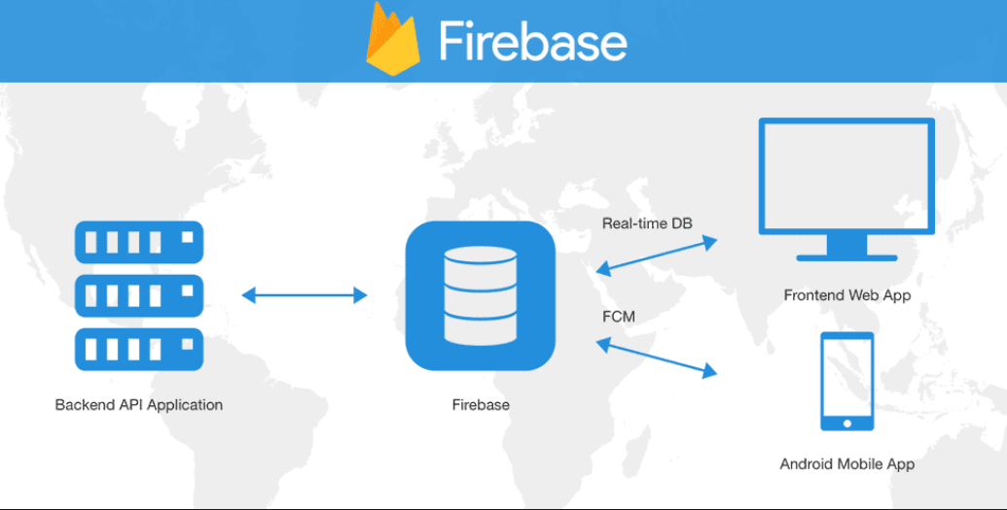

Here are some of the key features of the Firebase Realtime Database:

* Realtime data synchronization: The Realtime Database synchronizes data changes across all connected clients in realtime. This means that users can see changes to data immediately, without having to refresh their page.
* Offline support: The Realtime Database supports offline access, so users can continue to interact with your app even when they don't have an internet connection.

**Firebase Authentication** is a backend service that provides authentication for your Firebase apps. It provides a variety of sign-in methods, including email/password, Google Sign-In, Facebook Login, and Twitter Login. It also provides a number of features that make it easy to manage user accounts, such as password reset, email verification, and account linking.

Firebase Authentication is a good choice for applications that need to provide user authentication, such as social media apps, e-commerce apps, and gaming apps. It is also a good choice for applications that need to be secure, as it provides a number of security features, such as two-factor authentication and CAPTCHAs.

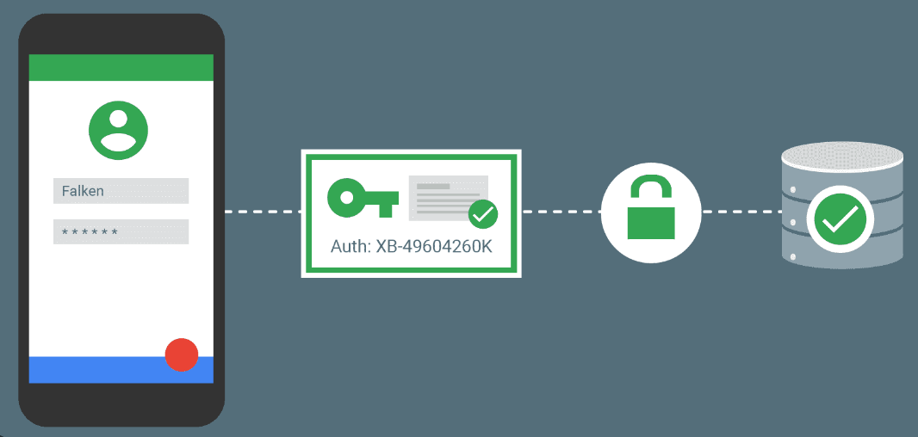

Here are some of the key features of Firebase Authentication:

* Multiple sign-in methods: Firebase Authentication supports a variety of sign-in methods, including email/password, Google Sign-In, Facebook Login, and Twitter Login. This makes it easy for users to sign in to your app using their preferred method.
* Passwordless sign-in: Firebase Authentication supports passwordless sign-in methods, such as phone number authentication and email link authentication. This makes it easy for users to sign in to your app without having to remember a password.



**Android Studio** is a robust integrated development environment (IDE) for Android app development, offering a comprehensive set of tools, including coding, visual design, emulator, and performance profiling features. It streamlines the app development process, enabling developers to create, test, and optimize Android applications efficiently. Android Studio supports various programming languages, offers version control integration, and facilitates API integration, making it a go-to choice for Android app development.



with a ratio of quantities and units. For example, write “Temperature (K)”, not “Temperature/K”.

##### Acknowledgment *(Heading 5)*

The preferred spelling of the word “acknowledgment” in America is without an “e” after the “g”. Avoid the stilted expression “one of us (R. B. G.) thanks ...”. Instead, try “R. B. G. thanks...”. Put sponsor acknowledgments in the unnumbered footnote on the first page.

ACKNOWLEDGMENT

I would like to express my sincere gratitude to the individuals and organizations who contributed to the successful completion of this research project.

First and foremost, I extend my heartfelt appreciation to my academic advisors and mentors [Name(s)] for their unwavering support, invaluable guidance, and expert insights throughout this research journey. Their mentorship was instrumental in shaping the direction and quality of this study.

We am grateful to , which made this research possible. Their generosity in providing the [Scholarship/Grant Name] significantly facilitated the execution of this project. We wish to thank the participants who willingly and enthusiastically took part in this research. Your cooperation and willingness to share your insights and experiences were essential in gathering the data required for this study.I am indebted to my colleagues and friends who provided encouragement and engaged in valuable discussions, enriching the quality of this research.

The facilities and resources provided by Research Gate were indispensable, and I acknowledge their support in making this research endeavor feasible.I want to express my gratitude to my family and friends for their unwavering support, understanding, and patience during the challenging phases of this research.

We extend my thanks to the anonymous reviewers and peers who offered their critical feedback and constructive suggestions, enhancing the quality of this work.

Finally, I acknowledge the broader academic community and researchers whose prior work laid the foundation for this study.

This research would not have been possible without the collective support and contributions of these individuals and institutions. Their involvement has been invaluable, and I am truly appreciative of their role in making this research a reality.

##### References

1. [1] Feldman, S.I., Turetsky, M., Najork, M., Wills, C.E.: Proc. of the International Conference on World Wide Web 2004, pp. 17–20. ACM, New York (2004) J. Clerk Maxwell, A Treatise on Electricity and Magnetism, 3rd ed., vol. 2. Oxford: Clarendon, 1892, pp.68–73.
2. [2] ISO – International Standard Organization, ISO/IEC 12207: Standard for Information Technology – Software Lifecycle Processes (1998) K. Elissa, “Title of paper if known,” unpublished.

.[3] Google Android Developers, Android Develop Guide, http://developer.android.com/guide/topics/fundamentals.html