The Linux Directory Structure
Commands | Description
/ | Root, the top of the file system hierarchy
/bin | Binaries and other executable programs
/etc | System Configuration files
/opt | Optional or third party software
/tmp | Temporary spece, typically cleared on reboot
/usr | User related programs
/var | Variable data, most notably log files.
/media | Used to mount removable media
/export | Shared file system
/mnt | Used to mount external file system
/proc | Provides info about running process
/sys | Used to display and sometimes configure the devices known to the linux kernel
usr/local,  /opt | Applications that are not part of the base OS can be install on these locations

Basic Linux Commands
Commands | Description
ls(ls-l, ls -a,ls -alh) | List directory contents
cd | Changes the current directory
pwd | Display present working directory
cat | Concatenates and display files
tac | Display the content in reverse order
man | Display the online manual of a specified command
echo | Display arguments to the screen
which | Where the location of specified command or where it comes from
Cd - | Previous directory

Directories and Files
Commands | Description
mkdir | To make dir/folder
rmdir | Remove empty dir
rm | Remove a file
touch | To create a file
rm | To remove file
Rm -rf filename | Remove a non-empty dir recursively
ls -F | To check the type of file /(dir), @(link), *(executable)
ls -t | List file w.r.t time
ls -r | In reverse order
ls -latr | Long listing all the file w.r.t time in reverse order
ls -R | List files recursively
tree -d | List directories only
tree -c | Same above but colorized output

Systemd

sudo apt-get update  sudo apt-get install systemd | Installing Systemd on ubuntu
Systemd | systemd is a system and service manager for Linux operating systems.  When run as first process on boot (as PID 1), it acts as init system hat brings up and maintains userspace services.  systemd is usually not invoked directly by the user, but is installed s the /sbin/init symlink and started during early boot.
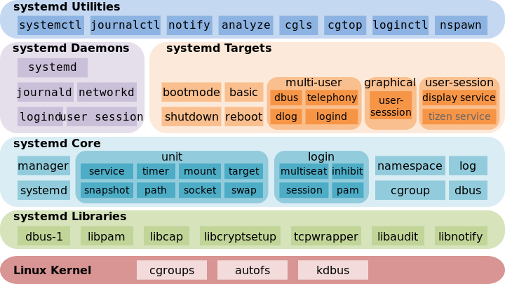
Systemctl start service-name | To start service
Systemctl stop service-name | To stop service
Systemctl status service-name | Check the status of service
Systemctl enable service-name | Enable service to running in bg
Systemctl disable service-name | To disable service
Systemctl restart service-name | To restart the service
Systemctl reload service-name | To reload the service
Systemctl mask/unmask service-name
Sytemctl list-system-files | List all the unit files available on system, both enabled and disables unit files

