### 

### SAVITRIBAI PHULE PUNE UNIVERSITY

**A PROJECT REPORT ON**

**“****3D Modeling of X-Ray Images using Virtual Reality”**

SUBMITTED TOWARDS THE

PARTIAL FULFILLMENT OF THE REQUIREMENTS OF

**BACHELOR OF ENGINEERING (Computer Engineering) BY**

Kevin Sheth B191024346 Kadambari Kate B191024262 Ajay Gaur B191024241

Yash Paliwal B191024299

**Under The Guidance of**

Mrs. Sonal Fatangare



**DEPARTMENT OF COMPUTER ENGINEERING**

**RMD SINHGAD SCHOOL OF ENGINEERING WARJE,**

**PUNE - 411058**



DEPARTMENT OF COMPUTER ENGINEERING

**CERTIFICATE**

This is to certify that the Project Entitled

### 3D Modeling of X-Ray Images using Virtual Reality

Submitted by

Kevin Sheth B191024346 Kadambari Kate B191024262 Ajay Gaur B191024241

Yash Paliwal B191024299

is a bonafide work carried out by Students under the supervision of **Prof. Vina Lomte** and it is submitted towards the partial fulfillment of the requirement of Bachelor of Engineering (Computer Engineering).

Mrs. Sonal Fatangare Prof. Vina Lomte

Internal Guide H.O.D

Dept. of Computer Engg. Dept. of Computer Engg.

Dr. V. V. Dixit Principal RMDSSOE

Signature of Internal Examiner Signature of External Examiner

### PROJECT APPROVAL SHEET

**3D Modeling of X-Ray Images using Virtual Reality**

### (3D Modeling of X-Ray Images using Virtual Reality)

Is successfully completed by

Kevin Sheth B191024346

Kadambari Kate B191024262

Ajay Gaur B191024241

Yash Paliwal B191024299 at

**DEPARTMENT OF COMPUTER ENGINEERING**

(RMD Sinhgad School of Engineering) SAVITRIBAI PHULE PUNE UNIVERSITY, PUNE ACADEMIC YEAR 2022-2023

Mrs. Sonal Fatangare Prof. Vina Lomte

Internal Guide H.O.D

Dept. of Computer Engg. Dept. of Computer Engg.

**Abstract**

Nowadays, advanced medical imaging is a widely accepted scientific discipline in the healthcare industry due to technological advances and software breakthroughs. Traditionally using digital images of X-Ray for diagnosing diseases in healthcare is very common. Many researchers have proposed different methods like X-Ray, CT-scan, and MRI for bone implantation. But the problem is while implantation it does not get the actual size as original, so it causes a bad impact on the health and the person suffers from pain. Therefore, to solve this problem, the proposed system uses a canny edge detection that can sketch the edges of knee bone present in an x-ray image with the size of the bone for implantation by using a virtual reality technique. The system will convert the 2D image to 3D and then the 3D model will be shown in a VR headset. So, we can get a clear visualization of the image. This model provides accurate measurements and detailed visualization of bones in virtual reality with 95.58% accuracy. Virtual reality-based visualization using X-ray images is more effective than CT-Scan in improving radiologists' accuracy and efficiency in diagnosing certain medical conditions, leading to a preference for X-ray images in certain diagnostic scenarios.

**Keywords:** Canny Edge detection, Image Processing, Digital Image, Digital, X-Ray, VR, Knee Arthroplasty, Google Cardboard.

**Acknowledgments**

*It gives us great pleasure in presenting the preliminary project report on* ***“3D Modeling of X-Ray Images using Virtual Reality”****.*

*I would like to take this opportunity to thank my internal guide* ***Mrs. Sonal Fatangare*** *for giving us all the help and guidance we needed. We are really grateful to them for their kind support. Their valuable suggestions were very helpful.*

*I am also grateful to* ***Prof. Vina M. Lomte****, Head of Computer Engineering Department, RMD Sinhgad School of Engineering, for her indispensable support, suggestions. .*

KEVIN SHETH

KADAMBARI KATE

AJAY GAUR

YASH PALIWAL

(B.E. Computer Engg.)

# INDEX

1. Synopsis 1

1.1 Project Title . . . . . . . . . . . . . . . . . . . . . . . . . . . . . . 2

1.2 Project Option . . . . . . . . . . . . . . . . . . . . . . . . . . . . 2

1.3 Internal Guide . . . . . . . . . . . . . . . . . . . . . . . . . . . . . 2

1.4 Technical Keywords (As per ACM Keywords). . . . . . . . . . . . 2

1.5 Problem Statement . . . . . . . . . . . . . . . . . . . . . . . . . . 2

1.6 Abstract . . . . . . . . . . . . . . . . . . . . . . . . . . . . . . . . 3

1.7 Goals and Objectives . . . . . . . . . . . . . . . . . . . . . . . . . 3

* 1. Relevant mathematics associated with the Project . . . . . . . . . . 3
  2. Names of Conferences / Journals where papers can be published . . 3
  3. Review of Conference/Journal Papers supporting Project idea . . . . 4

1.11 Plan of Project Execution . . . . . . . . . . . . . . . . . . . . . . . 4

1. Technical Keywords 5

2.1 Area of Project . . . . . . . . . . . . . . . . . . . . . . . . . . . . 6

2.2 Technical Keywords . . . . . . . . . . . . . . . . . . . . . . . . . . 6

1. Introduction 7

3.1 Project Idea . . . . . . . . . . . . . . . . . . . . . . . . . . . . . . 8

3.2 Motivation of the Project . . . . . . . . . . . . . . . . . . . . . . . 8

3.3 Literature Survey . . . . . . . . . . . . . . . . . . . . . . . . . . . 8

1. Problem Definition and scope 9
   1. Problem Statement 10
      1. Goals and objectives 10
      2. Statement of scope 10
   2. Major Constraints 10
   3. Methodologies of Problem solving and efficiency issues 10
   4. Outcome 10
   5. Applications 11
   6. Hardware Resources Required 11
   7. Software Resources Required 11
2. Project Plan 12
   1. Project Estimates 13
      1. Reconciled Estimates 13
      2. Project Resources 13
   2. Risk Management w.r.t. NP Hard analysis 13
      1. Risk Identification 13
      2. Risk Analysis 14
      3. Overview of Risk Mitigation, Monitoring, Management 15
   3. Project Schedule 15
      1. Project task set 15
      2. Task network 16
      3. Timeline Chart… 16
   4. Team Organization 16
      1. Team structure 16
      2. Management reporting and communication 16
3. Software requirement specification 17
   1. Introduction 18
      1. Purpose and Scope of Document 18
      2. Overview of responsibilities of Developer 18
   2. Usage Scenario 18
      1. User profiles… 18
      2. Use-cases… 18

|  |  |  |  |
| --- | --- | --- | --- |
|  | 6.2.3 | Use Case View . . . . . . . . . . . . . . . . . . . . . . . …………….... | 18 |
| 6.3 | Data | Model and Description ……………………………………….. | 19 |
|  | 6.3.1 | Data Description . . . . ………………. . . . . . . . . . . . . . . . . . . | 19 |
|  | 6.3.2 | Data objects and Relationships . . . . . …………. . . . . . . . . . . | 19 |

* 1. Functional Model and Description 19
     1. Data Flow Diagram 20
     2. Activity Diagram 20
     3. Non Functional Requirements 20
     4. State Diagram… 20
     5. Design Constraints 20
     6. Software Interface Description 20

### Detailed Design Document using Appendix A and B 22

* 1. Introduction 23
  2. Architectural Design 23
  3. Data design (using Appendices A and B) 23
     1. Internal software data structure 23
     2. Global data structure 24
     3. Temporary data structure 24
     4. Database description 24
  4. Component Design 24
     1. Class Diagram 24

### Project Implementation 26

* 1. Introduction 27
  2. Tools and Technologies Used 27
  3. Methodologies/Algorithm Details 27
     1. Haar Cascade Classifier 27
     2. Support Vector Machine(SVM) 27
  4. Verification and Validation for Acceptance 27

### Software Testing 28

* 1. Type of Testing Used 29
  2. Test Cases and Test Results 29

### Results 30

* 1. Screen shots 31
  2. Outputs 31

### Deployment and Maintenance 32

* 1. Installation and un-installation 33
     1. Installing MySQL… 33
     2. Uninstallation… 33
  2. User help 33

### Conclusion and future scope 34

### Annexure A References 36

### Annexure B Project Planner 37

### Annexure C Reviewers Comments of Paper Submitted 38

### Annexure D Plagiarism Report 39

### Annexure E Information of Project Group Members 40

# List of Figures

* 1. Iterative SDLC Model 18
  2. Risk Management w.r.t. NP Hard 19
  3. Use case diagram 29
  4. Entity Relationship Diagram 30
  5. Level 0 Data Flow Diagram 31
  6. Level 1 Data Flow Diagram 31
  7. Level 2 Data Flow Diagram 32
  8. Activity diagram 33
  9. State diagram… 34
  10. Architecture diagram 39
  11. Class Diagram 42
  12. Distinguishing Hyper Plane to Minimize the Error 46
  13. Hyper Plane Specified by the Equation WTx+b 47
  14. Image and Heart rate calculation timings 47
  15. Accuracy Diagram 47
  16. Plagiarism Abstract 65
  17. Plagiarism Literature Survey 66
  18. Plagiarism Introduction 67
  19. Plagiarism Proposed System 68
  20. Plagiarism Conclusion 69
  21. Priyanshu Singh 71
  22. Rajat Dosad 72
  23. Shruti Walunj 73
  24. Rohan Wala 7

# List of Tables

* 1. Risk Table 20
  2. Risk Probability definitions 20
  3. Risk Impact definitions 21

9.1 Test Cases 51

* 1. Output Table 51
  2. Timing Table 51
  3. Accuracy Table 51
  4. Comparative Analysis Table 51

## CHAPTER 1 SYNOPSIS

### PROJECT TITLE

3D Modeling of X-Ray Images using Virtual Reality

### PROJECT OPTION

Not a Sponsored project

### INTERNAL GUIDE

Mrs. Sonal Fatangare

### SPONSORSHIP AND EXTERNAL GUIDE

Sponsored by: NA

External Guide: NA

### TECHNICAL KEYWORDS (AS PER ACM KEYWORDS)

* + 1. Canny Edge Detection
    2. X-Ray
    3. Image Processing
    4. Digital Image
    5. Knee Arthroplasty
    6. Virtual Reality
    7. Google Cardboard

### PROBLEM STATEMENT

To develop 3D framework using Canny Edge Detection and Virtual Reality for medical bone implant.

### ABSTRACT

Nowadays, advanced medical imaging is a widely accepted scientific discipline in the healthcare industry due to technological advances and software breakthroughs. Traditionally using digital images of X-Ray for diagnosing diseases in healthcare is very common. Many researchers have proposed different methods like X-Ray, CT-scan, and MRI for bone implantation. But the problem is while implantation it does not get the actual size as original, so it causes a bad impact on the health and the person suffers from pain. Therefore, to solve this problem, the proposed system uses a canny edge detection that can sketch the edges of knee bone present in an x-ray image with the size of the bone for implantation by using a virtual reality technique. The system will convert the 2D image to 3D and then the 3D model will be shown in a VR headset. So, we can get a clear visualization of the image. This model provides accurate measurements and detailed visualization of bones in virtual reality with 95.58% accuracy. Virtual reality-based visualization using X-ray images is more effective than CT-Scan in improving radiologists' accuracy and efficiency in diagnosing certain medical conditions, leading to a preference for X-ray images in certain diagnostic scenarios.

### GOALS AND OBJECTIVES

The goal of this project is to develop 3D framework using Canny Edge Detection and Virtual Reality for medical bone implant.

**Objectives-**

* + - To study and identify current VR application and Image processing.
    - To create an adaptive 3D virtual environment.
    - To develop a range of interpreting scenarios that can be run in different modes.
    - To get a 3D model build using the unity tool.
    - To create 3D image by use of Canny Edge image processing algorithm with improved accuracy.

### RELEVANT MATHEMATICS ASSOCIATED WITH THE PROJECT

System Description:

* Input: 2D X-Ray image in JPEG.
* Output: 3D model of a bone from 2D X-Ray image.
* Functions:
  + File Upload
  + Canny Edge Detection Algorithm applied
  + Inkscape SVG conversion
  + Blender to convert SVG image to 3D model
  + Unity for Visualization of 3D model
  + Deploying the 3D model .obj file in Google SDK
  + View the 3D model in VR Headset
  + Predict Sentiment
* Success Conditions: Predict Sentiment based on Speech or text
* Failure Conditions: Predicting incorrect Sentiment

### NAMES OF CONFERENCES / JOURNALS WHERE PAPERS CAN BE PUBLISHED

1. International Research Journal of Engineering and Technology (IRJET)
2. International Journal of Creative Research Thoughts (IJCRT)
3. Journal of Emerging Technologies and Innovative Research (JETIR)
4. International Journal for Scientific Research and Development (IJSRD)

### REVIEW OF CONFERENCE/JOURNAL PAPERS SUPPORTING PROJECT IDEA

### ”Speech recognition using HTK toolkit for Marathi language”

**Author:** S. Supriya and S. M. Handore

**Publication:** 2017 IEEE International Conference on Power, Control, Signals and Instrumentation Engineering (ICPCSI).

### ”Applying natural language processing to analyze customer satisfaction”

**Author:** A. Alibasic and T. Popovi

**Publication:** 25th International Conference on Information Technology (IT), 2021

### ”Spontaneous emotion recognition for Marathi Spoken Words”

**Author:** V. V. Kamble, B. P. Gaikwad and D. M. Rana

**Publication:** International Conference on Communication and Signal Processing, 2014

### ”Spontaneous emotion recognition for Marathi Spoken Words”

**Author:** V. V. Kamble, B. P. Gaikwad and D. M. Rana

**Publication:** International Conference on Communication and Signal Processing, 2014

### ”Spontaneous emotion recognition for Marathi Spoken Words”

**Author:** V. V. Kamble, B. P. Gaikwad and D. M. Rana

**Publication:** International Conference on Communication and Signal Processing, 2014

### PLAN OF PROJECT EXECUTION

|  |  |  |
| --- | --- | --- |
| **Schedule** | **Date** | **Project Activity** |
| June | 08/07/2021 | Project Topic Selection |
| 15/07/2021 | Synopsis Submission |
| August | 05/08/2021 | Presentation on Project Ideas |
| 12/08/2021 | Submission of Literature Survey |
| 20/08/2021 | Feasibility Assessment |
| September | 02/09/2021 | Mid Sem Presentation |
| 16/09/2021 | Design of Mathematical Model |
| 23/09/2021 | End Sem Presentation |
| December | 07/12/2021 | Report Preparation and Submission |
| 20/12/2021 | 1st Module Presentation |
| January | 23/01/2022 | Discussion and Implementation of 2nd Module |
| 30/01/2022 | 1st and 2nd Module Presentation |
| February | 06/02/2022 | Discussion on flow of Project |
| 13/02/2022 | Designing new Module |
| 21/02/2022 | Worked on new Module |
| March | 06/03/2022 | Modification of Modules |
| 21/03/2022 | Designed test cases for our Module |
| April | 11/04/2022 | Worked on User Interface |
| 15/04/2022 | Integration of all Modules |

## CHAPTER 2 TECHNICAL KEYWORDS

### AREA OF PROJECT

Image Processing & Virtual Reality

### TECHNICAL KEYWORDS

* + - Sentiment Analysis
    - Speech to text
    - Data Mining
    - Natural Language Processing
    - Feature Extraction
    - Feature Calculation
    - SVM Classifier
    - Sentiment Prediction

## CHAPTER 3 INTRODUCTION

### PROJECT IDEA

Marathi Language is one of the Most widely used Languages across India and Ranks 3rd afteBengali in terms of LanguageSpeakers (68 million). Today it is being used across Social Media Platforms & also being used as primary language for communication with customers by various Ecommerce & Retail Giants. Thus it generates a huge amount of Data both informing of Speech & Text. Yet it is one of the least explored languages when it comes to Sentiment Analysis. Thus our goal is to explore the Speech and text data and gain meaningful and usefulInsights for Marathi Speech and Script.

### MOTIVATION OF THE PROJECT

In today’s Scenario, we can see that Sentiment analysis of the English language is being done the most and has a lot of outcomes each with a unique efficiency and result. But as we know, with technological advancements people are able to learn more than 2 languages. In short, people are able to speak multiple languages, so it becomes natural that even the machines that are learning should learn all the languages. There has been some great development even in other languages like Chinese, Bengali, etc. and all with successful results.

There are still certain areas which are not yet entirely focused or successfully researched in the field of sentiment analysis; and those fields are of the local languages, India is a very big country which speaks a lot of languages. There are 22 official languages in India and creating a successful sentiment analysis model for all of them is nearly impossible – mostly due to the fact that not enough data is available on the unscheduled languages and that not a lot of people really use the language.

A large number of people in India use English words or sentences in their day to day lives. Marathi is a language spoken by the state of Maharashtra and hence is the local language of the state. Hence, that makes Marathi one of the most important and spoken languages of the country. Hence, we have decided to use this as a local language for our study and research.

### LITERATURE SURVEY

**1. Paper Name:** Applying natural language processing to analyze customer satisfaction *IEEE*

**Author:** Armin Alibasic and Tomo Popovic, *Senior Member, IEEE*

**Description:** Armin Alibasic and Tomo Popovic propose an Analyzed Sentiments using Bigrams and Trigrams by using Python NLTK Functions so that the sentiment score is calculated using the frequency of appearing positive and negative words

**2. Paper Name:** Isolated Spoken Marathi Words Recognition using HMM

**Author:** Sai Sawant & Mangesh Deshpande

**Description:**  Sai Sawant and Mangesh Deshpande In this work proposed that isolated Marathi word recognition is performed with a limited number of phonemes. By doing the Pre-processing:Training and Testing the model Post-Processing:Hidden Markov Models (HMMs)it is observed that good recognition results are obtained when both speakers and test data are known.To increase the recognition performance and speaker independence of this system, training dataset needs to be increased by using data obtained from increased number of speakers.

**3. Paper Name:** Urdu Sentiment Analysis With Deep Learning Methods IEEE

**Author:** Lal Khan,Ammar Amjad,Noman Ashraf,HSIEN-TSUNG CHAN

**Description:** Paper achieved the highest F1 score of 82.05% using LR with a combination of features. The SVM classifier is the second highest performer for this task and its average performance is better than all other classifiers proposed by Lal Khan,Ammar Amjad,Noman Ashraf by doing the Pre-processing- Stop Words,Normalization Post-Processing:SVM, NB, RF, AdaBoost, MLP, LR, 1D-CNN, and LSTM

**4. Paper Name:** Deep Learning Based Language Identification System From Speech

**Author:**  Athira N P Poorna S S

**Description:**  A language identification system for Indian languages using deep learning is proposed in this paper.From the classification report,99.5% accuracy is achieved for the Bengali-Kannada and 99% accuracy for Kannada-Malayalam. For a dataset under analysis, the language combination Bengali-Marathi gives poor performance with an accuracy of 74%.

**5. Paper Name:**Vachantar–Lokbhasha: A Speech to Text Conversion for Marathi

**Author:** Archana. V. Chechare1

**Description:** As in this paper it is described about designing a system for speech recognition in Marathi, different tests have been performed in Offline and Runtime modes. And hence depending on the testing environment the system shows different accuracy values. The accuracy of the system in offline mode is more as compared to runtime mode.

**6. Paper Name:** L3CubeMahaSent: A Marathi Tweet-based Sentiment Analysis Dataset

**Author:** Atharva Kulkarni, Meet Mandhane Manali Likhitkar,

Gayatri Kshirsagar, and Raviraj Joshi

**Description:** In this paper, they have presented L3CubeMahaSent- the first major publicly available dataset for Marathi Sentiment Analysis which consists of 16000 distinct tweets. They also describe the annotation policy which They used for manually labeling the entire dataset. They performed 2-class and 3-class sentiment classification to provide a benchmark for future studies. The deep learning models used for sentiment prediction were CNN,Bi-LSTM, ULMFiT, mBERT, and IndicBERT. The publicly available Marathi fastText embeddings were used with word-based models. They report the best accuracy using IndicBERT and CNN with Indic fastText word embeddings. They hope that our dataset will play a crucial role in advancing NLP research for the Marathi language.

**7. Paper Name:** A Research Work on English to Marathi Hybrid Translation System

**Author:** Pramod Salunkhe,Mrunal Bewoor,Dr.Suhas Patil

**Description:** Precision and recall is found to be the best and most reliable method for dynamic evaluation of system. the above comparative analysis show that system achieves adequacy of 85% and Fluency of 90% on basis of manual evaluation and precision of 90 and 85% respectively with hybrid system. on and average a precision of 87.5% with comparison to machine translation.

**8. Paper Name:** A Spell-checker Integrated Machine Learning Based Solution for Speech to Text Conversion

**Author:** H.M Mahmudul Hasan ,Md.Toufique Hasan ,Md.Adnamul Islam, Md.Araf Hasan

**Description:** This study proposes to build such a speech to text conversion system for the Bengali language because Bengali, being one of the most popular languages worldwide, is very little explored in this research arena. Hence, the study aims to provide a platform to detect speech and recognize its content as text automatically. This work promises to help the mass of people who may not be educated enough to write fluently and accurately. In this study, the focus is on processing Bengali speech data using ‘DeepSpeech’, which creates a neural network to recognize the audio files containing speech and then, to transform the audio speech into its text format.

**9. Paper Name:** Natural Language Processing based Rule Based Discourse Analysis of Marathi Tex**t**

**Author:** Kalpana Khandale,C Namrata Mahendar

**Description:** In this paper they worked on the simple,complex and conflict discourse. These rules are based on the grammar of Marathi language and the POS tagger. In their database They worked on a total of 515 sentences from which 177 sentences are simple which are easy to resolve. 338 sentences are discourse where more than two or three sentences are linked together. And this type of discourse sentences are quite difficult to resolve.

**10. Paper Name:** SENTIMENT ANALYSIS OF MARATHI LANGUAGE

**Author:** Sujata Deshmukh,Nileema Patil,Surabhi Rotiwar,Jason Nunes

**Description:** This sentiment analysis model proposes a novel and effective approach to achieve desired functionality for Marathi language. This system mainly focused on creation of a vast and diverse up-to-date corpus, efficient mapping of data and generation of accurate sentiments for the data to erase the language barriers faced in the field of Sentiment analysis for Marathi.

## CHAPTER 4

**PROBLEM DEFINITION AND SCOPE**

### PROBLEM STATEMENT

To Design & develop a Cost-Effective System with Higher Accuracy for Analyzing Marathi Speech and Text Data.

### Goals and objectives

The goal of this project is to use Natural Language Processing (NLP) to perform sentiment analysis of Marathi text and speech unstructured data and gain insights about the sentiments.

Objectives-

* To create a Dataset for Marathi Speech & Text.
* To recognize & analyze Marathi Speech sentiment with Higher Accuracy.
* To create meaningful Insights from Large unstructured Speech & text data for Marathi Language.
* To create an analysis system which can be Accurate and cost effective.
* To create an API that can be used in various Applications.
* To detect Abusive & Harsh speech or text from Feedbacks, Reviews, etc.
* ●To Analyze Different surveys conducted in Marathi text & Speech.

### Statement of scope

The scope of this project is that to predict and analyze the sentiment and emotion of a particular Marathi audio/text stream and gain insights from a data driven approach. The scope also involves understanding how the audio sentiment analysis technique and some algorithm works and how using some NLP libraries, using SVM, LSTM algorithm, it will help in generating a better output. The scope of this project can be extended by taking different types of formats and adding more classification to the result after sentiment analysis.

### MAJOR CONSTRAINTS

The designed system is for Marathi language and the text/audio must be in this language so that application summarizes.

● The user must have a Web Browser.

● The web application requires a stable network connection.

### OUTCOME

● Sentiment Analysis

● Report Generation of Feedbacks

### APPLICATIONS

Social Media Monitoring: Social media posts often present some of the most truthful points of view about products, services, and businesses because users offer their opinions unsolicited.

● Customer support: Customer support management presents many challenges due to the sheer number of requests, varied topics, and diverse branches within a company – not to mention the urgency of any given request.

● Voice of customer (VoC): Combine and evaluate all of your customer feedback: from the web, customer surveys, chats, call centers, and emails & identify patterns and discover recurring topics and concerns.

● The project can help various Sectors like it can Help an organization to find overall Sentiment of the Marathi Speaking community about their product.

● The project can help Politicians during Elections to identify people’s sentiment across any topic or certain personality.

● The project can also help in various other domains like Healthcare Industries, Ecommerce Industries and many more.

### HARDWARE RESOURCES REQUIRED

* **Processor:** 1 gigahertz (GHz) or faster processor or SoC.
* **RAM:** 4GB and Above
* **Hard disk space:** 16 GB for 32-bit OS 20 GB for 64-bit OS

### SOFTWARE RESOURCES REQUIRED

1. **Operating system:** Windows 10
2. **Coding Language :** Python
3. **Platform:** Flask
4. **IDE: VS** Code, Jupyter Notebook

## CHAPTER 5 PROJECT PLAN

### PROJECT ESTIMATES

The Waterfall Model was the first to be introduced as a Process Model. A linear-sequential life cycle model is another term for it. It's incredibly easy to grasp and use. In a waterfall paradigm, each phase must be finished completely before moving on to the next. This technique is typically used for short projects with few ambiguous criteria. At the conclusion of each phase, a review is conducted to assess whether the project is on track and whether it should be continued or abandoned. Testing begins only when development is complete under this model. Phases in a waterfall model do not overlap.

* + - **Requirement Gathering:** All the functional and non-functional requirements of the project were identified. Interaction with the users and all other stake- holders of the project was conducted to identify all the requirements. The different requirements mainly fall into categories:

1.System features 2.Security parameters 3.User requirements

4.User interface.

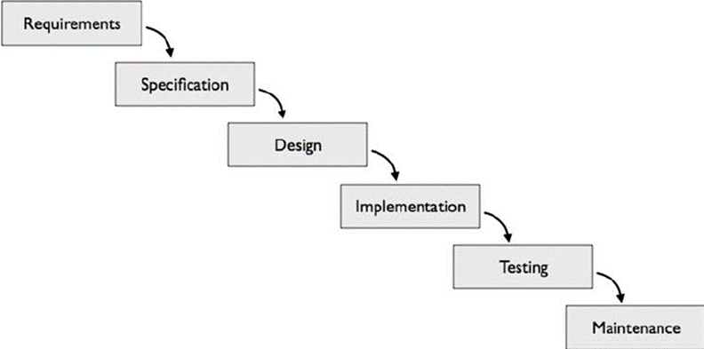

Figure 5.1: Iterative SDLC Model

* + - **Integration and system testing:** All the modules were integrated together. The user interface was integrated with the modules which made the use web services. In testing phase project was tested and debugged. Various test cases were developed and the project was tested at the developers end as well as users end. Debugging was done to discover errors and exception which were corrected.
    - **Installation and maintenance:** Our system is installed on one dedicated server and it is accessible to all authenticated users. Maintenance of our system is done on regular basis. New requirements and features can be added as and when required as long as they do not conflict with the existing features

### Reconciled Estimates

* + - 1. Cost Estimate

The initial cost estimate of the project before beginning the implementation process is INR 15000 for in house resources. This cost may vary. This estimate is subject to change according to the availability and/or need of a particular item.

* + - 1. Time Estimates

|  |  |  |  |
| --- | --- | --- | --- |
| **Task** | **Effort weeks** | **Deliverables** | **Milestones** |
| Analysis of existing systems | 4 weeks |  |  |
| & compare with proposed |
| one |
| Literature survey | 1 weeks |  |  |
| Designing & planning | 2 weeks |  |  |
| System flow | 1 weeks |  |  |
| Designing modules & its´ deliverables | 2 week | Modules: design |  |
| document |
| Implementation | 7 weeks | Primary system |  |
| Testing | 4 weeks | Test Reports | Formal |
| Documentation | 2 weeks | Complete project | Formal |
| report |

Table 5.1: Effort Estimate Table

* + - 1. Project Description

|  |  |  |
| --- | --- | --- |
| **Phase** | **Task** | **Description** |
| Phase 1 | Analysis | Analyze the information given in the IEEE paper. |
| Phase 2 | Literature survey | Collect raw data and elaborate on literature surveys. |
| Phase 3 | Design | Assign the module and design the process flow control. |
| Phase 4 | Implementation | Implement the code for all the modules and integrate all the modules. |
| Phase 5 | Testing | Test the code and overall process weather the process works properly. |
| Phase 6 | Documentation | Prepare the document for this project with conclusion and future enhancement. |

Table 5.2: Project Scheduling

### Project Resources

I) Hardware -

* Processor: Intel(R) Core i5 – 7200U CPU @ 2.50 GHz
* Processor Graphics: Intel(R) HD Graphics 620
* RAM: 4 GB for 32-bit or 6 GB for 64-bit.

II) Software -

* + - Operating System: Windows 10
    - IDE: Jupyter Notebook, Visual studio code
    - Framework: Flask
    - Programming Language: Python

### RISK MANAGEMENT W.R.T. NP HARD ANALYSIS Np Hard:

NP-hard (Non-deterministic Polynomial-time hard), is a class of problems that are, informally, at least as hard as the hardest problems in NP”. More precisely, a problem H is NP-hard when every problem L in NP can be reduced in polynomial time. As a consequence finding a polynomial algorithm to solve any NP-hard problem would give polynomial algorithms for all the problems in NP, which is unlikely as many of them are considered as hard. The class NP also contains all problems which can be solved in polynomial time.

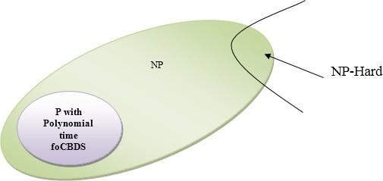The processing ability of the network is controlled by the inter unit connection

Figure 5.2: Risk Management w.r.t. NP Hard

strengths, or weights, achieved via adaptation to, or learning from, a set of training patterns. Since here P = NP so in initial stage our project is in Np-hard state.

### Risk Identification

* 1. Since we are building a web application, the UI design must not be too graphic intensive because it may cause the end product to be a slow, buggy and in-scalable web application.
* 2. Changes in UI makes users uncomfortable or difficult to interact with new one.
* 3. If a user is making changes in any of the modules and the user loses network connection then there is a possibility that changes made by the user may not be reflected at the database serve

### Risk Analysis

The risks for the Project can be analyzed within the constraints of time and quality.

1. Risk Analysis:

|  |  |  |  |  |  |
| --- | --- | --- | --- | --- | --- |
| ID | Risk Description | Probability | Impact | | |
| Schedule | Quality | Overall |
| 1 | Correctness | Low | Low | High | Low |
| 2 | Availability | High | Low | High | High |

Table 5.1: Risk Table

1. Risk Probability definitions:

|  |  |  |
| --- | --- | --- |
| Probability | Value | Description |
| High | Probability of occurrence is | *>* 75% |
| Medium | Probability of occurrence is | 26 *−*75% |
| Low | Probability of occurrence is | *<* 25% |

Table 5.2: Risk Probability definitions

1. Risk Impact definitions:

|  |  |  |
| --- | --- | --- |
| Impact | Value | Description |
| Very high | *>* 10% | Schedule impact or Unacceptable quality |
| High | 5 *−*10% | Schedule impact or Some parts of the project have low quality |
| Medium | *<* 5% | Schedule impact or Barely noticeable degradation in qual- ity Low Impact on schedule or Quality can be incorporated |

Table 5.3: Risk Impact definitions

### Overview of Risk Mitigation, Monitoring, Management

Following are the details for each risk.

|  |  |
| --- | --- |
| Risk ID | 1 |
| Risk Description | Third party access |
| Category | Networking Environment |
| Source | Internet. |
| Probability | High |
| Impact | High |
| Response | Mitigate |
| Strategy | Break security |
| Risk Status | Occurred |

|  |  |
| --- | --- |
| Risk ID | 2 |
| Risk Description | User can make fake profile |
| Category | Requirements |
| Source | Software Design Specification documentation review. |
| Probability | Low |
| Impact | High |
| Response | Mitigate |
| Strategy | Better testing will resolve this issue. |
| Risk Status | Identified |

|  |  |
| --- | --- |
| Risk ID | 3 |
| Risk Description | Server crash |
| Category | Technology |
| Source | This was identified during early development and testing. |
| Probability | Low |
| Impact | Very High |
| Response | Accept |
| Strategy | Example Running Service Registry behind proxy balancer |
| Risk Status | Identified |

### PROJECT SCHEDULE

### Project task set

Major Tasks in the Project stages are:

* + - * Task 1 : Literature Survey
      * Task 2 : Applications and Objectives
      * Task 3 : Platform/Technology Selection
      * Task 4 : Internal Presentation - 1
      * Task 5 : Study Of Algorithms
      * Task 6 : Mathematical Model
      * Task 7 : Software Requirements Specification
      * Task 8 : UML Diagrams
      * Task 9 : Problem Definition using NP Hard/ NP Complete
      * Task 10 : System Architecture
      * Task 11 : Testing phase
      * Task 12 : Internal Presentation - 2
      * Task 13 : Report Preparation
      * Task 14 : Installation
      * Task 15 : Overview of Project Model
      * Task 16 : Construction of GUI
      * Task 17 : Module Identification
      * Task 18 : Module 1 - User Authentication
      * Task 19 : Module 2 - Database generation
      * Task 20 : Module 3 - Connection of GUI to Database
      * Task 21 : Module 4 - Testing and Result
      * Task 22 : Test Planning
      * Task 23 : Testing
      * Task 24 : Poster Presentation
      * Task 25 : Research Of Journals For Final Report

### Task network

Task 21 is dependent on Task 19 and 20. The connection of GUI to database depends on User authentication and database generation. This creates inter-dependence of Task 21 as well.

### Timeline Chart

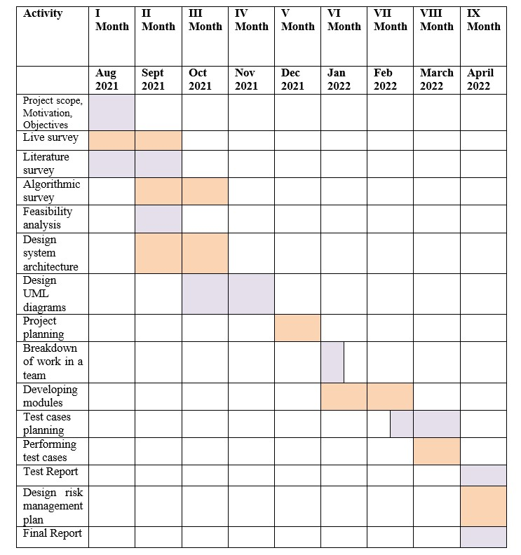

### TEAM ORGANIZATION

Our strategy is to divide the tasks equally amongst four of us. We decide a dead- line for each task. In the end we combine the results of individuals into one single outcome.

### Team structure

The team structure for the project is identified. Roles are defined.

|  |  |  |
| --- | --- | --- |
| Sr. No. | Member | Responsibilities |
| 1 | Kevin Sheth | Project analysis, Developer and Design |
| 2 | Kadambari Kate | Requirement Gathering and Developer |
| 3 | Ajay Gaur | Testing and Design |
| 3 | Yash Paliwal | Testing and Design |

### Management reporting and communication

The report progresses the progress of our project to our internal guide twice a week. We show our weekly status to our guide and incorporate the necessary changes. We communicate among ourselves in case we want suggestions while executing our tasks.

## CHAPTER 6

**SOFTWARE REQUIREMENT SPECIFICATION**

### INTRODUCTION

Music is a melody that defines a person’s emotions or feelings by connecting their soul and mind. According to the Indian Music Industry, Indians listen to music for

2.7 hours per day. When they can’t find songs that match their mood, most music fans become frustrated. As we go about our daily lives, our musical preferences change weekly, daily, or even hourly, and we create playlists to suit our moods. Mu- sic is another form of art that has been shown to help people connect with their emotions. It has the ability to make one feel better. Music has been shown in numerous studies to help people relax and focus.

Emotion and mood are usually conveyed through facial expressions. Anger, Fear, and Disgust are all natural ways for people to express emotions or moods that can help us understand how they behave. Unfortunately, music that does not match the listener’s current mood can be unhelpful. So, to de-stress, listen to music that suits your mood.

Computer vision is a field of study that aids computers in comprehending digital images and videos. Market potential and a variety of applications Face recognition technology draws in a larger number of users. It is a nonverbal form of communication that conveys information about a person’s current state or feelings. Despite the existence of several face detection systems, real-world applications have been rare due to functionality limitations such as image quality due to lighting, facial appearance, skin colour, and illumination effects. As a result, machines have a hard time recognizing emotions in images. Manually choosing a song from a playlist to match the mood is inconvenient and time-consuming. Par by creating playlists that match the user’s musical mood, we’ve taken music recommendation to the next level. This application saves time by locating the most appropriate track for the user’s mood. Songs would be recommended to the user based on their mood.

### Purpose and Scope of Document

The purpose of this document is to provide the software requirement specification report for study of the product.

The scope of this project is to predict and analyze the sentiment and emotion of a particular Marathi audio/text stream and gain insights from a data driven approach.The scope also involves understanding how the audio sentiment analysis technique and some algorithms works and how using some NLP libraries, using SVM algorithm, will help in generating a better output.

### Overview of responsibilities of Developer

* + - * Building Web based GUI.
      * Getting Details of the system.
      * Generating test results.
      * Displaying test results for analysis.
      * Testing the accuracy of the system.

### USAGE SCENARIO

The system replies using an effective Graphical User Interface, as if a real person is talking to the user.

### User profiles

The users of the application are mainly categories into 2 types:

* User: This will resemble the user of the application who will be acting as consumer who will provide us Speech and Textual Feedbacks.
* System: It will collect Speech and Textual Feedbacks from users and perform sentiment analysis,followed by Report Generation.

### Use-cases

All use-cases for the software are presented. Description of all main Use cases using use case template is as follows:

|  |  |  |  |
| --- | --- | --- | --- |
| Sr No. | Use Case | Description | Actors |
| 1 | Use Case 1 | User Profile | User/Consumer |
| 2 | Use Case 2 | System Profile | Admin |

### Use Case View

A use case diagram is a simple representation of a user’s interaction with the system that shows the relationship between the user and the different use cases in which the user is involved.

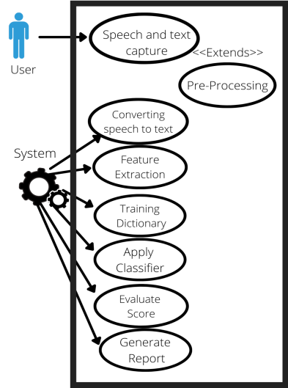

Figure 6.1: Use case diagram

### DATA MODEL AND DESCRIPTION

* + 1. **Data Description**

Data objects used in the system are: Tables and columns are used to attributes and multiple tables store multiple data items. Processing items are internally generated and processed by regretting two modules.

### Data objects and Relationships

ER diagram is a data model for describing the data or information aspects of a soft- ware system. The main components of ER models are entities and the relationships that exists among them. The various entities of the synchronization system are:

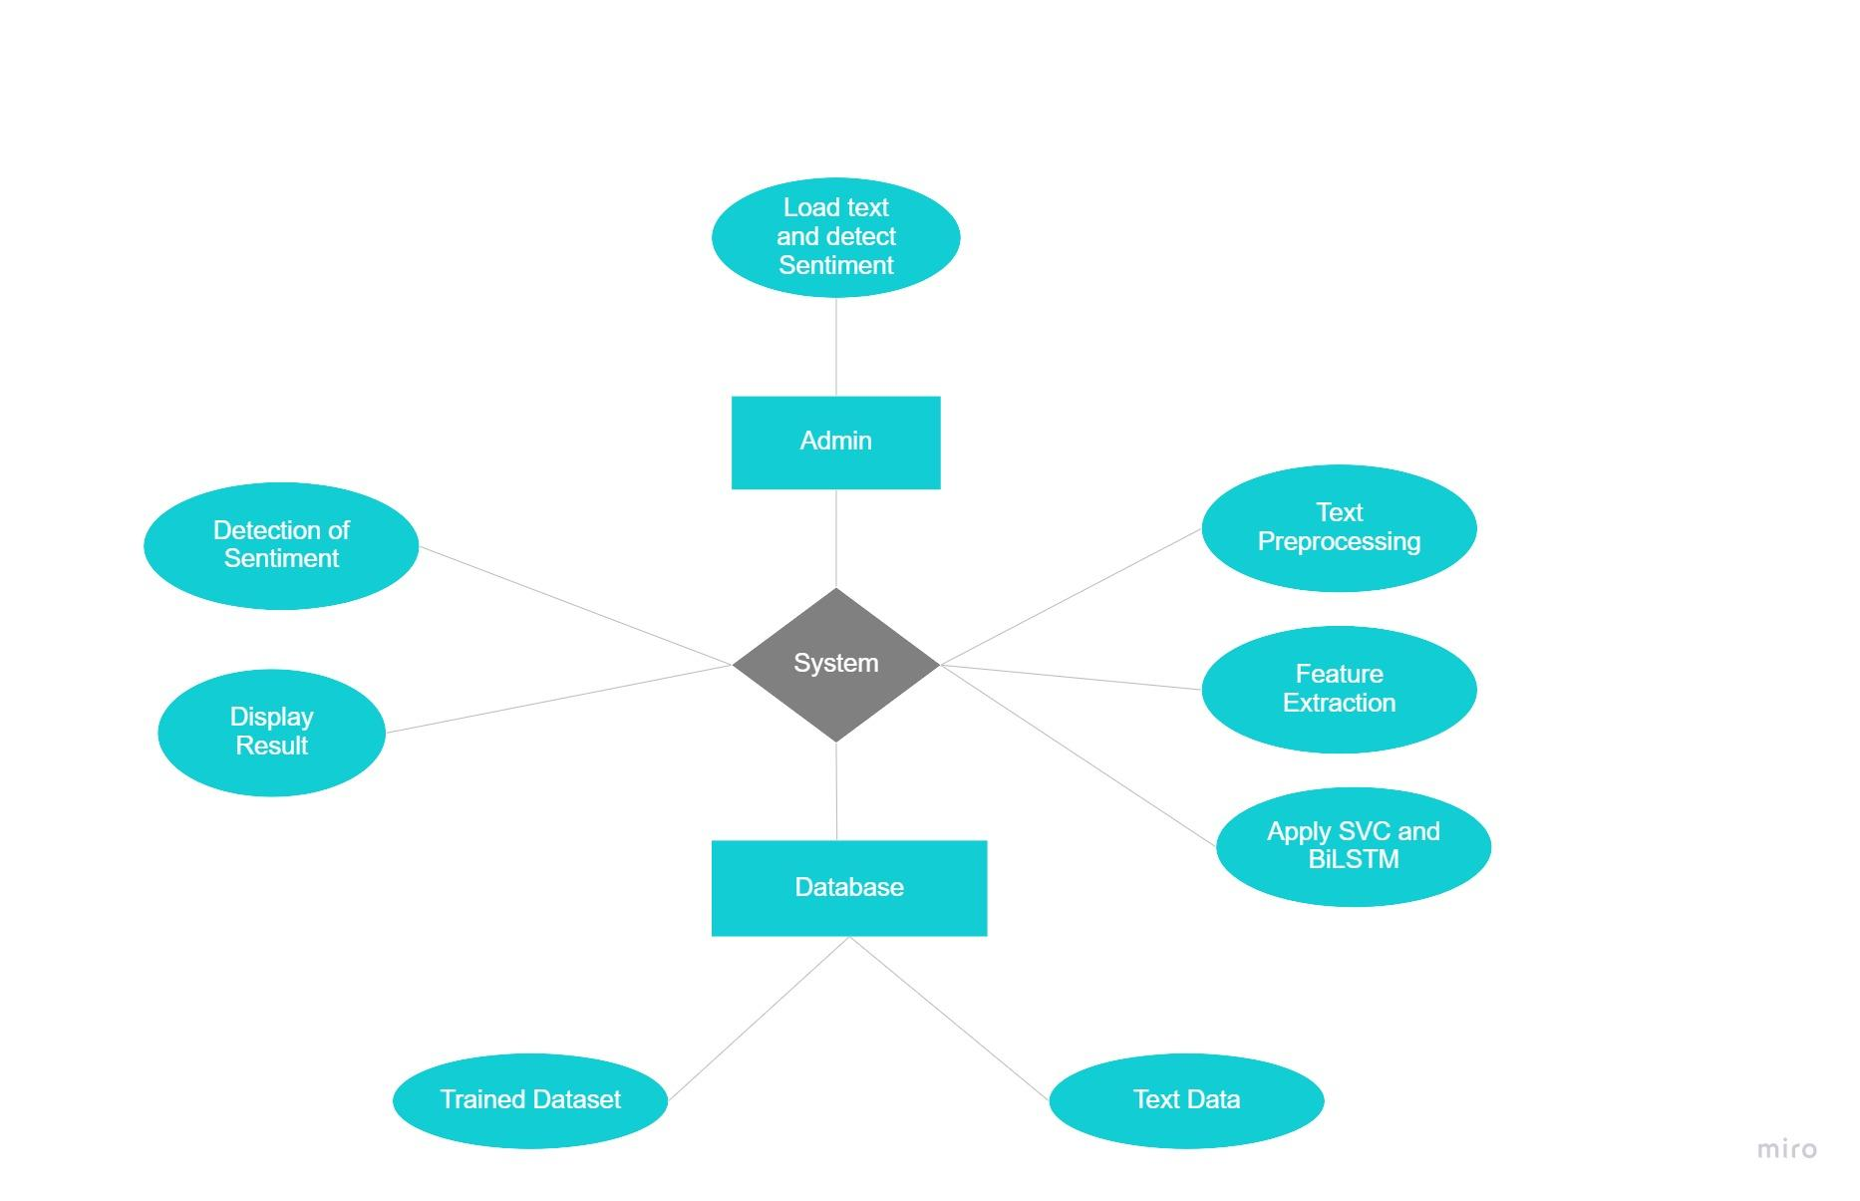

Figure 6.2: Entity Relationship Diagram

1. USER
2. SYSTEM

### Data modules and Description

* + Pre-processing
  + Clean the audio
  + Remove noise, disturbances
  + Segmentation
  + Convert .mp3 to .wav file
  + Stemming
  + Feature extraction
  + Filtering
  + Sentiment value
  + Report Generation
    1. **Data Flow Diagram**

Data Flow Diagrams (DFD) are used to recognizing existing business activities. Simply it gives the flow of the processes, from where it is going and where it is ending.

### Level 0 Data Flow Diagram

It shows the input and the output of the system. This DFD shows the overall purpose of the system, that is, Sentiment Report Generation. 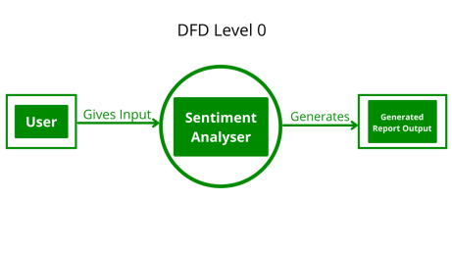

Figure 6.3: Level 0 Data Flow Diagram

### Level 1 Data Flow Diagram

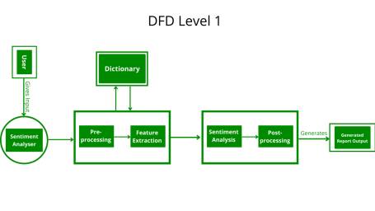

Figure 6.4: Level 1 Data Flow Diagram

### Activity Diagram:

Activity diagrams are graphical depiction of work flows. It shows distinct stages of activities and events with maintained iteration and concurrency. 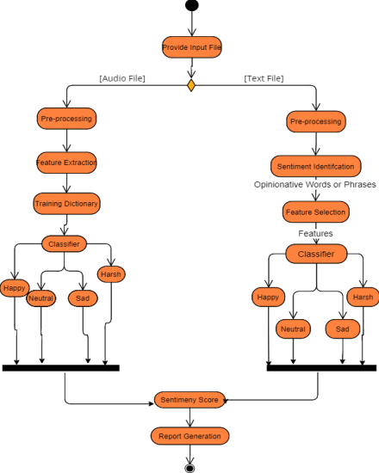

Figure 6.6: Activity diagram

### Non-Functional Requirements:

1. **Performance Requirement:**

* **High Speed**: System should process requested tasks in parallel for various actions to give quick response then the system must wait for process completion.
* **Accuracy**: The system should correctly execute the process. Finally, the original retinal image is first pre-processed and then particle analysis is performed.
* **Interoperability**: Systems should have the ability to exchange information and communicate with internal and external applications and systems. It must be able to exchange information both internally and externally.
* **Reliability**: System should be delivering specified and required data only.
* **Response Time**: The response time of the system should be deterministic at all times and very low, i.e., it should meet every deadline. Thus, the system will work in real time.

### Safety and Security Requirement:

The data safety must be ensured by arranging for a secure and reliable transmission media. The source and destination information must be entered correctly to avoid any misuse or malfunctioning.

### State Diagram:

State Transition Diagram:

The states are represented in ovals and the state of the system gets changed when certain events occur. The transitions from one state to the other are represented by arrows. The Figure shows important states and events that occur while creating new project.

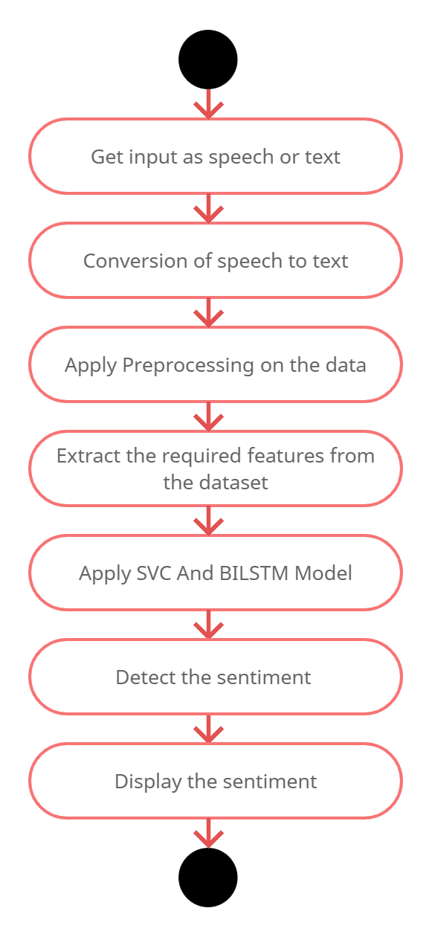

Figure 6.7: State Transition Diagram

**6.4.5 Sequence Diagram**

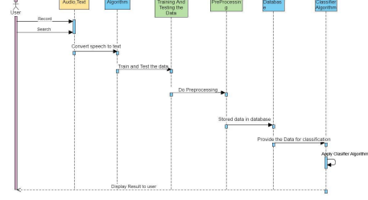

### 

### 6.4.6 Design Constraints

* **Error Free Recognition**: User Voice should be correctly recognized by canceling the background noise.
* **Speed**: Incoming Feedbacks speed should be in .wav format 0r textual. So that processing can be faster.
* **Structure**: The system should be designed in standard format

### General Constraints

* + - * This system is a web-based application.
      * Help to predict the sentiments from Marathi speech and script.

### Software Interface Description

**I) Python 3:**

Python is a high-level programming language. Python is very easy to learn the language as compared to other languages like C, C#, Javascript, Java, etc. It is very easy to code in python language and anybody can learn python basics in a few hours or days. It is also a developer-friendly language. Also Python comes inbuilt with a large number of libraries that can be imported at any instance and be used in a specific program. The presence of libraries also makes sure that you don’t need to write all the code yourself and can import the same from those that already exist in the libraries.

**II) Jupyter Notebook:**

The Jupyter Notebook is an open source web application that you can use to create and share documents that contain live code, equations, visualizations, and text. Jupyter Notebook is maintained by the people at Project Jupyter.Jupyter Notebooks are a spin-off project from the IPython project, which used to have an IPython Notebook project itself. The name, Jupyter, comes from the core supported programming languages that it supports: Julia, Python, and R. Jupyter ships with the IPython kernel, which allows you to write your programs in Python, but there are currently over 100 other kernels that you can also use.

**III) FLASK:**

Flask is also a Python-based microframework that is used for web application development.Flask is categorized as a micro framework because it does not depend on external libraries to perform the tasks of a framework. It has its tools, technologies and libraries to support the functionalities of web application development. Since this framework is more independent and flexible, many developers prefer to start with Flask.

## CHAPTER 7

**DETAILED DESIGN DOCUMENT USING APPENDIX A AND B**

### INTRODUCTION

The proposed framework Sentiment Analysis Application based on Speech and Textual Feedbacks and ML models like Bi-LSTM and SVM are used to detect the sentiments from the Feedbacks provided by User/Consumer.

### ARCHITECTURAL DESIGN

The proposed application is able to extract the user’s sentiment through audio file given as input or text given as input. The proposed method will be used for predicting sentiment based on speech or scripted given as input.

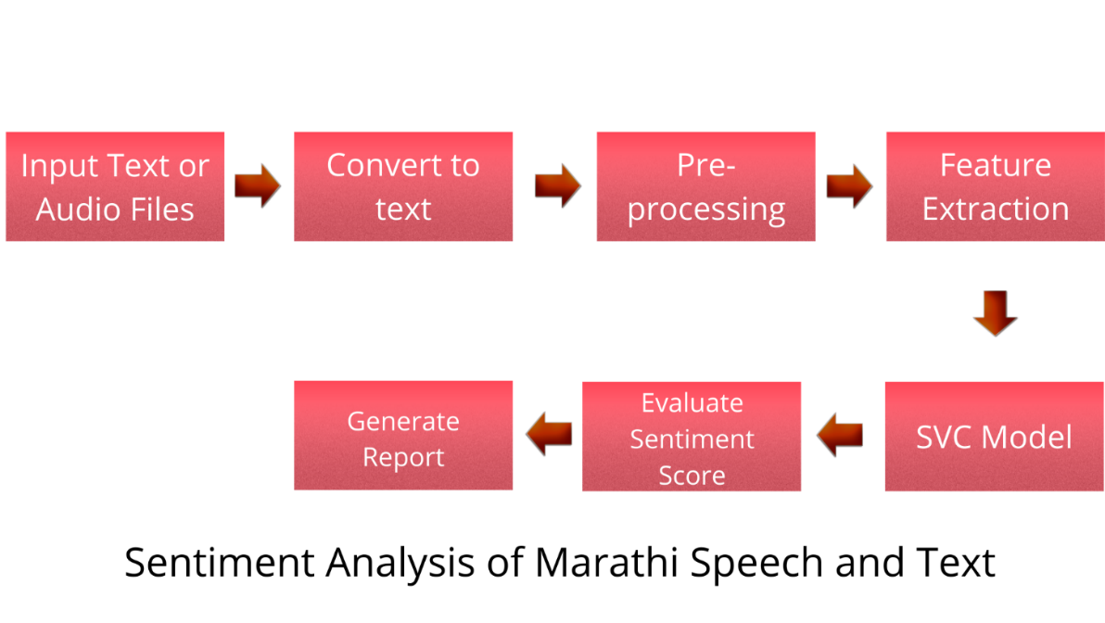

Figure 7.1: Architecture diagram

### DATA DESIGN (USING APPENDICES A AND B)

SQLite database is used in the whole system to manage and store audio files(.wav).

### Internal software data structure

File System: The file system is responsible for organizing files and directories keeping track of which areas of the media belong to which file and which are not being used

### Global data structure

Data structures that are available to major portions of the architecture are described.

### Temporary data structure

We will be using caches saved on our database to temporarily store the users uploaded audio files on the database and later delete those automatically once the sentiment is predicted from those audio files.

### Database description

Database will consist of a table which will store audio files from user into the database.

### COMPOENT DESIGN

Class diagram shows the structure of the classes, attributes, operations and relation-ship among them. Given below is the class diagram of the proposed system.

The class diagram shown below, includes in all 6 classes which describe the structure of the proposed system.

### 7.4.1 Class Diagram

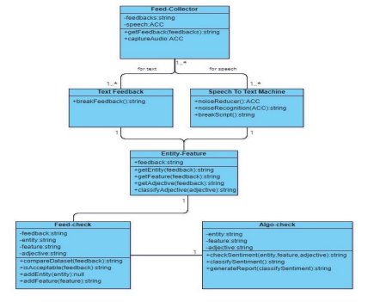

Figure 7.2: Class Diagram

## CHAPTER 8 PROJECT IMPLEMENTATION

### INTRODUCTION

The system's frontend was designed using Flask Framework. Core Technologies used were Python & SQLite. The overall development was done in the Jupyter Notebook and for designing Visual Studio Code was used.

The tool used for db functionalities was SQLite which was inbuilt provided by Django Framework. The software to predict sentiments from marathi textual and speech feedbacks involves following steps:

1. Speech and Text Capture

2. Converting Speech to text

3. Apply Preprocessing

4. Feature Extraction

5. Training Dictionary

6. Apply Classifier

7. Evaluate Score

8. Generate Report

### TOOLS AND TECHNOLOGIES USED

* **IDE:** Jupyter Notebook , Visual Studio Code
* **Framework:** Flask
* **Language :**  Python

### METHODOLOGIES/ALGORITHM DETAIL

### SUPPORT VECTOR MACHINE (SVM)

* SVM is a powerful classifier that is able to distinguish two classes. SVM classifies the test image in to the class with highest distance up to the neighboring point in the training.
* SVM training algorithm built a model that predict whether the test image fall into this class or another.
* SVM necessitate a vast training data to decide an decision boundary and computing cost is very high although we are using single pose (frontal) detection.
* The SVM is a learning algorithm for classification which attempt to dis- cover the finest distinguishing hyper plane which minimize the error for unseen pat- terns.
* The data which cannot be distinguished the input is mapped to high dimensional attribute space where they can be separated by a hyper plane.
* This projection is well performed by means of kernels. The positive and negative hyper plane with decision boundary is shown in figure2.
* If training set of samples and the equivalent resultant values *{*-1, 1*}*. So SVM intend to get the best separating hyper plane specified by the equation WTx+ b that make use of the distance between the two classes as shown in below figure 8.2

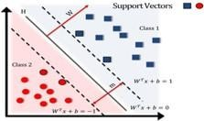

Figure 8.2: Hyper Plane Specified by the Equation WTx+b

## CHAPTER 9 SOFTWARE TESTING

### TYPE OF TESTING USED

Software testing is a method for examining the ability of a framework and confirms that it meets its results. It is produced by developers to keep up the quality of programming, software testing still remains a craftsmanship, because of less comprehension of the terms of testing. Fundamental issue in regards to the software testing is from the complication of programming: we can’t test entire program with less complexity.

Testing is more than just debugging. The purpose of testing can be quality assurance, verification and validation, or reliability estimation. There are 2 major types of testing’s:

1. Correctness testing
2. Reliability testing

Software testing has to deal between expenses, time and quality. Presently we will see the test cases for the making website. We execute functional non- functional testing system.

### TYPE OF TESTING

* **Unit testing :**

Unit testing involves the design of test cases that validate that the internal program logic is functioning properly, and that program inputs produce valid outputs. This is a structural testing, that relies on knowledge of its construction and is invasive. Unit tests perform basic tests at component level and test a specific business process, application, and/or system configuration. Unit tests ensure that each unique path of a business process performs accurately to the documented specifications and contains clearly defined inputs and expected results.

### Integration testing

Integration tests are designed to test integrated software components to deter- mine if they actually run as one program. Integration testing is specifically aimed at exposing the problems that arise from the combination of components.

### System Test

System testing ensures that the entire integrated software system meets requirements. It tests a configuration to ensure known and predictable results. An example of system testing is the configuration oriented system integration test. System testing is based on process descriptions and flows, emphasizing pre-driven process links and integration points.

### White Box Testing

White Box Testing is a testing in which in which the software tester has knowledge of the inner workings, structure and language of the software, or at least its purpose. It is purpose. It is used to test areas that cannot be reached from a black box level.

### Black Box Testing

Black Box Testing is testing the software without any knowledge of the inner workings, structure or language of the module being tested. Black box tests, as most other kinds of tests, must be written from a definitive source document, such as specification or requirements document, such as specification or requirements document. It is a testing in which the software under test is treated, as a black box .you cannot “see” into it. The test provides inputs and responds to outputs without considering how the software works.

### Unit Testing:

Unit testing is usually conducted as part of a combined code and unit test phase of the software life-cycle, although it is not uncommon for coding and unit testing to be conducted as two distinct phases.

### TEST CASES AND TEST RESULTS

|  |  |  |  |  |  |
| --- | --- | --- | --- | --- | --- |
| **Test ID** | **Test Case Name** | **Test Case**  **Description** | **Expected Result** | **Actual Result** | **Test**  **Status** |
| 1 | To verify uploaded file format should be .wav format | Select .wav file in upload file browser and click upload | If .wav file is uploaded the uploaded file name should be displayed else user is shown a message “Please Upload .wav file” | If .wav file is uploaded the uploaded file name should be displayed else user is shown a message “Please Upload .wav file” | Pass |
| 2 | To verify user selects only 1 file to upload | Select .wav file in upload file browser and click upload | If no file is selected and upload button is clicked, message is displayed to user “Please Upload .wav file” | If no file is selected and upload button is clicked, message is displayed to user “Please Upload .wav file” | Pass |
| 3 | To verify if speech to text module works | Upload .wav file and click on Detect speech from file | The speech from the file is converted and displayed in text format | The speech from the file is converted and displayed in text format | Pass |
| 4 | To verify if sentiment prediction module works | Upload .wav file and click on Detect speech from file and then click on predict sentiment | Sentiment of the audio file should be displayed | Sentiment of the audio file is displayed | Pass |

Table 9.1: Test Cases.

## CHAPTER 10 RESULTS AND DISCUSSION

### RESULTS:

* + 1. **SCREEN SHOTS**
       - We first run our Flask Server ’

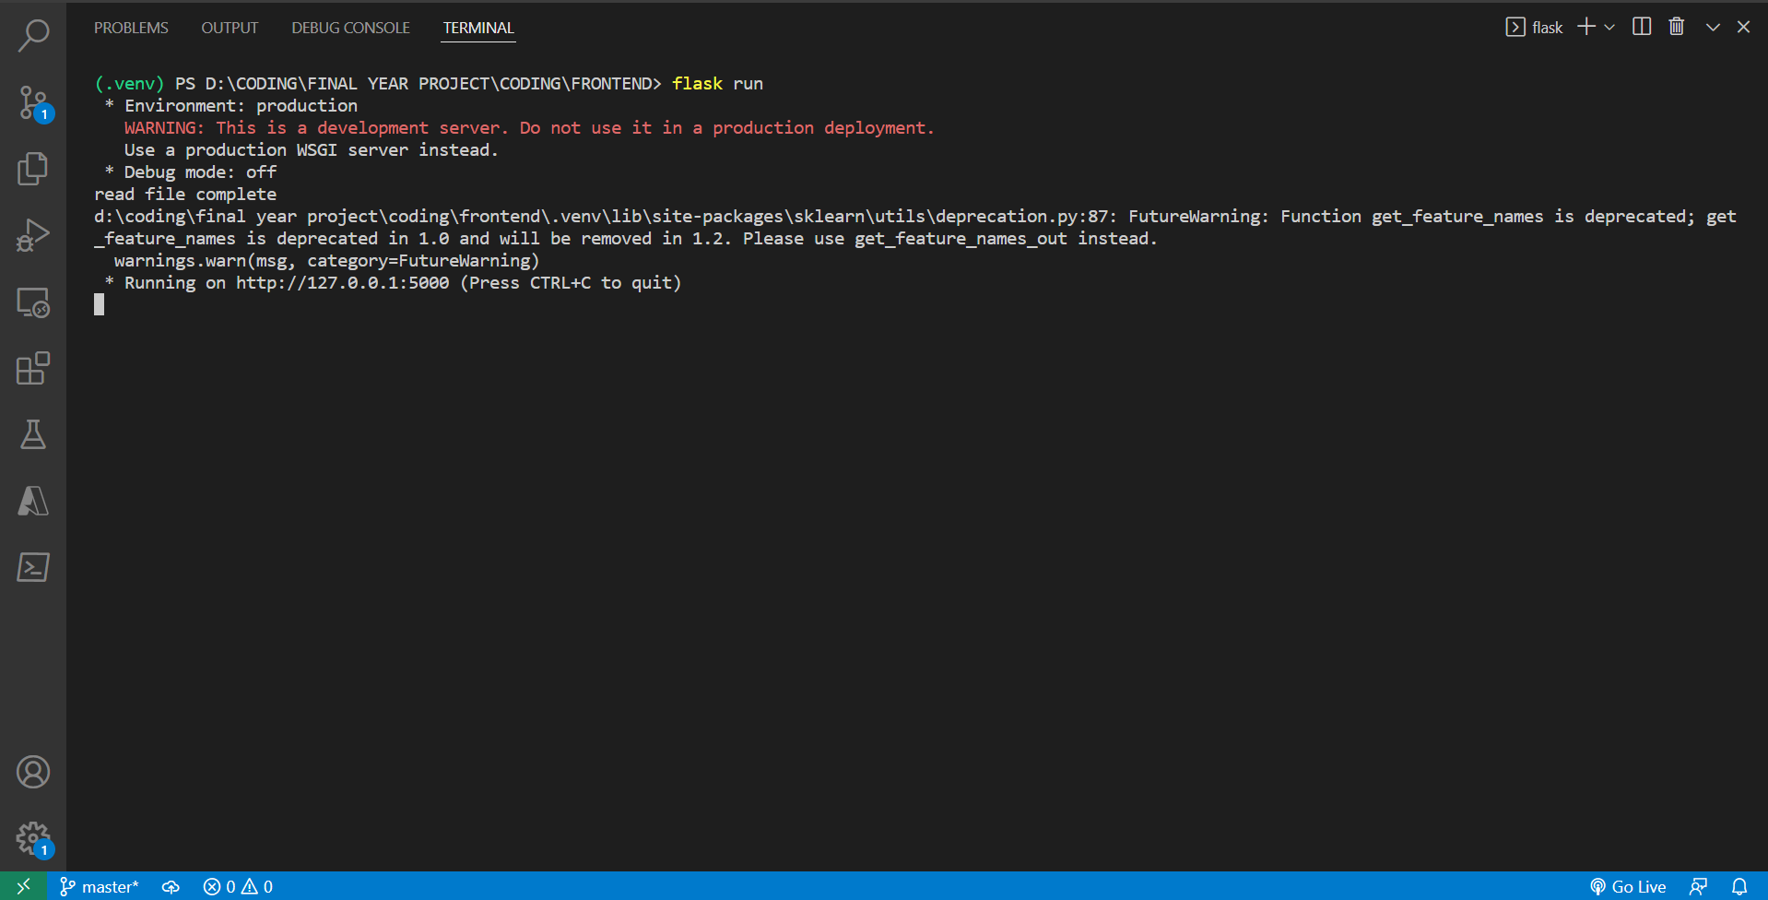

* + - * The Application is then launched on Local host and we get an url for the same

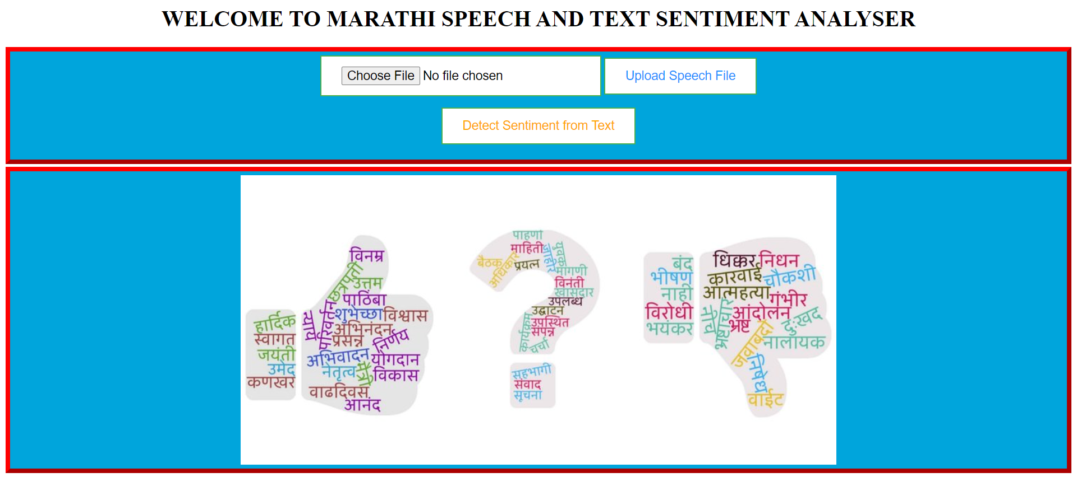

Now, we Have 2 Options for user:

* User can provide audio file or can directly put the text
* For Uploading file, we have provided user with file upload box

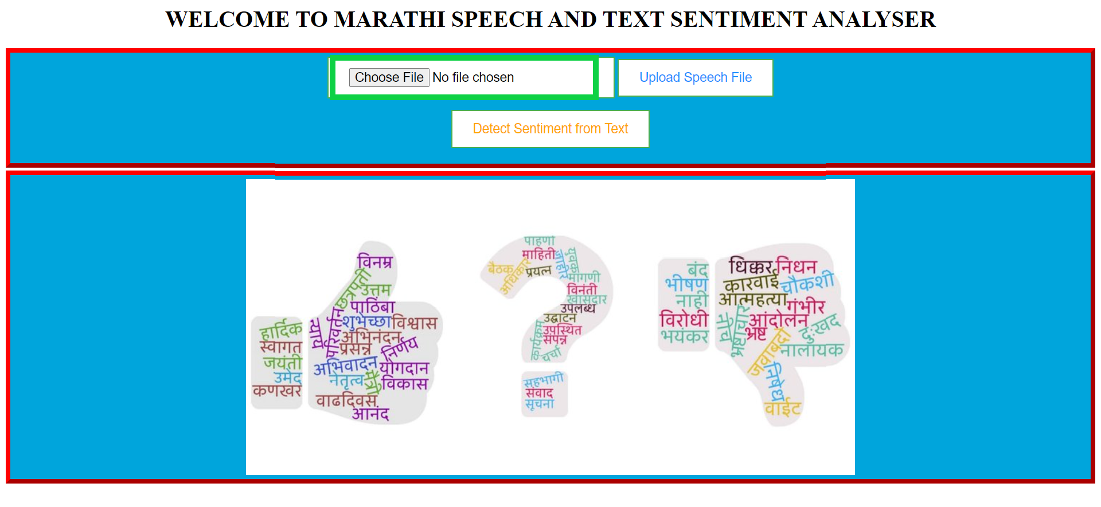.

* + - * User can browse and select any file from his/her files & Click on Upload

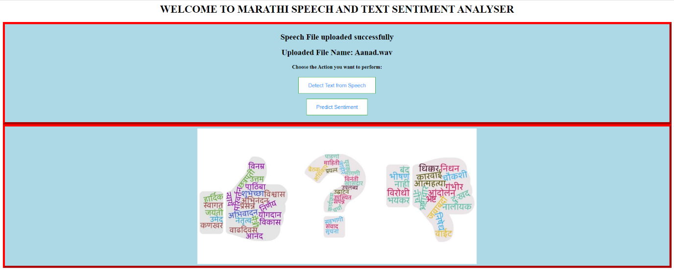

* + - * Once user uploads a File, the name of Uploaded file is displayed and the file is stored into the database

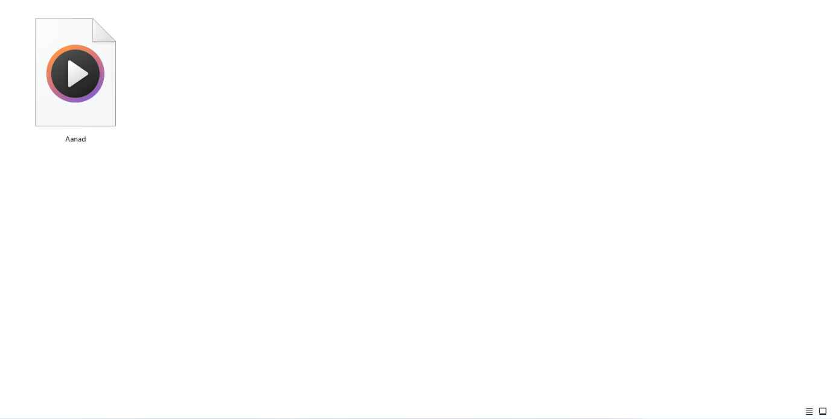

* + - * Once the file is Uploaded user gets 2 options to choose from
* Detect Speech from file which is displayed in text format
* Detect Sentiment of the audio file



* + - * If user selects Detect Speech, the speech is converted into text & is displayed 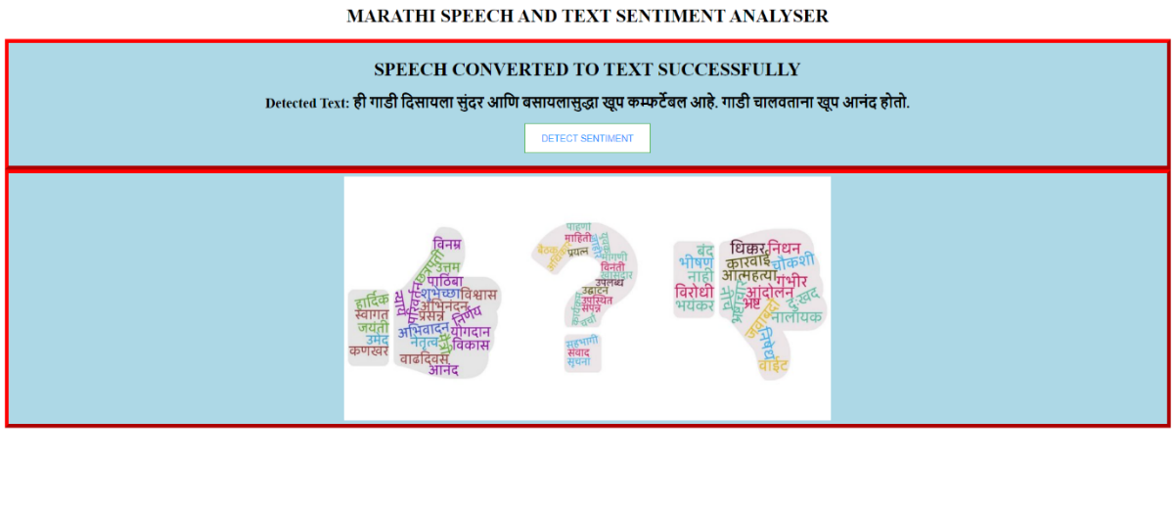
      * Once the speech is displayed in text user can select predict Sentiment and sentiment is Displayed. 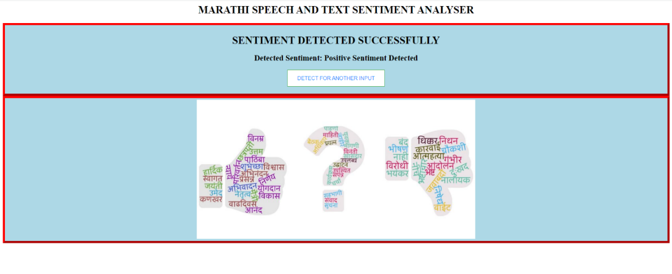

|  |  |  |
| --- | --- | --- |
| **Heart rate** | **Face recognition** | **Output** |
| 40 – 60 BPM | Sad | Sad |
| 60 – 80 BPM | Neutral | Neutral |
| 80 – 120 BPM | Happy | Happy |
| >120 BPM | Disgust | Disgust |
| >120 BPM | Surprise | Surprise |
| >120 BPM | Fear | Fear |
| >120 BPM | Angry | Angry |
| 40 – 60 BPM | Happy | Neutral |
| 60 – 80 BPM | Happy | Neutral |
| 80 – 120 BPM | Neutral | Neutral |
| 80 – 120 BPM | Sad | Neutral |

Table 10.1: Output Table

From table 10.1, we come to know about the final output depending upon the BPM calculated and

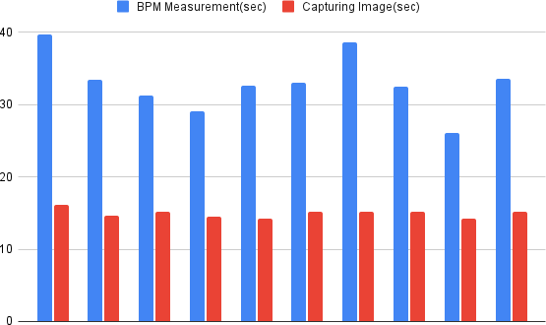

Figure 10.1: Image and Heart rate calculation timings

Table 10.2 shows the time taken for heart rate measurement and face recognition recorded for 10 different test case scenarios. The average time calculated for heart rate measurement is 32.982 seconds and the average time calculated for face emotion recognition is 14.99 seconds.

Overall accuracy

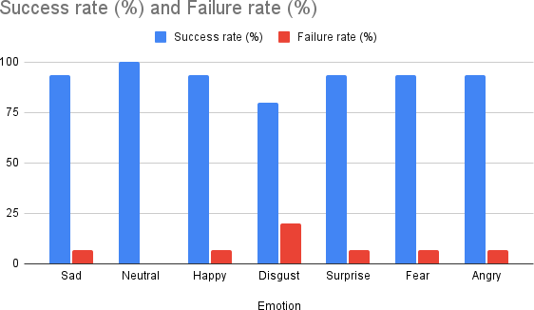Table 10.3: Accuracy Table

|  |  |  |  |
| --- | --- | --- | --- |
| **NO.** | **Emotion** | **Success rate (%)** | **Failure rate (%)** |
| 1 | Sad | 93.33 | 6.67 |
| 2 | Neutral | 100.0 | 0.00 |
| 3 | Happy | 93.33 | 6.67 |
| 4 | Disgust | 80.0 | 20.0 |
| 5 | Surprise | 93.33 | 6.67 |
| 6 | Fear | 93.33 | 6.67 |
| 7 | Angry | 93.33 | 6.67 |
| Avg. |  | 92.37% | 7.63% |

Figure 10.2: Accuracy Diagram

Table 10.3 shows the accuracy of each emotion based on 10 to 15 test cases performed individually. The average success rate of our proposed system is 92.37%.

### DISCUSSION:

Comparative analysis

|  |  |  |
| --- | --- | --- |
| NO. | Paper / model name | Accuracy % |
| 1 | EMOTIONS BASED MUSIC  PLAYER[20] | 64.5 |
| 2 | Facial Emotion Detection Using  Deep Learning[11] | 70.14 |
| 3 | Mood Based Music Player[15] | 81.6 |
| 4 | Emotion Based Music System[16] | 87.5 |
| 5 | Emotion-Based Music Player Emotion Detection from Live  Camera[14] | 90.0 |
| 6 | EMO-MUSIC (Emotion based  Music player)[7] | 92.00 |
| 7 | Our proposed system | 92.37 |

Table 10.4: Comparative Analysis Table

For recognizing sad, happy and neutral mood, we are making use of both heart rate and facial expressions as the final output for these moods based on the BPM calculated and the expression evaluated individually. As the range of BPM for these moods has large variation, but at the same time the other four moods do not have much variation in terms of BPM hence we are only making use of facial expression to detect those moods and the case when the facial expression and the heart rate are not matching with the same emotion at that time a default mood i.e neutral is given as output.

In the earlier proposed models the accuracy of the system ranges from 64.5% to 92%. The accuracy of these models is decreased due to extra devices such as band used for measuring heart rate and also the algorithm used is not trained for more than five emotions but in our proposed model we have trained the dataset for seven emotions also there is no extra device used for heart rate detection that is why the accuracy achieved by our system is more than all other proposed system and this accuracy can also be increased by training the dataset for large amount of data.

Also the time taken for measuring the heart rate and recognizing the facial expression can be reduced to get more faster result.

The average time our system takes to calculate BPM is 32.98 sec and for emotion recognition the average time taken is 14.99 sec. This can be improved by implementing other new techniques for calculation of BPM by which the average time can be reduced which will help us in achieving more accurate results in future.

## CHAPTER 11 DEPLOYMENT AND MAINTENANCE

### INSTALLATION AND UN-INSTALLATION

This system requires Apache Tomcat framework to be installed in the system with the version 7.0. When a user is installing this software on their laptop, it may help to know that this applications will run on the JAVA platform. Once you load the project other packages, jar les, however, may require you to load in the project from storage. Also, when installing software, make sure that the package is labeled for Windows PCs. To install software, open the project in NetBeans and select the Run option.

### Installing MySQL

* + - * Windows configures MySQL Installer.
      * A welcome screen provides several options.
      * Choose the first option: Install MySQL Products.
      * Download the latest MySQL products: MySQL installer checks and down- loads the latest MySQL products including MySQL server, MySQL Work- bench, etc.
      * Choosing a Setup Type: there are several setup types available. Choose the Full option to install all MySQL products and features.
      * Installation Progress: MySQL Installer downloads all selected products. It will take a while, depending on which products that you selected and the speed of your internet connection.
      * MySQL Server Configuration: choose Windows service details including Windows Service Name and account type, then click Next button to continue.
      * Installation Completes: the installation completes. Click finish button toclose the installation wizard and launch the MySQL Workbench.

### Uninstallation

To uninstall a piece of software from your laptop, first open the Eclipse and select the project which we want to delete and right click on it. Follow the prompts that

Appear on the screen to finish uninstalling the software.

### USER HELP

1. Register and Login to the system.
2. When you logged in as an Admin, you will be having access to manage the users in the system.
3. When you logged in as a User, you will be having access to write and compile the code in different programming languages.

## CHAPTER 12 CONCLUSION AND FUTURE SCOPE

Identification of human emotion based on human face emotions n has many applications in real life. It avoids the hectic work of choosing the song every time depending on the individual’s mood. Nowadays it has become necessary to identify the facial recognition of human which helps the organization as well as individual to recognize the emotions of person. It can applied to all different places where recognition plays an important role in identifying the emotion.

We are implementing an efficient method which will be used for song recommendation from play list based on the face emotion using SVM Classifier. The system first takes image and heart rate as input, detect face using HAAR cascade. Features like nose, lips, and eyes in the form of points are extracted from faces and b using SVM we can identify the mood and the particular song from the playlist is played.

## ANNEXURE A REFERENCES

1. Ramya Ramanathan ; Radha Kumaran ; R Ram Rohan ; Rajat Gupta ; Visha- lakshi Prabhu ”An Intelligent Music Player Based on Emotion Recognition”, 2017 2nd International Conference on Computational Systems and Information Technology for Sustainable Solution (CSITSS).
2. Krittrin Chankuptarat ; Raphatsak Sriwatanaworachai ; Supannada Chotipant

,”Emotion-Based Music Player”, 2019 5th International Conference on Engi- neering, Applied Sciences and Technology (ICEAST)

1. Rahul Hirve1, Shrigurudev Jagdale2, Rushabh Banthia3, Hilesh Kalal4 K.R. Pathak5, ”EmoPlayer: An Emotion Based Music Player”, Imperial Journal of Interdisciplinary Research (IJIR) Vol-2, Issue-5, 2016
2. Hemanth P1,Adarsh1,Aswani C.B1,Ajith P1, Veena A Kumar, ”EMO PLAYER: Emotion Based Music Player”, IRJET,Volume: 05 Issue: 04 — Apr- 2018.
3. Shlok Gilda,1Husain Zafar, Chintan Soni and Kshitija Waghurdekar ”Smart Music Player Integrating Facial Emotion Recognition and Music Mood Rec- ommendation”, 2017 IEEE.
4. Jyoti Rani, Kanwal Garg. “Emotion Detection Using Facial Expressions -A Review”. International Journal of Advanced Research in Computer Science and Software Engineering . Vol 4, Issue 4, April 2014.
5. Jayshree Jha, Akshay Mangaonkar, Deep Mistry, Nipun Jambaulikar, Prathamesh Kolhatkar. “Facial Expression Based Music Player”. International Journal of Advanced Research in Computer and Communication Engineering. Vol. 4, Issue 10, Oct 2015.
6. Henal Shaha, Tejas Magarb, Purav Shahcand Kailas Devadkar ”An Intelligent Music Player Using Sentimental Analysis”, International Journal of Innovative and Emerging Research in Engineering Volume 2, Issue 4, 2015.

[9]S. Deebika,K. A. Indira,Dr. Jesline,”A Machine Learning Based Music Player by Detecting Emotions”,2019 Fifth International Conference on Science Tech- nology Engineering and Mathematics (ICONSTEM).

1. Karthik Subramanian Nathan; Manasi Arun; Megala S Kannan “EMOSIC

— An emotion based music player for Android” 2017 IEEE International Sympo- sium on Signal Processing and Information Technology (ISSPIT)

## ANNEXURE B PROJECT PLANNER

|  |  |  |
| --- | --- | --- |
| **Schedule** | **Date** | **Project Activity** |
| June | 08/07/2021 | Project Topic Selection |
| 15/07/2021 | Synopsis Submission |
| August | 05/08/2021 | Presentation on Project Ideas |
| 12/08/2021 | Submission of Literature Survey |
| 20/08/2021 | Feasibility Assessment |
| September | 02/09/2021 | Mid Sem Presentation |
| 16/09/2021 | Design of Mathematical Model |
| 23/09/2021 | End Sem Presentation |
| December | 07/12/2021 | Report Preparation and Submission |
| 20/12/2021 | 1st Module Presentation |
| January | 23/01/2022 | Discussion and Implementation of 2nd Module |
| 30/01/2022 | 1st and 2nd Module Presentation |
| February | 06/02/2022 | Discussion on flow of Project |
| 13/02/2022 | Designing new Module |
| 21/02/2022 | Worked on new Module |
| March | 06/03/2022 | Modification of Modules |
| 21/03/2022 | Designed test cases for our Module |
| April | 11/04/2022 | Worked on User Interface |
| 15/04/2022 | Integration of all Modules |

**ANNEXURE C**

## REVIEWERS COMMENTS OF PAPER SUBMITTED

### Paper Title:

* 1. **Name of the Conference/Journal where paper submitted :**Music System based on facial expression and heart rate

### Paper accepted/rejected:

* 1. **Review comments by reviewer :**
  2. **Corrective actions if any :**

## ANNEXURE D PLAGIARISM REPORT

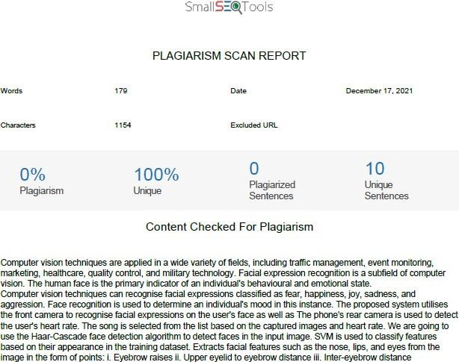

Figure D.1: Plagiarism Abstract

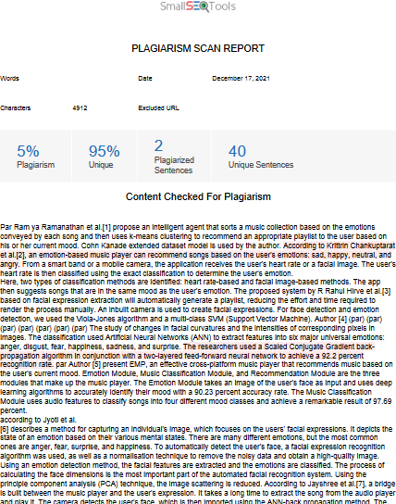

Figure D.2: Plagiarism Literature Survey

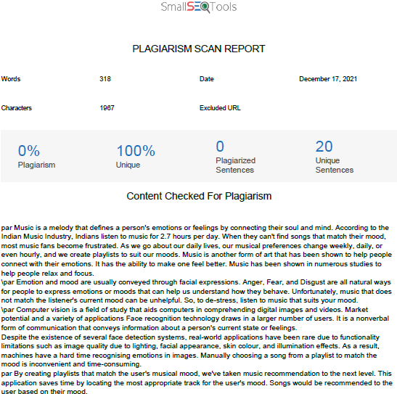

Figure D.3: Plagiarism Introduction

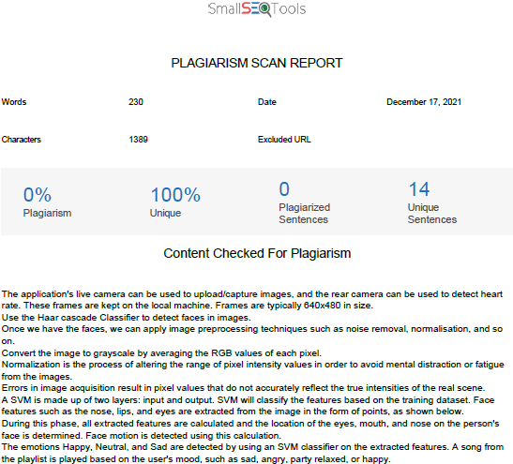

Figure D.4: Plagiarism Proposed System

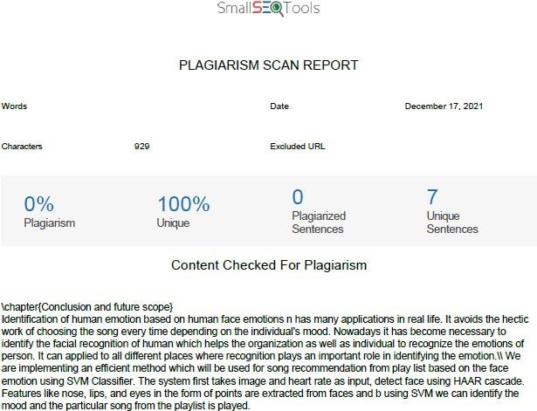

Figure D.5: Plagiarism Conclusion

## ANNEXURE E

**INFORMATION OF PROJECT GROUP MEMBERS**

references/images/p1.png

Figure 12.1: Rajat Dosad

1. Name: Rajat Dosad
2. Date of Birth: 16/11/1998
3. Gender: Male
4. Permanent Address:
5. E-mail: [rajatdosad16@gmail.com](mailto:rajatdosad16@gmail.com)
6. Mobile/Contact No.: 7720838966
7. Placement Details:
8. Paper Published: Yes

references/images/p2.png

Figure 12.2: Priyanshu Singh

1. Name: Priyanshu Singh
2. Date of Birth: 05/12/2000
3. Gender: Female
4. Permanent Address:
5. E-mail: [spriyanshu611@gmail.com](mailto:spriyanshu611@gmail.com)
6. Mobile/Contact No.: 9028643348
7. Placement Details:
8. Paper Published: Yes

references/images/p3.png

Figure 12.3: Shruti Walunj

1. Name: Shruti Walunj
2. Date of Birth: 29/05/2000
3. Gender: Female
4. Permanent Address: Warje, Pune
5. E-mail: [sswalunj](mailto:sswalunj4000@gmail.com)[4000@gmail.com](mailto:4000@gmail.com)
6. Mobile/Contact No.: 9370204410
7. Placement Details:
8. Paper Published: Yes

references/images/p4.png

Figure 12.4: Rohan Wala

1. Name: Rohan Wala
2. Date of Birth: 20/12/2000
3. Gender: Male
4. Permanent Address:
5. E-mail: [rohanwala7766@gmail.com](mailto:rohanwala7766@gmail.com)
6. Mobile/Contact No.: 8983875510
7. Placement Details:
8. Paper Published: Yes
   1. Name :

photo.jpg

* 1. Date of Birth :
  2. Gender :
  3. Permanent Address :
  4. E-Mail :
  5. Mobile/Contact No. :
  6. Placement Details :
  7. Paper Published :