**Summer Training Report/ Synopsis/ Minor Project**

**on**

**“ QUIZ ”**

**A Project Report/Synopsis submitted in partial fulfillment of**

**the requirements for the award of**

**Bachelor in Engineering**

**IN**

**COMPUTER SCIENCE AND ENGINEERING**

**Submitted by**

**D. Akhil Kumar**

**(Roll no: CO16312)**

**Dakshraj Sharma**

**(Roll no: CO16313)**

**Gursheesh Singh Chawla**

**(Roll no: CO16319)**

**Under the supervision of**

**Chandigarh College of Engineering and Technology,**

**Sector - 26,**

**Chandigarh**



**CHANDIGARH COLLEGE OF ENGINEERING AND TECHNOLOGY (DEGREE WING)**

Government Institute under Chandigarh (UT) Administration, Affiliated to Panjab

University, Chandigarh, Sector-26, Chandigarh. PIN-160019 **July, 2017**

CONTENTS

Aim of the project…….………………………………………………….……. i Equipment used.…….……………………………...…………………….…… ii

Abstract…...……………………………………………………………...….… iii

Theory...…………………………………………………..…………………… iv

Diagram…………….…………………………………………………………. v

Procedure…...………………………………...………………………………. vi

Benefits………………………………………...…………………………….. vi

System Requirements………………………………………………………… vii

Screenshot………….………………………………………………………… viii

Conclusion…………………………………………………………………… ix

AIM OF THE PROJECT:

The general objective of the program is to change the current manual system into computerized one. The project will be very useful foe educational institutes where regular evaluation of students is required.

A quiz is the ultimate way to test one’s knowledge. It allows one to judge his/her own capabilities and knowledge on a topic or a range of subjects. Moreover, a quiz need not just be for individual use. A quiz can also serve as a method to compete against others in your own field and expand your knowledge through the mistakes that you make during such events.

Through a simple JAVA project, we have tried to create a basic quiz and marks calculating program.

EQUIPMENT USED:

1. This project is made using JAVA platform (jre 1.7) and graphics using SWING ( Swing Builder ).
2. IDE used here is eclipse (Kepler).
3. We Initialize questions, possible answers, and correct answers.
4. We add title of the program window (CSE QUIZ) and color to window.
5. We made the program window close when the user clicks the close button.
6. We Specified the width and height of the program window when it opens.
7. We specifiied the location of the program window when it opens.
8. We used JCheckBox to select appropriate option.
9. We used JLabel to write text ( Questions and options ) in our window.
10. Create a JLabel object text to display the question.
11. Set the font name, font style, and font size of the text label.
12. Set the text color of the object to black.
13. Used JButtons to start test and finish.
14. Created the JButton next object to enable next question.
15. Set the text color of the next button tot the green color.
16. Created the JPanel panel object to hold the controls (label, check boxes , and button).
17. Added action event tot button to enable button-click action.
18. The actionPerformed method of the ActionListener interface is rewritten to handle the button click event.

19. We made to store marks in array.

20. We made sure that program window is visible after every action.

ABSTRACT :

The environment used for this project is JAVA (core JAVA).This quiz is a .jar file in which we have predefined questions. A timer runs during the execution of the file, limiting the time available to the user. Start button in the beginnig and Finish button at the end are available. Also, the next and previous buttons are available during the quiz. When we click the start button the online test get started, you will have to answer 10 questions.If you do not wish to answer a particular question you can move on to next question by pressing next button or if you wish to move to the previous question that you had skipped you can make this move by previous button.

THEORY :

Online Test is a software in which we have specified some questions, a timer runs for given time and within that period one has to answer for all those questions, some buttons are presented at the bottom of the window like start button, previous , next , finish.  
When we click the start button the online test get started, you will have to answer 10 questions and the timer runs.  
If you do not wish to answer a particular question you can move on to next question by pressing next button or if you wish to move to the previous question that you had skipped you can make this move by previous button.

The environment used for this project is JAVA. This project is based on core JAVA. The software used for this java SDK1.7, Window10 operating system.

DIAGRAM :

Student login Result

*Until all attempted/time out*

INPUT DETAILS

ANSWER QUESTION

START TEST

LOGIN

PROCEDURE :

* On executing the program, the Program window GUI opens up, with an intimation to start the quiz.
* On starting, the quiz begins, with each question having 4 options to choose from.
* The user may leave a question unmarked also.
* With every entered correct answer, one mark is added to the user's score.
* On answering the last question, the user reaches the final screen of the program, displaying the user's final score in the quiz.
* During the full duration of the Quiz, the timer keeps ticking, limiting the time available to a user.

BENEFITS:

* Provides a method to test one’s knowledge.
* Entertains the user through interesting questions and problems.
* Exercises the mind.
* Helps to judge the level of competition in one's field by comparing score to others.
* Through additions to the program and turning it into a survey, crucial data could be collected from the users, with could be beneficial for, for example, research purposes
* Since this software is designed in java, it is Platform independent..
* Successfully handles the problem.
* Reliability gives consistent results.
* System is robust.
* Good GUI.
* Less complexity and risk.

SYSTEM REQUIREENTS

* OS- Win XP/7/8/10
* R.A.M- Min. 256 Mb
* Storage- 10Mb Free space
* Java SDK 1.7
* Integrated Graphics

SCREENSHOT

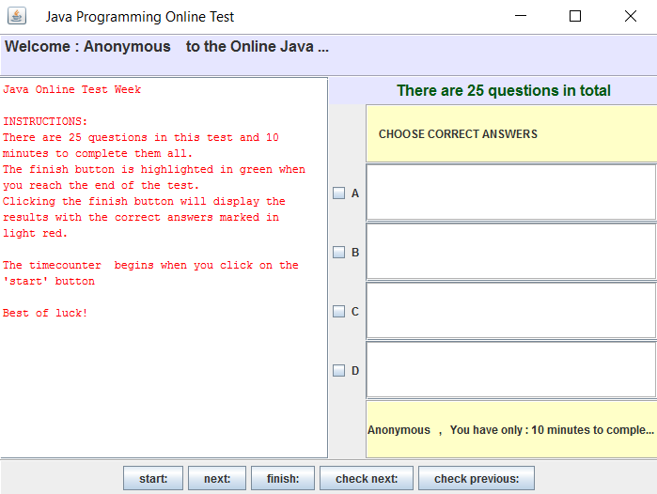

CONCLUSION :

Computerization is needed in this Shrinking world, where centralization is also required with globalization. Conducting online test is a step in this direction to ease the current structure of examination. This way of conducting test on one of the most secure operating system and with highly sophisticated technology is cost effective and save time too.

This way of conducting test not only save time but also lessens student’s and teacher’s frustration. It is an easier way of giving examination, any person across the globe can appear for the examination.