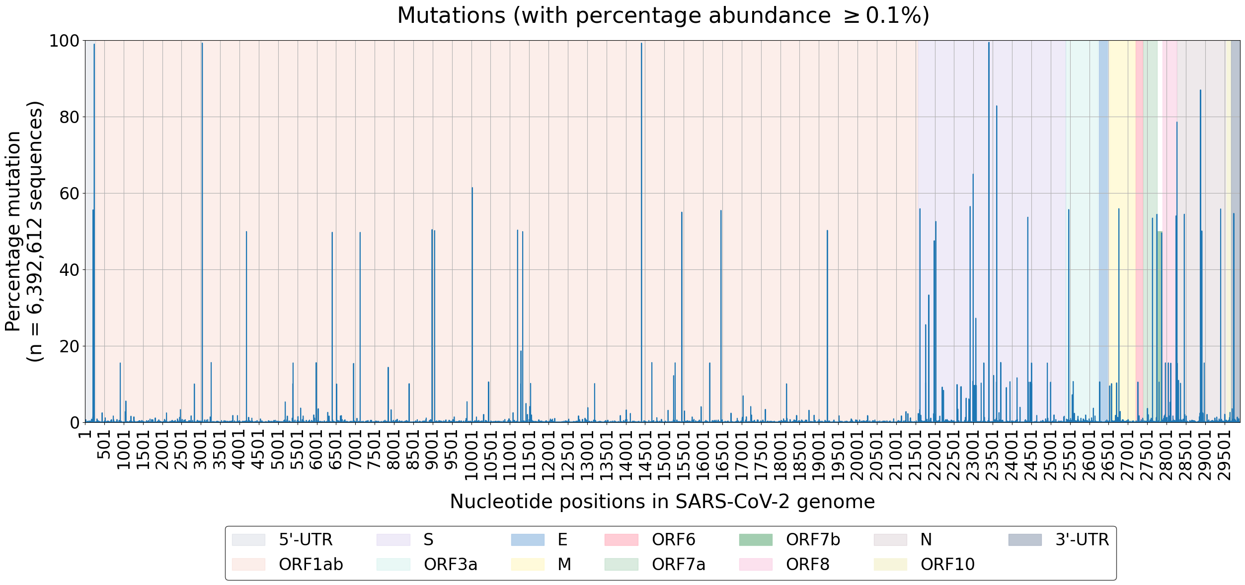
Figure 1A

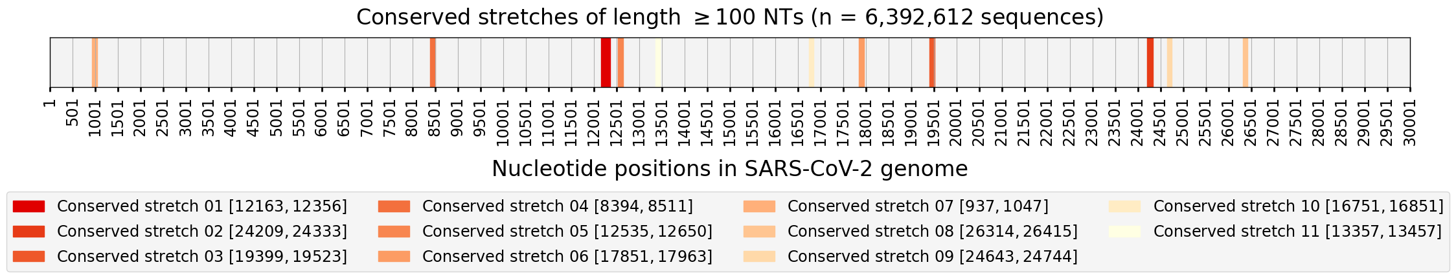
Figure 1B

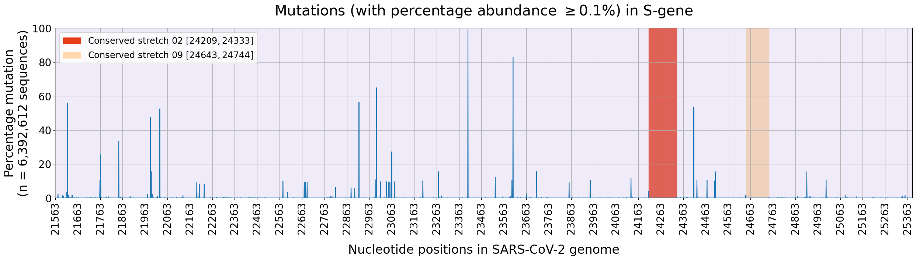
Figure 1C

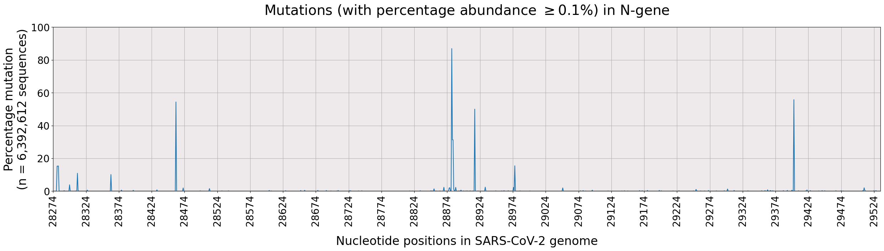
Figure 1D

