Lab: Arrays
You can check your solutions in Judge

Day of Week
Enter a number in range 1-7 and print out the word representing it or "Invalid day!". Use an array of strings.

Examples
Input | Output
1 | Monday
2 | Tuesday
10 | Invalid day!

Print Numbers in Reverse Order
Read n numbers and print them in reverse order, separated by a single space.

Examples
Input | Output
3  10  20  30 | 30 20 10
3  30  20  10 | 10 20 30
1  10 | 10

Hints
First, we need to read n from the console.
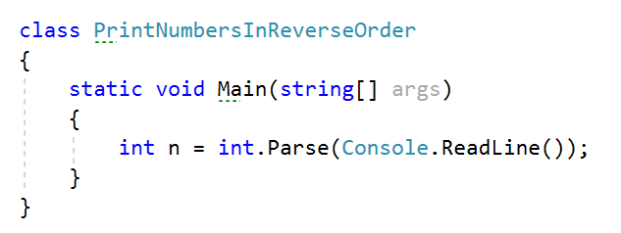
Create an array of integers with n size.
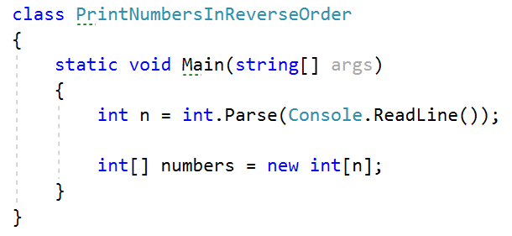
Read n numbers using for loop.
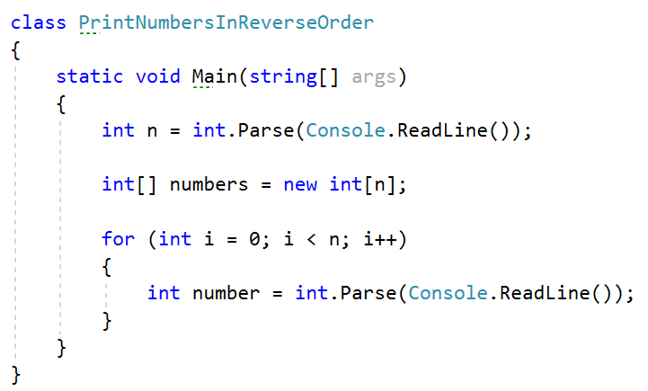
Set number to the corresponding index.
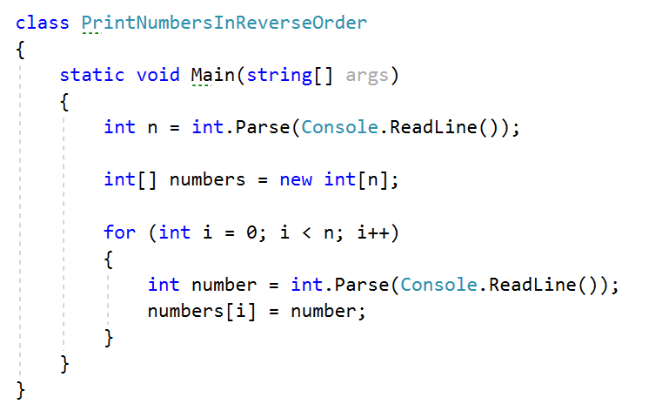
Print the array in reversed order.
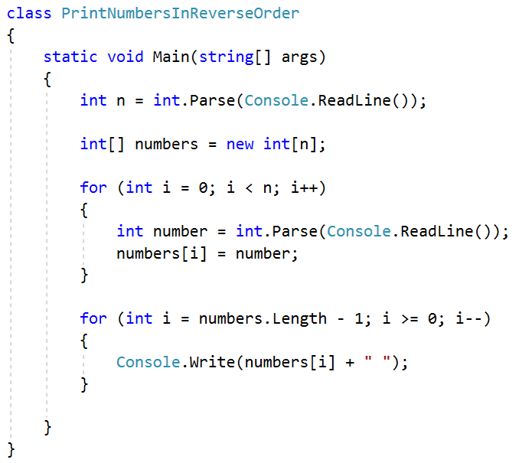

Rounding Numbers
Read an array of real numbers (space separated), round them in "away from 0" style and print the output as in the examples:

Examples
Input | Output
0.9 1.5 2.4 2.5 3.14 | 0.9 => 1  1.5 => 2  2.4 => 2  2.5 => 3  3.14 => 3
-5.01 -1.599 -2.5 -1.50 0 | -5.01 => -5  -1.599 => -2  -2.5 => -3  -1.50 => -2  0 => 0

Reverse Array of Strings
Create a program that reads an array of strings, reverses it, and prints its elements. The input consists of a sequence of space-separated strings. Print the output on a single line (space separated).

Examples
Input | Output
a b c d e | e d c b a
-1 hi ho w | w ho hi -1

Sum Even Numbers
Read an array from the console and sum only its even values.

Examples
Input | Output
1 2 3 4 5 6 | 12
3 5 7 9 | 0
2 4 6 8 10 | 30

Hints
First, we need to read the array.
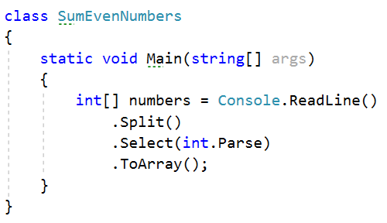
We will need a variable for the sum.
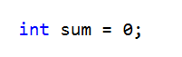
Iterate through all elements in the array with for loop.
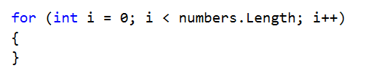
Check if the number at the current index is even.
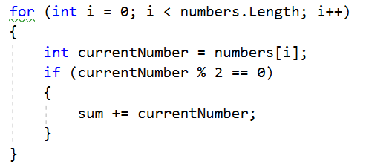
Print the total sum.
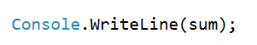

Even and Odd Subtraction
Create a program that calculates the difference between the sum of the even and the sum of the odd numbers in an array.

Examples
Input | Output | Comments
1 2 3 4 5 6 | 3 | Even: 2 + 4 + 6 = 12  Odd: 1 + 3 + 5 = 9  Result: 12 – 9 = 3
3 5 7 9 | -24 | Even: 0  Odd: 3 + 5 + 7 + 9 = 24  Result: 0 – 24 = -24
2 4 6 8 10 | 30 | Even: 2 + 4 + 6 + 8 + 10 = 30  Odd: 0  Result: 30 – 0 = 30

Hints
First, we need to read the array.
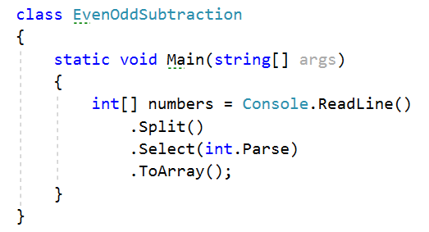
We will need two variables – even and odd sum.
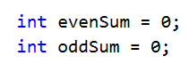
Iterate through all elements in the array with for loop.
Check the current number – if it is even, add it to the even sum, otherwise add It to the odd sum.
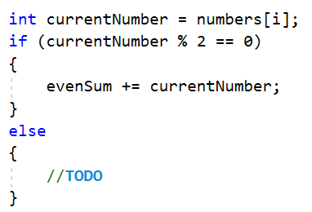
Print the difference.
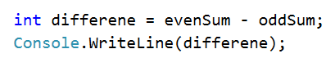

Equal Arrays
Read two arrays and determine whether they are identical or not. The arrays are identical, if all their elements are equal. If the arrays are identical, find the sum of the elements of one of them and print the following message to the console: "Arrays are identical. Sum: {sum}"
Otherwise, find the first index where the arrays differ and print the following message to the console: "Arrays are not identical. Found difference at {index} index"

Examples
Input | Output
10 20 30  10 20 30 | Arrays are identical. Sum: 60
1 2 3 4 5  1 2 4 3 5 | Arrays are not identical. Found difference at 2 index
1  10 | Arrays are not identical. Found difference at 0 index

Hints
First, we need to read two arrays.
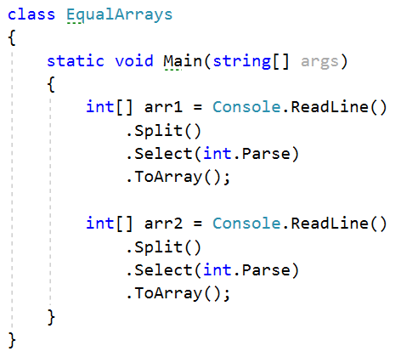
Iterate through arrays and compare elements. If the elements are not equal print the required message and break the loop.
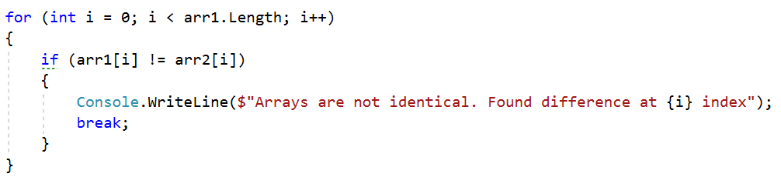
Think about how to solve the other part of the problem.

Condense Array to Number
Create a program to read an array of integers and condense them by summing all adjacent couples of elements until a single integer remains.
For example, let us say we have 3 elements - {2, 10, 3}. We sum the first two and the second two elements and get {2 + 10, 10 + 3} = {12, 13}, then we sum all adjacent elements again. This results in {12 + 13} = {25}.

Examples
Input | Output | Comments
2 10 3 | 25 | 2 10 3 2+10 10+3 12 13 12 + 13 25
5 0 4 1 2 | 35 | 5 0 4 1 2 5+0 0+4 4+1 1+2 5 4 5 3 5+4 4+5 5+3 9 9 8 9+9 9+8 18 17 18+17 35
1 | 1 | 1 is already condensed to number

Hints
While we have more than one element in the array nums[], repeat the following:
- Allocate a new array condensed[] of size nums.length.
- Sum the numbers from nums[] to condensed[].
  - condensed[i] = nums[i] + nums[i+1]
- nums[] = condensed[]
The process is illustrated below:
