More Exercises: Arrays
You can check your solutions in Judge

Encrypt, Sort, and Print Array
Write a program that reads a sequence of strings from the console. Encrypt every string by summing:
- The code of each vowel multiplied by the string length
- The code of each consonant divided by the string length
Sort the number sequence in ascending order and print it in the console.
On the first line, you will always receive the number of strings you have to read.

Examples
Input | Output | Comments
4  Peter  Maria  Katya  Todor | 1032  1071  1168  1532 | Peter = 1071  Maria = 1532  Katya = 1032  Todor = 1168
3  Sofia  London  Washington | 1396  1601  3202 | Sofia = 1601  London = 1396  Washington = 3202

Pascal Triangle
The triangle may be constructed in the following manner: In row 0 (the topmost row), there is a unique nonzero entry 1. Each entry of each subsequent row is constructed by adding the number above and to the left with the number above and to the right, treating blank entries as 0. For example, the initial number in the first (or any other) row is 1 (the sum of 0 and 1), whereas the numbers 1 and 3 in the third row are added to produce the number 4 in the fourth row.
If you want more info about it: https://en.wikipedia.org/wiki/Pascal's_triangle
Print each row element separated with whitespace.

Examples
Input | Output
4 | 1  1 1  1 2 1  1 3 3 1
13 | 1  1 1  1 2 1  1 3 3 1  1 4 6 4 1  1 5 10 10 5 1  1 6 15 20 15 6 1  1 7 21 35 35 21 7 1  1 8 28 56 70 56 28 8 1  1 9 36 84 126 126 84 36 9 1  1 10 45 120 210 252 210 120 45 10 1  1 11 55 165 330 462 462 330 165 55 11 1  1 12 66 220 495 792 924 792 495 220 66 12 1

Hints
- The input number n will be 1 <= n <= 60.
- Think about the proper type for the elements of the array.
- Don't be scared to use more and more arrays.

Recursive Fibonacci
The Fibonacci sequence is a quite famous sequence of numbers. Each member of the sequence is calculated from the sum of the two previous elements. The first two elements are 1, 1. Therefore the sequence goes like 1, 1, 2, 3, 5, 8, 13, 21, 34…
The following sequence can be generated with an array, but that's easy, so your task is to implement recursively.
So if the function GetFibonacci(n) returns the n^{th} Fibonacci number we can express it using GetFibonacci(n) = GetFibonacci(n-1) + GetFibonacci(n-2).
However, this will never end and in a few seconds, a StackOverflow Exception is thrown. For the recursion to stop, it has to have a “bottom”. The bottom of the recursion is GetFibonacci(2) should return 1 and GetFibonacci(1) should return 1.

Input
- On the only line in the input, the user should enter the wanted Fibonacci number.

Output
- The output should be the n^{th} Fibonacci number counting from 1.

Constraints
- 1 ≤ N ≤ 50

Examples
Input | Output
5 | 5
10 | 55
21 | 10946
For the N^{th} Fibonacci number, we calculate the N-1th and the N-2th number, but for the calculation of the N-1th number we calculate the N-1-1th(N-2th) and the N-1-2th number, so we have a lot of repeated calculations.
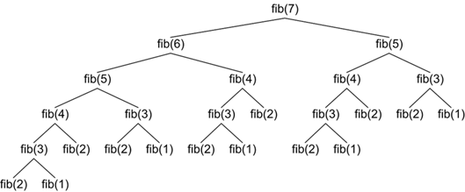
If you want to figure out how to skip those unnecessary calculations, you can search for a technique called memoization.

Fold and Sum
Read an array of 4*k integers, fold it like shown below, and print the sum of the upper and lower two rows (each holding 2*k integers):
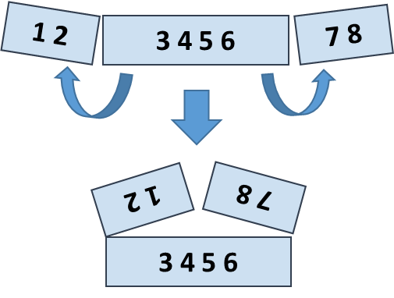

Examples
Input | Output | Comments
5 2 3 6 | 7 9 | 5 6 +  2 3 =  7 9
1 2 3 4 5 6 7 8 | 5 5 13 13 | 2 1 8 7 +  3 4 5 6 =  5 5 13 13
4 3 -1 2 5 0 1 9 8 6 7 -2 | 1 8 4 -1 16 14 | -1 3 4 -2 7 6 +  2 5 0 1 9 8 =  1 8 4 -1 16 14

Hints
- Create the first row after folding: the first k numbers reversed, followed by the last k numbers reversed.
- Create the second row after folding: the middle 2*k numbers.
- Sum the first and the second rows.

Longest Increasing Subsequence (LIS)
Read a list of integers and find the longest increasing subsequence (LIS). If several such exist, print the leftmost.

Examples
Input | Output
1 | 1
7 3 5 8 -1 0 6 7 | 3 5 6 7
1 2 5 3 5 2 4 1 | 1 2 3 5
0 10 20 30 30 40 1 50 2 3 4 5 6 | 0 1 2 3 4 5 6
11 12 13 3 14 4 15 5 6 7 8 7 16 9 8 | 3 4 5 6 7 8 16
3 14 5 12 15 7 8 9 11 10 1 | 3 5 7 8 9 11

Hints
- Assume we have n numbers in an array nums[0…n-1].
- Let len[p] hold the length of the longest increasing subsequence (LIS) ending at position p.
- In a for loop, we shall calculate len[p] for p = 0 … n-1 as follows:
  - Let left be the leftmost position on the left of p (left < p), such that len[left] is the largest possible.
  - Then, len[p] = 1 + len[left]. If left does not exist, len[p] = 1.
  - Also, save prev[p] = left (we hold in prev[] the previous position, used to obtain the best length for position p).
- Once the values for len[0…n-1] are calculated, restore the LIS starting from position p such that len[p] is maximal and go back and back through p = prev[p].
- The table below illustrates these computations:
index | 0 | 1 | 2 | 3 | 4 | 5 | 6 | 7 | 8 | 9 | 10
nums[] | 3 | 14 | 5 | 12 | 15 | 7 | 8 | 9 | 11 | 10 | 1
len[] | 1 | 2 | 2 | 3 | 4 | 3 | 4 | 5 | 6 | 6 | 1
prev[] | -1 | 0 | 0 | 2 | 3 | 2 | 5 | 6 | 7 | 7 | -1
LIS | {3} | {3,14} | {3,5} | {3,5,12} | {3,5,12,15} | {3,5,7} | {3,5,7,8} | {3,5,7,8,9} | {3,5,7,8,9,11} | {3,5,7,8,9,10} | {1}

