**Angular Http Communication**

1. Angular Http Configuration : app.module.ts

import {HttpClientModule} from '@angular/common/http'

@NgModule({

  imports: [

    HttpClientModule

  ]

})

export class AppModule { }

1. Angular Service : user.component.ts & profile.component.ts to user.service.ts

* Ng g s service/user

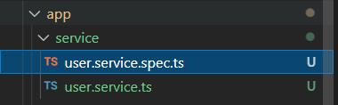

1. Injecting HTTP Client : user.service.ts

import { Injectable } from '@angular/core';

import { HttpClient } from '@angular/common/http';

@Injectable({

  providedIn: 'root'

})

export class UserService {

  constructor(private http: HttpClient) { }

}

1. Using Http Client : user.service.ts

getUsers(): Observable<User[]> {

    return this.http.get<User[]>(`https://jsonplaceholder.typicode.com/users`)

  }

  getUser(): Observable<User> {

    return this.http.get<User>(`https://jsonplaceholder.typicode.com/users/1`)

  }

1. Mapping Http response : Json to Typescript

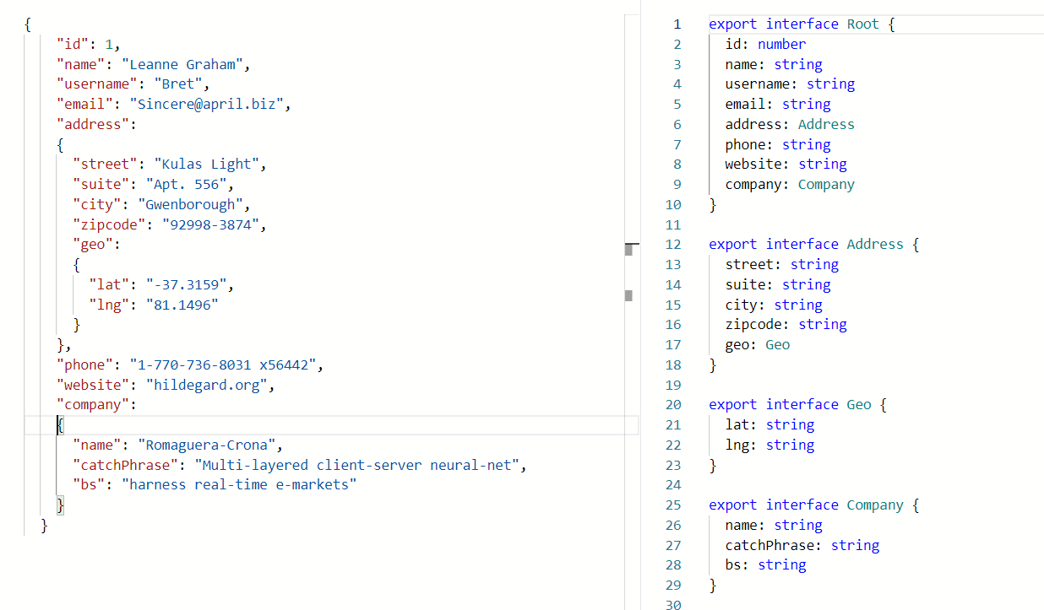

|  |  |
| --- | --- |
| ng g interface interface/user  ng g interface interface/address  ng g interface interface/geo  ng g interface interface/company |  |

1. Subscribing to Observables

* In user.service.ts

getUsers(): Observable<User[]> {

return this.http.get<User[]>(`https://jsonplaceholder.typicode.com/users`)

}

* user.component.ts

onGetUsers(): void

  {

  this.userService.getUsers().subscribe(

     (response) => console.log(response),

     (error: any) => console.log(error),

      () => console.log('Done getting users')

    );

  }

**Final user.component.ts**

import { HttpEventType } from '@angular/common/http';

import { Component, OnInit } from '@angular/core';

import { User } from './interface/user';

import { UserService } from './service/user.service';

@Component({

  selector: 'app-root',

  templateUrl: './app.component.html',

  styleUrls: ['./app.component.css']

})

export class AppComponent implements OnInit{

  title = 'HTTPV2';

  constructor(private userService: UserService) {}

  ngOnInit(): void {

    this.onGetUsers();

  }

  onGetUsers(): void

  {

  this.userService.getUsers().subscribe(

     (response) => console.log(response),

     (error: any) => console.log(error),

      () => console.log('Done getting users')

    );

  }

}

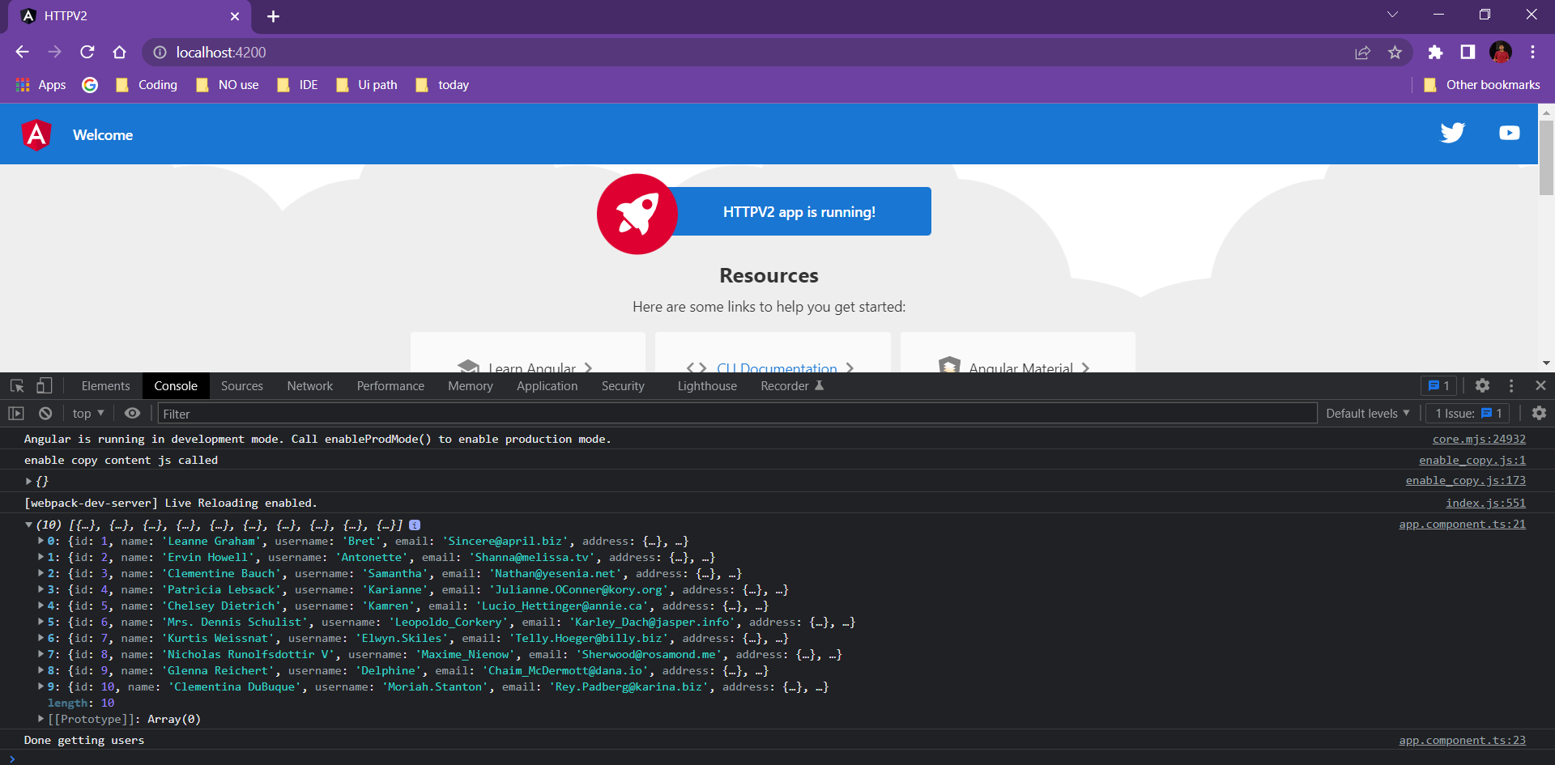18002673456

______________________________ Part 1 finished_________________________________________.