TABLE OF CONTENTS
Page
Chapter 1 – Introduction 1
1.1 Background of the Study 1
1.2 Problem Statement 1
1.3 Objectives of the Project 2
1.4 Scope of the Project 2
1.5 Significance of the Project 3
Chapter 2 – Literature Survey 4
2.1 Review of Existing Systems 4
2.2 Comparative Analysis 5
2.3 Research Gap and Limitations of Existing Systems 5
2.4 Proposed System 6
Chapter 3 – Software Requirement Analysis 7
3.1 Hardware Specification 7
3.2 Software Specification 7
3.3 Software and Tools and Their Features 8
Chapter 4 – System Analysis 10
4.1 Requirement Specification 10
4.2 Characteristics of the Existing System 11
4.3 Proposed System 11
4.4 Feasibility Study 12
4.5 Software Requirement Specification 12
Chapter 5 – System Design 14
5.1 System Architecture and Overall Workflow 14
5.2 Context Diagram 15
5.3 Use Case Diagram 15
5.4 Activity Diagram 16
5.5 Data Flow Diagram and ER Diagram 17
5.6 Database Design 19
5.7 User Interface Design 20
Chapter 6 – System Implementation 22
6.1 Modules Description 22
6.2 System Implementation 24
6.3 Validation Checks 27
6.4 User Interface Implementation 28
Chapter 7 – Testing and Evaluation 29
7.1 Test Cases 29
7.2 Unit Testing 29
7.3 Integration Testing 30
7.4 System Testing 31
7.5 Performance Evaluation 31
Chapter 8 – Results and Conclusion 32
8.1 Results 32
8.2 Discussion and Analysis 32
8.3 Limitations 33
8.4 Lessons Learnt 33
8.5 Conclusion 33
8.6 Future Enhancements 34
Chapter 9 – Appendices 35
Appendix 1 – Plagiarism Certificate 35
Appendix 2 – Screenshots 35
Appendix 3 – Sample Coding 44
Appendix 4 – User Documentation 52
Appendix 5 – Glossary 53
Chapter 10 – Bibliography and References 54

ABSTRACT
Installing a game, an application or a local artificial intelligence model is a routine task, but most users cannot tell in advance whether their computer can run it. The requirements are spread over store pages and model cards in jargon such as VRAM and SSE4.2, while the details of the computer are hidden in Windows settings. Hardware tools do not know what the software needs, requirement pages do not know the computer, and chat assistants may state invented figures with confidence. This project, GPS (Get PC Specs), was developed to solve this problem with a single web based compatibility checker.
The system was built with Python and the Flask framework on the server, SQLite with SQL as the database, and HTML, CSS, JavaScript and GSAP on the client. The database holds a users table with the email as primary key, and accounts are saved only after a six digit code sent by email has been verified. Passwords are stored as salted hashes, codes expire, and the dashboard opens only through a signed session cookie. The application scans the Windows PC locally and asks a hosted language model, openai/gpt-oss-120b on Groq with web search, for the requirements of the software named in the chat using exactly the same labels as the scan.
The requirement data is treated as untrusted and is screened with the Meta Prompt Guard classifier before it is shown or judged. Both sides are then shown row by row, and every row is judged as pass, partial or fail. Exact rules in code decide quantities, units, versions, architecture and operating system, and a local Ollama model named spec-checker is used only to compare named parts such as processor and graphics card models. The result is one plain yes or no verdict that names the blocking and weak components, with the calculation shown for every row. The theme and animation speed can be changed.
The application was tested at the unit, integration and system levels. Eighty automated checks of the account routes, the database, the scan parsing and the comparison rules all passed, and the functions that need Windows and the outside services are tested by hand. The code is stored in a GitHub repository and the application runs on the computer of the user. The result is a free, explainable and private tool. Its present limitations are that it scans only Windows, keeps pending codes and chat history in server memory and runs on the Flask development server. The planned enhancements are per user chat history, sign-in throttling and scanning of Linux and macOS.

LIST OF TABLES
Page
Table 2.1 Comparison of Compatibility Checking Approaches 5
Table 3.1 Hardware Specification 7
Table 3.2 Software Specification 7
Table 4.1 Functional Requirements 10
Table 4.2 Non-functional Requirements 10
Table 5.1 Description of Main Use Cases 16
Table 5.2 Structure of the users Table 19
Table 5.3 Structure of the pending Record (server memory) 19
Table 5.4 Structure of the Session Cookie 19
Table 5.5 Structure of a Comparison Row 19
Table 6.1 Modules and Their Implementation 23
Table 6.2 Routes of the Flask Application 24
Table 6.3 Configuration and Setup 26
Table 6.4 Validation Checks 27
Table 7.1 Functional Test Cases 29
Table 7.2 Unit Test Results 30
Table 7.3 Integration Test Scenarios 30
Table 7.4 System Test Results 31
Table 8.1 Objectives and Results 32
Table 9.1 Glossary of Terms 53

LIST OF FIGURES
Page
Fig. 5.1 System Architecture 14
Fig. 5.2 Deployment Architecture and Local Setup 15
Fig. 5.3 Context Diagram 15
Fig. 5.4 Use Case Diagram 16
Fig. 5.5 Activity Diagram of the Scan and Verdict 17
Fig. 5.6 Level 1 Data Flow Diagram 18
Fig. 5.7 Entity Relationship Diagram 18
Fig. 9.1 Server Start-up in the Command Prompt 36
Fig. 9.2 Landing Page of GPS 36
Fig. 9.3 Sign-up Form and Email Code Entry 37
Fig. 9.4 Sign-in and Password Reset Forms 37
Fig. 9.5 Chat with Requirements Tables at the End 38
Fig. 9.6 Step 1 Scan Chips for CPU, GPU, RAM, Disk and OS 38
Fig. 9.7 Step 2 Reading Your Hardware 39
Fig. 9.8 Step 3 Software Needs Beside Your PC 39
Fig. 9.9 Step 4 Pass, Partial and Fail Results 40
Fig. 9.10 Verdict Panel with Final Yes or No Answer 40
Fig. 9.11 Prompt Guard Stage Failure Message 41
Fig. 9.12 Settings with Theme and Animation Speed 41
Fig. 9.13 Dark Theme of the Dashboard 42
Fig. 9.14 Verification Email with the Six Digit Code 42
Fig. 9.15 Ollama List Showing the spec-checker Model 43
Fig. 9.16 Automated Test Run with 80 Checks Passed 43

Chapter 1 – Introduction

1.1 Background of the Study
Installing a game, an application or a local artificial intelligence model is a routine task, but knowing in advance whether a computer can run it is not simple. A modern download may be tens of gigabytes in size and may take hours to finish. If the processor, graphics card, memory, free disk space or operating system falls short, the user finds out only after the download, the installation or the first launch. The requirements are spread over store pages, vendor sites, model cards and forums and are written in jargon such as VRAM, SSE4.2, min and rec, while the details of the user's own computer are buried in Windows settings, Task Manager and Device Manager.
Research on language models shows both the opportunity and the risk in using them for this problem. Retrieval-augmented generation grounds the answer of a language model in documents that are looked up at the time of the question [7], which suits requirements that change with every release. However, language models can produce fluent statements that are wrong [6], and a wrong figure is costly when it decides whether a large download is started. Text that a model brings in from the web can also carry hidden instructions, an attack known as indirect prompt injection [2], which is listed among the main risks of language model applications [13]. Combining learned models with exact symbolic rules is a recognised way to make such systems more dependable [1].
These ideas are easy to understand but difficult to apply without a tool that reads the real hardware, finds the requirements, checks the data and compares the two sides in a way that can be explained. GPS (Get PC Specs) is a web based compatibility checker developed as a mini project to provide such a tool. It reads the system information of a Windows computer, fetches the requirements of the software that the user names, shows both side by side row by row and ends with one plain answer, yes or no. It combines an animated landing page, an email verified account system and a dashboard for chat, scan and verdict, and it can be opened from any modern browser.

1.2 Problem Statement
Users at present decide whether a PC can run a piece of software by reading store pages, searching forums, opening Windows settings and comparing the two sets of numbers by hand. These methods have several weaknesses. Manual checking is slow and easy to get wrong, especially when a minimum specification is confused with a recommended one. A hardware information tool shows the PC but does not know what the software needs. A requirements page shows what the software needs but does not know the PC. A general chat assistant can describe the requirements but cannot read the computer and may state a wrong figure with confidence. As a result the user has no single place to see what the software needs, what the PC has and whether the two match.
The problem addressed by this project is therefore to design and implement a simple, attractive and reliable web application that scans the user's own Windows PC without sending the scan to an external service, obtains the requirements of the named software using the same labels as the scan, checks that data for hidden instructions, compares the two sides row by row using exact rules wherever possible, and presents a clear pass, partial or fail result for every component together with one final verdict.

1.3 Objectives of the Project
The main objective of the project is to build a complete and secure compatibility checking system using Python, SQL and language model technologies. The specific objectives are listed below.
- To read the real processor, graphics card, memory, free disk space, operating system and architecture of a Windows PC locally and to present them as clean label and value lines that can be parsed.
- To obtain the requirements of the software named in the chat using exactly the same labels as the scan, so that the two lists line up row by row, and to avoid invented figures by returning N/A when a value is not published.
- To screen the requirement data produced by the language model with Meta Prompt Guard before it is shown or judged, and to report which stage failed if the data cannot be used.
- To judge every row with exact rule based checks for quantities, units, versions, architecture and operating system, and to use a local Ollama model only for comparing named parts such as processor and graphics card models.
- To present a pass, partial or fail result for every row, with the calculation that produced it, and one plain yes or no verdict that names the blocking and weak components.
- To protect the system through email one-time codes, hashed passwords, expiring codes with attempt limits and session based access control, and to store user accounts in a relational database with a primary key.
- To keep the hardware data private by running the scan on the user's own machine and by sending the hosted language model only the software name, the field labels and the recent chat.
- To present the system through animated and responsive web pages, namely a landing page, an account page and a dashboard, with theme and animation speed settings and support for reduced motion.

1.4 Scope of the Project
The system is designed for an individual user who wants to know whether a game, an application or a local AI model will run on a Windows PC before downloading it. Within this scope the application supports account creation with email verification, sign in and password reset, a chat about any software, a local scan of the PC that hosts the application, retrieval of the software requirements, a screening step for the retrieved data, a side by side comparison, a row by row verdict with a final yes or no, and settings for theme and animation speed. The application runs in a web browser and needs no installation by the end user other than starting the server.
The following are outside the scope of the present version: scanning of macOS and Linux computers, scanning of a remote computer, separate chat history for each user, a curated requirements database, a computed upgrade recommendation, screening of chat messages with Prompt Guard, sign in throttling and a log out button, and deployment on a production server. These are listed as future enhancements in Chapter 8.

1.5 Significance of the Project
For the user, the project replaces many browser tabs and manual comparisons with one tool that answers three practical questions: what the software needs, what the PC has, and whether the PC can run it. Because every row shows how its result was reached, the verdict can be understood and trusted instead of being a guess made before a long download.
From the academic point of view the project demonstrates the application of web development, authentication and security, database design, language model engineering, AI safety, hybrid rule based and model based reasoning and Windows systems programming in a single working system. It shows how an idea can be taken through analysis, design, implementation and testing using freely available tools, and it provides a base on which a multi-user version and a curated requirements database can be built.

Chapter 2 – Literature Survey

2.1 Review of Existing Systems
Before designing the system, the ways in which people commonly check whether a PC can run software were reviewed. They fall into five groups, which are described below, and they are supported by a small body of research on language models and their safety.

2.1.1 Manual checking with Windows tools
The simplest approach is to open Windows settings, Task Manager, Device Manager or the DirectX diagnostic tool and to note the processor, graphics card, memory, free space and operating system. The tools are free and always present, but the information is scattered over several windows, some names are hard to interpret, and the user must still find the requirements and compare every value alone.

2.1.2 Hardware information utilities
Many stand-alone programs list the details of a computer, including core counts, clock speeds and graphics adapters, in a single report. These tools are accurate and help a user to read the hardware, but they do not know what any particular game or application needs. The report has to be compared with a requirements page by hand, and the comparison is again left to the user.

2.1.3 Store pages, vendor sites and forums
Store pages and vendor sites publish minimum and recommended requirements, and model cards describe the memory of local AI models. They are the source of truth but they are written in different styles and jargon, some publish no figures at all, and forum posts may repeat old or wrong numbers. They cannot be compared automatically with the hardware of the reader.

2.1.4 Web based compatibility checkers
Some websites compare a PC with a stored database of games and answer whether a title can run. They are convenient, but their coverage is limited to the titles in the database, newer releases and AI models may be missing, some need a scan to be uploaded or a small program to be installed, and many give only a yes or no without showing the reason.

2.1.5 AI chat assistants
General purpose chat assistants can summarise the requirements of a program in a few seconds. The limitation is that they cannot read the computer, they may state an invented figure with confidence [6], and they are weak at exact arithmetic such as converting units or comparing versions. Grounding the answer in retrieved documents reduces the problem [7] but does not remove it, and the data they fetch is usually not screened before it is trusted.

2.1.6 Related research
Lewis and colleagues show that retrieval of external documents improves the factual quality of generated answers [7], while the survey by Ji and colleagues explains why language models still produce hallucinated content [6]. Greshake and colleagues demonstrate that instructions hidden in retrieved content can take control of a language model application [2], and the OWASP list of risks places prompt injection first among language model threats [13]. Meta released the Prompt Guard classifier to detect injection and jailbreak text [8]. Garcez and Lamb argue that learning systems become more reliable when they are combined with symbolic reasoning [1]. These findings support a tool that grounds its data in web search, screens that data and uses exact rules before a model, which is the purpose of the web search, the Prompt Guard screening and the rule engine in GPS.

2.2 Comparative Analysis
Table 2.1 compares the approaches reviewed above with the proposed system. The comparison is based on the general characteristics of each group of tools and not on any single product.
Table 2.1 Comparison of Compatibility Checking Approaches
Feature | Manual check | Info utility | Store pages | Web checker | AI chat | GPS
Reads real hardware automatically | Manual | Yes | No | Partial | No | Yes
Finds software requirements | No | No | Yes | Partial | Partial | Yes
Same labels side by side | No | No | No | Partial | No | Yes
Row by row pass, partial, fail | No | No | No | Partial | No | Yes
Single yes or no verdict | No | No | No | Yes | Partial | Yes
Covers games and AI models | No | No | Partial | Partial | Partial | Yes
Exact unit and version checks | Manual | No | No | Partial | No | Yes
Screens fetched data for injection | No | No | No | No | No | Yes
Keeps hardware scan on device | Yes | Yes | Yes | Partial | No | Yes
Explains how a result was reached | No | No | No | Partial | Partial | Yes
Verified account and sign in | No | No | No | Partial | Partial | Yes

2.3 Research Gap and Limitations of Existing Systems
The review shows that each existing approach solves only a part of the user's need. The main limitations that were identified are listed below.
- Hardware details and software requirements are found in different places and written in different styles, so the user must compare them by hand and may confuse a minimum with a recommended specification.
- Hardware tools do not know what the software needs, and requirement sources do not know the hardware of the user, so neither side can give a verdict alone.
- Language model answers may contain invented figures and are rarely checked, although unit conversion, arithmetic and version comparison are better done by exact code than by a model.
- Data that a model brings in from the web is seldom screened for hidden instructions before it is shown or used.
- Few tools combine scan, requirement lookup, side by side comparison and an explainable verdict while keeping the hardware data on the machine of the user.

2.4 Proposed System
GPS is proposed as a web application that closes these gaps. It scans the Windows PC locally, asks a hosted language model with web search for the requirements of the named software using the same labels as the scan, screens the returned data with Prompt Guard, judges each row with exact rules and a small local model, and presents the results as a row by row table with one final verdict. It also provides an email verified account system, so that the dashboard is available only after sign in. The application is built with open source tools and runs on the user's own computer, so the hardware data stays on the machine.

Chapter 3 – Software Requirement Analysis

3.1 Hardware Specification
The hardware used for development, hosting and use of the system is given in Table 3.1. The requirements are modest because the web pages are light, and the heaviest parts are the Prompt Guard classifier and the local Ollama model, which run on the same computer.
Table 3.1 Hardware Specification
Item | Minimum requirement | Recommended
Host and development computer | Dual core processor, 8 GB RAM, 10 GB free disk space | Quad core processor, 16 GB RAM, SSD
Local model (Ollama) | About 4 GB of free memory for a small model | 8 GB of free memory
Graphics | Integrated graphics (a dedicated GPU is not required) | Dedicated GPU for faster local model replies
Display | 1366 x 768 resolution | Full HD (1920 x 1080)
Network | Broadband or mobile internet | Stable broadband for web search and model calls
Mail account | Gmail address with 2-Step Verification and an App Password | Dedicated sender address for the project
Scanned PC | Windows 10 or Windows 11 computer that runs the server | Same computer with the latest updates

3.2 Software Specification
Table 3.2 Software Specification
Component | Specification
Operating system | Windows 10 or Windows 11 (the hardware scanner uses Windows-only interfaces)
Programming language | Python 3.10 or later
Web framework | Flask with Blueprints and signed session cookies, on Werkzeug
Database | SQLite 3 (included with Python) using SQL
Hosted language model | Groq API, model openai/gpt-oss-120b, with the browser_search tool
Local language model | Ollama, custom model named spec-checker
AI safety model | Meta Prompt-Guard-86M through Hugging Face Transformers and PyTorch
Hardware scan libraries | ctypes, winreg, wmic or PowerShell, psutil, platform and shutil
Email delivery | smtplib over SSL with a Gmail address and a Google App Password
Front end | HTML5, CSS3, JavaScript (ES6), GSAP 3.12 with TextPlugin, Geist fonts
Configuration | python-dotenv and a .env file for keys and secrets
Browser | Google Chrome or Microsoft Edge (latest versions)
Version control | Git with a .gitignore that keeps secrets and the database out of the repository

3.3 Software and Tools and Their Features
This section describes the main tools and the features of each tool that were used in the project.

3.3.1 Python
Python is a general purpose, high level programming language noted for its readable syntax and extensive standard library [16]. It was selected for the whole server side because it is simple to write, includes modules for SQLite, email, secure random numbers and HTTP, and offers libraries for language models and for reading hardware information.

3.3.2 Flask and Werkzeug
Flask is a small web framework that offers URL routing, request handling, signed session cookies and Blueprints for dividing an application into modules [14] [3]. In GPS the account routes are kept in a Blueprint that the main server file registers, and static file serving is switched off so that every page is delivered only through an explicit route. Werkzeug, the toolkit on which Flask is built, provides the salted password hashing used for stored passwords [14].

3.3.3 SQLite and SQL
SQLite is a relational database that needs no server and keeps all data in one file, while still supporting SQL, constraints and transactions [19]. In GPS it holds one table of users with the email as primary key, the user name, the password hash and the creation time. All queries use parameters, and no separate database server has to be installed or managed.

3.3.4 HTML, CSS, JavaScript and GSAP
HTML5 defines the structure of the pages, CSS3 provides the layout, colours and the light and dark themes through custom properties, and JavaScript provides the chat, the markdown and table renderer, the scan steps and the interaction with the server through the fetch function [10]. The GreenSock Animation Platform (GSAP) with its TextPlugin drives the timelines, the scroll based storytelling and the typing effect [5].

3.3.5 Groq API and gpt-oss-120b
Groq provides a hosted interface for running open weight language models [4]. GPS uses the model openai/gpt-oss-120b [12] through the Groq library with the browser_search tool, so that the model can look up official requirements. Two separate prompts are used: a chat prompt that gives an explanation first and tables last, and a data service prompt that returns strict JSON with the same labels as the scan. Several API keys can be listed, and the server moves to the next key when one fails.

3.3.6 Ollama and the spec-checker model
Ollama runs open language models on the user's own computer and offers them through a local HTTP interface [11]. GPS uses a custom model named spec-checker. It receives only a one line question that asks which of two parts is better in performance and must answer in one word, with the temperature set to zero. The model name and the address can be changed through environment variables.

3.3.7 Prompt Guard and Transformers
Prompt-Guard-86M is a small classifier released by Meta that labels text as benign, injection or jailbreak [8]. It is loaded through the pipeline interface of the Hugging Face Transformers library [20]. The wrapper treats the requirement data as third party content and blocks both injection and jailbreak labels. Because the classifier reads about 512 tokens, longer text is checked in chunks of about 1,200 characters and the worst chunk decides.

3.3.8 Windows hardware interfaces
Several interfaces are important for the scan. The GlobalMemoryStatusEx function of the Windows API, called through ctypes, returns the total and available memory [9]. The winreg module reads the marketing name of the processor from the registry [16]. The psutil library gives the physical and logical core counts and the maximum clock speed [17]. The wmic command, or PowerShell when wmic is missing, lists the graphics adapters, and the shutil module reports the free and total space of every drive.

3.3.9 Gmail SMTP and one-time codes
Account verification depends on a six digit one-time code that is generated with the secrets module, which produces cryptographically strong random numbers [16]. The code is sent with smtplib over SSL through a Gmail address and a Google App Password. The message is an HTML template with a plain text fallback, and the credentials are kept in a .env file outside the source code.

Chapter 4 – System Analysis

4.1 Requirement Specification
The requirements were collected from the problem statement and from the review of existing methods. They are divided into functional and non-functional requirements, following the usual classification in software engineering [18].

4.1.1 Functional requirements
Table 4.1 Functional Requirements
ID | Requirement
FR1 | The system shall allow a user to create an account with name, email and password, and shall save the account only after the six digit code sent by email has been verified.
FR2 | The system shall allow sign in with email and password, and shall allow a forgotten password to be reset after a code sent by email has been verified.
FR3 | The system shall allow the dashboard and its data services to be used only by a signed in user.
FR4 | The system shall provide a chat in which the user can ask about any game, application or AI model and receive answers based on official requirements found by web search.
FR5 | The system shall show the explanation of each answer first and every table at the end, and shall remember the software last discussed.
FR6 | The system shall scan the PC on request and shall show processor, graphics card, memory, free disk space and operating system, together with every other scanned value.
FR7 | The system shall fetch the requirements of the last discussed software using exactly the labels of the scan and shall return N/A for values that are not published.
FR8 | The system shall screen the fetched requirement data with Prompt Guard and shall show which stage failed if the data cannot be used.
FR9 | The system shall show the software needs and the PC values side by side row by row and shall drop rows in which either side is N/A.
FR10 | The system shall judge quantities, units, versions, architecture and operating system by exact rules in code.
FR11 | The system shall compare named parts such as processor and graphics card models with the local model, and shall mark an unreadable answer as partial.
FR12 | The system shall show a pass, partial or fail result for every row, with the calculation and its source, and shall give one yes or no verdict with counts, blockers and weak points.
FR13 | The system shall allow the chat to be cleared and the theme and animation speed to be changed.

4.1.2 Non-functional requirements
Table 4.2 Non-functional Requirements
Attribute | Requirement
Usability | A guided page with four clear steps, animated feedback, readable error messages that name the failed stage, and a keyboard shortcut to reach the chat.
Performance | The scan shall complete within a few seconds, and the verdict shall be calculated from the table rows without noticeable delay apart from the language model calls.
Reliability | The server shall move to another API key when one fails, shall never show an unscreened or unreadable result as a pass, and shall ignore answers that belong to an older request.
Portability | The pages shall run in common browsers on desktop and phone widths, while the scan is limited to Windows.
Maintainability | The code shall be modular, with separate files for the server, the account routes, the scanner, the safety layer and the verdict engine.
Security | Passwords shall be stored as salted hashes, codes shall expire and have an attempt limit, queries shall use parameters, session cookies shall be HttpOnly, and all text shall be escaped before display.
Privacy | The hardware scan shall stay on the machine, and the hosted model shall receive only the software name, the labels and the recent chat.
Cost | The system shall be built with open source tools and run on the user's own computer.

4.2 Characteristics of the Existing System
The existing way of working, which is described in Chapter 2, has the following characteristics. Hardware details and software requirements are kept in different places. There is no automatic link between the scan of a PC and the requirements of a program. Units and jargon have to be converted by hand, and the comparison is made by reading and guessing. Answers from chat assistants are not checked, and the data they fetch is not screened. These characteristics make the existing system time consuming, error prone and a frequent cause of failed downloads.

4.3 Proposed System
The proposed system, GPS, is a web application with a Flask server, a relational user database and a verdict engine. It collects the scan from the host PC, fetches the requirements through a hosted language model, screens them, judges each row mostly by exact code and presents the results on one dashboard in four steps. The hosted model sees only the software name, the labels and the recent chat, and the scan never leaves the machine. The advantages of the proposed system over the existing one are given below.
- Chat, scan, comparison and verdict are available in one place, one after the other.
- Software requirements and PC values use the same labels, so they line up row by row.
- Quantities, units and versions are checked by exact code, and a model is used only where judgement is needed.
- Every result shows how it was reached, and failing rows are named, so the verdict can be understood.
- Data produced by the language model is screened, and a failure is shown instead of unchecked data.
- The scan stays on the machine, and the dashboard is protected by a verified email, hashed passwords and session control.

4.4 Feasibility Study

4.4.1 Technical feasibility
Every technology used in GPS is well established, documented and free to use. The server relies on Python, Flask and SQLite, the scan relies on standard Windows interfaces, and the language models are reached through Groq and Ollama, with Prompt Guard loaded through the Transformers library. Since the developer already knew Python, SQL and the use of language model interfaces, building the system was technically achievable.

4.4.2 Economic feasibility
No software or hardware had to be purchased. The work was done on an existing computer with open source software, a Gmail account sends the codes, and the hosted model is used lightly because every check sends only a software name, a list of labels and the recent chat. The project therefore involved very little extra expense.

4.4.3 Operational feasibility
No training is needed to use the interface. A user can create an account, ask about a game and press the scan button within a few minutes, and every step gives animated feedback and a clear message that names the stage that failed. Because the system addresses an everyday need of people who install software, it is operationally practical.

4.4.4 Schedule feasibility
The project had a fixed submission date. The work was divided into small stages: first the account system with email verification, then the chat, then the scan and the requirement lookup, then the verdict engine, and finally the landing page, polishing and documentation. The incremental approach, a standard model of software development [15], made it possible to have a working system at every stage, so the schedule was feasible.

4.5 Software Requirement Specification

4.5.1 Purpose and scope
This specification describes the behaviour of GPS, a web based compatibility checker for an individual user. The system manages accounts, answers questions about software, scans the PC, compares the requirements with the hardware and shows a verdict.

4.5.2 Product perspective and users
GPS is a stand-alone web application with a browser client, a Flask application server and an SQLite database, supported by a hosted language model reached through Groq, a local Ollama model and the Prompt Guard classifier. There is one class of user, the signed in user, who has permission to use every function. A visitor who has not signed in can open only the landing page and the account page.

4.5.3 Operating environment
The server runs Python 3.10 or later on Windows 10 or Windows 11 with Ollama installed and running and the spec-checker model available. The client is a modern browser with JavaScript enabled. An internet connection is needed for the hosted model, the first download of Prompt Guard, the email service and the script and font libraries.

4.5.4 Design constraints
The scanner uses Windows-only interfaces and scans the machine that runs the server. The chat history and the last discussed software are kept in memory and are shared by every signed in user, and pending sign-ups and codes are lost when the server restarts. The application runs on the Flask development server, and Prompt Guard needs a Hugging Face token and an accepted licence. The animation library and fonts are loaded from the internet.

4.5.5 Assumptions and dependencies
It is assumed that Ollama is running with the spec-checker model, that the Groq keys are valid and that the server is started on the PC that is to be checked. The system depends on the availability of Groq, Hugging Face, Gmail and the content delivery network, and the accuracy of the requirements depends on the language model and on the web pages that it finds.

4.5.6 External interface requirements
The user interface consists of three responsive web pages: the landing page, the account page and the dashboard. The hardware interface is the set of Windows interfaces read through ctypes, winreg, wmic or PowerShell and psutil. The software interfaces are the SQLite library, the Groq API, the local Ollama HTTP interface, the Transformers library and SMTP. Communication uses HTTP and JSON between the browser and the server on the local address 127.0.0.1, https to Groq and SSL to the mail server.

Chapter 5 – System Design

5.1 System Architecture and Overall Workflow
GPS follows a three tier architecture, which is shown in Fig. 5.1. The client tier is the web browser, which displays the animated landing page, the account page and the dashboard, runs the GSAP animations, renders the chat answers and keeps the theme and speed settings. The application tier is a Flask application that receives requests, checks that the user has signed in, calls the outside services and runs the comparison. The data tier is an SQLite database that holds the users table, together with the pending codes, the chat history and the last discussed software, which are kept in server memory.
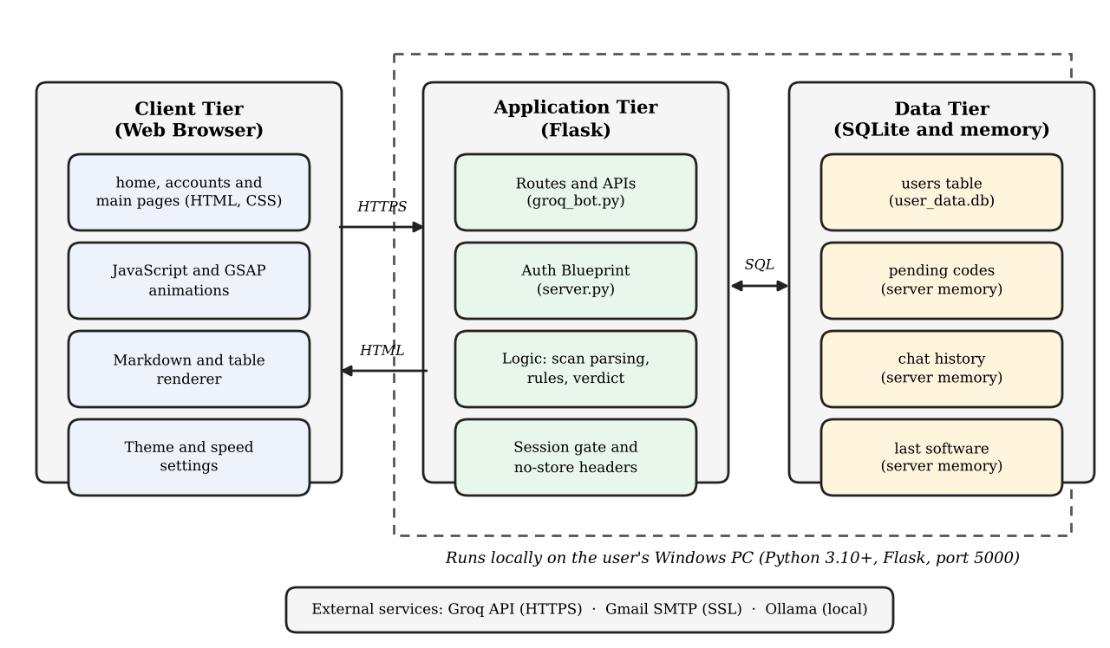
Fig. 5.1 System Architecture
The overall workflow is as follows. When the user opens the site, the browser requests the landing page, and its Scan my PC link leads to the account page. A new user sends a name, an email address and a password to the /api/send-otp route, which emails a six digit code. The account is written to the database only after the code is verified, and a signed session cookie then unlocks the dashboard. On the dashboard a question is sent to /api/chat, where the hosted Groq model answers with web search and the server remembers the name of the software. When the user presses Take my system data, the /api/collect_spec route runs the Windows hardware scan on the local machine, asks Groq for the requirements of the software using exactly the same labels as the scan, and screens the returned data with Prompt Guard. The browser then shows both lists side by side and sends them to /api/verdict, where exact rules and the local Ollama model grade every row and return one Yes or No answer.
The deployment architecture is shown in Fig. 5.2. GPS is meant to run on the computer of the user, because the hardware scanner uses Windows only interfaces and must read the machine on which the software will be installed. The code is kept in one project folder, with the pages in screens, the Python files in models, user_data_verification and storage, and the secrets in a .env file that is never committed. After the packages are installed with pip, the Gmail App Password, the Groq keys and the Hugging Face token are added to .env and the spec-checker model is created in Ollama. The command python models/groq_bot.py then starts the single Flask server on port 5000, which serves the pages, hosts every API and reads and writes the SQLite file. No separate continuous integration server is used in the present version.
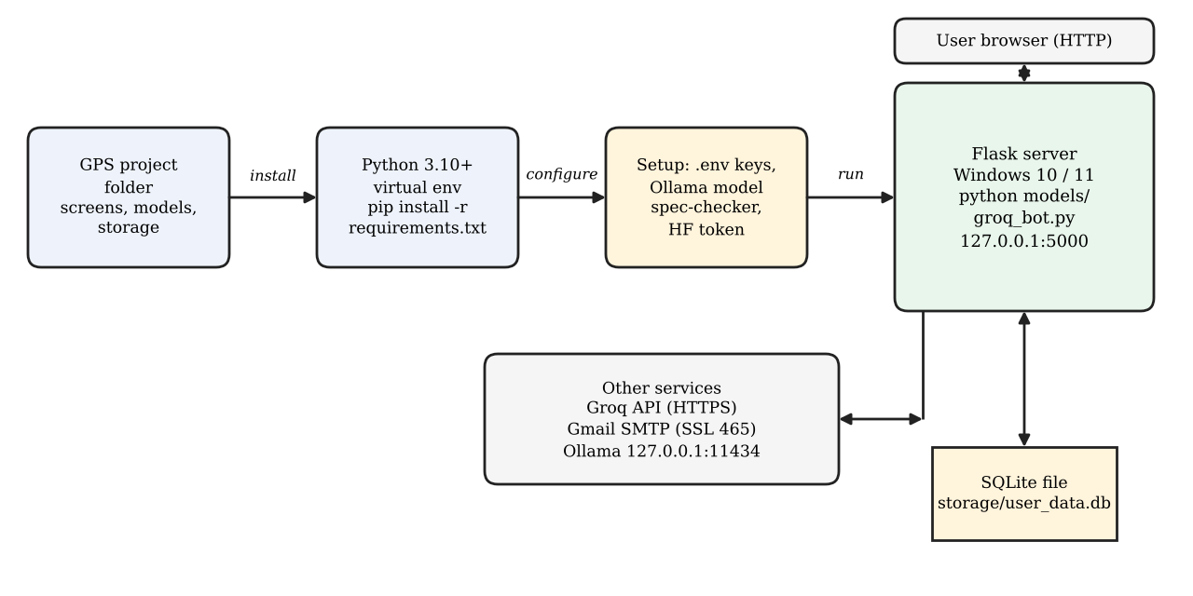
Fig. 5.2 Deployment Architecture and Local Setup

5.2 Context Diagram
The context diagram in Fig. 5.3 shows the system as one process that exchanges data with the user and with three outside services. The user supplies account details, email codes, questions, a scan request and display settings. The system returns the pages, the chat answers, the hardware snapshot and the final verdict. The Groq API receives the software name and the field labels and returns the requirements, Gmail SMTP delivers the six digit code, and the local Ollama model receives two part names and returns a one word comparison.
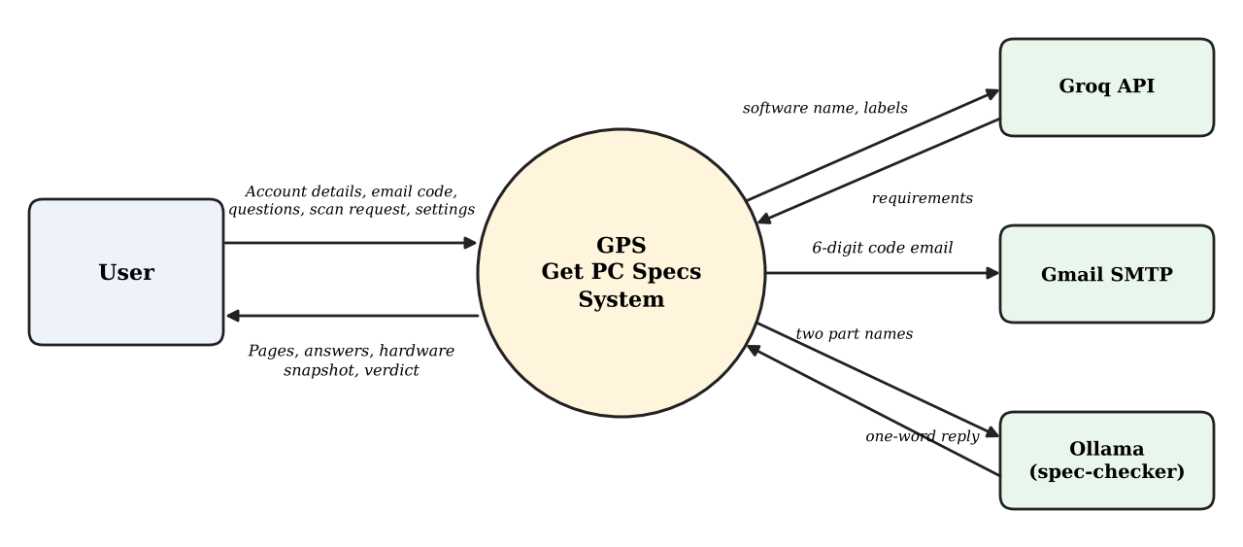
Fig. 5.3 Context Diagram

5.3 Use Case Diagram
Fig. 5.4 shows the twelve use cases of the system. The user is the only actor. The use cases on the left concern access to the system, and the use cases on the right concern the checking of software against the PC. Table 5.1 describes the more important use cases.
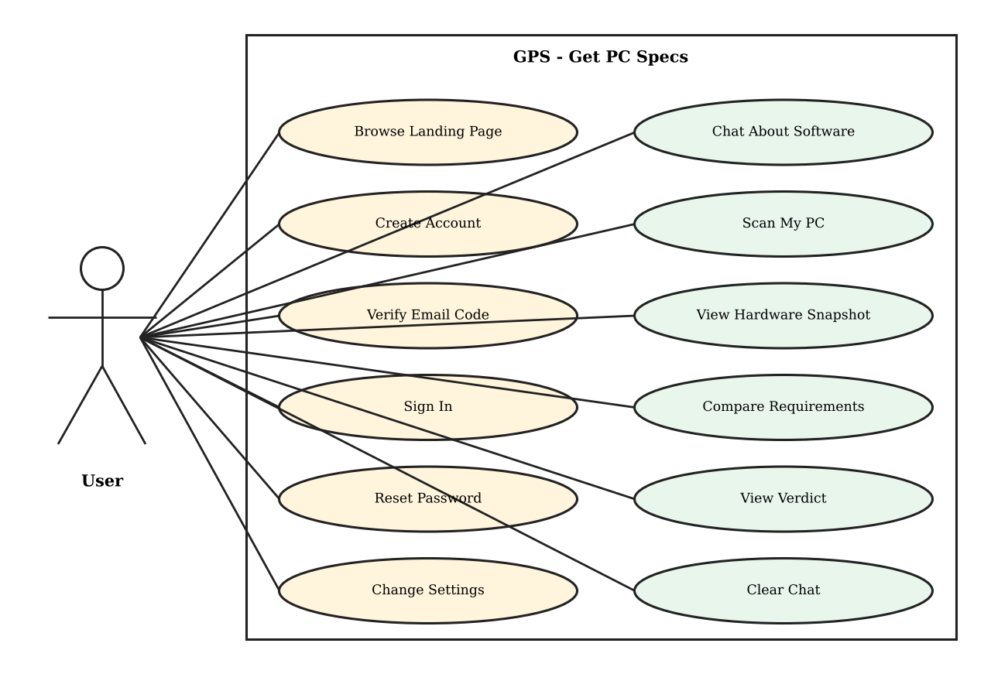
Fig. 5.4 Use Case Diagram
Table 5.1 Description of Main Use Cases
Use case | Main flow | Result
Create Account | User enters a name, email and password and presses Create account. | A six digit code is emailed and the sign-up is held until the code is verified.
Verify Email Code | User types the six digits, which are checked automatically. | Account is saved, the session starts and the dashboard opens.
Sign In | User enters email and password. | Session cookie is set and the dashboard opens. A wrong pair gives one common error.
Reset Password | User asks for a code from the sign-in form, verifies it and enters a new password. | Password hash is replaced and the user signs in again.
Chat About Software | User asks about a game, app or AI model. | Answer with requirement tables is shown and the software name is remembered.
Take System Data | User presses Take my system data. | PC is scanned locally and the requirements of the software are fetched and screened.
Compare Requirements | User scrolls to Step 3. | Software needs and Your PC are shown side by side, row by row.
View Verdict | User opens Step 4. | Pass, Partial or Fail is shown for every row, with one Yes or No answer.

5.4 Activity Diagram
Fig. 5.5 shows the activity flow of the scan and the verdict, which is the most complex function of the system. The user must first ask about a software in the chat, otherwise the server has no software name and no requirements can be fetched. When Take my system data is pressed, the hardware is read on the local machine, Groq is asked for the requirements using the same labels as the scan, and the returned data is screened by Prompt Guard. If the screening fails, the page names the stage that failed and Step 3 stays empty. Otherwise every row is judged, first by exact rules and then by the Ollama model for part names, and the rows with their results and the final Yes or No verdict are shown.
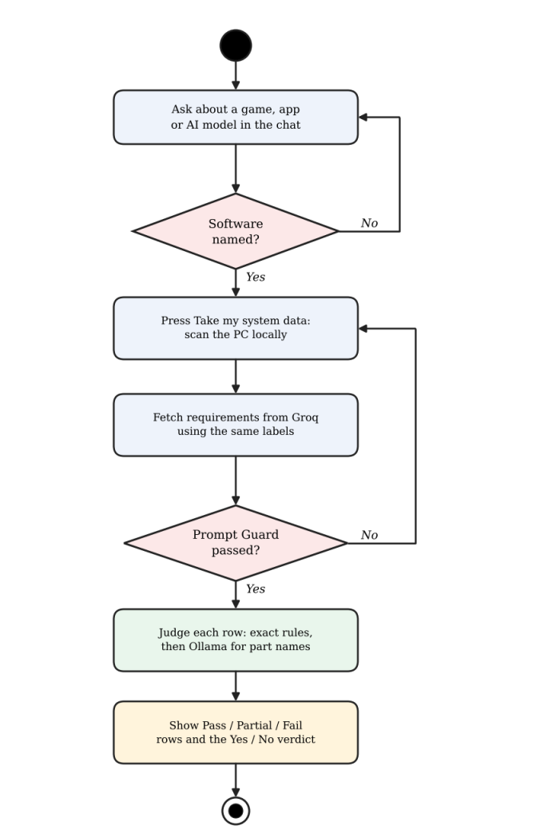
Fig. 5.5 Activity Diagram of the Scan and Verdict

5.5 Data Flow Diagram and ER Diagram

5.5.1 Data flow diagram
Fig. 5.6 is the level 1 data flow diagram. Four processes work on three data stores. Process 1.0 manages accounts and uses store D1, the users table, and store D2, the pending codes. Process 2.0 handles the chat and keeps the history and the last software in D3. Process 3.0 reads the software name from D3, scans the PC and fetches the requirements. Process 4.0 receives the rows from 3.0 and returns the verdict to the user.
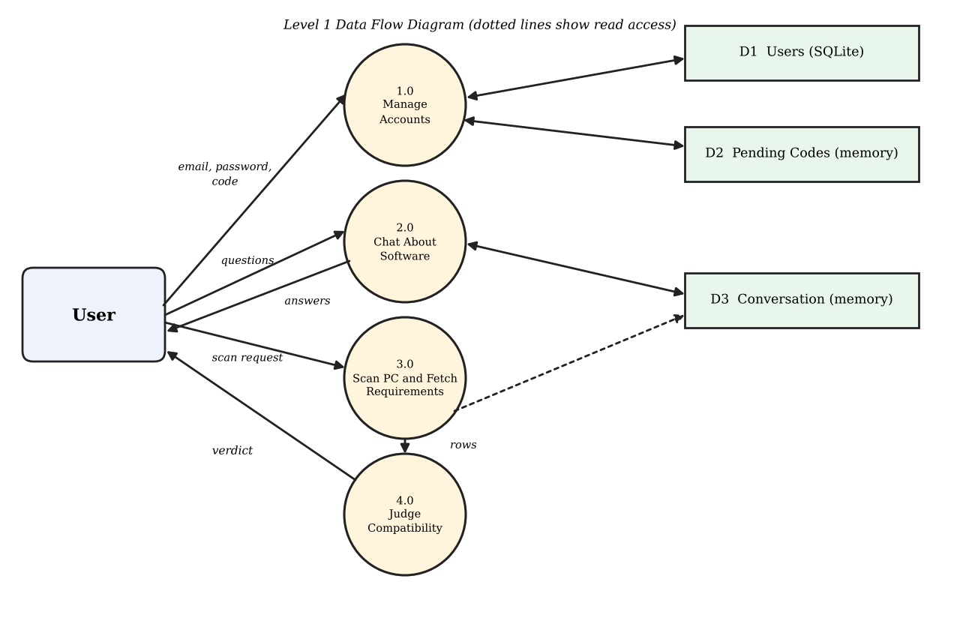
Fig. 5.6 Level 1 Data Flow Diagram

5.5.2 Entity relationship diagram
The entity relationship diagram in Fig. 5.7 has three entities. USERS and SESSION are related by a one to many relationship, because one user can be signed in from several browsers while each session cookie belongs to exactly one user. SESSION is not a table but a signed cookie that holds the email and the name. The entity PENDING is independent, because it exists only in server memory for a short time and is linked to USERS only by the value of the email, not by a foreign key.
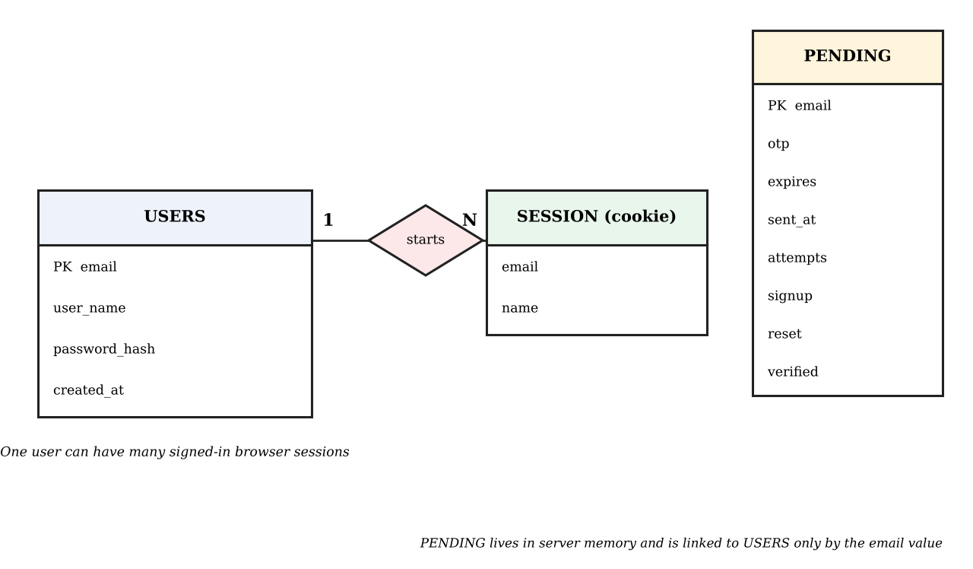
Fig. 5.7 Entity Relationship Diagram

5.6 Database Design
The database was designed in third normal form [15]. The users table has a primary key and every non-key column depends only on that key. Short lived data, namely the pending codes and the session cookie, are not stored in the database but are held in server memory and in a signed cookie, so that an unverified sign-up never reaches the database. Tables 5.2 to 5.5 give the structure of the users table, the pending record, the session cookie and a comparison row.
Table 5.2 Structure of the users Table
Column | Data type | Constraint | Description
email | TEXT | Primary key | Unique email address of the user, stored in lower case
user_name | TEXT | NOT NULL | Full name entered at sign-up
password_hash | TEXT | NOT NULL | Salted Werkzeug hash of the password
created_at | TEXT | Default: current time | Date and time the account was created

Table 5.3 Structure of the pending Record (server memory)
Column | Data type | Constraint | Description
otp | TEXT | 6 digits | One time code made with secrets.randbelow
expires | FLOAT | 5 minutes | Time stamp after which the code is invalid
sent_at | FLOAT | 30 second cool-down | Time the last code was sent
attempts | INTEGER | At most 5 | Number of wrong codes entered
signup | DICT or None | Name and password | Details of an account waiting for verification
reset | BOOLEAN | Default False | True for the forgot password flow
verified | BOOLEAN | Default False | True once a reset code is accepted

Table 5.4 Structure of the Session Cookie
Column | Data type | Constraint | Description
email | TEXT | Set at sign-in | Verified email of the signed-in user
name | TEXT | Set at sign-in | Name shown on the dashboard

Table 5.5 Structure of a Comparison Row
Column | Data type | Constraint | Description
label | TEXT | At most 60 characters | Component such as CPU, GPU or RAM
needs | TEXT | At most 120 characters | Value the software requires
has | TEXT | At most 120 characters | Value read from the PC
verdict | TEXT | pass, partial or fail | Result for the row
calc | TEXT | Short text | How the result was reached
src | TEXT | rule or model | Exact check or local model
info | BOOLEAN | Default False | True if the row is shown but never blocks

The statement used to create the table is given below.
CREATE TABLE IF NOT EXISTS users (
email TEXT PRIMARY KEY,
user_name TEXT NOT NULL,
password_hash TEXT NOT NULL,
created_at TEXT DEFAULT CURRENT_TIMESTAMP
);
The queries of the system are few, and all of them use placeholders so that user input is never joined into the SQL text. A primary key lookup checks for a duplicate email. An insert saves a verified account with its password already hashed. A select returns the stored hash for the sign-in check, and an update replaces the hash when a password is reset. Data for the dashboard is not read from the database, because the scan, the requirements and the verdict are produced for each request.
-- Duplicate check (primary key lookup)
SELECT 1 FROM users WHERE email = ?;

-- Create the account after the code is verified
INSERT INTO users (email, user_name, password_hash) VALUES (?, ?, ?);

-- Sign in (the hash is compared in Python)
SELECT user_name, password_hash FROM users WHERE email = ?;

-- Reset a forgotten password
UPDATE users SET password_hash = ? WHERE email = ?;

5.7 User Interface Design
The interface consists of three pages. The landing page is a scroll driven story of twelve sections that explains the problem and ends with a Scan my PC link. The account page shows one form at a time, either sign up or sign in, with a six box code entry and the password reset. The dashboard is a single scrolling page with a fixed side bar for Messages, Scan and Settings. It holds the chat with the input bar at the bottom, followed by Step 1 Scan, Step 2 Reading your hardware, Step 3 Your software meets your PC and Step 4 Can you run it, which ends with the verdict panel.
Several principles guided the design. Feedback is immediate, for example through the typing effects, the bouncing dots while the model answers, the status line on the account page and the drawn tick or cross of the verdict. The look is consistent because all three pages share the same fonts and colours, and the dashboard offers Auto, Light and Dark themes and three animation speeds. Every result shows how it was reached, since each row can show the calculation and whether it came from an exact check or from the model. Errors appear as a message instead of failing silently. The layout adjusts down to the width of a phone, and when the system asks for reduced motion the animations jump to their final frame.

Chapter 6 – System Implementation
GPS is an application and not a machine learning project that trains its own model. It uses a hosted language model and a small local model through their interfaces, so the sections of the project guidelines that concern datasets, preprocessing, feature engineering and model training do not apply and are omitted. This chapter describes the modules, the implementation of the main functions, the validation checks and the user interface.

6.1 Modules Description

6.1.1 Account and verification module
This module creates and checks accounts. A sign-up sends a name, an email and a password to /api/send-otp. The email must match a strict pattern with one plain address, a duplicate email is refused, and a second request within 30 seconds is refused. The sign-up is held in memory together with a six digit code that lives for five minutes and allows five wrong guesses. Only after /api/verify-otp accepts the code is the user written to the users table, with the password stored as a salted hash, and a session is started. Sign-in uses verify_login and gives the same message for a wrong email and a wrong password. A forgotten password uses the same code flow with reset set to true, and /api/reset-password works only after the code was verified.

6.1.2 Email delivery module
The code is made by generate_otp with secrets.randbelow, so it always has six digits. send_otp builds a message with a plain text part and an HTML part that is made from mail.html by replacing placeholders such as {{OTP}}, {{D1}} to {{D6}} and {{EXPIRY_MINUTES}}, and sends it through Gmail over SSL on port 465. The sender address and the App Password are read from the .env file by a small parser, and real environment variables take priority. If the template file is missing, the plain text message is still sent.

6.1.3 Access control module
A hook that runs before every request allows /main and the five dashboard APIs only when the signed session cookie contains an email. An anonymous request for the dashboard is redirected to /accounts, and an anonymous API call gets the status 401. Flask's static folder is switched off, so pages are served only by explicit routes. The session cookie is HttpOnly and SameSite Lax, and every response carries Cache-Control no-store so that the browser never shows an old copy of the dashboard.

6.1.4 Chat module
The chat module sends the question and the history to the Groq model openai/gpt-oss-120b with the browser_search tool, so that the answer is based on official requirements. The system prompt forbids invented figures, asks for "not published" instead of a guess, and puts all explanation first and all tables at the end. Every answer ends with a hidden tag [[SOFTWARE: name]], which the server removes and keeps as the software last discussed. Several keys can be listed in GROQ_API_KEYS; the module starts with the key that worked last and moves to the next one on failure, except for a bad request, which would fail on every key. If Groq rejects the search tool, the call is repeated without it.

6.1.5 Hardware scan module
get_the_system_spec.py prints one Label: value line for each fact: the operating system, the CPU name from the registry, the core counts and clock speed from psutil, the total and available memory from GlobalMemoryStatusEx, the free and total space of every drive, and the graphics adapters from wmic or, if that is missing, from PowerShell. The route /api/collect_spec captures these lines, parses them and builds five chips: CPU, GPU, RAM, Disk and OS. A dedicated graphics card is preferred to an integrated one, the disk chip shows the free space of the system drive, and Windows 11 is recognised from a build number of 22000 or more. All other lines are kept as details for Step 2, except noisy ones such as driver versions.

6.1.6 Requirements module
fetch_software_spec asks Groq in a second call, with a separate data service prompt and a temperature of 0.1, what the software discussed last needs. The call carries the software name, the labels of the scan and the last few chat turns, and it must answer with one JSON object that uses exactly those labels. The prompt tells the model how to convert units and how to write names in the same style as the scan. Only the requested labels are kept, each value is flattened to one line and cut to 120 characters, and a missing value becomes N/A.

6.1.7 Prompt Guard module
meta_llama_layer.py loads the Prompt-Guard-86M classifier once. The requirement data is treated as third party content, so a result of INJECTION or JAILBREAK with a score of 0.5 or more blocks it. The classifier reads only about 512 tokens, so the text is cut into pieces of about 1,200 characters and the worst piece decides. If the check cannot run or the data is blocked, the page names the stage that failed and Step 3 stays empty instead of showing unchecked data.

6.1.8 Verdict module
spec_checker.judge grades every row as pass, partial or fail. Exact rules decide the rows that are arithmetic or plain facts: quantities with units, the operating system and its build, the architecture, vague wording for the CPU and unknown values. Only the rows that rules cannot decide, such as two processor or graphics card names, go to the local Ollama model spec-checker with a one line question and a temperature of 0. A reply that cannot be read gives partial and never a silent pass. A spare drive or graphics card cannot block the result when another one passes, and the software runs when no row has failed.

6.1.9 Interface and settings module
The three pages are plain HTML, CSS and JavaScript with GSAP. The landing page tells the story in twelve sections, the account page holds the sign-up, code, sign-in and reset forms, and the dashboard holds the chat and the four steps. The settings give the theme (Auto, Light or Dark) and the animation speed (Slow, Normal or Fast), and a Clear chat button that also resets the memory of the server. A reload of the dashboard starts clean because the page calls /api/reset.
Table 6.1 Modules and Their Implementation
Module | Server side | Browser side
Account and verification | /api/send-otp, /api/verify-otp, /api/reset-password, /api/sign-in | Sign-up, code, sign-in and reset forms
Email delivery | otp_utils.py, SMTP over SSL | mail.html template inside the email
Access control | before_request hook, session cookie | Redirect to /accounts
Chat | /api/chat, Groq client | Markdown renderer, input bar
Hardware scan | get_the_system_spec.py, /api/collect_spec | Step 1 chips, Step 2 rows
Requirements | fetch_software_spec in groq_bot.py | Step 3 side by side rows
Prompt Guard | meta_llama_layer.py, guard_check | Stage message under the button
Verdict | spec_checker.judge, /api/verdict | Step 4 pills and verdict panel
Interface and settings | Routes for /, /main and /accounts | GSAP scenes, theme and speed settings

6.2 System Implementation

6.2.1 Project structure
The project is organised in a few folders around one server file, which keeps the code easy to follow.
GPS/
.env Secrets, not committed
requirements.txt Python packages
screens/ home, accounts, main and mail pages
storage/ db_utils.py, user_data.db (automatic)
user_data_verification/ server.py, otp_utils.py
models/ groq_bot.py (the server), scanner,
Prompt Guard, spec_checker.py

6.2.2 Server side routes
Table 6.2 Routes of the Flask Application
Route | Method | Purpose
/ and /home.html | GET | Shows the landing page
/accounts | GET | Shows the account page
/api/send-otp | POST | Emails a code for sign-up or reset
/api/verify-otp | POST | Checks the six digits
/api/reset-password | POST | Sets a new password after a verified code
/api/sign-in | POST | Checks email and password and starts the session
/main | GET | Shows the dashboard (sign-in needed)
/api/chat | POST | Chats with GPS
/api/software | GET | Gives the software discussed last
/api/collect_spec | POST | Scans the PC and fetches the requirements
/api/verdict | POST | Judges the Step 3 rows
/api/reset | POST | Forgets the conversation and the software

6.2.3 Database connection
A connection is opened for every database operation, and a row factory gives access to the columns by name. The database file always sits next to db_utils.py, whatever folder the server is started from, and the users table is created at start-up when it does not exist.
DATABASE_FILE = os.path.join(
os.path.dirname(os.path.abspath(__file__)), "user_data.db")

def get_connection():
connection = sqlite3.connect(DATABASE_FILE)
connection.row_factory = sqlite3.Row
return connection

6.2.4 One time code and attempt limit
A code is accepted only if it has not expired, the attempt counter is within the limit and the digits match. The comparison uses secrets.compare_digest, which takes the same time wherever the first wrong digit is, and a used code is removed from memory.
entry["attempts"] += 1
if entry["attempts"] > MAX_ATTEMPTS:
pending.pop(email, None)
return jsonify(error="Too many attempts, request a new code"), 429
if not secrets.compare_digest(entry["otp"], code):
return jsonify(error="Wrong code"), 400

6.2.5 Access gate
Pages and APIs that belong to a signed-in user are protected by a hook that runs before every request. The hook lets a request through when the signed session cookie holds an email. Otherwise a request for the dashboard is redirected to the account page and a request for an API gets the status 401.
@app.before_request
def require_verified_user():
if session.get("email"):
return None
if request.path in ("/main", "/main.html"):
return redirect("/accounts")
if request.path in ("/api/chat", "/api/software",
"/api/collect_spec", "/api/verdict",
"/api/reset"):
return jsonify({"error": "Sign in first"}), 401
return None

6.2.6 Requirements with the same labels
The requirements are requested with exactly the labels that the scan produced, so that both lists can be placed side by side. Only the requested labels survive, each value is flattened to one line and cut to 120 characters, and a missing value becomes N/A.
raw = chat([{"role": "user", "content": prompt}],
system=SPEC_SYSTEM, temperature=0.1)
start, end = raw.find("{"), raw.rfind("}")
data = json.loads(raw[start:end + 1])
clean = {}
for l in labels:
v = data[l] if l in data else lower.get(l.lower(), "N/A")
v = re.sub(r"\s+", " ", str(v)).strip()[:120]
clean[l] = v or "N/A"

6.2.7 Exact rule check for quantities
Rows that are arithmetic are judged in code, because a small language model is not reliable at sums. Both values are changed to the same unit, and the ratio of the PC value to the need decides: 0.97 or more is a pass, 0.6 or more is partial and anything lower is a fail. Disk rows are only pass or fail, since without space the software cannot be installed.
ratio = has_v / need_v
if _is_disk(label) or "free" in n.lower(): # no space, no install
return ("pass" if ratio >= 1 else "fail"), calc, False
verdict = ("pass" if ratio >= 0.97
else "partial" if ratio >= 0.6 else "fail")
return verdict, calc, False

6.2.8 Installation and running
GPS is installed and run on the computer of the user. First the code is placed in the project folder, a virtual environment is created and the packages are installed with pip. Then the .env file is written, access to the Prompt Guard model is accepted on Hugging Face and the spec-checker model is created in Ollama. Finally the command python models/groq_bot.py starts the server, and the application is opened at http://127.0.0.1:5000. The settings are summarised in Table 6.3.
Table 6.3 Configuration and Setup
Item | Value
Operating system | Windows 10 or 11 (needed by the scanner)
Python | 3.10 or newer
Web framework | Flask, with a Blueprint for the account routes
Database | SQLite file storage/user_data.db, created at start-up
Hosted model | Groq, openai/gpt-oss-120b with browser_search
Local model | Ollama model spec-checker (SPEC_CHECKER_MODEL)
Safety model | meta-llama/Prompt-Guard-86M (HF_TOKEN)
Email | Gmail over SSL, port 465, with a Google App Password
Secrets | In .env: SENDER_EMAIL, APP_PASSWORD, GROQ_API_KEYS, HF_TOKEN, SECRET_KEY
Start command | python models/groq_bot.py
Address | http://127.0.0.1:5000/

6.2.9 Automation and production use
The present version has no automated build or deployment pipeline. The server is started by hand with the command given above and runs on the development server of Flask with debug on, which is suitable for local use. Before the application is shown to other users, a production server such as Waitress should be used, debug should be turned off, and a continuous integration job that runs the automated checks of Chapter 7 should be added. This is listed as a future enhancement.

6.3 Validation Checks
Validation is carried out at three levels: in the form in the browser, in the Flask route and in the database. Table 6.4 lists the checks.
Table 6.4 Validation Checks
Check | How it is done | Level
Valid email | Strict pattern: one plain address, no commas, quotes or angle brackets | Server
Required fields | Name and password must be given, and an empty value is refused with a message | Browser and server
Duplicate account | email_exists check, the primary key and a handler for IntegrityError | Server and database
Code expiry and attempts | Code lives 5 minutes and is discarded after 5 wrong guesses | Server
Resend limit | 30 seconds between codes for the same address | Server
Password storage | Salted hash only, never plain text | Server and database
Safe reset | Code only for an existing account, reset only after verification, no sign-in by the code | Server
SQL injection | All queries use parameters | Server
Script injection | The front end escapes all text before building HTML | Browser
Unsafe or invented data | Prompt Guard screening, answer limited to the scan labels, values capped, unreadable reply gives partial | Server

6.4 User Interface Implementation
The three pages are written in plain HTML, CSS and JavaScript without a framework, and the animations use GSAP 3.12 with the TextPlugin from a CDN. The landing page draws a 1920 by 1080 stage that is scaled to fit any screen, and each of its twelve slides plays its own timeline once about a quarter of it is visible. The dashboard has a fixed side bar with a sliding indicator. The input bar sits at the bottom while the user chats and docks to the top, dimmed, when the user scrolls to the scan steps. The theme can be Auto, Light or Dark, and the animation speed is applied to the global GSAP timeline.
A custom markdown renderer shows the chat answers: it handles headings, bold text, lists and tables, escapes all text first, and gathers every table at the end under a Tables label, in line with the rule given to the model. After a reply arrives, the page scrolls to the first line of that reply. Step 2 shows each scanned value as a row with a scanning bar and flying data packets, Step 3 drops any row where either side is N/A, and Step 4 shows a Pass, Partial or Fail pill for every row, with the calculation in a hover text, followed by a verdict panel with a drawn tick or cross. All calls to the server use the fetch function, and if the user asks about another software while a verdict is being computed, the old answer is ignored. When the system asks for reduced motion, the slides jump to their final frame.

Chapter 7 – Testing and Evaluation

7.1 Test Cases
Test cases were prepared for every function of the system. Those that concern the account routes, the database, the scan parsing and the comparison rules were executed automatically in a test sandbox with the Flask test client and gave the results shown. Those that need a Windows computer, the outside services or the browser, such as the hardware scan, the Groq answers, the Ollama model and the animations, must be executed by hand on the running application and are marked Pending until then.
Table 7.1 Functional Test Cases
ID | Test case | Expected result | Status
T1 | Request a sign-up code | Code is created and nothing is saved yet | Pass
T2 | Enter the correct code | Account is saved and a session starts | Pass
T3 | Enter a wrong code | Refused and the attempt is counted | Pass
T4 | Sign up with an email that already exists | Refused with a message | Pass
T5 | Sign in with a right and a wrong password | Right one opens, wrong one gets one common message | Pass
T6 | Reset a forgotten password | New password works, old one fails | Pass
T7 | Open /main without signing in | Redirected to /accounts | Pass
T8 | Ask GPS about a game or an app | Answer with tables at the end, software remembered | Pending
T9 | Press Take my system data on Windows | Five chips and Step 2 rows with real values | Pending
T10 | Press the button before naming any software | Message asks the user to chat first | Pending
T11 | Fetch the requirements of a game | Step 3 shows needs beside the PC, N/A rows dropped | Pending
T12 | Judge rows that the PC meets | All rows pass and the answer is Yes | Pass
T13 | Judge rows where the PC has too little RAM | RAM fails and the answer is No, naming RAM | Pass
T14 | Compare two CPU names with Ollama | Local model answers and the row gets a result | Pending
T15 | Judge a CPU row while Ollama is not running | Clear message that Ollama cannot be reached | Pass
T16 | Press Clear chat or reload the dashboard | Conversation and software are forgotten | Pending

7.2 Unit Testing
Unit testing was done by calling the routes and functions directly in a test sandbox. The account routes were called through the Flask test client against a new database, and the helper and rule functions were called as plain Python. The sending of the email was replaced by a function that records the code, the address of Ollama was pointed to a port where nothing listens, and the output of the Windows scan was imitated with a sample text. Eighty checks were executed and all of them passed. Table 7.2 lists them in twelve groups. The Groq calls, the Prompt Guard model, the real scan and the browser pages cannot be covered in this way and are left to the system tests.
Table 7.2 Unit Test Results
Checks (80 in 12 groups) | Routes tested | Result
One time code is 6 digits, never starts with 0 and varies (3 checks) | generate_otp | Pass
Sign-up request: bad email, injected address and missing password refused, valid one accepted, nothing saved, resend refused (6 checks) | POST /api/send-otp | Pass
Code check: wrong code, counter, sixth guess, discard, correct code, saved account, session, hash only, single use, expiry (10 checks) | POST /api/verify-otp | Pass
Registered email refused, whatever its letter case (1 check) | POST /api/send-otp | Pass
Sign-in: right password, wrong password, same message for wrong email, empty password (4 checks) | POST /api/sign-in | Pass
Reset: unknown email, no reset before verification, code sent, no automatic sign-in, new password, old one fails (6 checks) | POST /api/send-otp, /api/verify-otp, /api/reset-password | Pass
Access gate: dashboard redirect, three APIs refused, signed-in user admitted twice (6 checks) | before_request hook | Pass
Software tag removed, NONE ignored, cut tag removed, citation marks removed (4 checks) | split_software_tag, CITE_MARK | Pass
Scan lines parsed, five chips correct, noisy lines hidden, no repeated labels (8 checks) | parse_spec_lines, summarize_spec | Pass
Exact rules for memory, disk, clock, OS, build, architecture, CPU wording and unknown values (21 checks) | _rule_check | Pass
Verdict runs or is blocked, spare GPU demoted, pipes removed, 60 row limit, empty list refused (6 checks) | judge, _demote_spares, _clean_rows | Pass
Ollama unreachable gives a clean error, model replies are read correctly, unreadable reply is never a pass (5 checks) | judge, _read_comparison | Pass

7.3 Integration Testing
Integration testing checked that the modules work together. The scenarios are given in Table 7.3.
Table 7.3 Integration Test Scenarios
ID | Scenario | Modules involved | Status
I1 | Sign up with a code, then sign in again from another browser | Accounts, Email (replaced), Database, Access control | Pass
I2 | Reset a password, then sign in with the new one | Accounts, Database | Pass
I3 | Turn a sample scan into chips and rows and judge them for a light and a heavy software | Scan parsing, Requirements rows, Verdict | Pass
I4 | Ask about a software, scan the PC and fetch its requirements | Chat, Scan, Requirements, Prompt Guard | Pending
I5 | Judge rows that need the local model | Verdict, Ollama | Pending

7.4 System Testing
System testing is done on the running application on a Windows computer, with Ollama started and the keys stored in the .env file. The tests concern the behaviour of the whole system and of different browsers. They have not yet been executed and are marked Pending.
Table 7.4 System Test Results
ID | Test | Expected result | Status
S1 | Start python models/groq_bot.py | Server starts, keys are loaded and Prompt Guard is ready | Pending
S2 | Open http://127.0.0.1:5000/ | Landing page loads and plays | Pending
S3 | Sign up with a real email address | Email arrives with the code and the dashboard opens | Pending
S4 | Ask about a game and press Take my system data | Steps 1 to 4 fill with real values and a verdict | Pending
S5 | Open the application in Chrome and in Edge | Same behaviour in both | Pending
S6 | Open the dashboard at the width of a phone | Layout adjusts to the screen | Pending

7.5 Performance Evaluation
Formal load testing was not carried out because the application is meant for one local user at a time. The hardware scan is guarded by a lock, so only one scan runs at once. The slowest steps are the two Groq calls, because web search takes time, and the Ollama comparisons, which are kept few by giving exact rules priority and by asking an identical pair of names only once. Prompt Guard is loaded in a background thread at start-up, so the first request does not wait for it. The pages use no framework, and the only external resources are the GSAP library and the fonts.

Chapter 8 – Results and Conclusion

8.1 Results
The system was developed and every objective has a working implementation. The checks that need no outside service passed, as shown in Chapter 7, and the tests that need a Windows computer, the outside services and the browser are marked Pending there. Table 8.1 compares each objective with the result. Screenshots of the working system are given in Appendix 2.
Table 8.1 Objectives and Results
Objective | Result
Read the real specifications of the PC | Windows scan of OS, CPU, GPU, RAM and drives with five summary chips
Fetch the requirements of any software | Groq with web search, answered with the same labels as the scan
Compare both sides | Software needs beside Your PC, row by row
Give an explainable verdict | Exact rules first, local model for part names, calculation shown for each row
Keep hardware data private | Scan stays local, Groq sees only the software name and the labels
Use model data safely | Prompt Guard screens the requirements before they are shown or judged
Secure accounts | Email code, salted hashes, attempt limits and protected routes
Clear interface | Animated landing page and a four step dashboard

8.2 Discussion and Analysis
Several problems were met during the work, and the way in which they were solved shows the reasons for some design decisions. The first problem was that a small language model is not reliable at arithmetic, so the comparison was split: exact rules in code decide every row that is a sum, a version or a plain fact, and the local model is asked only about names of processors and graphics cards. The second problem was privacy. Sending the specifications of a computer to a hosted model is not safe, so the scan stays on the machine, Groq receives only the software name and the field labels, and the comparison is done locally. The third problem was that model output can be wrong or even hostile, which was met by limiting the answer to the requested labels, cutting every value, screening the data with Prompt Guard and treating an unreadable reply as partial and never as pass.
Smaller problems led to smaller decisions. Several drives or graphics cards share one requirement, so a failing spare cannot block the result when another one passes. Older versions of Python report Windows 11 as Windows 10, so the build number is used. Prompt Guard reads only about 512 tokens, so the data is checked in chunks. The default context of Ollama can cut a prompt silently, so the context is set to 8192 tokens. The command wmic is missing on newer systems, so PowerShell is used as a fallback. If one Groq key fails the next one is tried, and if the search tool is refused the answer is given without it.

8.3 Limitations
- Pending sign-ups and codes are held in the memory of the server, so they are lost on a restart and do not work across several server processes.
- Sign-in has no throttling, because only the code attempts are limited, and there is no log-out button.
- The chat history and the software discussed last are global and are shared by every signed-in user.
- The scanner uses Windows only interfaces and reads the machine that runs the server.
- Prompt Guard screens the requirement data, but the chat messages of the user are not screened with it.
- Error messages reveal whether an email is registered, which allows account enumeration.
- The accuracy of the requirements depends on the language model and on web search, and the rules cannot remove every error.
- The server runs on the development server of Flask with debug on, which is suitable only for local use.

8.4 Lessons Learnt
The project gave practical experience of building a small product around language models. It showed that a model is best used for lookup and judgement, while arithmetic and rules belong in code, which makes the answer explainable. It showed the value of keeping private data on the local machine and of limiting what a hosted service receives. Treating model output as untrusted data, by fixing its labels, capping its length and screening it, was a practical lesson in AI safety. Building the account system showed why codes must expire, be limited in attempts and be compared in constant time. Working in small steps, testing each rule and writing code that can be explained were also found to be important.

8.5 Conclusion
GPS meets the need that was identified in the problem statement. It gives a person one place to read the real specifications of a PC, fetch the requirements of a game, an application or a local AI model, see both side by side and receive one plain answer, Yes or No, with every component explained, before hours are spent on a download. The application uses Python, Flask, SQL, a hosted and a local language model and a prompt injection classifier, and it protects access with email verified accounts. The checks that need no outside service all passed. The project therefore achieves its objectives and provides a sound base for further development.

8.6 Future Enhancements
- A small table or Redis with an expiry time for the pending codes, so that they survive a restart.
- Throttling of sign-in by address and by account, and a log-out button.
- Chat history and the software discussed last kept per user in the session.
- A small downloadable agent and collectors for Linux and macOS, so that any computer can be scanned.
- Screening of the chat messages with Prompt Guard in user mode.
- Neutral error messages that do not reveal whether an email is registered.
- A production server such as Waitress with debug turned off.
- A curated requirements database and an upgrade suggestion, for example 8 GB more RAM, when a component fails.

Appendix 3 – Sample Coding
Selected parts of the source code are given below. The complete code is stored in the GitHub repository github.com/Karthickroshan1909/gps_2077.

A3.1 Selected code from models/groq_bot.py
import io
import json
import os
import re
import secrets
import sys
import threading
from contextlib import redirect_stdout

import groq
from groq import Groq
from dotenv import load_dotenv
from flask import Flask, jsonify, redirect, request, send_from_directory, session

import get_the_system_spec # models/get_the_system_spec.py

BASE_DIR = os.path.dirname(os.path.abspath(__file__))
ROOT_DIR = os.path.dirname(BASE_DIR)
load_dotenv(os.path.join(ROOT_DIR, ".env"))

# ... _load_spec_checker() imports models/spec_checker.py (the local Ollama grader) ...

API_KEYS = [k.strip() for k in os.getenv("GROQ_API_KEYS", "").split(",") if k.strip()]
MODEL = "openai/gpt-oss-120b"

clients = [Groq(api_key=k, timeout=120) for k in API_KEYS] # web search answers take longer than 60 s sometimes
current = 0 # index of the key that last worked

app = Flask(__name__, static_folder=None)
# signs the login cookie; put SECRET_KEY=<long random text> in .env to stay signed in across restarts
app.secret_key = os.getenv("SECRET_KEY") or secrets.token_hex(32)
app.config.update(SESSION_COOKIE_HTTPONLY=True, SESSION_COOKIE_SAMESITE="Lax")

sys.path.insert(0, os.path.join(ROOT_DIR, "user_data_verification"))
from server import auth # noqa: E402 (this also loads storage/db_utils.py and otp_utils.py)

app.register_blueprint(auth)

# ... SYSTEM_PROMPT: look up the official requirements first, write all text first, put every table at the end ...

conversation = []
last_software = None # name of the software the user last chatted about (set from the [[SOFTWARE: ...]] tag)

def chat(messages, system=SYSTEM_PROMPT, search=False, **opts):
"""Try each key in turn, starting with the last one that worked.
search=True lets the model look things up (Groq browser_search); if Groq rejects that, answer without it."""
global current
if not clients:
raise RuntimeError(
"GROQ_API_KEYS is not configured. Add it to the .env file in the main folder."
)
last_error = None
call_opts = dict(opts)
if search:
call_opts.update(tools=[{"type": "browser_search"}], extra_body={"reasoning_effort": "low"})
for offset in range(len(clients)):
idx = (current + offset) % len(clients)
try:
response = clients[idx].chat.completions.create(
model=MODEL,
messages=[{"role": "system", "content": system}] + messages,
**call_opts,
)
current = idx
return CITE_MARK.sub("", response.choices[0].message.content or "")
except groq.BadRequestError as e:
if search: # Groq refused the search tool: answer without it rather than fail
print(f"[web search rejected: {e}] answering without it")
return chat(messages, system, search=False, **opts)
raise # a bad request fails on every key, so don't rotate
except Exception as e:
last_error = e
print(f"[Key {idx + 1} failed: {e}] Trying next key...")
raise last_error

@app.before_request
def require_verified_user():
"""main.html and the APIs it calls are only for someone who finished sign-up verification or signed in."""
if session.get("email"):
return None
if request.path in ("/main", "/main.html"):
return redirect("/accounts")
if request.path in ("/api/chat", "/api/software", "/api/collect_spec", "/api/verdict", "/api/reset"):
return jsonify({"error": "Sign in first"}), 401
return None

@app.route("/api/chat", methods=["POST"])
def api_chat():
data = request.get_json(silent=True) or {}
user_message = (data.get("message") or "").strip()
if not user_message:
return jsonify({"error": "Empty message"}), 400

conversation.append({"role": "user", "content": user_message})
try:
reply = chat(conversation, search=True)
except Exception as e:
conversation.pop() # don't keep a failed turn in history
return jsonify({"error": str(e)}), 500

global last_software
reply, software = split_software_tag(reply)
if software:
last_software = software # "NONE" keeps the previous software
conversation.append({"role": "assistant", "content": reply})
return jsonify({"reply": reply, "software": last_software})

def collect_system_spec():
"""Run get_the_system_spec.py's main() and capture everything it prints."""
buffer = io.StringIO()
with _spec_lock, redirect_stdout(buffer):
get_the_system_spec.main()
return buffer.getvalue().strip()

# ... summarize_spec() splits the scan into the five Step 1 chips (CPU, GPU, RAM, Disk, OS) and the Step 2 details ...

# ... fetch_software_spec() asks Groq for the same labels as a JSON object (SPEC_SYSTEM prompt) ...

def guard_check(text):
"""Run Groq's output through meta_llama_layer.check_prompt as third-party content.
Prompt Guard only reads ~512 tokens, so the text is checked in chunks."""
layer = load_guard()
chunks, cur = [], ""
for line in text.splitlines():
if cur and len(cur) + len(line) > 1200:
chunks.append(cur)
cur = ""
cur += line + "\n"
if cur.strip():
chunks.append(cur)
worst = None
for c in chunks:
r = layer.check_prompt(c, source="third_party")
if worst is None or (r["blocked"], r["score"]) > (worst["blocked"], worst["score"]):
worst = r
return worst

def software_report(details):
"""Software half of 'Take my system data'. Never raises: returns ok/message for the UI."""
name = last_software
if not name:
return {"name": None, "ok": False, "stage": "none",
"message": "No software yet. Ask GPS about one, then press the button again."}
try:
chips, sw_details = fetch_software_spec(name, [d["label"] for d in details])
except Exception as e:
return {"name": name, "ok": False, "stage": "groq",
"message": f"Failed: could not get {name} specs from Groq ({type(e).__name__}: {str(e)[:140]})."}
text = "\n".join([f"Software: {name}"] + [f"{x['label']}: {x['value']}" for x in chips + sw_details])
try:
verdict = guard_check(text)
except Exception as e:
return {"name": name, "ok": False, "stage": "guard",
"message": f"Failed: Prompt Guard could not check the {name} data ({type(e).__name__}: {str(e)[:140]})."}
print(f"[guard] {name}: {verdict}")
if verdict["blocked"]:
return {"name": name, "ok": False, "stage": "guard",
"message": f"Failed: Prompt Guard blocked the {name} data ({verdict['label']}, {verdict['score']})."}
return {"name": name, "ok": True, "stage": "done", "chips": chips, "details": sw_details,
"message": f"Success: {name} specs from Groq passed the Prompt Guard check."}

@app.route("/api/collect_spec", methods=["POST"])
def api_collect_spec():
try:
items = parse_spec_lines(collect_system_spec())
if not items:
return jsonify({"error": "get_the_system_spec.py printed nothing"}), 500
chips, details = summarize_spec(items)
except Exception as e:
return jsonify({"error": f"{type(e).__name__}: {e}"}), 500
return jsonify({"chips": chips, "details": details, "software": software_report(details)})

@app.route("/api/verdict", methods=["POST"])
def api_verdict():
"""Grade the rows shown in Step 3 (software needs vs this PC) with the local spec-checker model."""
data = request.get_json(silent=True) or {}
rows = data.get("rows")
if not isinstance(rows, list) or not rows:
return jsonify({"error": "No rows to judge. Run the scan first."}), 400
try:
result = spec_checker.judge(data.get("software") or last_software, rows)
except spec_checker.OllamaError as e:
return jsonify({"error": str(e)}), 502
except Exception as e:
return jsonify({"error": f"{type(e).__name__}: {e}"}), 500
print(f"[spec-checker] {result['software']}: run={result['run']} {result['counts']}")
return jsonify(result)

if __name__ == "__main__":
print(f"[groq_bot.py] .env path : {os.path.join(ROOT_DIR, '.env')}")
print(f"[groq_bot.py] Groq keys : {len(API_KEYS)} loaded")
print(f"[groq_bot.py] serving : {os.path.join(SCREENS_DIR, 'main.html')}")
print(f"[groq_bot.py] verdicts : Ollama model '{spec_checker.MODEL}' at {spec_checker._ollama_url()}")
threading.Thread(target=_warm_guard, daemon=True).start() # load Prompt Guard in the background
# use_reloader=False: the auto-reloader restarts the server (and drops requests) while transformers loads
app.run(host="127.0.0.1", port=5000, debug=True, use_reloader=False)

A3.2 requirements.txt
Flask
groq
python-dotenv
transformers
torch
psutil

A3.3 Selected code from models/spec_checker.py
(a) Comparison prompt and reading the one-word answer (Python)
def _compare_prompt(a, b):
"""The ONLY prompt the spec-checker model gets: two parts, 'which is better in performance', one-word answer.
Built by joining strings (not an f-string) because the template contains literal { and } characters."""
return (a + " or " + b + " which is better in performance; answer in one word{ "
+ a + " or " + b + " or are they similar [remember only say similar if they are similar]}}")

def _read_comparison(reply, a, b):
"""Turn the model's one-word reply into "a", "b", "similar", or None when it cannot be read."""
norm = lambda t: re.sub(r"[^a-z0-9]", "", str(t).lower())
r = norm(re.sub(r"<think>.*?</think>", "", reply or "", flags=re.S)) # reasoning models
na, nb = norm(a), norm(b)
if not r:
return None
if r.startswith("similar") or na == nb:
return "similar"
if r == na:
return "a"
if r == nb:
return "b"
in_a = bool(na) and (na in r or r in na)
in_b = bool(nb) and (nb in r or r in nb)
if in_a != in_b:
return "a" if in_a else "b"
return None

(b) Exact checks done in code before the model is asked (Python)
def _rule_check(label, need, has):
"""Exact verdict for rows where the answer is arithmetic or a plain fact.
Returns (verdict, calc, info) or None to leave the row to the model. info=True: shown, but never blocks."""
l, n, h = label.strip().lower(), need.strip(), has.strip()
if _NONE_NEEDED.fullmatch(n):
return "pass", "nothing required", False
if _NONE_NEEDED.fullmatch(h):
return "partial", "PC value unknown", False

if l == "os version" and re.fullmatch(r"\d+(\.\d+)+", n) and re.fullmatch(r"\d+(\.\d+)+", h):
nt, ht = tuple(map(int, n.split("."))), tuple(map(int, h.split(".")))
return ("pass" if ht >= nt else "fail"), f"build {ht[-1]} vs {nt[-1]}", False

if l in ("os", "os name", "operating system"):
nf, hf = _os_family(n), _os_family(h)
if nf and hf:
if not hf & nf:
return "fail", f"needs {'/'.join(sorted(nf))}", False
nn, hn = re.findall(r"\d+", n), re.findall(r"\d+", h)
if len(nf) == 1 and nn and hn:
ok = int(hn[0]) >= min(int(x) for x in nn)
return ("pass" if ok else "fail"), f"{hn[0]} vs {min(int(x) for x in nn)}", False
return "pass", "same OS family", False

if l in _ARCH_LABELS:
na, ha = _arch(n), _arch(h)
if na and ha:
if na == ha or (na == "x86" and ha == "x64"):
return "pass", f"{ha} meets {na}", False
if na == "x64" and ha == "arm64":
return "partial", "arm64 runs x64 by emulation", False
return "fail", f"{ha} vs {na}", False

if l in ("cpu", "processor") and _VAGUE_CPU.search(n) and not _SPECIFIC_CPU.search(n):
return "pass", "no specific model needed", False

qn, qh = _quantity(n, label), _quantity(h, label)
if qn and qh and qn[0] == qh[0] and qn[1] > 0:
dim, need_v, has_v = qn[0], qn[1], qh[1]
calc = f"{_fmt(dim, has_v)} vs {_fmt(dim, need_v)}"
ratio = has_v / need_v
if l.startswith("available"): # a live reading of what is free right now, never a hard fail
return ("pass" if ratio >= 1 else "partial"), calc + " (live reading)", ratio < 1
if _is_disk(label) or "free" in n.lower(): # no space, no install
return ("pass" if ratio >= 1 else "fail"), calc, False
verdict = "pass" if ratio >= 0.97 else "partial" if ratio >= 0.6 else "fail"
return verdict, calc, False

norm = lambda t: re.sub(r"[^a-z0-9]", "", t.lower())
if norm(n) and norm(n) in norm(h):
return "pass", "same part", False
return None
(c) Grading every row and deciding if the software runs (Python)
def judge(software, rows, timeout=300):
"""Grade every row and decide if the software runs.
Returns {software, results[{label, needs, has, verdict, calc, src, info}], counts, run, blockers, weak, model}.
src is "rule" (exact check in code) or "model". info rows are shown but never block."""
rows = _clean_rows(rows)
if not rows:
raise ValueError("There are no rows to judge.")
name = _flat(software or "this software", 80)

asked = {} # (needs, has) -> "a" / "b" / "similar" / None; an identical pair is only asked once
results = []
for r in rows:
row = {**r, "verdict": "partial", "calc": "not judged", "src": "model", "info": False} # unanswered is never a pass
rule = _rule_check(r["label"], r["needs"], r["has"])
if rule: # exact arithmetic beats the model, so the model is not even asked
row.update(verdict=rule[0], calc=rule[1], info=rule[2], src="rule")
else:
key = (r["needs"], r["has"])
if key not in asked:
reply = _ollama_chat(_compare_prompt(r["needs"], r["has"]), 24, timeout)
asked[key] = _read_comparison(reply, r["needs"], r["has"])
# "a" = what the software needs is better, "b" = what this PC has is better
outcome = {"b": ("pass", "PC part is stronger"),
"similar": ("pass", "PC part is about equal"),
"a": ("fail", "PC part is weaker")}.get(asked[key])
if outcome:
row.update(verdict=outcome[0], calc=outcome[1])
results.append(row)
_demote_spares(results)

counts = {k: sum(1 for r in results if r["verdict"] == k) for k in VERDICTS}
blockers = [r["label"] for r in results if r["verdict"] == "fail"]
weak = [r["label"] for r in results if r["verdict"] == "partial" and not r["info"]]

# The model no longer gives a separate "run" answer: any failed row blocks, otherwise it runs.
run = not blockers
return {"software": name, "results": results, "counts": counts, "run": run,
"blockers": blockers, "weak": weak, "model": MODEL}

A3.4 Selected code from the sign-in system
(a) Sending and verifying the OTP, user_data_verification/server.py (Python)
@auth.post("/api/send-otp")
def api_send_otp():
data, email = _email_from_request()
if not EMAIL_RE.match(email):
return jsonify(error="Enter a valid email address"), 400

# sign-up sends name + password too; the forgot-password flow sends only the email
signup = None
if "name" in data or "password" in data:
name = str(data.get("name", "")).strip()
password = str(data.get("password", ""))
if not name or not password:
return jsonify(error="Enter your name and a password"), 400
if email_exists(email):
return jsonify(error="Email already registered, sign in instead"), 409
signup = {"name": name, "password": password}

# forgot-password flow: only send a code to an address that has an account
reset = bool(data.get("reset"))
if reset and not email_exists(email):
return jsonify(error="No account with this email"), 404

now = time.time()
entry = pending.get(email)
if entry and now - entry["sent_at"] < RESEND_COOLDOWN:
wait = int(RESEND_COOLDOWN - (now - entry["sent_at"])) + 1
return jsonify(error=f"Wait {wait}s before requesting another code"), 429

otp = generate_otp()
try:
send_otp(email, otp)
except Exception as exc: # SMTP auth/network failure
current_app.logger.error("send_otp failed: %s", exc)
return jsonify(error="Could not send the email"), 502

pending[email] = {"otp": otp, "expires": now + OTP_TTL, "sent_at": now, "attempts": 0, "signup": signup,
"reset": reset, "verified": False}
return jsonify(ok=True)

@auth.post("/api/verify-otp")
def api_verify_otp():
data, email = _email_from_request()
code = str(data.get("code", "")).strip()
entry = pending.get(email)

if not entry or time.time() > entry["expires"]:
pending.pop(email, None)
return jsonify(error="Code expired, request a new one"), 400

entry["attempts"] += 1
if entry["attempts"] > MAX_ATTEMPTS:
pending.pop(email, None)
return jsonify(error="Too many attempts, request a new code"), 429

if not secrets.compare_digest(entry["otp"], code):
return jsonify(error="Wrong code"), 400

if entry.get("reset"): # forgot password: keep the verified entry so /api/reset-password can use it
entry["verified"] = True
entry["expires"] = time.time() + OTP_TTL
return jsonify(ok=True)

pending.pop(email, None)
signup = entry.get("signup")
if signup: # OTP verified: now save the new user
try:
create_user(signup["name"], email, signup["password"])
except sqlite3.IntegrityError: # someone registered this email in the meantime
return jsonify(error="Email already registered, sign in instead"), 409
session.clear() # a verified sign-up is signed in: this cookie is what unlocks main.html
session["email"] = email
session["name"] = signup["name"]
return jsonify(ok=True)
(b) Saving and checking passwords, storage/db_utils.py (Python)
def create_user(name, email, password):
"""Insert a new, OTP-verified user.

Raises sqlite3.IntegrityError if the email is already taken (belt and
braces on top of the email_exists() check the caller should already
have done, since the primary key enforces uniqueness at the DB level).
"""
password_hash = generate_password_hash(password)
with get_connection() as connection:
connection.execute(
"INSERT INTO users (email, user_name, password_hash) VALUES (?, ?, ?)",
(email, name, password_hash),
)
connection.commit()

def verify_login(email, password):
"""Return (True, user_name) if the email/password pair is valid, else (False, None)."""
with get_connection() as connection:
row = connection.execute(
"SELECT user_name, password_hash FROM users WHERE email = ?",
(email,),
).fetchone()

if row is None:
return False, None
if check_password_hash(row["password_hash"], password):
return True, row["user_name"]
return False, None
(c) Generating and emailing the OTP, user_data_verification/otp_utils.py (Python)
def generate_otp():
"""Return a random 6-digit OTP as a string (always 6 digits, no leading-zero loss)."""
return str(secrets.randbelow(900000) + 100000)

def send_otp(recipient_email, otp):
"""Email the given OTP to recipient_email. Raises on SMTP failure."""
msg = EmailMessage()
msg["Subject"] = "Your SOS verification code"
msg["From"] = SENDER_EMAIL
msg["To"] = recipient_email
msg.set_content(f"Your OTP code is: {otp}\n\nThis code expires in {EXPIRY_MINUTES} minutes.")
page = _render_html(recipient_email, otp)
if page: # HTML version for mail apps; plain text stays as the fallback
msg.add_alternative(page, subtype="html")

with smtplib.SMTP_SSL("smtp.gmail.com", 465) as smtp:
smtp.login(SENDER_EMAIL, APP_PASSWORD)
smtp.send_message(msg)

A3.5 Selected code from screens/main.html
(a) Step 1 and Step 4 sections (HTML)
<section class="scene" id="s1"><div class="in">
<div class="k">Step 1</div>
<h2 class="t"><span class="m"><span>Let GPS read</span></span><span class="m"><span>your PC.</span></span></h2>
<div class="card ask"><div class="cmd"><span id="cmdT"></span><i class="caret"></i></div>
<div class="chips" id="chips"></div>
<p class="mono muted">The scan runs on your device. Nothing leaves it without your OK.</p>
<button class="cta" id="take" type="button">Take my system data</button></div>
<div class="cur"><div class="arrow"></div><span class="tag">GPS</span></div>
</div></section>

...

<section class="scene" id="s4"><div class="in">
<div class="k">Step 4</div>
<h2 class="t"><span class="m"><span>Can you run it?</span></span></h2>
<div class="card" id="tbl" style="padding-top:14px"><div class="tr th"><span>Component</span><span>Needs</span><span>Your PC</span><span>Result</span></div></div>
...
(b) Colour variables and dark theme (CSS)
:root{--paper:#edf0f4;--ink:#000;--card:#fff;--blue:#2b4bff;--pink:#ff3d7f;--muted:#68707c;--tint:#f4f6f9;--dot:#c8ced7;--sh:#1a243322;--m:"Geist Mono",Consolas,monospace}
@media(prefers-color-scheme:dark){:root:not([data-theme=light]){--paper:#14161a;--ink:#f2f4f7;--card:#1e2128;--muted:#9aa3b0;--tint:#272b33;--dot:#2b3039;--sh:#0008}}
:root[data-theme=dark]{--paper:#14161a;--ink:#f2f4f7;--card:#1e2128;--muted:#9aa3b0;--tint:#272b33;--dot:#2b3039;--sh:#0008}
(c) Sending a chat message to the server (JavaScript)
async function reply(text){const d=say('b','',1);d.innerHTML='<span class="dots"><i></i><i></i><i></i></span>';const dots=$$('i',d);
gsap.to(dots,{y:-6,repeat:-1,yoyo:true,stagger:.12,duration:.3,ease:'sine.inOut'});
let out;
try{const r=await fetch('/api/chat',{method:'POST',headers:{'Content-Type':'application/json'},body:JSON.stringify({message:text})});
const j=await r.json().catch(()=>({}));out=r.ok?(j.reply||'(empty reply)'):'Error: '+(j.error||r.status);if(r.ok&&j.software!==undefined)setSoftware(j.software)}
catch(err){out='Could not reach the server. Run groq_bot.py and open http://127.0.0.1:5000 in the browser.'}
gsap.killTweensOf(dots);d.textContent='';d.classList.add('md');
d.innerHTML=md(out);
const kids=[...d.children];
gsap.from(kids,{autoAlpha:0,y:12,duration:.45,ease:'power2.out',stagger:Math.min(.12,1.6/Math.max(kids.length,1))});
/* show the reply from its first line: scroll to its top, never past the end of the chat (a short reply just ends at the bottom) */
scrollTo({top:Math.max(0,Math.min(d.getBoundingClientRect().top+scrollY-28,bottomY())),behavior:'smooth'})}
(d) Reading the PC and filling the chips (JavaScript)
async function takeData(){
if(busy)return;busy=1;showErr('');
resetChips();{const b=$('#take');b.textContent='Reading your PC…';b.style.background='#ff3d7f'}
try{
const r=await fetch('/api/collect_spec',{method:'POST'});
const j=await r.json().catch(()=>({}));
if(!r.ok)throw new Error(j.error||'HTTP '+r.status);
DATA=j;busy=0;
await new Promise(r=>setTimeout(r,700));
buildCapture(DATA.details);buildCompare(DATA);startVerdict();
if(j.software&&j.software.message)showErr(j.software.message,j.software.ok);
fillChips(DATA.chips,()=>{restoreBtn();setTimeout(()=>scrollTo({top:$('#s2').offsetTop,behavior:'smooth'}),700)});
}catch(err){
busy=0;setTimeout(restoreBtn,500);
showErr(err instanceof TypeError?'Could not reach the server. Run groq_bot.py and open http://127.0.0.1:5000 in the browser.':'Could not read your PC: '+err.message)}}
$('#take').onclick=()=>takeData();
(e) Asking the spec-checker for the verdict (JavaScript)
async function startVerdict(){
const my=++VT;
if(!CMPROWS.length)return;
buildVerdict({phase:'wait'});
try{
const r=await fetch('/api/verdict',{method:'POST',headers:{'Content-Type':'application/json'},body:JSON.stringify({software:CMPFOR,rows:CMPROWS})});
const j=await r.json().catch(()=>({}));
if(my!==VT)return;
if(!r.ok)throw new Error(j.error||'HTTP '+r.status);
buildVerdict({phase:'done',data:j})
}catch(err){
if(my!==VT)return;
buildVerdict({phase:'err',msg:err instanceof TypeError?'Could not reach the server. Run groq_bot.py and open http://127.0.0.1:5000 in the browser.':'Could not judge: '+err.message})}}

Appendix 4 – User Documentation

i) Installation Instructions
The application runs on a local Windows computer, because the hardware scan uses Windows system calls. To run it the following steps are used.
- Install Python 3.11 or a later version from python.org and tick the option to add Python to the path.
- Copy the project folder, which contains the models, screens, storage and user_data_verification folders, to the computer.
- Install Ollama from ollama.com and make sure the local model named spec-checker is available. It can be checked with the command ollama list.
- Create a text file named .env in the main project folder and add the values of GROQ_API_KEYS, HF_TOKEN, SENDER_EMAIL, APP_PASSWORD and SECRET_KEY.
- Open a command prompt in the project folder and install the packages with the command pip install flask groq python-dotenv transformers torch psutil.
- Start the application with the command python models/groq_bot.py.
- Open a browser and go to http://127.0.0.1:5000. The user database file is created automatically on the first run.
- To stop the application press Ctrl and C in the command prompt.
The .env file keeps the secret values outside the code. GROQ_API_KEYS holds one or more Groq keys separated by commas, and the program tries the next key if one fails. HF_TOKEN lets the Prompt Guard model download from Hugging Face on the first run. SENDER_EMAIL and APP_PASSWORD are the Gmail address and app password used to send the verification codes, and SECRET_KEY signs the login cookie so that users stay signed in after a restart.

ii) README and Instructions for Using the System
- Create an account. Open the sign-up page, enter a name, an email address and a password, and request a code. Type the six digit code that arrives by email within five minutes. A new code can be requested after 30 seconds, and five wrong tries cancel the code.
- Sign in or reset the password. Existing users sign in with the email and password. The forgot password option sends a code to the registered email, and a new password can be set after the code is verified.
- Ask GPS about a software. Type the name of a program, game or AI model in the box at the top of the chat and press Send. Press the / key to jump to the box. GPS looks up the official requirements and gives the explanation first and the tables at the end.
- Scan the PC. Press Take my system data in Step 1. GPS reads the processor, graphics card, memory, free disk space and Windows version and shows them as five chips. Step 2 lists the remaining details.
- Compare. Step 3 shows what the software needs next to what the PC has, one row for each item. The software values pass the Prompt Guard check before they are shown.
- Read the verdict. Step 4 marks every row as Pass, Partial or Fail and states in one sentence whether the software can run. Any Fail row blocks it.
- Check another software. Ask about a different software in the chat and press Take my system data again to repeat the comparison.
- Personalise. Open Settings in the side menu to choose the Auto, Light or Dark theme and the animation speed.
- Start again. Press Clear chat in Settings to remove the chat and make GPS forget the last software. Reloading the page also starts clean.

Appendix 5 – Glossary
Table 9.1 Glossary of Terms
Term | Meaning
API endpoint | A web address of the server that the browser calls to send or receive data, such as /api/chat
Blueprint | A Flask feature that groups related routes so they can be added to the main application
Flask | A lightweight Python framework for web applications
Groq | A cloud service that runs large language models and is used by GPS to answer questions and return software requirements
GSAP | A JavaScript animation library used for the scrolling scenes and chat effects of the pages
LLM | Large language model, an AI model that reads and writes text
Ollama | A program that runs AI models on the local computer; it runs the spec-checker model
OTP | One time password, a six digit code sent by email to verify a user
Password hash | A scrambled form of a password that is stored instead of the password itself
Prompt Guard | A small Meta model that detects prompt injection and jailbreak text before it is used
Quantisation | Storing the weights of an AI model with fewer bits, such as 4-bit, to reduce the memory it needs
Session cookie | A signed cookie that tells the server that the user has signed in
SMTP | Simple Mail Transfer Protocol, the standard used to send email
SQLite | A small database stored in a single file, used to keep the user accounts

Chapter 10 – Bibliography and References
[1]. GreenSock. "GSAP Documentation." GSAP, 2026. https://gsap.com/docs/v3/. Accessed 4 October 2026.
[2]. Grinberg, Miguel. Flask Web Development: Developing Web Applications with Python. 2nd ed., O'Reilly Media, 2018.
[3]. Groq. "GroqCloud Documentation." Groq, 2026. https://console.groq.com/docs. Accessed 4 October 2026.
[4]. Hugging Face. "Transformers Documentation." Hugging Face, 2026. https://huggingface.co/docs/transformers. Accessed 4 October 2026.
[5]. Meta. "Prompt-Guard-86M Model Card." Hugging Face, 2026. https://huggingface.co/meta-llama/Prompt-Guard-86M. Accessed 4 October 2026.
[6]. Microsoft. "GlobalMemoryStatusEx Function (sysinfoapi.h)." Microsoft Learn, 2026. https://learn.microsoft.com/en-us/windows/win32/api/sysinfoapi/nf-sysinfoapi-globalmemorystatusex. Accessed 4 October 2026.
[7]. Microsoft. "Win32_VideoController Class." Microsoft Learn, 2026. https://learn.microsoft.com/en-us/windows/win32/cimwin32prov/win32-videocontroller. Accessed 4 October 2026.
[8]. Mozilla. "Fetch API." MDN Web Docs, 2026. https://developer.mozilla.org/en-US/docs/Web/API/Fetch_API. Accessed 4 October 2026.
[9]. Ollama. "Ollama API Reference." GitHub, 2026. https://github.com/ollama/ollama/blob/main/docs/api.md. Accessed 4 October 2026.
[10]. OWASP. "LLM01:2025 Prompt Injection." OWASP Gen AI Security Project, 2025. https://genai.owasp.org/llmrisk/llm01-prompt-injection/. Accessed 4 October 2026.
[11]. Pallets Projects. "Flask Documentation." Pallets, 2026. https://flask.palletsprojects.com/. Accessed 4 October 2026.
[12]. Pallets Projects. "Werkzeug Documentation." Pallets, 2026. https://werkzeug.palletsprojects.com/. Accessed 4 October 2026.
[13]. Pressman, Roger S., and Bruce R. Maxim. Software Engineering: A Practitioner's Approach. 9th ed., McGraw-Hill Education, 2019.
[14]. Python Software Foundation. "Python Documentation." Python.org, 2026. https://docs.python.org/3/. Accessed 4 October 2026.
[15]. Python Software Foundation. "smtplib: SMTP Protocol Client." Python.org, 2026. https://docs.python.org/3/library/smtplib.html. Accessed 4 October 2026.
[16]. Silberschatz, Abraham, Henry F. Korth, and S. Sudarshan. Database System Concepts. 7th ed., McGraw-Hill Education, 2019.
[17]. Sommerville, Ian. Software Engineering. 10th ed., Pearson, 2016.
[18]. SQLite Consortium. "SQLite Documentation." SQLite, 2026. https://www.sqlite.org/docs.html. Accessed 4 October 2026.

