After running the last second cell of “recommender.ipynb”, it asks for the input of index number of the item for which we want recommendations. After giving this input, running the next cell will print the product_url of the item of which we gave the index above, and it will print product_url of top 5 recommendations for this product along with the cosine_similarity score.

Please note that the index number of this should be looked from “cleaned_data.csv” file provided in the folder. (Because from the original dataset, some rows were dropped to clean the data and new indices were assigned to the remaining products)

Example 1: Index of item: 0

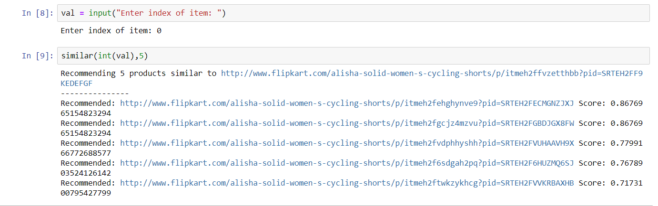

Example 2: Index of item: 1

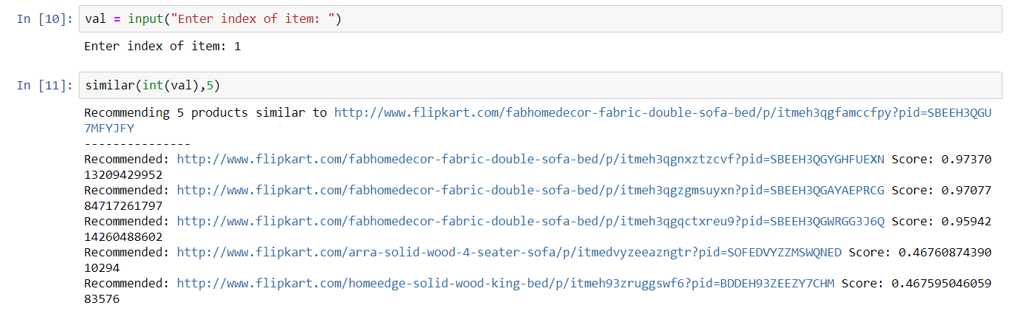

Example 3: Index of item: 90

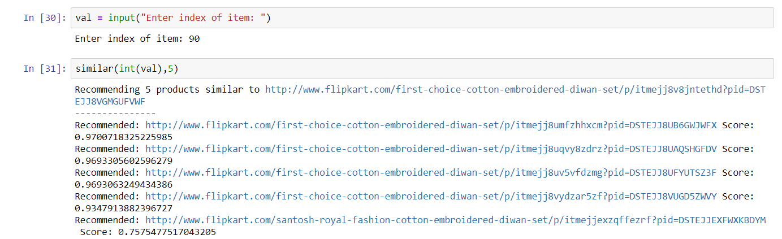

Example 4: Index of item: 945

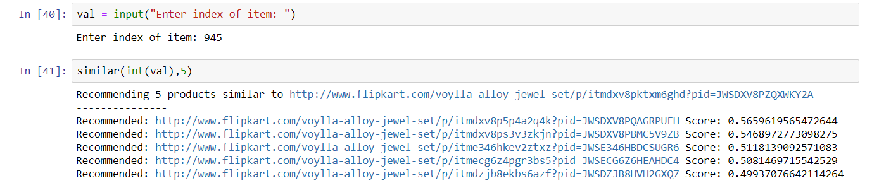

Example 5: Index of item: 10001

