Analysing Sentiments and Member activeness with
Data-Driven Insights using Python and ML

Professor. Dr Raghuraj Singh1, Utkarsh Singh2, Tushar Jaiswal3, Mehal Khare4, Arya Kumar5, Sparsh Rai6

---------------------------------------------------------------------***---------------------------------------------------------------------

Abstract-This study presents a WhatsApp chat analysis tool that uses process analysis techniques to extract insights and topics from group chat profiles. This tool can be used to analyze conversations and analyze topics, keywords, and analysis of words. Chat Analyzer can be used to analyze all types of group chats, including academic, business and personal. The results can be used to improve communication strategies and increase communication effectiveness. total productivity. The tool is easy to use and can be easily used by any computer user. Overall, WhatsApp Chat Analyzer is capable of providing great insights and facilitating effective communication.

Key Words: WhatsApp chat analyser, Chat data, pandas, NumPy, wordcloud, Matplotlib and Seaborn.

1.INTRODUCTION

WhatsApp is one of the most used messaging applications. Group discussion has become an important communication tool that people use for personal, educational and business purposes. The amount of information produced by group discussions can be overwhelming, making it difficult to extract insights and patterns.
To overcome this challenge, we created the WhatsApp Chat Analysis Tool, which uses data processing to extract useful insights from data. these discussions. These tools can provide insight into conversation topics, commonly used terms, and mutual opinions.
WhatsApp Chat Analyzer can be used in many ways such as education, business and social. In education, teachers can analyze students' discussion groups to identify topics of interest and monitor participation. In business, managers can analyze group discussions to identify areas for improvement and measure team communication. In a social context, people can use this tool to analyze their conversation history and gain insight into their communication patterns. This article provides an overview of WhatsApp Chat Analyzer and its applications. It provides in-depth analysis of WhatsApp chats to reveal insights and issues related to analysis of WhatsApp group chats. Additionally, this article shows the benefits and limitations of using WhatsApp chat analysis tools and its impact on communication.

practical. Overall, WhatsApp Chat Analyzer is useful for anyone who wants to analyze group chats and extract useful comments from the chat..

2.LITERATURE REVIEW

In the study by D. Bouhnik and M. Deshen, "WhatsApp for schools [1]: This study aims to find communication between teachers and students in the classroom with the high use of WhatsApp. How do these affect education and education in general? .
< br>Research on the Use and Effect of WhatsApp Messenger Based on Research on the Subject[2]: There are many studies and analyzes on the help and effect of WhatsApp. These studies investigate the effect of WhatsApp on students, while others are based on the local population. A study conducted in South India surveyed people between the ages of 18 and 23 to investigate the importance of WhatsApp among young people. From this study, we found that students spend 8 hours a day using WhatsApp and approximately 16 hours online. He uses WhatsApp to exchange images, audio and video with his friends. It also turned out that the only application that young people use while spending time on their smartphones is WhatsApp.
Whatsapp Chat Content Analysis study [3]: A study to analyze the effectiveness of WhatsApp application in Karachi. This study will be important to explore the possibility of WhatsApp becoming the leader in mobile communications in Pakistan. As a result of the introduction of mobile phones and the development of digital technology, Pakistan's communication environment has undergone significant changes. Smartphones and social networking applications have become popular in Pakistan, making communication faster and easier than ever before. The use of quantitative and qualitative research methods has increased over time due to changes in the environment. The method is designed to measure the characteristics and effects of communication tools on human behavior.
Effects of WhatsApp Messenger use on students [4]: ​​Analysis of WhatsApp as a communication tool for emergency surgery teams in hospitals in London. according to this

The findings showed that emergency medicine users participating in the study used WhatsApp for 19 weeks. Compare the sender and recipient of the message, the response time, and the type of communication that took place. Report a security incident. Their research shows that WhatsApp consumes students' study time. WhatsApp takes up a lot of students' study time and can be distracting while studying.
Appendix [5]: A comprehensive review of published literature and evidence using data from PubMed and other health and nutrition sound sources across multiple Instagram and WhatsApp platforms. It also explains the main problems of using WhatsApp and Instagram. It is used in health and medicine.
Using R for WhatsApp Chat Analysis [6]: WhatsApp group chat data used for analysis is 1 year old (May 2015 - May 2016), total of 55563 texts and sometimes users. WhatsApp group chat age, usage date, response level, message type sent by each person in the group (smiley, text, multi-person), reusable age group, etc. It depends. The main features provided in this analysis are the type of message sent, year/month/week/day. /time, time (am/pm), sender's age, gender (male/female).

3.PROPOSED WORK

This section includes the problem statement & proposed system architecture.

3.1. PROBLEM STATEMENT

Checking WhatsApp chat profiles can be a time-consuming task, especially for large groups or long chats. There is a need for a tool that can quickly and accurately analyze WhatsApp chat profiles to provide insight into chat topics. The tool should also provide clarity that will help users better understand the information and draw conclusions about the topic of discussion. Solutions need to be easy to use, efficient and scalable to handle large amounts of
Data.

3.2. PROPOSED SYSTEM ARCHITECTURE
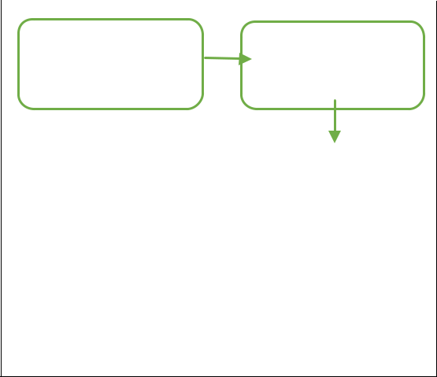

Data Collection | Data
 | Inspecting
Data | Data
Exploration | Transformation
Visualization
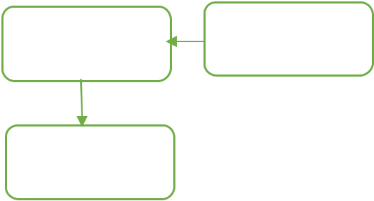

Figure 1 -architecture diagram
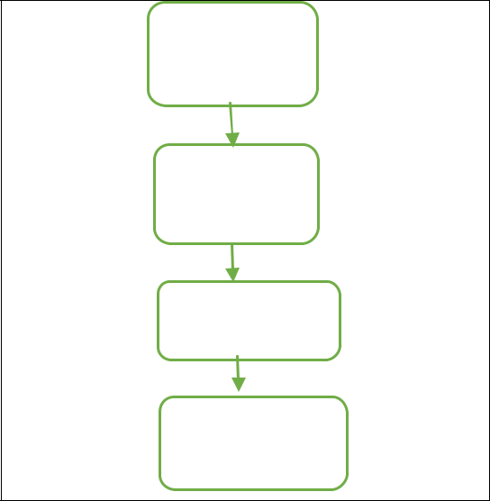

Open chat

group

Go to

setting

Export Chat

Without

media

Figure 2 – Steps involved in data collection

Module 1 : Data collection

The first step is to collect data from WhatsApp chats. This can be done by exporting the chat history as a text file from the WhatsApp application.

Module 2 : Data pre-processing

After the data is collected, it must first be analyzed. This includes removing unnecessary characters, converting text to lowercase, removing punctuation marks, etc..

Module 3 : Data Transformation

The raw string needs to be split into date, time, user and message (using regular expressions) and prepared in tabular format (using Pandas) to be used as a database document.

Module 3 : Data Exploration

Here the collected data is read and processed to train a classification model. Then the model is evaluated and serialized.

- Top Statistics: Shows all messages, total words and links to shared media.

- Monthly timeline: The chat frequency for a given month is shown in this graph.

- The daily timeline: the number of messages during the day is shown on this graph.

- Activity Map: provides a monthly breakdown of your busiest days and lowest workdays.

- Weekly Activity Map: Shows the most active time in chat.

- Words cloud: the word that's very common and often used.

- Most Busy Users

- Analysis of emoji usage: The most frequently used emojis.

Module 4 : Data Visualization

This analyzed data will be then displayed in on the screen in the form of graph for e.g.: line graph, bar graph, heat graph & so on.

4. RESULT & DISCUSSION

Following are the results obtained from experiment:

This displays various metrics related to group messaging activity
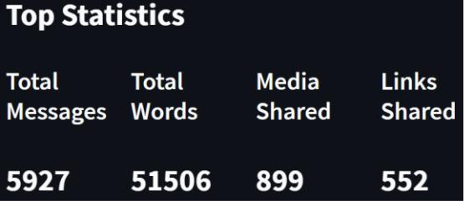

Figure 4 -Monthly Timeline
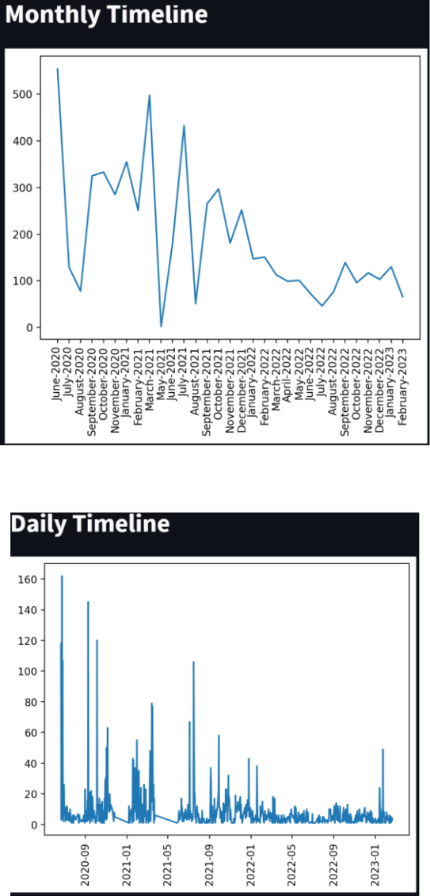

Figure 5- Daily Timeline

Users can view frequency of messages over time using line charts that show monthly and daily timelines.
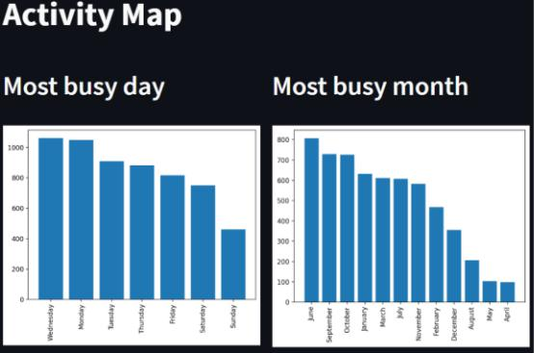

Figure 3 – Top Statistics

In Top Statistics, including the total number of messages, words, media, and links shared.

Figure 6 – Activity Map

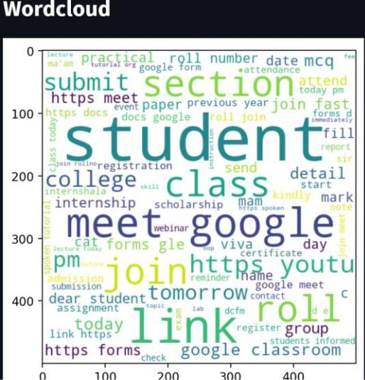
An activity map provides insight into the busiest month and day for messaging activity, displayed in bar chart format.
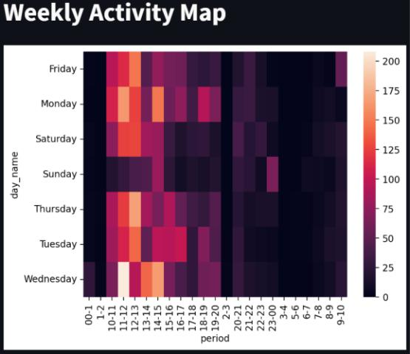

Figure 7 – Weekly Activity Map

A weekly activity map shows hourly usage trends across different days using a heat map.
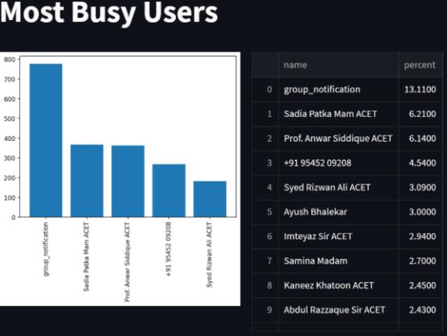

Figure 8 - Wordcloud

This word cloud is used to visualize & highlight the most commonly used words in messages.
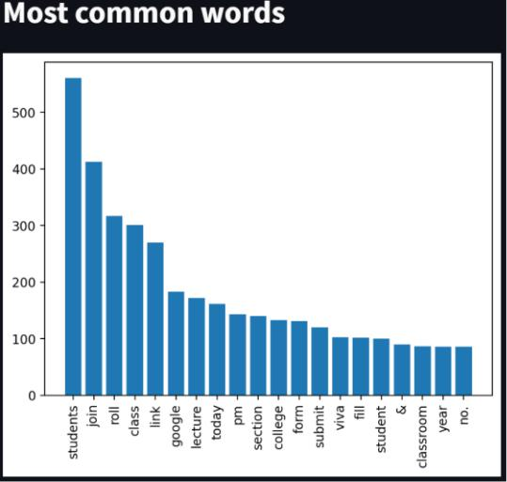

Figure 8 – Most Busy Users

Users can identify the top five most active users in the group using this graph and list, which also displays each user's percentage of overall group usage.

Figure 9 -Most Common Words

A bar chart displays the top twenty most frequently used words.
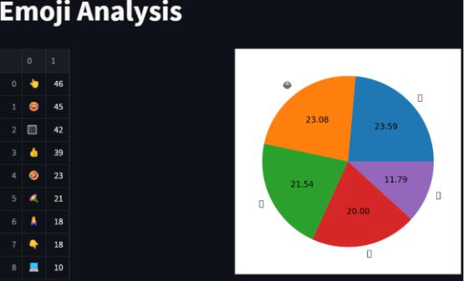

Figure – Emoji Analysis

This pie chart is used to display the top five most frequently used emojis as a percentage of overall emoji usage.

5. CONCLUSION

All in all, WhatsApp Chat Analyzer can be a powerful tool for understanding group chats. By analyzing messages, we can obtain information about the frequency of communication, the most frequently discussed topics, and the general mood of the group. Armed with this information, we can identify patterns and trends, helping us better understand our team dynamics and make more informed decisions about effective communication.

Muaj: https://bmcresnotes.biomedcentral.com
/articles/10.1186/s 13104015-1280-z. [Accessed date: 12 March 2019].
[9] W. Bani, “WhatsApp”, 22 April 2019. [online]. Available: https://en.welibani.org/weli/WhatsApp. [ Accessed 24 April

2019]. [6] S. Patil, "WhatsApp Group Data Analysis with R," International Journal of Computer Applications, vol. Volume 154 , no. 4, p. 0975 – 8887, November 2016.

- D. Bouhnik and M. Deshen, "WhatsApp Goes to School: Mobile Instant Messaging Between Teachers and Students," Journal of Information Technology Education: Research, vol. 13, pp. 217231, 25 August 2014.

REFERENCES

[1] S. Patil, “WhatsApp Group Data Analysis Using R,”
International Journal of Computer Applications, Vol.
Book 154, Vol. 4, p. 0975 – 8887, November 2016.
[2] Source:
http://www.statista.com/statistics/260819/numberof-
monthly - active users of WhatsApp . April 2013 – February
2016
Number of monthly WhatsApp users worldwide (in millions)
[3] Ahmed, I., Fiaz, T., "For Young People's Phones: Necessity
or
Dependency", African Journal of Business Management,
Vol. 5 (32), p. 123. 12512-12519, Aijaz, K. (2011).
[4] J. Yeboah and G. D. Ewur, "The Impact of WhatsApp
Messenger Usage on Students", Journal of Education and
Practice, vol. Nqe 5, no. 6, p. 157-164, 2014.
[5] M. N. K. Boulos, D. M. Giustini, and S. Wheeler, “Instagram
and WhatsApp in health and wellness: an overview,” Future
Internet Creative Co-ownership MDPi, vol. 8. No. 37 pm.
01-14, 2016.
[6] Aharony, N., T., G., WhatsApp
the importance of family groups: an evaluation. Aslib Journal
of Information Management, Vol. 68, Issue 2, p. 1-37" (2016).
[7] D.Radha, R. Jayaparvathy, D. Yamini, "Analysis of drug
addiction using data mining", International Journal of
Applied Computer (0975 – 8887) Vol 139
– Issue 7, Page 7 2326, 2016, 4 Kasım 2016.
[8] C. Montag, K. Błaszkiewicz, R. Sariyska, IB. Lachmann, I.
Andone, B. Trendafilov, M. Eibes, thiab A. Markowetz, "
Smartphone use in the 21st century: Who is active on WhatsApp?",
4 August 2015. [online].

