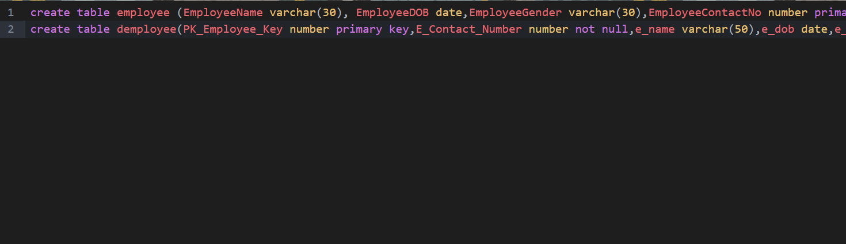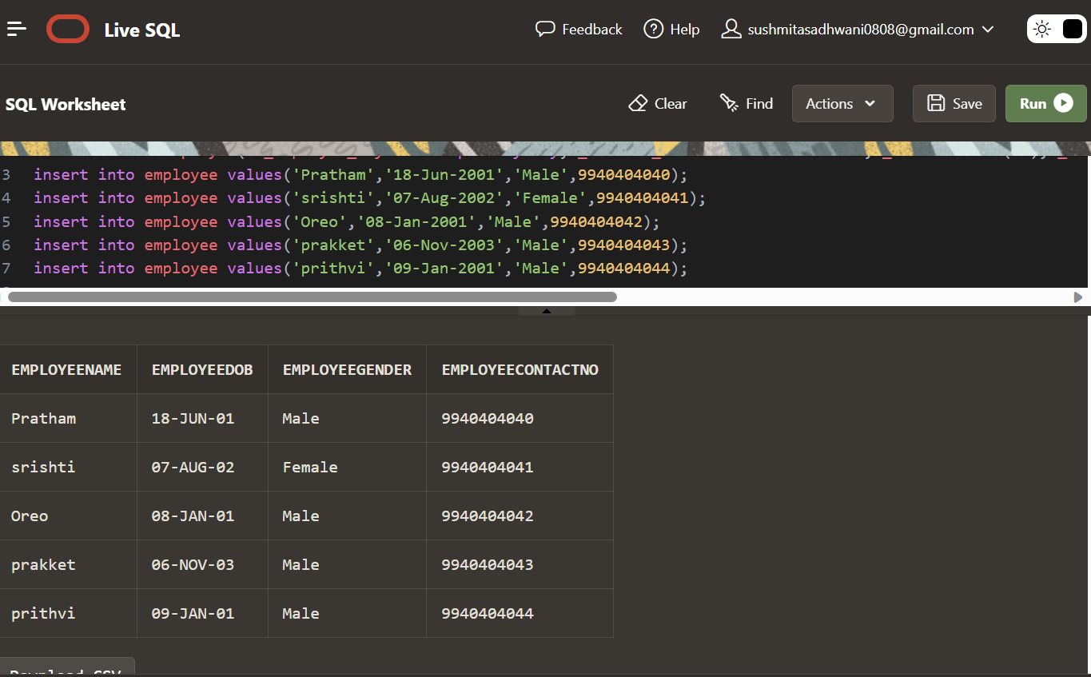

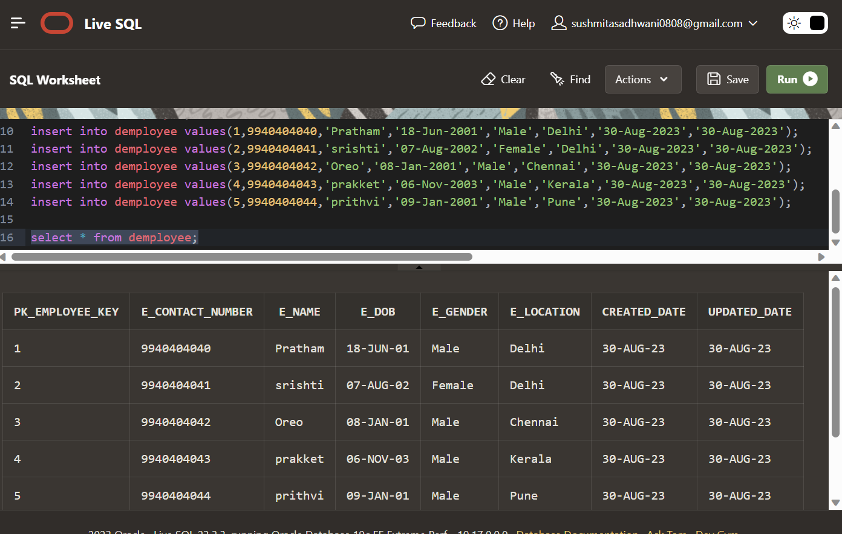

create table employee (EmployeeName varchar(30), EmployeeDOB date,EmployeeGender varchar(30),EmployeeContactNo number primary key);

create table demployee(PK_Employee_Key number primary key,E_Contact_Number number not null,e_name varchar(50),e_dob date,e_gender varchar(15),e_location varchar(50),created_date date,updated_date date);

insert into employee values('Pratham','18-Jun-2001','Male',9940404040);

insert into employee values('srishti','07-Aug-2002','Female',9940404041);

insert into employee values('Oreo','08-Jan-2001','Male',9940404042);

insert into employee values('prakket','06-Nov-2003','Male',9940404043);

insert into employee values('prithvi','09-Jan-2001','Male',9940404044);

select * from employee;

insert into demployee values(1,9940404040,'Pratham','18-Jun-2001','Male','Delhi','30-Aug-2023','30-Aug-2023');

insert into demployee values(2,9940404041,'srishti','07-Aug-2002','Female','Delhi','30-Aug-2023','30-Aug-2023');

insert into demployee values(3,9940404042,'Oreo','08-Jan-2001','Male','Chennai','30-Aug-2023','30-Aug-2023');

insert into demployee values(4,9940404043,'prakket','06-Nov-2003','Male','Kerala','30-Aug-2023','30-Aug-2023');

insert into demployee values(5,9940404044,'prithvi','09-Jan-2001','Male','Pune','30-Aug-2023','30-Aug-2023');

select * from demployee;

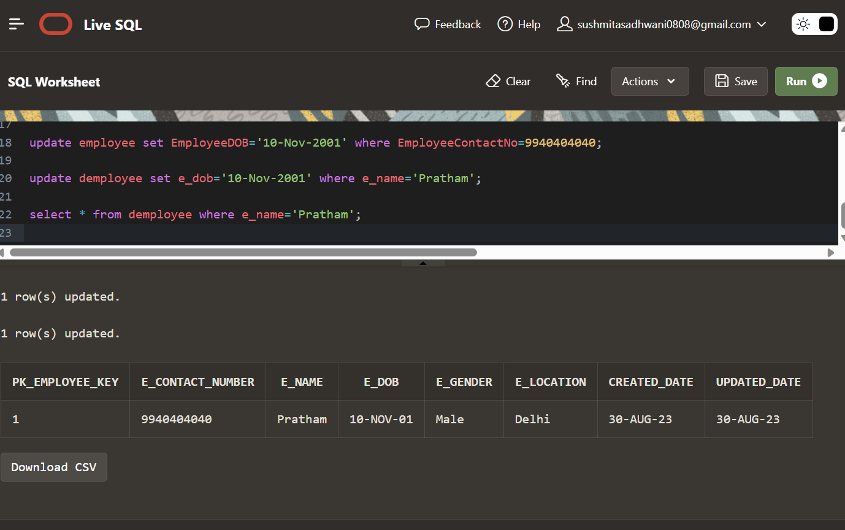

create table scd2(pk_employee_key number primary key,ename varchar(50),e_dob date,e_gender varchar(15),e_location varchar(50),start_date date,end_date date,version number,flag varchar(5));  
insert into scd2 values(1,'Pratham','17-Nov-2001','Male','Delhi','08-Aug-2023','',1,'N');  
insert into scd2 values(2,'Prath','07-Sep-2002','Male','Delhi','08-Aug-2023','',1,'N');  
insert into scd2 values(3,'Pratyush','08-Jan-2001','Male','Chennai','08-Aug-2023','',1,'N');  
insert into scd2 values(4,'Promola','06-Nov-2003','Female','Kerala','08-Aug-2023','',1,'N');  
insert into scd2 values(5,'Arolo','09-Jan-2001','Female','Pune','08-Aug-2023','',1,'N');  
select * from scd2;

