Area of the circle A = π * r * r

Circumference of circle P = 2 * π * r , where r is radius of circle

**Algorithm Flowchart**

1. 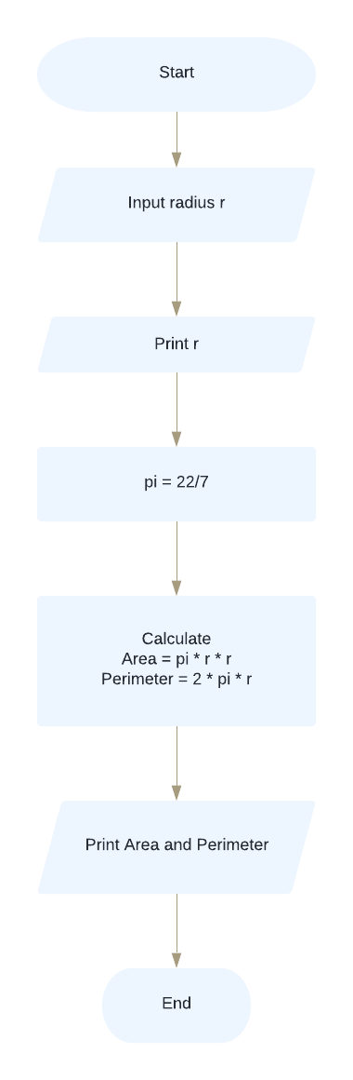Start
2. Input radius r of circle
3. Print r
4. π = 22/7
5. area = π * r * r
6. perimeter = 2 * π * r
7. Print area and sum
8. End

Print Area and Perimeter