F = 1.8 * C + 32, where F is temperature in Fahrenheit and C is temperature in degree Celsius.

**ALGORITHM FLOWCHART**

1. 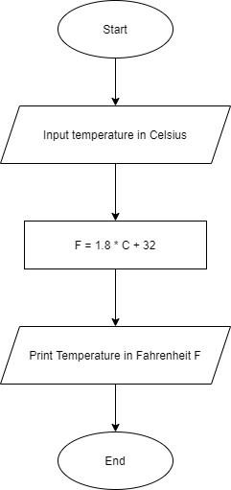Start
2. Input temperature in degree Centigrade C
3. Temperature in Fahrenheit

F = 1.8 * C + 32

1. Print temperature in Fahrenheit F
2. End