Ramesh’s basic salary is input through the keyboard. His dearness allowance is 40% and house rent allowance is 20% of his basic salary. Calculate his gross salary.

bs 🡪 basic salary

hra 🡪 House Rent Allowance

da 🡪 dearness allowance

gs 🡪 gross salary

gs = ba + hra + da

**ALGORITHM FLOWCHART**

1. 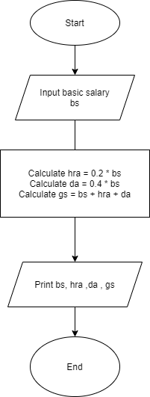Start
2. Input basic salary of Ramesh.
3. Calculate hra = 0.2 * bs
4. Calculate da = 0.4 * bs
5. Calculate gs = bs + hra + da
6. Print bs, hra, da, gs
7. End