|  |  |  |  |  |  |
| --- | --- | --- | --- | --- | --- |
| Maximum Marks (mm) | 100 | 100 | 100 | 75 | 75 |
| Marks Obtained (mo) | 95 | 85 | 87 | 54 | 49 |

totalMarks = 95 + 85 + 87 + 54 + 49

percentage = 100 * (95 + 85 + 87 + 54 + 49)/(100 + 100 + 100 + 75 +75)

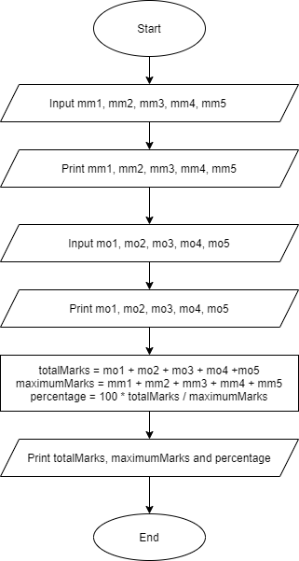**ALGORITHM FLOWCHART**

1. Start
2. Input mm1, mm2, mm3, mm4, mm5
3. Print mm1, mm2, mm3, mm4, mm5
4. Input mo1, mo2, mo3, mo4, mo5
5. Print mo1, mo2, mo3, mo4, mo5
6. totalMarks = mo1 + mo2 + mo3 + mo4 + mo5
7. maximumMarks = mm1 + mm2 + mm3 +

mm4 + mm5

1. percentage =

100 * totalMarks / maximumMarks

1. Print totalMarks, maximumMarks, percentage
2. End