**Aim -: (i)** Determine the factors which affect the period of oscillation.

**(ii)** Find the value of acceleration due to gravity on Planet X.

**(iii)** Describe the relationship between the velocity and acceleration vectors, and their relationship to motion at various points in the oscillation.

**(iv)** Explain how the free body diagram of the mass changes throughout the oscillation.

**(v)** Explain the conservation of Mechanical Energy using kinetic, elastic potential, gravitational potential and thermal energy.

**Theory -: For Aim(i)** Consider the vertical mass spring system shown in the figure below. Let the spring constant be equal to k N/m.

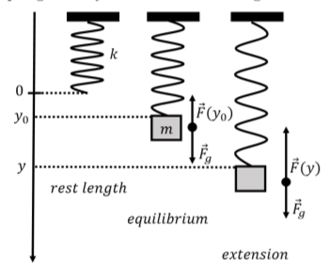

When the spring has no mass attached, the spring is at its natural length, and its lower end is at y = 0 of our co-ordinate system. Consider downward direction as positive y-axis.

When a mass m is attached to the spring, the spring extends and a spring force is developed in the spring in the upward direction. Consequently, the spring extends to a length such that the spring force is balanced by the weight of the mass. This position is the new equilibrium position of the spring mass system. Let this new equilibrium position be at y = $y_{0}$. Since, only spring force and weight are acting in vertical direction and the mass is at rest, from Newton’s Second Law, we obtain

$\sum{F_{y}}=mg-ky_{0}=0$------------- 1

Now, consider the case when the mass is stretched to y (y > $y_{0}$). The spring force in this case will be upwards and greater than the weight of the object, hence the mass will move upwards with acceleration a.

$\sum{F_{y}}=mg-ky=ma$------------ 2

Note that the net force on the object will act in a direction so as to restore the equilibrium position, $y_{0}.$ If the mass moves upwards relative to $y_{0}$, the net force will be downwards.

Substituting mg = k $y_{0}$ from equation 1 in equation 2, we get

$ma= -k (y-y_{0})$

$m\frac{d^{2}x}{{dt}^{2}}= -k(y-y_{0})$

$\frac{d^{2}x}{{dt}^{2}}= -\frac{k}{m}(y-y_{0})$------------ 3

where negative sign represents that the net force is towards the equilibrium position.

Comparing equation 3 with the standard equation of Simple Harmonic Motion, $\frac{d^{2}x}{{dt}^{2}}= -ω^{2}x$, we get,

$ω= \sqrt{\frac{k}{m}}$

Time period of Oscillation is given by, $T= \frac{2π}{ω}$, therefore,

$T= \frac{2π}{\sqrt{\frac{k}{m}}}= 2π\sqrt{\frac{m}{k}}$

**For Aim (ii)** Consider a mass m on Earth. Let the value of acceleration due to gravity on Earth be $g_{E}$ and let the spring constant be k. At equilibrium position, the mass is at position $y_{0}$. Therefore,

$mg_{E}=ky_{0}$

$k=\frac{mg_{E}}{y_{0}}$

Now suppose a planet X, where value of acceleration due to gravity is $g_{x}$ and let the equilibrium position on this planet is at $y^{'}$. Therefore,

$mg_{x}=ky^{'}$------------ 4

Substituting $k=\frac{mg_{E}}{y_{0}}$ in equation 4,

$g_{x}=$ $\frac{g_{E}}{y_{0}}$ $y^{'}$

**For Aim (iii)** Since, the force on the block is always pointing towards the equilibrium position, the acceleration of the block will always be pointing towards the equilibrium position, that is, opposite to the direction of displacement of block relative to the equilibrium position.

During the time when block moves from mean position to maximum displacement position (w.r.t. mean position) the velocity vector will be opposite to acceleration vector. While during the time when block will move from maximum displacement position (w.r.t mean position) to mean position the velocity vector will point in the direction of acceleration vector.

**For Aim (iv)** The free body diagram of a body is a figure which shows all the forces on the body. In the given system, the weight of the body will remain constant throughout the motion. Only the spring force will change and it will always act in upward direction. Spring force will be zero when the spring is at its natural length and when the mass will be at lowermost point, the spring force will be maximum.

At mean position, the spring force will balance the weight of the body. At a position above the mean position, weight will be greater than the spring force and hence acceleration will be downwards. And at a position below the mean position, the spring force will be greater than the weight and hence the acceleration will be upwards.

**For Aim (v)** The law of conservation of energy states that total energy of an isolated system will remain conserved. It can transform from one form to another form but the net energy of the system will be conserved. In a vertical spring-mass system, four kind of energies are associated with the motion. The kinetic energy of the block, the elastic potential energy of the spring, the gravitational potential energy of the block and the thermal energy of the block. The total energy is sum of all these energies.

* Kinetic energy is associated by the virtue of the motion of the block.
* Elastic potential energy is associated with the extension in spring.
* Gravitational potential energy is associated with the height of the block with respect to our line of zero potential energy.
* Thermal energy is associated with the movement of atoms and molecules comprising the system.

**Observations, Errors and Result** -: **(i) Observation Table for Aim(i)**

|  |  |  |  |  |  |  |
| --- | --- | --- | --- | --- | --- | --- |
| Keeping the values of g and k constant and varying mass m. | | | | | | |
| Sr.  No. | Mass  (m)  grams | Gravity  (g)  (m/ $s^{2}$) | Maximum  Displacement  w.r.t y = 0  x = $x_{f}-x_{i}$ (cm) | Spring Constant  (k)  (N/m) | Amplitude of Oscillations  (A)  (cm) | Time Period of 10  Oscillations  (T)  (seconds) |
| 1. | 100 | 9.8 | 33 | 4 | 16.5 | 8.18 |
| 2. | 120 | 9.8 | 39 | 4 | 20.0 | 8.91 |
| 3. | 180 | 9.8 | 58 | 4 | 29.0 | 10.87 |
| 4. | 250 | 9.8 | 81 | 4 | 41.0 | 12.81 |
| 5. | 290 | 9.8 | 95 | 4 | 47.0 | 13.82 |

Plotting a graph T versus m using table entries,

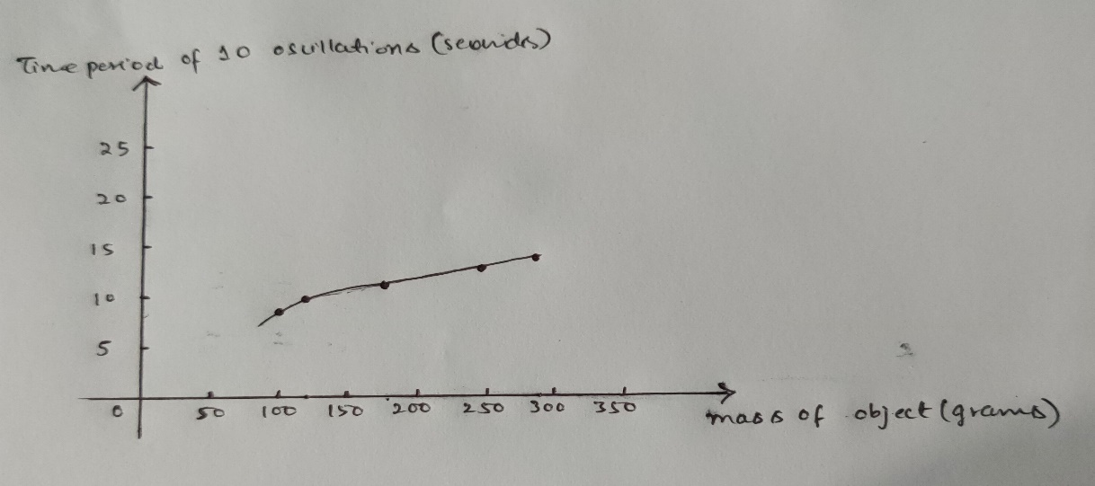

From the table and the graph, it has been observed that the time period of oscillation T is directly proportional to the square root of mass m of the block.

$T α \sqrt{m}$

|  |  |  |  |  |  |  |
| --- | --- | --- | --- | --- | --- | --- |
| Keeping the values of m and g constant and varying spring constant k. | | | | | | |
| Sr.  No. | Mass  (m)  grams | Gravity  (g)  (m/ $s^{2}$) | Maximum  Displacement  w.r.t y = 0  x = $x_{f}-x_{i}$ (cm) | Spring Constant  (k)  (N/m) | Amplitude of Oscillations  (A)  (cm) | Time Period of 10  Oscillations  (T)  (seconds) |
| 1. | 120 | 9.8 | 39 | 4.2 | 20 | 8.88 |
| 2. | 120 | 9.8 | 33 | 4.7 | 17 | 8.29 |
| 3. | 120 | 9.8 | 29.5 | 5.0 | 15 | 7.68 |
| 4. | 120 | 9.8 | 24 | 5.73 | 12 | 6.88 |
| 5. | 120 | 9.8 | 21 | 6.36 | 10 | 6.28 |

Plotting a graph T versus k using table entries,

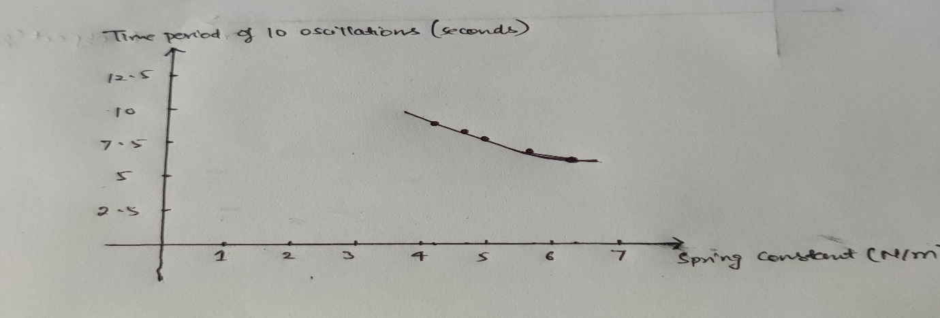

From the table and the graph, it has been observed that the time period of oscillation is inversely proportional to the square root of spring constant, k.

$T α \frac{1}{\sqrt{k}}$

|  |  |  |  |  |  |  |
| --- | --- | --- | --- | --- | --- | --- |
| Keeping m and k constant and varying g | | | | | | |
| Sr.  No. | Mass  (m)  grams | Gravity  (g)  (m/ $s^{2}$) | Maximum  Displacement  w.r.t y = 0  x = $x_{f}-x_{i}$ (cm) | Spring Constant  (k)  (N/m) | Amplitude of Oscillations  (A)  (cm) | Time Period of 10  Oscillations  (T)  (seconds) |
| 1. | 150 | 4.7 | 23 | 4 | 12 | 9.91 |
| 2. | 150 | 9.4 | 47 | 4 | 24 | 9.93 |
| 3. | 150 | 15.6 | 78 | 4 | 39 | 9.92 |
| 4. | 150 | 17.4 | 87 | 4 | 43 | 9.92 |
| 5. | 150 | 20.7 | 103 | 4 | 52 | 9.91 |

Plotting a graph T versus g using table entries,

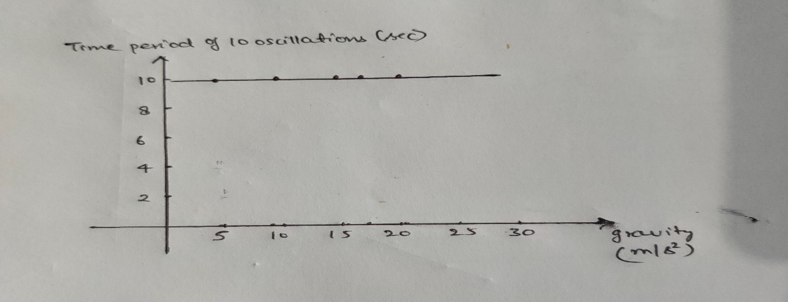

From the table and the graph, it has been observed that the time period of oscillation T does not depend on acceleration due to gravity g.

**Errors for Aim(i) -:** There are insignificant errors for this experiment and the dependence of time period of oscillation is not affected by these insignificant errors.

**Result for Aim(i) -:** Performing the experiment, it has been concluded that the time period of oscillation is directly proportional to square root of mass of block and inversely proportional to square root of spring constant.

$T α \frac{\sqrt{m}}{\sqrt{k}}$

$T=2π\frac{\sqrt{m}}{\sqrt{k}} ,$ where 2π is proportionality constant.

**(ii) Observation Table and Errors for Aim(ii) -:**

|  |  |  |  |  |  |  |  |
| --- | --- | --- | --- | --- | --- | --- | --- |
| Sr.  No. | Mass  (m)  grams | Gravity on  Earth $g_{E}$   (m/ $s^{2}$) | Equilibrium position  On Earth  y = $y_{0}$ (cm) | Spring constant $k=\frac{mg_{E}}{y_{0}}$   (N/m) | Equilibrium position  On Planet X  ($y^{'}$)  cm | Gravity On  Planet X $g_{x}=$ $\frac{g_{E}}{y_{0}}$ $y^{'}$ (m/ $s^{2}$) | Errors ${g_{x}}_{avg}-g_{i}$ |
| 1. | 50 | 9.8 | 14.5 | 3.379 | 18 | 12.165 | 0.755 |
| 2. | 75 | 9.8 | 19.5 | 3.769 | 25 | 12.563 | 0.357 |
| 3. | 110 | 9.8 | 26.5 | 4.067 | 34 | 12.573 | 0.347 |
| 4. | 145 | 9.8 | 33.0 | 4.306 | 44 | 13.066 | -0.146 |
| 5. | 170 | 9.8 | 38.0 | 4.384 | 50 | 12.895 | 0.025 |
| 6. | 200 | 9.8 | 43.0 | 4.558 | 58 | 13.220 | -0.300 |
| 7. | 220 | 9.8 | 47.0 | 4.587 | 63 | 13.136 | -0.216 |
| 8. | 255 | 9.8 | 53.5 | 4.671 | 72 | 13.189 | -0.269 |
| 9. | 280 | 9.8 | 58.0 | 4.731 | 78 | 13.179 | -0.259 |
| 10. | 300 | 9.8 | 61.5 | 4.780 | 83 | 13.226 | -0.306 |

The average value ofgravity at planet x,

${g_{x}}_{avg}= \frac{\sum_{i=1}^{i=10}{{g_{x}}_{i}}}{10}$

Where ${g_{x}}_{i}$ are the values of $g_{x}$ corresponding to entries of the observation table.

${g_{x}}_{avg}=12.92 m/s^{2}$

**Result for Aim(ii) -:** Using the simulator to find the equilibrium length $y_{0}$ on Earth yielded us the value of spring constant k, using the formula,

$k=\frac{mg_{E}}{y_{0}}$

and using the simulator to find the equilibrium length $y^{'}$ on the planet X yielded us the acceleration due to gravity on Planet X by using the formula,

$g_{x}=$ $\frac{g_{E}}{y_{0}}$ $y^{'}$

Performing the experiment on the simulator 10 times, yielded different values of $g_{x}$ and the average of these observations is taken as gravity on planet X. Hence, gravity on planet X is 12.92 $m/s^{2}$.

**(iii) Observations for Aim(iii) -:** Assuming the lower end of spring at y = 0 and the downward direction as positive y-axis. The equilibrium position is at y = $y_{0}$.

In the figures below, blue line represents y = 0, black line represents y = $y_{0}$. The green arrow on the box represents velocity and yellow arrow represents acceleration.

* At mean position y = $y_{0}$, two situations can arise as shown in figure below,

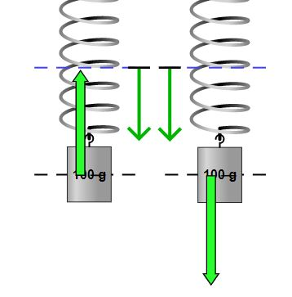

* At the extreme positions, only one situation is possible. The figure below represents the situation for both the extreme positions.

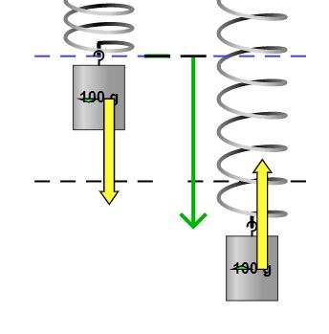

* At any general position, other than the extreme positions, two situations may arise. They are represented in the figure below.

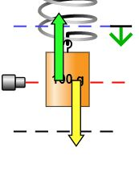 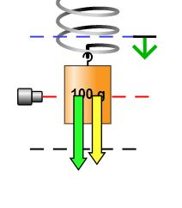

**Observation table**

|  |  |  |  |  |
| --- | --- | --- | --- | --- |
| Sr.  No. | Mass  m  (grams) | Spring Constant  k  (N/m) | Time  t  (seconds) | Displacement with  respect to y = 0  (y)  (cm) |
| 1. | 100 | 4 | 0 | 0 |
| 2. | 100 | 4 | 0.27 | 24.5 |
| 3. | 100 | 4 | 0.58 | 20.0 |
| 4. | 100 | 4 | 0.85 | 0 |
| 5. | 100 | 4 | 1.10 | 27.0 |
| 6. | 100 | 4 | 1.45 | 13.0 |
| 7. | 100 | 4 | 2.08 | 32.0 |
| 8. | 100 | 4 | 2.32 | 6.5 |
| 9. | 100 | 4 | 2.60 | 12.5 |
| 10. | 100 | 4 | 2.80 | 32.0 |

Plotting a graph y vs t using table entries,

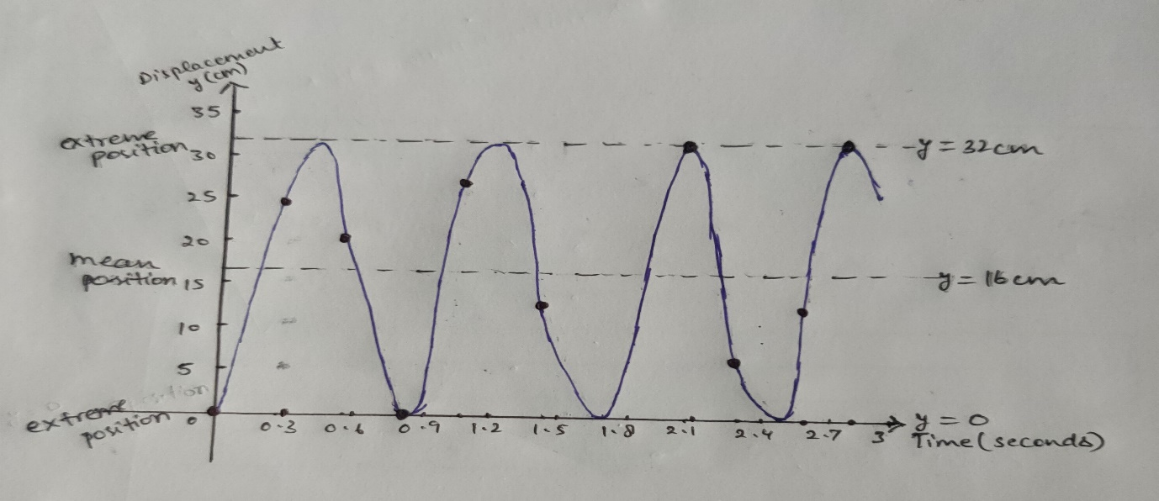

The derivative of y with respect to time at any position will yield the velocity of the block at that instant of time.

Also, the acceleration of the block is related to its position y as,

$\frac{d^{2}x}{{dt}^{2}}= -\frac{k}{m}(y-y_{0})$

where $y_{0}$ is the mean position of the spring-mass system.

**Calculation for Aim(iii) -:** From the given data in the table, the mean position $y_{0}=16 cm=0.16 m$, k = 4 N/m and m = 100 gm = 0.1kg.

$a=\frac{d^{2}x}{{dt}^{2}}= -\frac{4}{o.1}(y-0.16)$

* Therefore, at y = $y_{0}$, the acceleration of the block is zero.
* And at extreme position y = 0 and y = 0.32 m, magnitude of acceleration is

|

The direction of acceleration is towards the mean position. This value of acceleration is the maximum. At any position other than the extremes positions the value of acceleration will be lesser than $6.4 m/s^{2}$.

* At y = 20 cm = 0.2 m,

$a= -\frac{4}{o.1}(0.20-0.16)$ = 1.6 $m/s^{2}$

the direction this time is upwards, as the block is below the mean position.

* At y = 13 cm = 0.13 m,

$a= -\frac{4}{o.1}(0.13-0.16)$ = $- 1.2 m/s^{2}$

the direction this time is downwards as the block is above the mean position.

**Result for Aim(iii) -:** By performing the above experiment, following conclusions can be drawn,

1. The acceleration of the block will be towards the mean position at any instant of time.
2. The acceleration of the block will always be opposite to its displacement with respect to the mean position.
3. At the mean position, the acceleration will be zero and the velocity will be maximum.
4. Except at the extreme positions, the velocity of block at every other position can have upward or downward direction depending upon whether the block is moving towards or away from the mean position. However, the magnitude of velocity will be same in both the cases.
5. At the extreme positions, the velocity of block will be zero, as derivative of y with respect to time is zero at that position in the graph, but the acceleration will be maximum.

**(iv) Observations for Aim(iv) -:** In the figures below, blue line represents y = 0, black line represents y = $y_{0}$ and the red line represents the maximum displacement position.The free-body diagrams shown below contains red and blue vectors. The red vector represents weight and the blue vector represents the spring force.

* At the two extreme positions y = 0 and y = 2 $y_{0}$, the free-body diagram is shown in the figure below

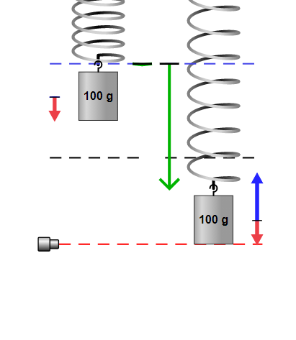

* At the mean position, that is at y = $y_{0}$, the free body diagram is shown below.

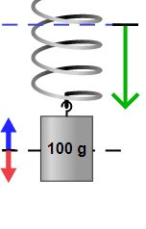

* At two general positions, the free body diagram is given below.

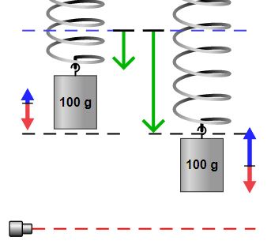

**Result for Aim(iv) -:** By observing the free-body diagrams at different positions, following conclusions can be drawn,

1. The gravitational force, that is weight of block, remains constant throughout the oscillation.
2. The magnitude of spring force does not remain constant but its direction is upward throughout the oscillation.
3. At mean position, the upward spring force balances the weight of the block.
4. Above the mean position, the spring force is lesser than the weight, the net force is, thus, downwards. Below the mean position, the spring force is greater than the weight, the net force is, thus, upwards.
5. The net force, and hence the acceleration, at any instant throughout the oscillation will direct towards the equilibrium position.

**(v) Observations for Aim(v) -:** Some position of the block and the energies related to it at that instant are given below.

* 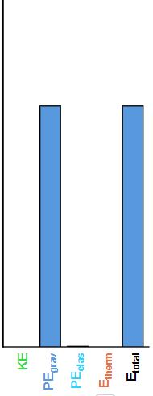At y = 0, one extreme end of oscillation,

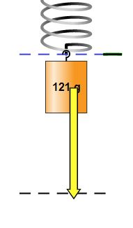

* At mean position, y = $y_{0}$,

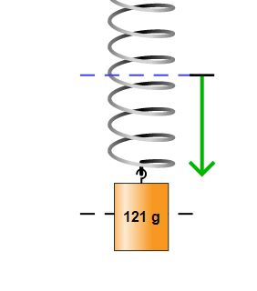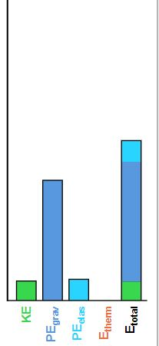

* At the other extreme position y = $2y_{0}$,

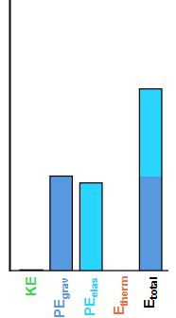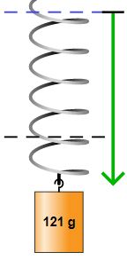

* At a position other than the mean and extreme positions,

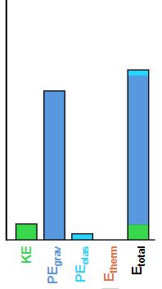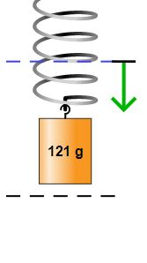

**Result for Aim(v) -:** Observing the energy diagrams, following conclusions can be drawn,

1. The total energy of the system is always conserved. Energy is transformed from one form to other but the sum of all the energies at any instant is constant.
2. If there is no damping then there will be no energy loss as thermal energy.
3. At y = 0, the spring is at its natural length, hence elastic potential energy is zero. Also, it is an extreme position for the oscillation, hence the velocity, thus, kinetic energy is zero. Since the block is at maximum height with respect to ground, there is only gravitational potential energy. Hence, at this position total energy comprises of only gravitational potential energy.
4. At the mean position, kinetic energy is maximum. As there is extension in the spring, there is elastic potential energy. But since the block moved down, it has suffered loss in gravitational potential energy, which appeared as kinetic and elastic potential energy.
5. At the other extreme position, y = $2y_{0}$, the kinetic energy will be zero. Further the block will be at its lowest position, hence gravitational potential energy will be lowest. But the extension in the spring will be maximum, and the loss of kinetic and gravitational potential energy will appear as elastic potential energy.
6. 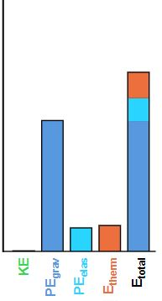In the cases discussed above there was no damping. Suppose if there is damping then an increase in thermal energy of the system will be observed.

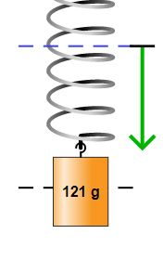

1. When there is damping, the maximum kinetic energy of the block will keep decreasing and it will appear as the thermal energy produced in the spring. After a very long time, the block will stop moving and will be at rest at equilibrium position. The kinetic energy of the block will be converted to the thermal energy. Kinetic energy will become zero, and gravitational potential energy, elastic potential energy and thermal energy will become constant. But their sum will still be constant and equal to total energy.
2. But the reverse, that is, providing thermal energy to the system will not result in any increase of kinetic energy of the system. This can be understood by using the concepts of thermodynamics. As stated by the Second Law of Thermodynamics, that the total entropy of the universe always increases for a spontaneous process. The change in entropy of universe for the given process will be negative and hence such a process is not possible.