**Aim-:** **(i)** Starting with default parameters and dragging the ball to the maximum starting position, analyse the motion of the ball and compare it with the simple harmonic motion.

**(ii)** Reset the simulation, change the friction parameter, b to 0.5 Ns/m and drag the ball to the maximum starting position and analyse the motion of the ball.

Try different values of b and compare the behaviour of motion of the ball for small values of b (less than 1 Ns/m) with that for larger values of b (greater than 2 Ns/m).

**(iii)** Using simulator, demonstrate under damped, over damped and critically damped motion and describe the differences between these three cases.

**(iv)** Set the friction parameter, b to 1 Ns/m and the angular frequency to be 1 rad/s. Set the magnitude of driving force, to be 1 N. Drag the ball to maximum starting position and analyse the motion of the ball. Describe the stable motion after the initial oscillations for this case. Take different values of driving force, keeping friction parameter and angular frequency constant and analyse the effect of larger driving force on amplitude of final stable motion of the ball.

**(v)** Check to see if the formula for damped and driven damped oscillation matching with the results of simulation. For this, you can plot the formula's in Mathematica (student version)/Octave/Matlab or any other tools for a particular parameter value and analyse the motion.

**Theory -: for Aim (i) -:** When a body repeats its motion after regular intervals of time it is said to be in a harmonic or periodic motion. If a body moves to and fro on the same path, it is said to perform oscillations. Simple Harmonic Motion (SHM) is a special type of oscillation in which the particle oscillates such that its acceleration is always directed towards a fixed point. This fixed point is called *centre of oscillation* (mean position or equilibrium position). Also, in SHM, the magnitude of acceleration is directly proportional to the displacement of particle from centre of oscillation. The standard equation of SHM is,

where is a positive constant and ω is known as angular frequency. If x is positive, is negative and if x is negative is positive. This means that the acceleration is always directed towards the centre of oscillation.

Now, consider a spring of spring constant k and let a mass m be attached to it at one end.

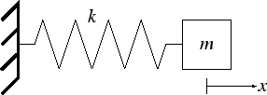

If this mass is stretched to a length x above the natural length of spring, the spring force developed in the spring will be,

From Newton’s Second Law of Motion, the acceleration of the particle will be given by,

Therefore, the equation of motion is,

And the solution to this equation is,

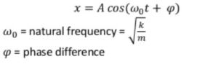

**Theory for Aim (ii) -:** The ideal harmonic oscillator is frictionless but in real scenario friction can not be neglected. The type of friction that is most encountered is , where b is damping constant and v is velocity of mass. Therefore, the total force on mass m is,

and the solution of the equation is,



hence, damped frequency ω is given by,



The mass will perform oscillations only if ω > 0, that is, .

**Theory for Aim (iii) -:** As the damped frequency ω is given by,



We have three cases for the value of b,



If the value of damping constant b is less than , the damped frequency of oscillations ω > 0 and the mass will perform oscillations or pass through the mean position at least twice. If during a damped harmonic oscillation, the mass performs at least one oscillation or pass through the mean position at least twice, it is said to be performing **underdamped oscillations.**



If the value of b equals, the damped frequency of oscillations ω = 0. In this case no oscillation will take place but the mass will reach the equilibrium position. If during a damped harmonic oscillation, the mass does not perform any oscillation and just reaches the equilibrium position it is called as **critically damped oscillation.**



If the value of b is greater than , the value of damped frequency of oscillations is not

defined and the mass does not perform any oscillations. Moreover, the mass is not able to

reach the equilibrium position. Such an oscillation is termed as **over damped oscillation.**

**Theory for Aim (iv) -:** When a harmonic oscillator is subjected to a time varying force F(t), it is called as *driven harmonic oscillator.* For a mass on spring, a force could be applied by the moving end of the spring. Let then end of the move according to as shown in figure below,

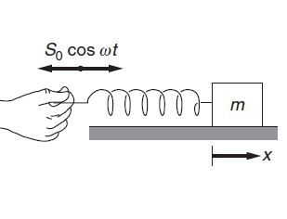

The force on the mass is ). The spring force is therefore,

where , let us assume that there is a damping force -bv also, so the equation of motion,

which can also be written as,



where Υ = and

The solution of the above equation is,



The damped oscillation slowly dies out and the oscillations due to force will go on with a constant amplitude A. The mass will execute stable oscillations after the damped oscillation dies out whose amplitude A is given by,

**Theory for Aim (v) -:** The formula for damped oscillation is,



and the formula for driven damped oscillation is,



**Observations and Result-: Observations for Aim (i) -:** The graph of the displacement of the mass versus time as obtained from the simulator is given below

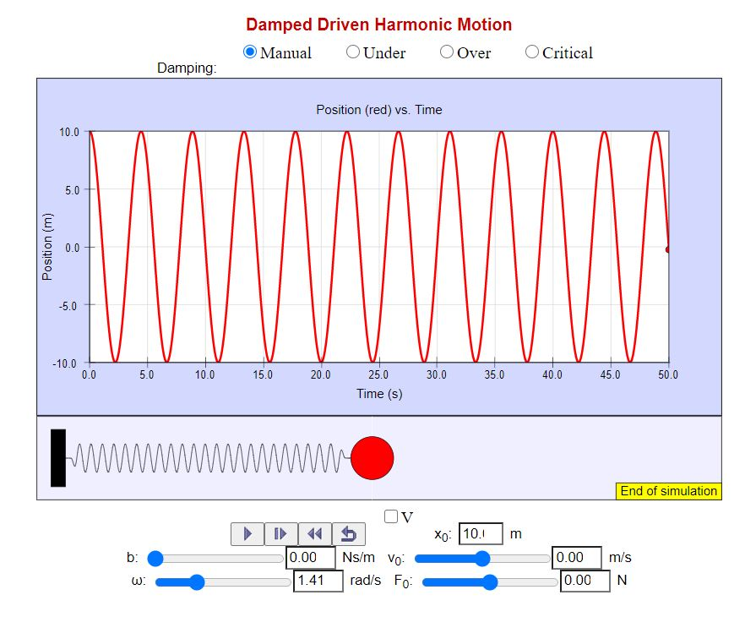

and the graph of displacement versus time for a Simple Harmonic Motion is

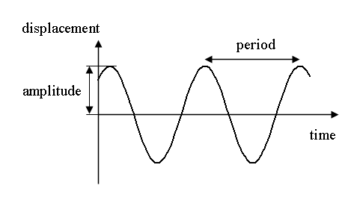

**Result for Aim (i) -:** As we saw in the spring-mass system the acceleration of the block is given by

We can conclude that the motion is a Simple Harmonic Motion as magnitude of acceleration is directly proportional to the displacement from the mean position.

Also, from the graph we can conclude:

1. The velocity (slope of graph) is 0 at the maximum displacement positions.
2. The slope, hence velocity, is maximum at the mean positions.
3. The motion is repeated after a constant time interval.

which are characteristics of Simple Harmonic Motion. Also, the graph of position vs time for spring-mass system is exactly similar to the graph of Simple Harmonic Motion.

Hence, we can conclude that the motion of a mass attached to a spring is a Simple Harmonic Motion.

**Observations for Aim (ii) -:** Keeping the value of angular frequency equal to 1.41 rad/s and stretching the mass to 10 m and recording the observations for different values of damping constant b.

1. b = 0.35 Ns/m

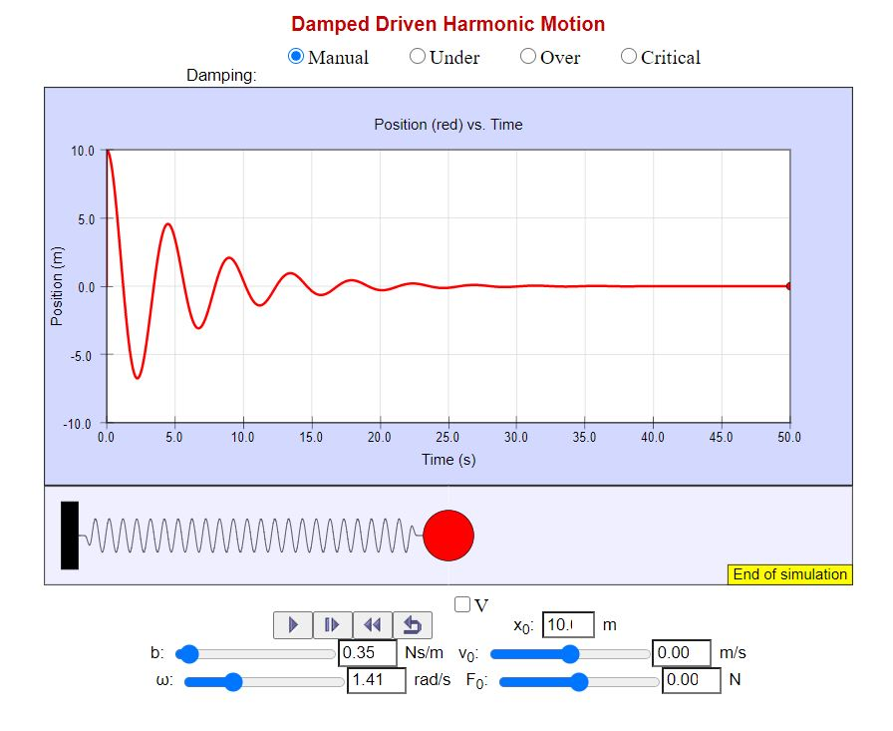

1. b = 0.5 Ns/m

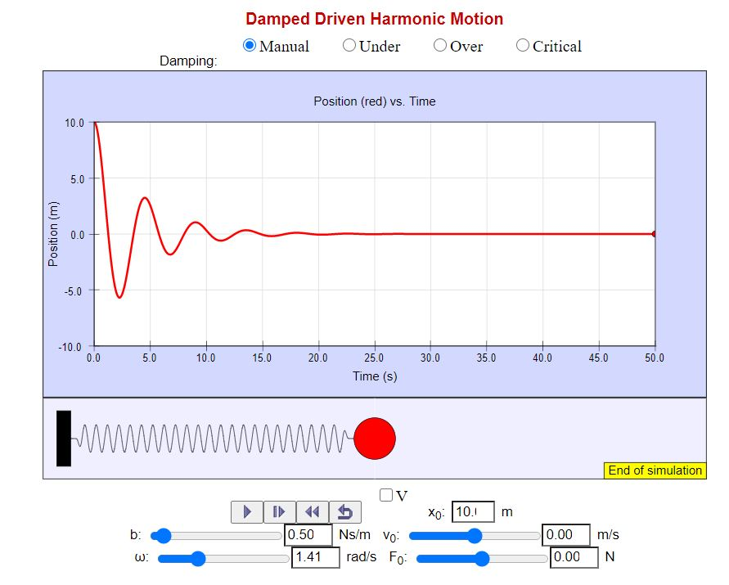

1. b = 0.7 Ns/m

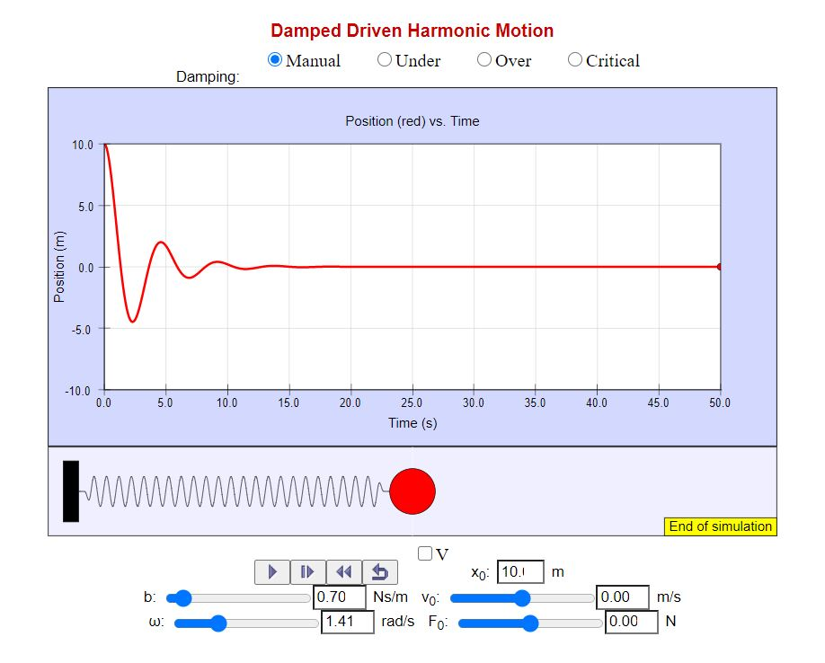

1. b = 1.0 Ns/m

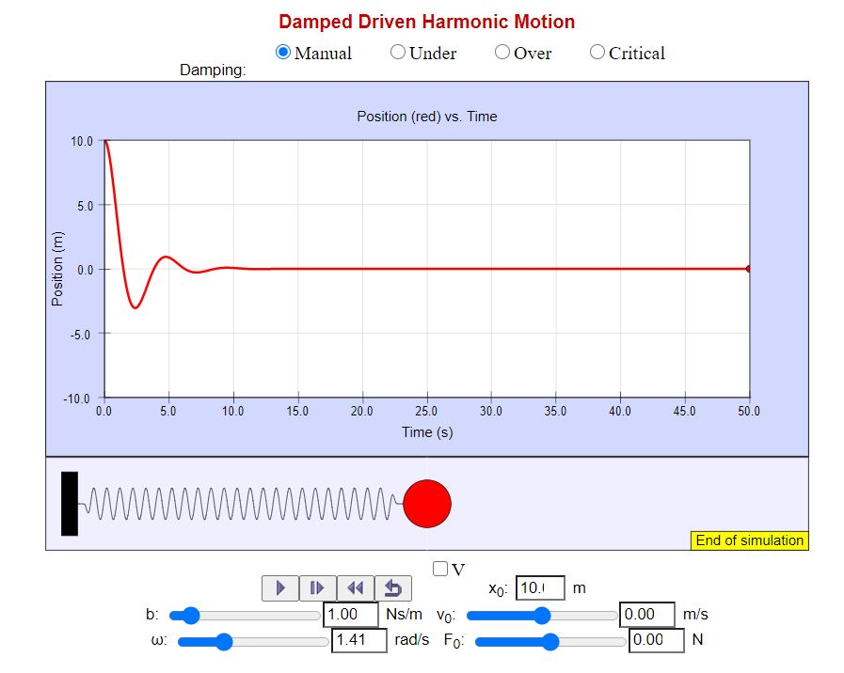

1. b = 1.5 Ns/m

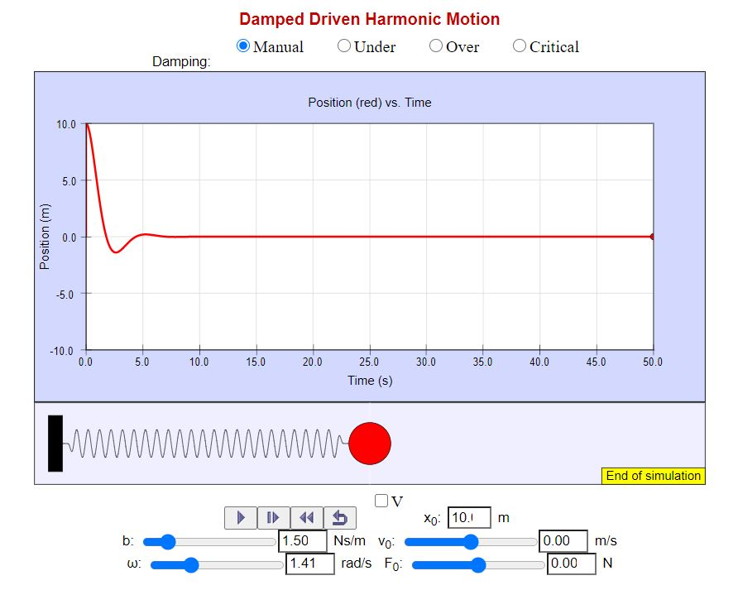

1. b = 2.0 Ns/m

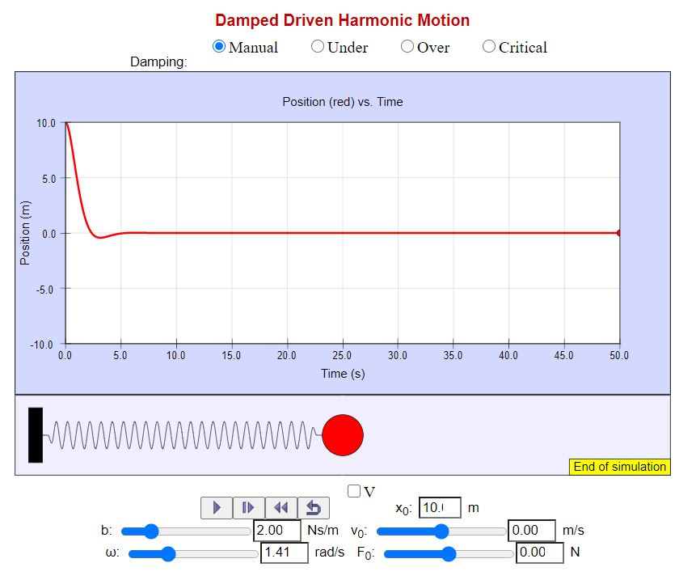

1. b = 2.4 Ns/m

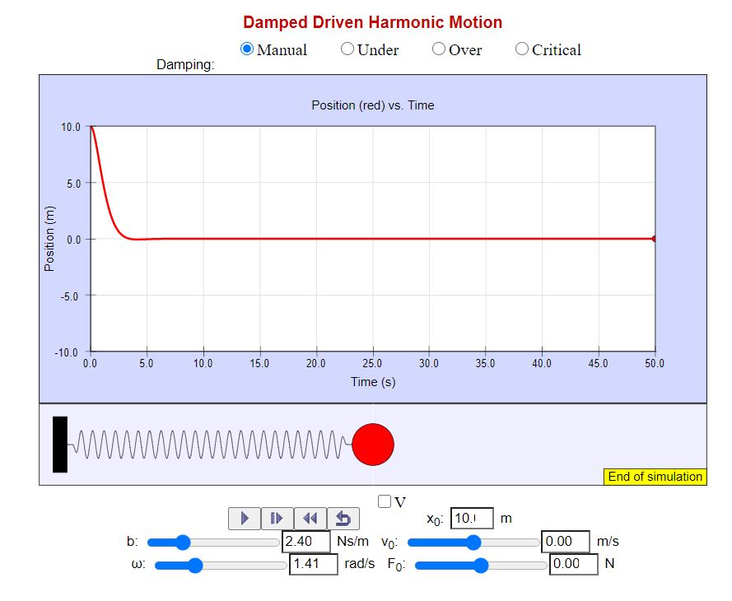

1. b = 3.1 Ns/m

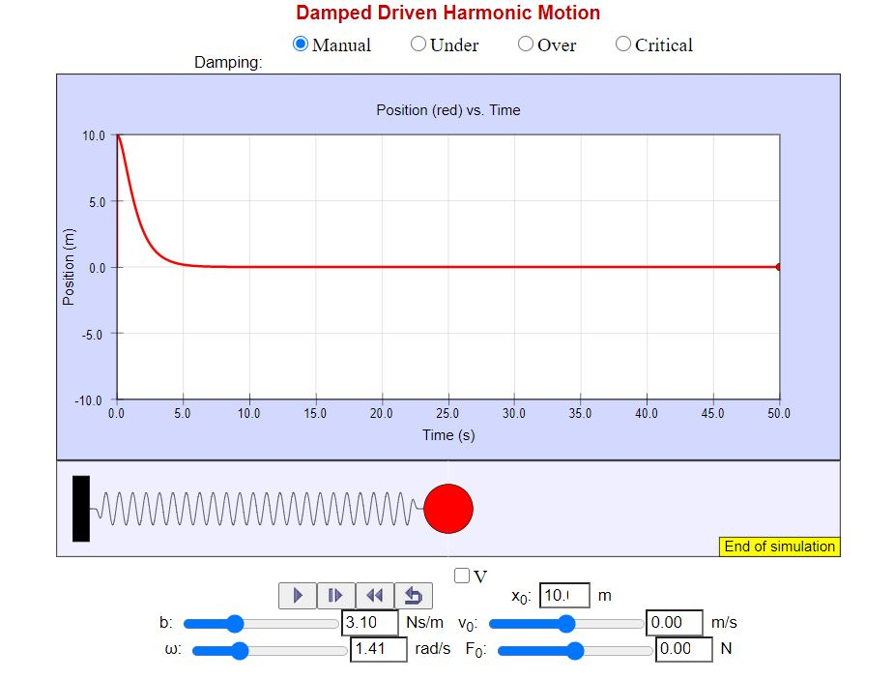

1. b = 3.5 Ns/m

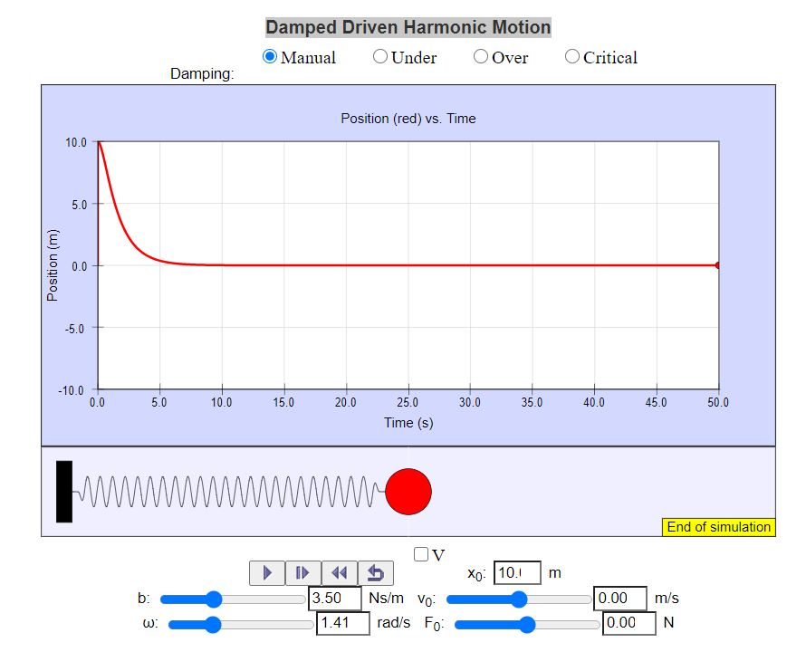

1. b = 4.0 Ns/m

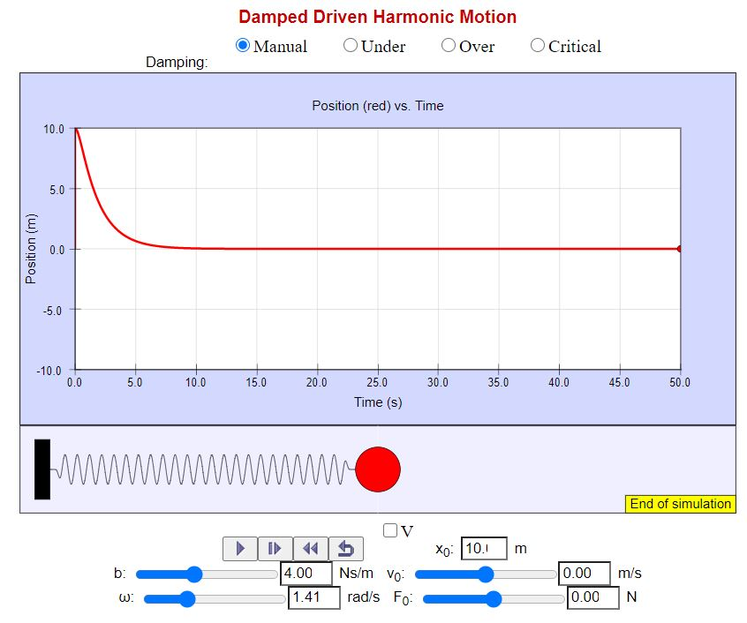

**Observation table -:**

|  |  |  |  |
| --- | --- | --- | --- |
| S. No. | Damping Constant  (b)  Ns/m | Time  seconds | Position of ball at time t    m |
| 1. | 0.35 | 5.03 | 3.46 |
| 2. | 0.50 | 5.03 | 2.82 |
| 3. | 0.70 | 5.03 | 0.54 |
| 4. | 1.00 | 5.03 | 0.39 |
| 5. | 1.50 | 5.03 | 0.27 |
| 6. | 2.00 | 5.03 | 0.02 |
| 7. | 2.40 | 5.03 | 0.12 |
| 8. | 3.10 | 5.03 | 0.36 |
| 9. | 3.50 | 5.03 | 0.63 |
| 10. | 4.00 | 5.03 | 0.90 |

**Result for Aim (ii) -:** From the observation table,

For values of b < 1 Ns/m,

we can see that the values of position x of the ball at a particular instant of time keeps on decreasing very fast as we gradually increase value of frictional constant b.

for values of b > 2Ns/m,

As we go on increasing b, the position x corresponding to a particular instant of time reaches a minimum at b=2.3 Ns/m, very close to equilibrium position. On further increasing b, we observe that the position x begins increasing with increase in b.

From the above analysis we can conclude that the motion of the mass is lightly damped (or under damped) when  . At , which is approximately equal to 2.3 the motion is critically damped and for the motion is heavily damped (or over damped).

**Observations for Aim (iii) -:** The graphs for underdamped, critically damped and overdamped motion are shown below,

1. **Underdamped Oscillation**

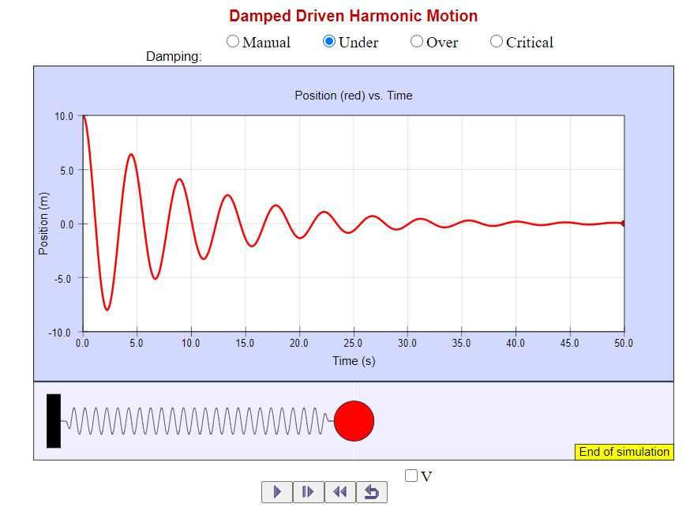

1. **Critically Damped Oscillation**

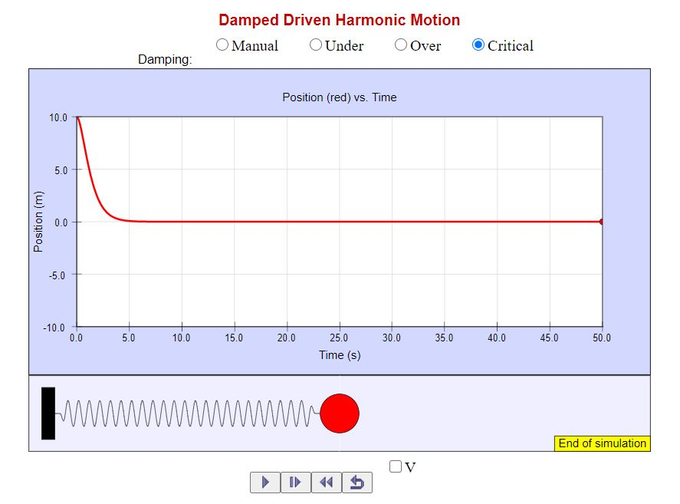

1. **Over Damped Oscillation**

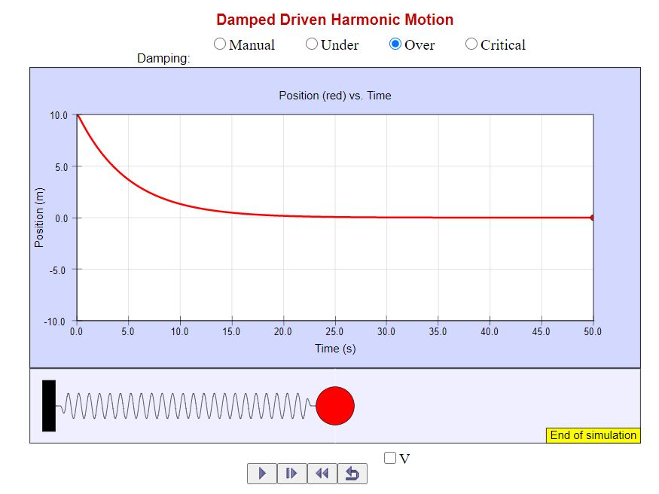

**Result for Aim(iii) -:** Performing the experiment it is observed that:

1. In under damped oscillation, at least one oscillation takes place and the mass crosses the mean position at least twice.
2. In critically damped oscillation, no oscillation takes place and damping constant is sufficiently high so that the mass just reaches the equilibrium position and do not crosses it.
3. In over damped oscillation, no oscillation takes place and moreover the mass never comes back to the equilibrium position again.

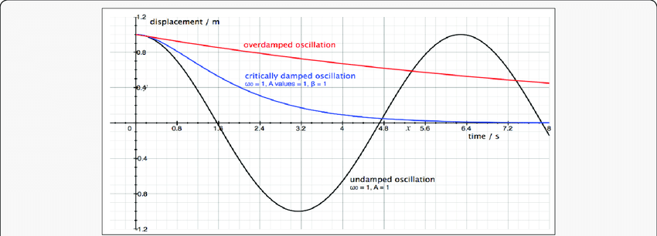

The figure above represents all three kinds of oscillations in the same graph.

Furthermore, we have observed that the motion is underdamped if the damping constant . This means that the particle will complete at least one oscillation if The mass will just reach the equilibrium position and no oscillation will take place if . This is the critically damped oscillation case. And, the mass will never come back to its equilibrium position if . This is the case of overdamped oscillation.

**Observations for Aim (iv) -:** Keeping frictional damping constant equal to 1 Ns/m and angular frequency equal to 1 radian/s, we extended the spring by 10 m and recorded the motion of ball for different values of .

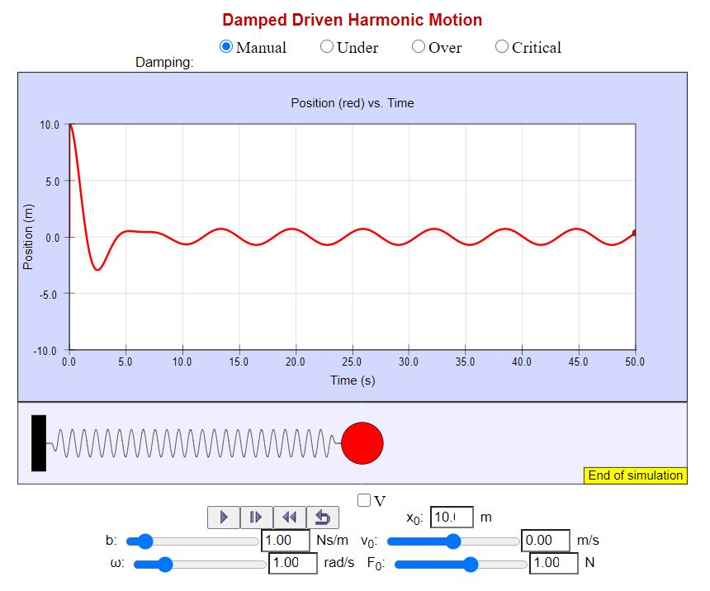

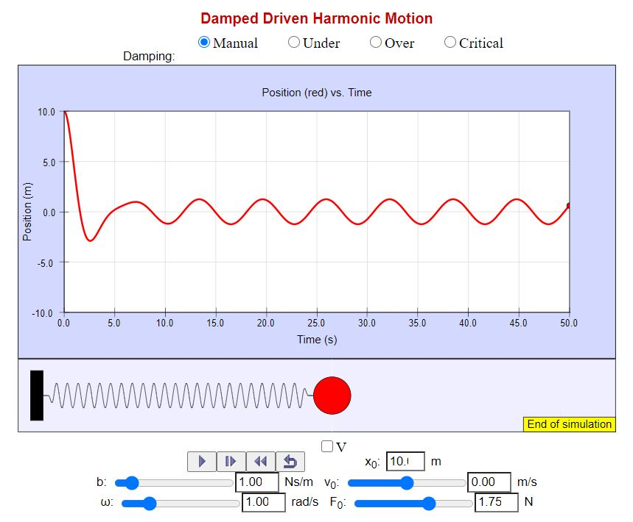

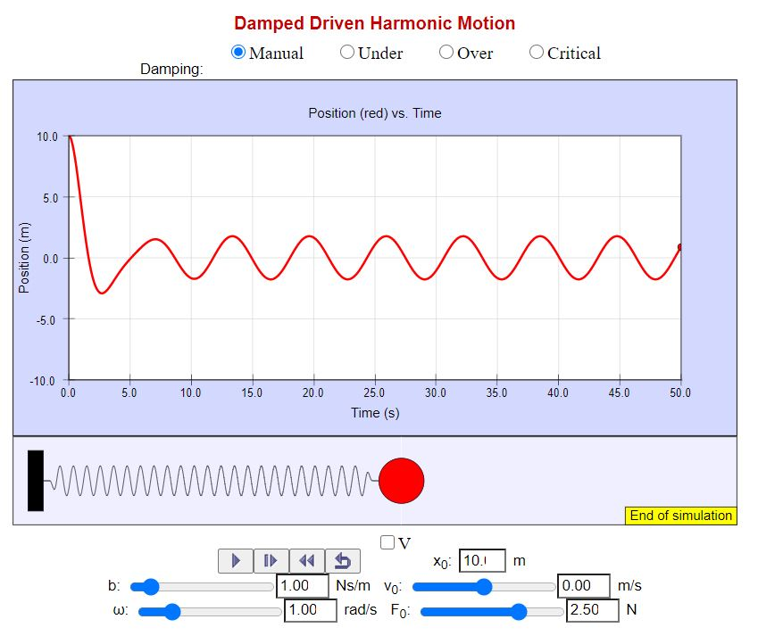

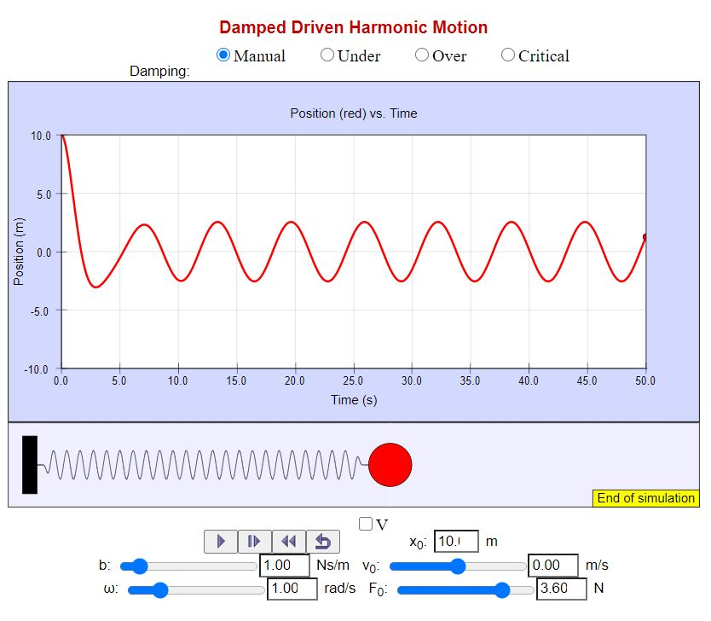

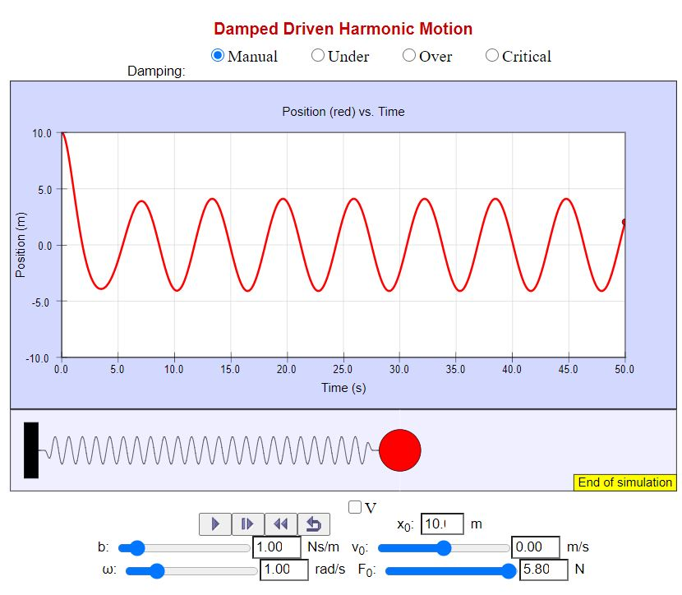

**Observation Table -:**

|  |  |  |  |
| --- | --- | --- | --- |
| S. No. | Value of  (N) | Time  (seconds) | Position of the ball  at time t  (m) |
| 1. | 1 | 5.05 | 0.54 |
| 2. | 1.75 | 5.05 | 0.26 |
| 3. | 2.50 | 5.05 | -0.01 |
| 4. | 3.60 | 5.05 | -0.65 |
| 5. | 5.80 | 5.05 | -1.47 |
|  | | | |

**Result for Aim (iv) -:** From the graphs obtained above, we saw that the motion of a mass in a forced damped oscillator is damped at first and becomes stable after some time. As we know, the equation of motion for a driven damped oscillator is,



and the solution is,



We know that if a damped mechanical oscillator is set into motion then the oscillations eventually die away due to frictional energy losses. In fact, the only way of maintaining the amplitude of a damped oscillator is to continuously feed energy into the system in such a manner as to offset the frictional losses. This is done by applying a time varying force to the damped oscillator. At the starting the damped oscillation and forced oscillation takes place simultaneously and the net displacement is sum of both type of oscillations. Eventually after some time, the damped oscillations die out and oscillations due to time varying force remains. Since the oscillations due to the time varying force are of constant amplitude, we observed a steady state (stable motion) after some time.

Also, we have observed from the graphs obtained using the simulator that the amplitude of stable oscillations in steady state is increasing with the time varying force, that is amplitude of stable oscillations is directly proportional to the time varying force’s amplitude .

Hence, the formula for the amplitude of stable oscillations is verified.

**Observations for Aim (v) -:** The graphs below are drawn using the Desmos software.

For damped harmonic oscillation, the equation is



The graph is plotted keeping damping factor equal to 0.11, phase difference φ = 0 and A = 8,

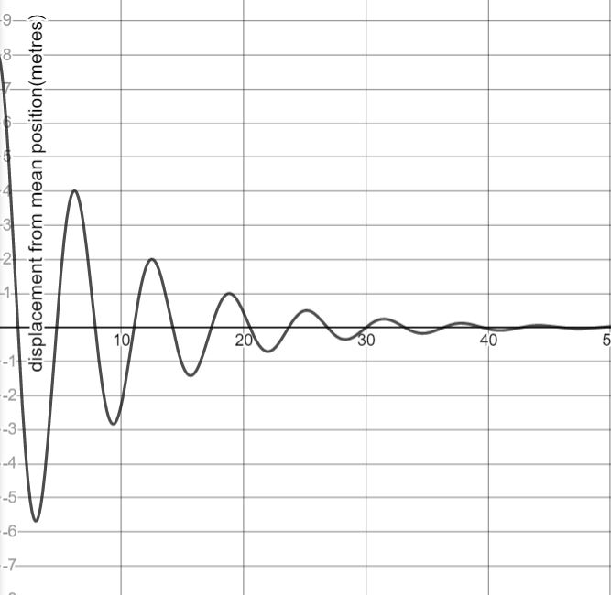

e

For driven harmonic oscillator, the equation is,



The graph is plotted keeping k = 6 N/m, F = 10 N and

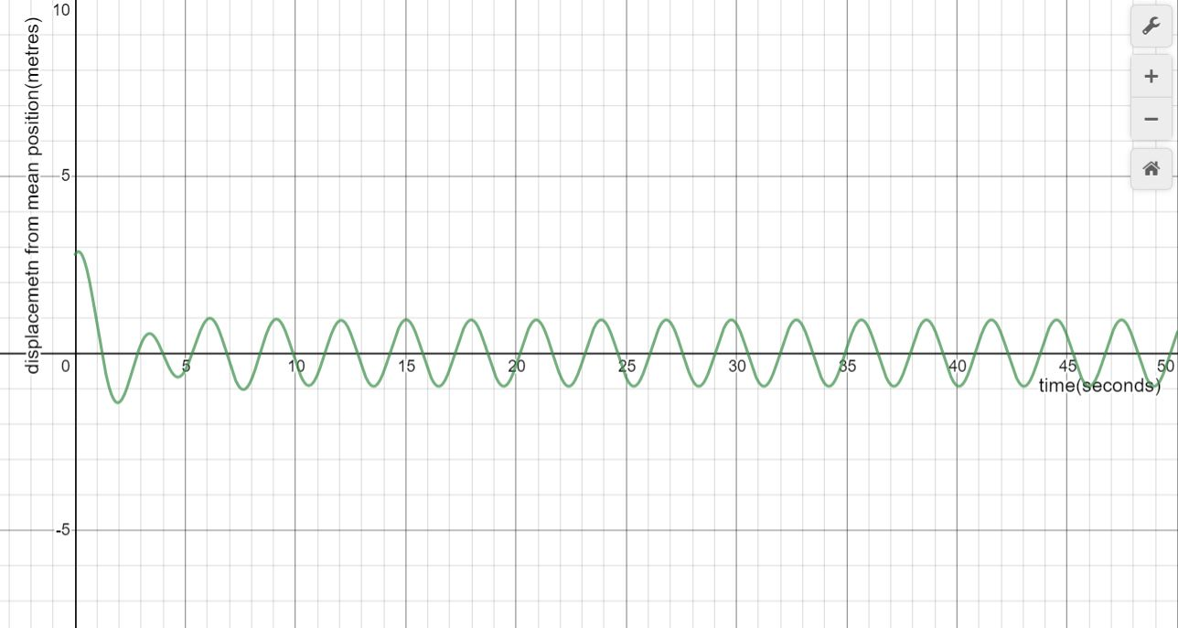

**Result for Aim (v) -:** The graphs obtained from the simulator are;

For damped harmonic oscillator,



For driven harmonic oscillator,



It can be observed that the graphs obtained from simulator and the graphs drawn using the equations are similar. The following conclusion can be drawn observing these graphs:

1. In damped oscillation graph, the amplitude is decreasing exponentially with time in both the graphs.
2. In driven harmonic oscillation, the motion initially is chaotic but afterwards the motion is stable and the mass oscillates with constant amplitude. It is observed in both the graphs.

Hence, the formulae for the damped harmonic oscillation and for the driven harmonic oscillation are matching with the results of simulation.