***Objective* -:** (i) To understand the phenomenon of Photoelectric Effect as a whole.

(ii) To draw kinetic energy of the photoelectrons as a function of frequency of incident radiation.

(iii) To determine the Planck’s Constant from stopping potential versus frequency graph.

(iv) To plot a graph connecting photocurrent and applied potential.

(v) To determine the stopping potential from the photocurrent versus applied potential graph.

***Theory*** **-:** **for Objective (i) -:** When light of sufficiently small wavelength is incident on a metal surface, electrons are ejected from the metal. This phenomenon is called the *photo-electric effect.* The electrons ejected from the metal surface are called *photoelectrons.*

As a metal surface has a lot of free electrons wandering throughout the body of the metal. However, these electrons are not free to leave the surface of the metal. As they try to come out, the metal attracts them back. Thus, a minimum amount of energy, known as *work function* (φ) of metal, is required for an electron to come out of the metal surface.

When light is incident on a metal surface, the photons collide with the free electrons. In a particular collision, the photon may give all of its energy to the free electron. If this energy is more than the work function of the metal, the free electron **may** come out of the metal surface. However, if the photon energy is more than work function, it is not necessary that the electron will come out.

A systematic study of photoelectric effect can be made in a laboratory with the apparatus shown in figure below,

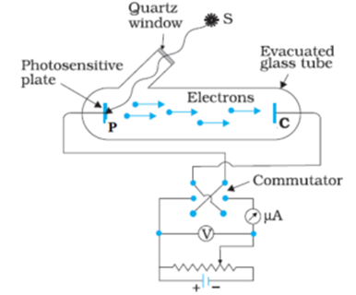

Two metal plates are sealed in a vacuum chamber. Light of reasonably small wavelength (or high energy) passes through the wall of chamber and falls on plate P which is called cathode (or emitter). The potential difference between cathode and anode can be changed using rheostat and batteries. The anode potential can be made positive or negative using the commutator.

**for Objective (ii) -:** Suppose a photon of energy E is incident on metal surface, giving all of its energy to a free electron. Assuming that the electron makes the most economical use of this energy, it will have a kinetic energy of (E – φ) after coming out. The actual kinetic energy lost depends on total energy lost in collisions. It may be possible that the electron loses so much energy that it fails to come out. So, the kinetic energy of an ejected electron can be anything between 0 and (E – φ). Hence, we can write,

---------1

Let the wavelength of radiation falling on metal surface be λ, and its frequency be ν, therefore,

where h is Planck’s constant and c is the speed of light in vacuum.

Therefore equation 1 becomes,

------------2

The equation 2 is known as Einstein’s Photoelectric Equation.

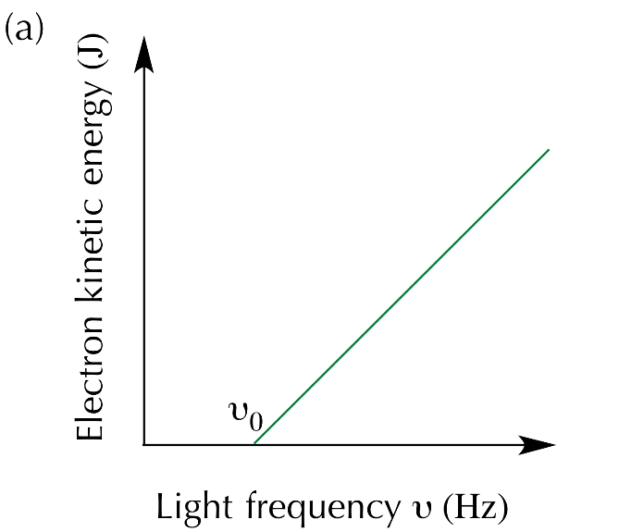**for Objective(iii) -:** The graph of versus ν is shown below,

Comparing equation 2 with the equation of line y = mx + c reveals that the slope of versus ν is equal to h, the Planck’s constant.

**for Objective (iv) -:**As electrons are emitted by cathode, the space between the cathode and anode contains a number of electrons making up the space charge. This negative charge repels fresh electrons coming from the cathode. However, some electrons reach the anode and there is a photocurrent. When the anode is given a positive potential with respect to cathode, electrons are attracted toward the anode and the photocurrent increases. The current thus depends on the potential applied at anode. If the potential of the anode is increased gradually, a situation arrives when the effect of the space charge becomes negligible and any electron that is emitted from the cathode is able to reach the anode. The current then becomes constant and is known as ***saturation current*.**

The saturation current increases as the intensity of light increases. This is because, a larger number of photons now fall on the metal surface and hence a larger number of electrons interact with photons. The number of electrons emitted increases and hence the photocurrent increases.

If the potential of anode is made negative with respect to the cathode, the electrons are repelled by the anode and the photocurrent decreases. At a certain value of this negative potential, the current is completely stopped. The smallest magnitude of the anode potential at which photocurrent becomes zero is known as **stopping potential.**

To stop the current, the fastest electron must not reach the anode. Suppose, the anode is kept at negative potential of with respect to cathode. As a photoelectron travels from cathode to anode, its potential energy increases by e, which is equal to its decrease in kinetic energy. The kinetic energy of the fastest electron as it reaches the anode is . If the fastest electrons just fails to reach the anode,

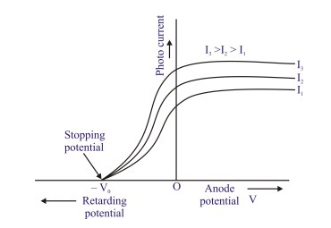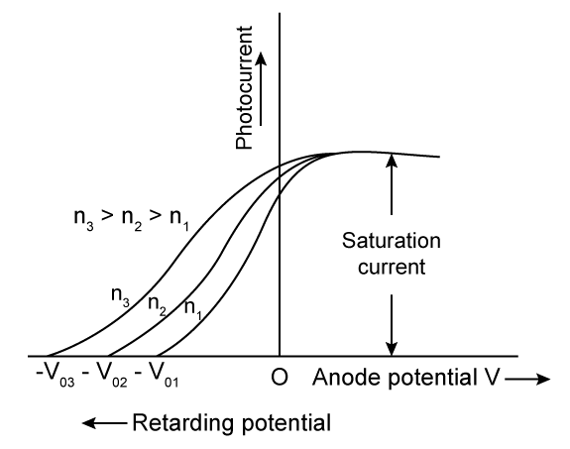The stopping potential depends on frequency of light and work function of metal. It does not depend on intensity of light.

The graph on the left shows that the saturation current increases with increasing intensity but the stopping potential does not vary with intensity of light. And, the graph on the right shows that the stopping potential increases with increasing frequency of light but the saturation current does not depend on frequency of light.

**for Objective (v) -:** The stopping potential can be calculated using the photocurrent versus applied potential graph. It is equal to the magnitude of negative potential where photocurrent becomes zero.

***Observations, errors and results* -:**

**For Objective (i)**

**Observations** -: Performing the photelectric effect experiment in the simulator led us to following observations -:

1. When light of sufficiently small wavelength falls on meatal surface, the metal emits electrons. The emission is almost instantaneous.
2. The kinetic energies of the photoelectron vary from 0 to such that

where φ is work function of the metal.

1. The photocurrent may be stopped by applying a negative potential at anode with respect to the cathode. The minimum magnitude of negative potential at which the photocurrent becomes zero is known as stopping potential.
2. The stopping potential does not depend on the intensity of the incident light.
3. The stopping potential depends on the wavelength (or frequency) of incident light.
4. The photocurrent increases if the intensity of light is increased and it does not depend on wavelength (or frequency) of incident light.

**Conclusion -:** Following conclusions can be drawn from the experiment -:

1. There is no time delay in the emission of a photoelectron from the metal surface.
2. The minimum frequency of radiation below which photoelectric effect does not take place is known as threshold frequency ()

1. The maximum wavelength above which no photoelectric effect takes place is known as threshold wavelength ()

1. Light has a *dual, that is, wave as well as particle nature*. The wave nature of light is experienced in Interference, Diffraction etc. The Photoelectric effect can be explained only by the particle theory of light. The points mentioned below explains why Photoelectric effect cannot be explained on the basis of wave theory of light -:
2. According to wave theory, when light falls on a metal surface, energy is continuously distributed over the surface. An electron may be ejected only when it acquires energy greater than the work function of metal. If we use a low intensity source, it may take hours before an electron acquires this much energy. This is contrary to experimental observations. No matter how small the intensity, photoelectrons are ejected without any time delay. This can be explained easily by particle theory. In particle theory, low intensity means low number of photons per unit time per unit area. However, any photon with enough energy may collide with an electron and provide it enough energy to leave the surface of metal.
3. According to wave theory, more intensity means more energy and hence the maximum kinetic energy of photoelectrons must increase with increasing intensity. However, maximum kinetic energy does not depend on intensity of incident light.
4. The dependence of maximum kinetic energy on wavelength is also against the wave theory of light. There should not be any threshold wavelength according to wave theory. According to this theory, by using sufficiently intense light of any wavelength, an electron may get enough energy and come out. However, experiments show the existence of a threshold wavelength.

**For Objective (ii)**

**Observations -:** The table below is for copper metal. The anode potential is kept zero with respect to cathode potential and the area of cathode plate is 0.1 The intensity of incident light is 5 W/.

There was no photocurrent observed in the simulator till a wavelength of 264 nm. Therefore, threshold wavelength for copper is 264 nm.

Hence, work function of copper .

|  |  |  |  |  |  |
| --- | --- | --- | --- | --- | --- |
| Sr.  No. | Work  Function(φ)  (eV) | Wavelength  of light(λ)  (nm) | Frequency  of light (ν)    (x | Energy of  photon(E)  E = hν  (eV) | Maximum kinetic energy of ejected electrons ()  (eV) |
| 1. | 4.7 | 240 | 1.25 | 5.177 | 0.477 |
| 2. | 4.7 | 207 | 1.449 | 6.002 | 1.302 |
| 3. | 4.7 | 182 | 1.648 | 6.826 | 2.126 |
| 4. | 4.7 | 148 | 2.027 | 8.394 | 3.694 |
| 5. | 4.7 | 128 | 2.344 | 9.706 | 5.006 |

The frequency vs graph is shown below for copper metal.

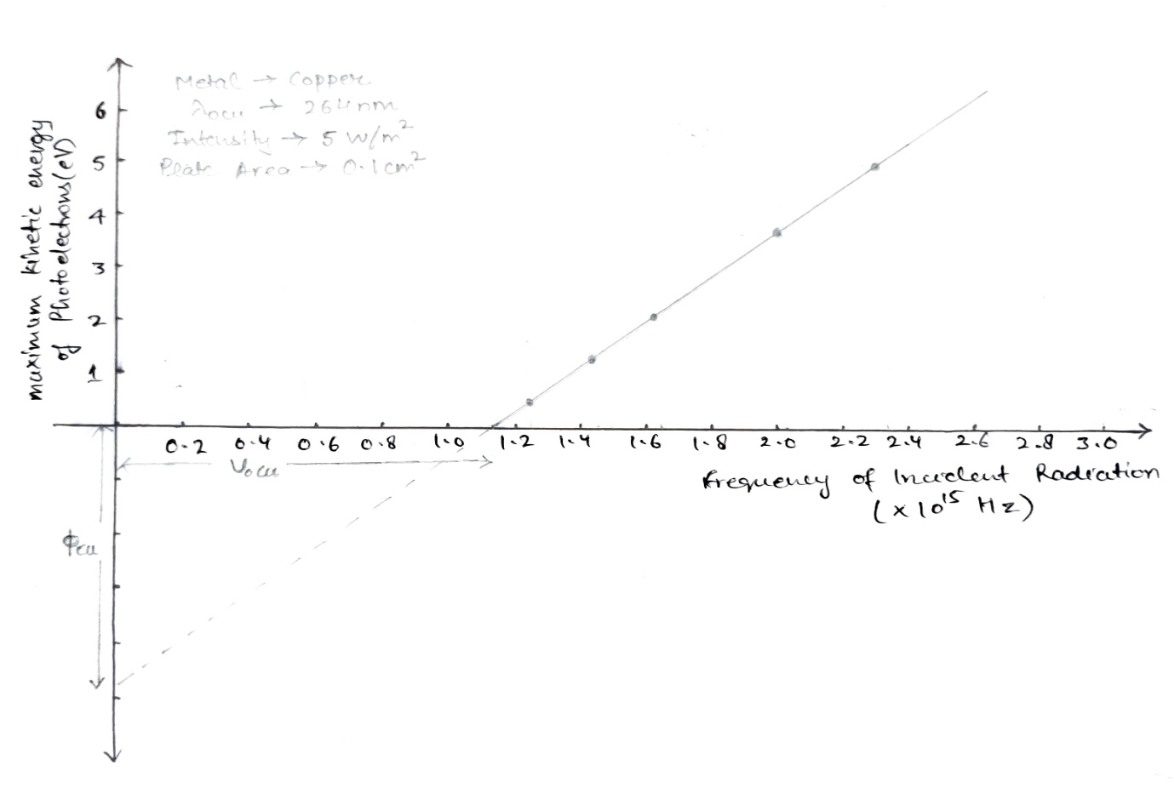

The table below is for Sodium metal. The anode potential is kept zero with respect to cathode potential and the area of cathode plate is 0.1 The intensity of incident light is 5 W/.

There was no photocurrent observed in the simulator till a wavelength of 544 nm. Therefore, threshold wavelength for Sodium is 544 nm.

Hence, work function of Sodium .

|  |  |  |  |  |  |
| --- | --- | --- | --- | --- | --- |
| Sr.  No. | Work  Function(φ)  (eV) | Wavelength  of light(λ)  (nm) | Frequency  of light (ν)    (x | Energy of  photon(E)  E = hν  (eV) | Maximum kinetic energy of ejected electrons ()  (eV) |
| 1. | 2.28 | 482 | 0.622 | 2.576 | 0.296 |
| 2. | 2.28 | 422 | 0.711 | 2.944 | 0.664 |
| 3. | 2.28 | 380 | 0.789 | 3.269 | 0.989 |
| 4. | 2.28 | 336 | 0.893 | 3.698 | 1.418 |
| 5. | 2.28 | 294 | 1.020 | 4.226 | 1.946 |

The frequency vs graph is shown below for sodium metal.

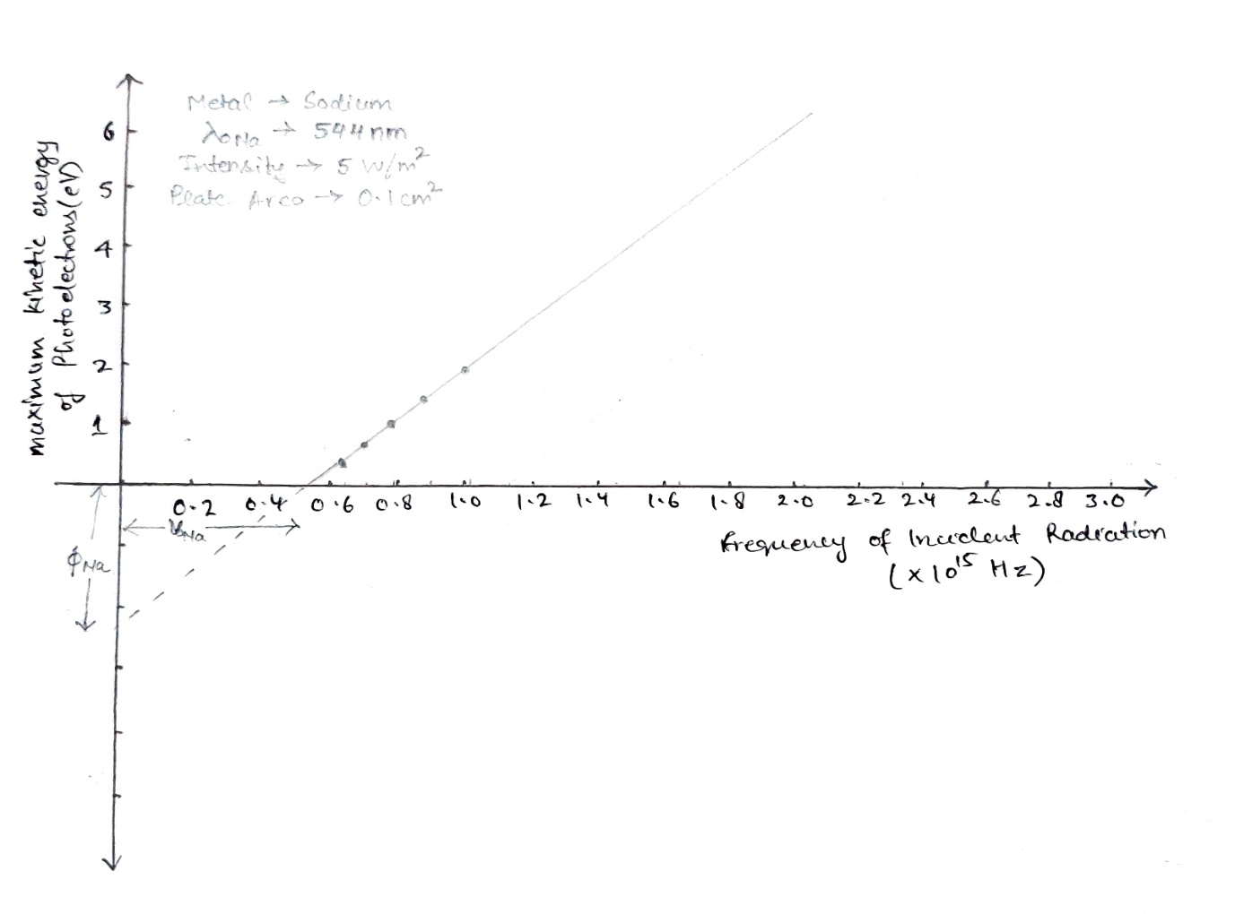The table below is for Zinc metal. The anode potential is kept zero with respect to cathode potential and the area of cathode plate is 0.1 The intensity of incident light is 5 W/.

There was no photocurrent observed in the simulator till a wavelength of 290 nm. Therefore, threshold wavelength for Zinc is 290 nm.

Hence, work function of Zinc .

|  |  |  |  |  |  |
| --- | --- | --- | --- | --- | --- |
| Sr.  No. | Work  Function(φ)  (eV) | Wavelength  of light(λ)  (nm) | Frequency  of light (ν)    (x | Energy of  photon(E)  E = hν  (eV) | Maximum kinetic energy of ejected electrons ()  (eV) |
| 1. | 4.28 | 264 | 1.136 | 4.706 | 0.426 |
| 2. | 4.28 | 218 | 1.376 | 5.699 | 1.419 |
| 3. | 4.28 | 185 | 1.622 | 6.715 | 2.435 |
| 4. | 4.28 | 152 | 1.974 | 8.174 | 3.894 |
| 5. | 4.28 | 124 | 2.419 | 10.019 | 5.739 |

The frequency vs graph is shown below for Zinc metal.

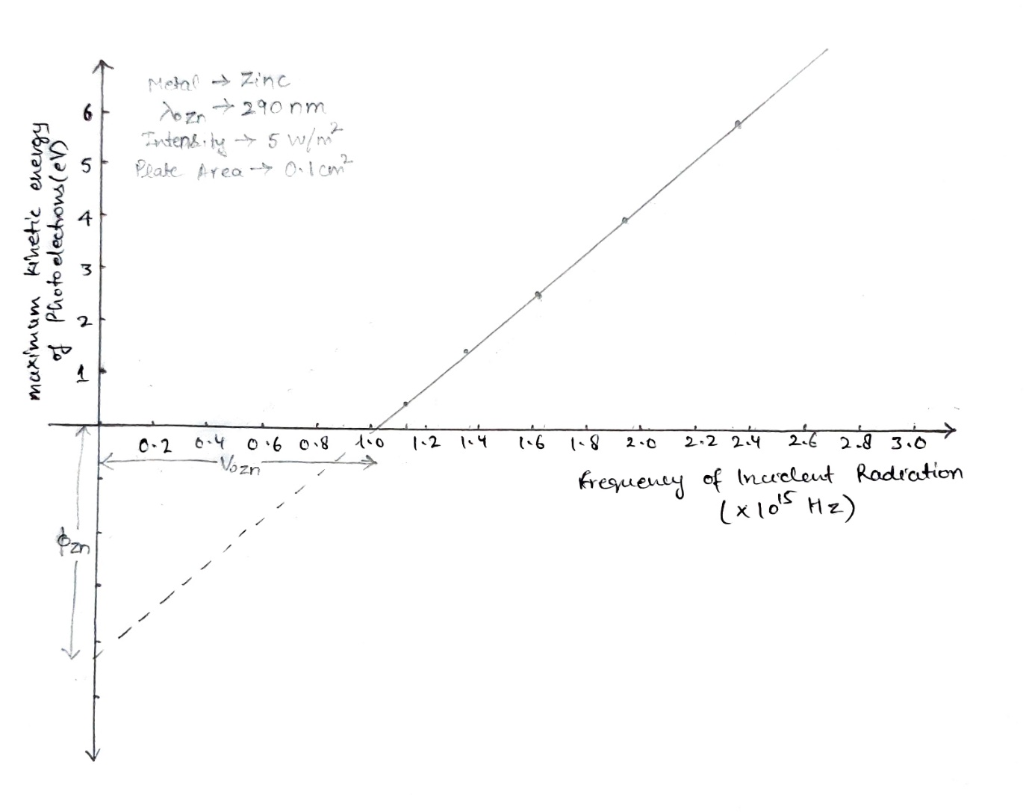

**Conclusion -:** From the graphs observed during the experiments, following points can be concluded -:

1. The graph of maximum kinetic energy against the frequency of incident light is a straight line. Hence, maximum kinetic energy varies linearly with the frequency of incident light.
2. The intercept made by the graph on the frequency axis is equal to the threshold frequency for the metal used, that is, below this frequency no photoemission will take place. The threshold frequencies for Copper, Sodium and Zinc are 1.136 x and respectively.
3. The magnitude of intercept made by the graph on the maximum kinetic energy axis is equal to the work function of the metal used. The work function of copper, sodium and zinc is 4.7 eV, 2.28 eV and 4.28 eV respectively.
4. The maximum kinetic energy of the emitted photoelectrons is thus given by the equation,

1. The maximum kinetic energy versus frequency graph for different material are parallel to each other, that is, they have same slope.

**For Objective (iii)**

**Observations -:** The metal used for the table below is copper. Intensity is equal to 10 W/ and plate area is 0.5 . Threshold Wavelength for copper is 264 nm.

|  |  |  |
| --- | --- | --- |
| Sr. No. | Frequency of incident light (ν)  (x | Stopping Potential  (V) |
| 1. | 1.25 | 0.5 |
| 2. | 1.51 | 1.6 |
| 3. | 1.81 | 2.8 |
| 4. | 2.11 | 4.1 |

The metal used for the table below is sodium. Intensity is equal to 10 W/ and plate area is 0.5 . Threshold Wavelength for sodium is 544 nm.

|  |  |  |
| --- | --- | --- |
| Sr. No. | Frequency of incident light (ν)  (x | Stopping Potential  (V) |
| 1. | 0.63 | 0.4 |
| 2. | 0.72 | 0.8 |
| 3. | 0.88 | 1.4 |
| 4. | 1.15 | 2.5 |

The metal used for the table below is zinc. Intensity is equal to 10 W/ and plate area is 0.5 . Threshold Wavelength for zinc is 290 nm.

|  |  |  |
| --- | --- | --- |
| Sr. No. | Frequency of incident light (ν)  (x | Stopping Potential  (V) |
| 1. | 1.17 | 0.6 |
| 2. | 1.35 | 1.3 |
| 3. | 1.67 | 2.6 |
| 4. | 2.03 | 4.1 |

The stopping potential versus frequency of incident light is shown below for copper, sodium and zinc metal.

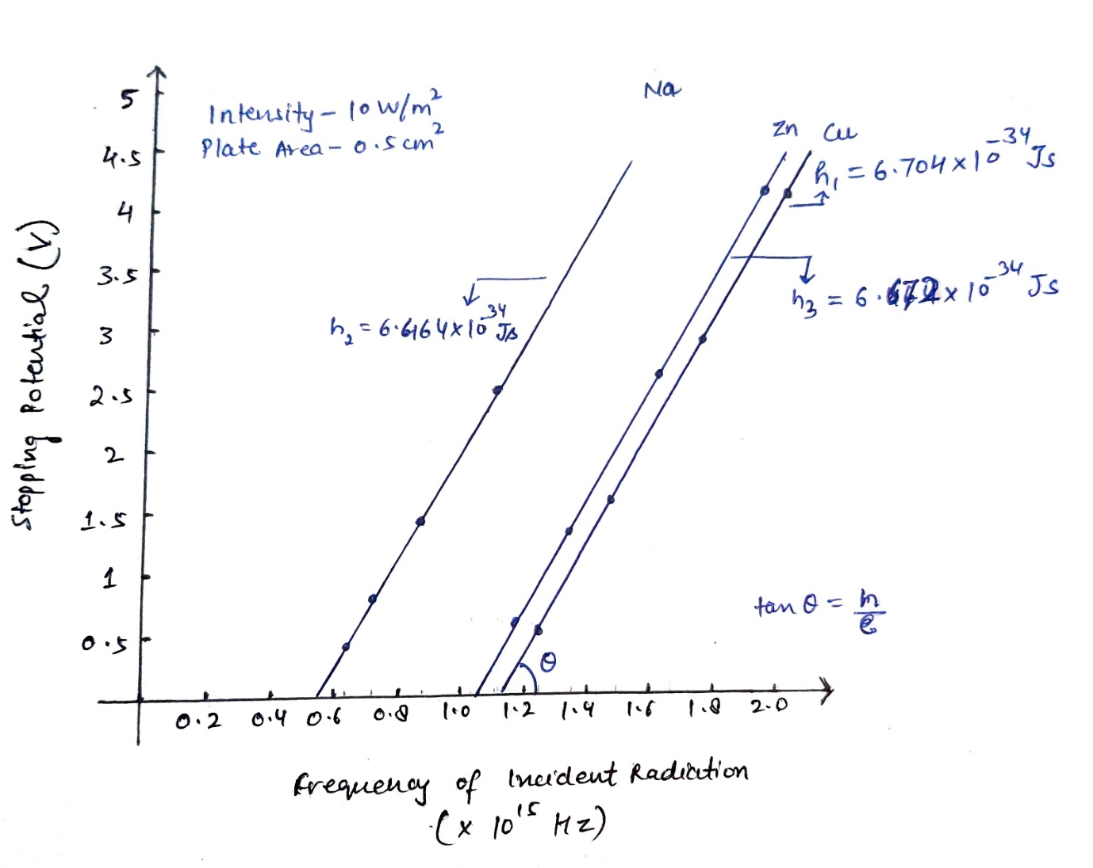

**Calculations -:** The equation,

suggests that the slope of stopping potential versus frequency graph is equal to .

The slope of the graph can be found using m = .

therefore, using the table entries, the slope from the copper graph,

Similarly, slope from the sodium graph,

Similarly, slope from the zinc graph,

Therefore, Planck’s constant from the graphs is equal to,

Hence, the value of Planck’s constant is average of

**Errors -:** The standard deviation(σ) can be calculated as,

**Conclusion -:** From the above experiment, following conclusions can be drawn,

1. The slope of graph of stopping potential versus frequency curve is equal to h/e.
2. The value of Planck’s constant is equal to .

**For Objective (iv)**

**Observations -:** The data below is observed for copper metal. The wavelength of incident light is 182 nm and plate area is 0.4 .

|  |  |  |
| --- | --- | --- |
| Intensity = 5 W/ | | |
| Sr. No. | Voltage applied at anode with  respect to cathode (V)  (volts) | Photocurrent (I)  (μA) |
| 1. | 0 | 4.24 |
| 2. | -0.6 | 3.04 |
| 3. | -1.1 | 2.04 |
| 4. | -2.0 | 0.24 |
| 5. | -2.2 | 0 |
| Intensity = 15 W/ | | |

|  |  |  |
| --- | --- | --- |
| 1. | 0 | 12.73 |
| 2. | -0.6 | 9.13 |
| 3. | -1.1 | 6.13 |
| 4. | -2.0 | 0.73 |
| 5. | -2.2 | 0 |
| Intensity = 30 W/ | | |

|  |  |  |
| --- | --- | --- |
| 1. | 0 | 25.46 |
| 2. | -0.6 | 18.26 |
| 3. | -1.1 | 12.26 |
| 4. | -2.0 | 1.46 |
| 5. | -2.2 | 0 |

The photocurrent versus applied potential graph for copper metal is shown below.

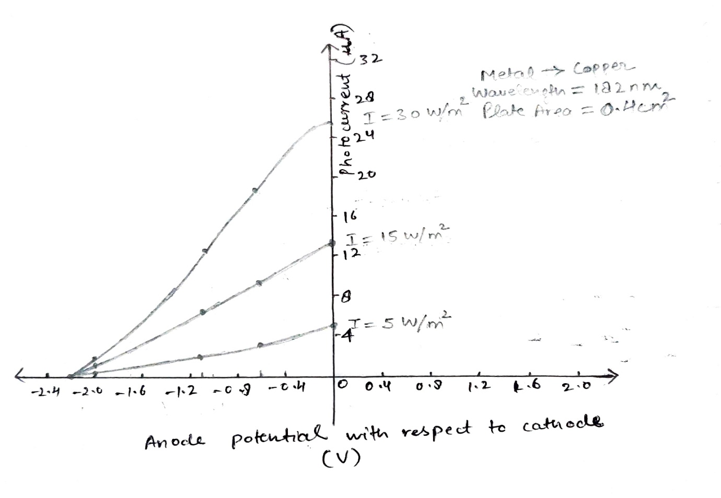

The data below is observed for Sodium metal. The wavelength of incident light is 376 nm and plate area is 0.4 .

|  |  |  |
| --- | --- | --- |
| Intensity = 5 W/ | | |
| Sr. No. | Voltage applied at anode with  respect to cathode (V)  (volts) | Photocurrent (I)  (μA) |
| 1. | 0 | 2.04 |
| 2. | -0.2 | 1.64 |
| 3. | -0.4 | 1.24 |
| 4. | -0.8 | 0.44 |
| 5. | -1.1 | 0 |
| Intensity = 10 W/ | | |

|  |  |  |
| --- | --- | --- |
| 1. | 0 | 4.09 |
| 2. | -0.2 | 3.29 |
| 3. | -0.4 | 2.49 |
| 4. | -0.8 | 0.89 |
| 5. | -1.1 | 0 |
| Intensity = 25 W/ | | |

|  |  |  |
| --- | --- | --- |
| 1. | 0 | 10.22 |
| 2. | -0.2 | 8.22 |
| 3. | -0.4 | 6.22 |
| 4. | -0.8 | 2.22 |
| 5. | -1.1 | 0 |

The photocurrent versus applied potential graph for Sodium metal is shown below.

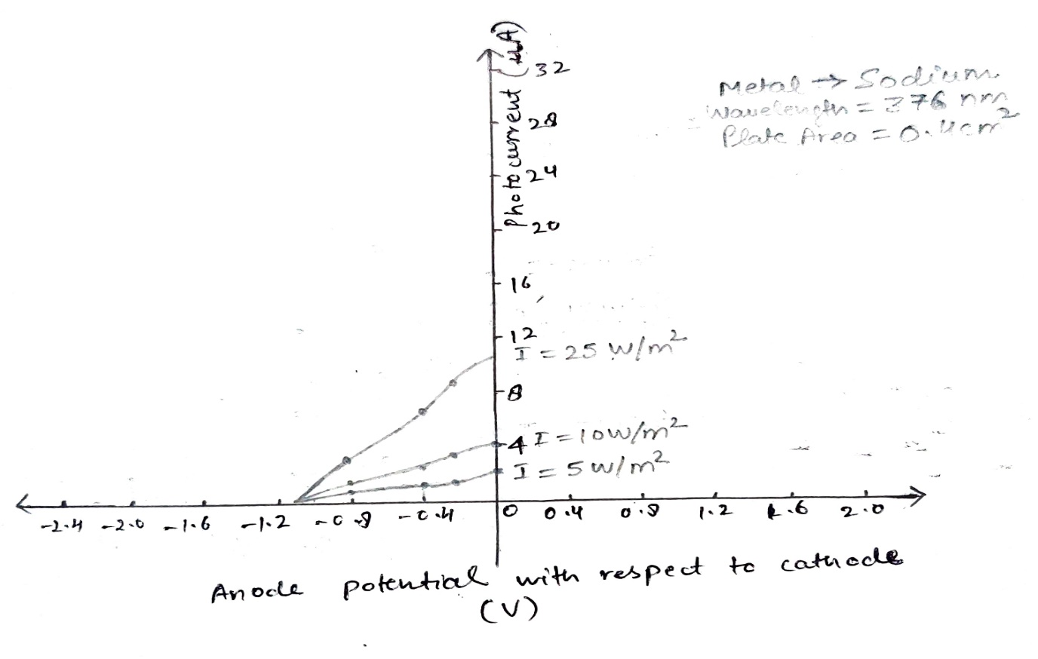

The data below is observed for Zinc metal. The wavelength of incident light is 196 nm and plate area is 0.4 .

|  |  |  |
| --- | --- | --- |
| Intensity = 5 W/ | | |
| Sr. No. | Voltage applied at anode with  respect to cathode (V)  (volts) | Photocurrent (I)  (μA) |
| 1. | 0 | 4.07 |
| 2. | -0.4 | 3.27 |
| 3. | -1.0 | 2.07 |
| 4. | -1.7 | 0.67 |
| 5. | -2.1 | 0 |
| Intensity = 15 W/ | | |

|  |  |  |
| --- | --- | --- |
| 1. | 0 | 12.21 |
| 2. | -0.4 | 9.81 |
| 3. | -1.0 | 6.21 |
| 4. | -1.7 | 2.01 |
| 5. | -2.1 | 0 |
| Intensity = 20 W/ | | |

|  |  |  |
| --- | --- | --- |
| 1. | 0 | 16.28 |
| 2. | -0.4 | 13.08 |
| 3. | -1.0 | 8.28 |
| 4. | -1.7 | 2.68 |
| 5. | -2.1 | 0 |

The photocurrent versus applied potential graph for Zinc metal is shown below.

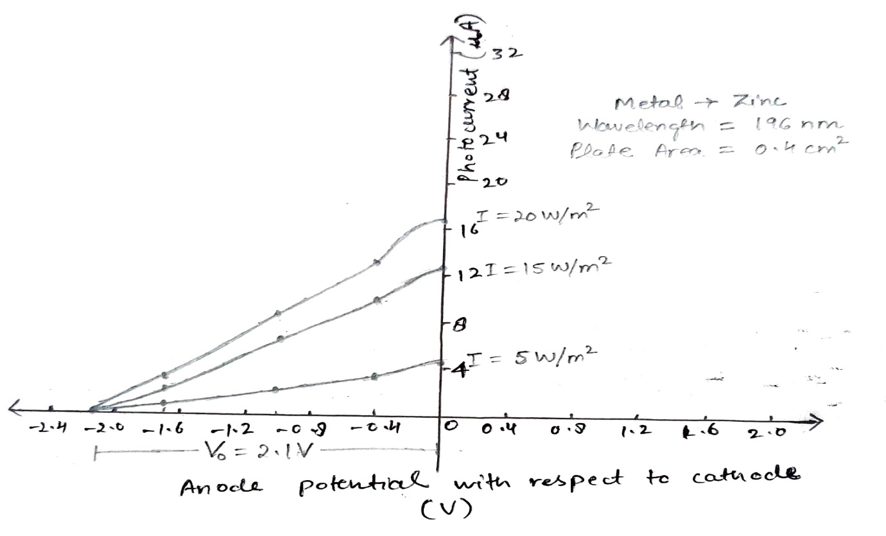

**Errors -:** 1. The negative potential of anode where the photocurrent is becoming zero has an error of because the least count of voltage meter in the simulator is 0.1. Hence an error of V may be induced in the calculations.

2. The simulator does not provide the flexibility to make the anode potential positive with respect to the cathode. Hence, saturation current cannot be calculated.

3. The graphs are drawn from free hand and hence they are not quite up to the mark. The actual graph removing all the errors is given below.

**Conclusion -:** Following conclusions can be drawn from the experiment -:

1. The photocurrent decreases on applying a negative potential at anode with respect to the cathode.
2. The photocurrent increases on increasing the potential at anode with respect to cathode up to a certain value of anode potential and then it becomes constant. This constant current is known as saturation current.
3. The photocurrent increases with the intensity of incident light. This can be observed in each table. On applying equal potential at anode at different intensities, the photocurrent observed is more in the table with higher intensity.
4. The stopping potential is independent of the intensity of light. This can be observed in each table. On measuring photocurrent applying different potentials at different intensities, the photocurrent becomes equal to 0 at equal value of anode potential for different intensities. Hence, stopping potential is independent of intensity of light.

**For Objective (v)**

**Observations** -: The magnitude of negative anode potential where the photocurrent becomes zero is equal to the stopping potential. It can be easily calculated from the photocurrent versus applied potential graph. The graphs obtained from the experiment for Copper, Sodium and Zinc at a fix value of frequency are shown below.

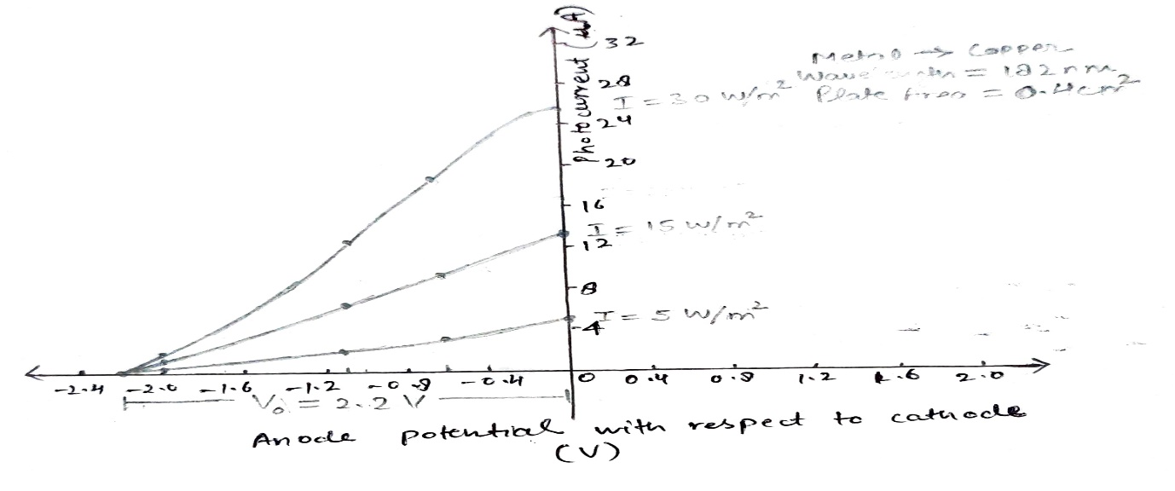

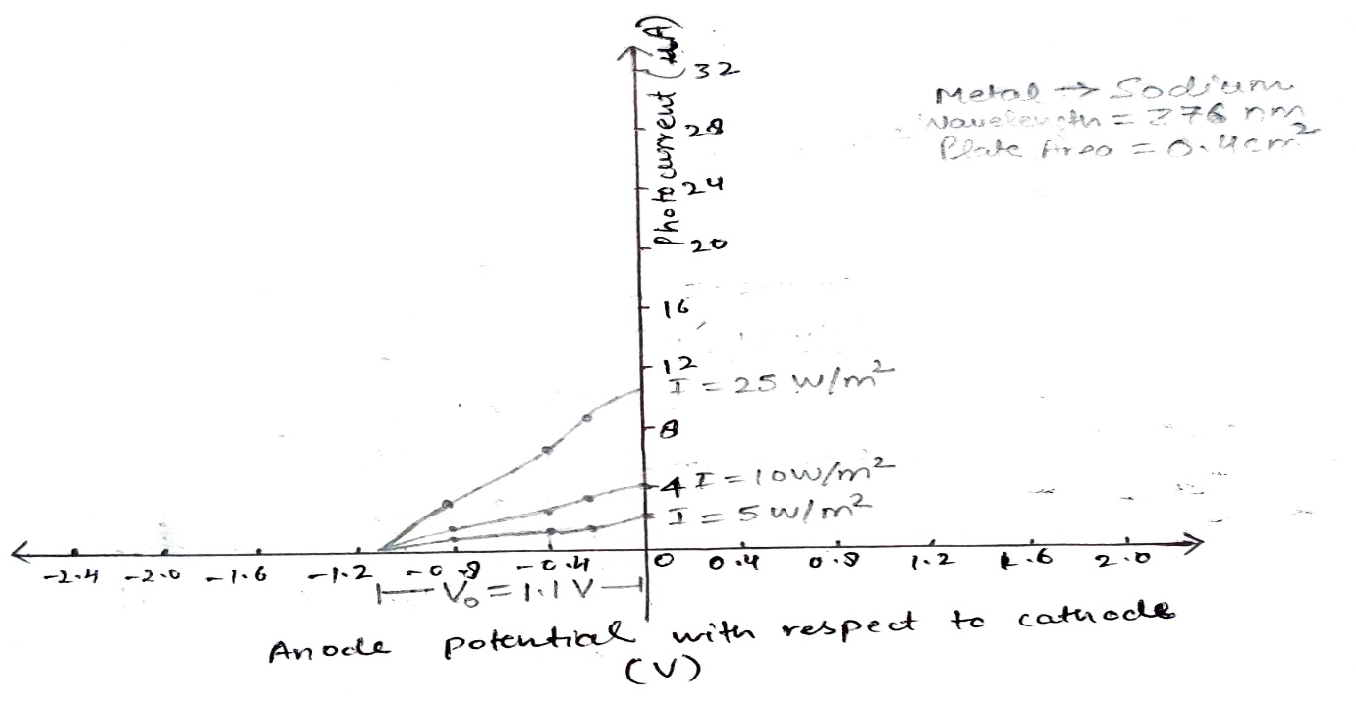

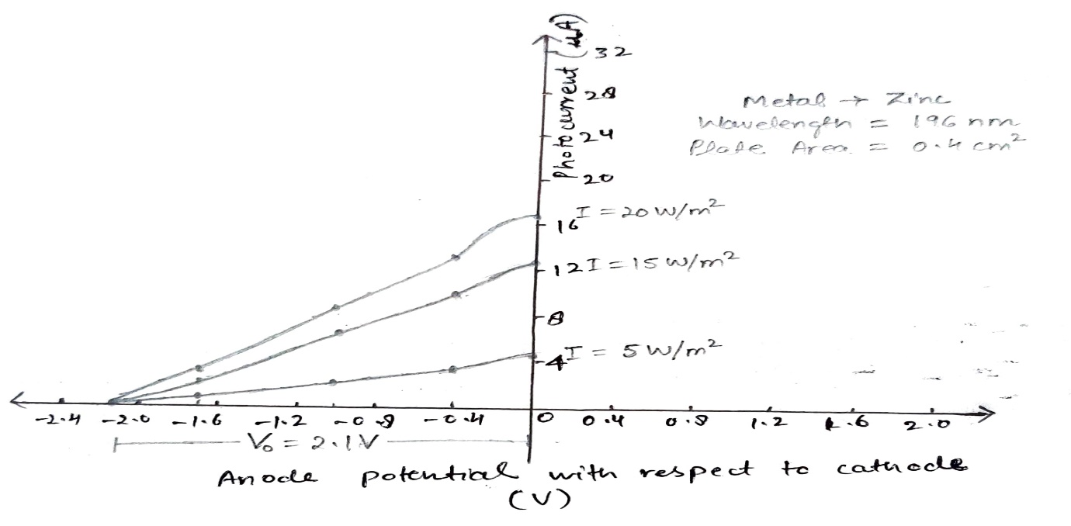

It can be observed that the photocurrent becomes zero at negative anode potential of 2.2 V, 1.1 V, and 2.1 V for copper, sodium and zinc respectively.

**Errors -:** As the simulator allows to change the potential only in steps of 0.1 V, an error of 0.1 V is present in the values of stopping potential.

**Conclusion -:** Following conclusions can be drawn from the above experiment-:

1. The stopping potential for a particular metal does not depend upon the intensity of light used. It can be clearly seen that at each frequency, the photocurrent becomes zero at the same negative potential.
2. The stopping potential for a particular metal does depend upon the frequency of incident light used. While performing the above experiment, the frequency of light is kept same during the whole experiment for every metal and we observed that the stopping potential does not changes. However, if we plot a similar graph but vary the frequency and keep the intensity of incident light constant, a graph shown below is observed.