***Objective -:***

1. To study the effect of detection of wave nature of particle in presence and absence of detector.
2. To visualize and analyze the intensity pattern for different matter waves.
3. To study the effect of slit width and vertical separation on the interference pattern from Young’s Double slit experiment.

***Theory -:***

In order to measure very small distances, it is often useful to employ wave interference. When two wave fields are superposed their wave crests may add up (constructive interference) while the encounter of a crest and a trough tends to cancel the wave (destructive interference). The pattern of constructive and destructive interference in space allows to determine the wavelength.

It is a particular trait of quantum physics that wave functions may be associated not only with dense ensembles of particles but even with an ensemble that has been diluted to a single particle in the machine at any instant. The wave function seemingly still describes the individual quantum object. This is why one often says that ‘each particle interferes with itself’.

Quantum theory can only predict probabilities for a certain outcome. Which of the many possibilities is finally assumed in a measurement on an initial superposition of options and states is entirely random.

All experiments so far have confirmed Born’s rule: the squared modulus of the state function ψ represents the probability to find a quantum object at time t at position r with all other parameters contained in ψ.

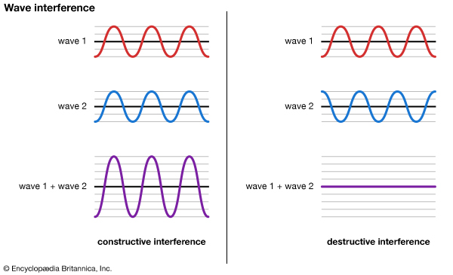

Quantum interference is quite different from the classical wave interference. Quantum interference is, however, similar to [optical interference](https://en.wikipedia.org/wiki/Wave_interference#Optical_interference).

Let be a wavefunction solution of the Schrdinger Equation for a quantum mechanical object. Then the probability of observing the object at position {\displaystyle x}at at at is where * indicates complex conjugation. Quantum interference concerns the issue of this probability when the wavefunction is expressed as a sum or linear superposition of two terms :

Usually, and correspond to distinct situations A and B. When this is the case, the equation . indicates that the object can be in situation A or situation B. The above equation can then be interpreted as: The probability of finding the object at  is the probability of finding the object at when it is in situation A plus the probability of finding the object at  when it is in situation B plus an extra term. This extra term, which is called the *quantum interference term*, is in the above equation. As in the classical wave case above, the quantum interference term can add (constructive interference) or subtract (destructive interference) from  in the above equation depending on whether the quantum interference term is positive or negative. If this term is absent for all , then there is no quantum mechanical interference associated with situations A and B. {\displaystyle |\Psi _{A}(x,t)|^{2}+|\Psi _{B}(x,t)|^{2}} {\displaystyle x}

In order to form an interference pattern, the incident light must satisfy two conditions:

1. The light sources must be coherent. This means that the plane waves from the sources must maintain a constant phase relation. For example, if two waves are completely out of phase with φ = π, this phase difference must not change with time.
2. The light must be monochromatic. This means that the light consists of just one wavelength.

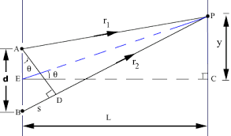

Consider light that falls on the screen at a point P a distance y from the point C that lies on the screen a perpendicular distance L from the double-slit system. The two slits are separated by a distance d. The light from slit 2 will travel an extra distance to the point P than the light from slit 1. This extra distance is called the path difference. From Figure, we have, using the law of cosines,

The distance PE = r.

and,

Subtracting the above two equations,

In the limit L >> d, the sum can be approximated to 2r.

Hence, the path difference s becomes,

Whether the two waves are in phase or out of phase is determined by the value of s. Constructive interference occurs when s is zero or an integer multiple of the wavelength λ:

For constructive interference,

where n is called the order number. The zeroth-order (n = 0) maximum corresponds to the central bright fringe at θ = 0, and the first-order maxima (n = ±1) are the bright fringes on either side of the central fringe.

On the other hand, when s is equal to an odd integer multiple of , the waves will be out of phase at P, resulting in destructive interference with a dark fringe on the screen. The condition for destructive interference is given by 180°

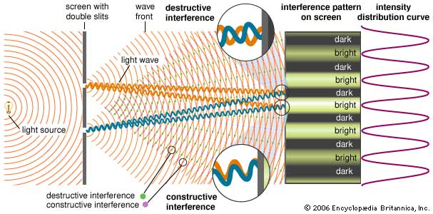

***Observations, conclusions and error analysis-:***

For Objective 1

**Observations** -: Analysis of interference pattern of:

* **Photon**

|  |  |  |  |
| --- | --- | --- | --- |
| S.No. | Slit Width  (nm) | Vertical Separation  (nm) | Distance between two maxima(nm) |
| 1. | 400 | 1300 | 975 |
| 2. | 400 | 1100 | 750 |
| 3. | 400 | 1400 | 1180 |
| 4. | 530 | 1690 | 1000 |
| 5. | 530 | 1120 | 780 |

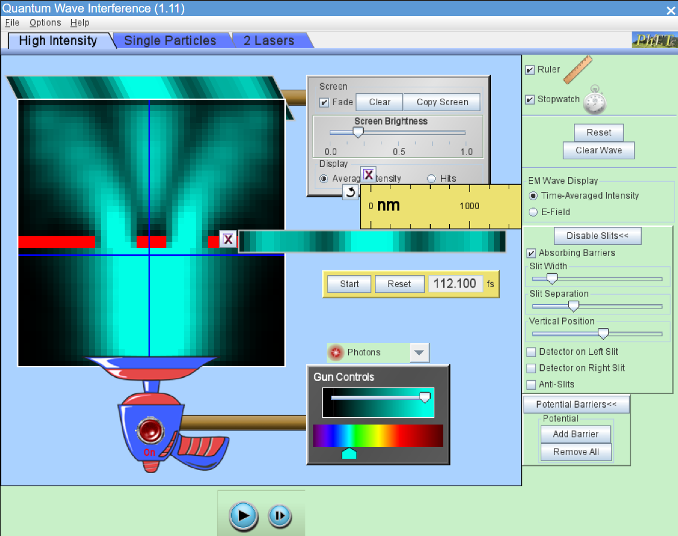

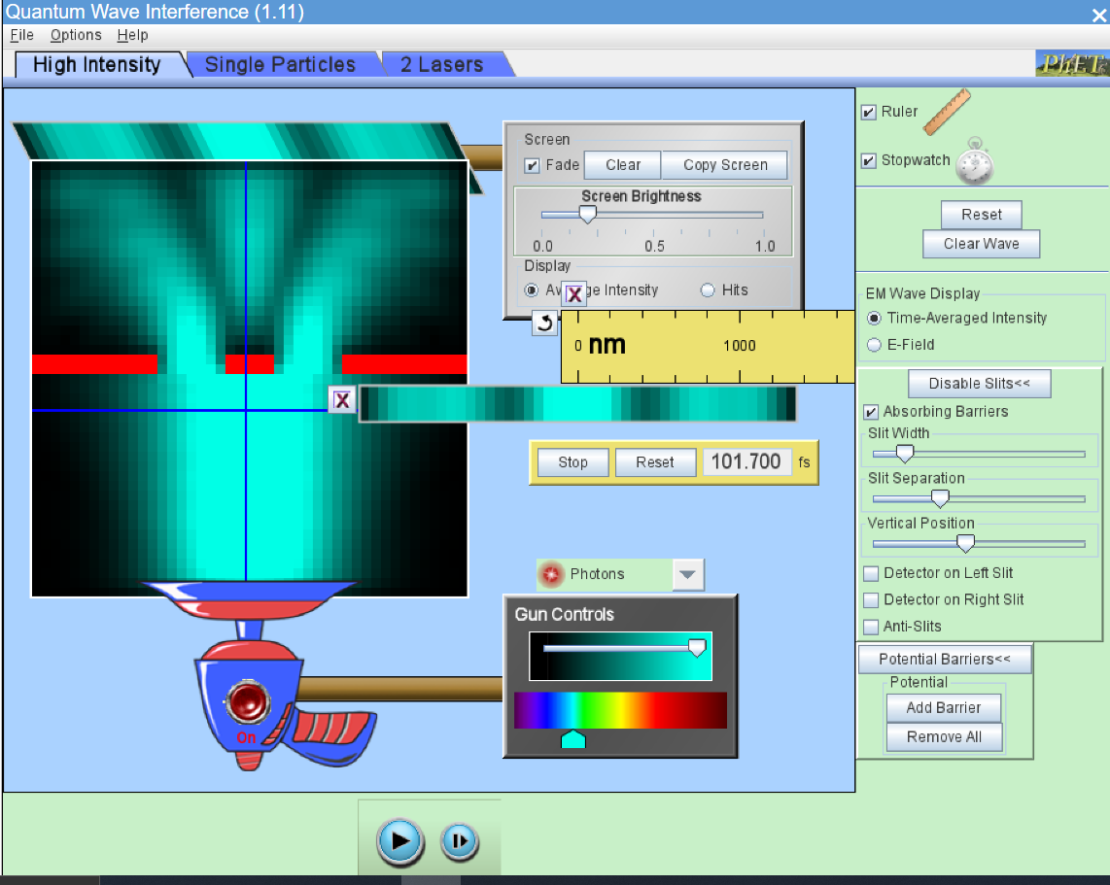

* **Electron**

|  |  |  |  |
| --- | --- | --- | --- |
| S.No. | Slit Width  (nm) | Vertical Separation  (nm) | Distance between two maxima(nm) |
| 1. | 1.7 | 2.00 | 1.10 |
| 2. | 1.7 | 2.20 | 1.20 |
| 3. | 1.7 | 2.85 | 1.25 |
| 4. | 0.7 | 2.80 | 1.23 |
| 5. | 0.5 | 2.80 | 1.25 |

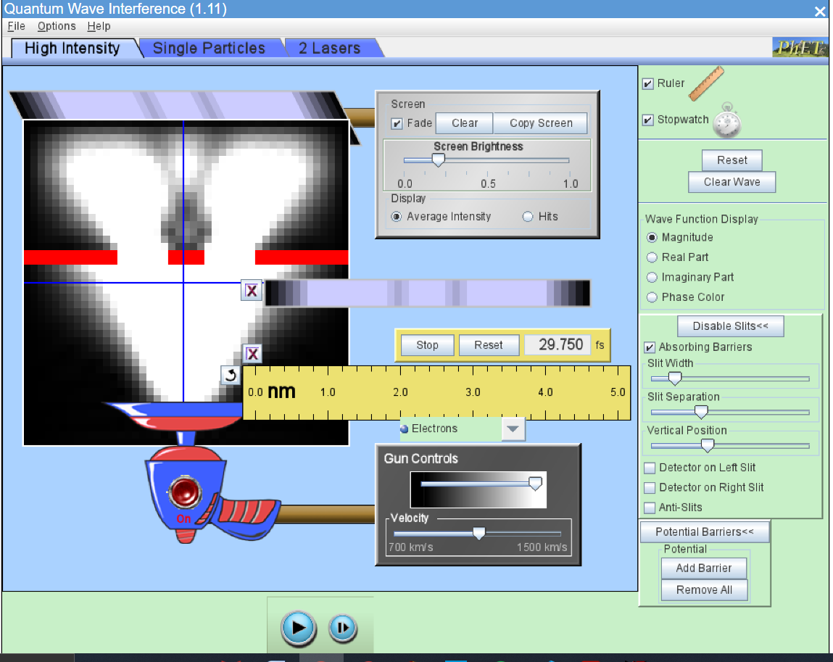

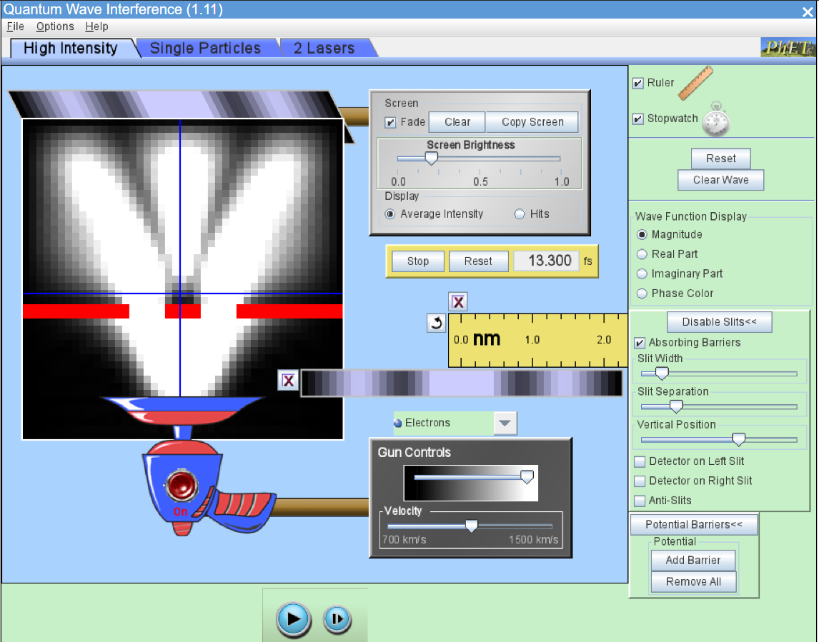

* **Neutron**

|  |  |  |  |
| --- | --- | --- | --- |
| * S.No. | Slit Width  (nm) | Vertical Separation  (nm) | Distance between two maxima(nm) |
| 1. | 0.7 | 2.3 | 0.9 |
| 2. | 0.7 | 1.9 | 0.7 |
| 3. | 0.7 | 3.2 | 1.20 |
| 4. | 0.5 | 1.3 | 0.55 |
| 5. | 0.5 | 2.6 | 1.35 |

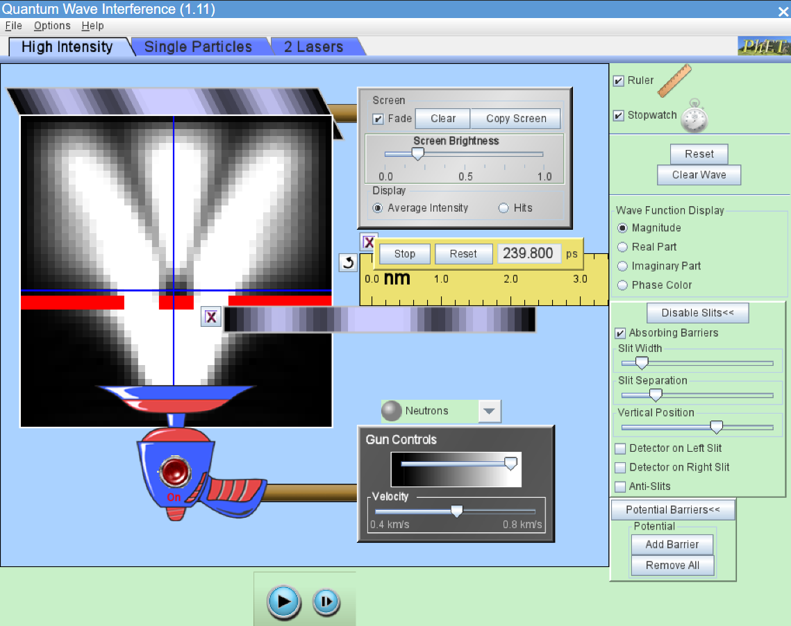

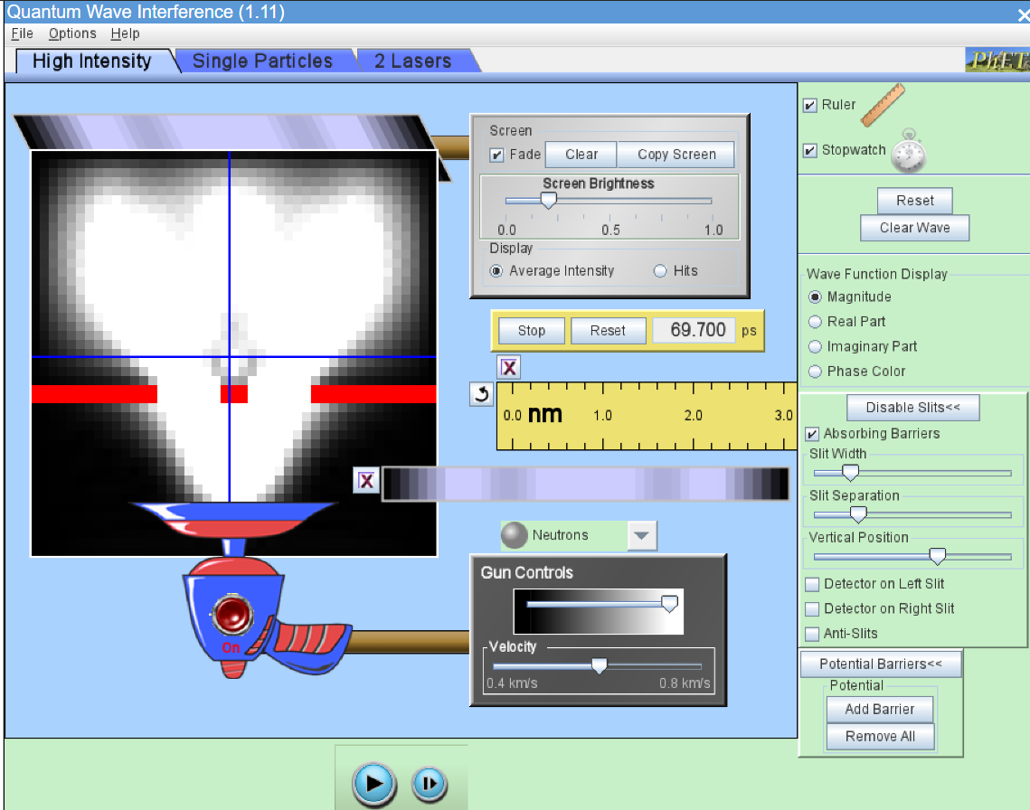

* **Helium Atom**

|  |  |  |  |
| --- | --- | --- | --- |
| S.No. | Slit Width  (nm) | Vertical Separation  (nm) | Distance between two maxima(nm) |
| 1. | 0.7 | 2.0 | 0.80 |
| 2. | 0.7 | 2.7 | 1.30 |
| 3. | 0.7 | 3.1 | 1.50 |
| 4. | 0.5 | 2.7 | 1.35 |
| 5. | 0.5 | 3.2 | 1.60 |

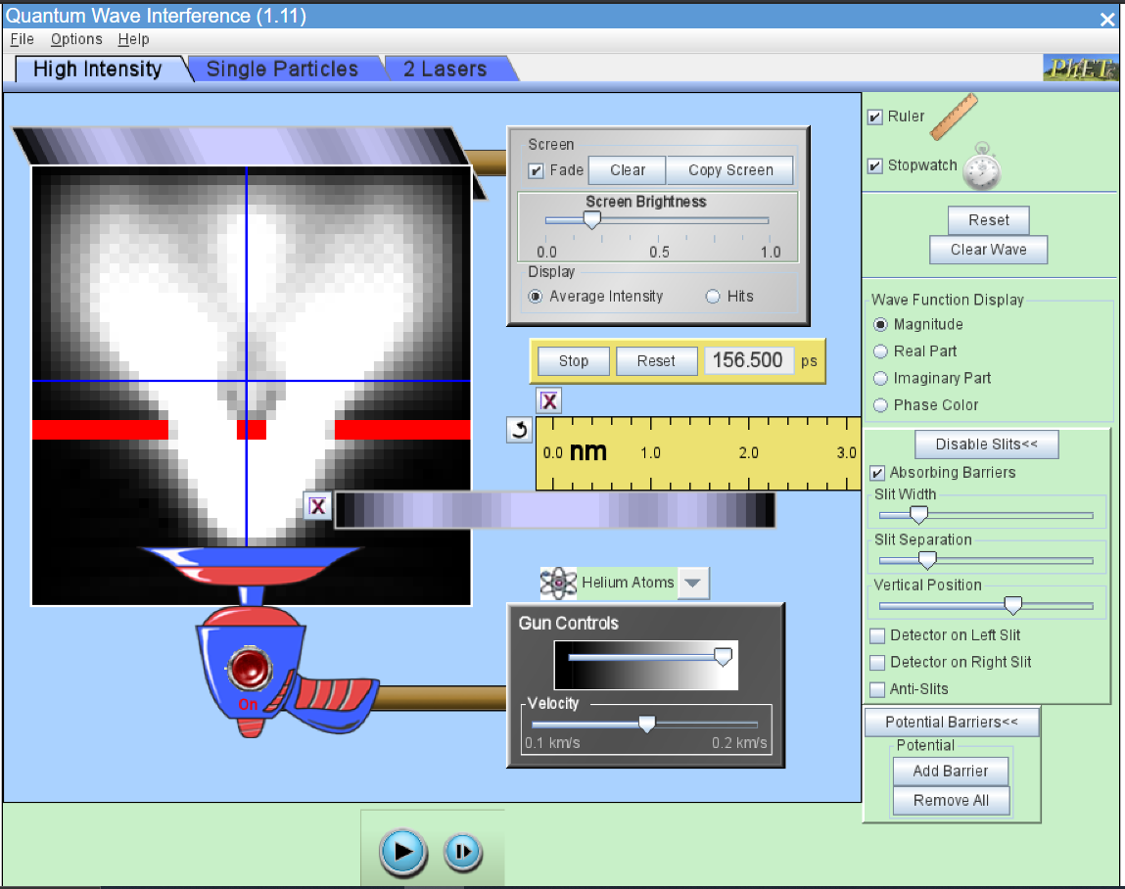

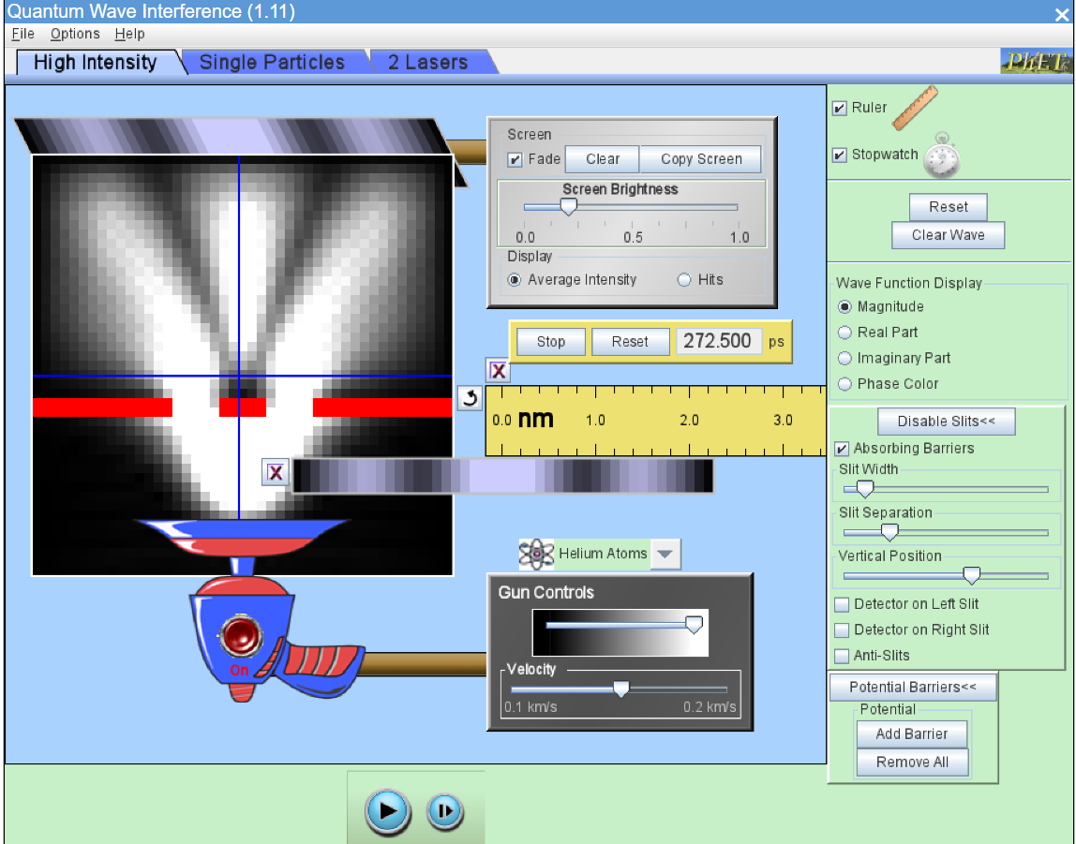

**Conclusion** -: Effects on Interference Pattern due to -:

1. **Slit Width** -: When the widths of the slits are greater than the wavelength of the light, the light casts the shadow. When the widths of the slits are narrow, light undergoes diffraction and the light waves overlap on the screen. Hence, the intensity of the light is more as the width of the slit increases.
2. **Slit Separation -:** The slit separation and the distance between the wall and the slits did have an effect on the interference pattern. As the slit separation increased, the fringe width decreased, meaning there was less interference.
3. **Vertical Distance -:** As long as the light that exposure the slits is collimated the intensity distribution behind the slits will be sharp. So, a source with a collimated beam could be moved towards the slits or away from the slits, the intensity distribution will not change in theory. In practice moving the source far away will decrease the intensity of the light due to air dust and due to the imperfect collimating, the beam will be broader and broader at long distances.
4. Young's equation for the calculation of the wavelength of the used monochromatic light does not contain a parameter for the distance from the source to the screen.

**Error Analysis** -: In this experiment, the least count of the ruler provided is not sufficient to measure accurate values of slit separation, slit width, distance between two maxima’s which thus creates a lot of errors in the measurements.

Here, we can’t calculate numerical error as there is no way to measure the slit width, slit separation and distance between two maxima’s other than the simulator method.

For Objective 2

**Observations** -: ***Behavior of Wave Function in presence of a detector -:***

1. Detector on right slit

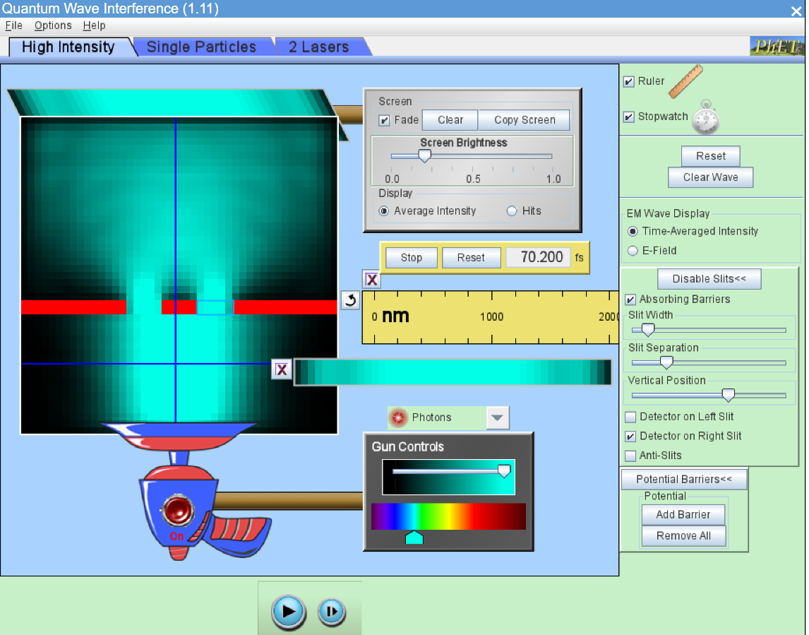

1. Detector on left slit

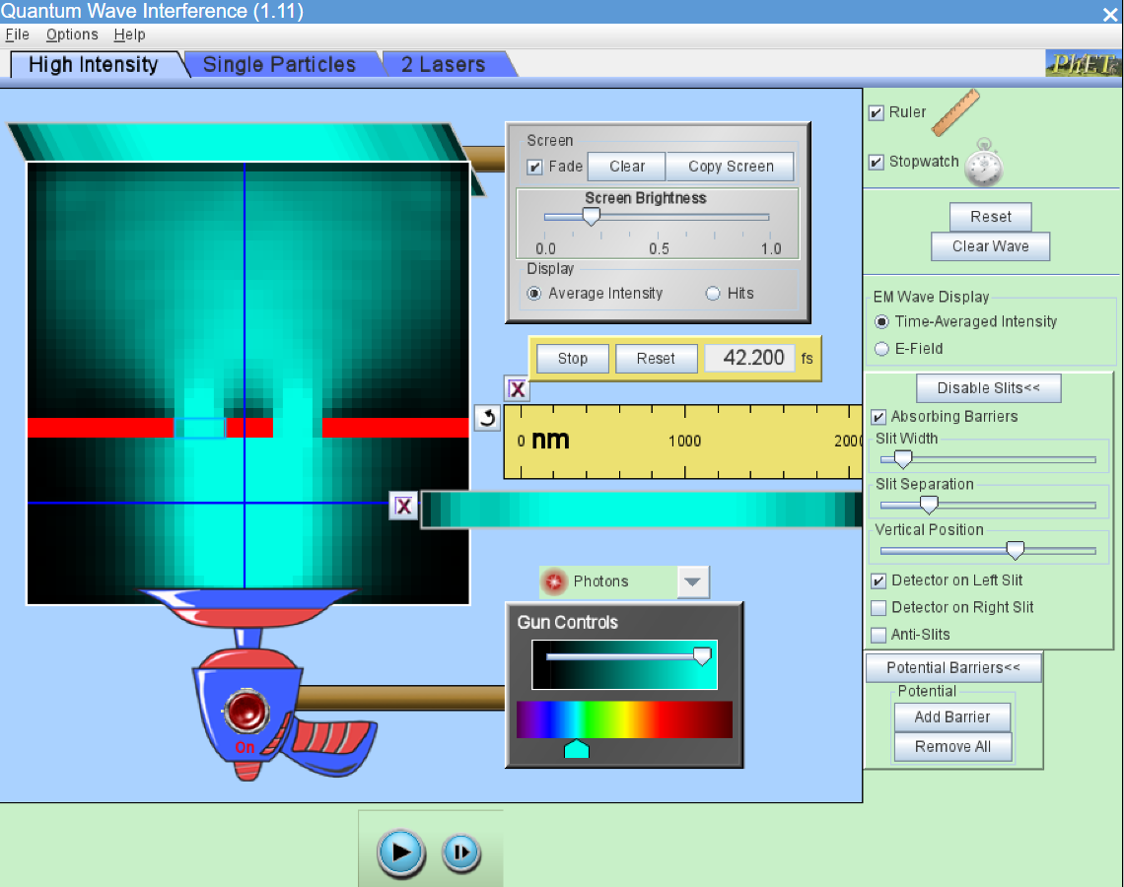

1. Detector on both slits

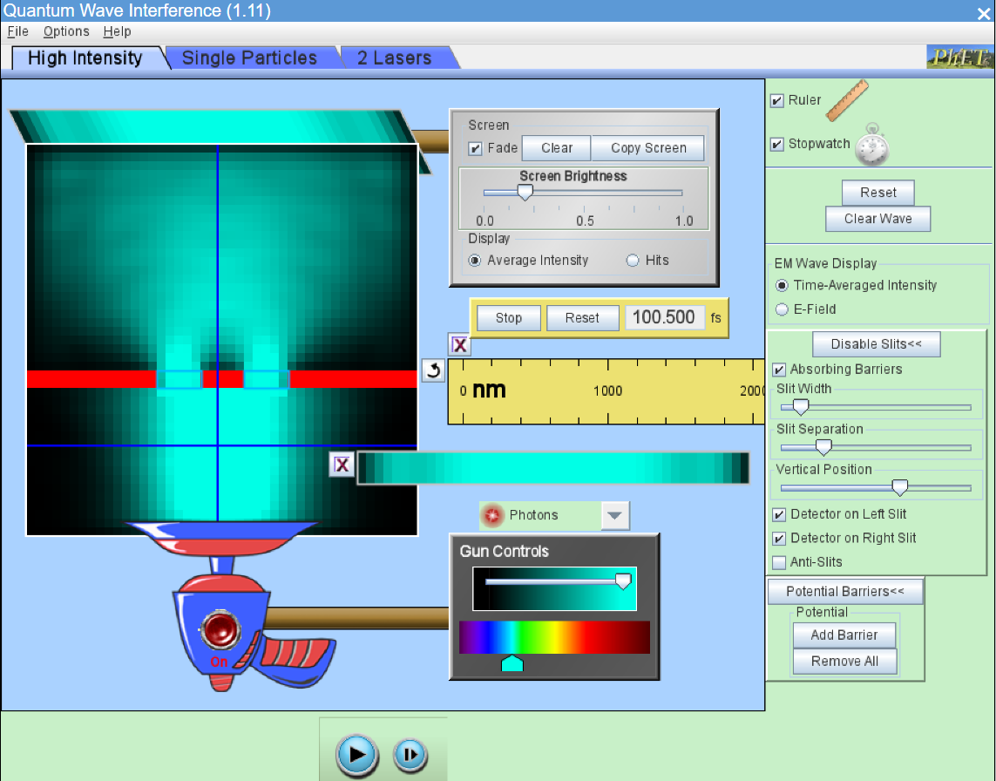

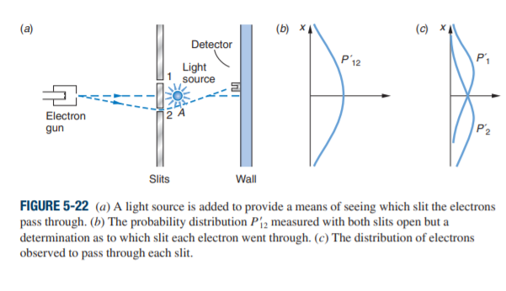**Conclusion** -:

Since charged particles scatter light, an electron going through slit 2 along the dashed line to the detector would scatter some light near A and we would see the flash in the vicinity of slit 2. Similarly, an electron passing through slit 1 will result in a flash in the vicinity of slit 1. When we do the experiment, here is what happens: whenever the detector records an electron, we see a light flash either in the vicinity of slit 1 or in the vicinity of slit 2 but never near both at once; that is, the electrons don’t go partly through slit 1 and partly through slit 2. The same is always true no matter where along the wall the detector is situated. This result says that when we “look” at an electron (i.e., scatter light from it as at A), we can tell which slit a particular electron went through.

However, when the counting-rate data for all of the electrons that went through both slits is graphed, curve P= 12 in Figure 5-22b results, where now P= 12 is the sum of P= 1 and P= 2 and the double-slit diffraction pattern has disappeared! By “looking” at the electrons as they came through the slits, we have changed their motion; for example, an electron that may have gone to a P12 maximum, after being bumped by the light, may end up at a P12 minimum instead. This, the observation of the electrons, is what destroyed the double-slit pattern. Speaking a bit more quantitatively, determining that the electrons went through a particular one of the slits means that we have localized its position to within x d>2, where d is the slit separation. The uncertainty principle then gives

Thus, if an electron was originally headed toward the interference maximum of at ϴ = with momentum p = , it will be deflected by the light scattering event through an angle that is uncertain by the amount where

which, as we noted earlier, is about the position of the first minimum of the diffraction pattern. Thus, the observation of the electrons washes out the pattern.

***Result analysis -:***

1. Young’s double-slit experiment gave definitive proof of the wave character of light.
2. An interference pattern is obtained by the superposition of light from two slits.
3. For an interference pattern to be observable over any extended period of time, the two sources of light must be coherent with respect to each other. This means that the light sources must maintain a constant phase relationship. For example, two harmonic waves of the same frequency always have a fixed phase relationship at every point in space, being either in phase, out of phase, or in some intermediate relationship.
4. An important parameter in the double-slit geometry is the ratio of the wavelength of the light λ to the spacing of the slits d. If λ/d is much smaller than 1, the spacing between consecutive interference fringes will be small, and the interference effects may not be observable.
5. A higher frequency corresponds to a shorter wavelength. Waves of shorter wavelength spread out (diffract) less after passing through the slits, and the short wavelength leads to a smaller angle at which constructive interference (one wavelength path difference between the two waves) will occur.
6. When the widths of the slits are significantly greater than the wavelength of the light, the rules of geometrical optics hold—the light casts two shadows, and there are two illuminated regions on the screen. However, as the slits are narrowed in width, the light diffracts into the geometrical shadow, and the light waves overlap on the screen.