***Objective -:***

1. To visualize and compare the diffraction pattern and intensity plot at different velocities of electron.
2. Calculate the wavelength of electron from the Bragg’s law and De Broglie equation and calculate the difference between them.
3. To visualize and analyze the change in intensity profile on changing atomic radius.

***Theory -:***

**The Davission – Germer Experiment**

The Davisson–Germer experiment was a 1923-27 experiment by Clinton Davisson and Lester Germer in which electrons, scattered by the surface of a crystal of nickel metal, displayed a diffraction pattern. This confirmed the hypothesis, advanced by Louis de Broglie in 1924, of wave-particle duality, and was an experimental milestone in the creation of quantum mechanics.

According to Maxwell’s equations, light was thought to consist of waves of electromagnetic fields and matter was thought to consist of localized particles. However, this was challenged in Albert Einstein 1905 paper on the photoelectric effect, which described light as discrete and localized quanta of energy (now called photons). In 1924, Louis de Broglie presented his thesis concerning the wave–particle duality theory, which proposed the idea that all matter displays the wave–particle duality of photons.

According to de Broglie, for all matter and for radiation alike, the energy E {\displaystyle E}of the particle was related to the frequency ν of its associated wave {\displaystyle \nu }by the Planck relation

And the momentum p of the particle {\displaystyle p}was related to its wavelength by the de Broglie relation

The experimental setup of the experiment is given below,

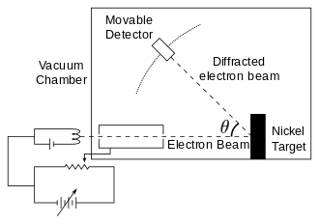

The experiment consisted of firing an electron beam from an electron gun at a nickel crystal, perpendicular to the surface of the crystal, and measuring how the number of reflected electrons varied as the angle between the detector and the nickel surface varied. The electron gun was a heated tungsten filament that released thermally excited electrons which were then accelerated through an electric potential difference, giving them a certain amount of kinetic energy, towards the nickel crystal. To avoid collisions of the electrons with other atoms on their way towards the surface, the experiment was conducted in a vacuum chamber. To measure the number of electrons that were scattered at different angles, a Farday cup electron detector that could be moved on an arc path about the crystal was used.

During the experiment, air accidentally entered the chamber, producing an oxide film on the nickel surface. To remove the oxide, Davisson and Germer heated the specimen in a high temperature oven, not knowing that this caused the formerly polycrystalline structure of the nickel to form large single crystal areas with crystal planes continuous over the width of the electron beam.

When they started the experiment again and the electrons hit the surface, they were scattered by nickel atoms in crystal planes (so the atoms were regularly spaced) of the crystal. This generated a diffraction pattern with unexpected peaks.

The angular dependence of the reflected electron intensity was measured and was determined to have the same diffraction pattern as those predicted by Bragg for X-rays. The Davisson–Germer experiment confirmed the de Broglie hypothesis that matter has wave-like behavior.

**The Bragg’s Law**

Bragg diffraction occurs when radiation, with a wavelength comparable to atomic spacings, is scattered in a specular fashion by the atoms of a crystalline system, and undergoes constructive interference. For a crystalline solid, the waves are scattered from lattice planes separated by the interplanar distance *d*. When the scattered waves interfere constructively, they remain in phase since the difference between the path lengths of the two waves is equal to an integral multiple of the wavelength. The path difference between two waves undergoing interference is given by 2*d*sin *ϴ*, where *ϴ* is the glancing 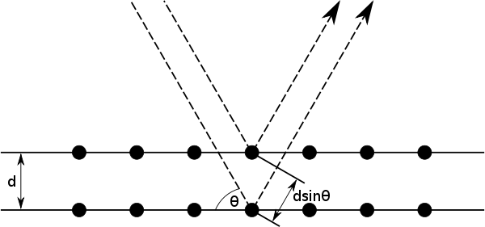angle

The effect of the constructive or destructive interference intensifies because of the cumulative effect of reflection in successive crystallographic planes of the crystalline lattice. This leads to Bragg's law, which describes the condition on *ϴ* for the constructive interference to be at its strongest

where *n* is a positive integer and *λ* is the wavelength of the incident wave.

***Observations -:***

**For Objective (i) -:** The snapshots of the diffraction patterns at different velocities and different parameters are shown below. The exact value of the parameter can be seen in the snapshot.

* **Snapshot 1 -:** velocity = 814 km/s

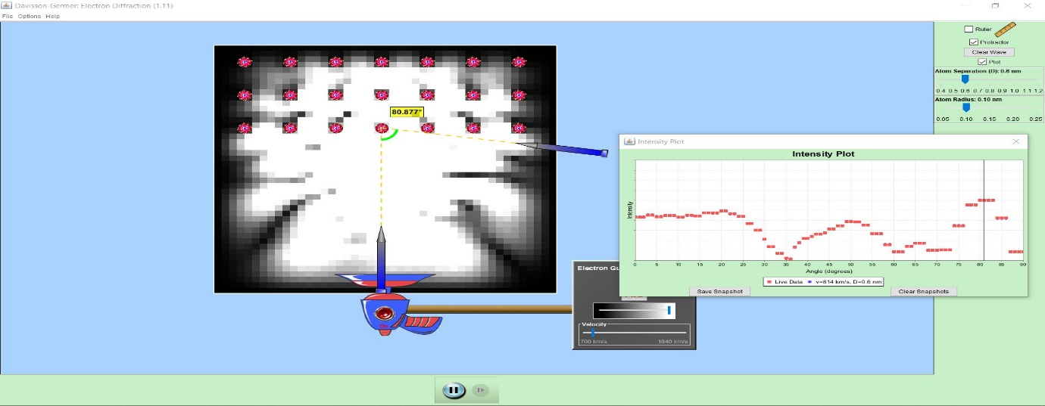

* **Snapshot 2 -:** velocity = 928 km/s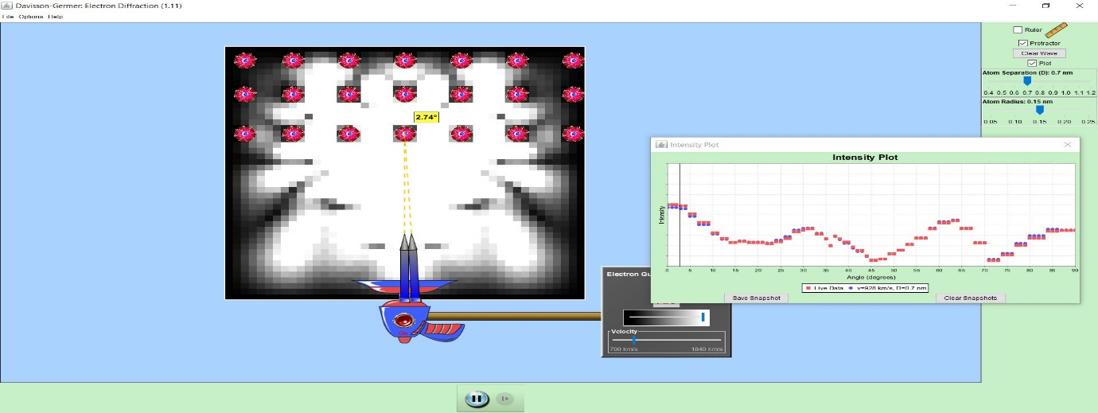
* **Snapshot 2 -:** velocity = 1156 km/s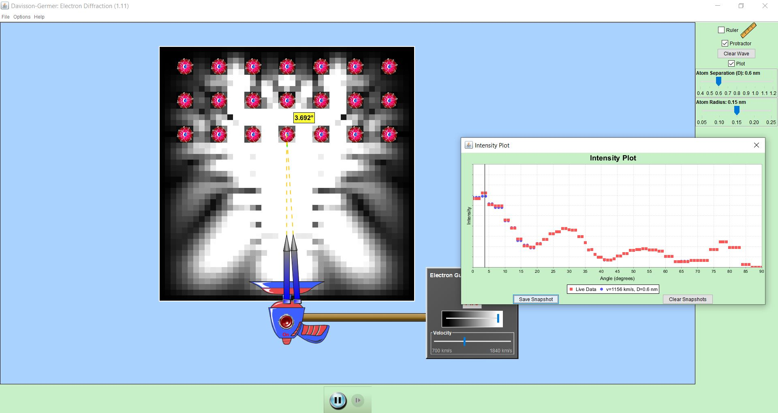
* **Snapshot 4 -:** velocity = 1498 km/s

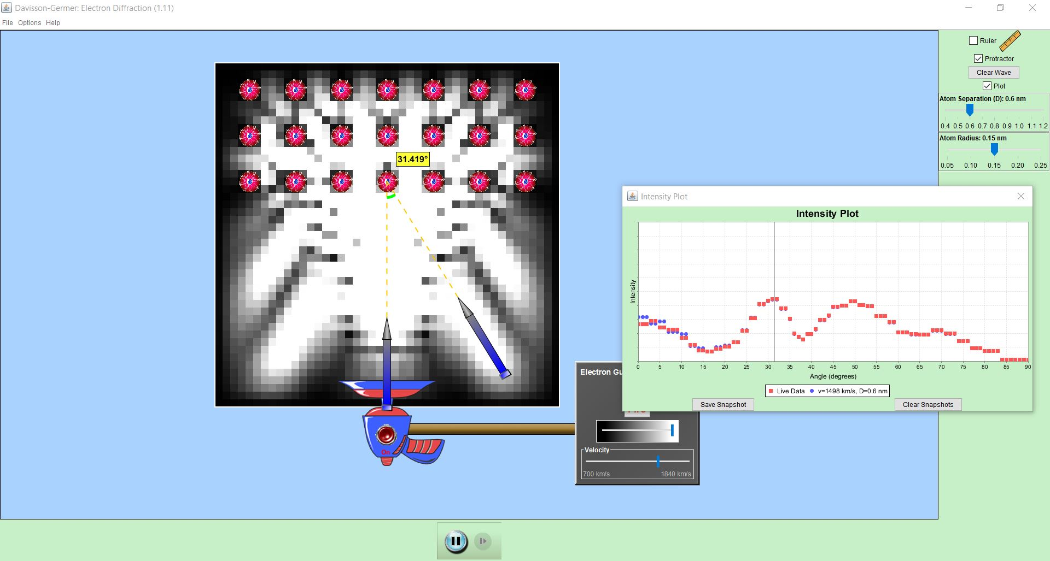

* **Snapshot 5 -:** velocity = 928 km/s

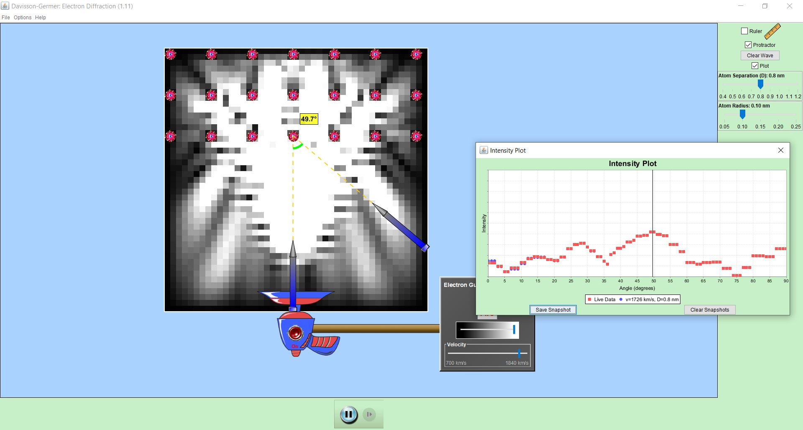

**For Objective (ii) -:** The following observations were noted and their de Broglie wavelength and wavelength using Bragg’s equation were calculated. The difference between both the wavelengths was observed to be very small.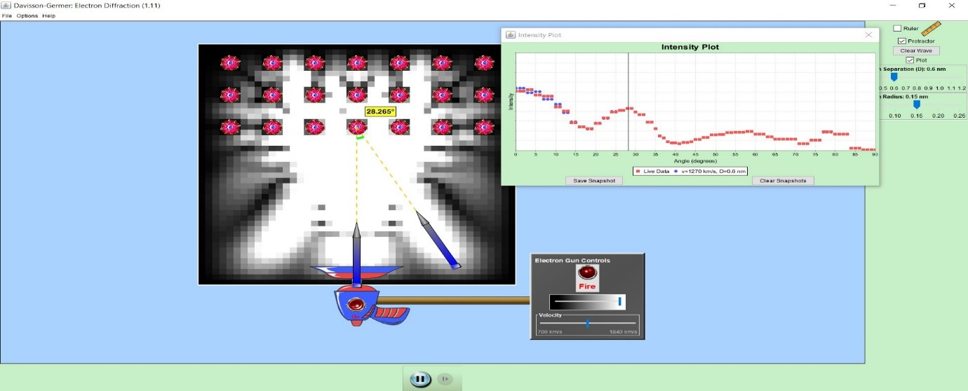

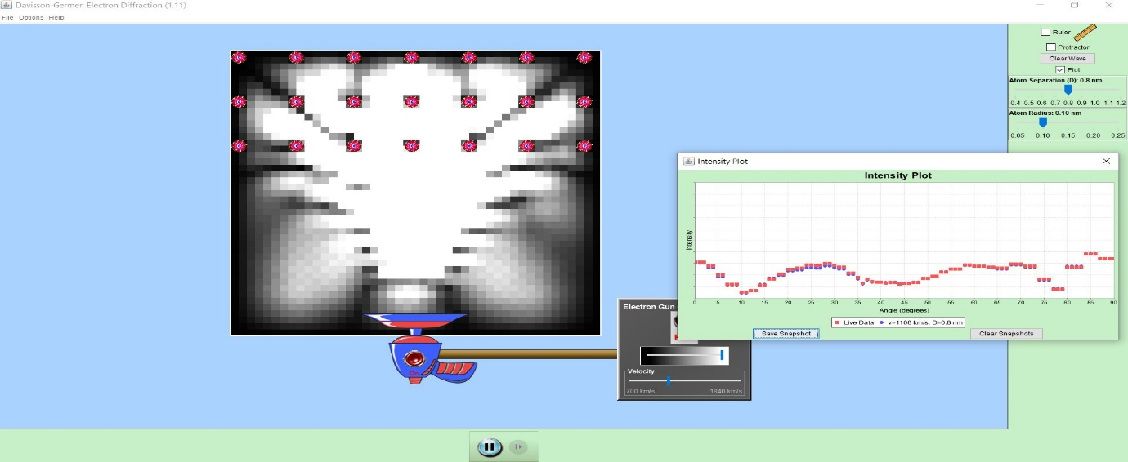

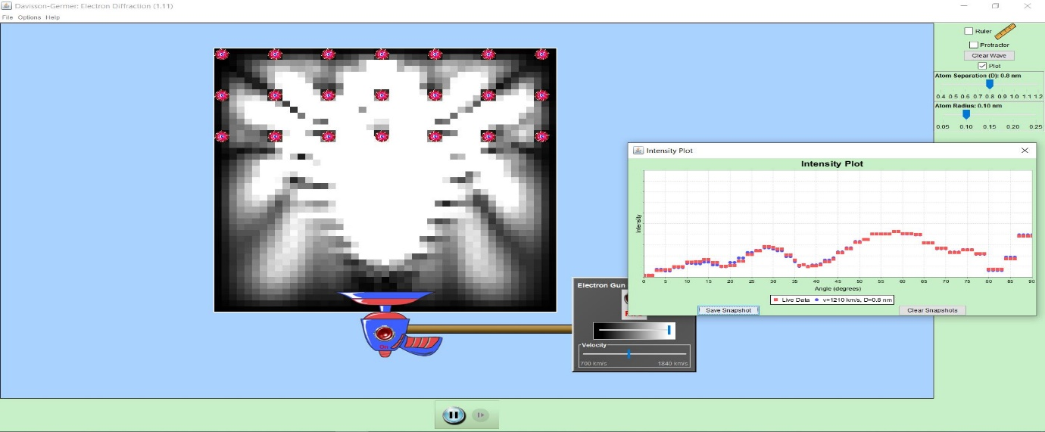

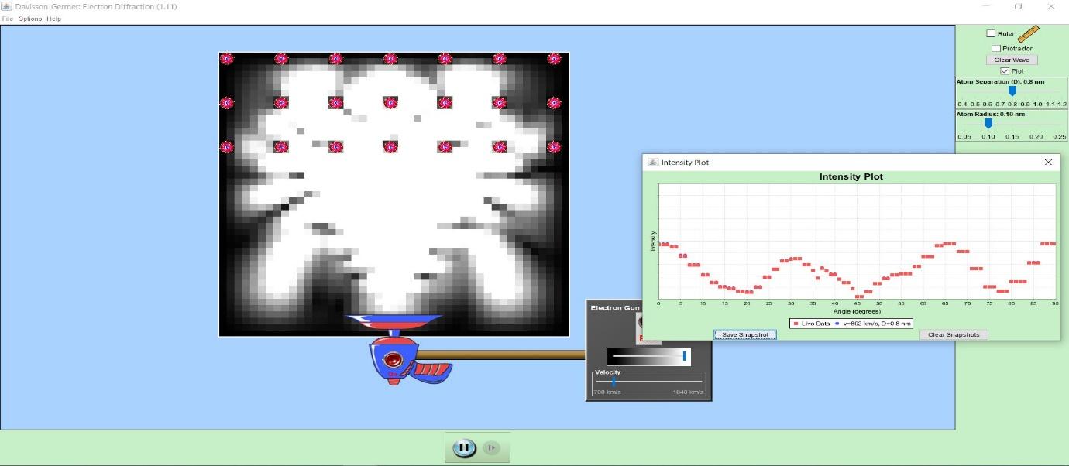

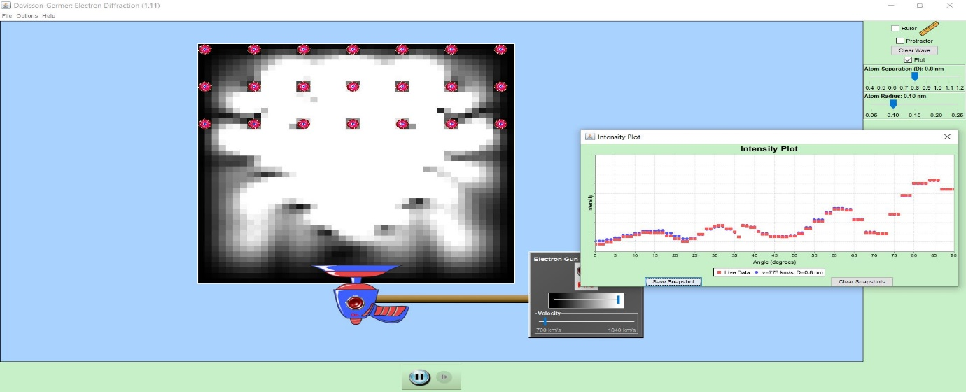

The corresponding entries of the snapshots above are noted in the table below. The mass of electron is

|  |  |  |  |  |  |  |
| --- | --- | --- | --- | --- | --- | --- |
| Sr.  No. | Atomic  Radius  (nm) | Atomic  Separation  (d)  (nm) | Velocity of  Electron  (v)  (km/s) | Angle of  Diffraction  (ϴ)  (degrees | Wavelength from Bragg’s Law () | de Broglie wavelength  ( |
| 1. | 0.15 | 0.6 | 1270 | 28.265 | 0.5683 | 0.5727 |
| 2. | 0.10 | 0.8 | 1108 | 2 | 0.6585 | 0.6569 |
| 3. | 0.10 | 0.8 | 1210 | 4 | 0.6028 | 0.6019 |
| 4. | 0.10 | 0.8 | 892 | 1 | 0.8155 | 0.8165 |
| 5. | 0.10 | 0.8 | 778 | 16 | 0.9348 | 0.9360 |

**Calculations -:**

1. Using Bragg’s Law for table entry 1,

and the de Broglie wavelength,

1. Using Bragg’s Law for table entry 2,

and the de Broglie wavelength,

1. Using Bragg’s Law for table entry 3,

and the de Broglie wavelength,

1. Using Bragg’s Law for table entry 4,

and the de Broglie wavelength,

1. Using Bragg’s Law for table entry 5,

and the de Broglie wavelength,

**Error Analysis -:** Average error in difference of wavelength obtained from Bragg’s Law and de Broglie equations is,

Therefore, the percentage error in the difference of wavelength is 0.182 %.

**For Objective (iii) -:** *Intensity profile for different atomic radius.*

* Atomic Radius = 0.05 nm

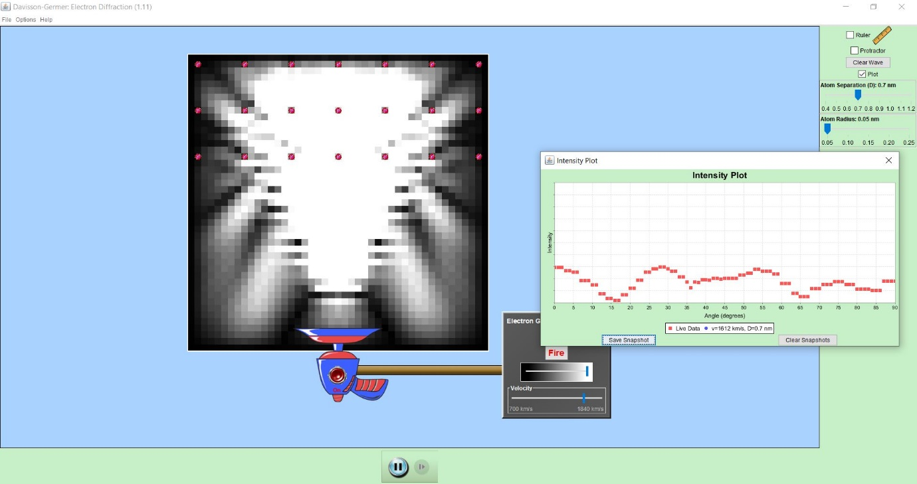

* Atomic Radius = 0.10 nm

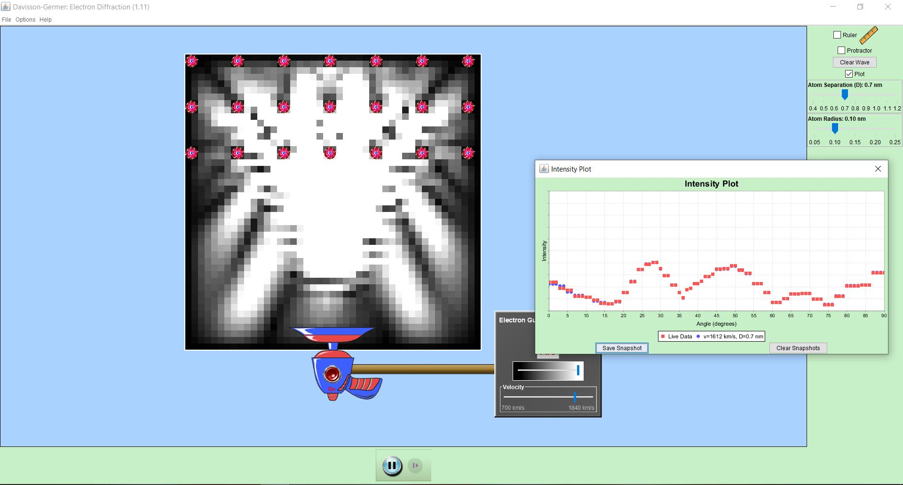

* Atomic Radius = 0.15 nm

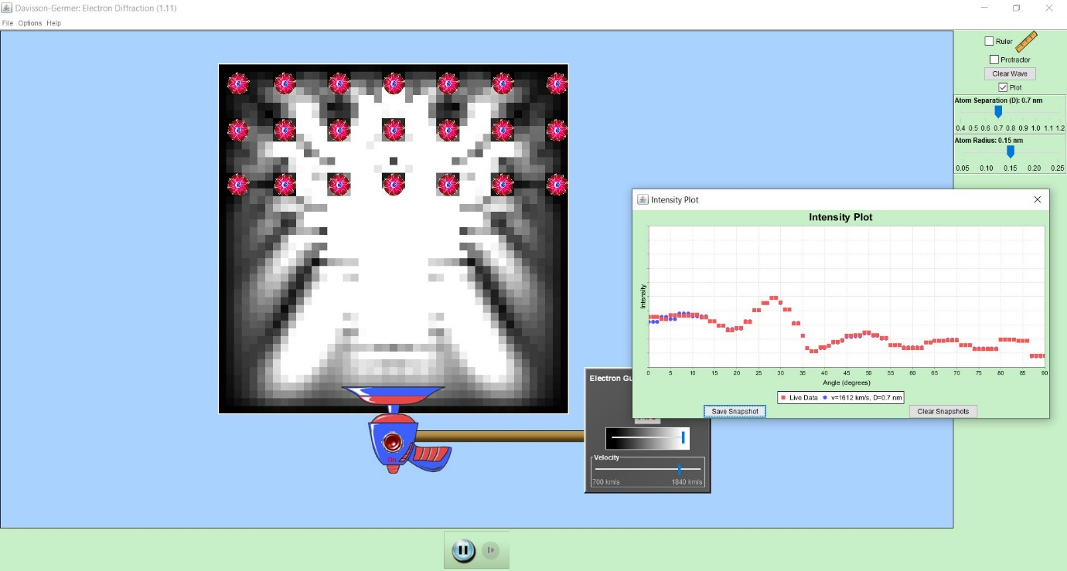

* Atomic Radius = 0.20 nm

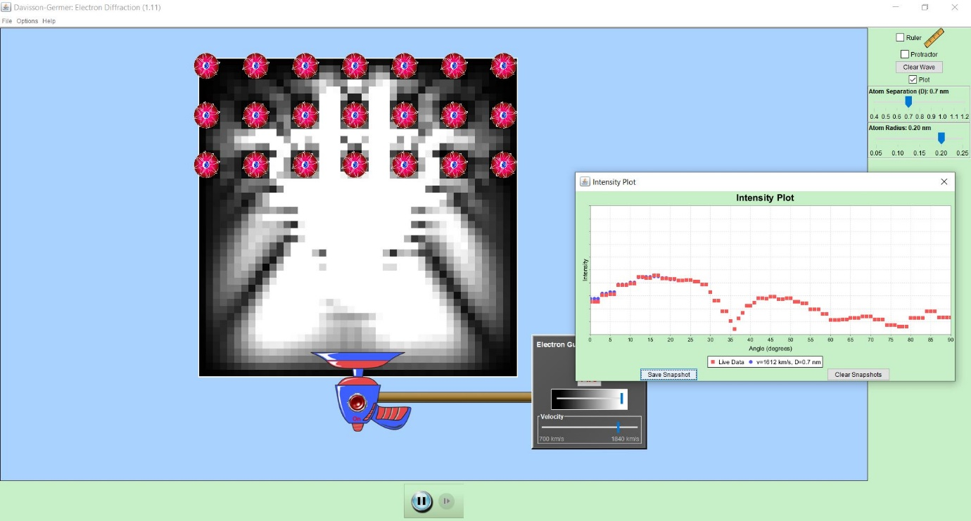

* Atomic Radius = 0.25 nm

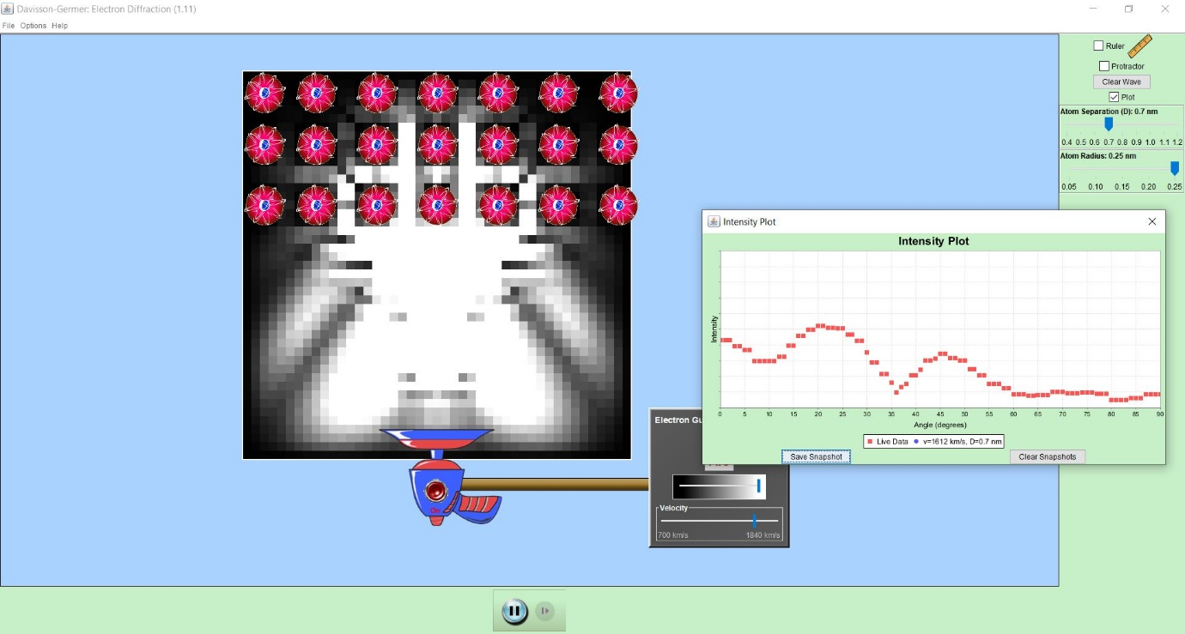

The intensity plot can be compared by observing all the graphs above simultaneously. The red is for 0.05 nm, purple is for 0.10 nm, yellow is for 0.15 nm, green is for 0.20 nm and blue is for 0.25nm.

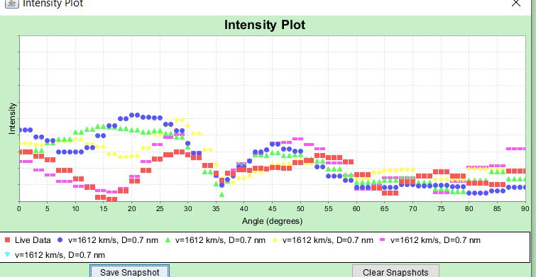

***Conclusion -:***  Following conclusion can be drawn from this experiment-:

1. The experiment confirmed the wave – nature of electrons and confirmed the de Broglie’s hypothesis of matter waves.
2. The experiment helped in learning about the variation in the Intensity plot at different scattering angles. The peaks observed in the curve are due to constructive interference of the electron waves.
3. By performing the experiment, the variation in the intensity plot versus angle of diffraction at different values is also observed.
4. The experiment also confirmed the matter waves are diffracted when the size of the obstacle is comparable to the wavelength of matter waves.
5. The wavelength of the matter waves as calculated by Bragg’s Law and de Broglie’s hypothesis comes out to almost equal. It only differs by few picometers.
6. By changing the accelerating potential difference, the accelerated voltage was varied from 44V to 68 V. With the intensity (I) of the scattered electron for an accelerating voltage of 54V at a scattering angle θ = 50º, we could see a strong peak in the intensity. This peak was the result of constructive interference of the electrons scattered from different layers of the regularly spaced atoms of the crystals.

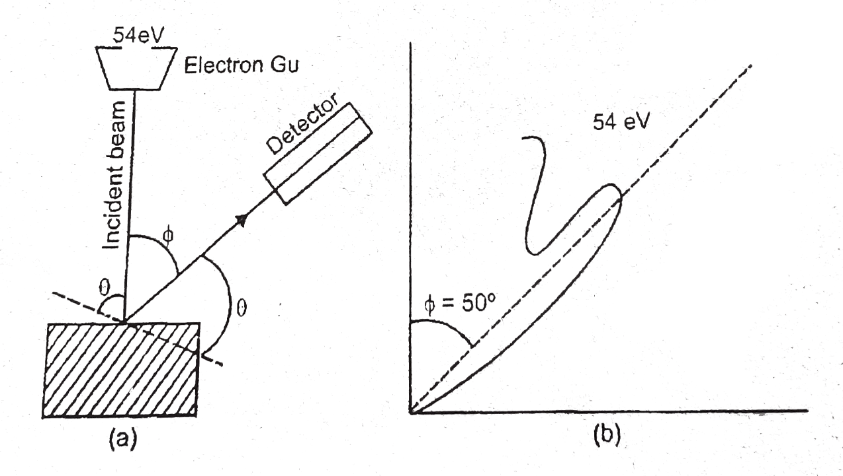

With the help of electron diffraction, the wavelength of electron waves was calculated to be 0.165 nm.