***Aim* -:** To observe the transmitted and reflected waves through a potential barrier.

***Theory -:*** Tunnelling is a quantum mechanical phenomenon when a particle is able to penetrate through a potential energy barrier that is higher in energy than the particle’s kinetic energy. The tunnel effect actually occurs notably in the case of alpha particles emitted by certain radioactive nuclei. Quantum tunnelling plays an essential role in physical phenomena, such as *nuclear fusion*. It has applications in the *tunnel diode*, *quantum computing,* and in the *scanning tunnelling microscope.*

The phenomenon is interesting and important because it violates the principles of classical mechanics.

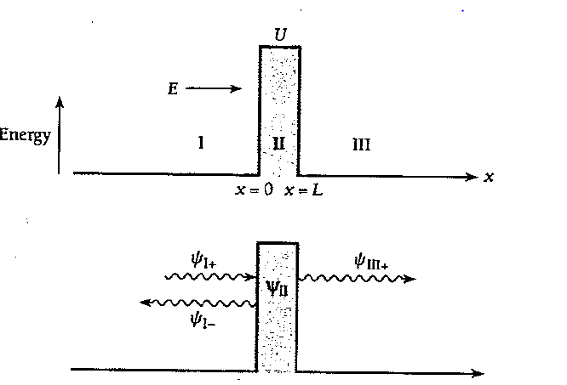

When a particle of energy E < U approaches a potential barrier, according to classical mechanics the particle must be reflected. In quantum mechanics, the de Broglie waves that correspond to the particle are partly reflected and partly transmitted, which means that the particle has finite chances of penetrating the barrier.

Let us consider a beam of identical particles all of which have the kinetic energy E The beam is incident from the left on a potential barrier of height U and width L. On both sides of the barrier U = 0, which means that no forces act on the particles there. The wave function $ψ_{I+}$ represents the incoming particles moving to the right and $ψ_{I-}$ represents the reflected particles moving to the left. $ψ_{III+}$ represents the transmitted particles moving to the right. The wave function $ψ_{II}$ represents the particles inside the barrier, some of which end up in region III while the others return to region I.

Outside the barrier, in regions I and III, the Schr $\ddot{o}$ dinger equation for the particle takes the form of,

$\frac{d^{2}ψ_{I}}{dx^{2}}+ \frac{2m}{ħ^{2}}Eψ_{I}=0$

$\frac{d^{2}ψ_{III}}{dx^{2}}+ \frac{2m}{ħ^{2}}Eψ_{III}=0$

The solutions to these equations that are appropriate here are,

$$ψ_{I}=Ae^{ik_{1}x}+Be^{-ik_{1}x}$$

$$ψ_{III}=Fe^{ik_{1}x}+Ge^{-ik_{1}x}$$

where $k_{1}$ is the wave number outside the barrier and,

$k_{1}= \frac{\sqrt{2mE}}{ħ}$

As it was shown in the figure, the incoming wave is a wave of amplitude A incident from the left on the barrier.

**Incoming Wave: $ψ_{I+}=Ae^{ik_{1}x}$**

This wave corresponds to the Incident beam of particles in the sense that ${ {|ψ}_{I+}|}^{2}$ is their probability density. If $v_{I+}$ is the group velocity of the incoming wave, which equals the velocity of the particles, then

$S= { {|ψ}_{I+}|}^{2}v_{I+}$

is the flux of particles that arrive at the barrier, that is the number of particles per second that arrive there.

At x = 0, the incident wave strikes the barrier and is partially reflected, with

**Reflected Wave: $ψ_{I-}= Be^{-ik_{1}x}$**

$ψ_{I}=ψ_{I+}+ ψ_{I-}$

On the far side of the barrier (x > L) there can only be a wave

**Transmitted Wave: $ψ_{III+}= Fe^{ik_{1}x}$**

traveling in the +x direction at the velocity $v_{III+}$ since region III contains nothing that could reflect the wave, hence G = 0 and

$ψ_{III }= ψ_{III+}= Fe^{ik_{1}x}$

In region II, the Schr $\ddot{o}$ dinger equation for the particle is,

$$\frac{d^{2}ψ_{II}}{dx^{2}}+ \frac{2m}{ħ^{2}}(U-E)ψ_{II}=0$$

The solution of the above equation is,

$ψ_{II}=Ce^{-ik_{2}x}+De^{ik_{2}x}$

where the wave number inside the barrier is $k_{2}$ and,

$k_{2}= \frac{\sqrt{2m(U-E)}}{ħ}$

Since the exponents are real quantities, $ψ_{II}$ does not oscillate and therefore does not represent a moving particle. However, the probability density ${ {|ψ}_{II}|}^{2}$ is not zero, so there is a finite probability of finding a particle within the barrier. Such a particle may emerge into region III or it may return to region I.

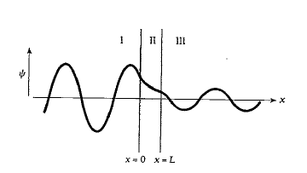At each wall, the wave functions inside and outside must match up perfectly, which means that they must have the same values and slopes there.

The approximate transmission probability is given by T, such that,

$T= e^{-2k_{2}L}$

***Observations -:***

The snippets of the observations are given below and the corresponding entries are given below in the table.

* Snip 1

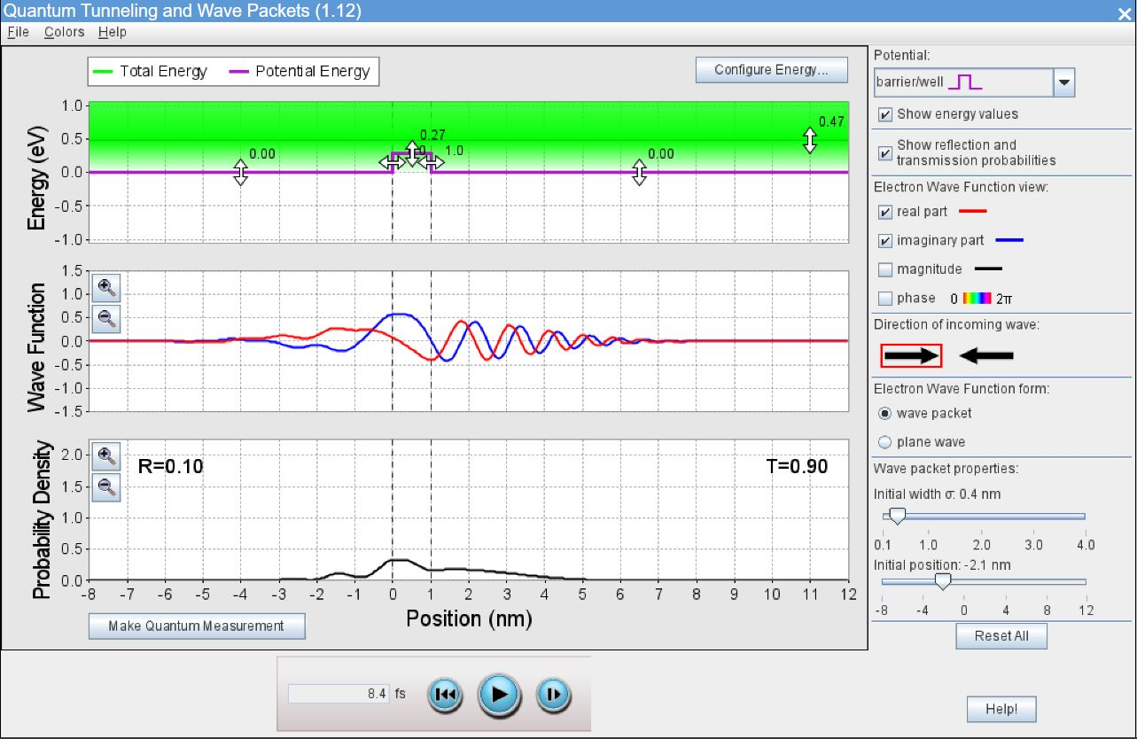

* Snip 2

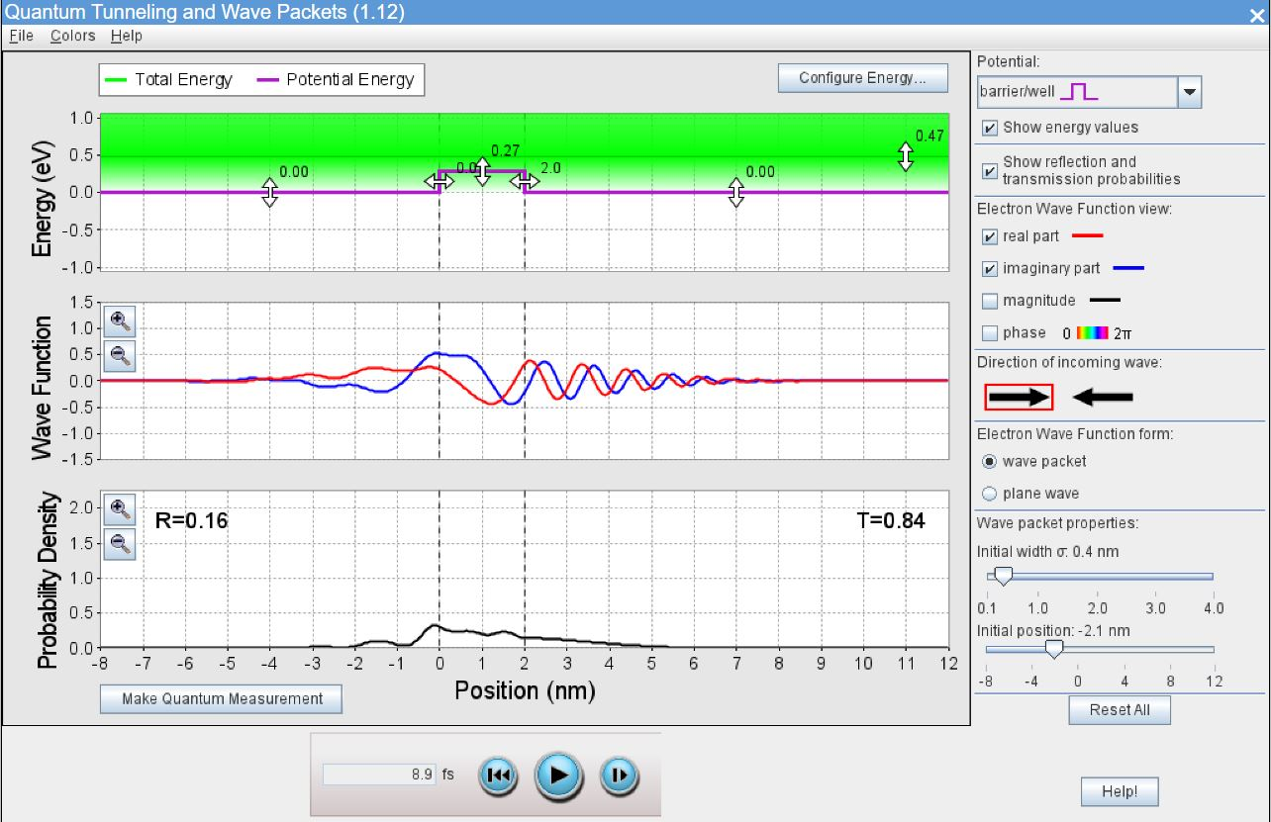

* Snip 3

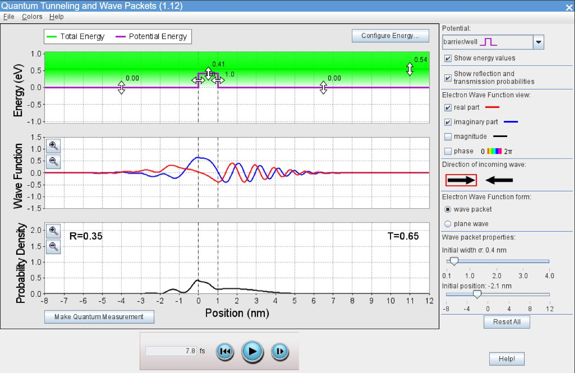

* Snip 4

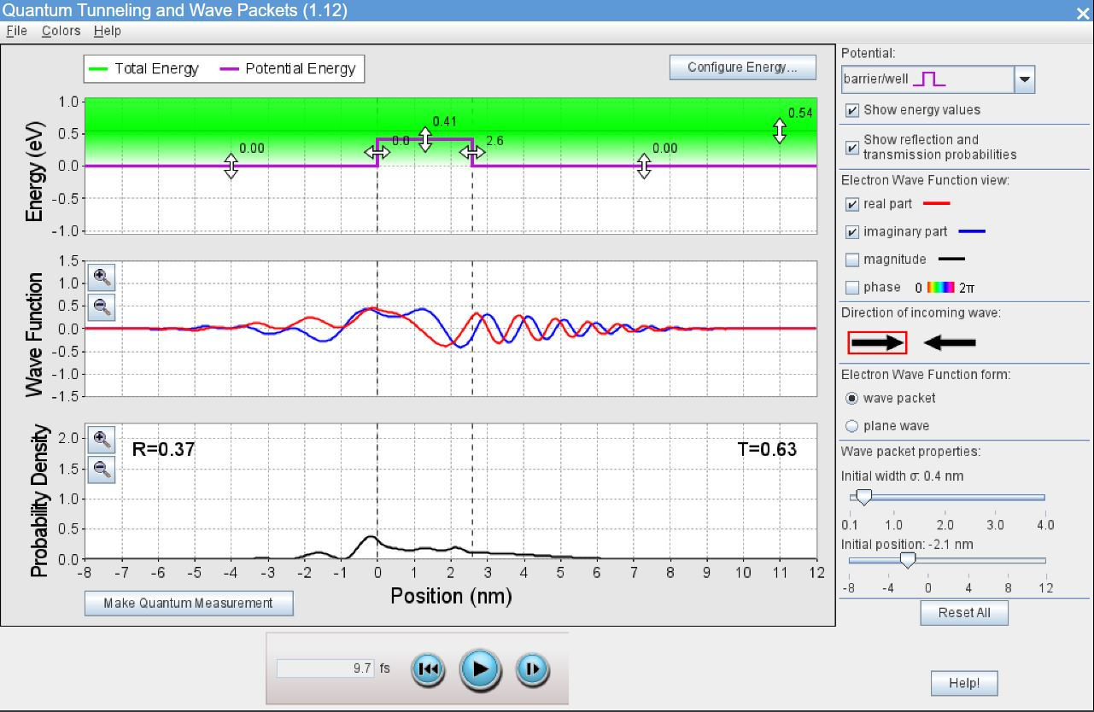

The initial width of the incident wavepacket is 0.4 nm and its starting position is -2.1 nm. The direction of incident wavepacket is from left to right.

|  |  |  |  |  |  |
| --- | --- | --- | --- | --- | --- |
| Sr.  No. | Barrier  Width  (nm) | Barrier  Height  (eV) | Total Energy  (eV) | Probability  of  Reflection | Probability  of Transmission |
| 1. | 1 | 0.27 | 0.47 | 0.10 | 0.90 |
| 2. | 2 | 0.27 | 0.47 | 0.16 | 0.84 |
| 3. | 1 | 0.41 | 0.54 | 0.35 | 0.65 |
| 4. | 2.6 | 0.41 | 0.54 | 0.37 | 0.63 |

Another observation is taken for the last entry, by reversing the direction of incident wavepacket and changing its width.

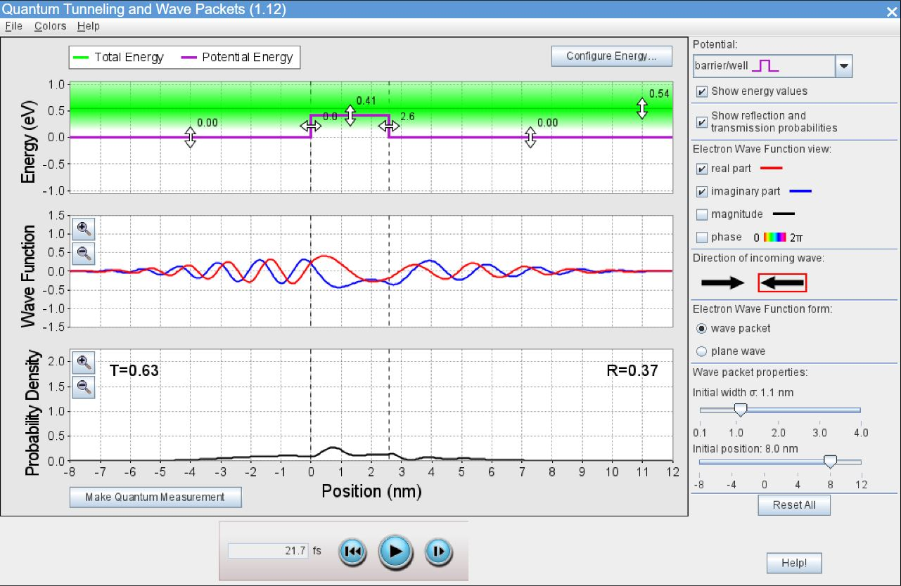

***Conclusions -:***

* A quantum particle that is incident on a potential barrier of a finite width and height may cross the barrier and appear on its other side. This phenomenon is called ‘quantum tunnelling.’ It does not have a classical analog.
* To find the probability of quantum tunnelling, we assume the energy of an incident particle and solve the stationary Schrӧdinger equation to find wave functions inside and outside the barrier. The tunnelling probability is a ratio of squared amplitudes of the wave past the barrier to the incident wave.
* The probability of transmission of wave decreases if the barrier potential is increased. Consequently, if a particle is trapped in a box with infinite potential energy at the walls, it will never come out of the box.
* The probability of transmission of wave decreases if the barrier width is increased. Consequently, if a particle is trapped in a box with finite potential energy at the walls, but with an infinite width, the particle will never come out of the box.
* In snip 4 and 5, the energies and barrier width is kept same, but the initial width of the wavepacket and its direction is changed. It has been observed that it doesn’t affect the probability of transmission. Hence, the probability of transmission does not depend upon initial width and direction of the wavepacket.