***Objective -:***  To determine the Stefan – Boltzmann constant σ.

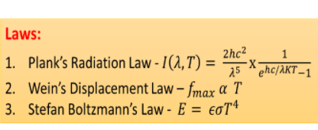***Theory -:*** A black body is an ideal body which absorbs or emits all types of electromagnetic radiation. The term ‘black body’ was first coined by the German physicist Kirchhoff during 1860’s. Black body radiation is the type of electromagnetic radiation emitted by a black body at constant temperature. The spectrum of this radiation is specific and its intensity depends only on the temperature of the black body. It was the study of this phenomenon which led to a new branch of physics called Quantum mechanics.

According to Stefan’s Boltzmann law (formulated by the Austrian physicists, Stefan and Boltzmann), energy radiated per unit area per unit time by a body is given by,

$R=eσT^{4}$------ 1

where R = energy radiated per area per time, Є = emissivity of the material of the body, σ = Stefan’s constant = 5.67x10-8 Wm-2K-4, and T is the temperature in Kelvin scale.

For an ideal black body, emissivity Є=1, and equation (1) becomes,

$R=σT^{4}$

The block diagram of the experimental setup to determine the Stefan – Boltzmann constant is given below.

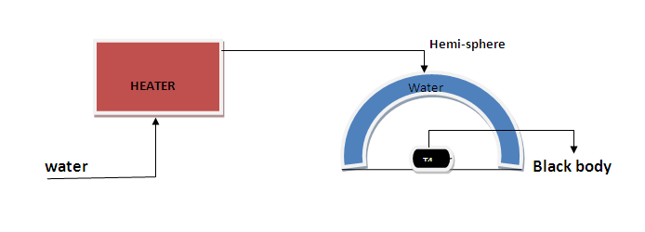

A copper disc is used as an approximation to black body in this setup which absorbs radiation from metallic hemisphere as shown in the block diagram. The metallic hemisphere is heated with the help of hot water generated by the heater.

Let $T_{d}$ and $T_{h}$ be the steady state temperatures of copper disc and metallic hemisphere respectively. According to Stefan – Boltzmann Law, the net heat transfer to the copper disc per second is,

$\frac{∆Q}{∆t}=σA(T_{h}^{4}-T_{d}^{4})$-----1

where A is the area of copper disc.

Now, we have another equation from thermodynamics for heat transfer as,

$\frac{∆Q}{∆t}=mC_{p}\frac{dT}{dt}$------2

where m is mass of copper disc, $C_{p}$ is specific heat capacity of copper and $\frac{dT}{dt}$ is change in temperature per unit time.

Equating 1 and 2,

$σA\left(T_{h}^{4}-T_{d}^{4}\right)= mC_{p}\frac{dT}{dt}$

$σ= \frac{mC_{p}\frac{dT}{dt}}{A\left(T_{h}^{4}-T_{d}^{4}\right)}$------3

***Observations And Calculations -:***  The table below depicts the Temperature of the blackbody with time.

The mass of the disc is 6 grams and radius of disc is 2 cm.

The average temperature of the hemisphere is $T_{h}= \frac{T_{1}+T_{2}+T_{3}}{3}$.

It has been observed that $T_{1}=T_{2}=T_{3}= T_{h}=70 °C$ = 343 K

The initial temperature of disc is $T_{4}= 30 °C=303 K$ and the temperature of disc in the steady state is $T_{d}$.

|  |  |  |
| --- | --- | --- |
| **Sr. No.** | **Time (in seconds)** | **Temperature (in $°C)$** |
| 1. | 0 | 30.00 |
| 2. | 30.558 | 34.29 |
| 3. | 59.925 | 38.59 |
| 4. | 91.562 | 42.88 |
| 5. | 121.068 | 47.17 |
| 6. | 149.495 | 51.47 |
| 7. | 182.102 | 55.76 |
| 8. | 210.524 | 60.05 |
| 9. | 240.057 | 64.34 |
| 10. | 259.960 | 67.21 |
| 11. | 270.000 | 67.21 |
| 12. | 300.000 | 67.21 |

Hence, temperature of body in steady state $T_{d}=67.21℃=340.21 K.$

Plotting a temperature vs time graph using entries of the table.

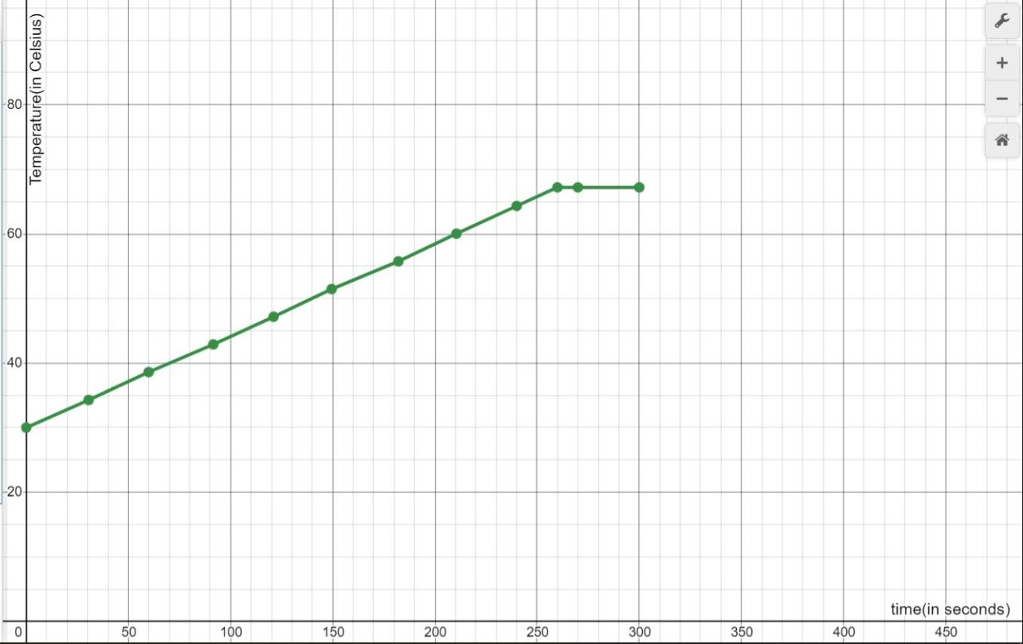

The slope of the graph $\frac{dT}{dt}$ can be calculated using the table entries as,

$\frac{dT}{dt}= \frac{T^{'}-T}{t^{'}-t}$

Therefore, slope $\frac{dT}{dt}=\frac{42.88-38.59}{91.562-59.925}=\frac{4.29}{31.637}=0.1356 K/s$.

For copper, specific heat capacity is equal to 385 J/kg K.

Therefore, Stefan – Boltzmann Constant σ can be calculated using equation 3

$σ= \frac{(6×{10}^{-3})(385)(0.1356)}{\left(3.14 ×2 ×2 ×{10}^{-4}\right)\{{\left(343\right)}^{4}-{\left(340.21\right)}^{4}\}}$

$σ= \frac{3.132 × {10}^{-1}}{\left(1.256 ×{10}^{-3}\right) × (4.449 × {10}^{8})}$

$σ=0.56049 × {10}^{-6} W m^{-2}K^{-4}$

$σ=5.6049 × {10}^{-7} W m^{-2}K^{-4}$

The table below depicts the Temperature of the blackbody with time.

The mass of the disc is 6 grams and radius of disc is 2 cm.

The average temperature of the hemisphere is $T_{h}= \frac{T_{1}+T_{2}+T_{3}}{3}$.

It has been observed that $T_{1}=T_{2}=T_{3}= T_{h}=75 °C$ = 348 K

The initial temperature of disc is $T_{4}= 25 °C=298 K$ and the temperature of disc in the steady state is $T_{d}$.

|  |  |  |
| --- | --- | --- |
| **Sr. No.** | **Time (in seconds)** | **Temperature (in $°C)$** |
| 1. | 0 | 25.00 |
| 2. | 30.512 | 30.78 |
| 3. | 62.115 | 36.56 |
| 4. | 91.562 | 42.34 |
| 5. | 121.078 | 48.12 |
| 6. | 150.558 | 53.91 |
| 7. | 179.997 | 59.69 |
| 8. | 210.500 | 65.47 |
| 9. | 240.047 | 71.25 |
| 10. | 249.492 | 73.18 |
| 11. | 270.000 | 73.18 |
| 12. | 300.000 | 73.18 |

Hence, temperature of body in steady state $T_{d}=73.18 ℃=346.18 K.$

Plotting a temperature vs time graph using entries of the table.

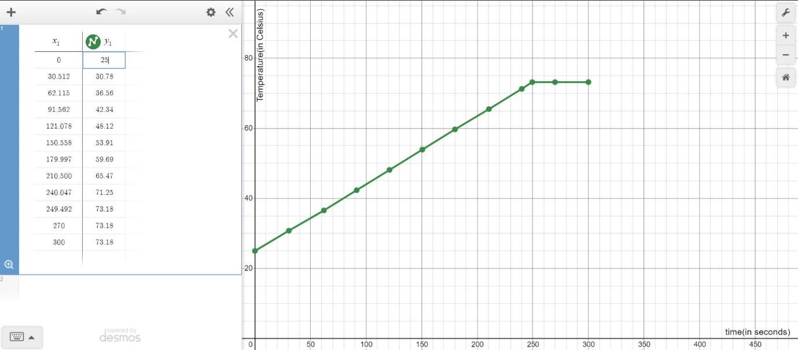

Therefore, slope $\frac{dT}{dt}=\frac{71.25-65.47}{240.047-210.500}=\frac{5.78}{29.547}=0.1956 K/s$.

Therefore, Stefan – Boltzmann Constant σ can be calculated using equation 3

$σ= \frac{(6×{10}^{-3})(385)(0.1956)}{\left(3.14 ×2 ×2 ×{10}^{-4}\right)\{{\left(348\right)}^{4}-{\left(346.18\right)}^{4}\}}$

$σ= \frac{4.518 × {10}^{-1}}{\left(1.256 ×{10}^{-3}\right) × (3.044 × {10}^{8})}$

$σ=1.1817 × {10}^{-6} W m^{-2}K^{-4}$

The table below depicts the Temperature of the blackbody with time.

The mass of the disc is 6 grams and radius of disc is 2 cm.

The average temperature of the hemisphere is $T_{h}= \frac{T_{1}+T_{2}+T_{3}}{3}$.

It has been observed that $T_{1}=T_{2}=T_{3}= T_{h}=80 °C$ = 353 K

The initial temperature of disc is $T_{4}= 50 °C=323 K$ and the temperature of disc in the steady state is $T_{d}$.

|  |  |  |
| --- | --- | --- |
| **Sr. No.** | **Time (in seconds)** | **Temperature (in $°C)$** |
| 1. | 0 | 50.00 |
| 2. | 20.022 | 54.28 |
| 3. | 40.026 | 58.56 |
| 4. | 61.058 | 62.84 |
| 5. | 81.069 | 67.12 |
| 6. | 99.980 | 71.40 |
| 7. | 122.144 | 75.68 |
| 8. | 131.428 | 77.82 |
| 9. | 140.000 | 77.82 |
| 10. | 160.000 | 77.82 |

Hence, temperature of body in steady state $T_{d}=77.82 ℃=350.82 K.$

Plotting a temperature vs time graph using entries of the table.

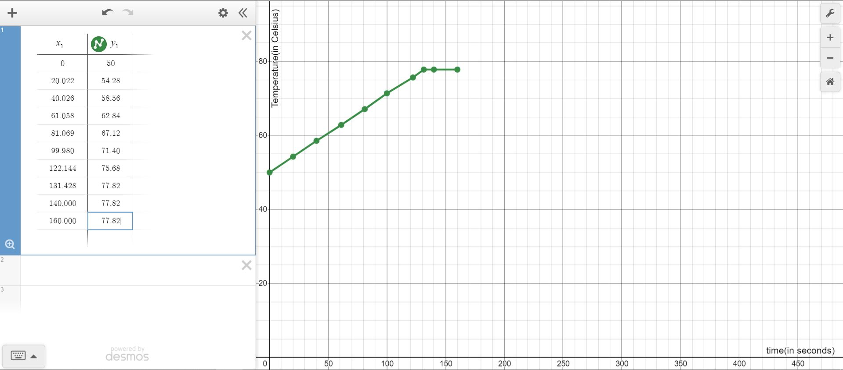

Therefore, slope $\frac{dT}{dt}=\frac{75.68-71.40}{122.144-99.980}=\frac{4.28}{22.164}=0.1931 K/s$.

Therefore, Stefan – Boltzmann Constant σ can be calculated using equation 3

$σ= \frac{(6×{10}^{-3})(385)(0.1931)}{\left(3.14 ×2 ×2 ×{10}^{-4}\right)\{{\left(353\right)}^{4}-{\left(350.82\right)}^{4}\}}$

$σ= \frac{4.461 × {10}^{-1}}{\left(1.256 ×{10}^{-3}\right) × (3.809 × {10}^{8})}$

$σ=0.93246 × {10}^{-6} W m^{-2}K^{-4}$

$σ=9.3246 × {10}^{-7} W m^{-2}K^{-4}$

Therefore $σ_{avg}= \frac{5.6049+11.817 +9.3246 }{3}×{10}^{-7} W m^{-2}K^{-4}$

$σ_{avg}=8.9155 ×{10}^{-7} W m^{-2}K^{-4}$

***ERRORS -:***  As it can be observed that the value of Stefan’s Constant is coming out to be around 16 times the actual value of Stefan’s constant. The reason for this error is hidden in the simulator. The steady state temperature of the copper blackbody is coming out be very close to the temperature of water, which should not be the case.

In fact, in some cases the steady state temperature of the black body reached more than the temperature of the water which is impossible.

As the steady state temperature is coming out very close to the initial temperature of water the term $\left(T_{h}^{4}-T_{d}^{4}\right)$ in the denominator of equation 3 is becoming very small than what it should be. This decrease in the denominator term is leading to an increased value of the Stefan’s constant.

Generally, the steady state temperature of the blackbody is nearby to the average of the initial temperature of the blackbody and the temperature of water.

***ConCLUSION -:***

1. A **black body** or **blackbody** is an idealized [physical body](https://en.wikipedia.org/wiki/Physical_object) that [absorbs](https://en.wikipedia.org/wiki/Absorption_(electromagnetic_radiation)) all incident [electromagnetic radiation](https://en.wikipedia.org/wiki/Electromagnetic_radiation), regardless of frequency or [angle of incidence](https://en.wikipedia.org/wiki/Angle_of_incidence_(optics)). The name "black body" is given because it absorbs radiation in all frequencies, not because it *only* absorbs: a black body can *emit* [black-body radiation](https://en.wikipedia.org/wiki/Black-body_radiation).
2. A black body in [thermal equilibrium](https://en.wikipedia.org/wiki/Thermal_equilibrium) (that is, at a constant temperature) emits electromagnetic black-body radiation. The radiation is emitted according to [Planck's law](https://en.wikipedia.org/wiki/Planck%27s_law), meaning that it has a [spectrum](https://en.wikipedia.org/wiki/Frequency_spectrum) that is determined by the [temperature](https://en.wikipedia.org/wiki/Temperature) alone, not by the body's shape or composition.

An ideal black body in thermal equilibrium has two notable

Properties -:

(a)It is an ideal emitter: at every frequency, it emits as much or more thermal radiative energy as any other body at the same temperature.

(b)It is a diffuse emitter: measured per unit area perpendicular to the direction, the energy is radiated [isotropically](https://en.wikipedia.org/wiki/Isotropic_radiator" \o "Isotropic radiator), independent of direction.

1. Real materials emit energy at a fraction—called the [emissivity](https://en.wikipedia.org/wiki/Emissivity)—of black-body energy levels. By definition, a black body in thermal equilibrium has an emissivity *ε* = 1. A source with a lower emissivity, independent of frequency, is often referred to as a gray body. Constructing black bodies with an emissivity as close to 1 as possible remains a topic of current interest.
2. **Stefan's Law** states that the radiated power density (W/m2) of a **black body** is proportional to its absolute temperature T raised to the fourth power. E = e σ T^4. The emissivity e is a correction for an approximate **black body** radiator, where e = 1 – R, is the fraction of the light reflected (R) by the **black body.**
3. The Stefan-Boltzmann constant, symbolized by the lowercase Greek letter sigma ( https://whatis.techtarget.com/WhatIs/images/sigma-lc.gif), is a physical constant involving [black body](https://whatis.techtarget.com/definition/blackbody) radiation. A black body, also called an ideal radiator, is an object that radiates or absorbs [energy](https://whatis.techtarget.com/definition/energy) with perfect efficiency at all electromagnetic [wavelength](https://searchnetworking.techtarget.com/definition/wavelength)s. The constant defines the power per unit area emitted by a black body as a function of its thermodynamic [temperature](https://whatis.techtarget.com/definition/temperature-T) .
4. Steady-state conduction is the form of conduction that happens when the temperature difference(s) driving the conduction are constant, so that (after an equilibration time), the spatial distribution of temperatures (temperature field) in the conducting object does not change any further. Thus, all partial derivatives of temperature *concerning space* may either be zero or have nonzero values, but all derivatives of temperature at any point *concerning time* are uniformly zero. In steady-state conduction, the amount of heat entering any region of an object is equal to the amount of heat coming out (if this were not so, the temperature would be rising or falling, as thermal energy was tapped or trapped in a region).