***Circuit***

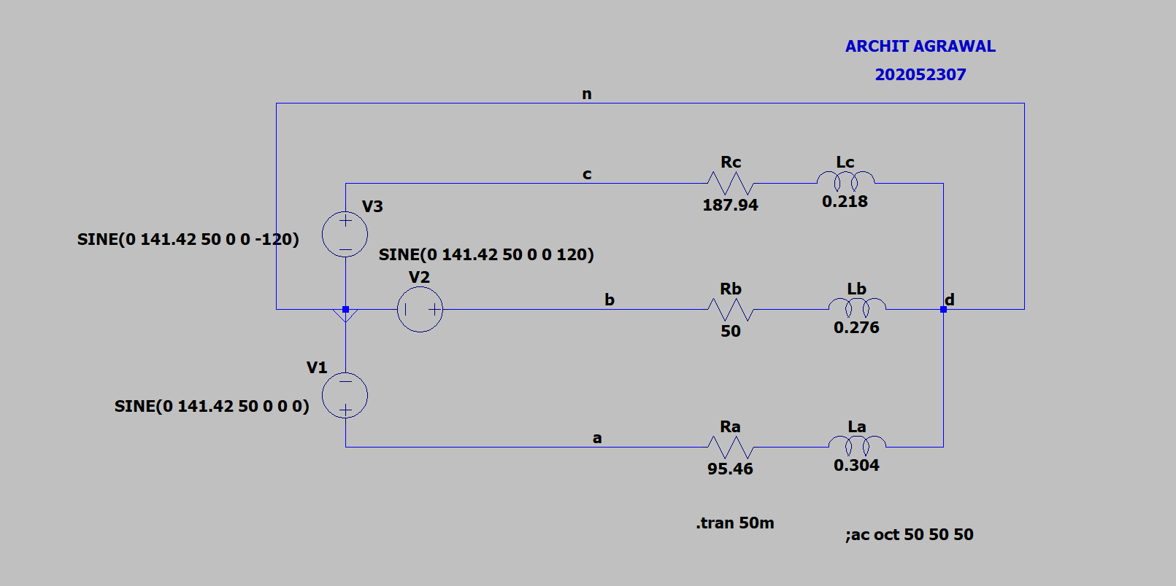

***Voltage, Current and Power across source ‘a’***

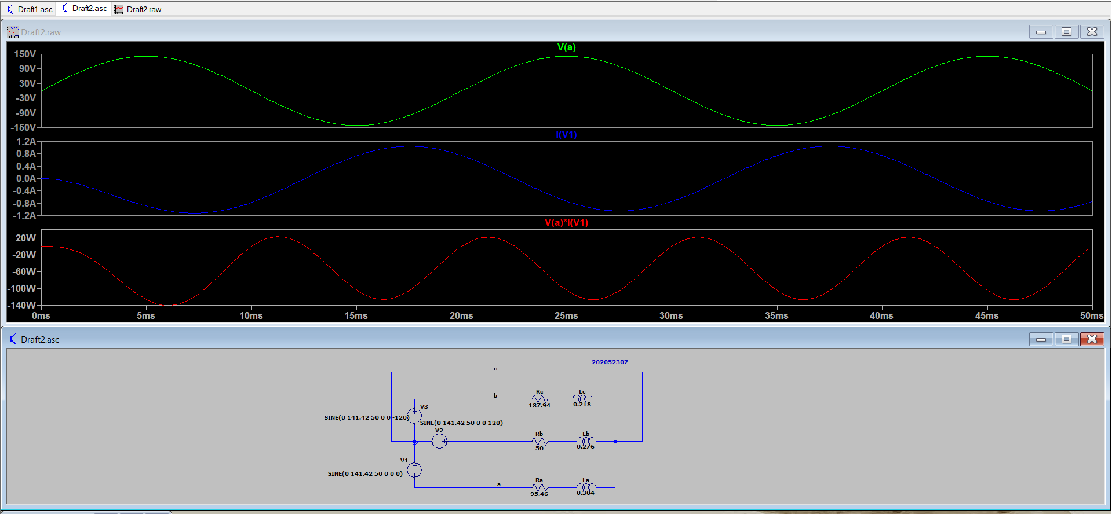

***Voltage, Current and Power across source ‘b’***

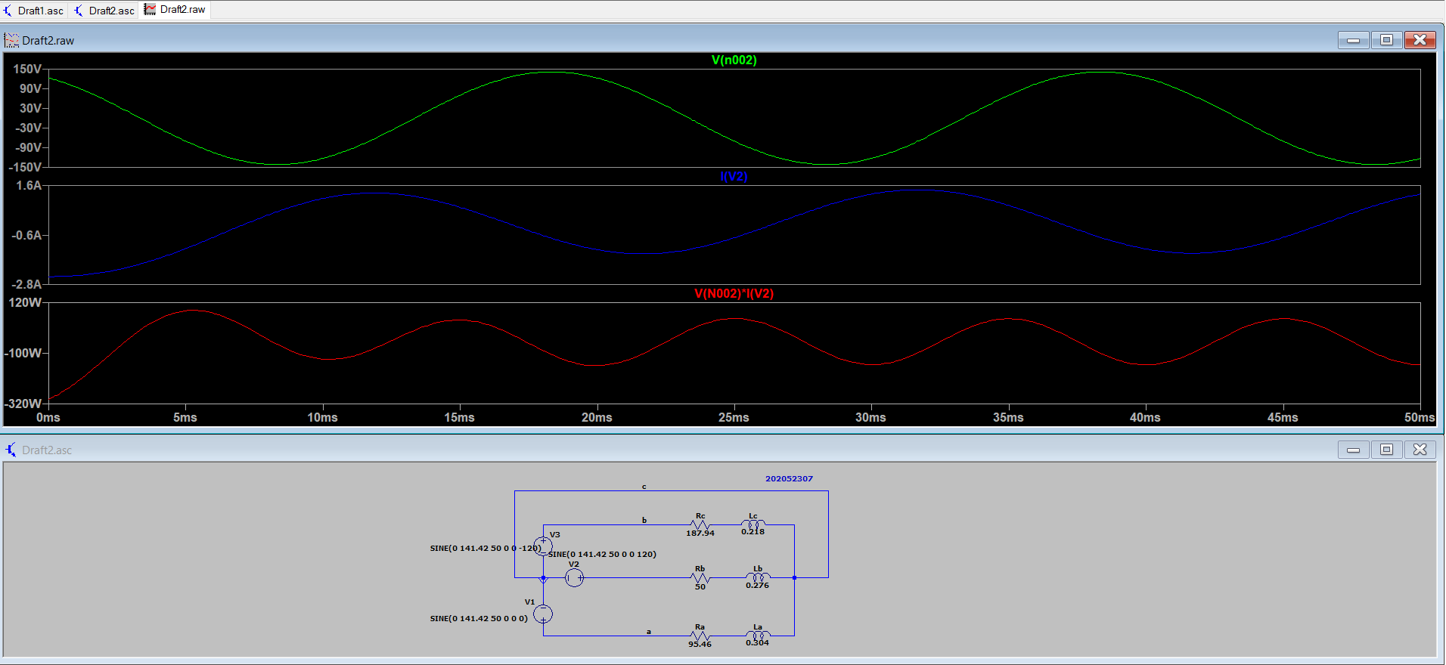

***Voltage, Current and Power across source ‘c’***

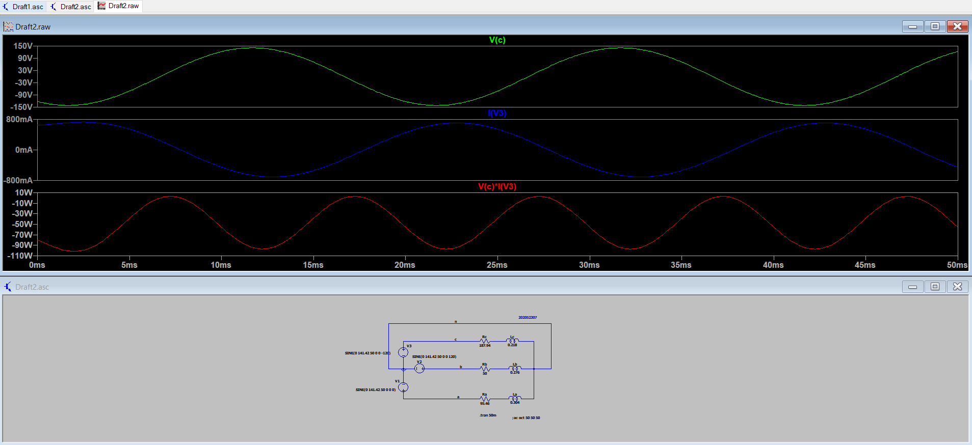

***Voltage, Current and Power across load ‘a’***

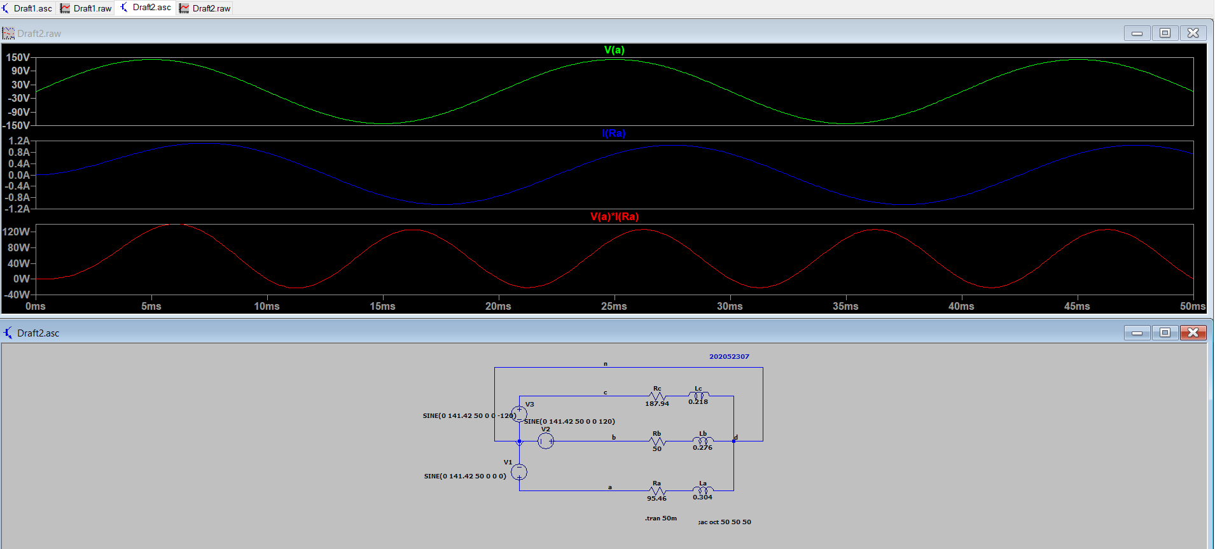

***Voltage, Current and Power across load ‘b’***

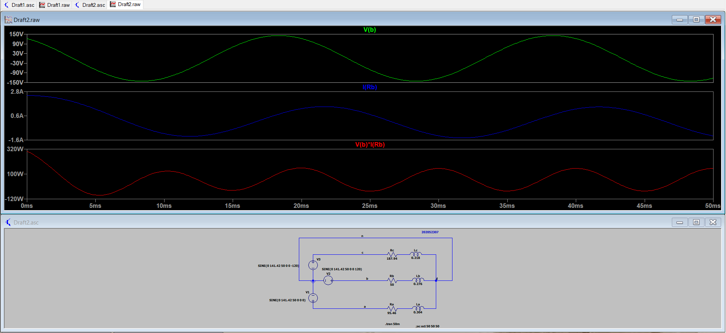

***Voltage, Current and Power across load ‘c’***

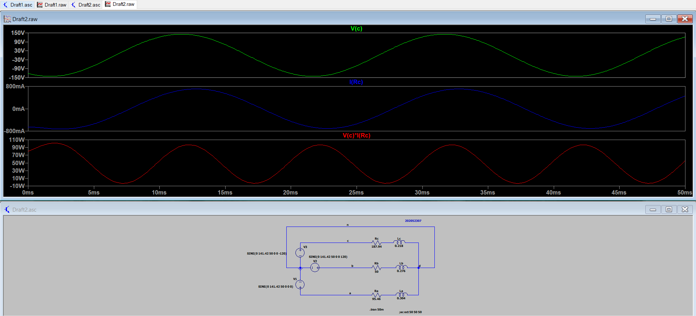

***Voltage, Current and Power across load line ‘a’***

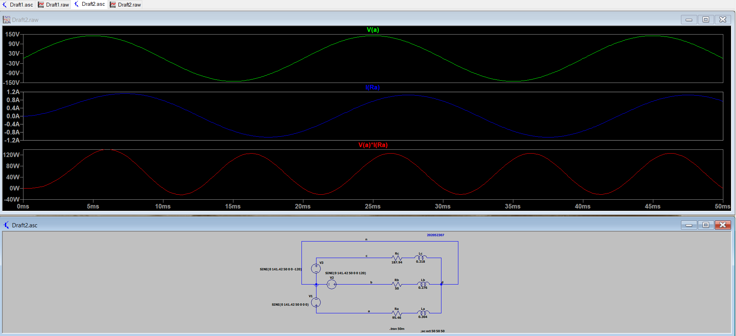

***Voltage, Current and Power across load line ‘b’***



***Voltage, Current and Power across load line ‘c’***



***Total Power of Circuit***

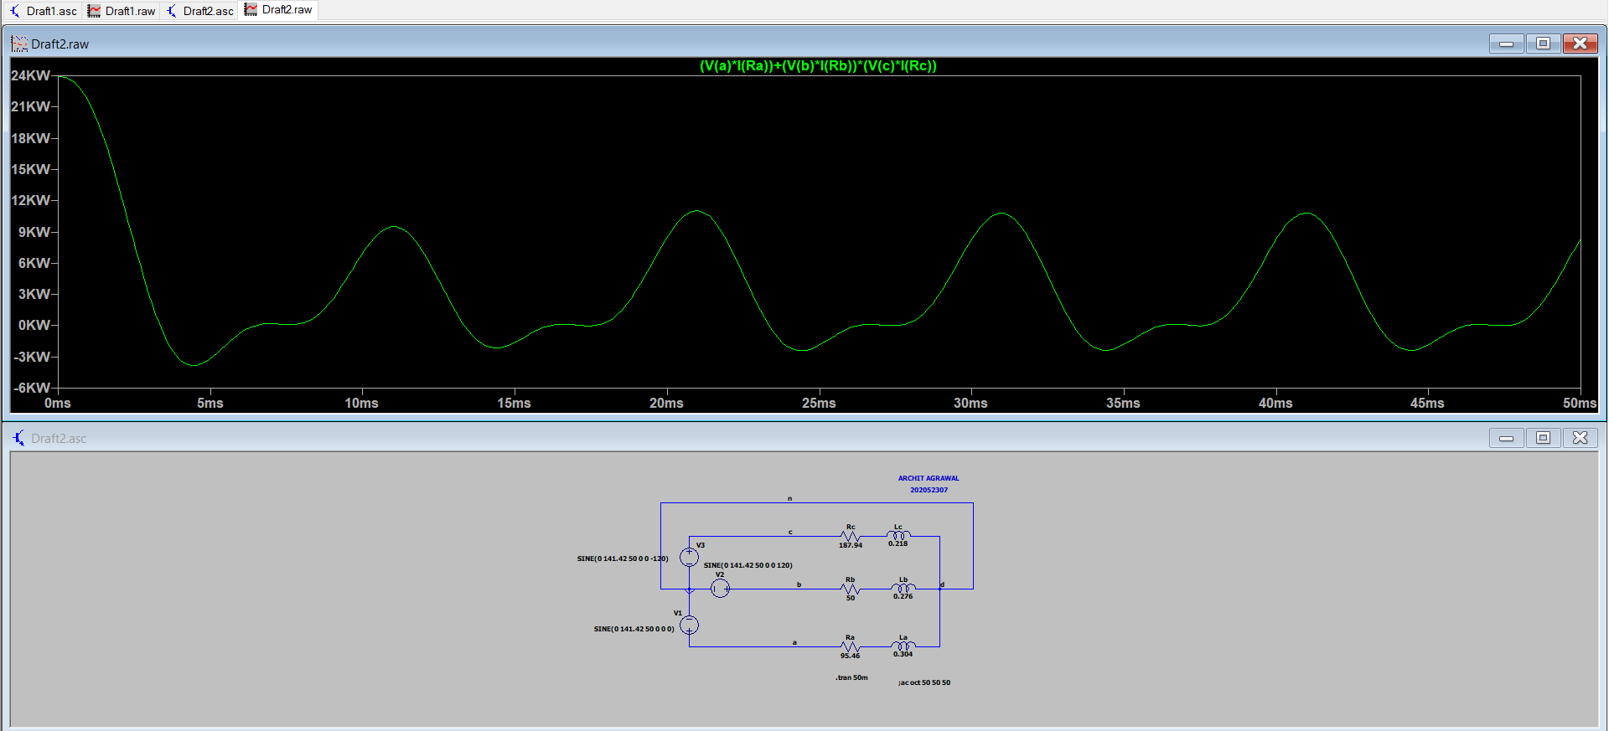

***AC Analysis***

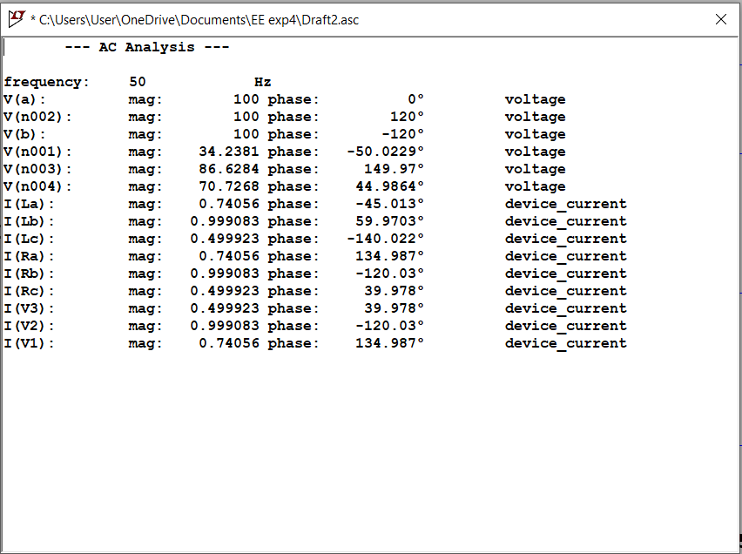

***Circuit***

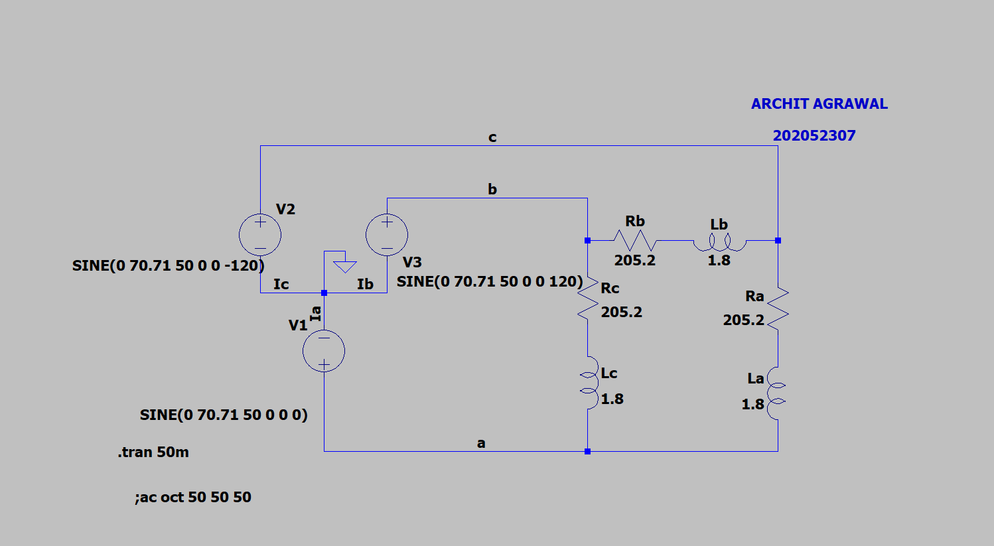

***Voltage, Current and Power across source ‘a’***

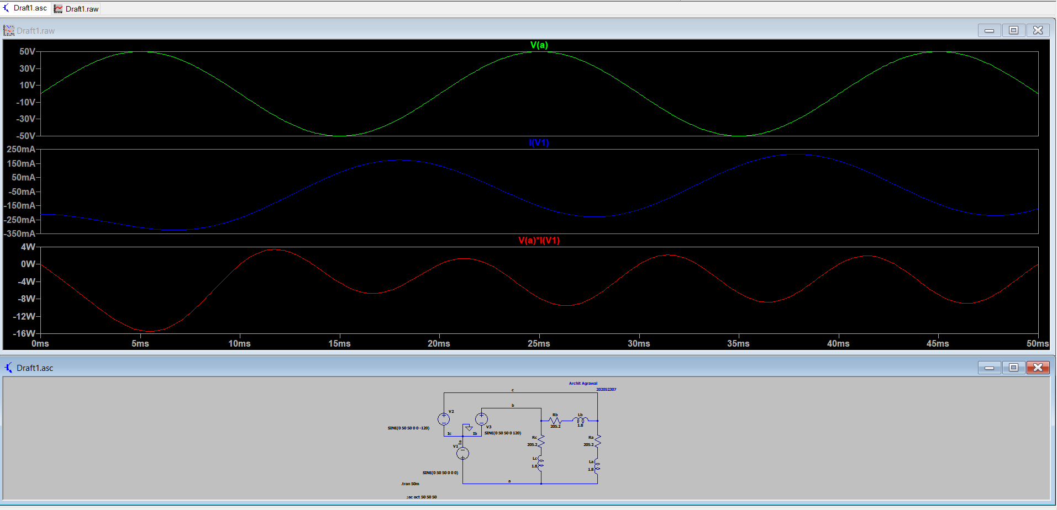

***Voltage, Current and Power across source ‘b’***

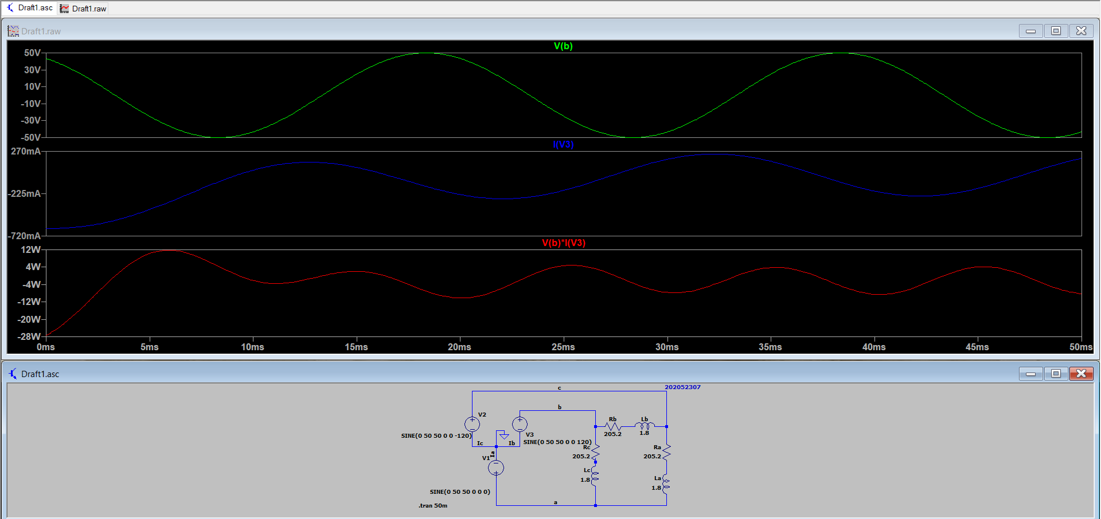

***Voltage, Current and Power across source ‘c’***

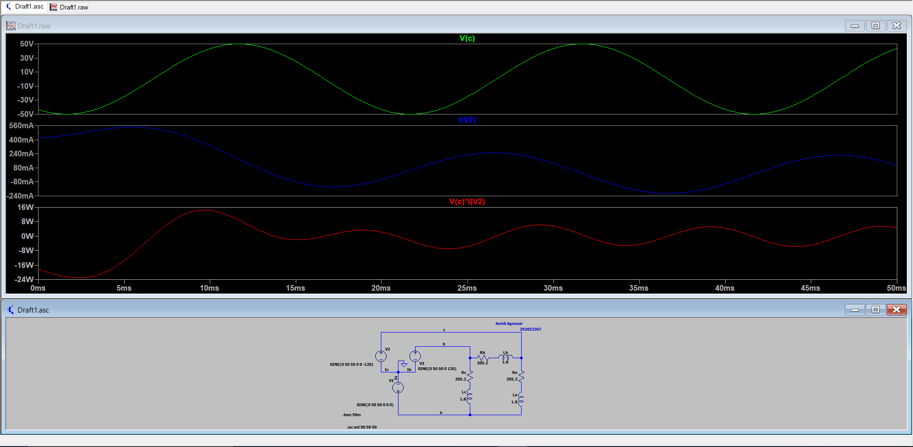

***Voltage, Current and Power across load ‘a’***

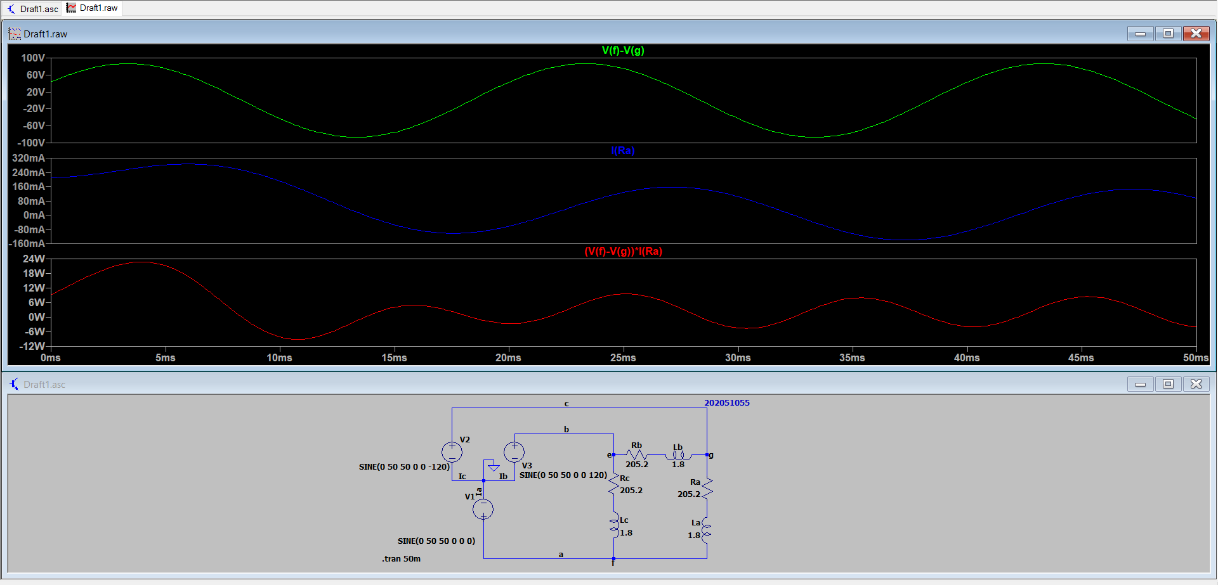

***Voltage, Current and Power across load ‘b’***

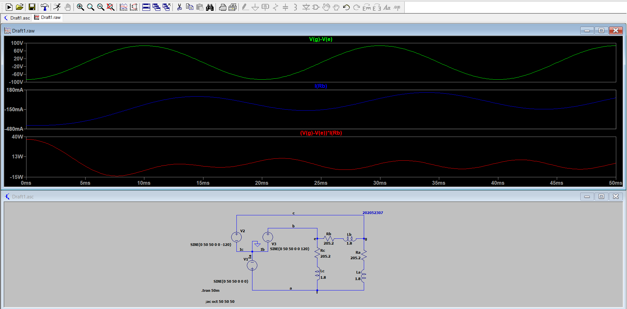

***Voltage, Current and Power across load ‘c’***

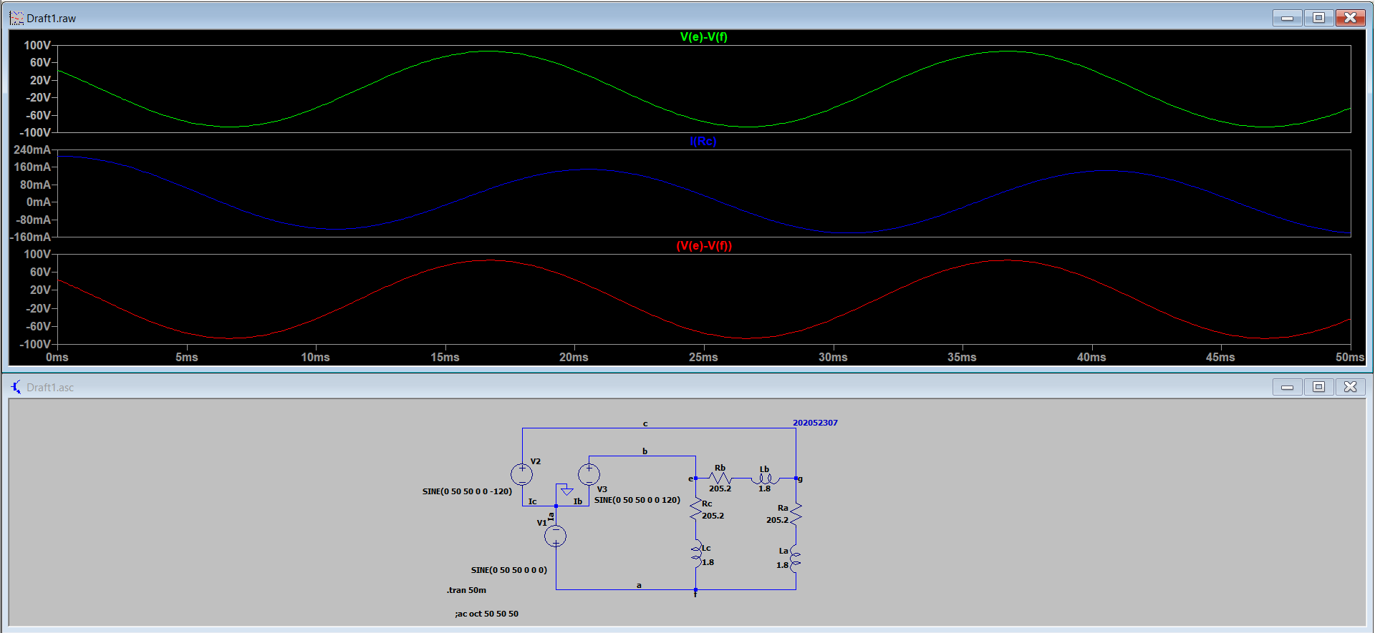

***Voltage, Current and Power across load line ‘a’***

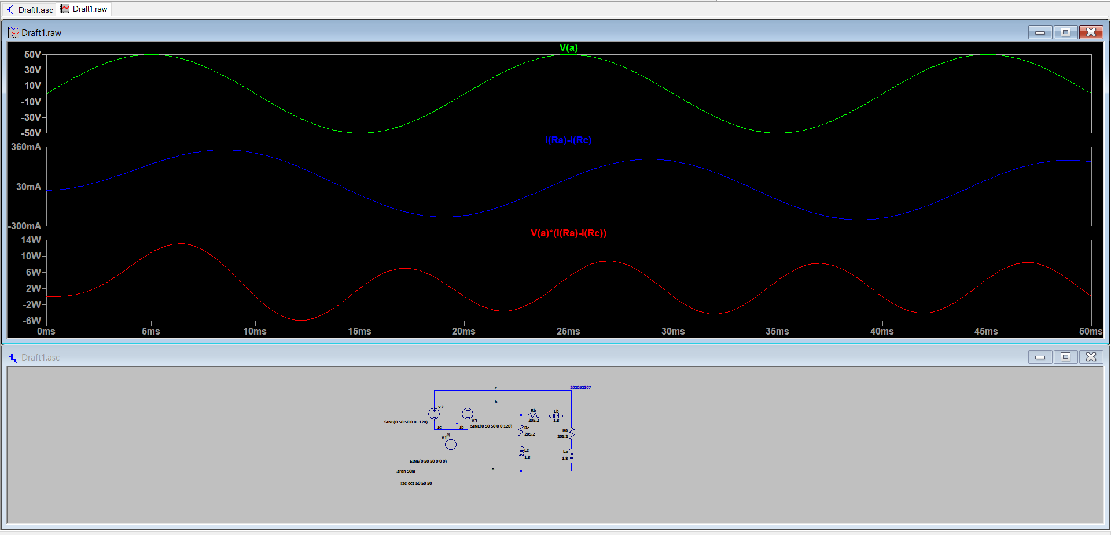

***Voltage, Current and Power across load line ‘b’***

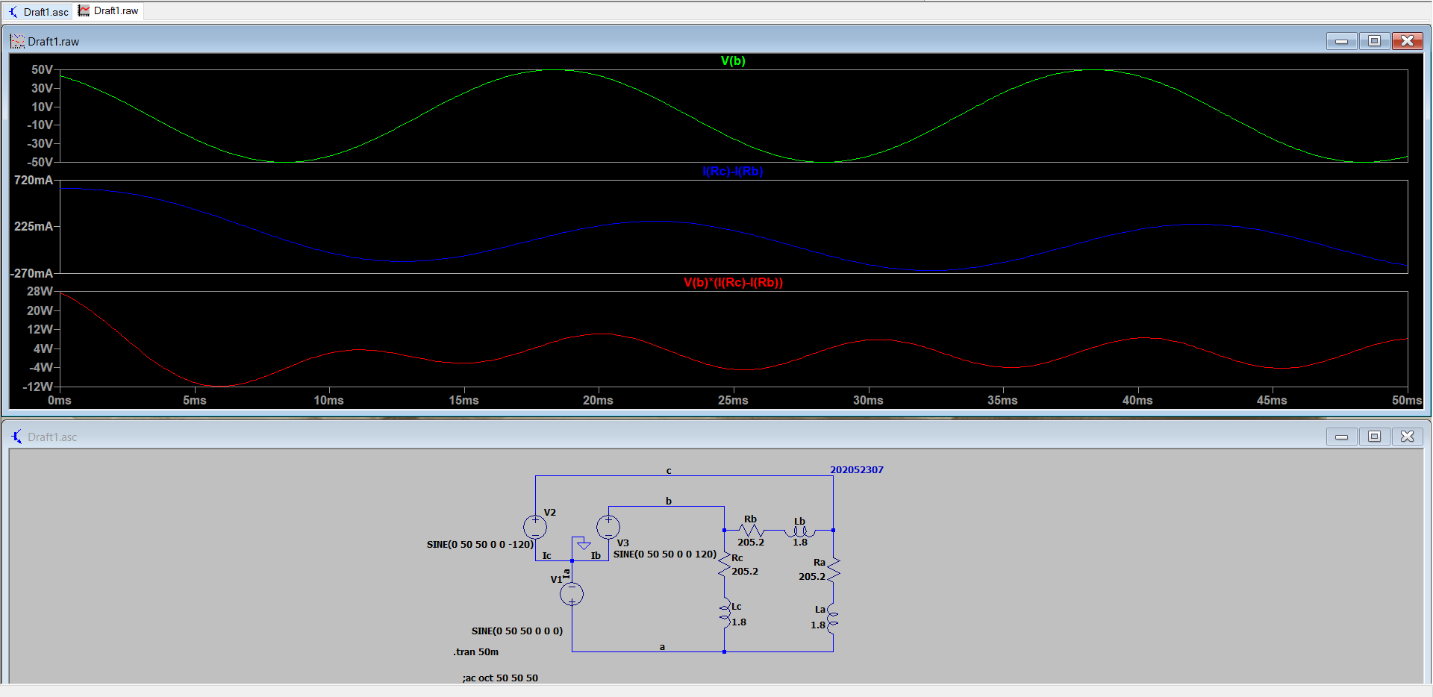

***Voltage, Current and Power across load line ‘c’***

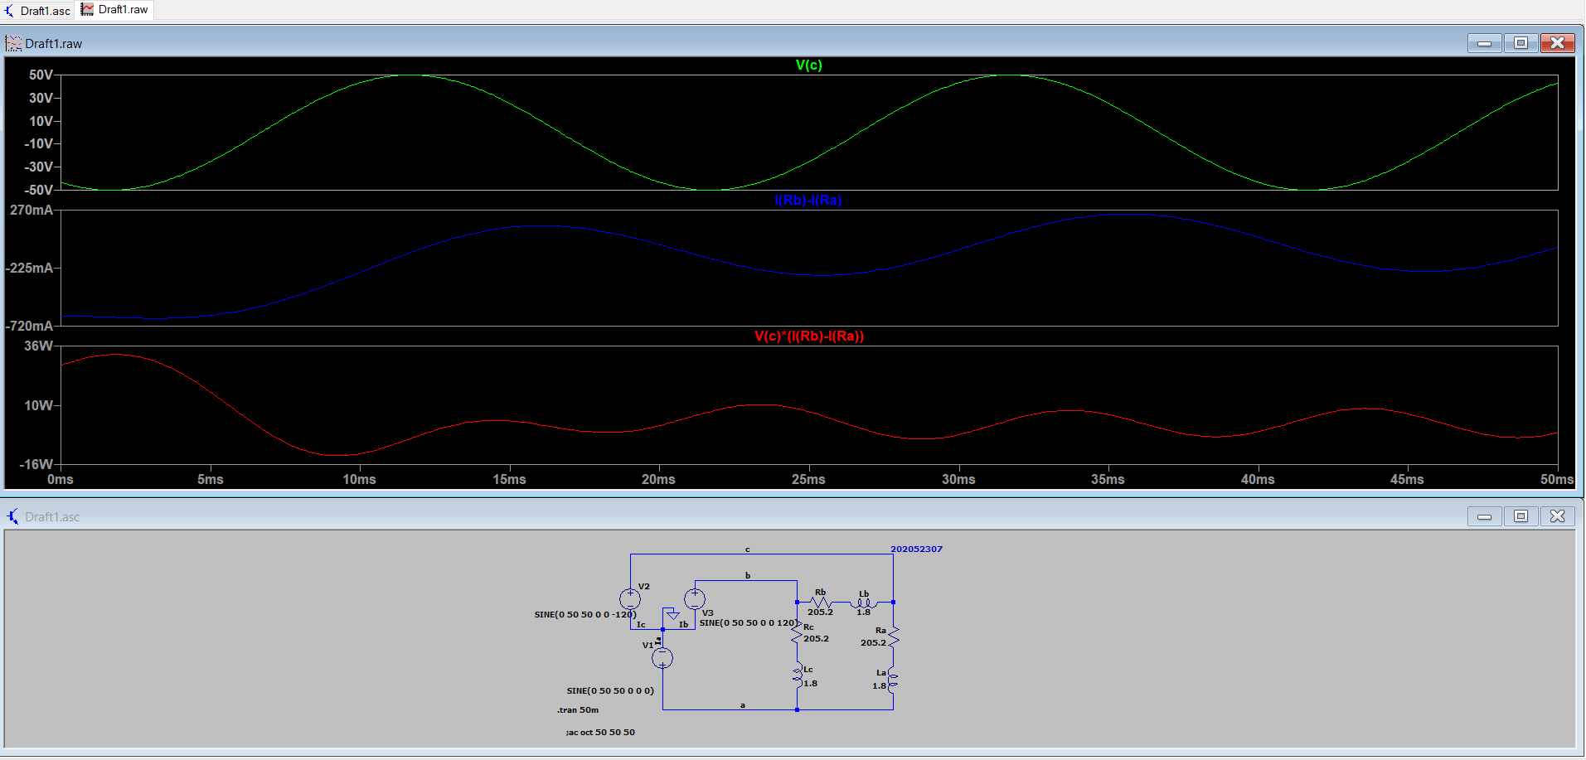

***Total Power of Circuit***

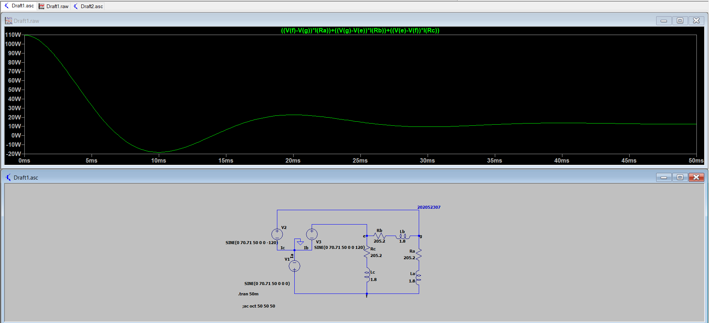

***AC Analysis***

