***Circuit 1 (without transformer)***

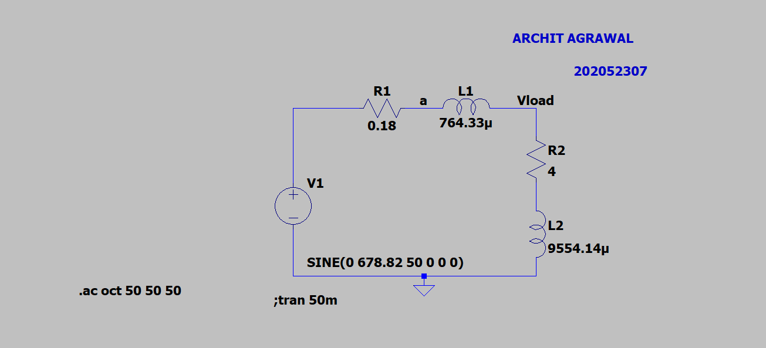

***Voltage, Current and Power across Generator***

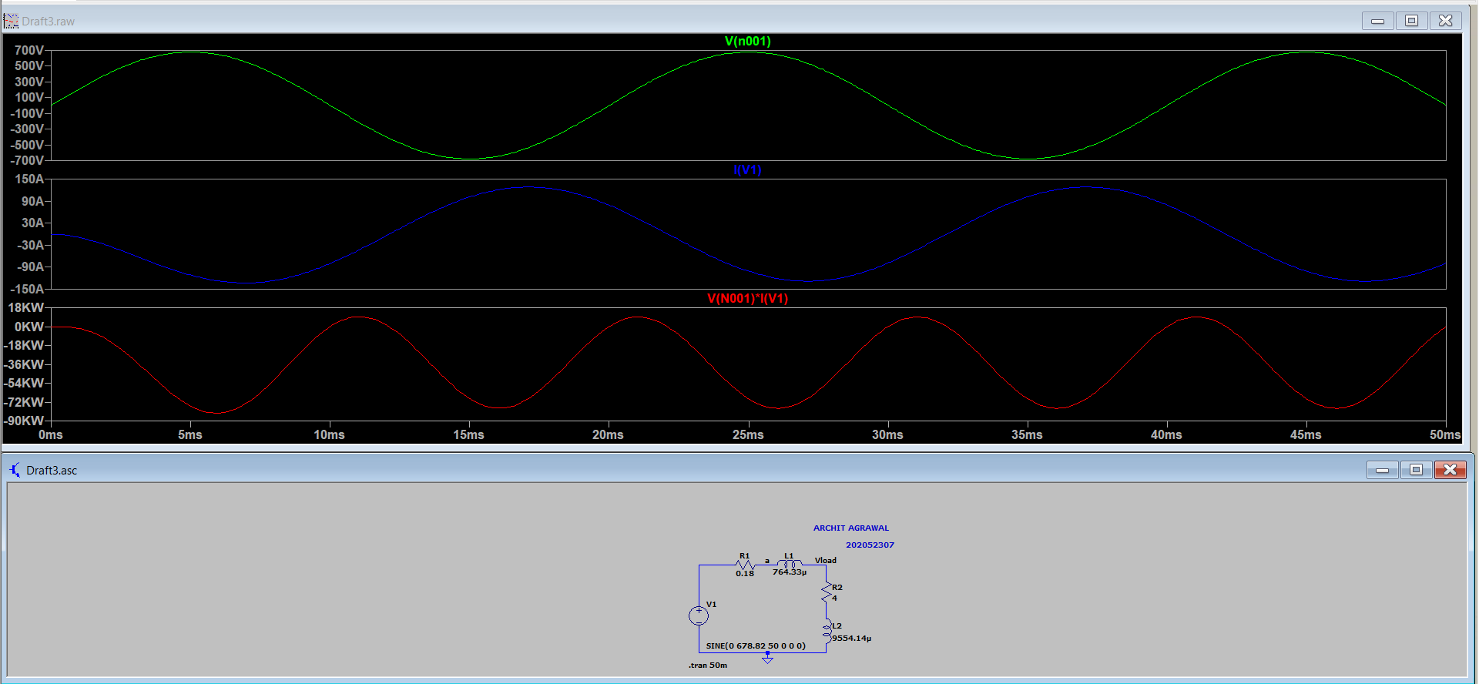

***Voltage, Current and Power across Transmission Line***

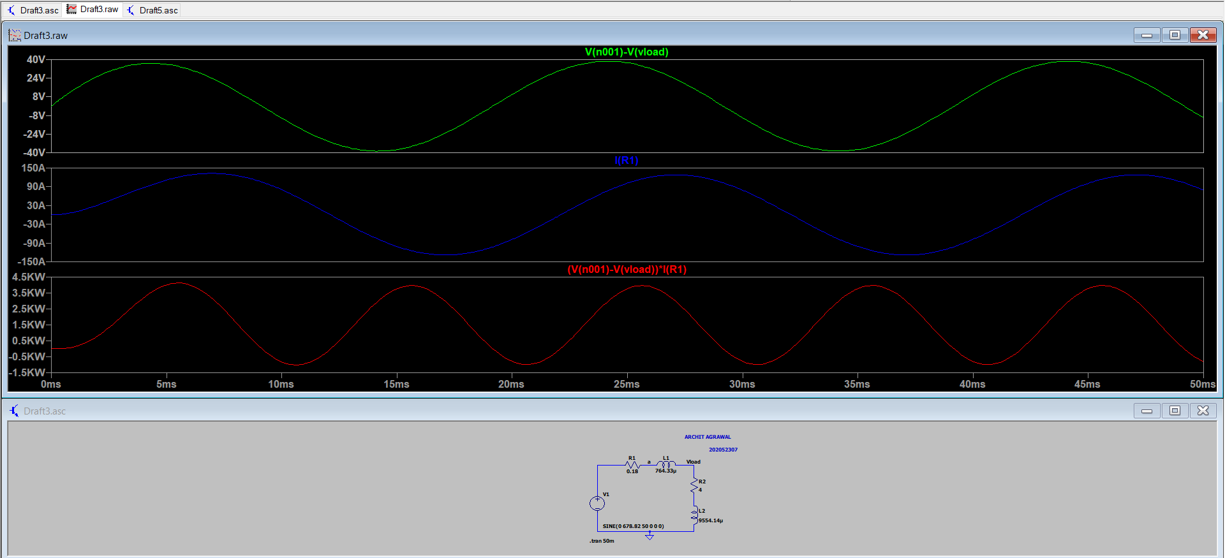

***Voltage, Current and Power across Load***

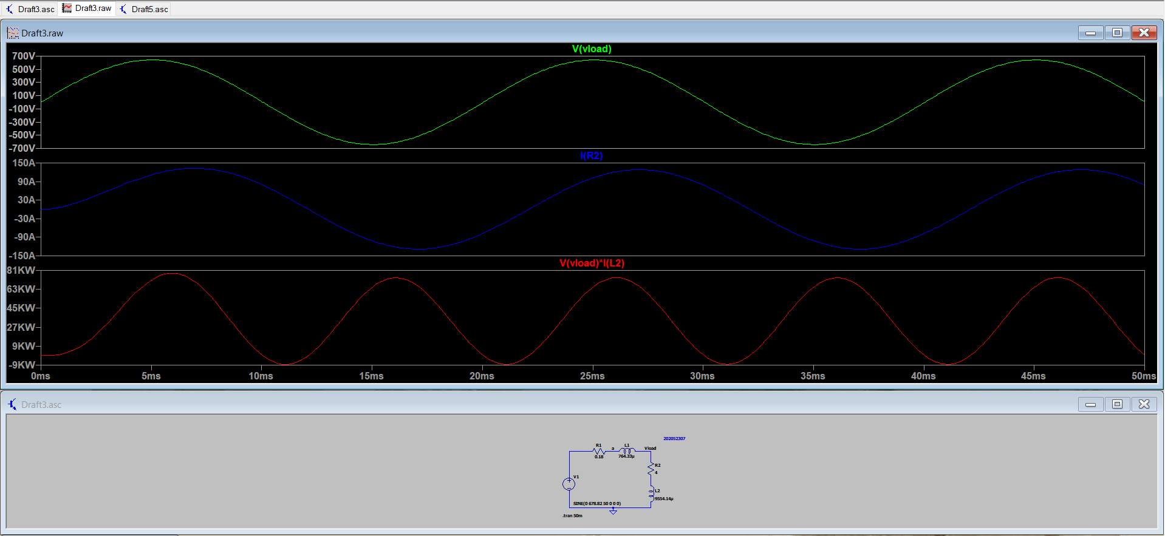

***AC Analysis***

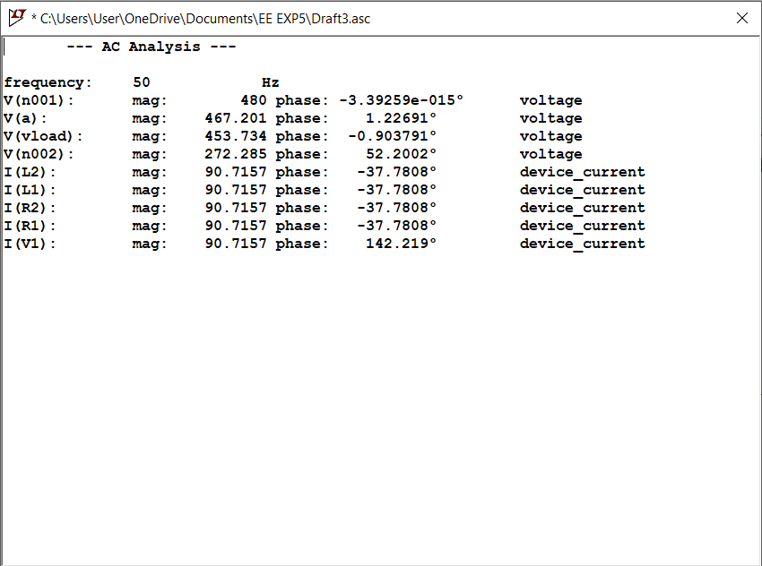

***Circuit 2 (with transformer)***

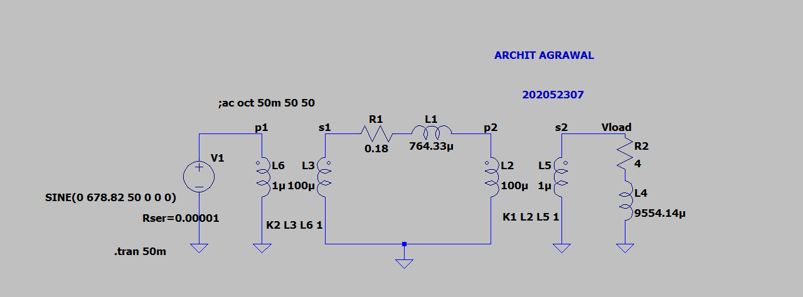

***Voltage, Current and Power across Generator***

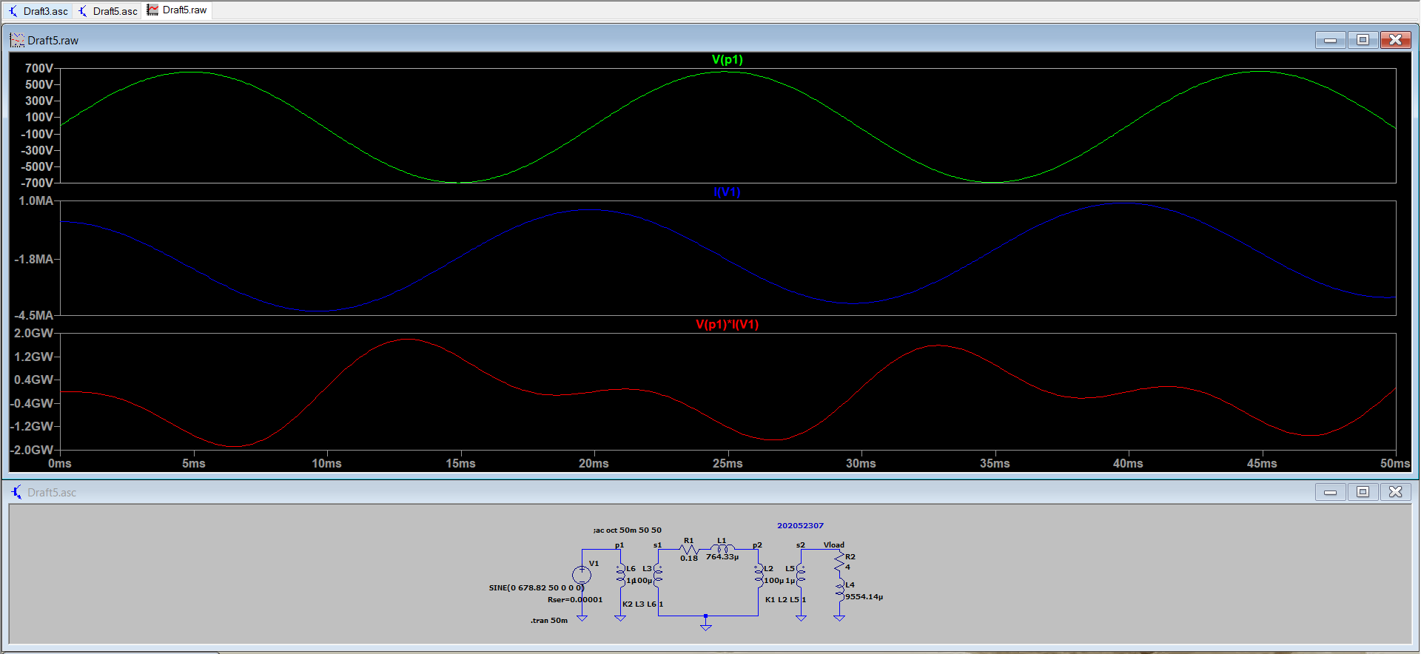

***Voltage, Current and Power across Transmission Line***

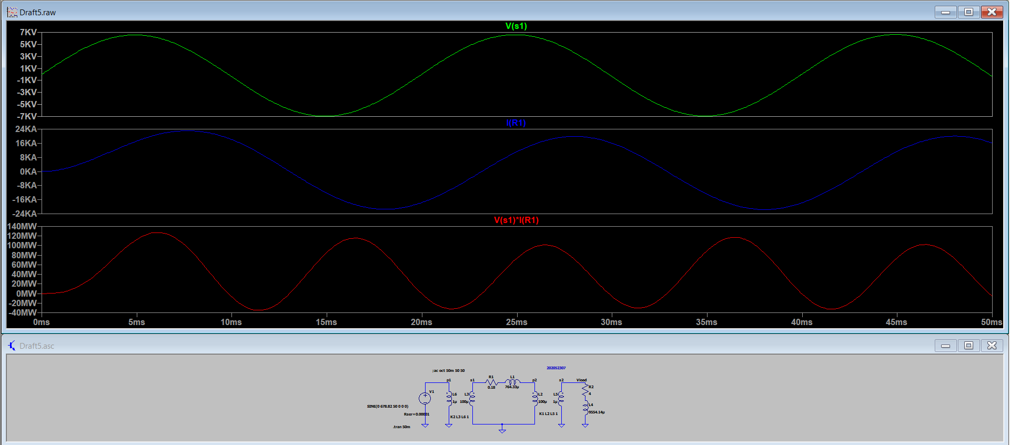

***Voltage, Current and Power across Load***

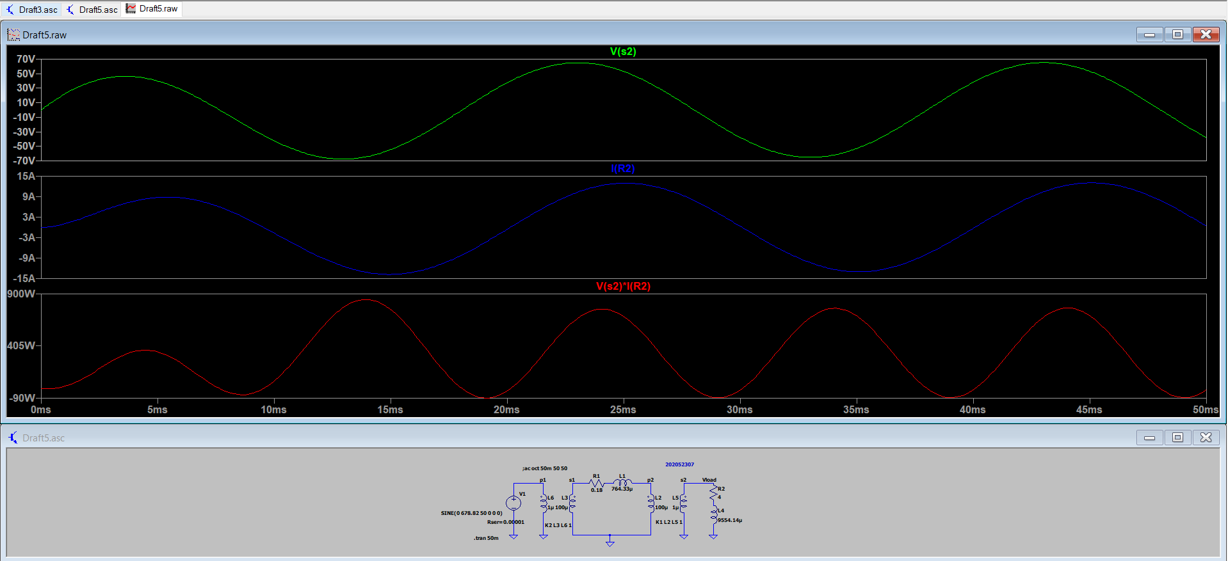

***AC Analysis***

