***Objectives* -:**

Create and execute a MATLAB Program that simulates:

* Rotating Magnetic Field

*If a three-phase set of currents, each of equal magnitude and differing in phase by 120o, flows in a three-phase winding, then it will produce a rotating magnetic field of constant magnitude.*

Observe the following:

* What will happen when the current in any two of the three coils is swapped?
* What would be the effect of variation of the amplitude of currents in each phase?
* What would be the effect of variations in phase angles?
* What would be the effect of increasing / decreasing the value of electrical frequency?
* What would be the effect of incorporating more sets of three-phase winding, *i.e.*, increasing the number of magnetic poles?
* Interaction of the magnetic field produced by a current carrying one-loop rotor with the rotating magnetic field of the three-phase stator windings.

Observe the following:

* Is the loop’s magnetic field trying to align with the rotating magnetic field?
* If yes then what is the mechanical speed of the loop’s magnetic field?
* What would be the effect of variations in the initial mechanical angle between the two fields?

***Description of model* -:**

A rotating magnetic field is the resultant magnetic field produced by a system of coils symmetrically placed and supplied with poly-phase currents.

A rotating magnetic field can be produced by a poly- phase (two or more phases) current or by a single-phase current provided that, in the latter case, two field windings are supplied and are so designed that the two resulting magnetic fields generated thereby are out of phase.

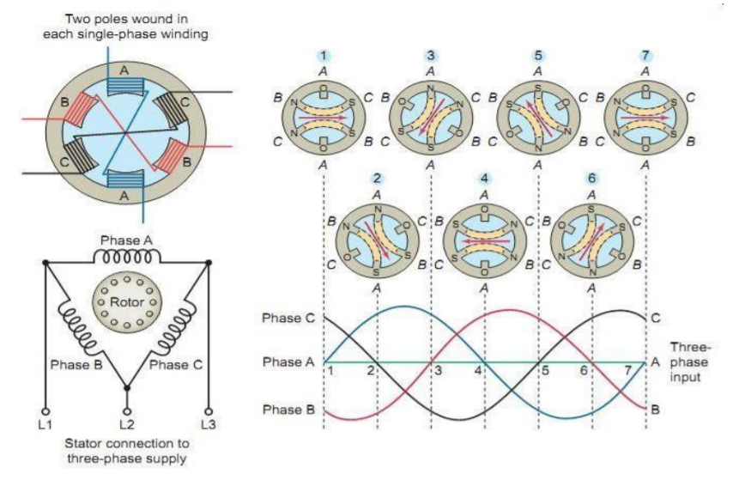

The rotating magnetic field is produced by the three-phase current of the stator in the actual three-phase induction motor. It can be replaced by permanent magnets in a permanent magnet synchronous motor. The three-phase windings of the inner stator are spaced 120° electrical degrees apart.

An induction motor or asynchronous motor is an AC electric motor in which the electric current in the rotor needed to produce torque is obtained by electromagnetic induction from the magnetic field of the stator winding. An induction motor can therefore be made without electrical connections to the rotor.

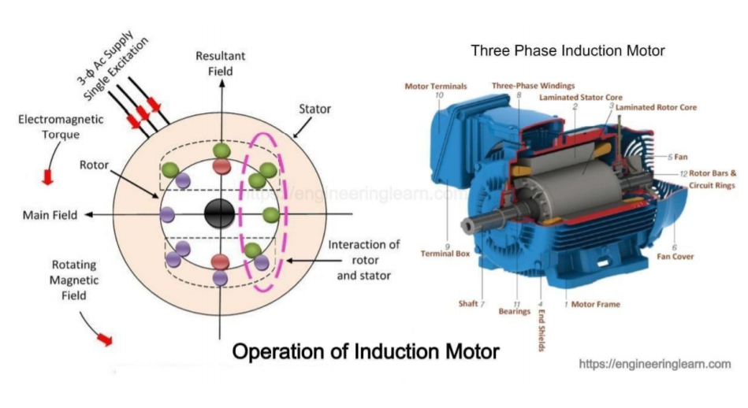

***SCHEMATIC DIAGRAM* -:**

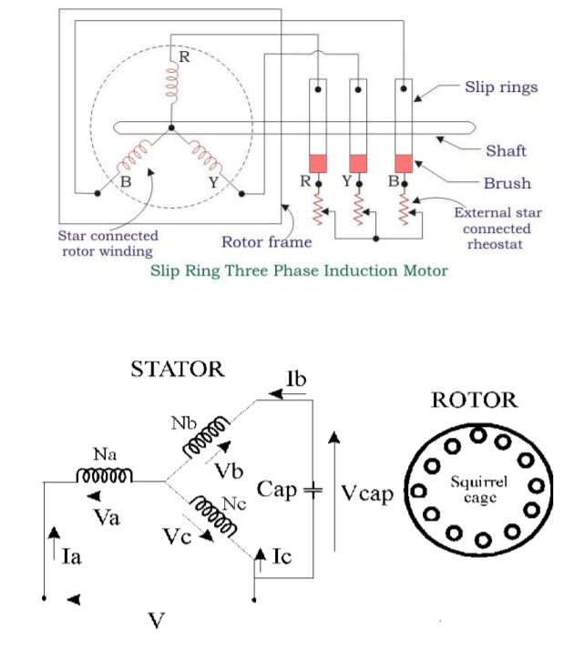

***MATLAB CODES* -:**

**For Objective 1:**

% Archit Agrawal

% 202052307

% A1

bmax = 1; % Normalize bmax to 1

freq = 60; % 60 Hz

w = 2*pi*freq; % angular velocity (rad/s)

% First, generate the three component magnetic fields

t = 0:1/12000:15/15;

Baa = sin(w*t) .* (cos(0) + j*sin(0));

Bbb = sin(w*t-2*pi/3) .* (cos(2*pi/3) + j*sin(2*pi/3));

Bcc = sin(w*t+2*pi/3) .* (cos(-2*pi/3) + j*sin(-2*pi/3));

% Calculate Bnet

Bnet = Baa + Bbb + Bcc;

% Calculate a circle representing the expected maximum

% value of Bnet

circle = 1.5 * (cos(w*t) + j*sin(w*t));

% Plot the reference circle

plot(circle,'k','LineWidth',2.0);

figure(1);

hold on;

% Plot the reference vectors for the B-field components

Baa_ref = 1.5 .* (cos(0) + j*sin(0));

Bbb_ref = 1.5 .* (cos(2*pi/3) + j*sin(2*pi/3));

Bcc_ref = 1.5 .* (cos(-2*pi/3) + j*sin(-2*pi/3));

line('XData',[0 real(Baa_ref)], ...

'YData',[0 imag(Baa_ref)], ...

'Color','k','LineStyle',':','EraseMode','xor');

line('XData',[0 real(Bbb_ref)], ...

'YData',[0 imag(Bbb_ref)], ...

'Color','k','LineStyle',':','EraseMode','xor');

line('XData',[0 real(Bcc_ref)], ...

'YData',[0 imag(Bcc_ref)], ...

'Color','k','LineStyle',':','EraseMode','xor');

% Add magnetic field annotations

text (1.6 * cos(0), 1.6 * sin(0), '\bfB_{aa}');

text (1.6 * cos(2*pi/3) - 0.2, 1.6 * sin(2*pi/3) + 0.1, '\bfB_{bb}');

text (1.6 * cos(-2*pi/3) - 0.2, 1.6 * sin(-2*pi/3), '\bfB_{cc}');

% Plot the initial positions of the magnetic vector lines.

% Note that Baa is black, Bbb is blue, Bcc is magneta,

% and Bnet is red.

ii = 1;

h1=line('XData',[0 real(Baa(ii))], ...

'YData',[0 imag(Baa(ii))], ...

'Color','k','EraseMode','xor', ...

'Linewidth',2.0);

hold on;

h2=line('XData',[0 real(Bbb(ii))], ...

'YData',[0 imag(Bbb(ii))], ...

'Color','b','EraseMode','xor', ...

'Linewidth',2.0);

h3=line('XData',[0 real(Bcc(ii))], ...

'YData',[0 imag(Bcc(ii))], ...

'Color','m','EraseMode','xor', ...

'Linewidth',2.0);

h4=line('XData',[0 real(Bnet(ii))], ...

'YData',[0 imag(Bnet(ii))], ...

'Color','r','EraseMode','xor', ...

'Linewidth',2.0);

% Labels and annotations

title ('\bfThe Rotating Magnetic Field');

xlabel('\bfFlux Density (T)');

ylabel('\bfFlux Density (T)');

axis square;

axis([-2 2 -2 2]);

% Now update the lines as a function of time.

for ii = 2:length(t)

set(h1,'XData',[0 real(Baa(ii))]);

set(h1,'YData',[0 imag(Baa(ii))]);

set(h2,'XData',[0 real(Bbb(ii))]);

set(h2,'YData',[0 imag(Bbb(ii))]);

set(h3,'XData',[0 real(Bcc(ii))]);

set(h3,'YData',[0 imag(Bcc(ii))]);

set(h4,'XData',[0 real(Bnet(ii))]);

set(h4,'YData',[0 imag(Bnet(ii))]);

drawnow;

end

hold off;

figure(2);

title('\bfMagnetic Field In the time Domain');

ylabel('\bfFlux Density (T)');

xlabel('\bfTime(sec)');

axis([0 n*T -2 2]);

hold on;

grid on;

plot(t,Baa,'c');

plot(t,Bbb,'b');

plot(t,Bcc,'m');

plot(t,Bnet,'r');

legend('Baa','Bbb','Bcc','Bnet')

clc;

**For Objective 2:**

% Archit Agrawal

% 202052307

% A1

% Set up the basic conditions

bmax = 1; % Normalize bmax to 1

freq = 60; % 60 Hz

w = 2*pi*freq; % angluar velocity (rad/s)

% First, generate the three component magnetic fields

t = 0:1/12000:15/15;

Baa = sin(w*t) .* (cos(0) + j*sin(0));

Bbb = sin(w*t+2*pi/3) .* (cos(2*pi/3) + j*sin(2*pi/3));

Bcc = sin(w*t-2*pi/3) .* (cos(-2*pi/3) + j*sin(-2*pi/3));

% Calculate Bnet

Bnet = Baa + Bbb + Bcc;

% Calculate a circle representing the expected maximum

% value of Bnet

circle = 1.5 * (cos(w*t) + j*sin(w*t));

% Plot the reference circle

plot(circle,'k','LineWidth',2.0);

figure(1);

hold on;

% Plot the reference vectors for the B-field components

Baa_ref = 1.5 .* (cos(0) + j*sin(0));

Bbb_ref = 1.5 .* (cos(2*pi/3) + j*sin(2*pi/3));

Bcc_ref = 1.5 .* (cos(-2*pi/3) + j*sin(-2*pi/3));

line('XData',[0 real(Baa_ref)], ...

'YData',[0 imag(Baa_ref)], ...

'Color','k','LineStyle',':','EraseMode','xor');

line('XData',[0 real(Bbb_ref)], ...

'YData',[0 imag(Bbb_ref)], ...

'Color','k','LineStyle',':','EraseMode','xor');

line('XData',[0 real(Bcc_ref)], ...

'YData',[0 imag(Bcc_ref)], ...

'Color','k','LineStyle',':','EraseMode','xor');

% Add magnetic field annotations

text (1.6 * cos(0), 1.6 * sin(0), '\bfB_{aa}');

text (1.6 * cos(2*pi/3) - 0.2, 1.6 * sin(2*pi/3) + 0.1, '\bfB_{bb}');

text (1.6 * cos(-2*pi/3) - 0.2, 1.6 * sin(-2*pi/3), '\bfB_{cc}');

% Plot the initial positions of the magnetic vector lines.

% Note that Baa is black, Bbb is blue, Bcc is magneta,

% and Bnet is red.

ii = 1;

h1=line('XData',[0 real(Baa(ii))], ...

'YData',[0 imag(Baa(ii))], ...

'Color','k','EraseMode','xor', ...

'Linewidth',2.0);

hold on;

h2=line('XData',[0 real(Bbb(ii))], ...

'YData',[0 imag(Bbb(ii))], ...

'Color','b','EraseMode','xor', ...

'Linewidth',2.0);

h3=line('XData',[0 real(Bcc(ii))], ...

'YData',[0 imag(Bcc(ii))], ...

'Color','m','EraseMode','xor', ...

'Linewidth',2.0);

h4=line('XData',[0 real(Bnet(ii))], ...

'YData',[0 imag(Bnet(ii))], ...

'Color','r','EraseMode','xor', ...

'Linewidth',2.0);

% Labels and annotations

title ('\bfRotating Magnetic Field with Phase B & C Currents Swapped');

xlabel('\bfFlux Density (T)');

ylabel('\bfFlux Density (T)');

axis square;

axis([-2 2 -2 2]);

% Now update the lines as a function of time.

for ii = 2:length(t)

set(h1,'XData',[0 real(Baa(ii))]);

set(h1,'YData',[0 imag(Baa(ii))]);

set(h2,'XData',[0 real(Bbb(ii))]);

set(h2,'YData',[0 imag(Bbb(ii))]);

set(h3,'XData',[0 real(Bcc(ii))]);

set(h3,'YData',[0 imag(Bcc(ii))]);

set(h4,'XData',[0 real(Bnet(ii))]);

set(h4,'YData',[0 imag(Bnet(ii))]);

drawnow;

end

hold off;

figure(2);

title('\bfMagnetic Fieldsin the time Domain');

ylabel('\bfFlux Density (T)');

xlabel('\bfTime(sec)');

axis([0 n*T -2 2]);

hold on;

grid on;

plot(t,Baa,'c');

plot(t,Bbb,'b');

plot(t,Bcc,'m');

plot(t,Bnet,'r');

legend('Baa','Bbb','Bcc','Bnet')

clc;

***OBSERVAtions* -:**

* Rotating Magnetic Field

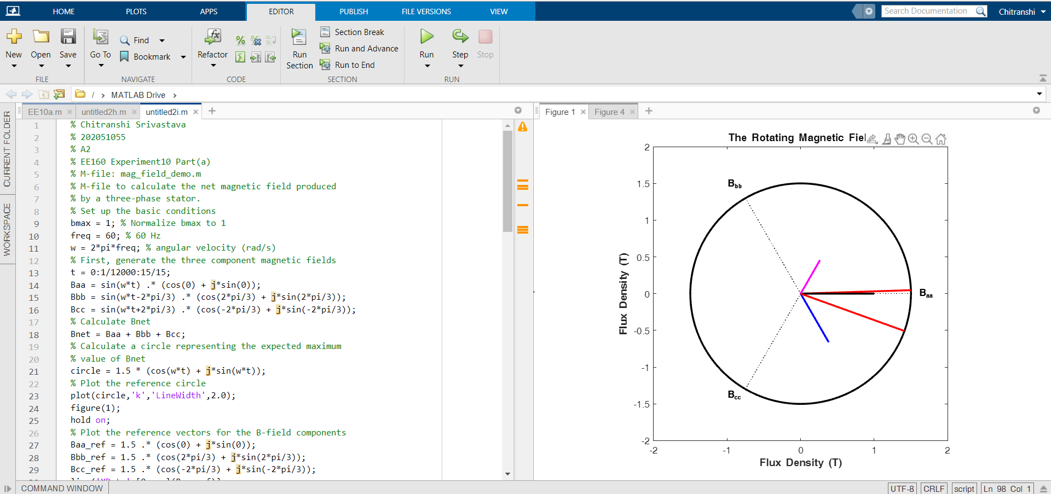

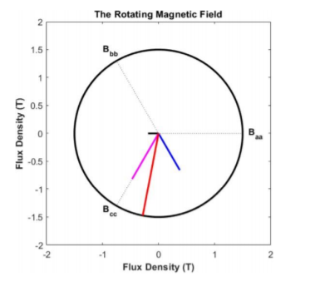

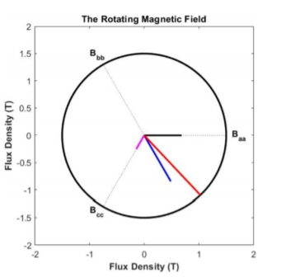

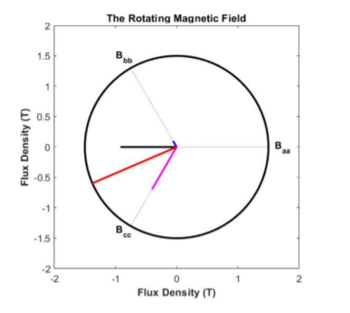

* Rotating Magnetic Field with phase B & C currents swapped 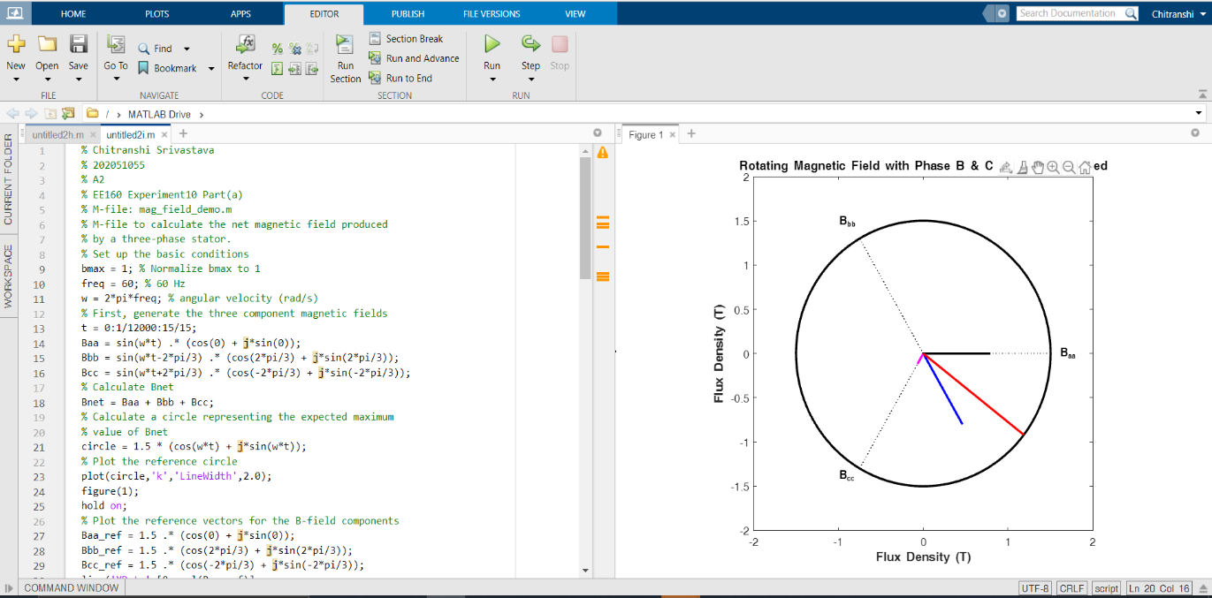

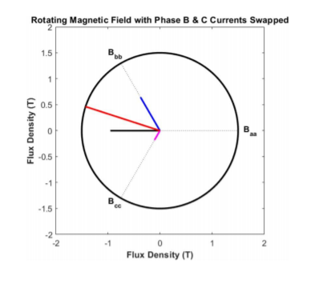

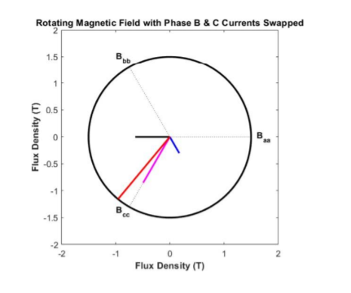

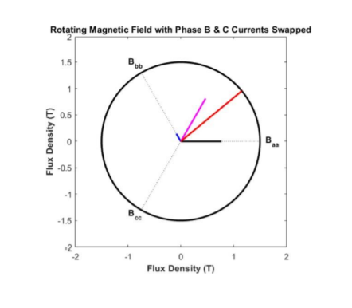

***GRAPHs* -:**

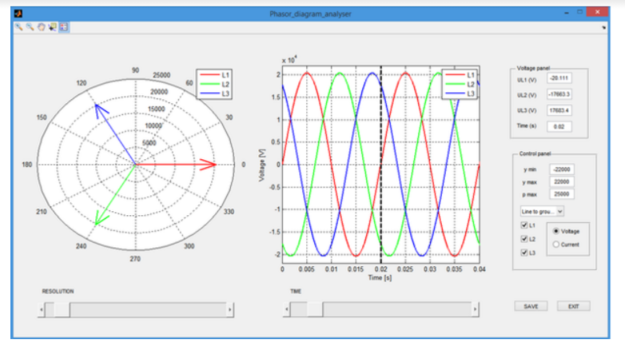

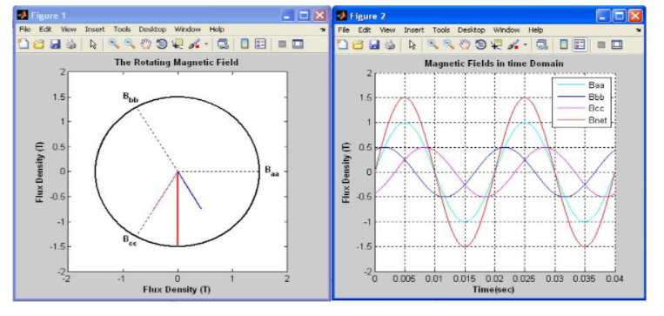

***CONCLUSION* -:** In the first aim we saw a clockwise magnetic field direction. As we changed phase or current in any two was swapped, the rotation became anti- clockwise.

We also coded both via MATLAB and achieved our objectives, which stand in perfect correlation to the theoretical knowledge. Hence, we can conclude this experiment.