***Objectives* -:**

* To measure the refractive index of a prism.

***Theory* -:**

Refraction is the bending of light (it also happens with sound, water and other waves) as it passes from one transparent substance into another.

This bending by refraction makes it possible for us to have lenses, magnifying glasses, prisms and rainbows. Even our eyes depend upon this bending of light. Without refraction, we wouldn’t be able to focus light onto our retina.

The extent of bending of light rays entering from one medium to another is the ***Refractive Index.*** It is denoted by the letter ‘n’ or ‘μ’. It is represented as:

where c = velocity/speed of light of a certain wavelength in the air and v = velocity of light in any medium.

***SNELL’S LAW***

It gives the amount of bending of light rays. It also determines the relationship between the angle of incidence, the angle of refraction and relative indices of a given pair of media. It states that the ratio of the sine of the angle of incidence to the sine of the angle of refraction is a constant for the light of given color (precisely wavelength) and for the given pair of media.

***LAWS OF REFRACTION***

The angle of incidence is the angle between the incident ray and the normal; denoted as ‘i’. The angle of refraction is the angle between the refracted ray and the normal; denoted as ‘r’.

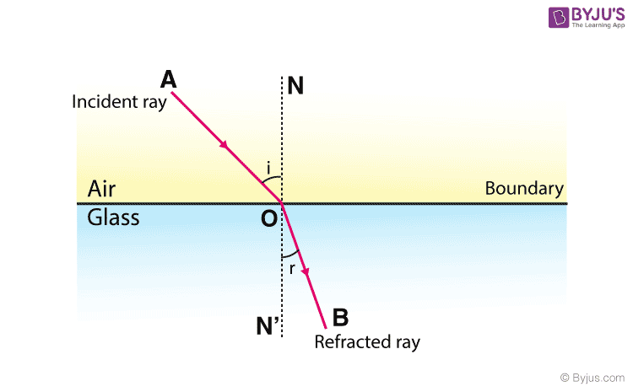

Laws of refraction state that:

* The incident ray, reflected ray and the normal, to the interface of any two given mediums; all lie in the same plane.
* The ratio of the sine of the angle of incidence and sine of the angle of refraction is constant.

***REFRACTION THROUGH GLASS PRISM***

A glass prism is a transparent object having two triangular ends and three rectangular sides. The refraction of light in glass prism is different from a glass slab. This is because in glass prism, the incident ray of light is not parallel to emergent ray of light.

When a ray of light enters the glass prism it gets deviated two times. First when it enters the glass prism and second when it comes out of the prism. This is because the refracting surfaces of the prism are not parallel to each other. Also, when the ray of light passes through the prism it bends towards its base.

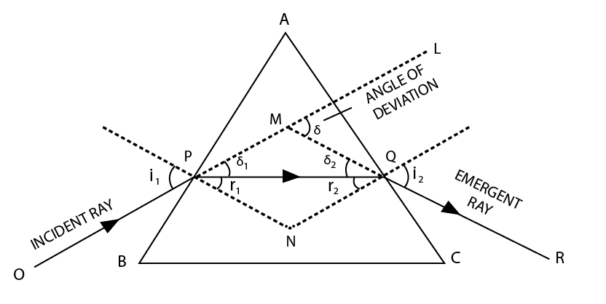

The incident ray strikes the surface AB of the prism at an incident angle and refraction takes place. The ray is refracted and the angle of refraction of refraction is . The angle of incidence at the surface AC is and the ray is again refracted and the refracted angle is . The angle is known as angle of emergence and the ray QR is known as emergent ray.

The angle is the angle between the original direction of incident ray and the ray PQ. Similarly, the angle is the angle between the original direction of ray PQ and the emergent ray.

Using the exterior angle property in the ,

The angle is known as the angle of deviation. It is the angle between the original direction of incident ray and the emergent ray. It denotes the net deviation that the incident ray has suffered while passing through the prism.

In a prism, the angle of deviation decreases with increase in the angle of incidence up to a particular angle. This angle of incidence where the angle of deviation in a prism is minimum is called the minimum deviation position of the prism and that very deviation angle is known as the minimum angle of deviation .

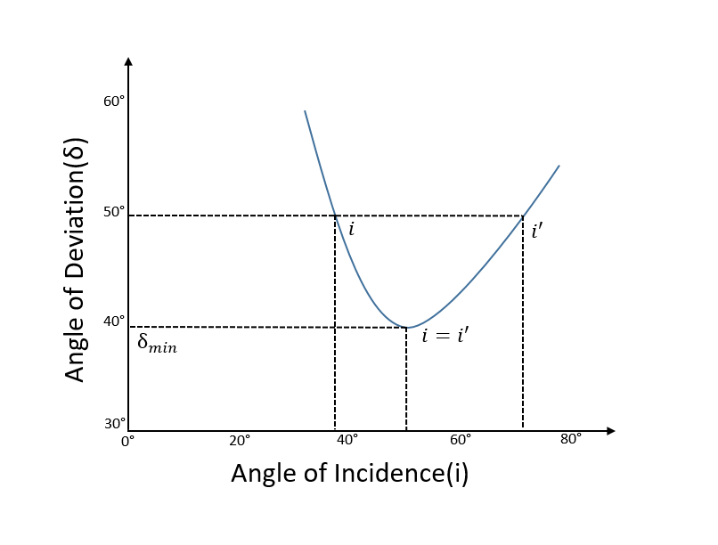The variation of angle of minimum deviation with the incidence angle is shown in the figure below.

The angle of minimum deviation is useful in calculating the refractive index of the material of prism. The relation between the refractive index of the prism and the angle of minimum deviation is given by

where A is the angle of prism (angle BAC in the figure).

***Procedure* -:**

***Steps for Preliminary Adjustments* -:**

* Focus the telescope from this slider and start the experiment.
* Switch on the light
* Focus the slit from the slit focus slider.
* Coincide the slit with cross wire in the telescope.

***Steps to determine the angle of Prism* -:**

* Place the Prism.
* Place the edge of prism, pointed towards collimator.
* Move the telescope using Telescope slider up to see the slit on side. Make coincide the slit with the cross wire using fine angle adjusting slider. Then note the reading in the tabular column.
* Move the telescope in the opposite direction and do the same.
* Find the difference between two angles i.e. 2θ. Hence, find the angle of prism θ.

***Steps to determine the Minimum Angle of Deviation* -:**

* Now we have to change the position of prism using vernier table slider for its base to be parallel to the prism.
* Now we have to move the telescope to obtain the deviated light, bring the deviated light to cross section of the wire.
* Now to obtain the minimum angle of deviation use fine angle slider of vernier table you will notice at some point deviated light retrace its path that is the minimum angle of deviation.
* Bring the cross wire of the telescope to that minimum deviated ray.
* Take the Main scale and Vernier scale readings on vernier 1 and 2.
* Then remove the prism using the button "Remove Prism".
* Carefully turn the telescope so as to get the direct ray from collimator, make it coincide with cross wire in the telescope and again note vernier 1 and 2 readings.
* Hence, calculate the angle of minimum deviation () by measuring the difference between emerged ray readings and direct ray readings.

***Observations and cAlculations* -:**

**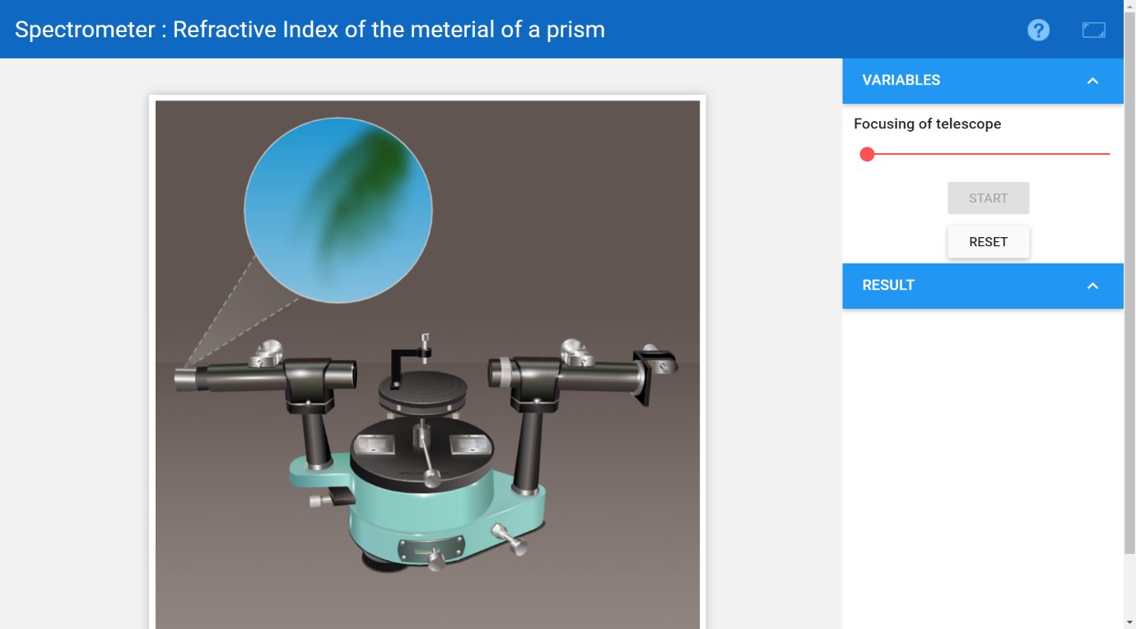*Snapshots for Preliminary Adjustments* -:**

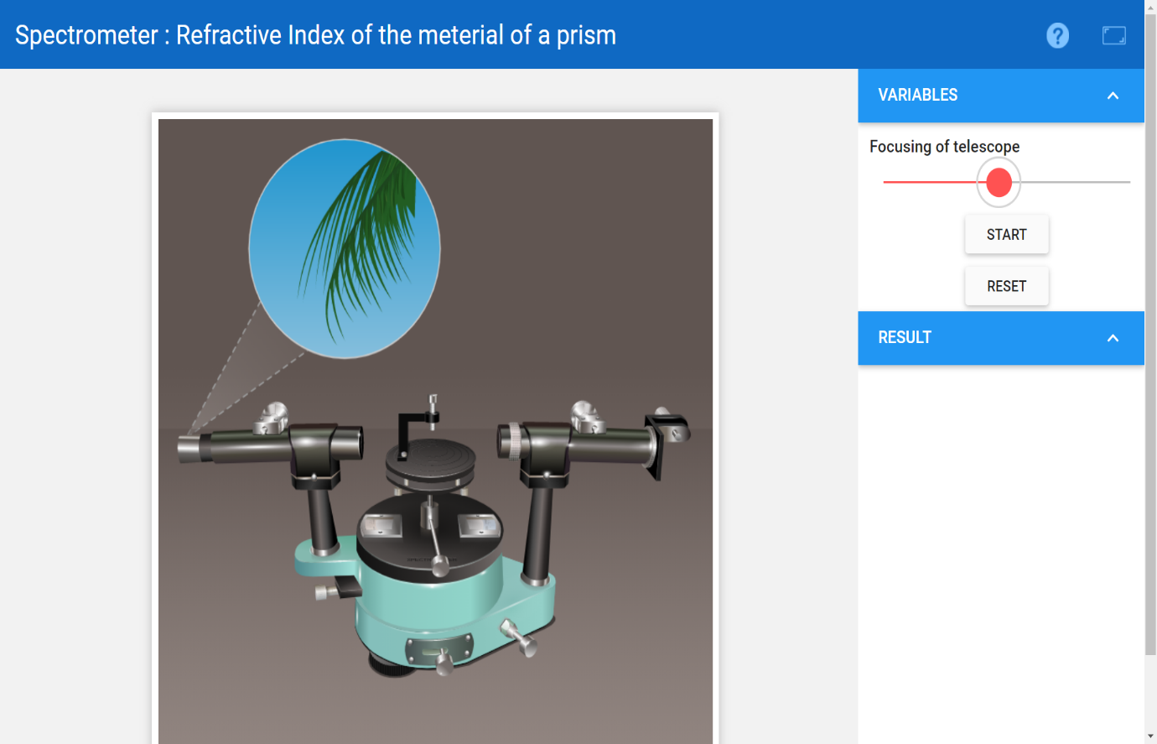

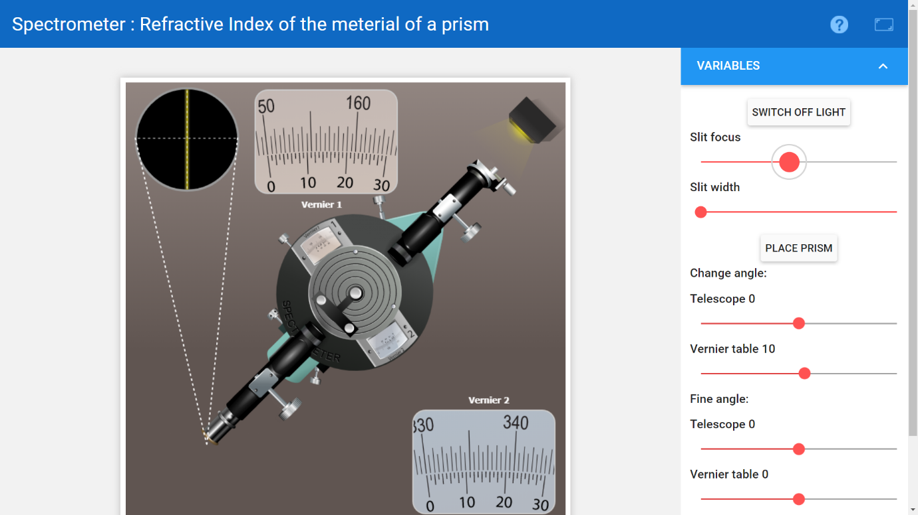

Now, it can be observed that the Main Scale has 20 divisions in between and , which means that the Main Scale Division is .

Number of divisions on Vernier Scale = 30.

Therefore, least count = .

**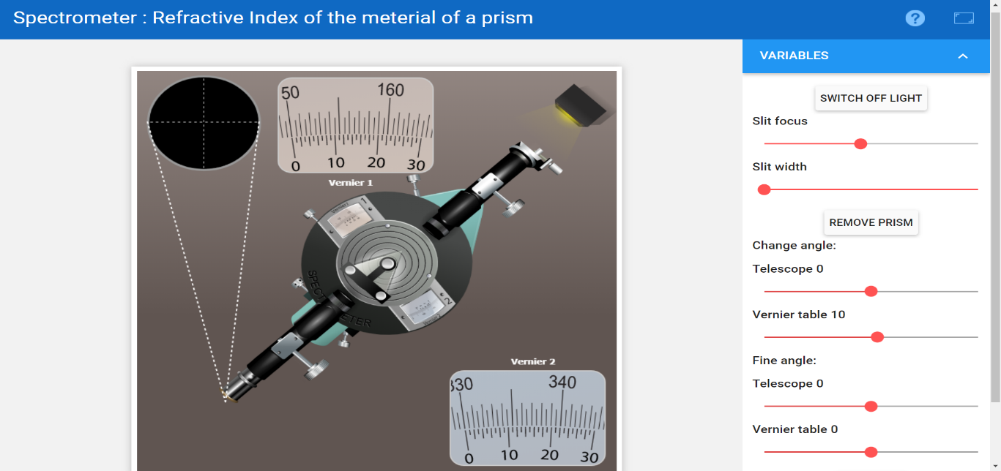*Snapshots for determining the Angle of Prism* -:**

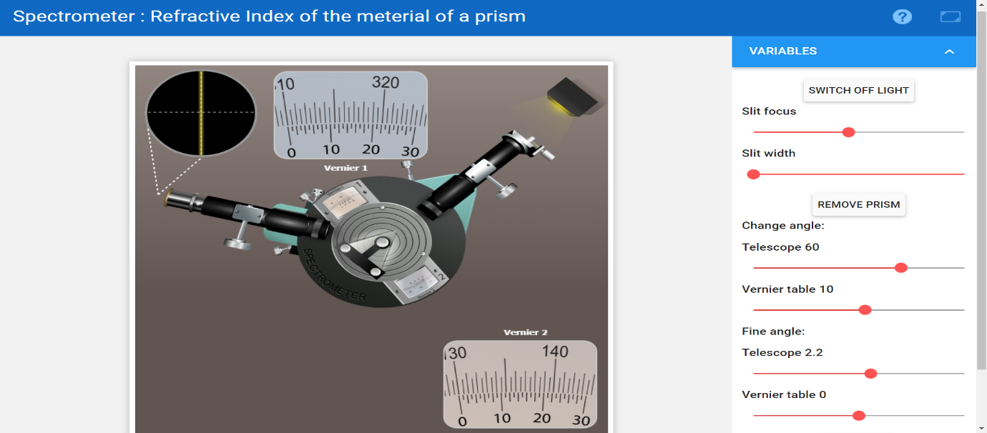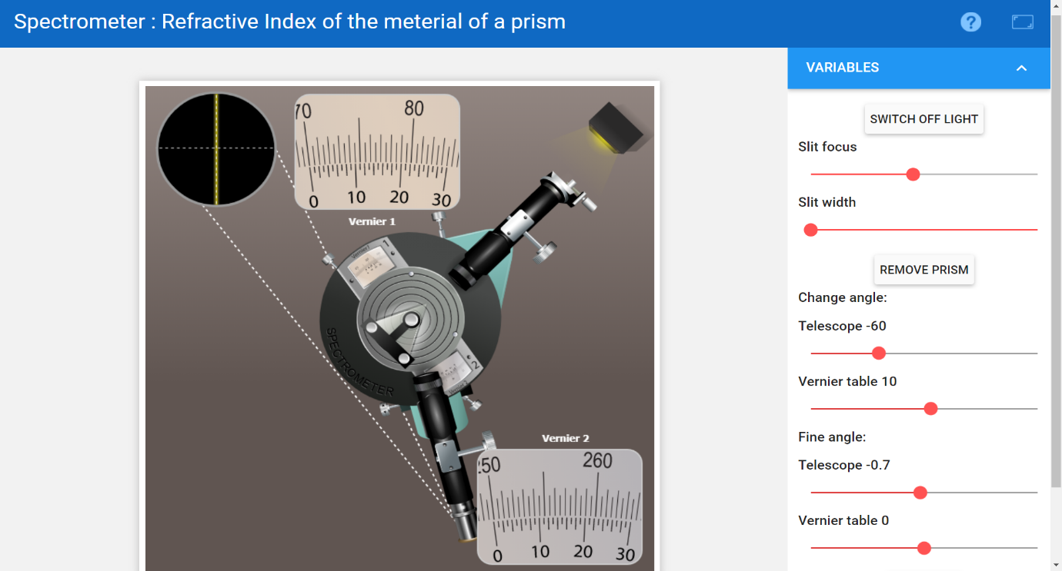

|  |  |  |  |  |  |  |  |
| --- | --- | --- | --- | --- | --- | --- | --- |
| ***Reading Reflected Ray From*** | | ***Vernier Scale 1*** | | | ***Vernier Scale 2*** | | |
|  | ***MSR*** | ***VSR*** | ***Total*** | ***MSR*** | ***VSR*** | ***Total*** |
| Face 1 | 310 | 10 |  | 129.5 | 9 |  |
| Face 2 | 70 | 10 |  | 249.5 | 9 |  |
| Difference between face 1 and 2 |  | |  |  | |  |

Therefore,

Hence, the Angle of Prism i.e A = .

**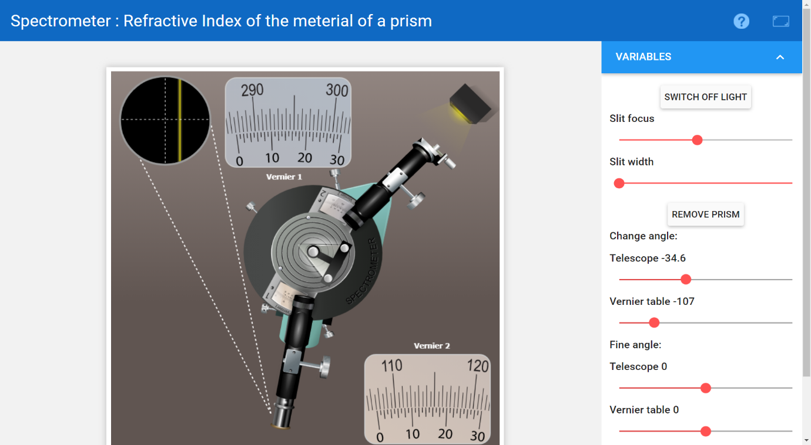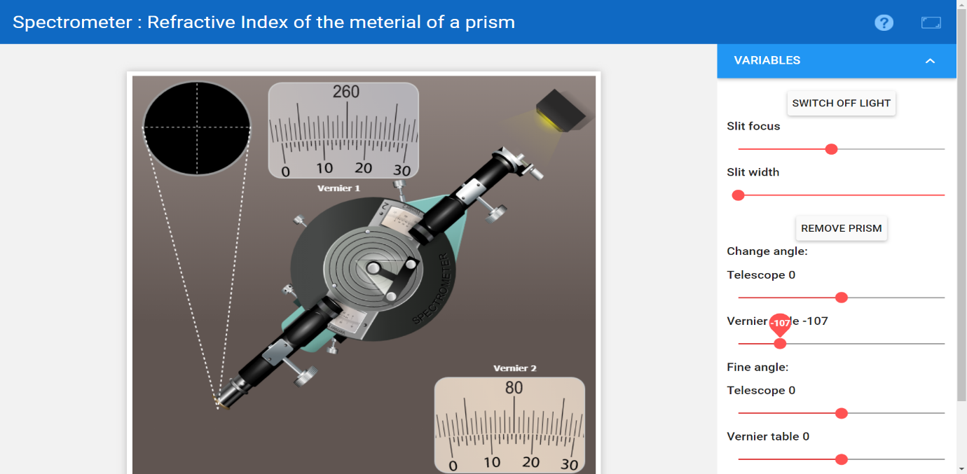*Snapshots for determining the Minimum Angle Of Deviation* -:**

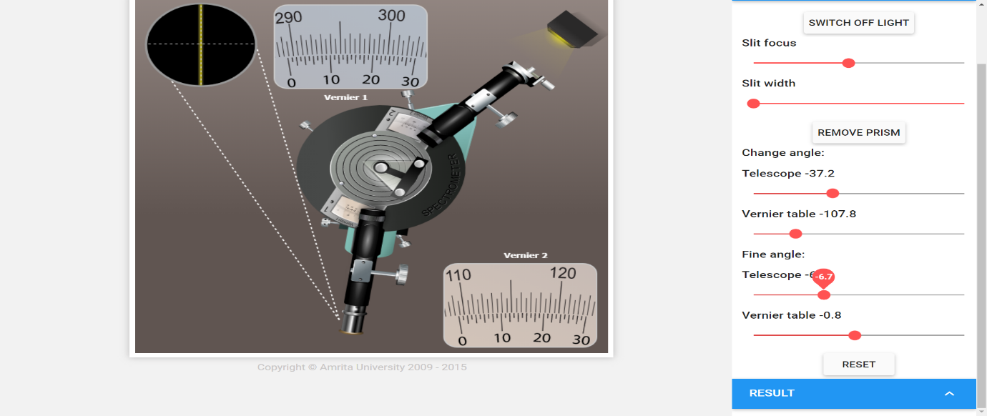

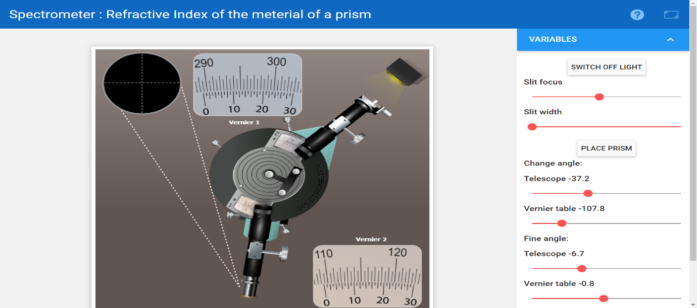

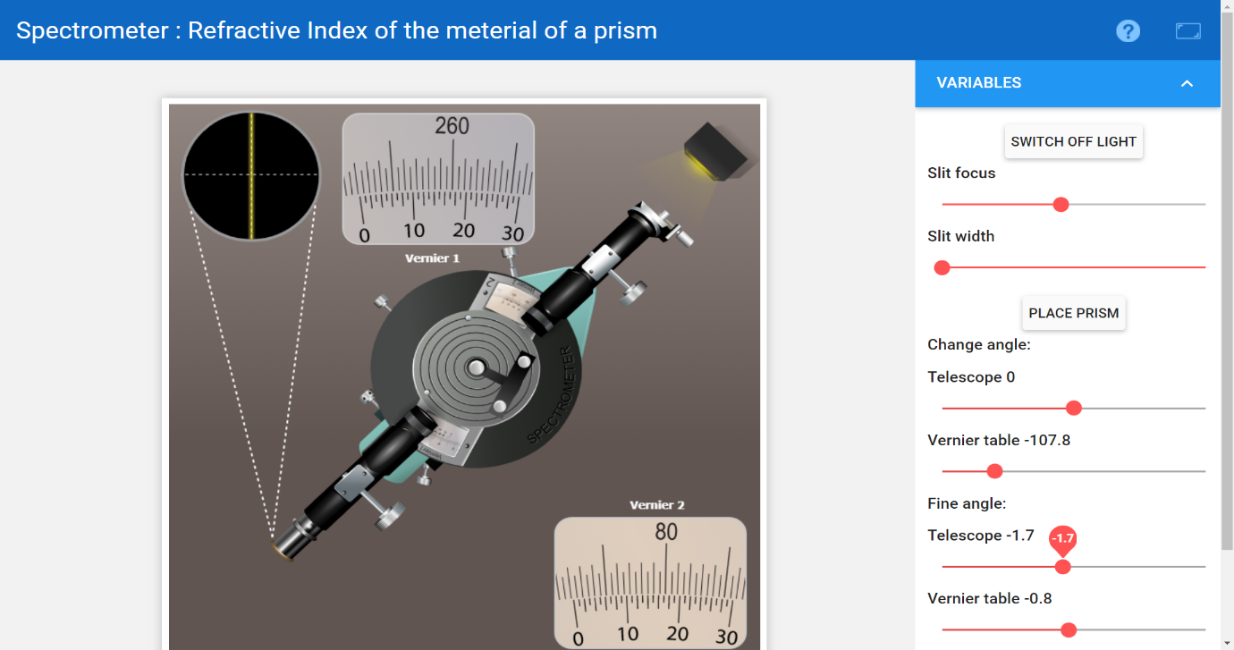

|  |  |  |  |  |
| --- | --- | --- | --- | --- |
|  | ***Vernier Scale 1*** | | ***Vernier Scale 2*** | |
| ***MSR*** | ***VSR*** | ***MSR*** | ***VSR*** |
| Emergent Ray |  |  |  |  |
| Direct Ray |  |  |  |  |
|  |  | |  | |

Therefore, the angle of minimum deviation of the prism is (average value from both the vernier scales).

Using the value of angle of minimum deviation, the refractive index of prism can be calculated.

***ERROR ANALYSIS*** **-:** Following errors may take place when performing the experiment in a real lab -:

* The vernier scales may not be calibrated properly and hence this may induce zero error.
* The slit may not be focused on the cross wire.

The above mentioned errors did not occur in simulation. The error that is induced while performing the simulation of lab is because the least count of vernier scale is 1’, i.e. it cannot calculate more precisely than 1’.

***coNCLUsION* -:** Performing the experiment in the simulator led us to draw following conclusions -:

* The angle of prism used in the simulator comes out to be .
* The minimum angle of deviation of the prism is approximately .
* The refractive index of the prism is calculated to be equal to 1.486.