***Objective* -:** (i) To study and understand the Millikan’s Oil Drop Experiment and determine the charge of at least 10 droplets using the experiment simulator. After finding these values of charges, observe if these values have some pattern, or are they random.

(ii) Relate the electrostatic force magnitude to the charges and the distance between them.

(iii) Explain Newton's third law for electrostatic forces.

(iv) Use measurements to determine Coulomb’s constant.

(v) Determine what makes a force attractive or repulsive.

***Theory*** **-:** **Electric Charge** is the physical property of matter that causes it to experience a force when placed in an electromagnetic field. The excess or deficiency of electrons in a body as compared to the protons gives the concept of charge. There are two types of electric charge: ***positive***and ***negative***. Like charges repel each other and unlike charges attract each other. An object with an absence of net charge is referred to as **neutral**. The SI Unit of charge is **Coulomb.**

*Basic Properties of Electric Charge are given as follows*

* Charge is a scalar quantity.
* **Charge is transferable:** When a charged body is put in contact with an uncharged body, the uncharged body becomes charged due to transfer of electrons from one body to the other. If the charged body is positive it will draw some electrons from the uncharged body and if it is negative then it will transfer some of its excess electrons to the uncharged body.
* Charge cannot exist without mass though mass can exist without charge.
* **Charge is quantized:** When a physical quantity has only discrete values the quantity is said to be quantized. Millikan oil drop experiment established that the smallest charge that can exist in nature is the charge of an electron. If the charge of an electron (e = 1.6 × C) is taken as the elementary unit, i.e., quanta of charge, the charge on a body will be an integral multiple of e. i.e., q = ± ne with n = 1, 2, 3, 4…
* In an isolated system the total charge does not change with time, though individual charge may change. Charge can neither be created nor destroyed.

**Millikan’s Oil Drop Experiment**

The Oil-Drop Experiment, otherwise known as the Millikan Oil-Drop Experiment, is one of the most influential studies in the history of physical science.

Performed by Robert Millikan and Harvey Fletcher in 1911, the experiment was designed to determine the charge of a single electron, otherwise known as the elementary electric charge. Millikan designed his experiment to measure the force on oil droplets between two electrodes.

He used an atomizer to spray a mist of tiny oil droplets into a chamber, which included a hole. Some droplets would fall through this hole and into a chamber, where he measured their terminal velocity and calculated their mass. Millikan then exposed the droplets to X-rays, which ionized molecules in the air and caused electrons to attach to the oil droplets, thus making them charged. The top and bottom of the chamber were attached to a battery, and the potential difference between the top and bottom produced an electric field that acted on the charged oil drops.

Adjusting the voltage perfectly, Millikan was able to balance the force of gravity (which was exerted downward) with the force of the electric field on the charged particles (which was exerted upward),

causing the oil droplets to be suspended in mid-air. A visual representation of the experiment can be seen in the figure:



Millikan then calculated the charge on particles suspended in mid-air. His assumptions were that the force of gravity, which is the product of mass (m) and gravitational acceleration (g), was equal to the force of the electric field (the product of the charge (q) and the electric field (E)). Although the charge of each droplet was unknown, Millikan adjusted the strength of the X-rays ionizing the air and measured many values of (q) from many different oil droplets. In each instance, the charge measured was a multiple of 1.5924 ×C. Thus, it was concluded that the elementary electric charge was 1.5924 ×C.

The results were very accurate. The calculated value from the Oil-Drop Experiment differs by less than one percent of the current accepted value of 1.602176487 ×C. The Oil-Drop Experiment was tremendously influential at the time, not only for determining the charge of an electron, but for helping prove the existence of particles smaller than atoms.

**Electric Charge and Electric Forces**

A charge at rest produces electric field around it. When another charge is placed in this field, it experiences a force due to the electric field of the first charge. Coulomb's law, or Coulomb's inverse-square law, is an experimental law of physics that quantifies the amount of force between two stationary, electrically charged particles. The electric force between charged bodies at rest is conventionally called electrostatic force or Coulomb force. The law states that the magnitude of the electrostatic force of attraction or repulsion between two point charges is directly proportional to the product of the magnitudes of charges and inversely proportional to the square 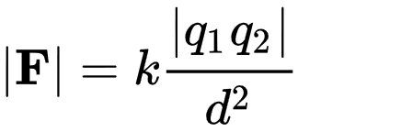of the distance between them, i.e.

Here, q1 and q2 are the signed magnitudes of the charges, and the scalar r is the distance between the charges. The force is along the straight line joining the two charges. The proportionality constant *k* is known as **Coulomb’s Constant**. Its value depends on the permittivity of the medium of the system in which the charges are placed. It is given by,

where Ɛ is the permittivity of the medium. The permittivity of free space (vacuum) is 8.85418782 × . For vacuum, the value of Coulomb’s Constant is approximately equal to 9 x N .

Electric force between two static charges has following properties -:

* Like charges repel each other; unlike charges attract. Thus, two negative charges repel one another, while a positive charge attracts a negative charge.
* The attraction or repulsion acts along the line between the two charges.
* It obeys **Newton’s Third Law of Motion** that is the electrostatic force exerted by two charges on each other is always equal in magnitude and opposite in direction.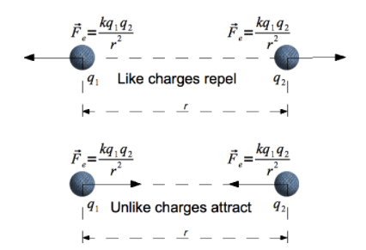

***Observations -:***

***Objective(i)***

The value of constant k and the distance between the plates is given in this simulator,

k = 4.086 x 10-17 and d = 5 cm = 0.05 m

***Procedure -:***

* Click on Run at the top left and notice the terminal velocity and pause the simulation.

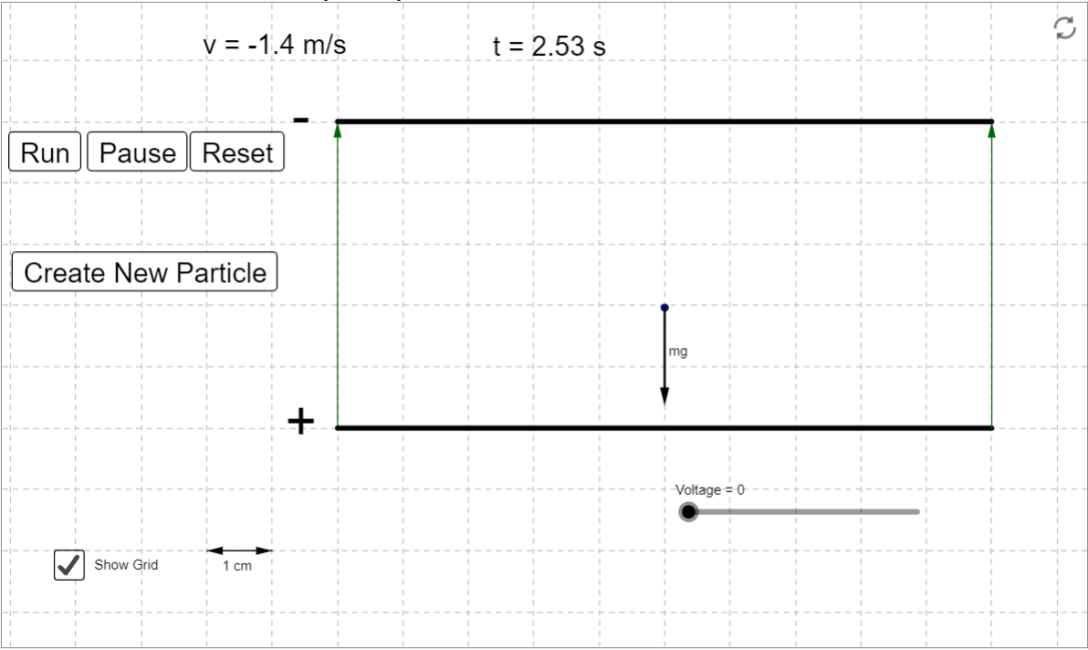

* Using the value of v, calculate mass using the equation,

m = 8.008 kg

* Vary the potential difference and find the minimum potential at which the velocity becomes zero.

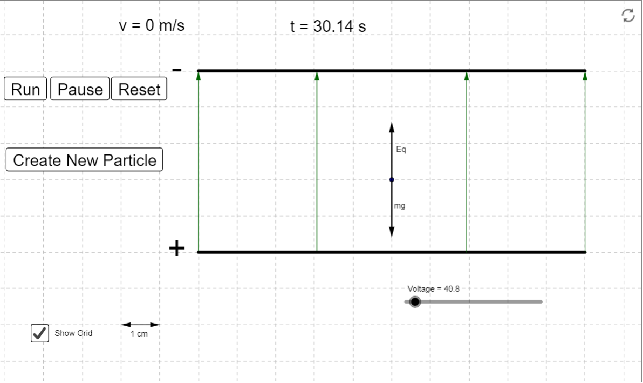

* Using this potential compute electric field strength E

E = V/d

E = 816 N/C

* Compute the charge on oil droplet using the equation

q =

q = 9.62 C

**Observation Table** -:

|  |  |  |  |  |  |  |
| --- | --- | --- | --- | --- | --- | --- |
| **Sr.No.** | **Terminal**  **Velocity**  **v**  **(m/s)** | **Mass of**  **Charge**  **m = k**  **(kg)** | **Voltage**  **for v=0**  **V**  **(volts)** | **Field**  **Strength**  **E = V/d**  **(N/C)** | **Charge**  **q =**  **(C)** | **n = q/E** |
| 1. | 1.4 | 8.008 | 40.8 | 816 | 9.62 | 5.99 |
| 2. | 1.202 | 5.903 | 25.8 | 516 | 11.21 | 6.98 |
| 3. | 1.391 | 7.906 | 26.9 | 538 | 14.40 | 8.97 |
| 4. | 1.31 | 7.012 | 42.9 | 858 | 8.01 | 4.99 |
| 5. | 1.161 | 5.508 | 56.2 | 1124 | 4.802 | 3.00 |
| 6. | 1.222 | 6.106 | 62.3 | 1246 | 4.8024 | 3.00 |
| 7. | 1.281 | 6.705 | 68.4 | 1368 | 4.803 | 2.99 |
| 8. | 1.382 | 7.084 | 24.0 | 478 | 14.46 | 9.003 |
| 9. | 1.242 | 6.303 | 193 | 3860 | 1.60 | 0.996 |
| 10. | 1.319 | 7.108 | 43.5 | 870 | 8.007 | 4.986 |

***Objective(ii)***

Fix the charges of both bodies and vary the distance between them. Then, observe the change in force.

**Snapshots of simulation:**

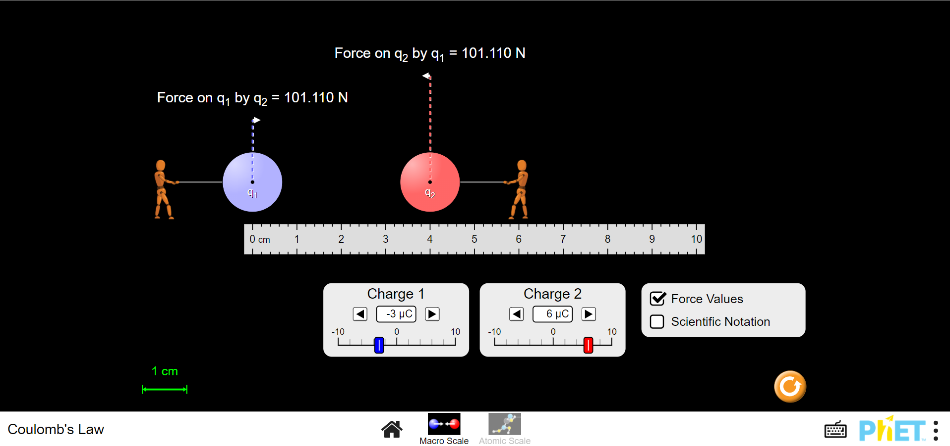

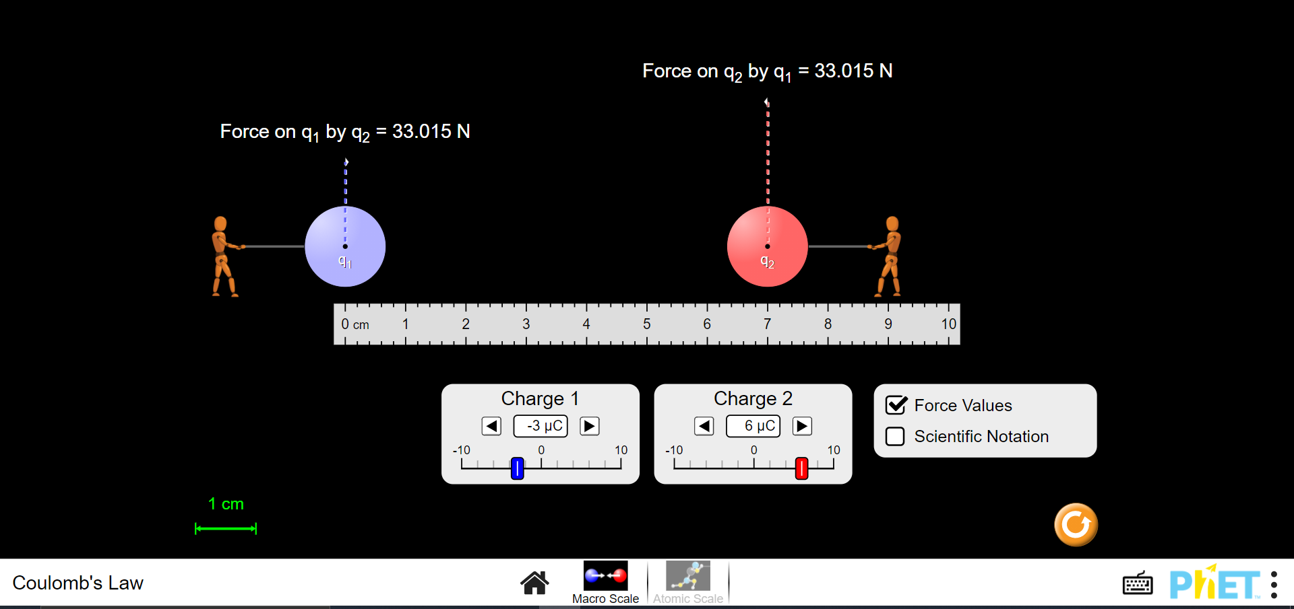

**Observation Table** -:

|  |  |  |  |  |
| --- | --- | --- | --- | --- |
| **S.No.** | **Charge on first body1 ()**  **(in µC)** | **Charge on first body2 ()**  **(in µC)** | **Distance**  **(r)**  **(in cm)** | **Force**  **(F)**  **(in N)** |
| **1.** | -3 | 6 | 4 | 101.110 |
| **2.** | -3 | 6 | 5 | 64.710 |
| **3.** | -3 | 6 | 6 | 44.938 |
| **4.** | -3 | 6 | 7 | 33.015 |
| **5.** | -3 | 6 | 8 | 25.277 |
| **6.** | -3 | 6 | 9 | 19.972 |
| **7.** | -3 | 6 | 10 | 16.178 |

**Graph of F vs r in SI units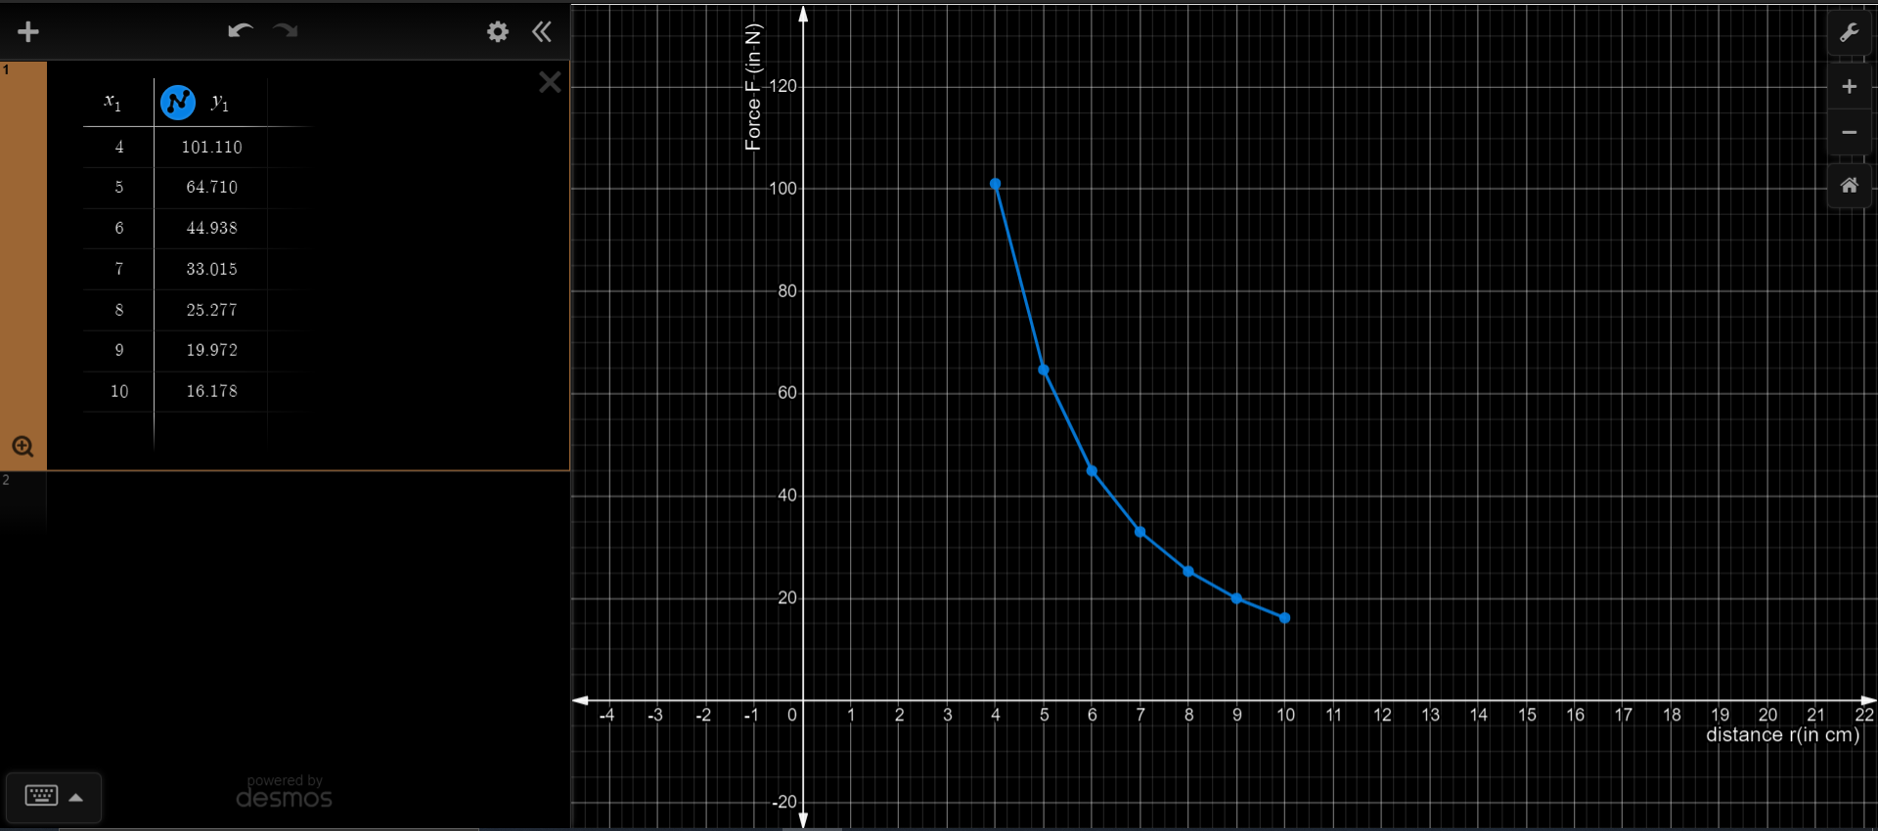:**

Fixing charge and distance between both charges and varying and observing the changes in F.

**Snapshots of simulation:**

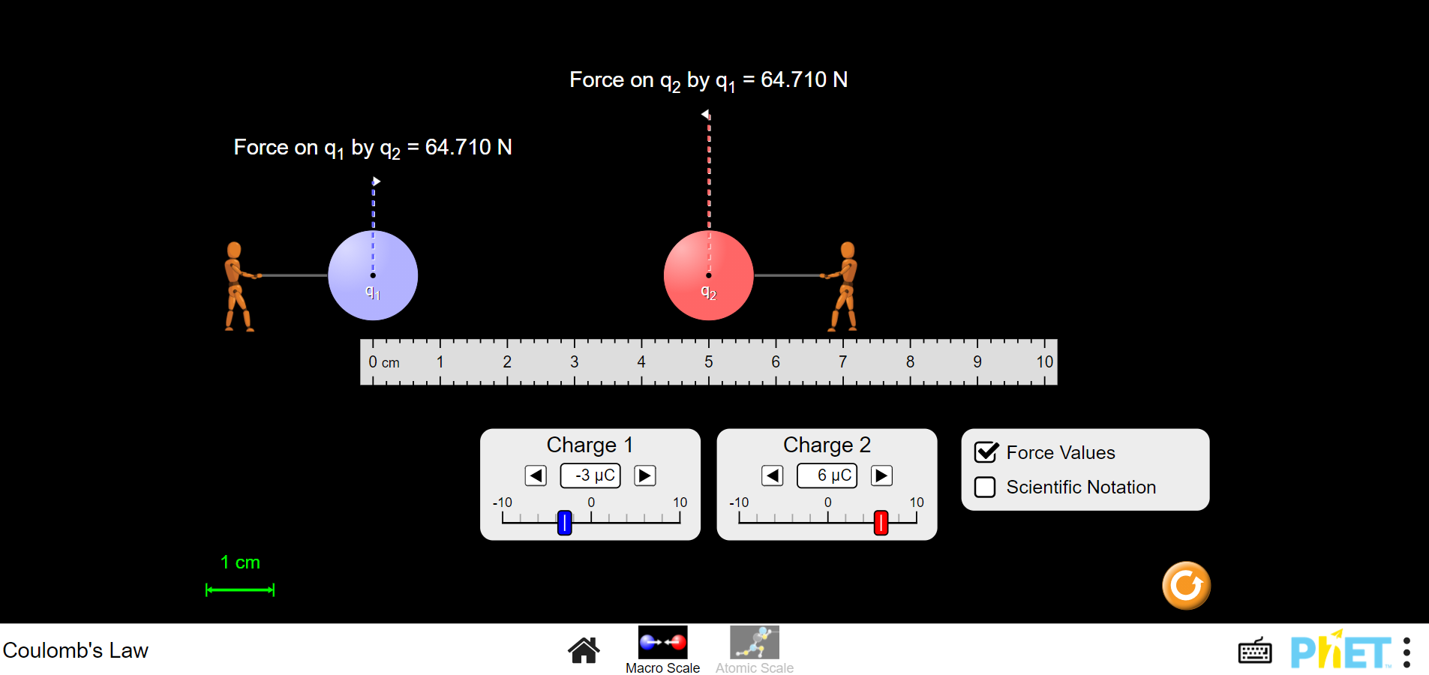

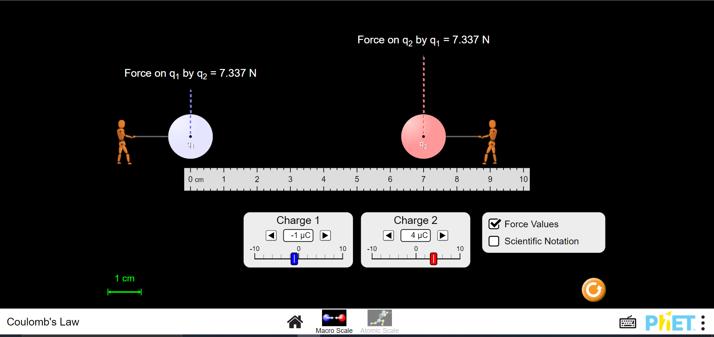

**Observation Table** -:

|  |  |  |  |  |
| --- | --- | --- | --- | --- |
| **S.No.** | **Charge on first body1 ()**  **(in µC)** | **Charge on first body2 ()**  **(in µC)** | **Distance**  **(r)**  **(in cm)** | **Force**  **(F)**  **(in N)** |
| **1.** | 2 | -9 | 5 | 64.710 |
| **2.** | 2 | -6 | 5 | 43.140 |
| **3.** | 2 | 1 | 5 | 7.190 |
| **4.** | 2 | 2 | 5 | 14.380 |
| **5.** | 2 | 5 | 5 | 35.950 |
| **6.** | 2 | 7 | 5 | 50.330 |
| **7.** | 2 | 8 | 5 | 57.520 |

**Graph of F (in N) vs (in µC) -:**

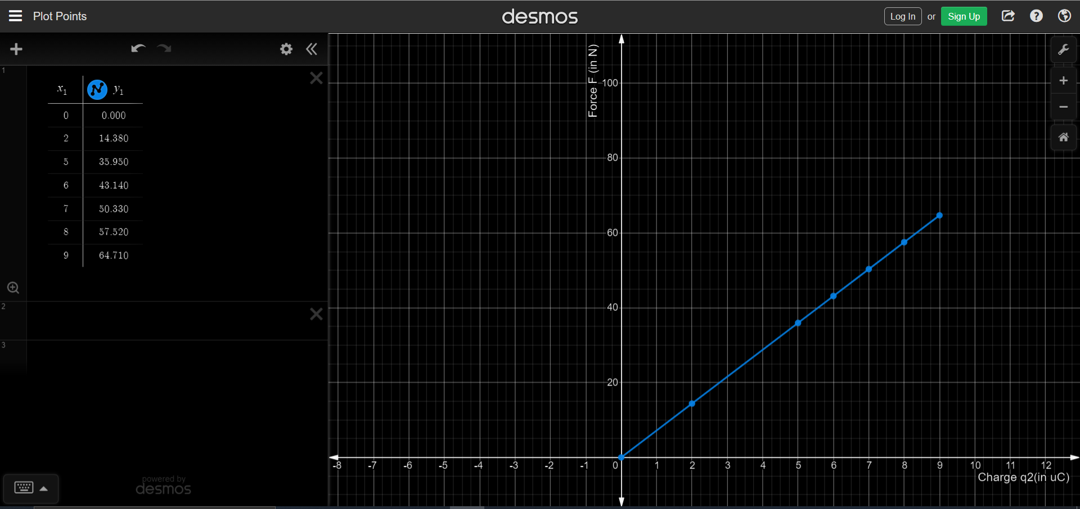

***Objective(iii)***

Let us consider the force between two charges  and − placed at a distance "r" apart. The magnitude of electrostatic force is given by:



The charge applies a force  on the charge  and charge  applies a force  on . The two forces are equal in magnitude, but opposite in direction such that:

The above can be observed from the simulation too.

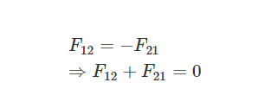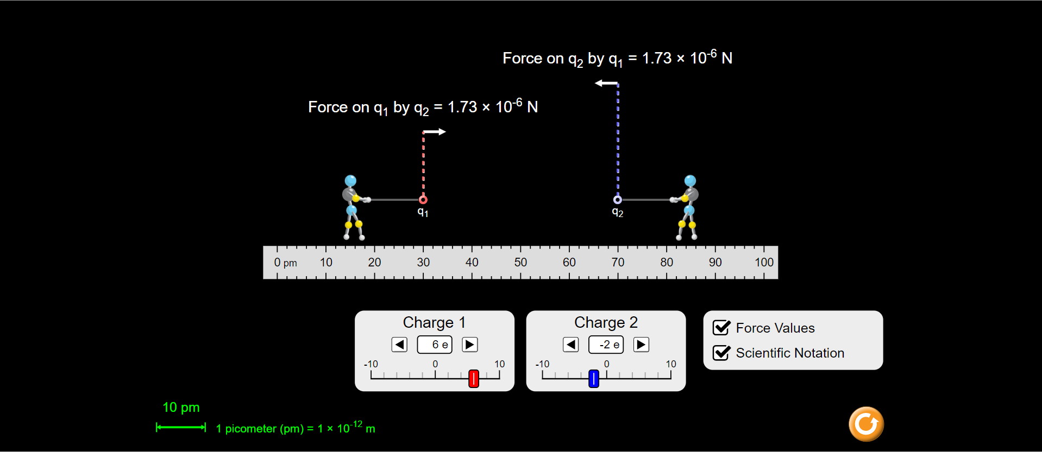It should be emphasized that though vector sum of two forces is zero, but this condition does not indicate a state of equilibrium. This is so because two forces, often called as action and reaction pair, are acting on different bodies. Equilibrium of a body, on the other hand, involves consideration of external forces on the particular body.

***Objective(iv)***

Calculating Coulomb’s constant k using set of observations.

**Calculation** -:

We know Coulomb’s Law States that:

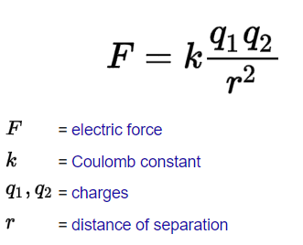Force F between two charges and at a separation r is given by formula

For a set of Observation,

= 2 µC and = 8 µC

r = 5 cm

F = 57.520N

k = 8.988 x

Using this formula to calculate the value of all k for all set of observations.

|  |  |  |  |  |  |
| --- | --- | --- | --- | --- | --- |
| **S.No.** | **Charge on first body1 ()**  **(in µC)** | **Charge on first body2 ()**  **(in µC)** | **Distance**  **(r)**  **(in cm)** | **Force**  **(F)**  **(in N)** | **Coulomb’s constant(k)**  **(in )** |
| **1.** | -3 | 6 | 4 | 101.110 | 8.988 |
| **2.** | -3 | 6 | 5 | 64.710 | 8.988 |
| **3.** | -3 | 6 | 6 | 44.938 | 8.988 |
| **4.** | -3 | 6 | 7 | 33.015 | 8.987 |
| **5.** | -3 | 6 | 8 | 25.277 | 8.987 |
| **6.** | -3 | 6 | 9 | 19.972 | 8.987 |
| **7.** | -3 | 6 | 10 | 16.178 | 8.988 |

***Objective(v)***

To determine what makes a force attractive or repulsive

1. When is negative and is positive

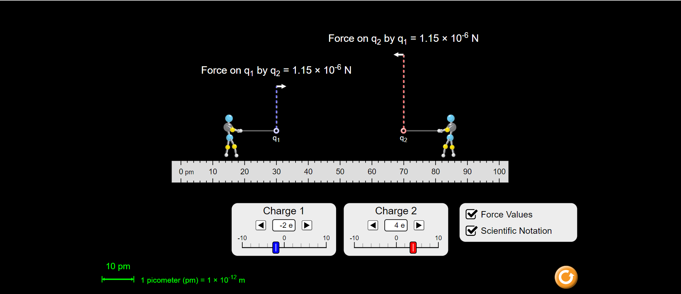

1. When is negative and is positive



1. When and both are positive

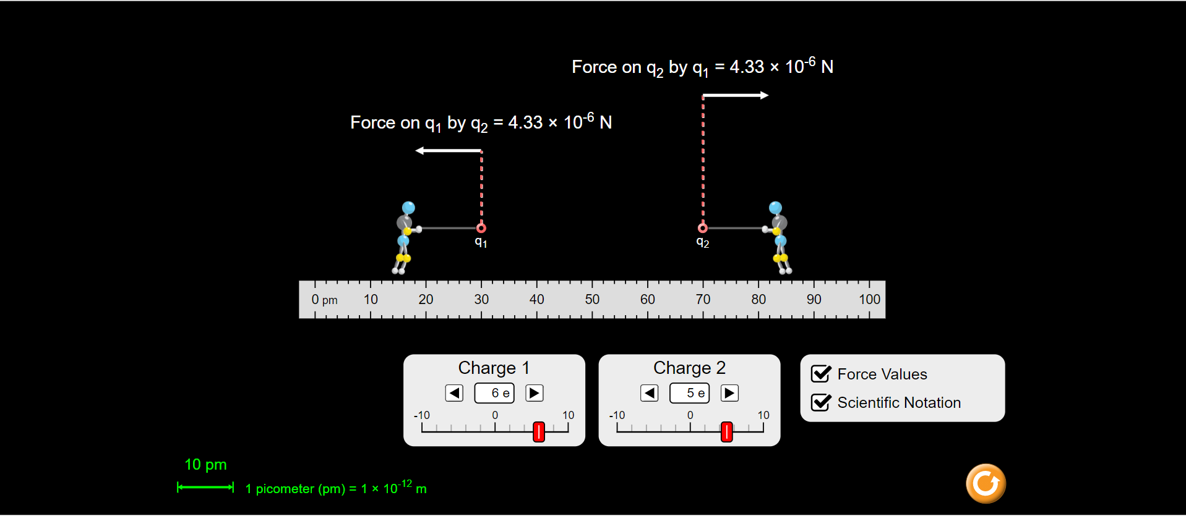

1. When and both are negative

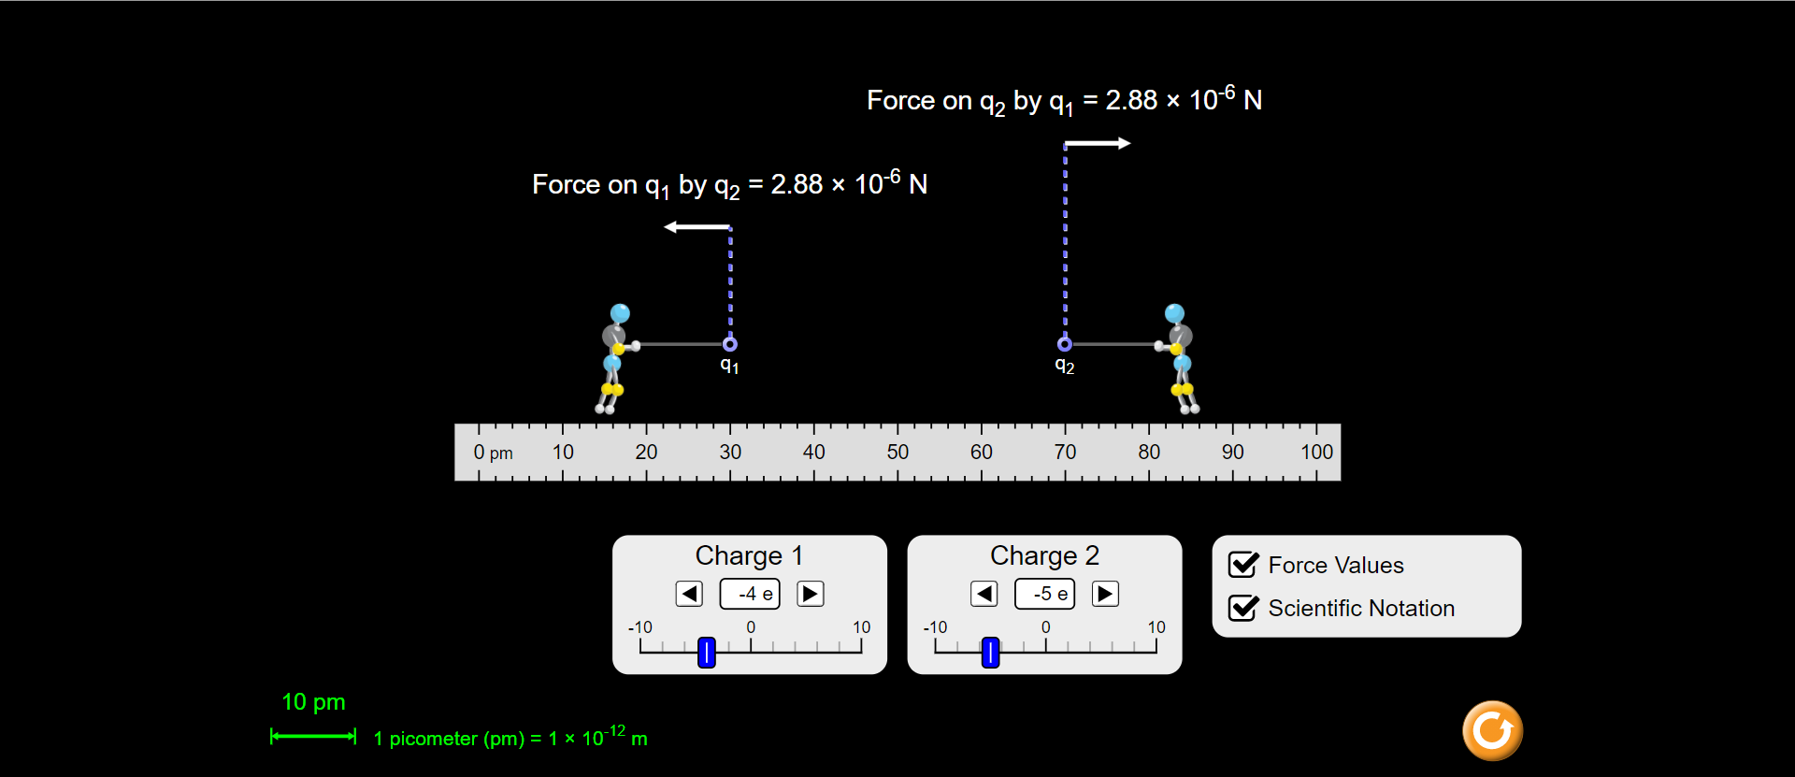

***Errors -:***

* In simulator of Objective 1, the velocity could not be made exactly 0 by varying the potential difference because the potential difference has a least count of 0.1 V. Hence, the value of potential is taken such that the change in velocity is slowest when v = 0. This induces some errors in calculation.
* **Calculation of Error Percentage in Objective (iv):**

= 8.988 x

The standard deviation d,

Therefore,

and percentage error,

Here, the percentage error obtained in the calculation of Coulomb’s constant k is 0.0137% which is in the acceptable range. This error is due to the value of Force obtained on the simulator but this cannot be reduced as it totally depends on the algorithm used in simulator. Had we performed this in Lab, there would have been many physical errors due to instruments and physical surroundings.

***Conclusion -:***

***Objective(i)***

* The charge on 10 oil droplets have been found using the Millikan’s Oil Drop Experiment. The important conclusion to be drawn is that the charge on each drop is an integral multiple of the charge on electron.
* This implies that charge can exist only in discrete steps, and it should always be an integral multiple of charge of an electron i.e. (e = 1.6 × C).
* Charge is quantized and the smallest charge that can exist is that of an electron.

**Note** -: Particles with charge e/3 and 2e/3 exist (known as quarks) but they are always found in pairs.

***Objective(ii)***

* The electrostatic force between two static charges is directly proportional to the product of magnitudes of both the charges and is inversely proportional to the square of the distance between them.
* The force on a charge placed in a given electric field is directly proportional to the magnitude of the charge.

***Objective(iii)***

* The electrostatic force between two charges obeys Newton’s Third Law of Motion.
* The electrostatic force between two charges on each other is equal in magnitude and opposite in direction.

***Objective(iv)***

* The value of Coulomb’s Constant in free space came out to be .

***Objective(v)***

* When the two charges are of similar type, the electrostatic force is repulsive.
* When the two charges are of different types, the electrostatic force is attractive.
* Like charges repel each other and unlike charges attract each other.