***Objective* -:** (i) Determine the relationship between charge and voltage for a capacitor.  
(ii) Determine the energy stored in a capacitor or a set of capacitors in a circuit.  
(iii) Explore the effect of space and dielectric materials inserted between the conductors of the capacitor in a circuit.

(iv) Determine the equivalent capacitance of a set of capacitors in series and in parallel in a circuit.

***Theory*** **-:** A **capacitor** is a device that stores electrical energy in an electric field. It is a passive electric component with two terminals. The effect of a capacitor is known as **capacitance**. The SI unit of capacitance is **Farad**.

***Constructing a Capacitor***

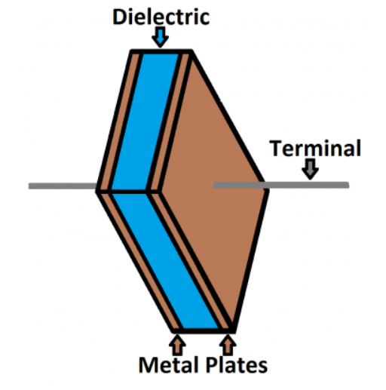A capacitor is created out of two metal plates and an insulating material called a dielectric. The metal plates are placed very close to each other, in parallel, but the dielectric sits between them to make sure they don't touch.

The dielectric can be made out of all sorts of insulating materials: paper, glass, rubber, ceramic, plastic, or anything that will impede the flow of current.

The plates are made of a conductive material: aluminium, tantalum, silver, or other metals. They're each connected to a terminal wire, which is what eventually connects to the rest of the circuit.

***Working of a Capacitor***

When current flows into a capacitor, the charges get stuck on the plates because they can't get past the insulating dielectric. Electrons are sucked into one of the plates, and it becomes overall negatively charged. The large mass of negative charges on one plate pushes away like charges on the other plate, making it positively charged.

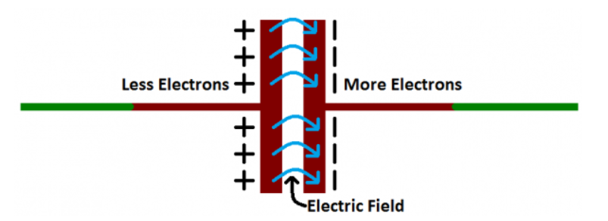

The positive and negative charges on each of these plates attract each other but with the dielectric sitting between them, as much as they want to come together, the charges will forever be stuck on the plate (until they have somewhere else to go). The stationary charges on these plates create an electric field, which influence electric potential energy and voltage. When charges group together on a capacitor like this, the cap is storing electric energy just as a battery might store chemical energy.

***Factors affecting capacitance of a capacitor***

* the shape of the conducting plate(s)
* the size of the conducting plate(s) (precisely surface area)
* the distance between the plates of capacitor
* the dielectric material between them

***Relationship between charge and voltage for a Capacitor***

A capacitor's capacitance tells us the amount of charge it can store. The amount of charge a capacitor is currently storing depends on the potential difference (voltage) between its plates. This relationship between charge, capacitance, and voltage can be modelled with this equation:

Q = CV

*Charge (Q) stored in a capacitor is the product of its capacitance (C) and the voltage (V) applied to it.*

***Energy stored in a Capacitor***

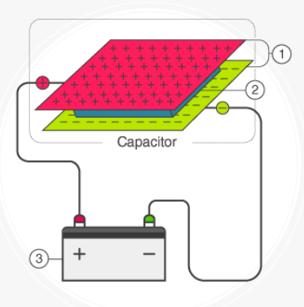The energy stored in a capacitor is nothing but the electric potential energy and is related to the voltage and charge on the capacitor. Consider the following circuit -:

If the capacitance of a conductor is C, then it is initially uncharged and it acquires a potential difference V when connected to a battery. If Q is the charge on the plate at that time, then

Q = CV

The work done is equal to the product of the potential and charge. Hence,

W = QV

If the battery delivers a small amount of charge dQ at a constant potential V, then the work done is

Now, the total work done in delivering a charge of an amount Q to the capacitor is given by

Therefore, the energy stored in a capacitor is given by,

U =

Substituting Q = CV in the equation above, we get

***Capacitance of a Capacitor with a dielectric material of dielectric constant k between the plates***

The electric field between the plates of parallel plate capacitor is directly proportional to capacitance C of the capacitor. The strength of the electric field is reduced due to the presence of dielectric. If the total charge on the plates is kept constant, then the potential difference is reduced across the capacitor plates. In this way, dielectric increases the capacitance of the capacitor.

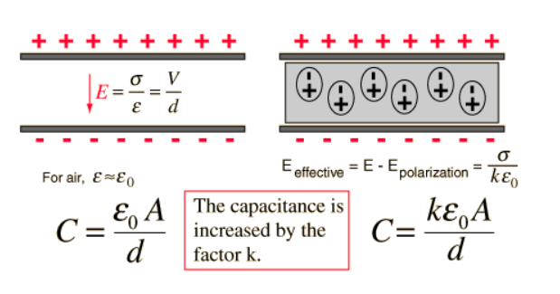

Since, the capacitance of parallel plate capacitor increased k times, the total energy stored in the capacitor also increases k times.

***Capacitors in Series and Parallel Combination***

1. *Capacitors in Series*

## Let the capacitance of each capacitor be​, ​ and and their equivalent capacitance be  ​

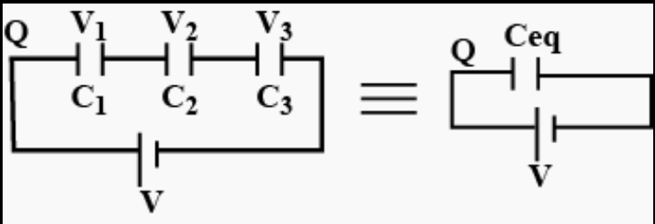

## As these capacitors are connected in series, thus charge across each capacitor is same as Q.

## When some electrical components are connected in series with each other, the potential difference of the battery V gets divided across each component as ​,  and ​ as shown in the figure.

## 

## V = ​+ ​+ ​

## 

In general, for series combination of n capacitors,

1. 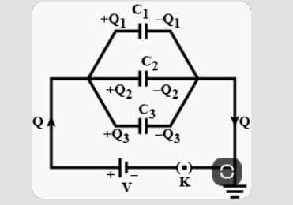*Capacitors in Parallel*

In the given figure, capacitors ​, ​ and ​ are connected in parallel. The same potential is applied across all the three capacitors. Let ​, ​ and ​ are charges on the three plates of capacitors such that,

​​

​​

​​

The total charge stored is Q = ​ + ​ + ​ and ​. Hence,

In general, if n capacitors are connected in parallel then,

***Observations -:***

***Objective(i)***

***Procedure -:*** Keeping the value of capacitance constant and varying the potential between the plates and observing the value of charge on plates.

*Snapshot of Simulator* -:

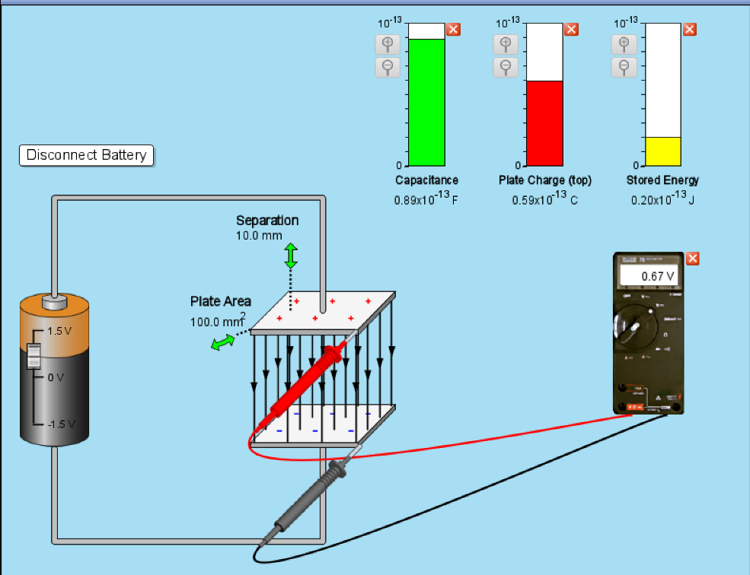

**Observation Table** -:

|  |  |  |  |
| --- | --- | --- | --- |
| **S.No.** | **Capacitance** | **Voltage**  **(volts)** | **Charge** |
| **1.** | 0.89 | 0.67 | 0.59 |
| **2.** | 0.89 | 1.035 | 0.92 |
| **3.** | 0.89 | 1.5 | 1.33 |
| **4.** | 0.89 | -0.418 | -0.37 |
| **5.** | 0.89 | -1.148 | -1.02 |

**Graph of V vs Q:**

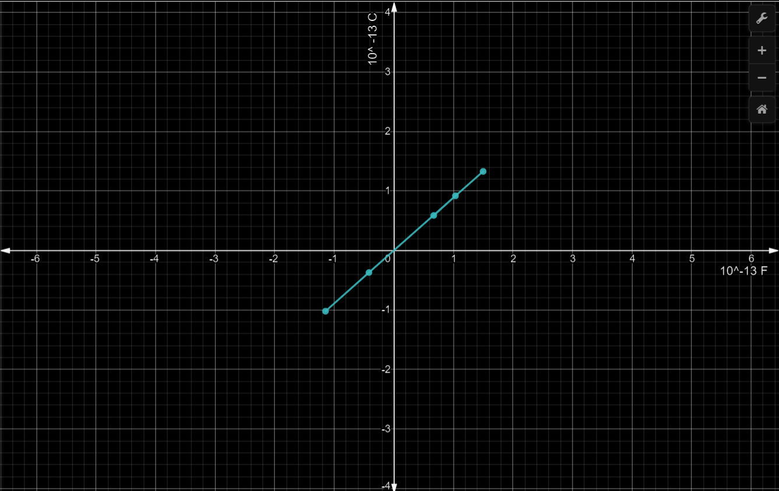

***Objective(ii)***

***Procedure -:*** Keeping the value of capacitance constant and varying the potential between the plates and observing energy stored in the capacitor.

*Snapshot of Simulator* -:

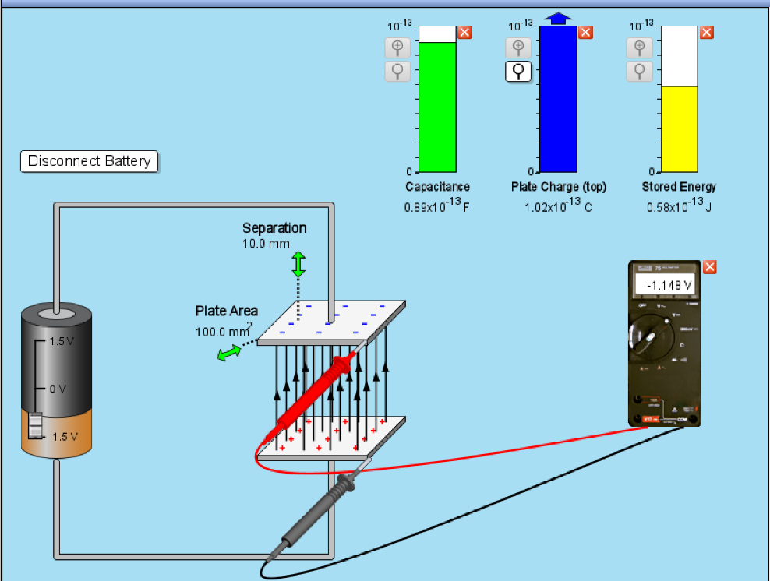

**Observation Table** -:

|  |  |  |  |
| --- | --- | --- | --- |
| **S.No.** | **Capacitance** | **Voltage**  **(volts)** | **Energy** |
| **1.** | 0.89 | 0.67 | 0.20 |
| **2.** | 0.89 | 1.035 | 0.45 |
| **3.** | 0.89 | 1.5 | 1.00 |
| **4.** | 0.89 | -0.418 | 0.08 |
| **5.** | 0.89 | -1.148 | 0.58 |

**Graph of V vs Energy:**

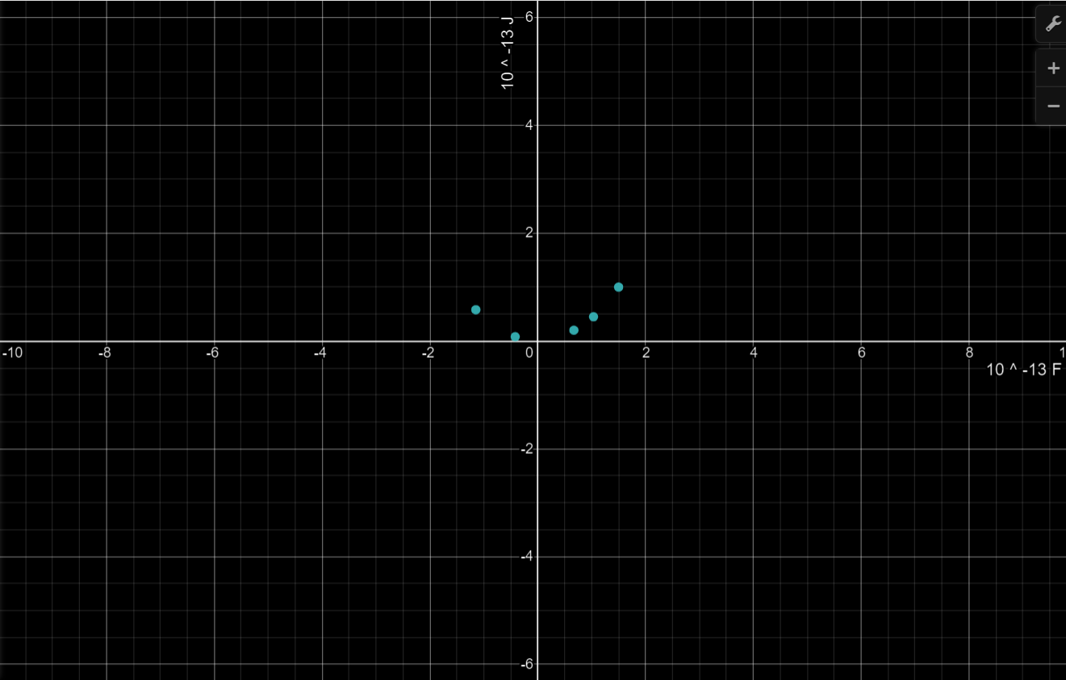

***Procedure -:*** Keeping the value of voltage constant and varying the capacitance and observing energy stored in the capacitor.

*Snapshot of Simulator* -:

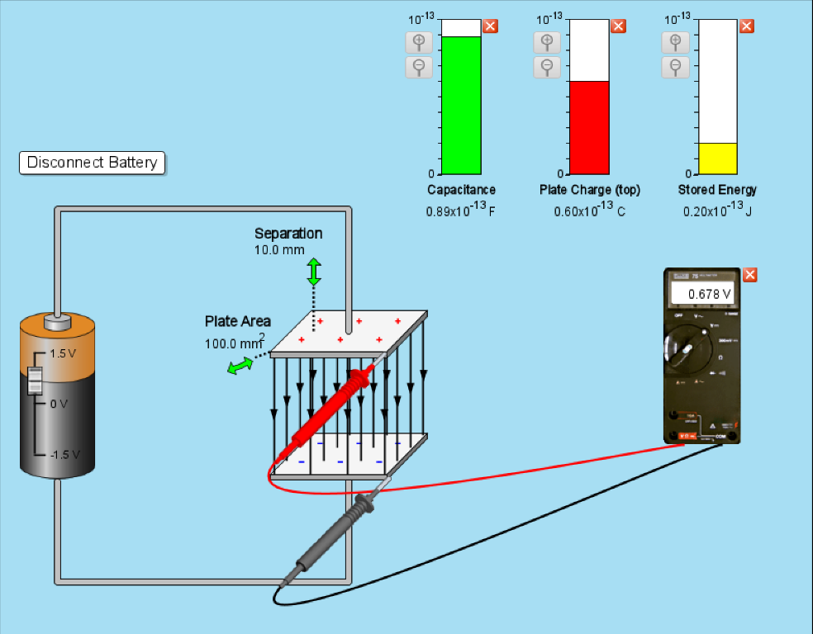

**Observation Table** -:

|  |  |  |  |
| --- | --- | --- | --- |
| **S.No.** | **Voltage**  **(volts)** | **Capacitance** | **Energy** |
| **1.** | 0.678 | 0.89 | 0.20 |
| **2.** | 0.678 | 1.96 | 0.45 |
| **3.** | 0.678 | 2.88 | 0.66 |
| **4.** | 0.678 | 5.48 | 1.26 |
| **5.** | 0.678 | 3.54 | 0.81 |

**Graph of C vs Energy:**

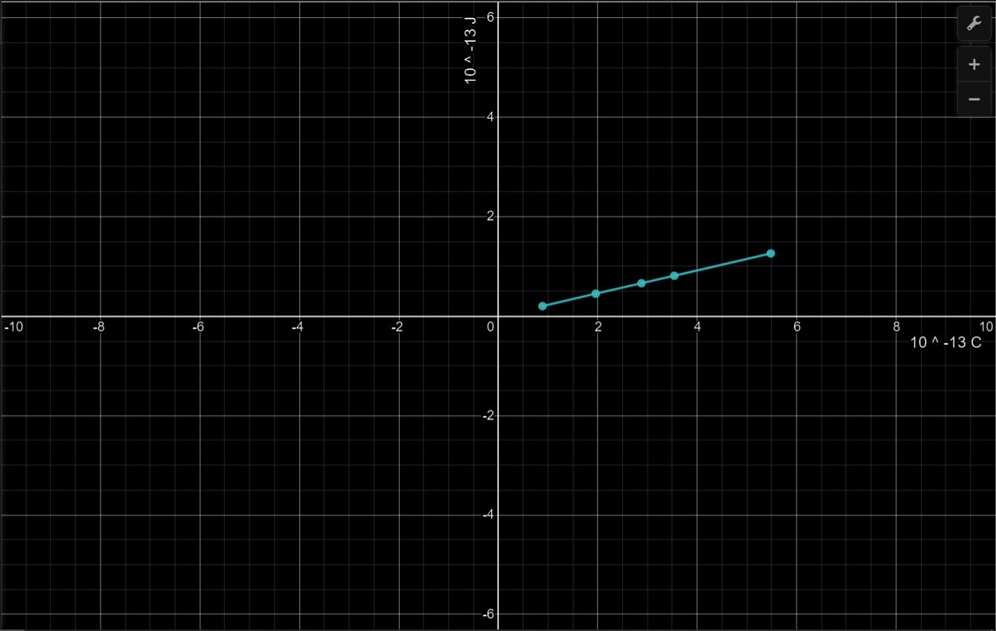

***Objective(iii)***

***Procedure -:*** Keeping the value of dielectric constant k and plate area constant in all observations and varying separation

*Snapshot of Simulator* -:

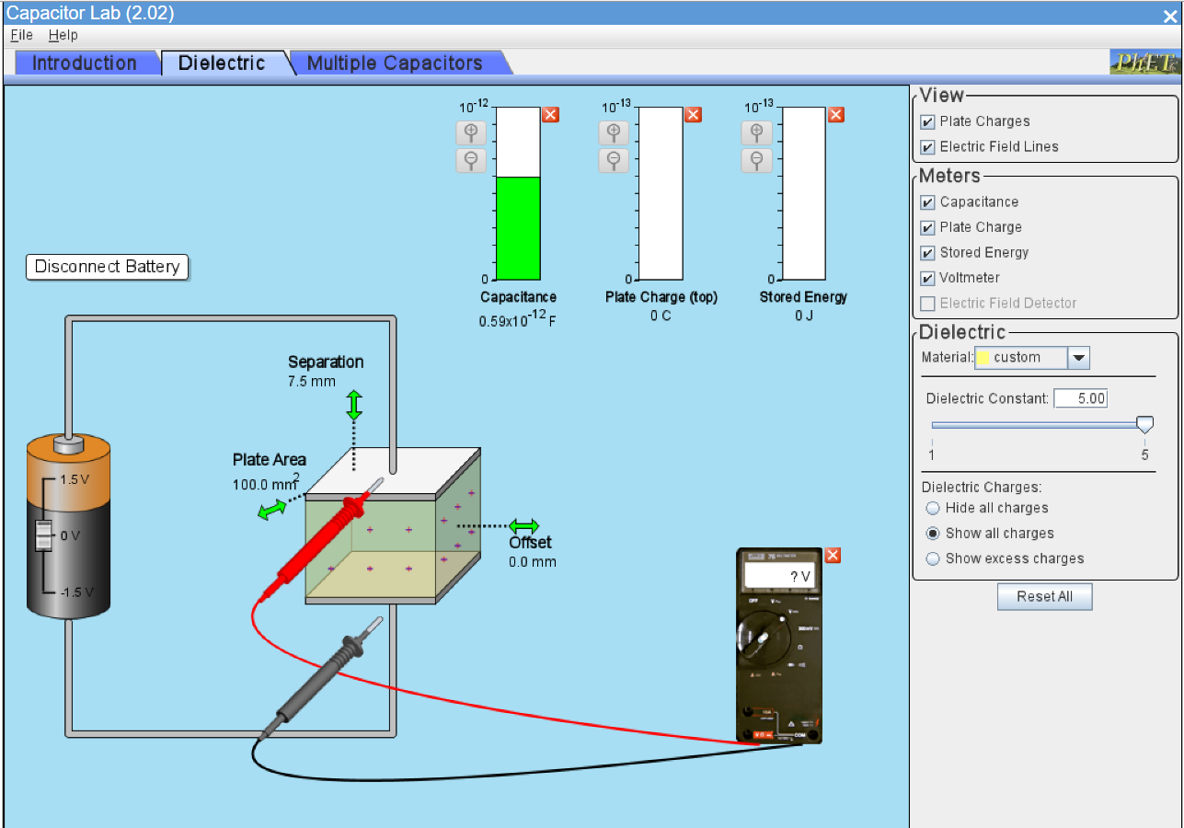

**Observation Table** -:

|  |  |  |  |  |
| --- | --- | --- | --- | --- |
| **S.No.** | **Dielectric Constant(k)** | **Area(A)**  **(in )** | **Separation(d)**  **(in mm)** | **Capacitance(C)**  **(in pF)** |
| 1. | 5 | 100.0 | 10.0 | 0.44 |
| 2. | 5 | 100.0 | 9.3 | 0.48 |
| 3. | 5 | 100.0 | 8.4 | 0.53 |
| 4. | 5 | 100.0 | 7.5 | 0.59 |
| 5. | 5 | 100.0 | 7.1 | 0.62 |

**Graph of C(in pF) vs d(in mm):**

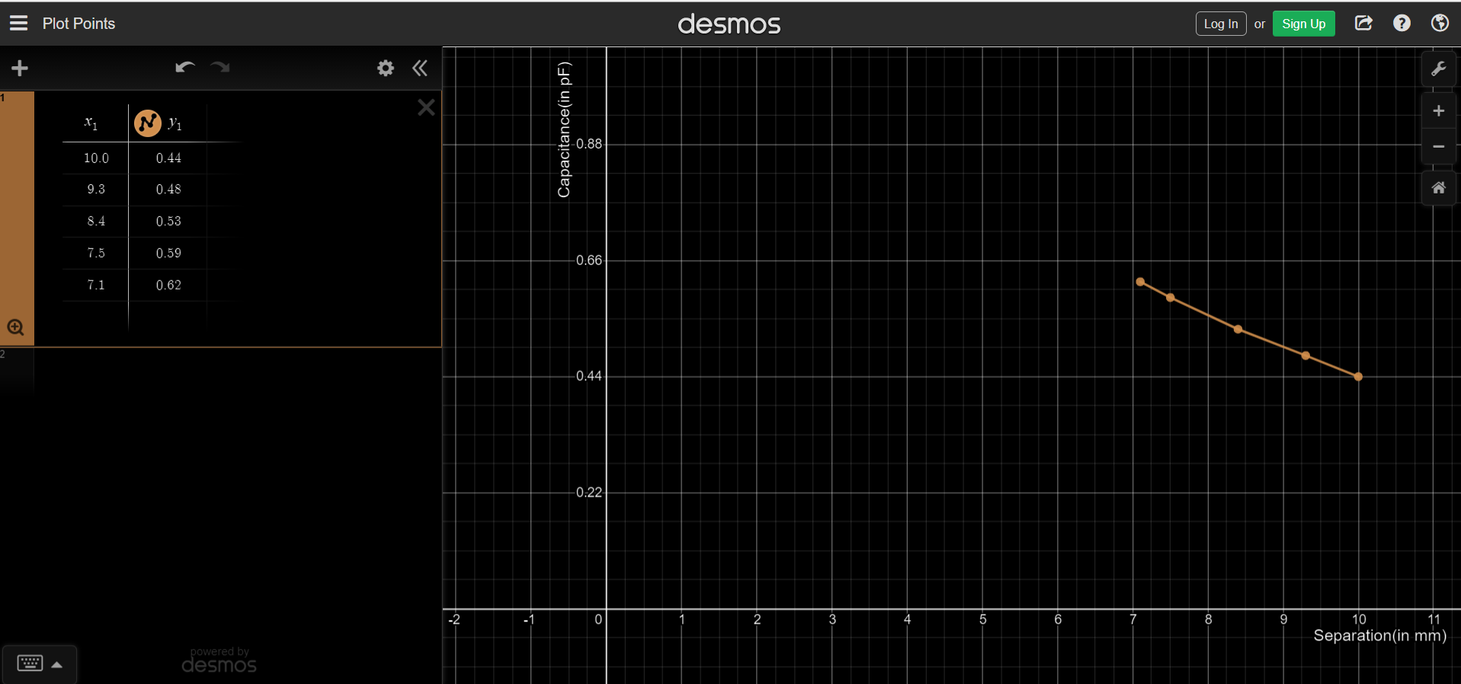

***Procedure -:*** Keeping the value of dielectric constant k and plate separation constant in all observations and varying plate area

*Snapshot of Simulator* -:

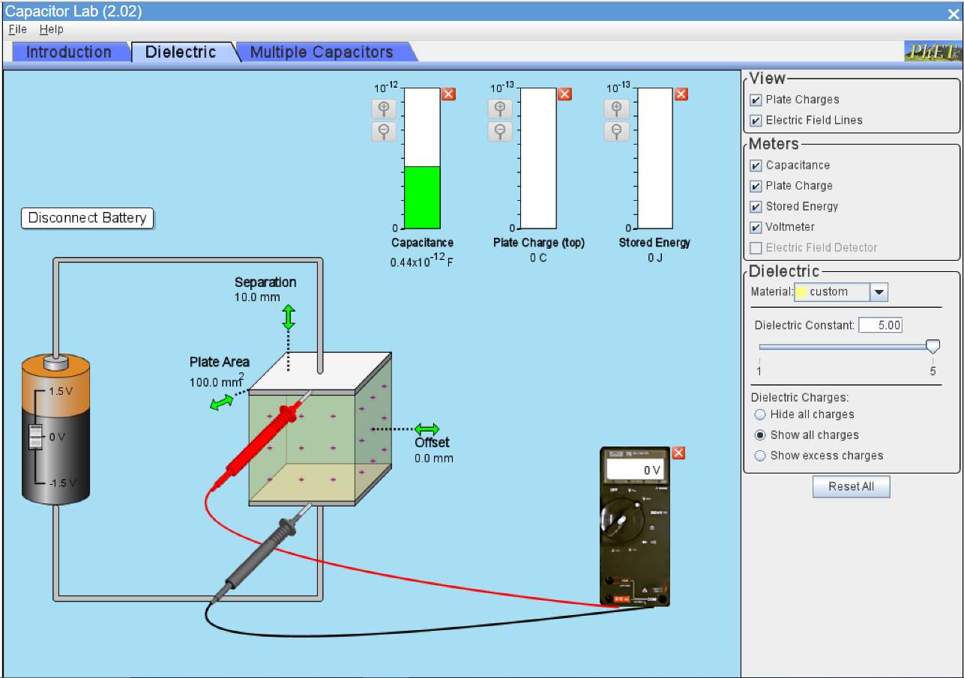

**Observation Table** -:

|  |  |  |  |  |
| --- | --- | --- | --- | --- |
| **S.No.** | **Dielectric Constant(k)** | **Area(A)**  **(in )** | **Separation(d)**  **(in mm)** | **Capacitance(C)**  **(in pF)** |
| 1. | 5 | 100.0 | 10.0 | 0.44 |
| 2. | 5 | 116.3 | 10.0 | 0.52 |
| 3. | 5 | 143.1 | 10.0 | 0.64 |
| 4. | 5 | 169.3 | 10.0 | 0.75 |
| 5. | 5 | 224.3 | 10.0 | 1.00 |

**Graph of C(in pF) vs A(in ):**

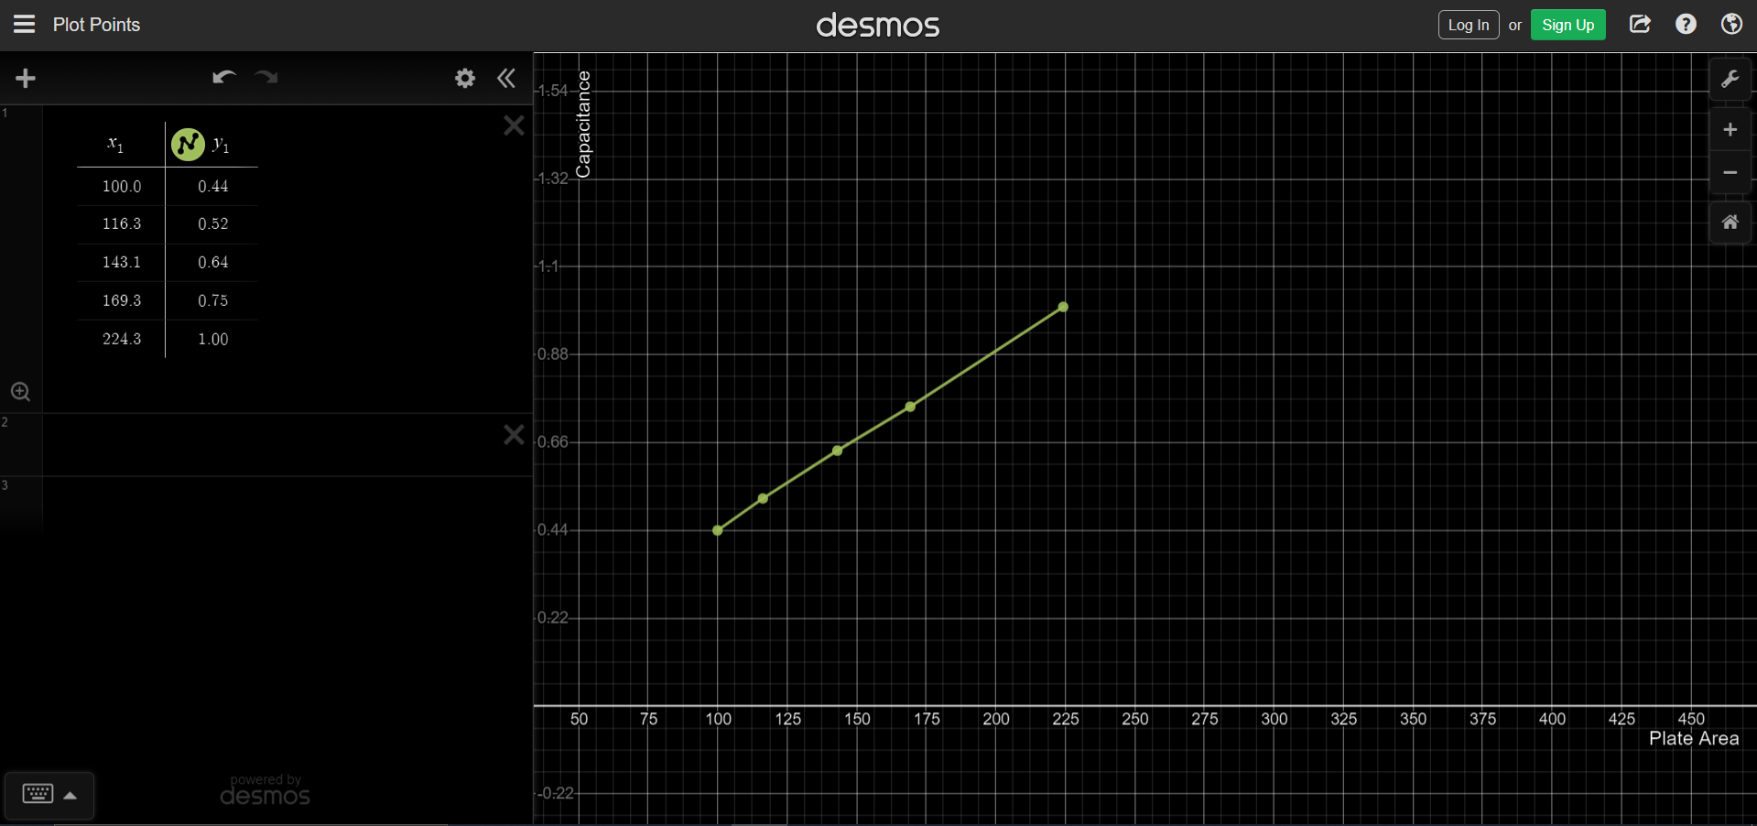

***Procedure -:*** Keeping the value of plate area A, separation between plates d constant and varying the value of dielectric constant k.

*Snapshot of Simulator* -:

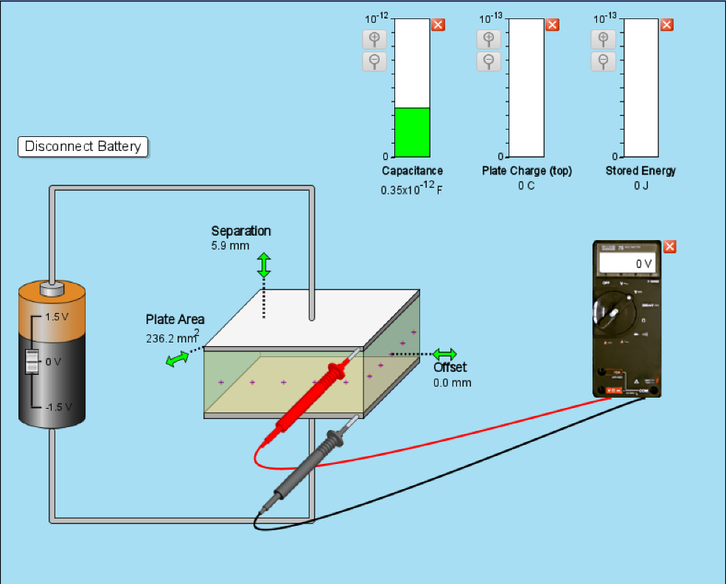

**Observation Table** -:

|  |  |  |
| --- | --- | --- |
| **S.No.** | **Dielectric**  **Constant**  **(k)** | **Capacitance**  **(p** |
| **1.** | 1 | 0.35 |
| **2.** | 2.01 | 0.71 |
| **3.** | 2.83 | 1.00 |
| **4.** | 3.84 | 1.36 |
| **5.** | 5 | 1.77 |

**Graph of k vs C:**

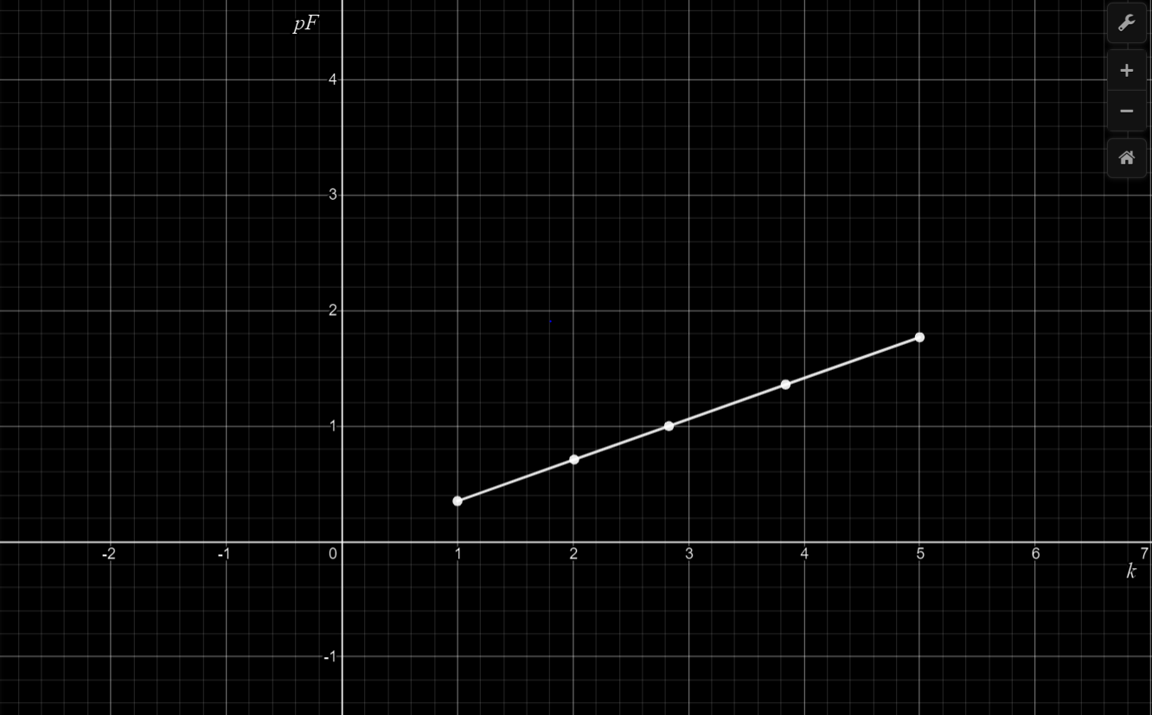

***Procedure -:*** Keeping the value of plate area A, separation between plates d and the voltage constant and varying the value of dielectric constant k.

*Snapshot of Simulator* -:

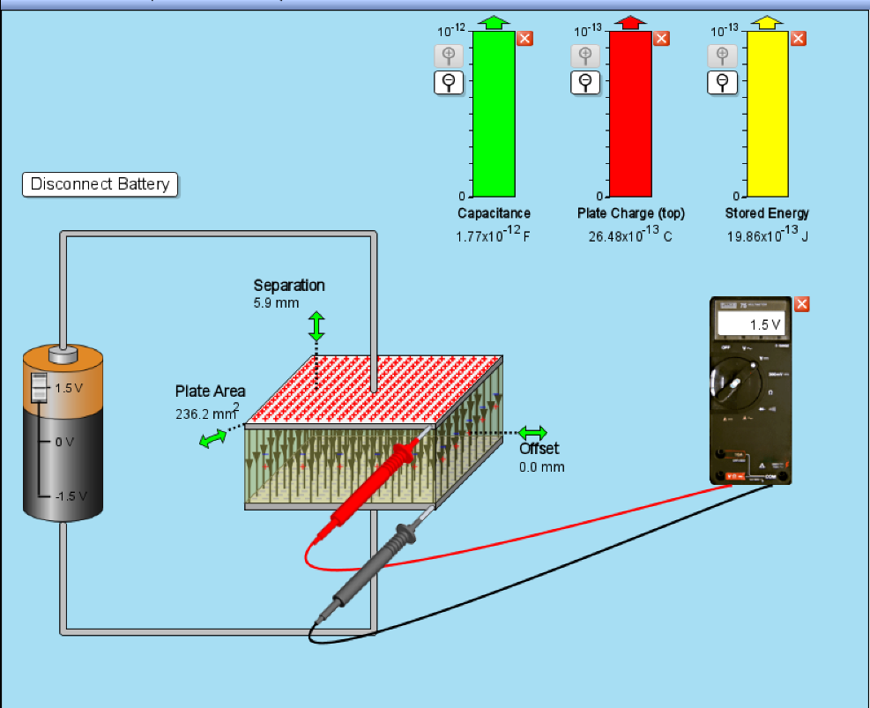

**Observation Table** -:

|  |  |  |
| --- | --- | --- |
| **S.No.** | **Dielectric**  **Constant**  **(k)** | **Energy** |
| **1.** | 1 | 3.97 |
| **2.** | 2.01 | 7.98 |
| **3.** | 2.83 | 11.24 |
| **4.** | 3.84 | 15.25 |
| **5.** | 5 | 19.86 |

**Graph of k vs E:**

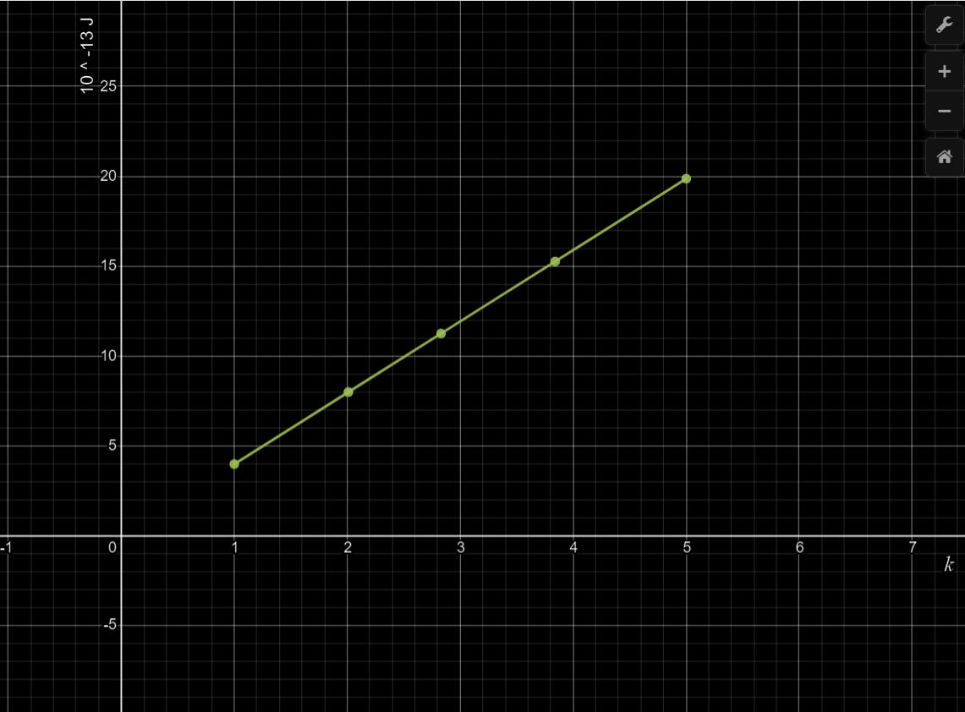

***Objective(iv)***

* Series Combination

Keeping the voltage constant and varying and observing the value of

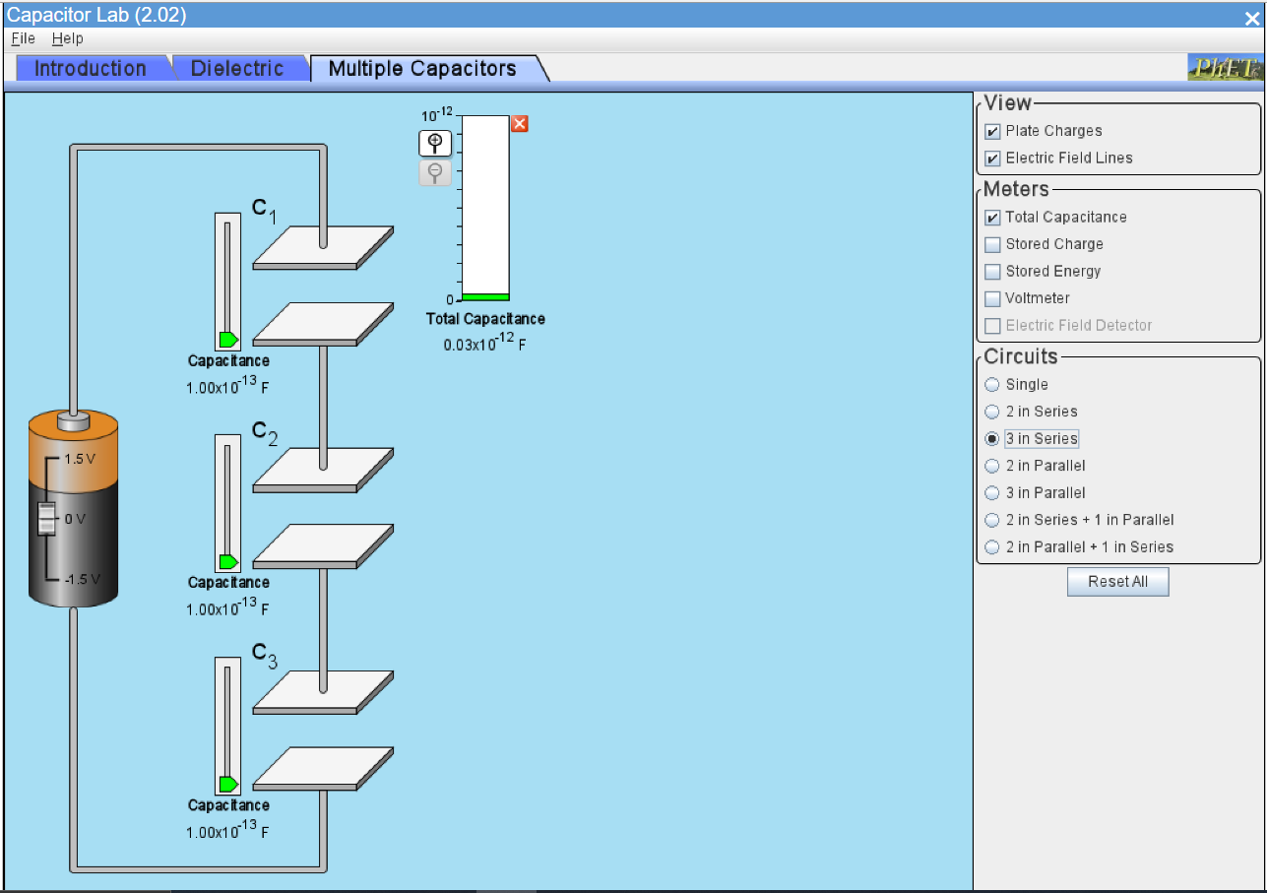

**Observation Table** -:

|  |  |  |  |  |
| --- | --- | --- | --- | --- |
| **Sr.No.** |  |  |  |  |
| **1.** | 1 | 1 | 1 | 0.33 |
| **2.** | 1 | 2.5 | 1 | 0.42 |
| **3.** | 1.4 | 1.5 | 1 | 0.42 |
| **4.** | 1.8 | 1.9 | 2.3 | 0.66 |
| **5.** | 1.2 | 1.4 | 1.6 | 0.46 |

Calculating using the formula,

is giving the same result.

* Parallel Combination

Keeping the voltage constant and varying and observing the value of

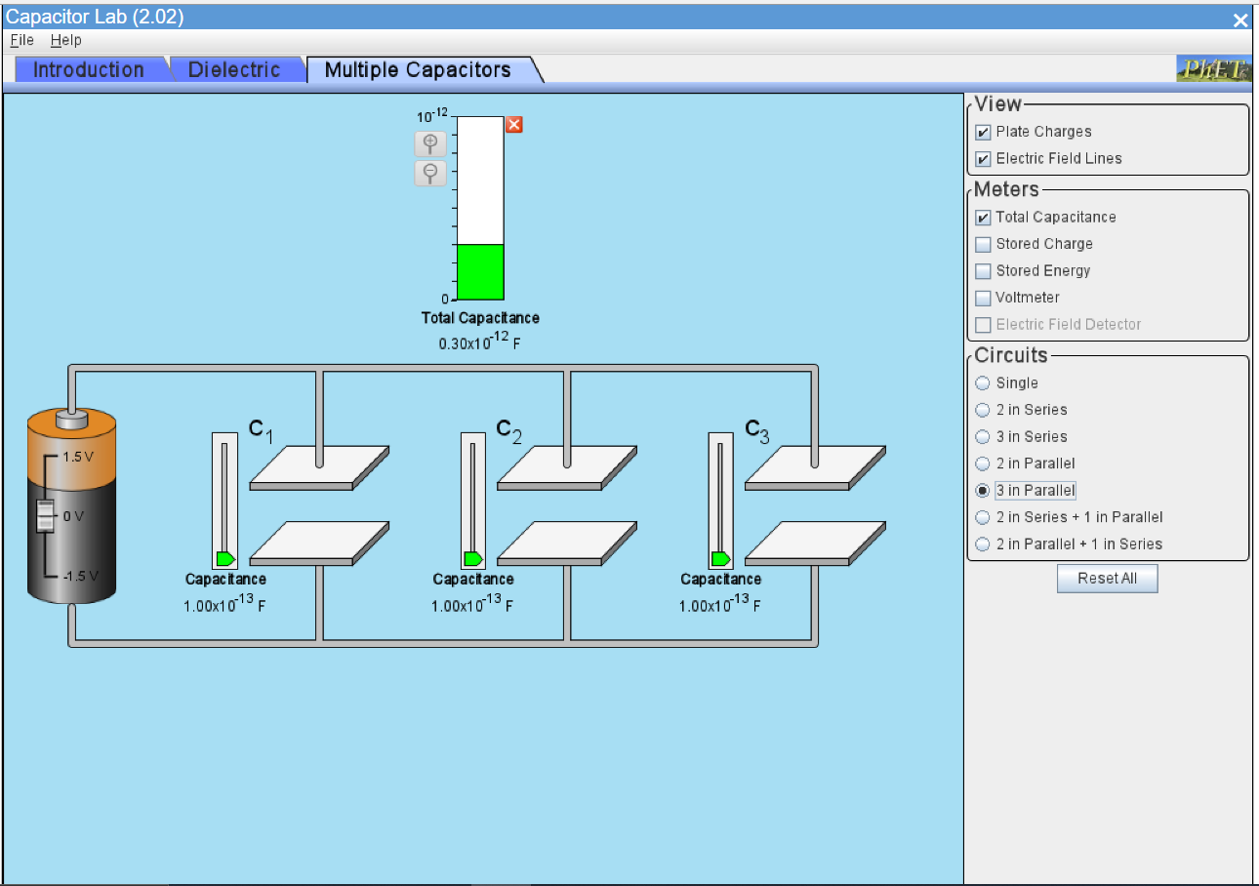

**Observation Table** -:

|  |  |  |  |  |
| --- | --- | --- | --- | --- |
| **Sr.No.** |  |  |  |  |
| **1.** | 1 | 1 | 1 | 3 |
| **2.** | 1.2 | 1.6 | 1.3 | 4.1 |
| **3.** | 2.4 | 2.2 | 1.7 | 6.3 |
| **4.** | 1.2 | 2.7 | 1.4 | 5.3 |
| **5.** | 1.6 | 1 | 1 | 3.6 |

Calculating using the formula,

is giving the same result.

***Errors -:***

Since the simulator does work on actual calculations, there is no significant error. However, there is some error induced when the values are calculated to more than 3 decimal places because the simulator provides values only up to 2 decimal places.

For example, in the series connection observation table entry 1,

the calculated equivalent capacitance is 0.3333 , while the observed equivalent capacitance is 0.33 . This induces an error of 0.0033, which is insignificant.

The percentage error in calculations taking this into account comes out to be 0.495%.

***Conclusions -:***

***Objective(i)***

* As we have observed, the graph between the charge on capacitor and voltage across capacitor is a straight line passing through origin, therefore, the charge stored on the capacitor is directly proportional with the voltage across it.

***Objective(ii)***

Using the simulator and observing the readings between the energy and capacitance and voltage across the capacitor, two graphs were drawn and following conclusions can be drawn from these graphs,

* Energy stored in a capacitor is directly proportional to the value of its capacitance.
* Energy stores in a capacitor is directly proportional to the square of voltage across it.
* Therefore, energy stored in a capacitor is equal to,

***Objective(iii)***

* The capacitance of a parallel plate capacitor is directly proportional to the plate area, inversely proportional to the plate separation and directly proportional to the dielectric constant of the dielectric material between its plate.

where is the permittivity of free space.

* When a dielectric material is inserted between the plates of a capacitor the strength of the dielectric field reduces, consequently its capacitance increases.
* The capacitance of a parallel-plate capacitor becomes k times on inserting a dielectric of dielectric constant k in between its plates. As energy is directly proportional to capacitance, the energy stored in the capacitor also increases k times.

***Objective(iv)***

* When the capacitors are connected in series connection, the charge on each capacitor is same.
* When the capacitors are connected in parallel connection, the voltage across each capacitor is same.
* If we connect n capacitors having capacitances in series connection, the equivalent capacitance is given by,

that is, the sum of reciprocals of individual capacitances is equal to the reciprocal of equivalent capacitance.

* If we connect n capacitors having capacitances in parallel connection, the equivalent capacitance is given by,

that is, the equivalent capacitance is the sum of all capacitances.