***Objective* -:** To determine the volume magnetic susceptibility of Manganese sulphate solution at different concentrations.

***Theory* -:** In electromagnetism, the magnetic susceptibility  is a proportionality constant which is dimensionless and indicates the degree of magnetization of a material in response to an applied magnetic field. Mathematically, we express it as

where M is the magnetization, H is the applied field and is the relative permeability of the material.

The magnetic susceptibility   is a proportionality constant which is dimensionless and indicates the degree of magnetization of a material in response to an applied magnetic field.

***Quincke’s Method -:***

The Quincke’s method is used to determine magnetic susceptibility of diamagnetic or paramagnetic substances in the form of a liquid or an aqueous solution. This method is based on the force experienced by a magnetized material in a non-uniform magnetic field. When an object is placed in a magnetic field, a magnetic moment is induced in it. Basically, magnetic susceptibility is a proportionality constant which is dimensionless and indicates the degree of magnetization of a material in response to applied magnetic field. A liquid sample in a narrow tube placed between the poles of a magnet experiences a force and hence when the field is turned on, the meniscus in the narrow tube rises by an amount h, relative to its zero-field position. A measurement of this rise helps to determine the susceptibility of the solution.

Here we are determining the susceptibility of  solution (which is paramagnetic) at different concentrations. The experimental set-up used for Quincke's method is shown below,

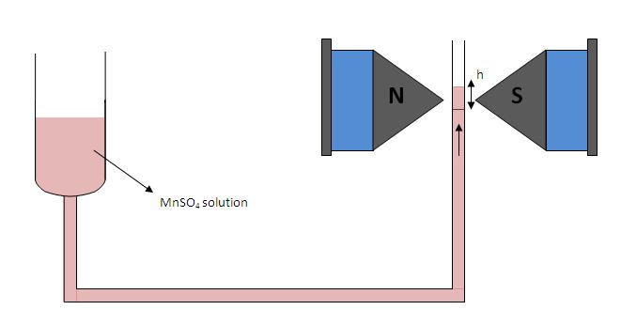

Here, manganese sulphate solution under investigation is placed in a vertical U-tube with one limb of wide bore and the other with narrow bore. The narrow limb is placed in between the pole pieces of the electromagnet. It should be noted that the surface of the liquid in the narrow limb must lie at the line of centers of the pole pieces when the field is off.

When the current is switched on a strong field is appeared at upper surface of the narrow column while the lower portion will be in a state of comparatively weak field. Hence a force will act upon the column and if the liquid is paramagnetic it will rise.

We can derive an expression for the susceptibility of the liquid as given below,

where χ2, χ1 are the susceptibilities of the solution and air; ρ, σ are the densities of liquid and air; 'g' the acceleration due to gravity; 'h' the rise in the surface of the liquid; and is the final field applied.

Taking the susceptibility of air approximately equal to zero, the previous equation becomes,

***Barkhausen Effect -:***

A ferromagnet has a spontaneous magnetic moment. The atoms (or molecules) of ferromagnetic materials have a net intrinsic magnetic dipole moment which is primarily due to the spin of electrons. The interaction, called as spin exchange interaction, between the neighbouring atomic magnetic dipoles is very strong and exists even in the absence of an external magnetic field.

Magnetization could be explained based on Domain theory. Weiss postulated the existence of domains within the ferromagnetic material. Within these domains the material is magnetized to saturation but the direction of magnetization differs from domain to domain, resulting in zero resultant magnetization of the specimen. The process of magnetization consists in rotating the different domains in the direction of applied external field so that the specimen exhibits a net magnetization externally.

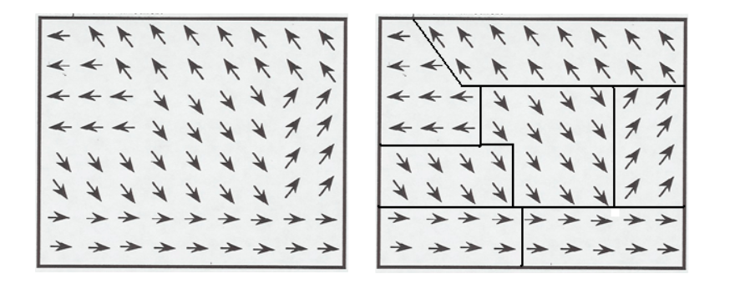

The Barkhausen effect is an indirect evidence of the existence of magnetic domains within ferromagnetic materials. When domains grow, under an applied magnetic field, the movement of the domain walls occurs by discontinuous and abrupt Barkhausen jumps. The jumps in magnetization of a ferromagnetic material can induce a voltage in a winding coil of wire that in turn can produce Barkhausen noise.

In the Barkhausen effect, a large coil of fine wire is connected through an amplifier to a speaker. When an iron rod is placed within the coil and stroked with a magnet, an audible roaring sound will be produced from the sudden realignments of the magnetic domains within the rod. Due to electromagnetic induction, the shifting of a domain creates a change in the magnetic field around the iron, and that changing magnetic field induces a current in the surrounding coil detectable by the amplifier.

***Observations* -:**

***Simulation 1*** -:

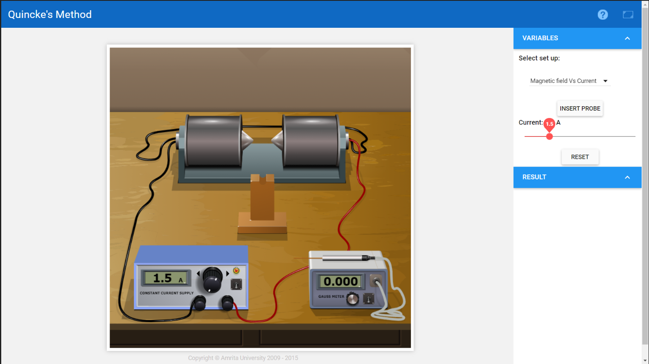

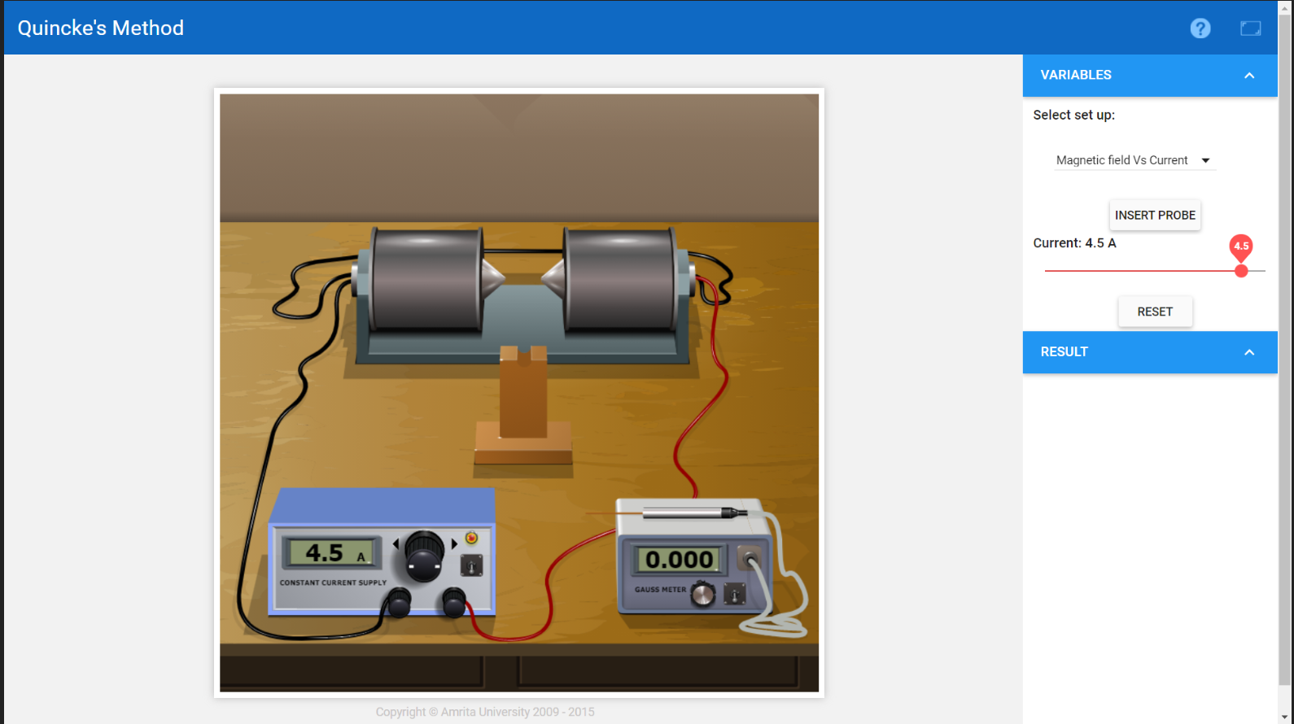

**Observation Table 1** -:

|  |  |  |
| --- | --- | --- |
| **S.No.** | **Currennt I**  **(in A)** | **Magnetic Field B**  **(Gauss)** |
| ***1.*** | 1.0 | 0.227 |
| ***2.*** | 1.5 | 0.340 |
| ***3.*** | 2.0 | 0.453 |
| ***4.*** | 2.5 | 0.567 |
| ***5.*** | 3.0 | 0.680 |
| ***6.*** | 3.5 | 0.793 |
| ***7.*** | 4.5 | 1.020 |

**Graph of Current vs Magnetic Field**

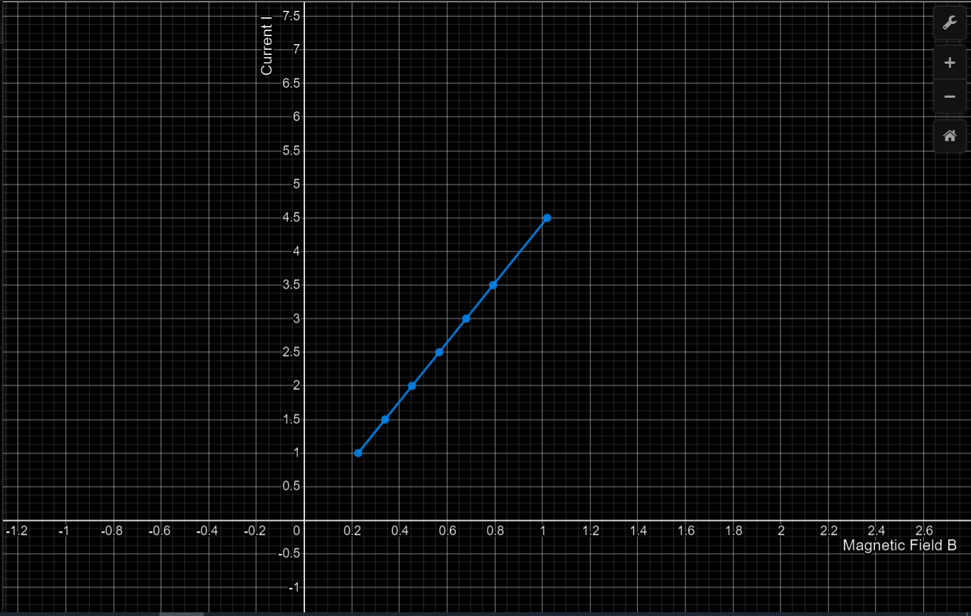

***Simulation 2*** -:

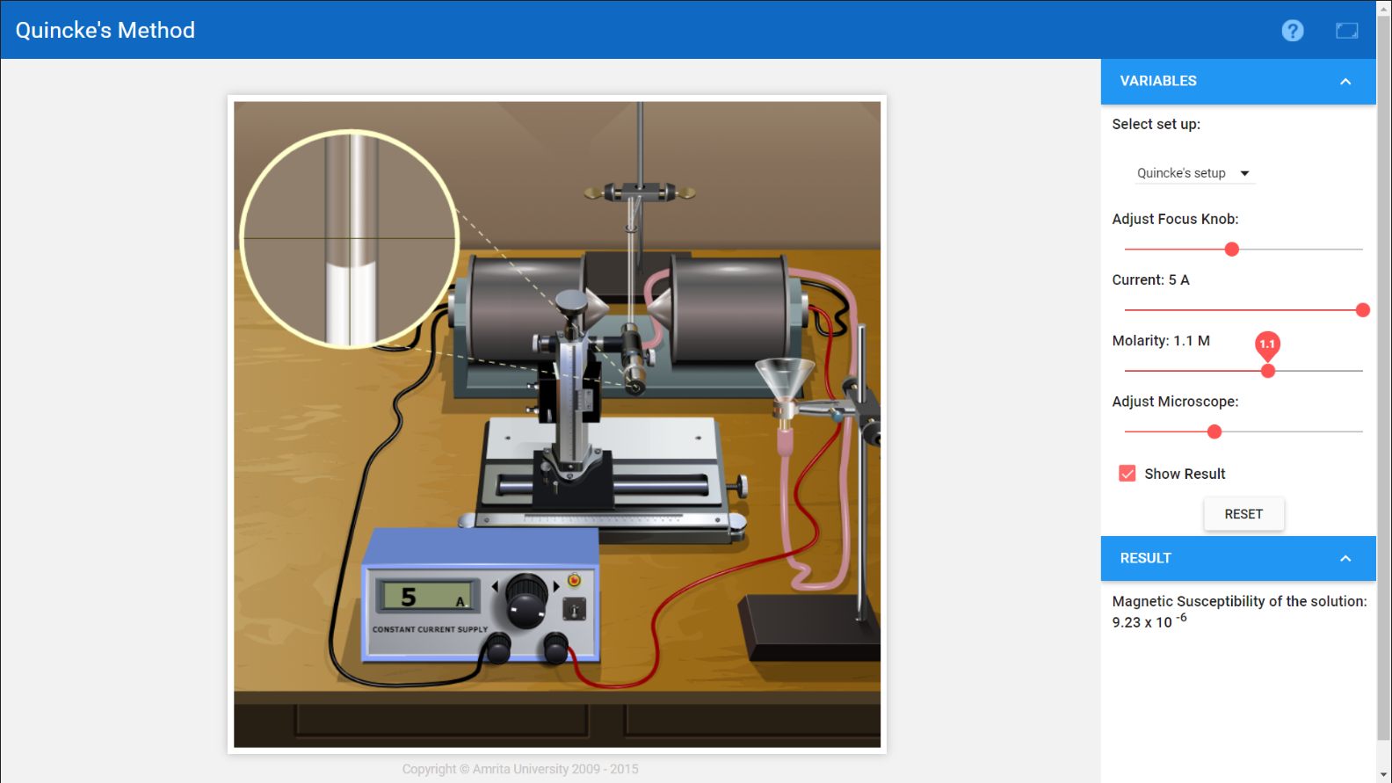

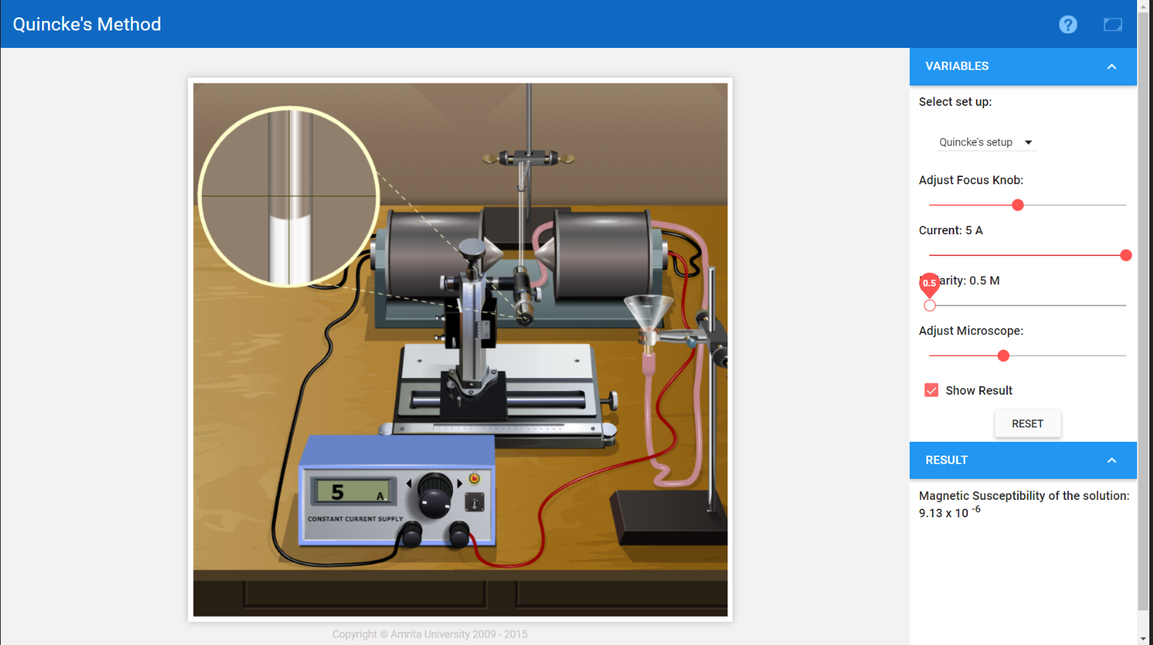

**Observation Table 2** -:

Keeping current constant, I = 5A

|  |  |  |
| --- | --- | --- |
| **S.No.** | **Molarity**  **M** | **Magnetic Susceptibility**  **x** |
| **1.** | 0.5 | 9.13 |
| **2.** | 0.7 | 9.16 |
| **3.** | 0.8 | 9.18 |
| **4.** | 1.0 | 9.21 |
| **5.** | 1.1 | 9.23 |
| **6.** | 1.3 | 9.27 |
| **7.** | 1.5 | 9.30 |

**Graph of Magnetic Susceptibility vs Molarity**

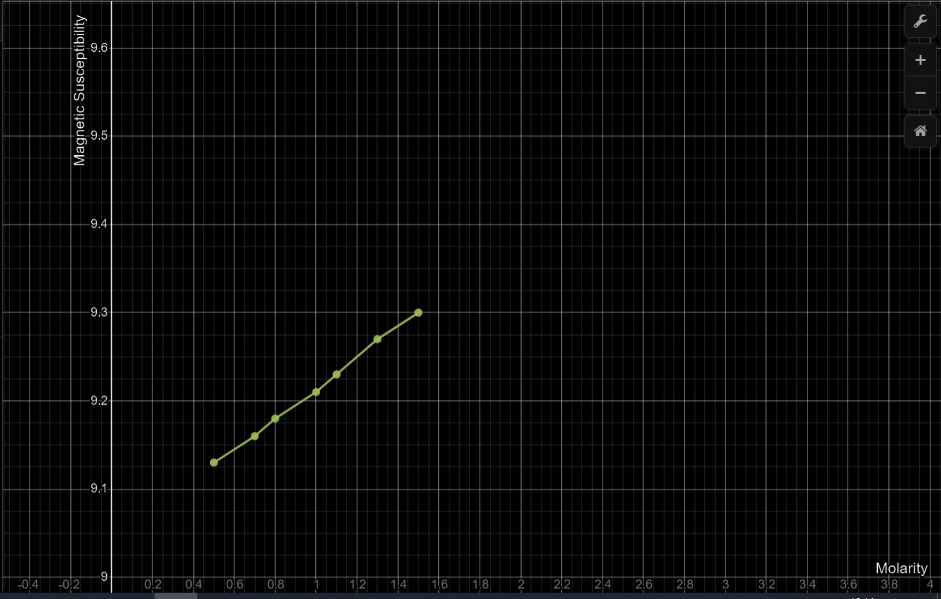

***Simulation 3*** -:

* We can firstly remove the rod and look at the output graph by moving the magnet.
* Then we can insert the rod of ferromagnetic material and look at output graph of EMF produced with time.
* We can change the no. of coils and see how produced EMF changes.

**Snapshots** -:

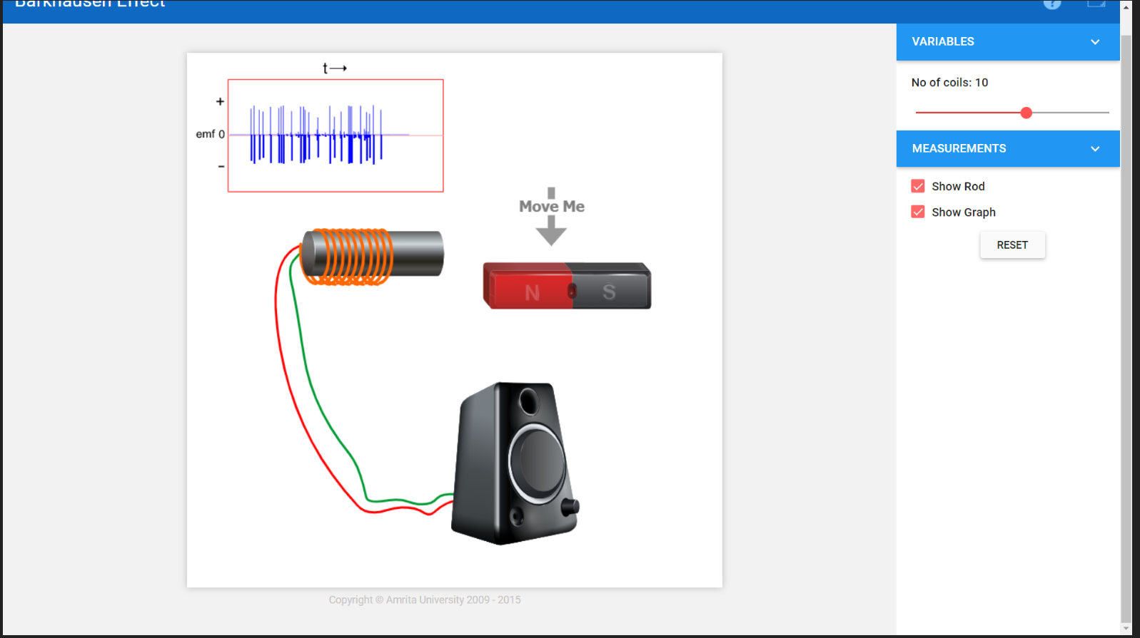

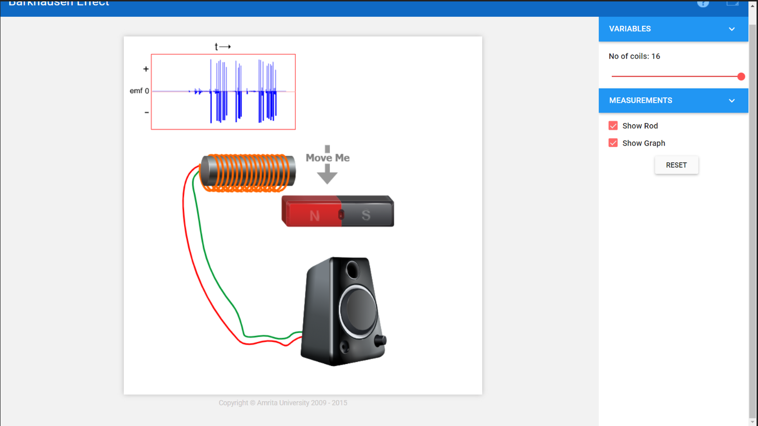

***Error analysis* -:** Errors may be instrumental, environmental, procedural and errors due to least count.

In this experiment, systematic and random errors may arise due to least count of ammeter and other practical factors .

Here there may be slight error in the calculations due to the error in taking readings from ammeter but that is in the agreeable range. We cannot minimize these errors as it is due to the simulation algorithm.

***Conclusions* -:**

* *For Quincke’s Method*

For the first setup, we had to insert the probe in the setup of constant current supply and a Gauss meter. Here the gauss meter measures magnetic field. Here, as we increased current, the magnetic field was observed to increase linearly.

For second setup, we kept a constant current of 5A and varied the values of molarity from 0.5 to 1.5.As we increased molarity, there was a gradual increase in susceptibility.

* *For Barkhausen’s Effect*

As we moved the bar magnet around the coil, an emf was induced and we could hear noise being generated from the speakers. The change in emf could be seen from the graph in the simulation. Also, the emf induced was proportional to the number of turns in coil.