***Objective* -:** To study the variation of magnetic field with distance along the axis of a circular coil carrying current.

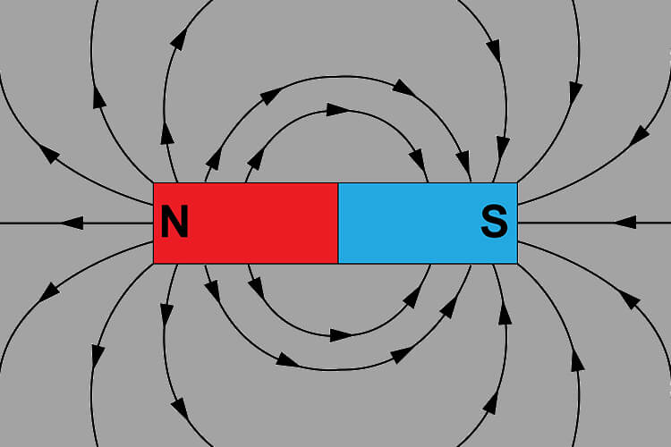***Theory*** **-:** A **magnetic field** is a vector field that describes the magnetic influence on moving electric charges, electric currents, and magnetic materials. A moving charge in a magnetic field experiences a force perpendicular to its own velocity and to the magnetic field. In simple terms, magnetic field is the area around a magnet in which a moving charge experiences a magnetic force. The SI Unit of magnetic field is Tesla.

The image represents the magnetic field of a bar magnet.

***Oersted’s Experiment***

In 1820, a Danish physicist, Hans Christian Oersted, discovered that there was a relationship between electricity and magnetism. By setting up a compass through a wire carrying an electric current, Oersted showed that moving electrons can create a magnetic field.

In his experiment, he observed that when a compass needle is brought near a current carrying wire, there is a deflection in the compass needle. Moreover, he observed that when the direction of current is reversed, the compass needle also deflected in the other direction.

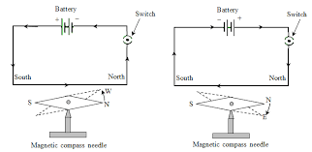

Further he observed that the direction of deflection in the needle obeys the **Right-Hand Rule**. He concluded that, “A current carrying wire produces a magnetic field around it.”, from his experimental observations.

***Biot-Savart Law***

According to Biot-Savart’s law, the magnetic field at a point due to an element of a conductor carrying current is,

* directly proportional to the **strength of the current, i**
* directly proportional to the **length of the element, dl**
* directly proportional to the **sine of the angle θ** between the element and the line joining the element to the point and
* 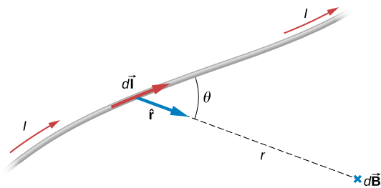inversely proportional to the **square of the distance r** between the element and the point.

(the $×$ sign indicate ‘inside the plane of paper’ direction and $°$ sign indicate ‘outside the plane of paper’ direction.)

$$∴\left|dB\right| α \frac{i dl \sin{ϴ}}{r^{2}}$$

$$\left|dB\right|= \frac{μ_{0}}{4π} \frac{i dl \sin{ϴ}}{r^{2}}$$

In vector form,

$$d\vec{B}= \frac{μ_{0}}{4π} \frac{i d\vec{l} × \vec{r}}{r^{3}}$$

where $μ_{0}$ is the permeability of free space or vacuum.

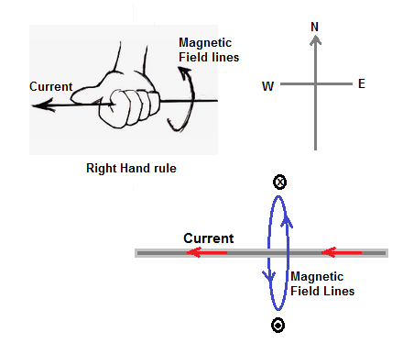The direction of the magnetic field is always in a plane perpendicular to the line of element and position vector. It is given by the right-hand thumb rule where the thumb points to the direction of conventional current and the other fingers show the magnetic field’s direction.

***Magnetic Field due to a current carrying circular coil at axis***

Consider a circular coil of radius r, carrying a current I. Consider a point P, which is at a distance x from the centre of the coil. We can consider that the loop is made up of a large number of short elements, generating small magnetic fields. So the total field at P will be the sum of the contributions from all these elements.

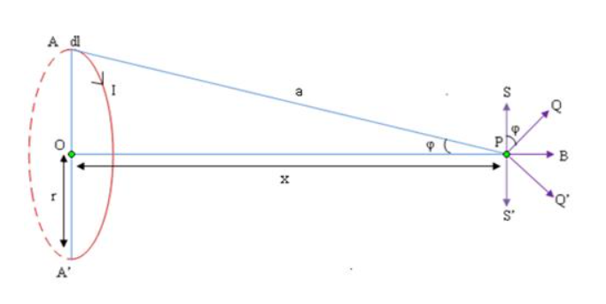

By Biot- Savart’s law, the field dB due to a small element dl of the circle, centred at A is given by,

$$\left|dB\right|= \frac{μ_{0}}{4π} I\frac{ dl }{x^{2}+r^{2}}$$

This can be resolved into two components, one along the axis OP, and other PS, which is perpendicular to OP. PS is exactly cancelled by the perpendicular component PS’ of the field due to a current and centred at A’. So, the total magnetic field at a point which is at a distance x away from the axis of a circular coil of radius r is given by,

$$\left|dB\right|= \frac{μ_{0}}{4π} I\frac{2 \sin{φ} }{x^{2}+r^{2}}$$

$$\left|dB\right|= \frac{μ_{0}I}{2π} \frac{ r }{{(x^{2}+r^{2})}^{3/2}}$$

Therefore, the magnetic field at a point on axis of ring x distance away from the centre will be πr $×$ $\left|dB\right|$

$$B_{x}= \frac{μ_{0}I}{2} \frac{r^{2} }{{(x^{2}+r^{2})}^{3/2}}$$

The direction of this field is along x-axis $(\vec{OP})$.

If the circular coil has n turns the magnetic field also becomes n times,

$$B_{x}= \frac{μ_{0}nI}{2} \frac{r^{2} }{{(x^{2}+r^{2})}^{3/2}}$$

Therefore, at the centre of the ring (x = 0), the magnetic field is,

$$B_{c}= \frac{μ_{0}nI}{2r}$$

***Tangent Law***

The tangent law of magnetism is a way of measuring the strengths of two perpendicular magnetic fields. When a magnet is exposed to a magnetic field B that is perpendicular to the Earth’s horizontal magnetic field ($B_{H}$)(in general, any two perpendicular magnetic fields), the magnetic field will rest at an angle theta(ϴ). The relation between the magnetic fields is as follows:

$B= B_{H}\tan{ϴ}$

***Observations* -:**

The horizontal component of the earth’s magnetic field varies greatly over the surface of the earth. For the purpose of this simulation, we will assume its magnitude to be $B_{0}=3.5×{10}^{-5}T$.

**Observation Table 1:**

Fixing the radius of coil to be 5 cm and number of turns in coil be 10 and the current to be 1 A.

|  |  |  |  |  |  |  |  |  |  |  |  |  |
| --- | --- | --- | --- | --- | --- | --- | --- | --- | --- | --- | --- | --- |
| **Magnetic field along the axis of coil** | | | | | | | | | | | | |
| **r = 5 cm, I = 1 A, n = 10** | | | | | | | | | | | | |
| **Observation Table** | | | | | | | | | | | | |
| **Distance from the centre** | **Deflection with compass box on left side** | | | | **Deflection with compass box on right side** | | | | **Mean θ (degree)** | **tan θ** | **B = BH tan θ (10 ^ -5 T)** | **Bth (from Biot-Savart's Law)** |
|  | **Direct** | | **Reverse** | | **Direct** | | **Reverse** | |  |  |  | **(10 ^ -5 T)** |
| **x (cm)** | **θ1** | **θ2** | **θ3** | **θ4** | **θ1** | **θ2** | **θ3** | **θ4** |  |  |  |  |
|  |  |  |  |  |  |  |  |  |  |  |  |  |
| 0 | 75 | 75 | 75 | 75 | 75 | 75 | 75 | 75 | 75 | 3.732 | 13.06 | 12.56 |
| 3 | 66 | 66 | 66 | 66 | 66 | 66 | 66 | 66 | 66 | 2.246 | 7.86 | 7.92 |
| 9 | 22 | 22 | 22 | 22 | 22 | 22 | 22 | 22 | 22 | 0.404 | 1.414 | 1.44 |
| 17 | 5 | 5 | 5 | 5 | 5 | 5 | 5 | 5 | 5 | 0.087 | 0.306 | 0.282 |
| -3 | 66 | 66 | 66 | 66 | 66 | 66 | 66 | 66 | 66 | 2.246 | 7.86 | 7.92 |
| -7 | 35 | 35 | 35 | 35 | 35 | 35 | 35 | 35 | 35 | 0.7 | 2.45 | 2.466 |
| -17 | 5 | 5 | 5 | 5 | 5 | 5 | 5 | 5 | 5 | 0.087 | 0.306 | 0.282 |
| 12 | 9 | 9 | 9 | 9 | 9 | 9 | 9 | 9 | 9 | 0.158 | 0.554 | 0.715 |

**Graph of B vs x for table 1:**

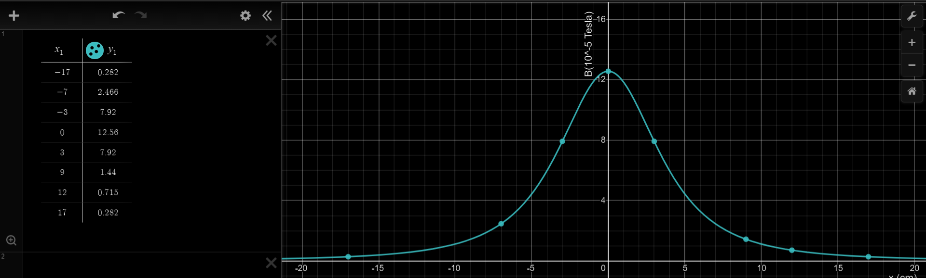

**Observation Table 2:**

|  |  |  |  |  |  |  |  |  |  |  |  |  |
| --- | --- | --- | --- | --- | --- | --- | --- | --- | --- | --- | --- | --- |
| **Magnetic field along the axis of coil** | | | | | | | | | | | | |
| **r = 7.5 cm, I = 0.167 A, n = 25** | | | | | | | | | | | | |
| **Observation Table** | | | | | | | | | | | | |
| **Distance from the centre** | **Deflection with compass box on left side** | | | | **Deflection with compass box on right side** | | | | **Mean θ (degree)** | **tan θ** | **B = BH tan θ (10 ^ -5 T)** | **Bth (from Biot-Savart's Law)** |
|  | **Direct** | | **Reverse** | | **Direct** | | **Reverse** | |  |  |  | **(10 ^ -5 T)** |
| **x (cm)** | **θ1** | **θ2** | **θ3** | **θ4** | **θ1** | **θ2** | **θ3** | **θ4** |  |  |  |  |
|  |  |  |  |  |  |  |  |  |  |  |  |  |
| 0 | 45 | 45 | 45 | 45 | 45 | 45 | 45 | 45 | 45 | 1 | 3.5 | 3.49 |
| 3 | 39 | 39 | 39 | 39 | 39 | 39 | 39 | 39 | 39 | 0.81 | 2.83 | 2.79 |
| 9 | 15 | 15 | 15 | 15 | 15 | 15 | 15 | 15 | 15 | 0.268 | 0.938 | 0.915 |
| 17 | 4 | 4 | 4 | 4 | 4 | 4 | 4 | 4 | 4 | 0.07 | 0.245 | 0.229 |
| -3 | 39 | 39 | 39 | 39 | 39 | 39 | 39 | 39 | 39 | 0.81 | 2.83 | 2.79 |
| -7 | 21 | 21 | 21 | 21 | 21 | 21 | 21 | 21 | 21 | 0.384 | 1.344 | 1.363 |
| -17 | 4 | 4 | 4 | 4 | 4 | 4 | 4 | 4 | 4 | 0.07 | 0.245 | 0.229 |
| 12 | 9 | 9 | 9 | 9 | 9 | 9 | 9 | 9 | 9 | 0.158 | 0.554 | 0.519 |

**Graph of B vs x for table 2:**

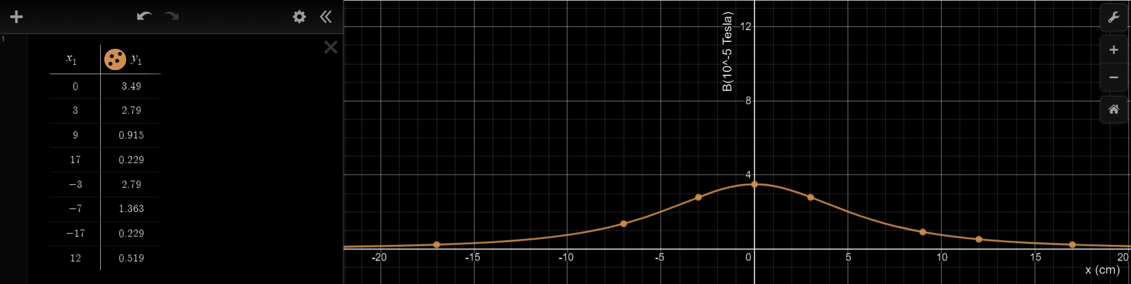

***ERROR ANALYSIS* -:**

Error for the observations in table 1 is calculated below:

|  |  |  |
| --- | --- | --- |
| **B = BH tan θ $${(10}^{-5} T)$$** | **Bth (from Biot-Savart's Law) $${(10}^{-5} T)$$** | **Error**  **B - Bth** |
| 13.06 | 12.56 | 0.50 |
| 7.86 | 7.92 | -0.06 |
| 1.414 | 1.44 | -0.026 |
| 0.306 | 0.282 | 0.024 |
| 7.86 | 7.92 | -0.06 |
| 2.45 | 2.466 | -0.016 |
| 0.306 | 0.282 | 0.024 |
| 0.554 | 0.715 | -0.161 |
|  |

* The compass in the simulator had the least count of 1 degree, so exact value of ϴ was not known.
* The mean error in our observations has come out to be $0.028125 ×{10}^{-5}T$, which is insignificant.

***Conclusion* -:** Performing the experiment in the simulator led us to draw following conclusions -:

* The magnetic field at the axis of a circular coil, of radius r having n turns and carrying current I, at a distance x from the centre of the coil is equal to,
$$B_{x}= \frac{μ_{0}nI}{2} \frac{r^{2} }{{(x^{2}+r^{2})}^{3/2}}$$

* The magnetic field at the centre of a circular loop is given by,
$$B_{c}= \frac{μ_{0}nI}{2r}$$

* The magnetic field at a distance x on both sides of the centre of coil is equal.
* As we go far away off the centre on the axis, the magnitude of magnetic field decreases, and its magnitude is maximum at the centre of the coil.