CS202

ASSIGNMENT 1

NAME:

ARCHIT AGRAWAL

ROLL NO. :

202051213

SECTION:

2

## Explore your current machine (Desktop/Laptop/Mobile) you are using, collect the details of the following.

## 1. Name and Model of device

Name -> HP Pavillion Gaming Notebook

Model -> 5-AU009TX

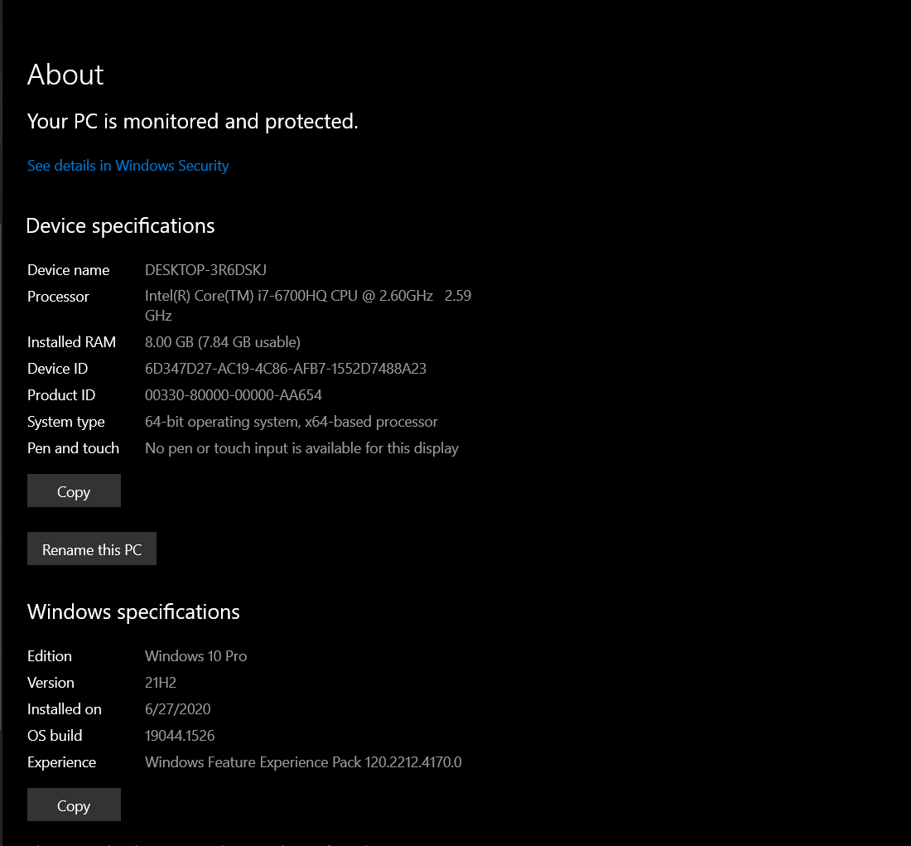

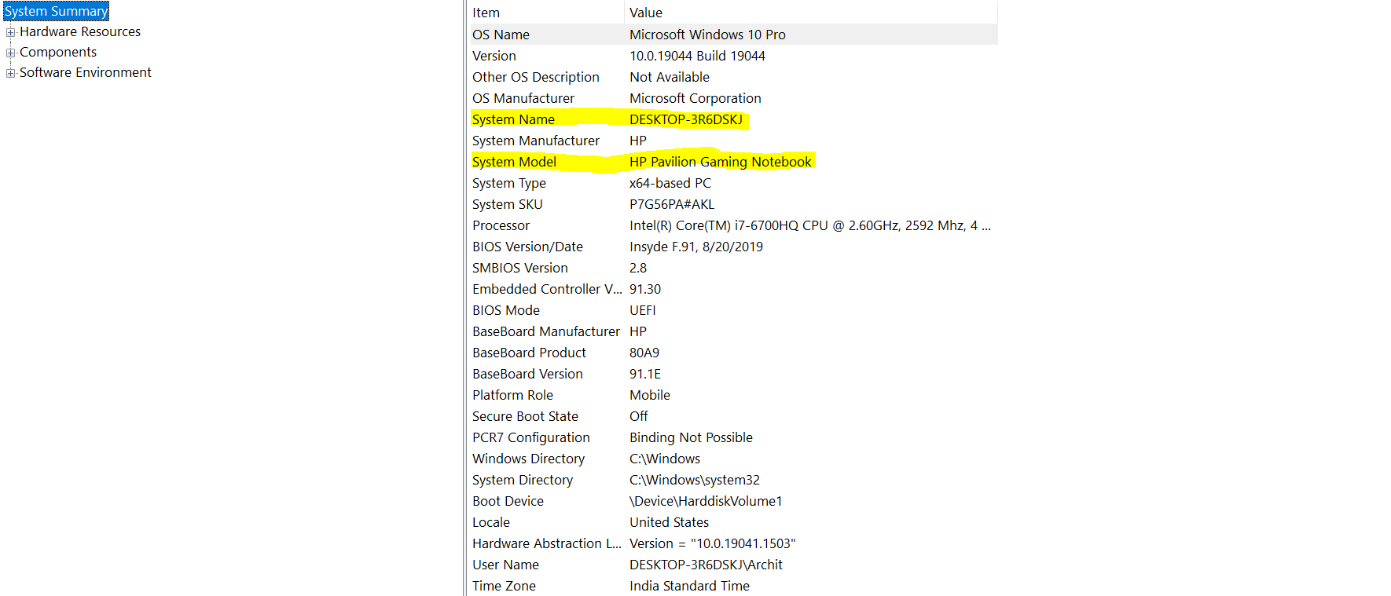

## 2. Take a device picture

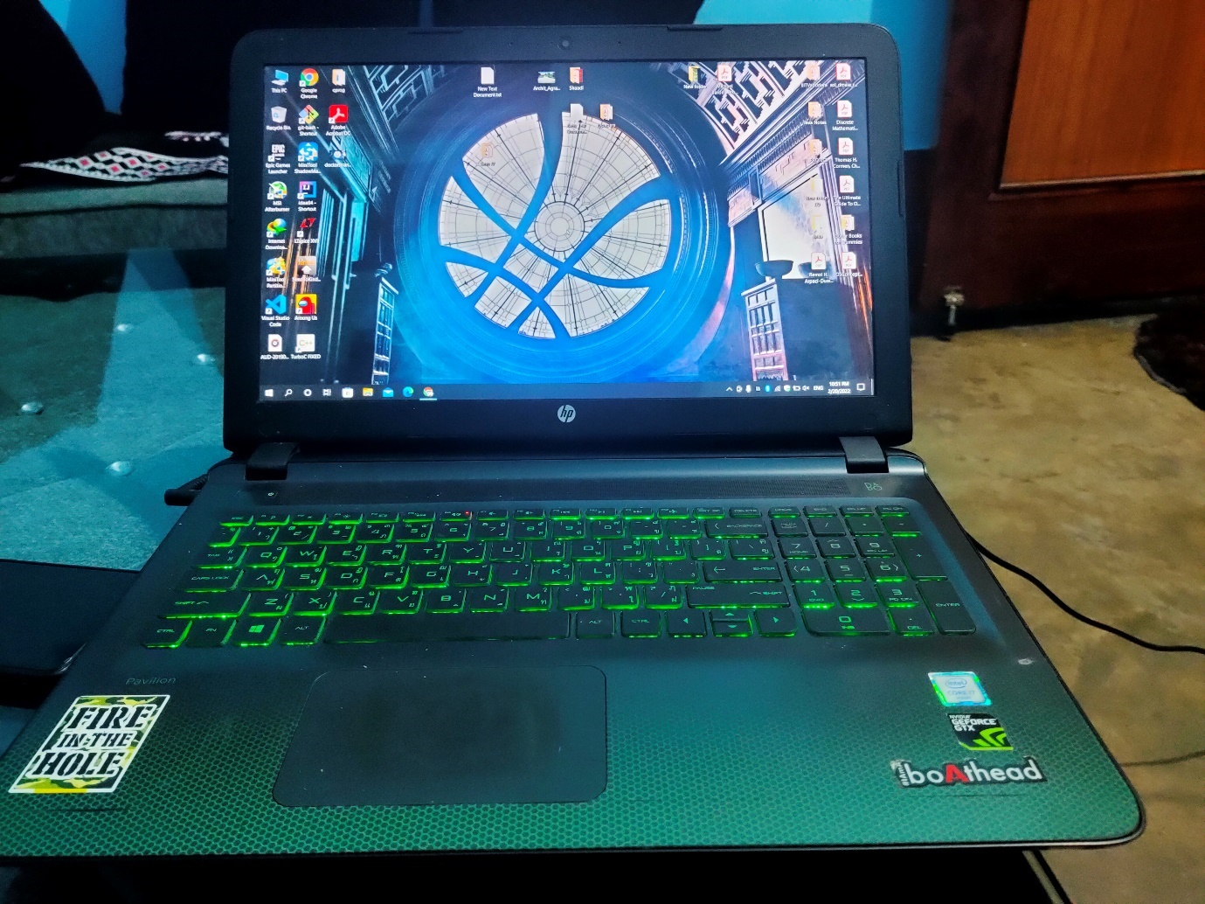

3. CPU

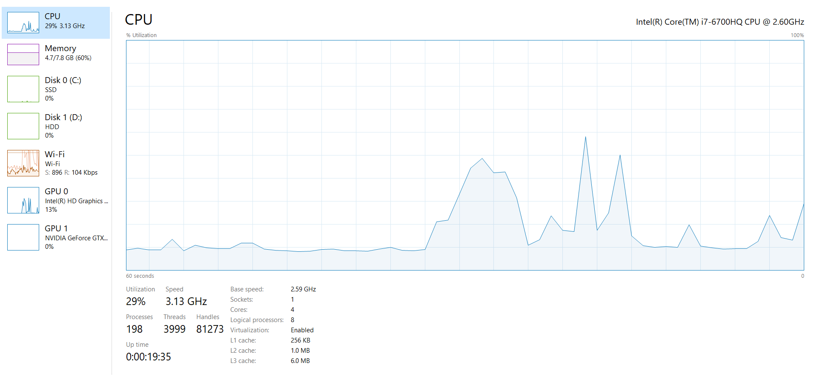

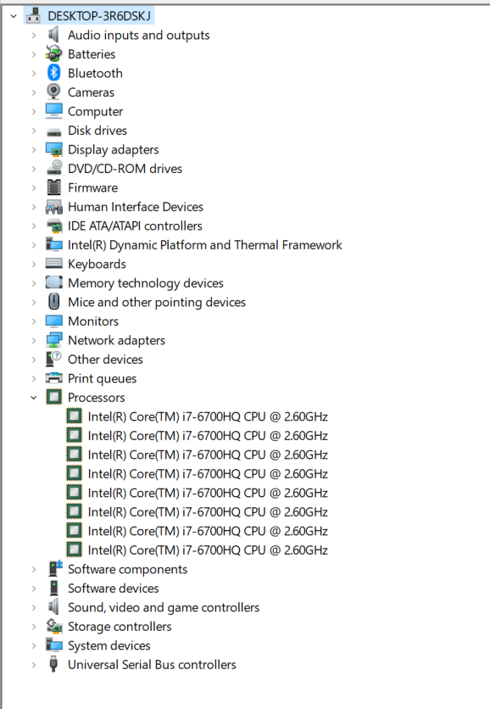

## 4. Register Size

🡪 64 bits

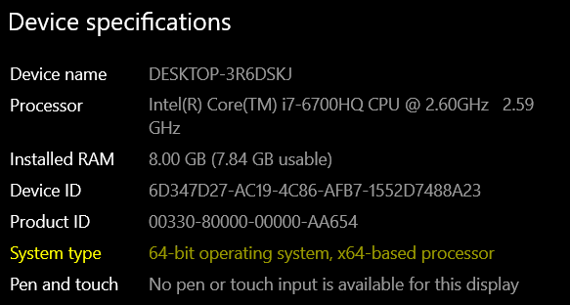

## 5. RAM

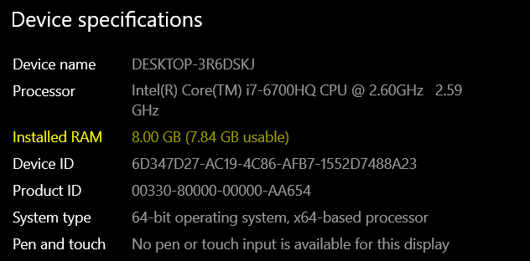

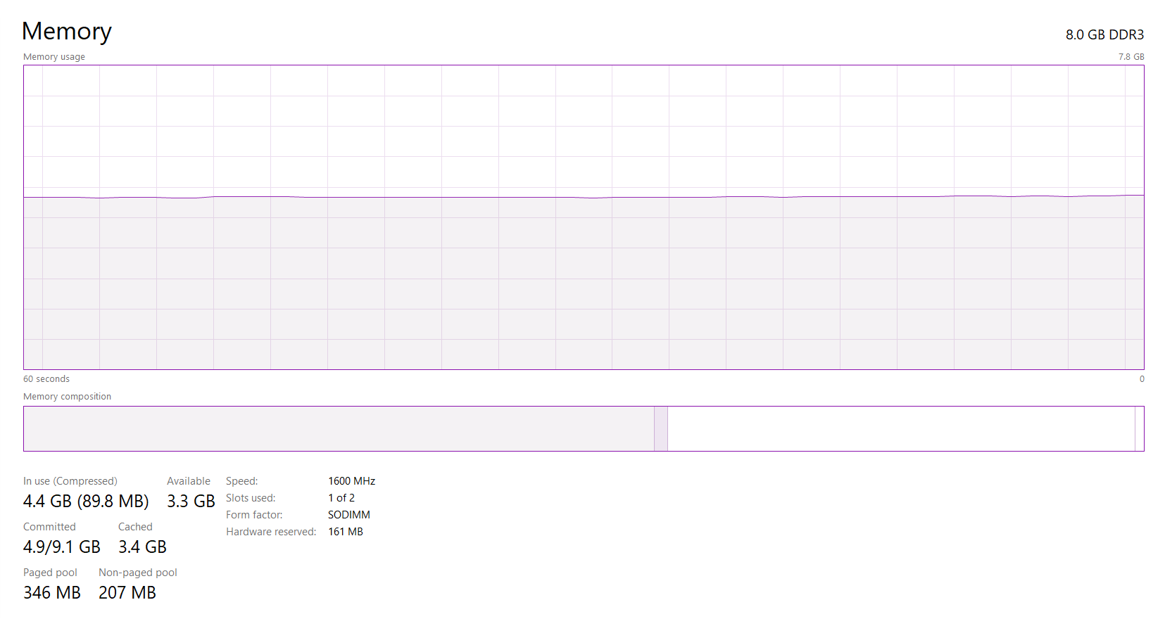

## 6. Cache

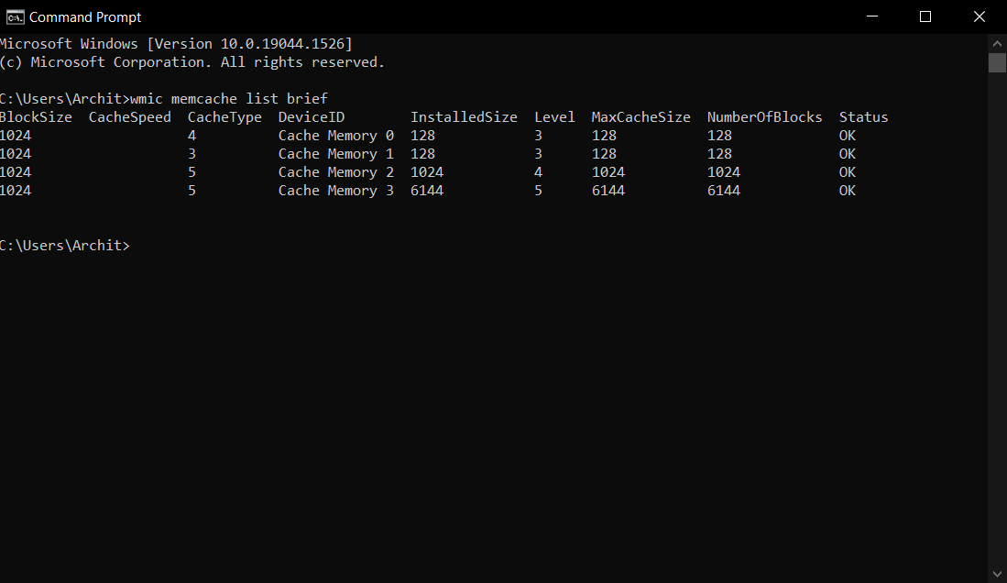

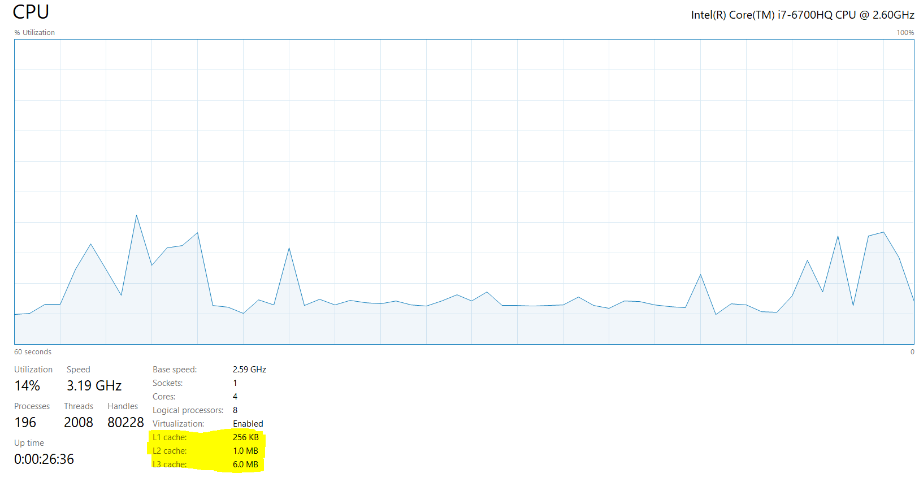

## 7. Motherboard

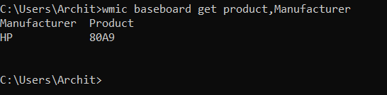

## 8. Word size

🡪 64 bits

## 9. List of Ports

* 1 x USB 2.0, 2 x USB 3.0 (1 HP USB Boost)
* 1 x HDMI Port
* SD Card Slot
* Mic Port
* Ethernet Connector

## 10. Other details

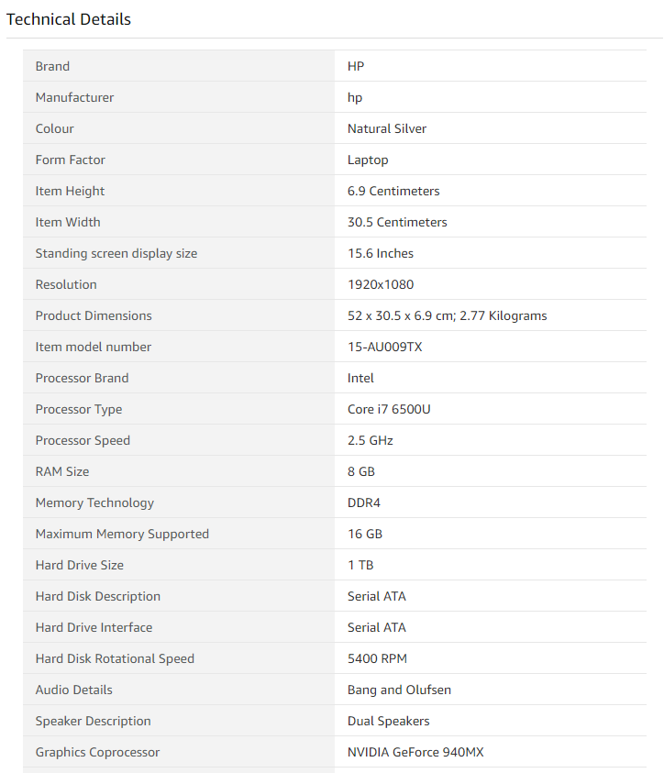

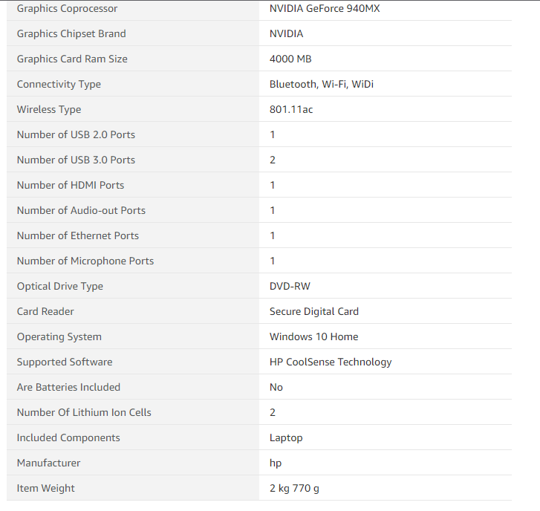

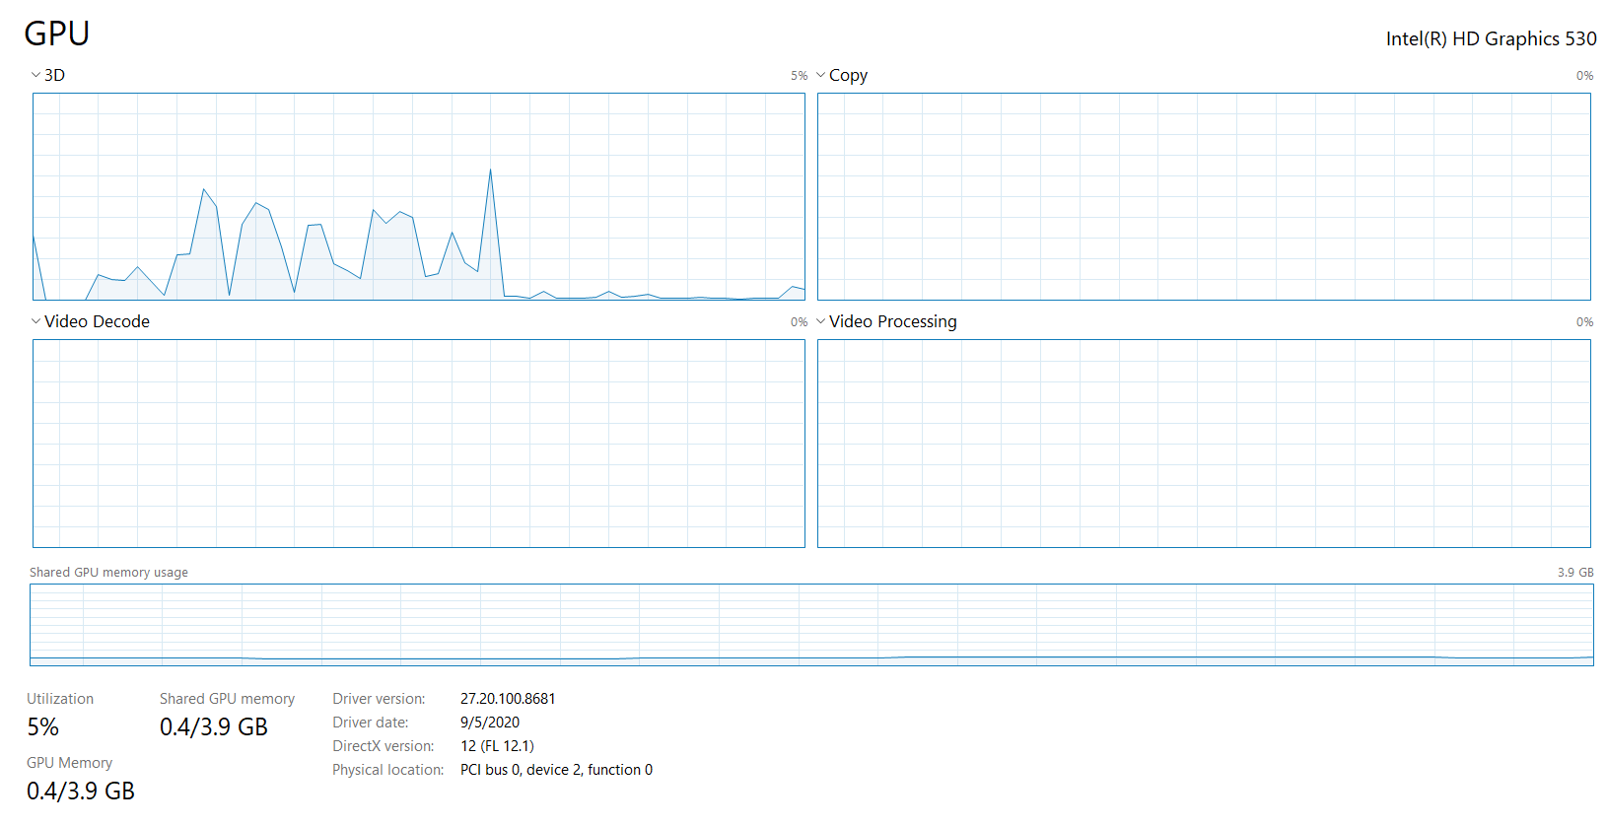

## 2. Write a generic C (or any other language) program to verify the Endianness of a machine. Verify its output on your machine. Send a pdf file containing the program and the outputs (analyze it over different size of inputs).

*Code:*

#include <stdio.h>

void show_mem_rep(char *start, int n)

{

    int i;

    for (i = 0; i < n; i++)

        printf(" %.2x", start[i]);

    printf("\n");

}

int main()

{

int i = 0x33504;

show_mem_rep((char *)&i, sizeof(i));

getchar();

return 0;

}

*Output:*

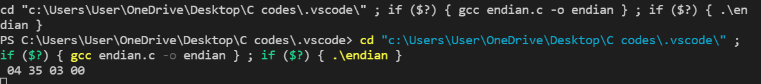

Since last byte of binary representation of the multibyte data-type is present first, we can conclude that the machine is Little endian.