***UNIVERSITY DATABASE MANAGEMENT SYSTEM***

**Group Members**

(Section 2)

Archit Agrawal (202051213)

Kalash Singh Jadoun (202051097)

Sarang Nagar (202051168)

Sahil Kumar Rai (202051167)

Sushil Kumar Patel (202051188)

Reporting TA : Amit Dwivedi

***INTRODUCTION***

University Database Management System is a MySQL database designed to handle the university records. The University Database Management System creates, manages and performs all the activities related to the database of a given university.

The database consists of information about the university, branches, students, faculties, courses, library, clubs etc. The main aim of this project is to manage the database in such a way that information can be retrieved and modified in an efficient way.

* **Submitted in Previous Report**:
* ER Diagram
* Conversion from ER to Relational Model
* MySQL Database
* SQL Queries on the database
* **This Report Includes**:
* Modification in ER Diagram
* A well-designed MySQL Database
* Schema’s of all the database tables
* Functional Dependencies
* Normalization (1NF, 2NF, 3NF and BCNF)

***Entity-Relationship Diagram***

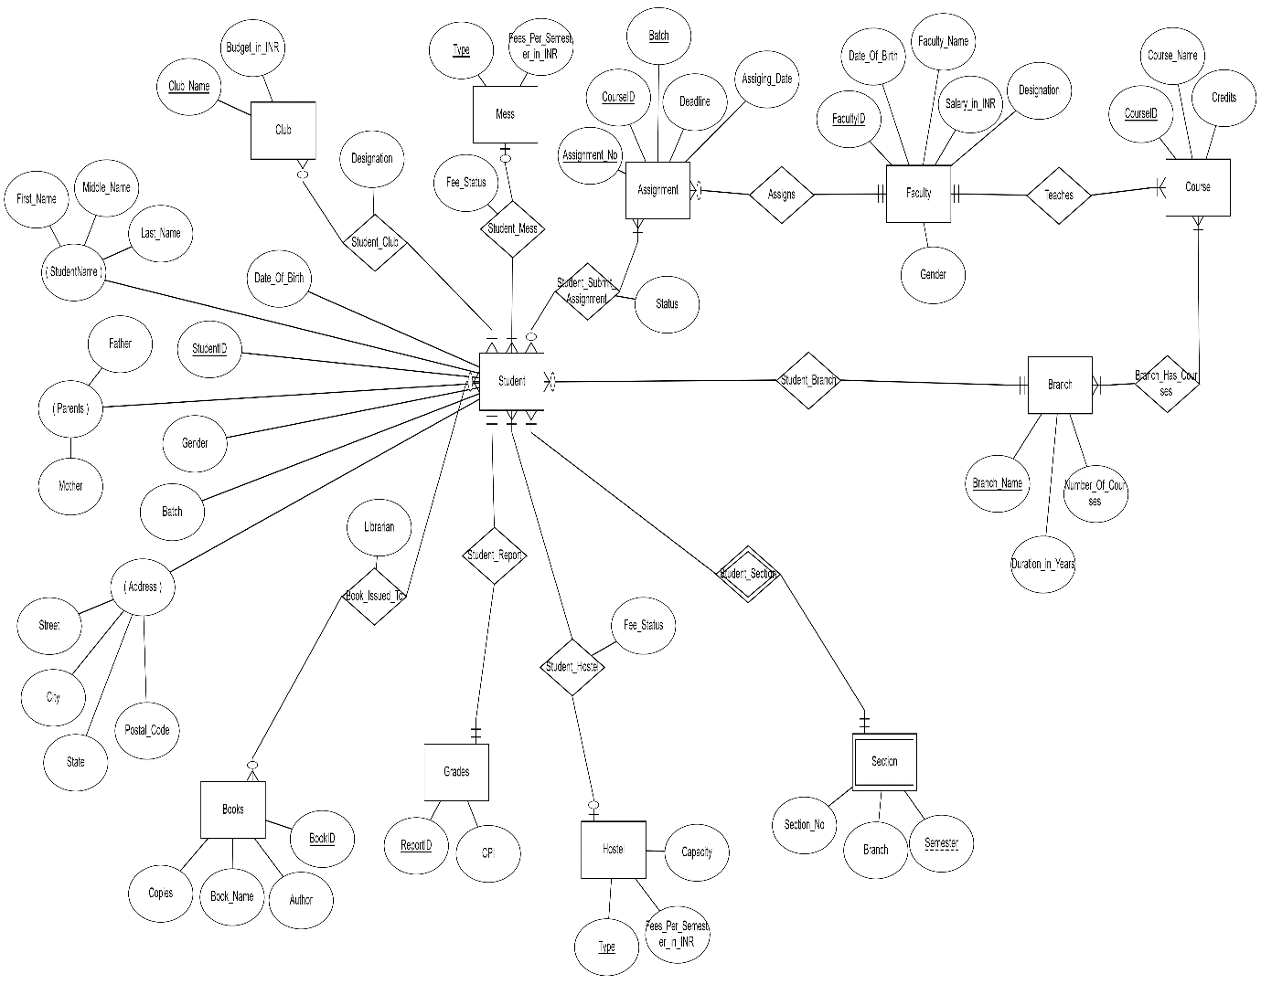

(The ER diagram is also submitted separately in the zip file as it is not clearly visible here.)

We have increased the number of entities and relations according to our needs as we proceeded with the project.

***MySQL Database***

This report deals mainly with the functional dependencies and normalization. Hence, instead of pasting screenshots of all the database tables along with its data, we have just pasted the schemas of all the tables (there are 25 tables).

**List of all tables in the database:**

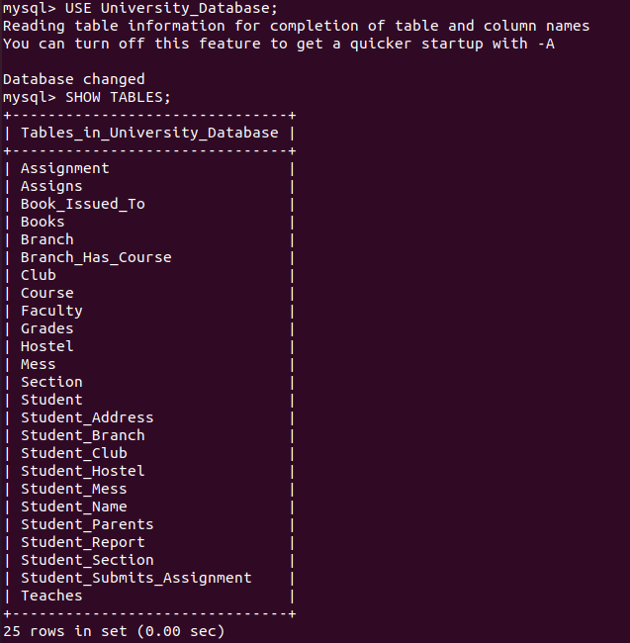

As you can see, there are 25 tables overall. The description of all of the tables is pasted below.

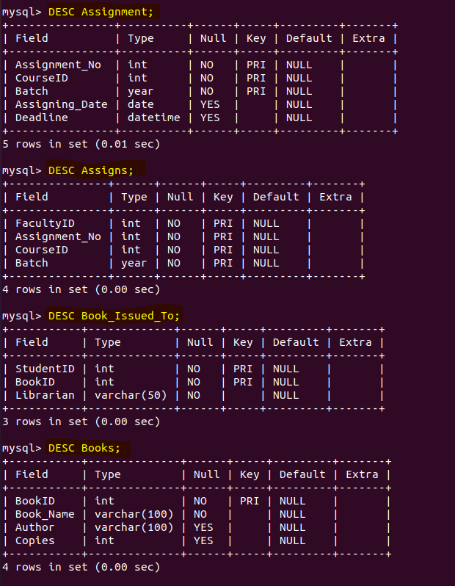

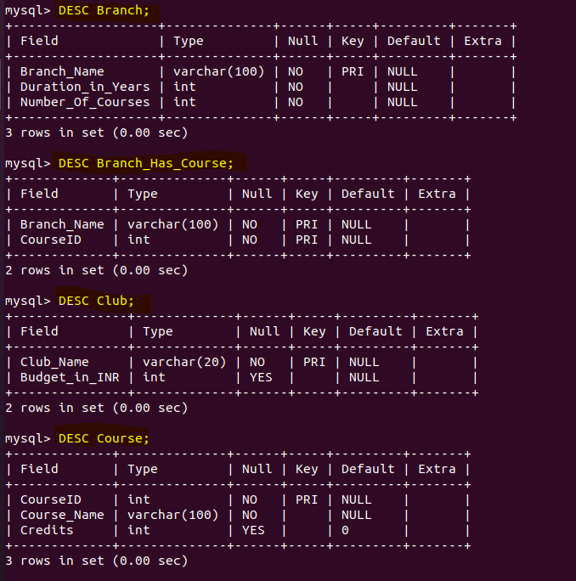

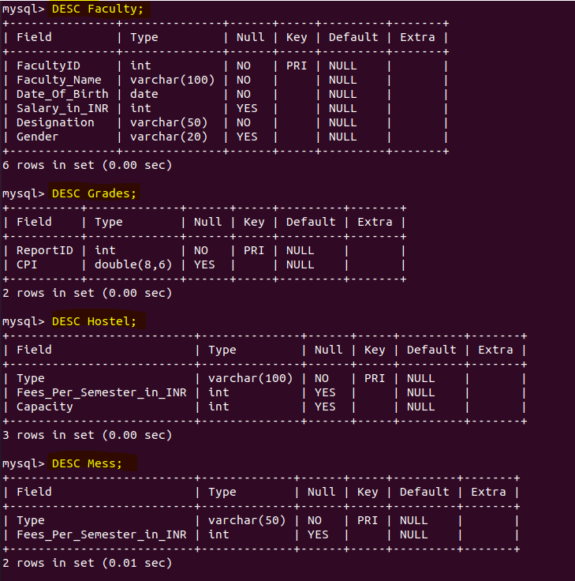

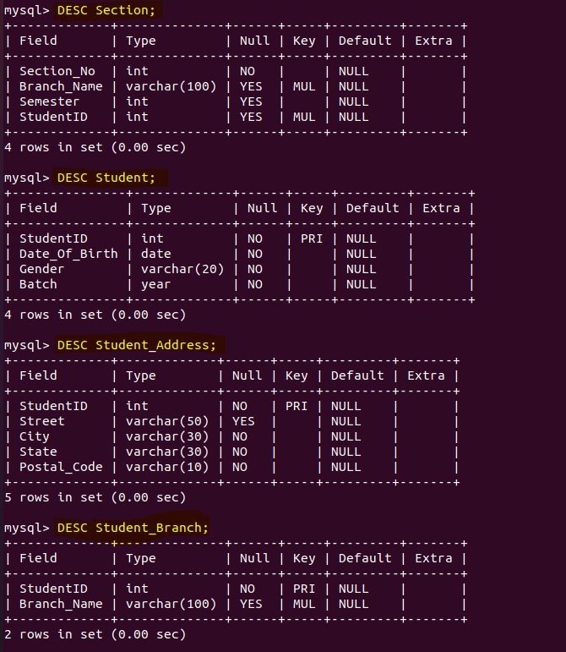

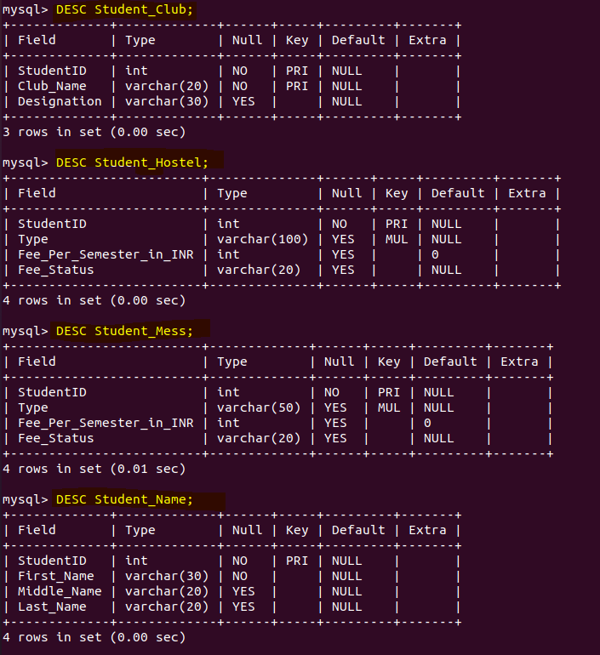

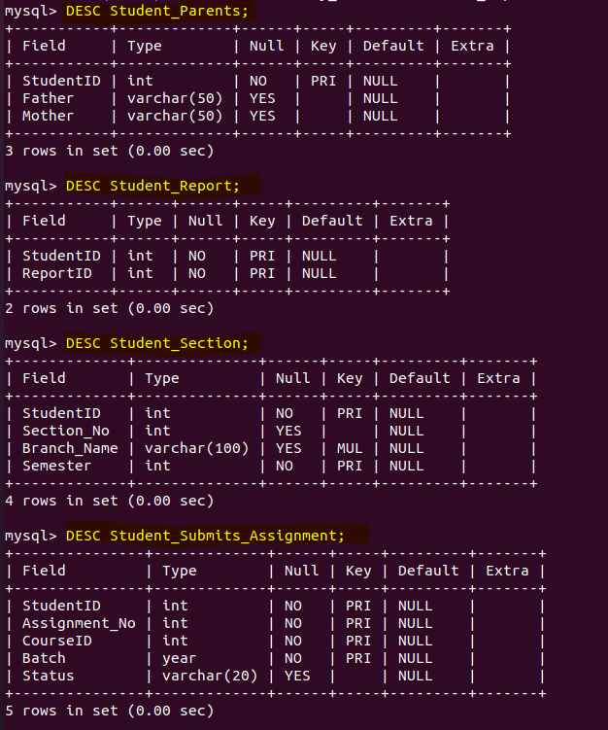

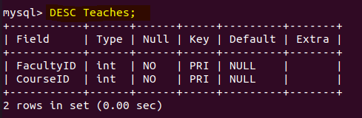

***Canonical Form of Functional Dependencies***

In this section, we have mentioned all the functional dependencies that are present in our database.

* In Table “Assignment”
  + 1. Assignment_No, CourseID, Batch 🡪 Assigning_Date
    2. Assignment_No, CourseID, Batch 🡪 Deadline

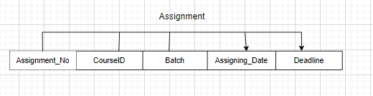

* In Table “Assigns”
  + 1. Only Trivial (Reflexive) Functional Dependency
* In Table “Book_Issued_To”
  + 1. StudentID, BookID 🡪 Librarian

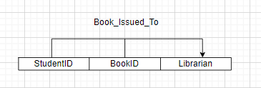

* In Table “Books”
  + 1. BookID 🡪 Book_Name
    2. BookID 🡪 Author
    3. BookID 🡪 Copies

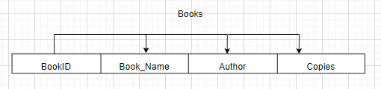

* In Table “Branch”
  + 1. Branch_Name 🡪 Duration_in_Years
    2. Branch_Name 🡪 Number_Of_Courses

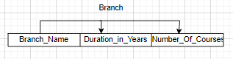

* In Table “Branch_Has_Course”
  + 1. Only Trivial (Reflexive) Functional Dependency
* In Table “Club”
  + 1. Club_Name 🡪 budget_in_INR

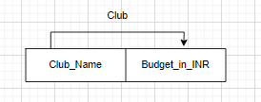

* In Table “Course”
  + 1. CourseID 🡪 Course_Name
    2. CourseID 🡪 Credits

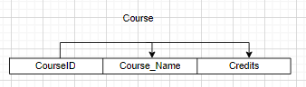

* In Table “Faculty”
  + 1. FacultyID 🡪 Faculty_Name
    2. FacultyID 🡪 Date_Of_Birth
    3. FacultyID 🡪 Salary_in_INR
    4. FacultyID 🡪 Designation
    5. FacultyID 🡪 Gender

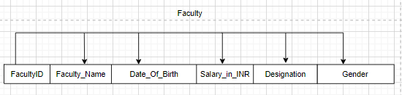

* In Table “Grades”
  + 1. ReportID 🡪 CPI

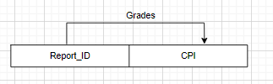

* In Table “Hostel”
  + 1. Type 🡪 Fees_Per_Semester_in_INR
    2. Type 🡪 Capacity

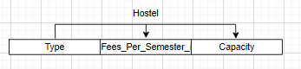

* In Table “Mess”
  + 1. Type 🡪 Fees_Per_Semester_in_INR

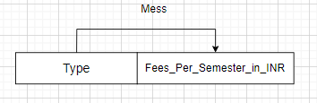

* In Table “Section”
  + 1. StudentID 🡪 Section_No
    2. StudentID 🡪 Branch_Name
    3. StudentID 🡪 Semester

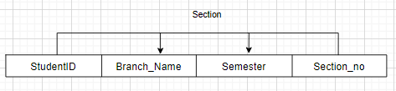

* In Table “Student”
  + 1. StudentID 🡪 Date_Of_Birth
    2. StudentID 🡪 Gender
    3. StudentID 🡪 Batch

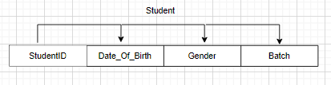

* In Table “Student_Address”
  + 1. StudentID 🡪 Street
    2. StudentID 🡪 City
    3. StudentID 🡪 State
    4. StudentID 🡪 Postal_Code

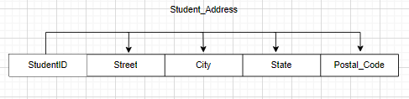

* In Table “Student_Branch”
  + 1. StudentID 🡪 Branch_Name

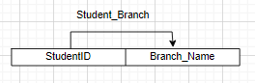

* In Table “Student_Club”
  + 1. StudentID, Club_Name 🡪 Designation

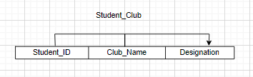

* In Table “Student_Hostel”
  + 1. StudentID 🡪 Type
    2. StudentID 🡪 Fees_Per_Semester_in_INR
    3. StudentID 🡪 Fee_Status

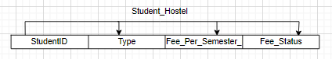

* In Table “Student_Mess”
  + 1. StudentID 🡪 Type
    2. StudentID 🡪 Fees_Per_Semester_in_INR
    3. StudentID 🡪 Fee_Status

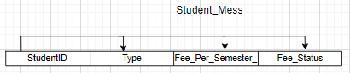

* In Table “Student_Name”
  + 1. StudentID 🡪 First_Name
    2. StudentID 🡪 Middle_Name
    3. StudentID 🡪 Last_Name

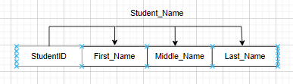

* In Table “Student_Parents”
  + 1. StudentID 🡪 Father
    2. StudentID 🡪 Mother

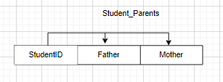

* In Table “Student_Report”
  + 1. Only trivial (reflexive) functional dependency.
* In Table “Student_Section”
  + 1. StudentID, Semester 🡪 Section_No
    2. StudentID, Semester 🡪 Branch_Name

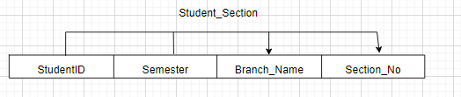

* In Table “Student_Submits_Assignment”
  + 1. StudentID, Assignment_No, CourseID, Batch 🡪 Status

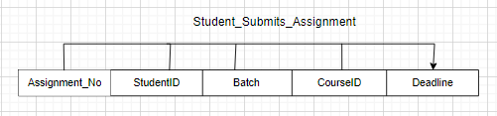

* In Table “Teaches”
  + 1. Only trivial (reflexive) functional dependency.

***Normalization***

In this section, we have justified the normalization in our database for the relations. Below is our justification of normality for each relation.

* **For “Assignment”:**
* 1NF:- Since all the attributes are atomic and single valued, therefore the table is already in 1NF.
* 2NF:- FDs:- {Assignment_No 🡪 CourseID,Batch, Assigning_Date, Deadline}. This is already an FFD (since there is only one FD). Therefore, table is in 2NF.
* 3NF:- There is only one FD in the table therefore there is no Transitive dependency in the table. Hence, it is in 3NF.
* BCNF:- Since Assignment_No is the primary key of the table, implies that it is a super key. Hence the table is in BCNF.
* **For “Book_Issued_To”:**
* 1NF:- Since all the attributes are atomic and single valued, therefore the table is already in 1NF.
* 2NF:- FDs:- {StudentID, BookId 🡪 Librarian}. This is already an FFD (since there is only one FD). Therefore, table is in 2NF.
* 3NF:- There is only one FD in the table therefore there is no Transitive dependency in the table. Hence, it is in 3NF.
* BCNF:- Since, {student ID, BookID} is the primary key of the table, implies that it is a super key. Hence, the table is in BCNF.
* **For “Books”:**
* 1NF:- Since, all the attributes are atomic and single valued, therefore the table is already in 1NF.
* 2NF:- FDs:- {BookID 🡪 Book_Name, Author, Copies}. This is already an FFD (since there is only one FD). Therefore, table is in 2NF.
* 3NF:- There is only one FD in the table therefore there is no Transitive dependency in the table. Hence, it is in 3NF.
* BCNF:- Since BookID is the primary key of the table, implies that it is a super key. Hence, the table is in BCNF.
* **For Branch**
* 1NF:- Since all the attributes are atomic and single valued, therefore the table is already in 1NF.
* 2NF:- FDs:- {Branch_Name 🡪 Duration_in_Years, Number_of_Course}. This is already an FFD (since there is only one FD). Therefore, table is in 2NF.
* 3NF:- There is only one FD in the table therefore there is no Transitive dependency in the table. Hence, it is in 3NF.
* BCNF:- Since Branch_Name is the primary key of the table, implies that it is a super key. Hence the table is in BCNF.
* **For Club**
* 1NF:- Since all the attributes are atomic and single valued, therefore the table is already in 1NF.
* 2NF:- FDs: - {Club_Name 🡪 Budget_in_INR}. This is already an FFD (since there is only one FD). Therefore, table is in 2NF.
* 3NF:- There is only one FD in the table therefore there is no Transitive dependency in the table. Hence, it is in 3NF.
* BCNF:- Since Club_Name is the primary key of the table, implies that it is a super key. Hence the table is in BCNF.
* **For Course**
* 1NF:- Since all the attributes are atomic and single valued, therefore the table is already in 1NF.
* 2NF:- FDs:- {CourseID 🡪 Course_Name, Credits}. This is already an FFD (since there is only one FD). Therefore, table is in 2NF.
* 3NF:- There is only one FD in the table therefore there is no Transitive dependency in the table. Hence, it is in 3NF.
* BCNF:- Since CourseID is the primary key of the table, implies that it is a super key. Hence the table is in BCNF.
* **For Faculty**
* 1NF:- Since all the attributes are atomic and single valued, therefore the table is already in 1NF.
* 2NF:- FDs: - {FacultyID 🡪 > Faculty_Name, Date_of_Birth, Salary_in_INR, Designation, Gender}. This is already an FFD. (since there is only one FD). Therefore, table is in 2NF.
* 3NF:- There is only one FD in the table therefore there is no Transitive dependency in the table. Hence, it is in 3NF.
* BCNF:- Since FacultyID is the primary key of the table, implies that it is a super key. Hence the table is in BCNF.
* **For Grades**
* 1NF: - Since all the attributes are atomic and single valued, therefore the table is already in 1NF.

2NF: - FDs: - {Report_ID->CPI}

           This is already an FFD. (since there is only one FD)

           Therefore, table is in 2NF.

3NF: - There is only one FD in the table therefore there is no Transitive dependency in the table.      Hence, it is in 3NF.

BCNF: - Since Report_ID is the primary key of the table, implies that it is a super key. Hence the table is in BCNF.

**For Student_Hostel**

1NF: - Since all the attributes are atomic and single valued, therefore the table is already in 1NF.

2NF: - FDs: - {StudentID ->Type,Fee_Per_Semester,Fee_Status}

           This is already an FFD. (since there is only one FD)

           Therefore, table is in 2NF.

3NF: - There is only one FD in the table therefore there is no Transitive dependency in the table.      Hence, it is in 3NF.

BCNF: - Since StudentID is the primary key of the table, implies that it is a super key. Hence the table is in BCNF.

**For Mess**

1NF: - Since all the attributes are atomic and single valued, therefore the table is already in 1NF.

2NF: - FDs: - {Type -> Fees_Per_Semester_in_INR}

           This is already an FFD. (since there is only one FD)

           Therefore, table is in 2NF.

3NF: - There is only one FD in the table therefore there is no Transitive dependency in the table.      Hence, it is in 3NF.

BCNF: - Since Type is the primary key of the table, implies that it is a super key. Hence the table is in BCNF.

**For Section**

1NF: - Since all the attributes are atomic and single valued, therefore the table is already in 1NF.

2NF: - FDs: - {StudentID ->Branch_Name,Semester,Section_no}

           This is already an FFD. (since there is only one FD)

           Therefore, table is in 2NF.

3NF: - There is only one FD in the table therefore there is no Transitive dependency in the table.      Hence, it is in 3NF.

BCNF: - Since Section is the primary key of the table, implies that it is a super key. Hence the table is in BCNF.

**For Student_ Address**

1NF: - Since all the attributes are atomic and single valued, therefore the table is already in 1NF.

2NF: - FDs: - {StudentID ->Street,city,State,postal code}

           This is already an FFD. (since there is only one FD)

           Therefore, table is in 2NF.

3NF: - There is only one FD in the table therefore there is no Transitive dependency in the table.      Hence, it is in 3NF.

BCNF: - Since student ID is the primary key of the table, implies that it is a super key. Hence the table is in BCNF.

**For Student_Branch**

1NF: - Since all the attributes are atomic and single valued, therefore the table is already in 1NF.

2NF: - FDs: - {StudentID -> Branch_Name}

           This is already an FFD. (since there is only one FD)

           Therefore, table is in 2NF.

3NF: - There is only one FD in the table therefore there is no Transitive dependency in the table.      Hence, it is in 3NF.

BCNF: - Since StudentID is the primary key of the table, implies that it is a super key. Hence the table is in BCNF.

**For Student _Club**

1NF: - Since all the attributes are atomic and single valued, therefore the table is already in 1NF.

2NF: - FDs: - {StudentID,Club_Name -> Designation}

           This is already an FFD. (since there is only one FD)

           Therefore, table is in 2NF.

3NF: - There is only one FD in the table therefore there is no Transitive dependency in the table.      Hence, it is in 3NF.

BCNF: - Since student ID and Club_Name is the primary key of the table, implies that it is a super key. Hence the table is in BCNF.

**For Student_Hostel**

1NF: - Since all the attributes are atomic and single valued, therefore the table is already in 1NF.

2NF: - FDs: - {StudentID ->Type,Fee_Per_Semester,Fee_Status}

           This is already an FFD. (since there is only one FD)

           Therefore, table is in 2NF.

3NF: - There is only one FD in the table therefore there is no Transitive dependency in the table.      Hence, it is in 3NF.

BCNF: - Since StudentID is the primary key of the table, implies that it is a super key. Hence the table is in BCNF.

**For Student_Mess**

1NF: - Since all the attributes are atomic and single valued, therefore the table is already in 1NF.

2NF: - FDs: - {StudentID ->Type,Fess_Per_Semseter,Fee_Status}

           This is already an FFD. (since there is only one FD)

           Therefore, table is in 2NF.

3NF: - There is only one FD in the table therefore there is no Transitive dependency in the table.      Hence, it is in 3NF.

BCNF: - Since student ID is the primary key of the table, implies that it is a super key. Hence the table is in BCNF.

**For Student Name**

1NF: - Since all the attributes are atomic and single valued, therefore the table is already in 1NF.

2NF: - FDs: - {StudentID ->First_Name,Middle_Name,Last_Name}

           This is already an FFD. (since there is only one FD)

           Therefore, table is in 2NF.

3NF: - There is only one FD in the table therefore there is no Transitive dependency in the table.      Hence, it is in 3NF.

BCNF: - Since student ID is the primary key of the table, implies that it is a super key. Hence the table is in BCNF.

**For Student_ Parents**

1NF: - Since all the attributes are atomic and single valued, therefore the table is already in 1NF.

2NF: - FDs: - {StudentID ->Father ,Mother}

           This is already an FFD. (since there is only one FD)

           Therefore, table is in 2NF.

3NF: - There is only one FD in the table therefore there is no Transitive dependency in the table.      Hence, it is in 3NF.

BCNF: - Since student ID is the primary key of the table, implies that it is a super key. Hence the table is in BCNF.

**For Student_Section**

1NF: - Since all the attributes are atomic and single valued, therefore the table is already in 1NF.

2NF: - FDs: - {StudentID -> Semester,Branch_Name,Section}

           This is already an FFD. (since there is only one FD)

           Therefore, table is in 2NF.

3NF: - There is only one FD in the table therefore there is no Transitive dependency in the table.      Hence, it is in 3NF.

BCNF: - Since StudentID is the primary key of the table, implies that it is a super key. Hence the table is in BCNF.